
ABN 31 384 184 778

Level 1, 21 Murray Crescent
GRIFFITH ACT 2603

Tel: (02) 6239 8900
Fax: (02) 6239 8999

PUBLIC SAFETY MOBILE BROADBAND

POLICE FEDERATION OF AUSTRALIA: SUBMISSION TO
PRODUCTIVITY COMMISSION ISSUES PAPER, April 2015

INTRODUCTION

The Police Federation of Australia represents all of the nation’s 59,000 police officers. We have an ongoing commitment to achieving mobile broadband communications for our police services because of the once-in-a-lifetime transformation we expect it to bring to frontline policing in Australia. Effective communications in the field are key to the public safety and security functions that our police men and women carry out on a daily basis in the interest of the community. The same can be said for our emergency service partners. Therefore we are keen to collaborate with the Productivity Commission and Governments to ensure police and their public safety partners have modern communications to enable them to best serve the community.

We have no objection to our submission being made public.

PUBLIC SAFETY MOBILE BROADBAND VIA DEDICATED SPECTRUM – AN ESSENTIAL PUBLIC GOOD

As many of our political leaders have remarked recently in the context of terrorism, keeping the community safe is the first priority of governments. The work of our public safety agencies—police, ambulance, fire and emergency services—is critical in doing so. And to do that job effectively those services need modern, reliable and effective communications.

In this day and age, that means mobile broadband communications. This capability is an essential “public good”.

As the most recent Parliamentary Committee investigating this issue said “There is no greater use of spectrum as a public resource than that of ensuring the safety of the Australian public. Public safety operations are essential to the public interest”.

There are around 400,000 frontline personnel in Australia’s emergency services, including 59,000 police officers, for whom this issue is vital.

The PFA wants to make it very clear that having 21st Century mobile broadband communications is also vital to police officer work health and safety, particularly officers working on the front-line. Police officers need the best in intelligence about offenders they are pursuing, up-to-date situational awareness, and data, video and other forms of critical information to operate most effectively and safely in the interests of the community and their own welfare.
Our law enforcement officers put themselves in danger in the interests of keeping the community safe. Communications are central to their existence.
Under the heading, Broadband is the future so act now, one USA article put it this way−
“For a cop, being able to communicate is all about survival. Not even an officer’s service weapon is more critical when it comes to safety. This is why the fight to secure the section of broadband spectrum…….exclusively for first responders is so important.”
As the Commissioner of the Queensland Fire and Rescue Service put it, “Situational awareness is King”.
In his State of the Union address to Congress in 2011, US President Obama said a 16 year old with a smart phone has a more advanced communications capability than a police officer carrying a two-way radio. In Australia, very little has changed since then.
The option of police and other public safety agencies relying on the networks of the commercial telecommunications carriers is seriously undermined by the frequency of telco shutdowns in times of natural disaster.

Most revealing is the report of these mass service disruptions in the 2012 financial year (more recent figures should be available to the PC.). The Telecommunications Industry Ombudsman’s (TIO) report (TIO News, June 4, 2013 and media story on the TIO Report) shows that the commercial carriers declared 584 mass service disruptions, some for “up to four months, and were applied to capital cities and other large or densely populated areas”. Such areas included metropolitan Melbourne and western Victoria, metropolitan and greater Sydney, the Hunter, Central Tablelands and the Illawarra (from 29 January to 3 May), and Tasmania during the bushfires. The northern half of Queensland was without telecommunications services for weeks during floods and cyclones. The increase in disruptions is attributed to the increasing number of severe weather events and the location and severity of those events. By contrast, the networks of our police services are hardened so that they are better able to withstand those sorts of breakdowns and are encrypted to guard against interception.

It is also materially significant that neither of the big carriers—Telstra and Optus—cover even half of the Australia landmass with their mobile networks. Telstra covers approximately 30% and Optus around 12.6%. That is no basis on which to found a public safety mobile broadband network.

The PFA embarked on the campaign for spectrum for public safety agencies in June 2010. Five years have passed without decisive action. And yet, the fact is that 30 MHz of quality spectrum in the 700 MHz band is ‘left over’ following the 2013 Digital Dividend auction which saw Telstra and Optus bid for less than expected. There can no longer be any excuse for not resolving this important public policy issue.

Is seems clear that governments are simply delaying action to resolve this issue in order to put off allocating funds to deliver mobile broadband communications for public safety.

Why else would public safety agencies be the ONLY sector which is required to now undergo a cost/benefit analysis before securing spectrum for this purpose. No cost benefit analysis has been required for the mining sector, the rail operators, defence, the telecommunications sector, or radio and television broadcasters to name just a few.

Setting a target date of 2020 for achieving mobile broadband capability for public safety is disgraceful.

The delay by Federal governments of both persuasions is unconscionable and not in the public interest or national interest.

ADDRESSING THE PRODUCTIVITY COMMISSION’S QUESTIONS:

We have addressed below only those questions to which we can contribute something worthwhile, noting that many of the questions are best addressed by technical experts, economists and the public safety agencies themselves.

- THE COMMISSION’S PROPOSED APPROACH

The PC’s proposed approach is commendable as far as it goes, particularly in the wide scope of Cost/Benefit Analysis considerations. The PFA is quite impressed with the Issues Paper on that score. However, it needs to be complemented first with a careful understanding of the critical importance of secure, reliable, up-to-date communications systems to a modern and effective police force and the other key emergency services – ambulance, fire, and SES which communities and all our governments rely on.

Unless your study is based on a full appreciation of the centrality of such communications to modern public safety agencies it will face difficulties in capturing the importance, and value, of mobile broadband communications based on dedicated spectrum for their services.

Governments are responsible for ensuring that their public safety agencies are well equipped to undertake the onerous duties expected of them in a first world society. This is reflected in the legislation governing radio spectrum, under which the Parliament has expressly provided that the Minister and the ACMA must:

“make adequate provision of the spectrum:
- For use by agencies involved in the defence or national security of Australia, law enforcement or the provision of emergency services.”

That obligation set out by Parliament in the Radiocommunications Act 1992 is yet to be honoured.

We consider that in the 21st century “adequate spectrum” means mobile broadband spectrum, not just narrow band for voice communications. Virtually all consumers in Australia now expect to have broadband services. There is no sound reason why Australia’s public safety agencies should be denied mobile broadband capability for their vital work for the community.

In fact, as the 2015 report, Digital Australia sector report: Government by EY Sweeney makes clear, Australian Governments are lagging behind other sectors of the community in its digital capability. The report says “Without a committed focus on these areas, the nation’s ability to gain competitive advantage through innovative use of digital technology will quickly be eroded. Compared to other nations, we have stalled.”

Based on the provisions of the Act, the PFA considers that the issue to be addressed by the Productivity Commission is not “Providing mobile broadband capability to PSAs” but “providing a mobile broadband communications system over dedicated radio spectrum for PSAs’.

That does not necessarily preclude varying degrees of private sector involvement, from the obvious like handsets, to the provision of spill-over capacity onto telco systems when the PSAs system is at capacity such as during mission-critical incidents.

It does however preclude the option of “relying on commercial networks”.

- DOMESTIC AND INTERNATIONAL DEVELOPMENTS

Apart from the studies of PSMB you have identified, on the domestic front you will no doubt have regard to the two unanimous Parliamentary Inquiries into this matter in Australia, namely:
- The Senate Environment and Communications References Committee report, The capacity of communications networks and emergency warning systems to deal with emergencies and natural disasters, November 2011; and
- The Parliamentary Joint Committee on Law Enforcement report, Spectrum for public safety mobile broadband, July 2013.

The 2013 report unanimously recommended that 20 MHz of 700 (or 800) MHz band spectrum be allocated for public safety agencies to develop a public safety mobile broadband network. It recommended that the Australia Government fund that spectrum allocation. A regulatory framework for overflow arrangements onto commercial carriers was also recommended.

In terms of international developments there have been several recent initiatives of central importance to the PC inquiry.

The University of Hong Kong study by Professor John Ure, Public Protection and Disaster Relief Services and Broadband in Asia and the Pacific: A Study of Value and Opportunity Cost in the Assignment of Radio Spectrum, May 2013 examined eight Asia-Pacific economies including Australia. “The findings are that in all eight cases the per capita losses sustained by society greatly outweigh the auction revenues plus consumer surplus that would arise from assigning the spectrum to 4G LTE operator. In the most marginal case of Singapore, the balance of the outcome is still over 2:1.” In other words, in terms of cost/benefit analysis, the balance is strongly in favour of allocating spectrum to public safety compared to telecommunications companies because of the significant savings to society during mission critical events like natural disasters or terrorism events. The study concluded that a minimum of 20 MHz of spectrum is warranted for public safety.

The Canadian Government in its 2015 Budget announced that it is providing 20 MHz of the 700 MHz band spectrum for its public safety agencies, a step up from the 10 MHz that it had previously committed to providing. The government also announced $3 million in funding to support the start-up of the new national entity that will manage the Canadian Public Safety Broadband Network. The Government of Canada Budget Plan 2015 says “ Economic Action Plan 2015 also proposes new funding to support the safety of Canadians by investing in the development of a high-speed mobile public safety network to enhance Canada’s emergency management system’.

The new research (other than the cost/benefit studies you have noted) of particular relevance to your PC inquiry is the CBA for the European Commission by SCF Associates, Is Commercial Cellular Suitable for Mission Critical Broadband?, Final Report. The study examined the needs of public safety agencies and a number of other sectors requiring mission-critical networks. It found that technically, commercial LTE networks could support mission critical needs but only if certain conditions are met. It went on to say “(t)hese conditions would fundamentally change the operating environment for the commercial mobile networks”.

A number of the study’s findings are significant:
- The capital expenditure cost for an LTE network in the 700 MHz band is estimated to be 20% less than a similar network in the 800 MHz band. This is important in the Australian context because one debate has been about whether the PSMB network should be in the 700 or 800 MHz band.
- They find that cost is not the only consideration. “Our overall conclusion is that it could be possible for commercial mobile broadband networks to be used for mission critical purposes but only if five conditions are met (SCF Associates emphasis). To quote from the report:

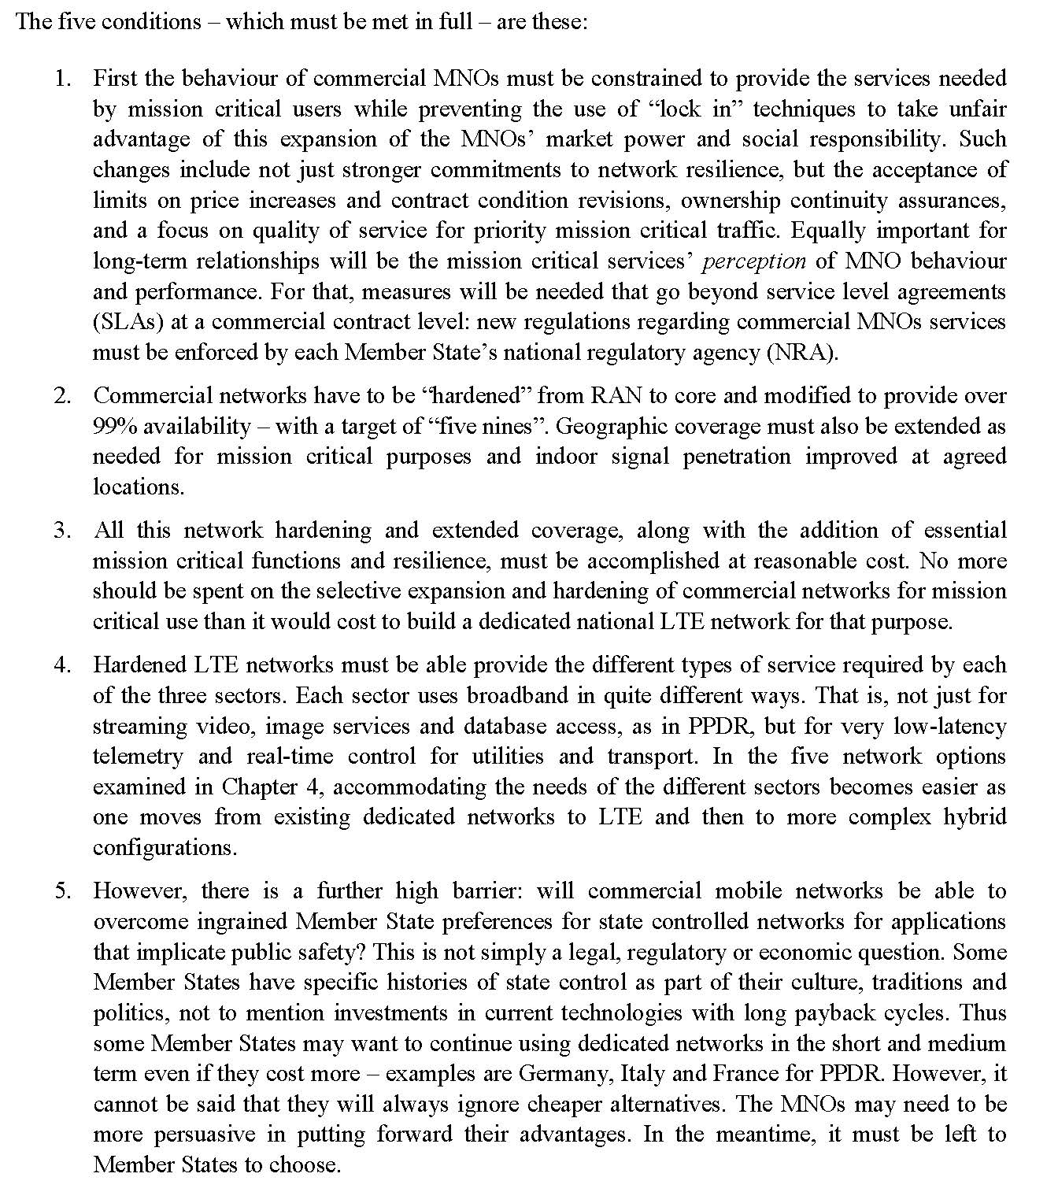

The above extract refers to all Member States of the European Union, and MNOs are the European mobile network operators, the Australian equivalents being Telstra, Optus and Vodafone.

The study went on to say that a number of important regulatory measures would also be needed:

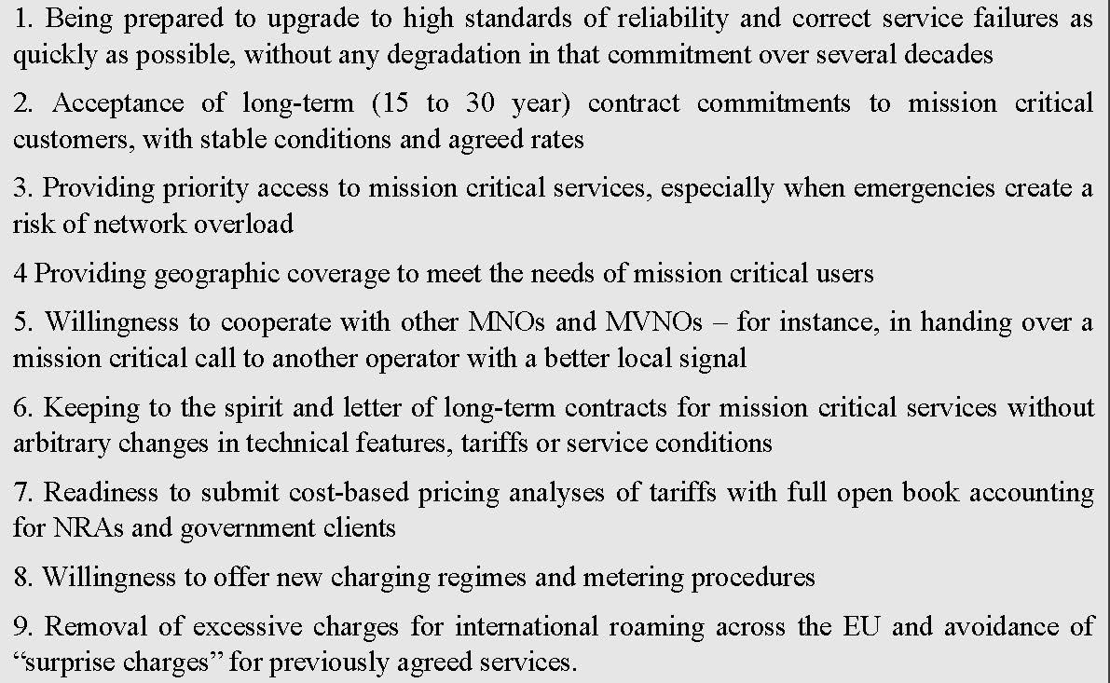

Realistically, it is not possible to see these two sets of quite onerous conditions being met in the near term, if at all, in Australia (or in the EU).

The report goes on:

“These obstacles to commercial use cannot be removed immediately. ……The crucial barrier is the current MNO mass-market business model, which needs to be suitably amended to provide appropriate levels of service to priority clients with special needs. But perceptions of MNOs will take time to change. Hence as mission critical networks are the responsibility of national administrations, it is likely that dedicated state-owned networks will continue to be the preferred model in the near term.”

The fact is that commercial enterprises are not motivated first and foremost by the public interest or the national interest as governments are, or should be. They are necessarily bound to put their shareholders’ interests, and financial interests above other considerations, so it is unsurprising that they would not fit comfortably in the public safety communications space where mission critical service is paramount.

Two other recent reports should provide useful findings and data for the PC inquiry. Natural Disaster Funding Arrangements, Productivity Commission Inquiry Report, No. 74, 17 December 2014 reports that Deloitte Access Economics estimates the total economic cost of natural disasters in Australia at $6.3 billion per year. The PC report recommends shifting the balance of funding from disaster recovery towards mitigation and prevention measures. Improved public safety measures, including by first responders, should contribute to savings in this area.

Finally, the ACMA report, The economic impacts of mobile broadband on the Australian economy from 2006 to 2013, shows that it contributed $33.8 billion in 2013 or more than 2% of the nation’s GDP - $7.3 billion in economic activity and $26.5 billion worth of time savings for businesses.

It is reasonable to assume, given that public safety agencies are one of the most mobile sectors of the national workforce, similar or greater returns, productivity improvements, savings and other benefits would arise from this sector. It would be useful if the PC inquiry could extrapolate the economic benefits, and benefits in terms of productivity, effectiveness and efficiency, from the public safety sector using mobile broadband communications.

- IMPLICATIONS FROM SPECTRUM REVIEW

When considering any implications from the Department of Communications review of spectrum policy currently underway, it should be noted that approximately 22 of the 38 submissions to the review argued that spectrum for “public good” purposes should not be dealt with in a market-based system of spectrum allocation and should not be charged market prices for spectrum. The obligation on the Federal Government to provide “adequate spectrum” for such purposes should continue. We were pleased to see that this is recommended in the Department’s Spectrum Review proposals released in May 2015.

- PSAs WHICH SHOULD BE IN-SCOPE

The PFA believes that police, ambulance, fire and emergency services should be within the scope of the PC study. We are open to considering whether or not marine search and rescue services should also be included.

- PSA INSTITUTIONAL ARRANGEMENTS

We note that the Commonwealth’s law enforcement agencies are likely to be outside the scope of this study. However, bodies like the AFP, ASIO and the Australian Border Force during numerous serious incidents, like terrorist events and serious and organized crime, are reliant on, or partner with, State and Territory police services and the mobile communications which they have now and into the future. Joint Counter-Terrorism Task Forces in various states are one example of this. The Commonwealth therefore has a stake in the effectiveness of these communications systems and should be contributing financially to them. In fact the former Federal Government’s offer to the States of spectrum included requiring “an agreement to provide reasonable access to State and Territory networks by relevant Commonwealth agencies”. This mutual reliance, including for inter-operability, will only increase in the future.

- MISSION CRITICAL COMMUNICATIONS SYSTEMS

As you suggest mission critical communications must be resilient, secure (e.g. from criminal hacking), with adequate redundancy to operate under adverse conditions. Currently, the mobile broadband communications systems of the major telecommunications companies simply do not meet those fundamental requirements. There is ample evidence of this reality from the numerous inquiries and Royal Commissions following serious natural disasters in Australia. Triple Zero outages are further evidence of this. See also our reference to mass service disruptions on page 2.

The most recent natural disaster was the Hunter Valley storms in April 2015. As the Newcastle Herald headlined on 15 May 2015, Sid Fogg’s bus business without phones, internet for six weeks. This is just an extreme example of the telco system failures which public safety agencies are unable to tolerate. They need a much greater degree of resilience than the man or woman in the street or the Hunter Valley bus business.

13. COMMERCIAL SOLUTIONS AND BARRIERS

See PFA discussion at item 2 above.

14, 15 AND 16. PSA APPLICATIONS

We think the PSAs are best place to provide this information.

17. THREE OPTIONS AND PSMB CAPABILITY CHARACTERISTICS

In relation to a dedicated PSMB network (option 1, page 10), in the PFAs view the very point of such a network is to own and control the network. We do not consider those characteristics as optional as your outline seems to suggest. That ownership and control gives the PSA the capacity always to determine standards of reliability, security and redundancy necessary for its mission critical work. It also avoids them being exposed to predatory pricing by virtual monopoly service providers. See also PFA comments under item 2 above.

We are open to considering a hybrid approach (option 3) where such an approach combines a dedicated PSMB network (owned and operated by PSAs) and an allied commercial network to provide spill-over capacity when the dedicated network is at full capacity or overloaded.

The suggestion that a dedicated PSMB network might be confined to specific disaster-prone areas or significant population centres is seriously problematic, both because the location of disaster-prone areas is so unpredictable and extensive in Australia, and because it is hard to imagine many MPs or Senators putting their hands up to be an area not covered by police, fire, ambulance and emergency services communications.

18. INTEROPERABILITY

National interoperability should include interoperability between networks, devices and applications, and between different PSAs and across jurisdictions.

22-26. NETWORK COVERAGE

PSAs are best placed to provide this information but non-metropolitan coverage is vitally important to PSAs, particularly for natural disasters where the location of events is notoriously unpredictable. See also PFA comment on page 3 regarding coverage by Telstra and Optus and in item 17 above.

30- 33. INTEGRITY AND SECURITY OF PSA COMMUNICATIONS

Of PSAs, Police have the highest need for security and integrity of communications because of their work in dealing with terrorists and serious criminal organisations. The risks to security and integrity will increase without a dedicated PSA mobile broadband network.

34-38. CAPACITY AND PRIORITY ISSUES

All of the estimates and cost/benefit studies we have examined confirm that a minimum of 20 MHz of quality (700 MHz preferably, and 800 MHz possibly) spectrum is necessary for PSAs. See PFA discussion under item 2 above.

39-42. RESILIENCE AND CONTINUITY OF SERVICE

For the PFA these are critical features unable to be met by commercial options. If the PC was to ask the Australian public if they would accept public safety agencies like the police to be subject to the same vagaries as consumers regarding mobile phone and Internet services, we doubt that they would agree. People understand that “public good” services require higher levels of certainty and reliability. In a variety of challenging circumstances the public interest must have the highest priority as most of the community would agree.

The New York Police Department Commissioner Kelly pointed out that on September 11, 2001 and after the crash of a commercial jet into the Hudson River several years ago, commercial mobile phone networks were quickly overwhelmed making police and fire communications using commercial phone lines virtually impossible. Kelly explained, “We need a system that we build according to our own specifications and that we control. We know from past experience that we can’t depend on systems run by the private sector. Along with the fact that these companies will be reluctant to shut down service for their own customers to give us priority, commercial systems are too susceptible to failure in a crisis. It’s just too costly for them to build networks that meet our standards. Because of our mission, we build networks tough enough not to fail during disasters like 9/11 and Hurricane Katrina.”

48-49. OPTIONS AND ASSUMPTIONS

The PFA considers that all options investigated should assume:
- A minimum of 20 MHz of dedicated 700 or 800 band mobile broadband spectrum for PSAs; and
- 4G/LTE mobile broadband technology and network architecture.

53-57. NETWORK COSTS

The EC report referred to under item 2 above has useful information on network costs.

58-59. OPPORTUNITY COTS OF SPECTRUM

The Hong Kong report by Ure has useful information on opportunity costs of spectrum.

The PFA supports consideration of dedicated PSA spectrum being shared when and if it is not being fully utilized by PSAs in order that valuable spectrum is not wasted. The Department of Communications Spectrum Review report of May 2015 seems to support this option when it proposes “permitting agencies to either lease or sell the spectrum and retain the benefit of doing so”.

60-61. DISCOUNT RATE AND TIME SCALE

The PFA is not in a position to propose a particular discount rate but a number of recent articles in The Public Sector Informant (Canberra Times) have discussed discount rates for investments of this kind. The articles have been provided to the Productivity Commission team.

Because investment in PSMB will be a long term investment on the part of governments, and because the benefits will also accrue long into the future, a time scale reflecting those features will be necessary.

62. EXPECTED OUTCOMES

PSA outcomes from PSMB communications include the ability to send and/or receive all manner of usable information and intelligence:
- Data
- Real-time video and images
- Networked CCTV camera images
- DNA information
- Digital photographs of detainees
- Facial recognition technology
- Electronic fingerprints
- GPS information
- Meteorological updates like fire and wind direction and speed
- Flood level updates
- Person of interest IDs, mobile phone number, outstanding warrant details, and criminal history
- Motor vehicle registrations details and automatic number plate recognition
- Information on firearms ownership and registration
- Plans and diagrams of buildings and industrial plant
- Data on hazardous chemicals on premises and
- Information about critically ill or injured patients.

That sort of information and intelligence available during operations should enable police and other public safety agencies to deliver better outcomes in terms of quality, productivity, effectiveness and efficiency.

63-67. IDENTIFYING AND ESTIMATING BENEFITS

The range of benefits outlined in your Issues Paper are the kind that should be measured so far as possible. It would also be important to factor into the estimates improved effectiveness and efficiency of say police services since senior ranks of the largest police force in Australia expect mobile broadband communications will transform police services in this country. They see it as a-once-in-a-lifetime game-changer. It is also likely to generate savings for Commonwealth, State and Territory governments and the wider community.

Given that natural disasters in Australia are estimated to cost the economy $6.3 billion dollars per annum (PC Report: Deloitte Access Economics) potential savings in this area are likely to be material and should be estimated so far as possible.

It may be possible to draw on the ACMA report into the economic impact of mobile broadband use by business in 2013, to estimate the likely economic impact for PSMB use by the public safety agencies. Because they are an even more mobile workforce than most of the business community, it may be that the economic impact will be even greater in the PSA sector. The estimated $26.5 billion of time savings for the nation’s businesses suggests a proportionate or greater time savings for police and emergency services.

CONCLUSION

The PFA would be pleased to discuss our submission with the Productivity Commission at your convenience.

Yours sincerely

Mark Burgess APM
Chief Executive Officer

1 June 2015

American Police Beat, April 2011.

