Submission to the Productivity Commission Inquiry:

Economic Regulation of Airports



Archerfield Airport Chamber of Commerce Incorporated

About AACCI
Archerfield Airport Chamber of Commerce Inc is incorporated pursuant to the Associations Incorporation Act 1981 and the Associations Incorporation Regulation 1999 being Queensland statutes and being the incorporated body of the previous unincorporated body of Archerfield Airport Chamber of Commerce, collectively (“AACCI” and “the Chamber”).
The objects of the Chamber are: To Foster, preserve, maintain and develop aviation on Archerfield Airport (primarily), other secondary airports and nationally.
The Chamber’s members range from the most senior representatives of an international world class airline through to fixed wing (airplane) and helicopter Air Charter, and flying training organisations, corporate flight departments, professional (Commercial) and private pilots, aviation tenants, aircraft owners whose aircraft are or have been predominantly based at Archerfield and the representatives of aviation community organisations: aircraft maintenance, overhaul, airframe, instruments, avionics and related engineering experts and much more. The Chamber also has interstate Chamber affiliated- members.
The Chamber is a not-for-profit organisation whose objects have been declared a public purpose with a sanction to receive public donations pursuant to The Collections Act 1966 (Qld).
Readers of this submission who would like to make (anonymous) public donations pursuant to The Collections Act 1966 for the Chamber to run a head of power challenge in the High Court based principally upon the Robertson SC opinion (refer Annexure D1 &D2 to this submission) may do so by making deposits to the Chamber’s Bank of Queensland Bank Account and emailing notification about the deposit to the treasurer to receive a receipt.

Background
Purposes of Air Travel
The primary purpose of travelling by air whether by buying an airline ticket on an RPT service, chartering an aircraft or helicopter (or indeed owning either) is the time utility that the aircraft or service provides. If there is a failure to achieve that time utility, the value of the air travel or service is significantly diminished. This also applies generally to freight and critically to perishable freight. This core time utility concept does not seem to be something that Government or Regulators sufficiently appreciate.
The Air Transport System Operates as a “Whole”
The RPT Airline Aircraft operate primarily between the Primary Capital City Airports, International Airports and the Major City and larger Regional Airports all under Instrument Flight Rules (“IFR”).
General Aviation Aircraft operate primarily from the Secondary Airports and the Regionals, Certified and Registered airports and authorized landing areas. Commercial Air Transport and Corporate GA Aircraft also may operate from the Capital City Primary Airports and Major City Airports. General Aviation Aircraft operate both under Visual Flight Rules (“VFR”) and IFR depending on the aircraft certifications, on-board equipment, pilot qualifications and airport design standards and approvals including the airport’s instrument approaches (if any).
Aircraft must land at airports / aerodromes or authorised landing areas by law and are economically captive to such airports. The ability of a flight from airport “A” to airport “B” to proceed is dependent upon the airport system “as a whole” not just departure airport “A” and arrival airport “B”. The availability and suitability of Airport “C” (possible thousands of kilometers away and never intended to be a destination) can solely determine if the A-B flight can proceed – if at all.
A flight may be able to plan to proceed to an “acceptable airport” but must always be able to fly to a “suitable” airport. Essentially a suitable airport is not one which also requires an alternate itself. An airport’s aeronautical infrastructural facilities (e.g. runway lighting, standby power generation, navigation aids, availability of an ARO (responsible person in attendance), number, length and direction of runways, imposed curfews, forecast weather conditions and the airport’s policies and practices of the airport management must all be aligned for such flights to proceed.
Secondary airports and Primary Capital City Airports in our advanced aviation environment are designed to work as airport pairs, the Capital City Airport handling scheduled public transportation (e.g. Airlines) and the secondary airport non-scheduled air services (mostly referred to as General Aviation). With limited exceptions Brisbane Airport doesn’t handle Helicopter operations leaving that to the secondary and other airports. The secondary airport also relieves the primary airport of traffic that would otherwise inundate the primary airport’s traffic capacity if it were not there. Other capital cities have multiple secondary airports, but Brisbane has only the one, being Archerfield.
Airports, in the national interest, cannot be operated with singular interest as isolated fiefdoms and with disregard to the Air Transport System as a Whole.

Composition of The Australian VH Aircraft Register
Page 1 Figure 1 to this Inquiry’s Issues Paper refers to the rising number of passengers and international air freight however this is not the sum-total of the Sky – far from it.
The Australian Aircraft VH Register, (which excludes the non- VH registered aircraft such as Warbirds, and Sports and Recreational Aircraft which are on separate self-administered bodies registers) lists 15,551 aircraft as at 18th October 2018.
Approximately 1603 of the VH Register were either Gliders and Motor Gliders (1,178) and Manner Free Balloons (425).
Rotorcraft (Helicopters) were approximately 2267.
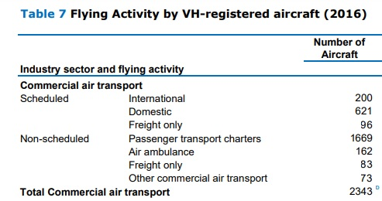
The BITRE Australian Aircraft Activity 2016 report includes in Table 7 the make-up of “Commercial Air Transportation” but includes in a note D that “the sum of Total General Aviation and Total Commercial Air Transport aircraft will exceed Total aircraft as some aircraft operate in both industry sectors”.
The entire fleets of the three major RPT airlines total only 309 aircraft (Qantas 133, Jetstar 76, and Virgin 100).
Examination of the most common RPT airline aircraft types reveals that there are only 591 of them on the Australian VH Register however being of that type is not sufficient to assume RPT operations.
Assuming however that they are all used for RPT operations, the remaining approximately 13,357 aircraft are what has traditionally, in the past, been known known as “General Aviation”. The Commercial Air Transport Sector statistics obviously includes aircraft that play a significant and generally under-recognised role in passenger and freight operations in the Commercial Air Transport Sector. It is noted from the BITRE General Aviation Study (2017) that the ICAO classification of Civil Aviation Activities and the ICAO Reference Manual for Aviation Statistics makes no distinction regarding aircraft size.
A key difference between the traditional view of GA and the new ICAO classification is the treatment of air transport charter activity. Previously, small transport charter operations were considered to be part of GA. However, the new ICAO definition explicitly excludes them.
Additionally, how the BITRE reports aviation statistics compared to the ICAO model can be found in Figures 1.1 and 1.2 in the study.
The BITRE General Aviation Study (2017) reports “a serious lack of comprehensive and robust data on the entire GA sector, including its level of activity and its economic and community contribution”.
Rotorcraft (Helicopters) comprise approximately 2267 of the 13,357-aircraft leaving approximately 11,090 Fixed Wing, Commercial, Private and Corporate Aircraft.
Buried within the BITRE Table 7 “Flying Activity VH-Registered Aircraft” subheading “General Aviation” is a further sub-heading.
Own Use Business | Own Business Travel | 2254

These 2254 aircraft include significant operations that are passenger and/ or freight transport operations.
One example is “Angel Flight” whereby aircraft owners donate their aircraft to transport sick but able persons and their carers from remote localities to major cities for medical treatment.
Corporate Flight department operations are also buried in this statistical classification and are passenger and freight operations.
One example of this is Western Grazing Company group that has a fleet of turbine and piston engine aircraft (including operating “A” class aircraft - in the airline transport category) transporting its own staff and management between multiple outback properties from its permanent aviation base and substantial own private hangar facilities at Brisbane Airport. This company group formerly operated from its own facilities on Archerfield Airport until its lease was not renewed by the ALC but is now inconveniently restricted to operations in the middle of the day at Brisbane Airport due to airport demand restrictions. It’s group is the owner of the largest hangar facility on Brisbane Airport.
Another example is the FKG Group, a privately owned dynamic industrial and infrastructural projects group which is based at Toowoomba Airport to support substantial projects in remote locations in Australia (and Papua New Guinea) with multiple aircraft including class A air transport category turbine aircraft transporting some of its more than 1000 staff and delivering time critical freight or equipment to support its project operations. It also operates as required into Brisbane airport to transport time critical staff.
Applying the analogy of Ground Transportation:
RPT Airline Aircraft are analogous in operation to the Busses and the B doubles and is the most familiar type of air transport to the general-public, and government.
The General Aviation Fixed Wing Fleet are largely analogous to the Min-Buses, Limousines, Taxis, Couriers, Utility vehicles and Private Cars
The General Aviation Helicopters have a variety of roles analogous to Limousines, Sky Cranes, motor cycles and small special operations vehicles.

Aircraft on the Australia Register that are powered aircraft operate on the following fuels.
FUEL | NUMBER OF AIRCRAFT | PERCENT
Diesel | 14 | NSV
Gasoline (Avgas or alternatively approved fuel e.g. Mogas) | 11,561 | 82%
Kerosene (JetA1 or Avtur) | 2,529 | 18%
TOTAL | 14104 | 100%

From the above table Diesel fuel specific aircraft are not significant in the fleet although it is acknowledged that some turbine aircraft are approved to consume diesel as a substitute for kerosene e.g. turbine agricultural aircraft.
Aviation Turbine Fuel Sales data as published by the BITRE shows rising consumption.
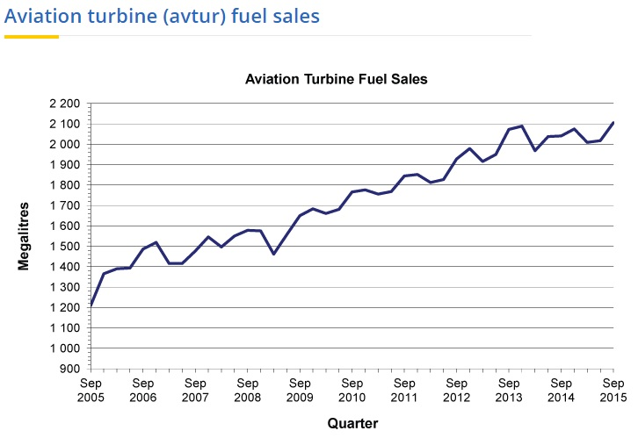
Whereas Avgas Fuel Sales data as published by the BITRE shows falling consumption.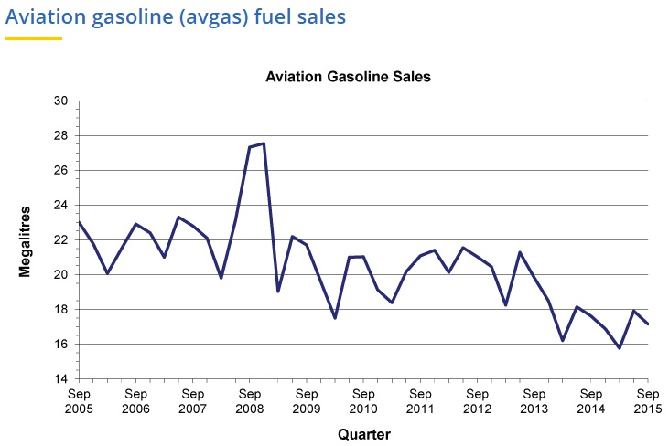
The BITRE in its General Aviation Study (December 2017) states that “Sales of Avgas in Australia Fig 3.3 have been falling for some time, mirroring the gradual fall in hours flown in VH-registered aircraft.’ Figure 3.3 is reproduced below.
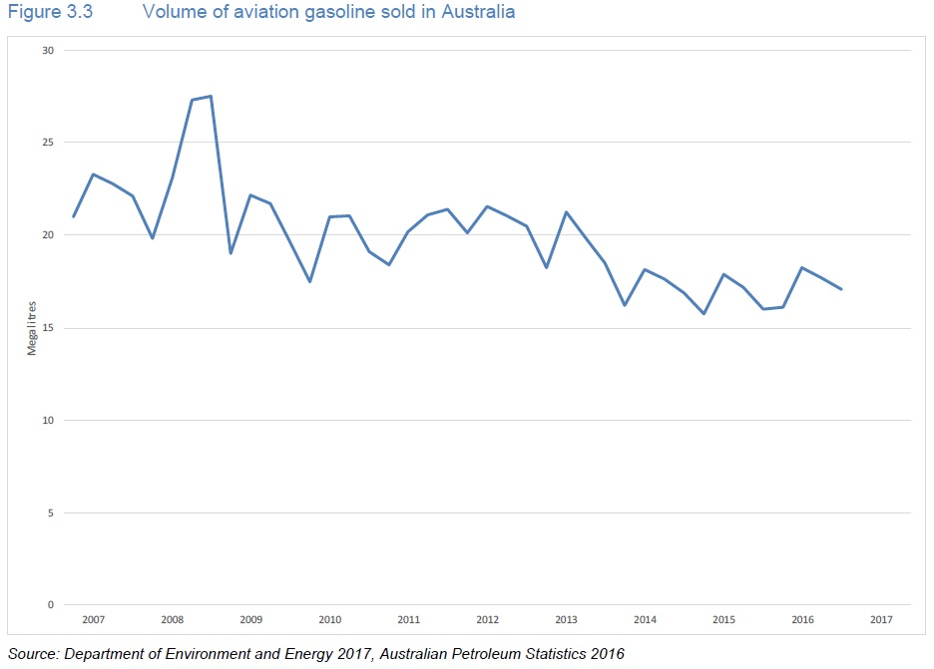
In a growing economy with increasing population it is expected that passenger and freight operations (as per figure 1 of the issues paper) should be and are rising. It is also expected that General Aviation being a significant part of the economy and supporting multiple business sectors, should also similarly be rising, yet the opposite is true.
Clearly something is seriously wrong for this not to be the case.
AACCI believes the current privatised regulatory environment, the Federal Governance of Secondary Airports and the ALOP airports, is a central issue.
Commericalisation of certain Airports for other than aviation purposes, abuse of market power of the privatised secondary airports as unrestrained monopolies, the unconscionable conduct, misleading and deceptive conduct and degradation of aviation infrastructure by the Airport leasing companies or ALOP airport successors have hampered, economically restricted and in some cases decimated the general aviation community and associated industries.
It is welcoming that the Productivity Commission has no pre-determined position on airport regulation arrangements and will provide a report to the Australian Government with its assessment of the regulatory framework. This is long overdue.
Only a review of Airport Regulation that considers General Aviation, ends “Light- Hands” government administration, and considers the head of power will be acceptable to the General Aviation Industry and AACCI.
Airport Regulatory Framework
History
A dot- point precis of Federal Airports Regulation since Federation by Airport Ownership and Operation phases follows:
Phase 1 Federal Government as Owner and Federal Government as Operator
- Commonwealth of Australia -Federation – 1901. (Note: There were no direct powers contained in Commonwealth Constitution as aeroplanes were not invented until 1903 (e.g. Wright Flyer).
- Secondary Airports acquired by the Federal Government by Compulsory Acquisition pursuant to the Lands Acquisition Act 1906-1936 for Commonwealth Defence Purposes (e.g. Archerfield Airport -1929-1936 and – 1942 to 1946 – Refer Annexure A Statement of Dr V Dennis)
- Secondary Airports were initially operated by Department of Defence and the first hangars and other Aviation Buildings were built on the airport by the Commonwealth Government.
- Powers in relation to airports and civil aviation were sought to be added to the Constitution by referendum in 1937 but this failed and as a work-a-around the States individually passed Air Navigation Acts.
- The Commonwealth signed international aviation treaties/ conventions. Department of Aviation was created, and control over Secondary airports was handed over from the Dept of Defence
- Civil Aviation developed and grew and used these airports and the Federal government built more buildings / hangars for civil aviation.
- As Civil Aviation exponentially grew the Federal Government did not want to keep funding more buildings and hangars for use by civil aviation. It became the practice and then the policy of the Commonwealth from at least July 1982 not to provide airport buildings other than those required for Departmental purposes or joint user terminals and to provide ground leases for civil aviation users permitting private construction and development for approved aviation purposes of hangars and aviation buildings upon Airport land.
- Department of Aviation (and like titles) (“DOA”) however would only grant air operators certificates and aircraft maintenance organisations licensing if they had a presence on the secondary airports (i.e. Constructed their own building on a Commonwealth airport or had a long-term lease of a Commonwealth owned building)
- Federal Government decided to lease out ground leases and permit aviation air operators etc to construct their own buildings on the airports – pursuant to the Airports (Business Concessions) Act 1959 which only provided for leases for up to 21 years (excepting terminals).
- Civil Aviation organisations objected to the Federal Government short lease terms and claimed it was just not economically viable for their businesses to build expensive aviation use structures / hangars etc with DOA stringent building standards for only 21 years or shorter periods and was a financial barrier to civil aviation development.
- In response, DOA then represented to each civil aviation operator to the effect that prior to the operator agreeing to take ground leases, that ,provided the operator timely paid their rent to the Commonwealth and complied with lease conditions (e.g. environmental requirements etc) that their leases of airport land (and buildings as applicable) would, subject to airport planning constraints, be continually renewed (as ground leases and no reversion if applicable) (“the collateral agreement with the Commonwealth” and “the Equitable Interests in the Land “). The applicable departmental document in 1977 being “General Principles on the Leasing of Sites and Buildings, other than Terminals at Commonwealth Airports” and in 1985 the Airport Site Rental Policy. (Refer Annexure B statement and statutory declaration by Barry Thomson - former Manager General Aviation Federal Airports Corporation)
- Note that in this Phase 1 – all Departmental planning for airports was subject to parliamentary oversight, approval and parliamentary committee scrutiny and users could make submissions to the parliamentary public works committee / attend hearings and the parliament would query departmental offices and direct the Department to ensure civil aviation user requirements were being met/ accommodated.
Phase 2 Federal Government Qango as Owner and Operator (Federal Airports Corporation)
- Federal Airports Corporation (“FAC”) was formed pursuant to the Federal Airports Corporation Act 1986 (“FAC Act”) with the result that primary and secondary federal airport land was owned by the FAC and the airports were operated by the FAC (a Qango) under the FAC Act. The FAC Act substituted the Federal Airports Corporation for the Commonwealth in respect of leases or licenses of airport land or airport authorities and exercised the Ministerial powers of the Airports (Business Concessions) Act 1959 in so far as they were not inconsistent and a range of other Governmental regulatory functions (on airport access, control over off airport developments interference -e.g. obstacles interfering in protected airspace above land surrounding airports. Leases or authorities in existence at the time of transfer continued.
- The issue of lack of economic viability of inadequately short lease terms of ground leases including site rental policy was incorporated into the Document of Policy Statements & Standard Lease & Licences in 1992 or 1993 and updated in 1994 into the “FAC Policy Manual Volume 8 Property Policy”. These policies were represented to intending lessees of ground leases upon which constructed hangar structures such that they would have a land lease document for up to 25 years (“the legal interest in the land”) and an entitlement to three times renewal of the legal interest in the land without reversion of lease build improvements (i.e. common law right waved by the FAC) and at the ground lease rate, that is without regard to the improved value (“the FAC collateral agreement” and “the Equitable Interests in the Land “ ). This general policy was subject to only one exception and that was when the specific land was needed for airport master planning that may affect the availability of the site.
Phase 3 Federal Government as Owner and Private Airport Leasing Companies as Operators.
- In 1996 / 1997 the Federal Government decided to transfer the ownership of the Primary and Secondary Airports back to the Commonwealth from the FAC and then grant long term leases (generally 50 year leases with a further 49 year option) to Airport Leasing Companies ( ALC’s).
- The Commonwealth and/or the FAC assigned their right, title and interest in the lease of Secondary Airports to the ALC pursuant to the Airports (Transitional) Act 1996 (“ATA”) and the Specific Airport Sale Agreement (which included the Airport’s Airport Transfer Instrument (Exhibit G to the Sale Agreement) and the Section 11 Declaration (Exhibit F to the Sale Agreement). Pursuant to section 20(d) of the ATA, the Act applied to Secondary Airports. The notes to Section 11 of the ATA state: This section only provided for the transfer of the FAC’s rights, title and interests. Accordingly, it did not affect the continued existence of existing leases or other existing interests.
- Pursuant to sections 31 and 33 of the ATA the Minister for Finance could, by written instrument, declare that, a liability of the FAC:
a) Ceased to be a liability of the FAC immediately after the grant; and
b) Became a liability of the ALC immediately after the grant
- The word “liability” is broadly defined in section 4 to mean “liability or duty, including a contingent or prospective one”
- Then Minister for the Department of Finance and Administration of the Commonwealth making a declaration pursuant to the ATA in relation to the Airport (the declaration) that:
a) Pursuant to section 31 of the ATA the FAC’s rights under Specified Contracts, as defined in the declaration, ceased to be the rights and obligations of the FAC immediately after the Grant Time (as defined by the declaration) and became rights and obligations of the ALC immediately after the Grant Time
b) Pursuant to section 33 of the ATA:
i) Each Specified Liability ceased to be a liability of the FAC immediately after the
Grant Time and became a liability of the ALC immediately after the Grant Time;
ii) The ALC became the FAC’s successor in law in relation to each Specified Liability immediately after the Specified Liability became a liability of the ALC.
The Airport Transfer Instrument [ATI] being Exhibit “G” to the Airport Sale Agreement. “Specified Liability” is defined in clause 1.1 and Part 1 of Schedule C to the ATI as:
“Any liability of the FAC (other than a liability under contract or a liability to refund all or part of an aeronautical charge which arises as a result of litigation, action or demand
concerning the validity of that charge by the FAC) in respect of, in relation to, in connection
with or which arises from:
(a) A Specified Asset, a Specified Contract, a Specified Employee;
(b) Any land or Structure the subject of the Airport Lease;
(c) The ownership, occupation or operation of the Airport Site by the FAC at any time
before the Grant Time; or
(d) A former employee of the FAC who was last employed at the Airport Site;
or any combination of the above
Words in the ATI have the same meaning as the ATA, including the word “instrument”. The
ALC is therefore the successor in law to the rights, liabilities and obligations of the Commonwealth and/or the FAC.
Section 4 of the ATA defines “Instrument” as follows:
Instrument includes a document.
The Explanatory Memorandum to the Airports Transitional Bill 1996 states:
‘The term "instrument" includes a document which under the Acts Interpretation Act has
a very broad meaning. For example, it could include, memoranda, correspondence both formal and informal, waivers, notices and other writings.’
It is submitted that statements made by the representatives of the Commonwealth , the “Airport Site Rental Policy” and the conduct of the Commonwealth in issuing leases in accordance with the Aviation Site Rental Policy, the statements and circulation to lessees of the FAC "Document of Policy Statements & Standard Lease & Licence Agreements" and the conduct of the FAC in issuing leases in accordance with the "Document of Policy Statements & Standard Lease & Licence Agreements" or Policy Manual Volume 8 :
a) Gave rise to a collateral contract;
b) Gave rise to an equitable estoppel; and/or
c) Created an equitable interest in the land;
or constituted misleading and deceptive conduct.
This right is an equitable lease on the same terms as the previous lease. The right was capable of specific performance.
The ALC’s took the lease of the airports subject to these rights. The ALC’s have persistently refused to recognize the rights and indeed have actively pursued The ALC’s right to the reversion of the buildings and other fixtures constructed by the lessees.
It is therefore submitted that the ALC’s each took the lease of the Airport subject to the equitable interests or equities held by the aviation tenants as a result of the conduct of the Commonwealth as to the renewal of the leases.
Further, the collateral contract is a contractual obligation that transferred to the ALC’s and binds the ALC’s.
The Airports (Business Concessions) Act 1959 was repealed by the Airports Act 1996.
Most of the states Air Navigation Acts have now been repealed as many states are of the belief that the Federal Government has the head of power from its foreign affairs powers.
The Air Navigation Act 1937 (Qld) though still remains a current statute.
The Background to Privatisation of Airports
The history of Airports above shows that the Airports were acquired for defence purposes. It was never contemplated at inception that the originally acquired airports from a planning and design perspective be mixes of aviation and non-aviation developments.
Any significant non-aviation development on these airports generally only can be made at the expense of diminished aviation facilities and infrastructure.
It can be said also from Hansard that there had been no stomach in Canberra for any more Investment in Terminals at the Major Airports that was a significant driver of ‘sale’ of the T1’s.
The regulatory regime related to Federal Airports is represented below.
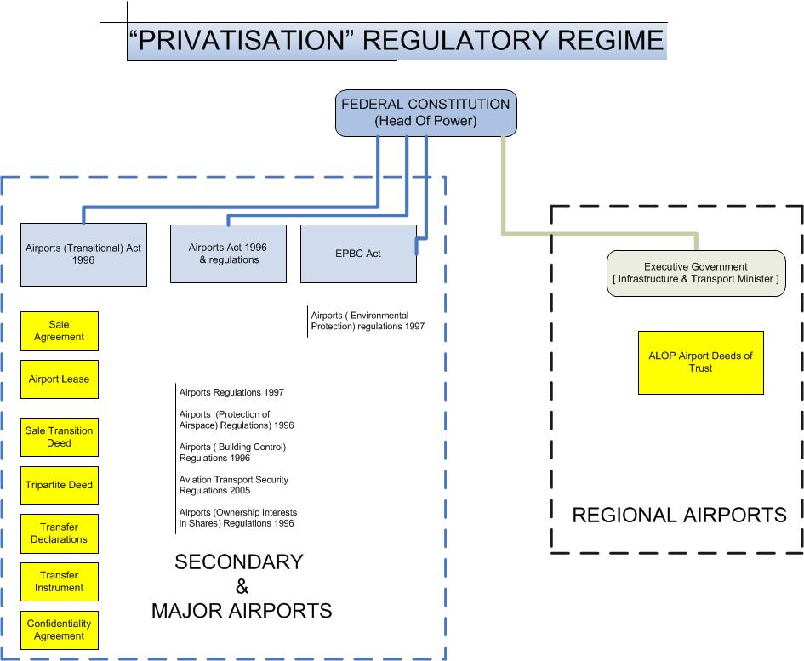
We have seen a progressive abandonment by the Federal Government of its responsibilities related to Airports over time. This does not only apply to the major and secondary airports but also to the ALOP airports whereby the ALOP concept started in the 1950s but accelerated around 1986-1989.
The Hon. E. P. Pickering, the New South Wales Minister for Police and Emergency Services, in addressing the New South Wales Legislative Council in April 1992, provided the following description of the Commonwealth’s intentions regarding local airports
The Federal Government in 1989 announced its intention to withdraw from ALOP over five years. Past capital investment was written off, and no further development funds were made available. The shires and councils that already own the local airports were ‘invited’ to take over full responsibility
Mr Graham Bailey (a former Assistant Departmental Secretary and a professional in airport engineering has stated:
When Federal Airports were run as Government owner and operator major development works came under the purview of the House of Representatives Standing Committee on Public Works (“PWC”). This process included written submissions by the proponent covering considerations as cost effectiveness and the public interest with stakeholder input and followed by public hearings. There was absolute transparency and accountability on every major Commonwealth Works. As part of that process Airport Master Plans also came under review. This could not happen without a team of appropriate technocrats skilled in airport, aviation and public works technical matters.
A constant theme behind the privatisation of Airports has been pressure from the Department of Finance.
It was the Hawk Government that proceeded away from the departmental control and ownership of airports model which ended up as a first step towards airport privatisation (and it is no secret that, in retrospect it was former Prime Minister Hawke’s single most regret of his term in office, himself being a qualified fixed wing pilot).
Former aviation minister in the Hawk Government Mr Peter Morris has stated
“During my period as Federal Minister for Aviation, the Department of Finance was pressing the government to privatise the airports. It was the view of cabinet at the time that Commonwealth Airports were a monopoly and that a monopoly was best run by Government as a Public monopoly, that is, transparent and publicly accountable as opposed to private enterprise that had lack of transparency or any public accountability. The Department of Aviation warned of the consequences of privatisation including that the airport companies would prioritise to profit at the expense of the airport asset and would not be able to be controlled adequately by the Commonwealth but the Department of Finance had the view it could be controlled with legislation and the Hawke government concluded that it could not.
The Federal Airports Corporation took over the management of Primary and Secondary airports from departmental control from 1st January 1986 and it was widely acknowledged they ran the airports adequately.
Senator Woodley during the second reading speech of the Airports Bill 1996 and the Airports Transitional Bill stated:
“The FAC is a very profitable government business enterprise. Last year, it recorded a profit of $128 million. Sydney airport recorded a $69 million profit, Melbourne, $52.3 million, and Brisbane, $43.5 million. By the standards of the Stock Exchange, its earnings over assets ratio is up there among the top three or four firms ahead of the big Australian BHP and ahead of News Corporation. Its productivity, measured by the passenger per employee ratio, increased by 14 per cent in 1994-95 following the 15 per cent improvement the previous year. What more do you want from a company?
Its fees are the fourth lowest of a world representative listing of 40 major airports, with increases kept below the CPI over the past five years. What more do you want FAC to do? They are doing a fantastic job. This is an organisation which is achieving the shareholders' objectives. Why on earth and I nearly used a word I wouldn't use are we selling it? The Australian people, as the shareholders, are entitled to continue to ask this question.
In 1995 it was the Keating Labor government that “paved the way” and put forward bills into Federal Parliament for the privatisation of the Federal Airports. Prime Minister Keating liked it as he regarded it as the Clayton's sell-off of Federal Airports being a sell-off you are having when you are not having a sell-off because, instead of selling the airports outright, what was being sold was a right to run airports for 50 years.
It was the Howard Government however that implemented nearly the same Labor legislation to privatise the Airports. The Howard Government reasons given for the sale in press releases related to sales was they were sold to pay for Labor’s debt.
Senator Woodley during the second reading debate stated the obvious question “why is the privatisation of airports necessary? The answer, of course, is that privatisation is not necessary”.
“Virtually all major airports overseas have been publicly owned and operated. That is a fact. Australians should be asking why we are deviating from this principle. The Democrats would argue that little, if any, micro-economic benefit will flow from the new airports regulatory regime.
We are told that competition will force down airport usage prices. The reality, in the case of airports, is that scope for competition between Sydney and Melbourne, for example, or between Sydney and Perth airports is very remote. In fact, it is a ridiculous proposition. Not only is disaggregation against the world best practice of keeping airports together in a network, it is also against the advice of the FAC.
It is hard to see how anyone could seriously believe that there could be significant competition between airports in Australia. Just to state it makes obvious how ridiculous such a proposition is. Clearly, people fly to destinations because of location attractions not just because of the airport. They are not going to fly to Melbourne in preference to Sydney because they like the airport lounge in Melbourne better. They fly to the destination because that is where they want to go. The proposition just leaves me speechless and that is unusual for me.
The merit for breaking up the very profitable FAC into a string of single airport companies is also not immediately evident. The FAC, and many industry observers, are not convinced. Like many other decisions of the previous government and even more so of this government this so-called reform is likely to impact even more negatively on regional Australia. Senator Collins was more eloquent than I could be about the effect on regional Australia.
As a monopoly, the consumer benefits of the private sector running airports are only as good as the regulator overseeing them. We need to ask some fundamental questions, beginning with: are our airports now inefficient? Will the private sector run them so much better that the regulators might be able to force them to deliver lower costs? The Democrats believe the answer is no.
Senator Woodley summarised the proposed regulatory environment “The Commonwealth will retain responsibility for land use, planning and building controls at the major airports. The Commonwealth will retain reserve powers to deal with demand management issues that may arise during the 50-year leases. The Airports Bill also sets out details of the post-leasing regulatory arrangements to apply to the airports.
The running of an airport every day requires a long string of decisions made in the public interest. It is impossible to divorce the commercial aspect of running an airport from the public policy aspect. For more than almost any other utility, the Democrats believe this is the case. In short, there is a good, long list of reasons why airports should stay in public hands and few reasons why they should be in private sector hands.
Despite the privatisation wave across the world, virtually no other country outside the lunacy of Margaret Thatcher's Great Britain has sold its airports, because other governments throughout the world realise that to do so is to get rid of a utility that is too vital to a community, to its commerce, to its quality of life and to its environment to be trusted to private sector hands. That is not to disparage the private sector, but it is to point out a few obvious things. There are no market forces to constrain the private sector on airports. Competition will be at the margins only
It is evident from a review of Hansard in relation to the introduction and passage of the Airports Bill 1996 and the Airports Transitional Bill 1996 that there was no parliamentary discussion about the Secondary Airports and barely a mention of General Aviation.
As a former Transport Minister advised this Chamber fifteen years post privatisation, word to the effect that all the parliamentary debate was about the T1 airports, that is the Capital Cities and nothing about the Secondary Airports and further that in retrospect the Secondary Airports should not have been sold. Further that it was the finance division that was trying to get the dollars out of it to pay for the national debt.
It would appear that airports privatisation was indeed rushed.
Given that politicians experiences with aviation are most likely to have been dominated by flights with the major carriers to Canberra and the Qantas Lounge T1 only debate is unremarkable.
The Secondary Airports aviation operations do differ significantly to primary capital city airports (e.g. Close parallel runway operations in VFR conditions only – one for circuit training operations and the other for arrivals and departures to the regions, then converting to single runway operations during instrument conditions only weather at the airport.) Yet secondary airports were bundled into the same regulatory environment as the T1’s. That is regulated by the Airports Act 1996 plus regulations and the Airports Transitional Act 1996 and regulations and the non-regulatory contractual documents related to the sale.
The FAC being a Federal Government QANGO was in reality the Federal Government and in that capacity exercised certain legislative powers in respect of federal aviation and airports legislation.
Upon privatisation each privatised airport however became the government’s successor in law permitting them to exercise those powers formerly exercised by the FAC. This has given airport leasing companies powers that in our view are a conflict of interest and should never have been transferred to them as private corporations. This has created an environment where misuse has been inevitable.
The price capping regimes and price and quality of service monitoring regimes that has applied to Primary Capital City airports and more recently on a self-administered basis to Second Tier Federal airports has never been implemented for the Secondary Airports nor ALOP airports.
The Airports Amendment Act 2007 introduced changes to allow Ministers to seek additional specified material from an airport-lessee company rather than have to make a decision based only upon what was presented to the Minister by the ALC and to notify state and local officials of the commencement of “public consultation” (Refer Explanatory Memorandum to the Bill).
The Airports Amendment Act 2010 required additional aspects to be including in Master Plans:
Airport-lessee companies will be required to provide detailed information in relation to the first five years of the master plan including:

a ground transport plan on the landside of the airport;
the likely effect of the proposed developments set out in the master plans on employment at the airport and on the local and regional economy and community including an analysis of how the proposed developments fit within the planning schemes for commercial and retail development in the area adjacent to the airport;
and
detailed information on the proposed use of precincts at the airport that are to be used for purposes not related to airport services

Under Option C a range of development types regarded as incompatible with airport operations, such as long-term residential development, residential aged or community care facilities, nursing homes, hospitals and schools would be prohibited. However, airports
would have the opportunity to demonstrate the existence of exceptional circumstances to the Minister to seek the Minister’s approval to proceed with the development .

Airports Act Case Study - Archerfield
Archerfield Airport is the Capital City Pair (Secondary Airport) for Brisbane.
Prior to 1986, to have any form of airport occupancy it was necessary that the intending occupant have an explicit aviation requirement, that is have an aviation business (e.g. hold an Air Operators Certificate “AOC”) and or a need for hangarage of an aircraft or be a specialised aviation support industry. Conversely in order to be issued with an AOC a permanent presence in the form of a long-term lease or the construction of a building on airport land was required. In other words, the General Aviation industry in the immediate region was captive to the airport and the airport was used only for purposes consistent with its compulsory acquisition purpose as a Commonwealth Place. Also refer to history – phase 1 in this submission and particularly in relation to ground leases.
From 1st January 1986, under the FAC administration, the FAC began to look for ways to mitigate the costs of running the airport; raised rents, introduced a General Aviation Infrastructure Tariff Charge (“GAIT”), closed the runway 13/31 complex, and granted some leases for non-aviation tenants.
The FAC edged out from the former aviation only use of the airport by granting a sizeable ground lease of airport land to BP on part of the land previously at the extreme NW end of former runway 13/31 and called the “BP Truckstop”, eventually becoming the major contributor of non-aviation property rental on the airport. Our Chamber has been made aware from former FAC officers that the FAC always had concerns about any non-aviation developments from a constitutional perspective and it is historical fact that the FAC had a specific section in their policy and procedures manual about Constitutional and Statutory powers. It is also significant that the section 11 of the policies manual related to FAC exposure to the Trade Practices Act 1974 and particularly in regard to misrepresentation, property leases and section 52, misleading or deceptive or likely to mislead or deceive.
To the Chamber’s knowledge at no time did the FAC on Archerfield ever actually displace existing aeronautical tenant’s developed facilities with non-aviation related facilities although in only one case known to the Chamber the FAC canvassed same but offered all the costs of relocation to be paid for by the FAC.
It is clear from the Government’s own Archerfield Airport Information Memorandum prepared for the phase 2 airport sales that there was very little non-aviation rental needed to make the airport profitable as Archerfield Airport already had positive EBIT.
Around 1996 -1997 with knowledge of impending sale the FAC on Archerfield Airport was rushing around to all tenants offering refreshing of lease rental agreements.
As part of the sale process the Office of Asset Sales requested permission from each tenant that the Departmental Files and FAC files related to their tenancies could be reviewed by intending bidders. The successful bidders of the phase 2 Airport sales had full access and knowledge about the collateral agreements related to lease renewal and the FAC policy manual.
The Federal Government had tried to dispose of all Phase 2 non-core regulated airports (which included Archerfield, Essendon Jandakot, Moorabbin, Mt Isa, Parafield and Tenant Creek) as freehold land. The following statement was made about the Phase 2 non-core regulated airports in the Phase 2 General Information Memorandum:
Note 3 To be sold freehold subject to a suitable agreement with the relevant states and territories and passage of amendments to the Airports (Transitional) Act
If sold as freehold land Archerfield would have become regulated entirely under Queensland state law. We note that the Brisbane City Council zoning of the airport at the time was strictly only for aviation and aviation related purposes so that aviation only zoning would never have permitted non-aviation industrial development generally.
The press at the time reported that the ALC of Brisbane Airport wanted to purchase Archerfield Airport to ensure it remained open as it feared that a freehold sale would eventually mean the closure of Archerfield Airport and a transfer of Archerfield air traffic to Brisbane Airport – impacting on the revenue of Brisbane Airport. Ultimately being the ALC of two airports was not permitted by the Federal Government.
The bidding process for Archerfield Airport which was later criticised by the National Audit Office was highly irregular, including excluding persons from bidding for the airport, the selected bidder not meeting tender criteria as to deposits, and being allowed to retender and the amount paid for the airport a mere fraction of the FAC carrying value in their financial statements (refer statement of Mr Desmond Harrison).
The amount of $3.1million ($2.1Million plus a capital expenditure amount was accepted for the airport) and this included all the Commonwealth Buildings (i.e. the Commonwealth Hangars, Terminal buildings etc).
Alleged interference in the bidding process by former Federal MPs Mr David Jull and Mr Gary Hargrave has been communicated to the Chamber but remains unproven.
The successful company Meingrove Pty Ltd was without any aviation qualifications or experience yet other bidders had years of aviation experience on the airport (e.g. Royal Queensland Aero Club Ltd & Others consortium– since 1929).
The Tender Evaluation Committee selecting a land developer as the lessee ahead of experienced aviation professionals defied logic for the future preservation of Archerfield as an airport and expanding aviation facility.
The current Secretary of the Department of Infrastructure and Transport Mr MrDack was one of the only two members from DoTARS on the Tender Evaluation Committee that decided the successful bidder of Archerfield Airport in 1997/98 and selling the airport at less than one fifth of its official Commonwealth / Federal Airports Corporation valuation according to the 1996/1997 financial year audited “Special Purpose Financial Report”
The very first Public Statement written into the sale documents by the successful tenderer was:
"'We look forward to unlocking the potential of a strategic land bank which is at the hub of S.E. Qld transport,
He said “Fifty hectares of prime industrial and commercial land which is surplus to aviation needs will be progressively developed to underpin the viability of the airport itself. Major corporations will be involved in best practice developments of the calibre of the recently completed BP Truckstop."
The self-serving presumption that there was any land “surplus to aviation needs” for the future or that there was “Fifty Hectares of it” or that it needed to be developed at all into non-aviation commercial or industrial development, set the ALC and the aviation users and this Chamber on a collision course ever since.
Post- privatisation hand over the Chamber had disturbing verbal reports from members that alleged at a social function held by the airport leasing company that a Director of AAC had informed those present that he would reduce Archerfield Airport down to one flying school and one aircraft maintenance organisation.
The 2000 Draft Master Plan showed written evidence of the Airport Leasing Company’s (“ALC”) commencement of non – aviation land development ambitions to dispose of existing needed aviation infrastructure by removing runways or lessening runway lengths related to the 04/22 runway complex (being in essence the entire North East airport land compulsorily acquired in 1942 specifically to expand the airport with longer, and into prevailing wind 04/22 direction runways for heavier military bomber aircraft – Approximately 121 acres less Barton Street).
On 19th August 2004 a meeting in Royal Queensland Aero Club was held by “Fly Archerfield” and Mr Richard Kent, General Manager of Archerfield Airport Corporation (“AAC”) presented at the meeting in relation to the 2015 draft master plan for Archerfield Airport. He stated to the effect that AAC would not be renewing any leases on the eastern side of the airport (that is the entire Beatty Road aviation precinct) nor any leases of than 3000 sqM (a standard commercial industrial lease block) and that if the tenants didn’t like it they could move to Watts Bridge (a visual conditions only grass airfield 1.5 – 2 hours’ drive from Archerfield). This Chamber sought letters from those present to present a case to the ACCC. Those letters are attachment A1 to A10 of the statement of Desmond Harrison. Some business tenants in attendance declined to provide letters stating fear of reprisals from AAC if they did provide same.
On 3rd February 2005 a judgement in the Federal Court was handed down by Cooper J, in the matter of Westfield Management Ltd v Brisbane Airport Corporation Ltd [2005] FCA 32 (“Westfield vs BAC”) . Minister John Anderson as recorded in the press was delighted with the outcome to permit non-aviation commercial development on Brisbane Airport. This has been a precedent case that the Federal Government, ALC’s and the Administrative Appeals Tribunal has relied upon for permitting non-aviation development on other airports including Archerfield.
During 2005, Sailco Pty Ltd’s hangar site 235 (in the Beatty Road Aviation Precinct) became the first ground lease on Archerfield Airport to come up for lease renewal. Sailco Pty Ltd (“Sailco”) requested renewal in accordance with the collateral agreement as to renewal with the Commonwealth. AAC advised they would not renew the lease sighting “planning” requirements. Sailco requested if renewal was available by re-location on the aerodrome on any basis. Sailco Pty Ltd was offered only a 3000 SQM industrial block of land at fully serviced industrial land rates – five times the current hangar lease of 600 Sq M. Sailco wrote to the then Transport Minister Warren Truss advising that the lease non-renewal issue was an “endemic” issue and requested an injunction in the Federal Court. Sailco’s Commonwealth lease had clauses within the lease giving a right to remove the hangar however it became clear that the actions of on AAC were being conducted in an unconscionable way to obtain my any means Sailco’s hangar improvements for nil consideration by reversion.
AAC also offered a one-year lease to Sailco which scrapped removal clauses and whereby AAC would acquire by reversion the Sailco hangar at the end of the one-year lease. Minister Truss advised Sailco it was a commercial matter between AAC and Sailco and did not intervene.
Sailco, out of options and rather than permit AAC to gain the hangar for nil consideration dismantled the hangar. After the hangar was dismantled and removed AAC built another aircraft hangar upon Sailco’s 600SqM concrete hangar slab on the foundations, thus proving the unconscionable conduct and abuse of power of AAC in using “planning requirements” as a mechanism to not renew the leases to acquire Sailco’s hangar improvements. More detail of this case can be perused in Annexure B9-1
The Sailco case became the template of behaviour of AAC excepting most lessees (who had no right of removal) have lost their assets by reversion. Where there was still a right by the lessee to remove the lessees improvements AAC learnt from the Sailco experience and subsequently made offers “under financial duress” for the improvements generally of about 10 percent of the true market value / replacement cost of the lessees improvements.
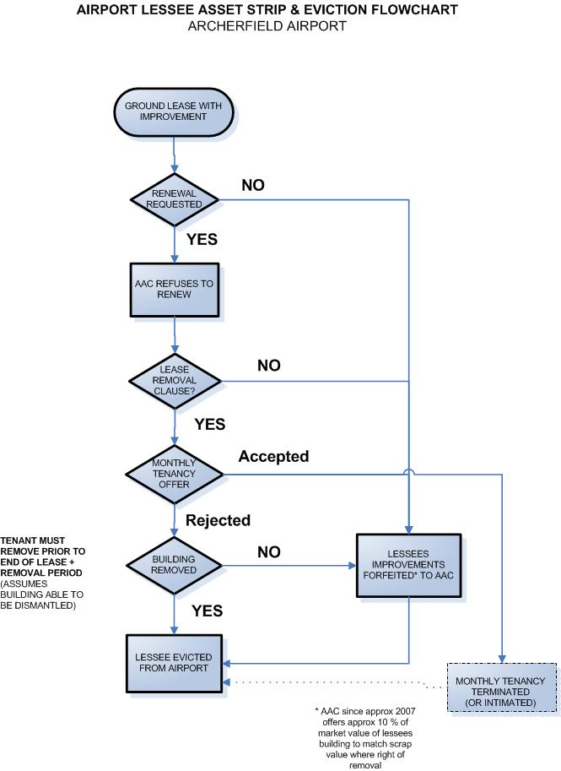There were 142 leases on Archerfield the airport as per the FAC property system report of 1st December 1997. As of before June 2018 all previously renewed FAC leases have come up for 20-year renewal with the result that there is now (to the Chamber’s knowledge) all airport lessees pre-privatisation improvements not removed now being AAC’s property. It is the Chamber’s estimate that AAC has acquired approximately $180 Million value of all lessee’s assets by reversion or financial duress and controls the entire rental market of hangars and facilities and access to it on Archerfield Airport. The below diagram illustrates the position between power and control and aviation investment on the Archerfield Airport immediately after airport privatisation.
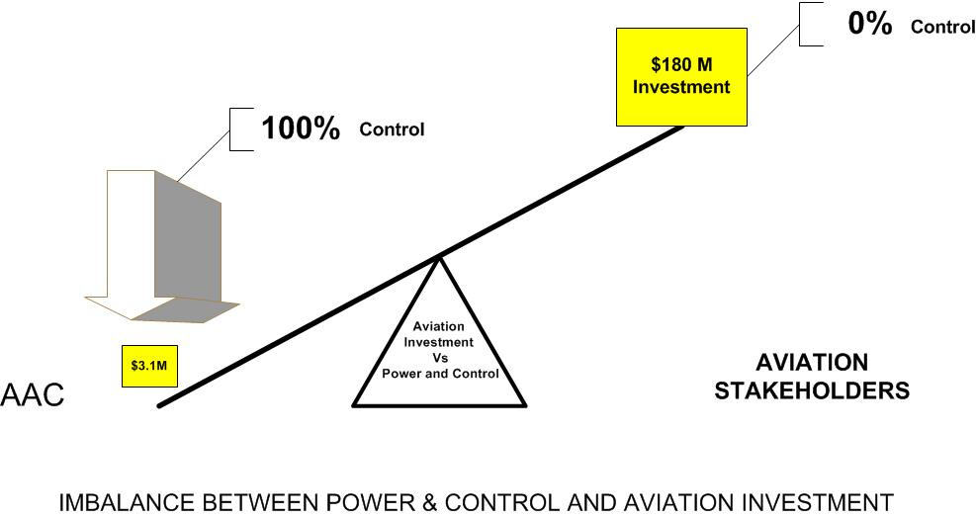

Sailco, in 2011, in order to preserve its legal rights commenced action in the District Court of Queensland against AAC ( first defendant) and the Commonwealth ( second defendant) claiming damages under the Trade Practices Act 1974 for unconscionable conduct, misleading or deceptive conduct, breach of collateral agreement, estoppel, and an order requiring to either of the defendants to grant a lease of the site (as defined in the claim) or an equivalent site at Archerfield Airport for a further period of 20 years or rectify the lease in accordance with the collateral agreement (being a further two options to renew of 20 years each).
In 2013, Sailco, being devoid of financial capability to sustain court action, there being no Airport Inquiry on the horizon, the Commonwealth engaging Ashurst lawyers to defend the case and filing defences including that Sailco was out of time as regards the Trade Practices Act 1974 in respect of relief, had no choice except to sign a deed of release and lodge a notice of discontinuance.
An example of the economic consequence to Queensland of the Sailco hangar loss follows. Crown Engineering (“Crown”), was a shareholder in the Sailco hangar and hangared its Beechcraft Baron aircraft in one of the “T” hangar bays. Crown Engineering manufactured parts under license including for huge drag lines that operate in the open cut Mining Industry. As a superior customer service, when a dragline was unserviceable and waiting on parts, Crown would engage an overnight shift of engineering staff to make the dragline part and if the part could be carried by their aircraft would freight it out in their Baron aircraft which could depart Archerfield 24/7 as soon as the part was made, ensuring a speedy return to mining operations. A mine not operating can costs many tens of millions of dollars a day and time is critical. Following the loss of the Sailco hangar and their capital investment and given the sovereign risk of being on Archerfield Airport and no access Crown engineering ceased its service. Parts were subsequently freighted by truck adding another day or ao for delivery to the mines.
On 18th August 2005 a delegation of the Chamber and Royal Queensland Aero Club, met in the Ministerial Office of then Minister Warren Truss voicing concerns over the deteriorating position on Archerfield for aviation businesses (prices, lease non-renewals etc) and the proposals in 2005 Draft Master Plan to convert up to 60 percent of the airport into non-aviation industrial development involving closing down or shifting runways. At that meeting the following matters were raised.
1. Non-Renewal of Aviation Leases
2. Breaches of the Airports Act 1996 and Commonwealth Lease
3. Matters for the ACCC
4. Evidence of run down and downgrading of Assets on the Airport
5. Safety issues
6. 2005 Draft Master Plan – analysis
Minister Truss called upon the Chamber to “show him the evidence”. A written evidence report was provided to Minister Truss on 15th September 2005 together with 208 additional objections to the Master Plan. The written evidence report is attached to this submission (exclusive of plan rebuttal documents for the sake of brevity).
A letter prepared by the Chamber accompanying the submissions also stated:
“the AACC is aware of problems in the working of the act being raised with your department by other parties. The response in general to those letters was that these matters were to be resolved between the two parties as the Government was not involved or had any responsibility in this area.
With the greatest of respect this does not resolve any of the problems.
As an example I attach a copy of a recent letter received by one of our members from a Mr Peter Marchi (policy advisor) from your office, which makes reference to the Airport Leasing Company (“ALC”) needing to make a profit. Mr Marchi’s comments mark a singular departure of Federal Government practice by supporting the financial interest of a particular operator rather than the community at large.”
Fortunately, Minister Truss required AAC to remove any reference in the 2005 Draft Master Plan in relation to removal / downgrading of runways and required the Beatty Road Precinct to be kept for aviation use. In a 5th December 2005 letter to our Chamber, Minister Truss outlined the steps he had taken also stating:
I wish to assure you and your colleagues that my major concern in considering the master plan was to ensure that the development plans for the airport reflected a commitment to the development of aviation uses as the primary and unconstrained purpose of the lease. While development for other commercial uses may assist in supporting the development of the airport, I am concerned to ensure that the nature and extent of such development does not prejudice the maintenance and growth of aviation activity.
There was no assistance however from the Minister in relation to ACCC matters raised with him.
On 16th March 2006 the Chamber wrote to the ACCC and submitted a letter and issues paper. The ACCC responded on 24th March 2006 and then again on 6th April 2006. The Chamber replied on 26th April 2006 advising to the effect that the issues were “endemic” not isolated contractual hard bargaining. On 18th May 2006 the ACCC responded with comments along the lines that it does not act for individual complainants but for the community in general and they weren’t going to spend any budget on it. The ACCC could not see for example that the Scouts were in effect the “canary in the coal mine” of a systemic issue. The Chamber drew the conclusion that the ACCC may well have received government direction to have “light hands” in regard to ACCC action on airports and that there was not going to be any help from the ACCC.
Head of Power
The Chamber had for some time been conducting its own investigations and research into Westfield v BAC and was made aware from interviewing counsel acting in the case that “Facts Issues and Contentions” agreed to during the court case between the parties were that the parties would not seek any to examine the head of power, that is to constrain the scope of the court to a decision without reference to the head of power (the Federal Constitution).
The Chamber was also made aware during its research process, that the Sydney City Council, opposing a proposed Retail and Commercial Development planned for Sydney Airport, and not having “standing” in the Administrative Appeals Tribunal in relation to the Sydney Master Plan engaged from Barrister Tim Robertson SC constitutional advise in May 2006.
The minutes of Sydney City Council of 7th August 2006 stated:
“The City has obtained legal advice about whether the proposed commercial uses, which have no connection with aviation activities, can legally and validly be carried out on airport land under the Airports Act.
That legal advice has been provided by Tim Robertson SC. Given the public interest in this issue, a copy of that advice is attached (Attachment C).
While the issues are complex, a simple summary of the legal advice is that:
1. There is a reasonable argument that the provision in the Airports Act, which exempts airport uses from State planning laws, applies only to aviation related uses, and not the proposed retail and commercial development;
2. As a consequence, it is arguably beyond the power of the Federal Minister for Transport to approve the proposed retail and commercial development;
3. The exemption in the Airport Act is limited by the constitutional power of the Federal Government. As a result, the Airports Act does not empower the Minister to approve the proposed retail and commercial development”
If the new development proposal is approved, it is open to a range of affected parties, including adjoining Councils, to challenge the decision by seeking a declaration from the High Court. While the proposed development will have a significant impact on the inner city, the City of Sydney is unlikely to be considered an affected party for the purpose of instigating legal action.
RECOMMENDATION It is resolved that Council:
(A) express concern that Sydney Airport is proposed to be further developed for nonaviation uses;
(B) receive and note the legal advice in relation to the limits on the Minister of Transport’s powers to approve the retail proposal at Sydney Airport;
(C) note the Lord Mayor has provided a copy of the legal advice to the NSW Premier and NSW Minister for Planning, other Capital City Lord Mayors, adjoining councils, and other interested parties; and
(D) call on the State Government to lead with the Local Government and Shires Association to coordinate a High Court challenge on any approval that the Federal Minister gives to non-aviation related development at Sydney Airport.”
The Constitutional Opinion of Tim Robertson SC (“the Robertson Opinion) was placed in the public domain (Sydney City Council’s website) as Attachment C to the council minutes of 7th August 2006 and is attached to this submission in full as an annexure.
Armed with the Robertson Opinion representatives of our Chamber met in October 2006 with Mr David Lowy at Westfield and we requested Westfield take the Westfield vs BAC decision on appeal.
Westfield advised the Chamber that the course of litigation was upset as the original solicitors acting for Westfield had to be replaced part way though the action as the originally appointed firm were found to have a gross conflict of interest, in acting for an Airport Leasing Company in another matter.
Further that the Westfield v BAC litigation in the Federal Court was brought by Westfield solely pursuant to post sale undertakings required by the terms of the sale agreement of Toombul Shopping Centre to Centro and the litigation was in Westfield’s name only but actually was run by Centro.
David Lowy advised additionally that Westfield, in litigating the action in the Federal Court, had wholly satisfied their obligations under the sale agreement and did not need to appeal the decision in the Full Federal Court or High court and not running constitutional arguments in Westfield v BAC was by agreement between counsel for the Applicants and Respondents.
David Lowy further advised the Chamber that Westfield was a public company, would act solely in its own commercial interest, and, although he could see the benefits for aviation, could not justify to Westfield shareholders spending company finances on any appeal proceedings as it was not a contractual obligation to Centro.
In consequence of the Robertson material Westfield Ltd in November 2006 re-examined the issues and engaged a Sydney leading Constitutional Barrister to review the opinion of Robertson. Westfield also engaged Senior Council to review Cooper’s decision. These advices are legal professional privilege of Westfield obviously however it is the Chamber’s understanding that the Robertson opinion was corroborated.
In 2009 the Chamber contributed to an article published in Aviator Magazine (September 2009 edition) with the lead headline
The demise of Australia’s general aviation industry would threaten the national economy at every level. It’s unthinkable. So it’s surprising then that Australia’s secondary and smaller airports, which are essential to general aviation services, are being carved up and sold out to private investors for industrial use. The sell-out is nothing to do with the need for general aviation services which are still valuable and
growing strong. The reason is simply greed. Australia’s general aviation industry is being threatened by the pressure of privatization and profit.
While this article goes some way to explaining the issues being experienced up to publication date at Archerfield in 2009 it records that the issues were not isolated to Archerfield Secondary Airport e.g. Jandakot Airport.
Archerfield and the other Secondary Airports operate as a gateway to the regions for non-scheduled charter, freight and private flights (usually departing on one parallel runway) and training operations (on its paired other parallel runway).
The major airlines can’t operate without pilots to fly RPT passenger and freight operations, however pilots are not created or trained at Capital City Primary Airports. The pilots have been created from extensive training operations at flying schools at the Secondary Airports and their general experience in GA non-scheduled operations. Overseas airlines training contracts are hallmarked by requirements for training to be conducted at airports with a control tower which is one reason amongst many why Secondary Airports are so important.
As Captain Snell stated in the article
“We cannot afford to allow this valuable facility to be squandered. Australia is desperately short of pilots and as Archerfield is a primary and secondary school of training if that goes, don’t expect any university graduates to the airlines. This issue isn’t going to go away”.

The issue of pilots has not gone away but intensified and is now a critical problem for the Major and Secondary Airlines not being able to meet recruitment requirements and resulting in inability to crew intended flights.

The BTRE flight training hours statistics graph (as shown below) records training hours Australia wide dropped from a high of approximately 480,000 hours in 1997 – 1998 just prior to phase II secondary airport privatisation, a sharp decline post-privatisation, a brief rise most likely due to the generous ‘Vet-Fee help” era then a cliff edge fall to 300,000 hours at the 2015 year.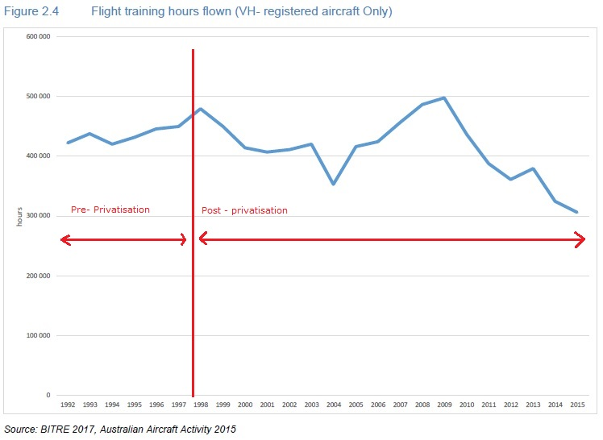

Below is the Airservices Australia movement statistics for Archerfield from 1991 to 2013 plotted against Australian General Aviation Hours flown for the same period being both pre and post phase II privatisation. This is only shown to 2013 because BTRE aviation statistics after 2013 changed such that GA charter is not included in GA statistics but buried within the Commercial Transport data. The chart shows Australian General Aviation hours have been almost a flat line in the same period whereas Archerfield Airport movements have halved in this period. It is the Chamber’s view the movement collapse well reflects the known damage inflicted to General Aviation tenants and users from the post-privatisation management of the airport by AAC.

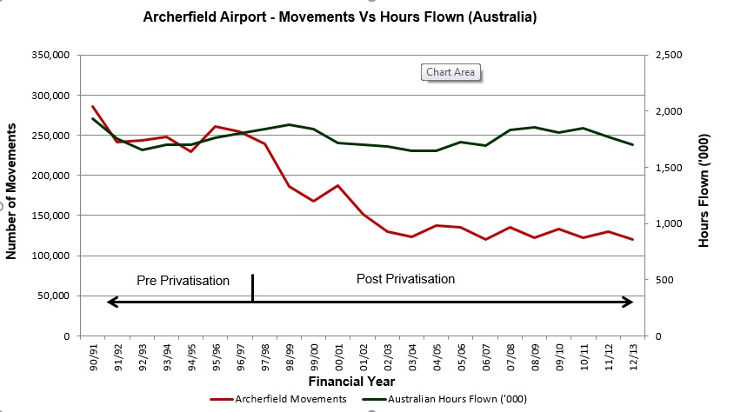

Post 2013 there has been a rise in movements, but mostly all helicopters movements. The helicopter movements in the 2013 financial year were 30,854 out of a total of 120,196 movements, but rose in 2016 to 50,858 and then in 2018 to 76,872. The increase is primarily due to new Queensland State Government Funded helicopter operations e.g. police air, Life Flight, Emergency Management Queensland who were prepared to pay the high lease costs and improvements to tired original Commonwealth hangars. These are aerial ambulance and enforcement activity movements not Air Transport operations which remain at historical low levels.

In a survey conducted by the Chamber of its members in 2006, their most concerning issue was the lease renewal issues on Archerfield airport the instability that created, and exponentially rising costs at a high cost airport. Many believed their businesses would not survive the next 10 years on Archerfield Airport which has proven correct.

As at the preparation of this submission every flying training school existing on the airport at privatisation has collapsed financially or been shut down (excepting only Gil Layt’s Flying School). The director/owner reports that with the rental cost of having to rent their own building now lost by reversion, there is no profit from the business to pay himself any wages for his full-time management effort.

The Flying Schools, with some rare exceptions, also held charter licences (now Air Transport category licences) and retained charter aircraft for non-scheduled passenger operations in addition to their flying training activities.

Further at privatisation there were five CASA approved aircraft engine overhaul businesses on Archerfield Airport, now there are none.

There are now no IFR (multiengine all weather) helicopters for Air Transport passenger carrying operations at Archerfield Airport following the departure of Austcopters.

Lease issues are central to the departure or demise of all of the above referred to aviation businesses.

Pacific Air Freighters which used a DC4 Airline Transport aircraft because it could fly very significant freight tonnage (approximately 11 tonne freight payload) into unprepared unrated airstrips in the outback or pacific islands due to its low impact tyres and had its own on-board palette loading system was driven mercilessly off the airport. AAC did this by not providing access and exercising powers under airport control regulations (i.e. not giving access to service vehicles airside) and AAC making Archerfield (Airport prior permission required for aircraft over 5,700kg in the AIP Enroute Supplement.

Further the Chamber has been made aware from a multi- millionaire aviation user that approached AAC to build approximately $30Million dollars of hangars on the airport and was even prepared to fund runway upgrades, but AAC did not agree to provide access.

In the AAT case of Steven Hammond v AAC supported by the Chamber because aircraft owners including visiting aircraft could not have their aircraft instruments and electrical systems engineer attend to their aircraft because of access issues. The Chamber’s analogy is if your car was broken down in a carpark and you were paying for the parking and needed the RACQ to enter to provide mechanical assistance the RACQ should not be asked to pay a further annual commercial access fee to the carpark. The AAT decision however permitted the ALC to charge the annual fee even if access was a once off.
We have seen the absurd situation where Mr Hammond was servicing aircraft on the airfield by parking his high precision diagnostic and calibrating analyser equipment test vehicle landside and passing the vehicles “umbilical cords” through the airport fence to closely parked helicopters/ aircraft.

The previous three paragraphs above illustrate access issues and likely non-compliance with the Commonwealth Lease.

Additionally, we have seen the loss of the multi city overnight air express operator Jetcraft whose base and centre of management was originally Archerfield Airport and also the departure of Macair Airlines administrative department from Archerfield.

More recently aircraft maintenance engineers Ian Aviation, made a commercial decision because of the high costs on Archerfield Airport and the management style of AAC to move its entire engineering operation onto private land near Atkinsons Dam with its own airstrip and now there is the ridiculous situation of aircraft having to fly away from Archerfield Airport which has historically been the centre of advanced aviation technology and excellence to a private airstrip for aircraft maintenance.

“Light Hands” Policy
At a meeting between Department heads and the Committee of the Chamber on the 22nd October 2009, Mr John Doherty (Executive Director Aviation and Airports), Karen Gosling, General Manager – Airports, and Luke Osborne (Section Head Queensland and Territories – Airports Branch) each stated when introducing themselves that they were career public servants and they had no aviation qualifications.
At the 22nd October 2009 meeting the Chamber warned the aforementioned persons that they needed to be careful that they were not running their department unlawfully.
There is no basis at law for any “light handed” administrative approach by the Federal Government in applying legislation governing the regulation of airport leasing companies.
2011-2031 Master Plan
AAC, having been thwarted by the Chamber in all earlier plans to close / alter and diminish the 04/22 runway complex embarked on an elaborate plan of misleading and deceptive conduct to support closure of the 04/22 runway complex again in the 2010 PDMP. Despite over 900 objections to the plan the plan was approved by Minister Albanese and the Chamber commenced proceedings in the Administrative Appeals Tribunal.
AAC, had engaged the services of Randl Pty Limited (“Randl”), the Director and principal consultant being Mr Rodney Sullivan (“Sullivan”), a civil engineer and former Department of Aviation employee involved in the planning of airports (including Archerfield Airport when under departmental control and the FAC) and a Director of Burnie Airport Corporation in Tasmania preparing its master plan. Sullivan though an accomplished airport planner and academic had no pilot qualifications and runway paving was not his core engineering specialty.

Sullivan acknowledges preparing technical papers/reports on:
• practical capacity of the proposed airfield layout;
• wind usability analysis;
• runway unserviceability and usability;
• RPT aircraft performance planning; and
• pavement strength
These reports/ technical papers were touted by AAC as a basis for closure of the 04/22 runway complex.
There was no name on the reports as to who had prepared them, their qualifications, the terms of reference of the engagement or any other identifying marks usual to technical reports.
Mr Clement Grehan has stated:
“None of the “Technical Papers” or “Technical Studies” described in the previous paragraph are
identified as being produced by any qualified expert or by the person who has prepared and claims
ownership to the documents, its content and certifies its professionalism. Any professional such as a
qualified engineer would date and sign their technical report as their work, as would anyone who had
reviewed and approved same. They would also include the name of the organisation involved, if any,
and their position within that organisation”.
Engineer WC Whitney has stated:
“5. I note that Mr Sullivan alleges that he is qualified as a professional engineer but he fails to not mentioned whether he has membership of Engineers Australia or whether he holds registration with the Board of Professional Engineers in Queensland or any other State.
6. The Professional Engineers Act 2002 (Qld) (PE Act) provides for the registration of professional engineers to practice in Queensland. The Act prohibits persons who are not registered from providing professional engineering services unless they practice under the supervision of registered professional engineers registered in the same area of engineering”
Post the AAT hearing, the Chamber lodged a complaint to the Board of Professional Engineers (Qld) which found Sullivan had likely provided professional engineering services breaching the PE act but was statute barred from prosecuting Sullivan. If Sullivan had been a Registered Professional Engineer Qld (RPEQ) he would also have had to comply with their code of practice that required him to consider, amongst other things, if he could accept the appointment, and direct consultation directly with users of Archerfield Airport (the Chamber for example) and other matters rather than producing documents solely to assist AAC to close the 04/22 runways complex.
The master plan was accompanied by a series of Fact Sheets prepared by Shac Communications – an aggressive marketing company used by developers – whose mantra as has been stated on its website is “Rules are not made to be broken; its knowing which parts to bend”.
the Fact Sheets are not facts and that they contain a whole series of false statements
The “spin-doctored” illogical arguments from AAC in their master plan was to the effect that the 04/22 grass runways were unusable 26.25% of the time due to “rain events” and that by “realigning” them, again as grass runways but to a 01/19 direction and shortening the runways lengths would somehow improve usability by an unremarkable 11.32 days per year. AAC also claimed the 04/22 Runways were flood prone however even the Brisbane 2011 floods did not result in any curtailment of air operations on the use of those runways during that period.
AAC’s statistics about the lack of useability of the 04/22 runways has diminished credibility when Senior Air Traffic Controller Glen Shield stating to the Chamber that he was tired of lying in announcements over the airport automated terminal information service (ATIS) that the 04/22 runways were out of service due “works in progress” when this was not in fact the case. His written statement puts this in politer terms
Sullivan performed a wind analysis, relying on “new data” which he has never made available to the Chamber and which purported to represent that the best direction, given a keeping of the 10/28 runway system (given a tolerance of aircraft to 10 knots of crosswind) would be a 01/19 runway direction. Even if Sullivan’s work is accepted as unbiased scientific fact it could form no decision basis to changing the runway direction to improve usability because...
“The crosswind analysis has made a call on pavement suitability in its conclusions. This is a staggering assumption as it is not possible for an analysis of crosswinds to talk about pavements this is a topic for engineers and hydrologists…
Clearly there is a problem with either the data collected or data is being misused for the purpose to
present a certain point of view….
To really improve the accessibility of the grass runway the runway pavement should be sealed. Bituminous seal would be sufficient for the traffic you have today and compared to an ashphalt overlay not that expensive”

The Draft Master Plan is not proposing to seal the realigned runways and such a claim for an unsealed runway is ridiculous for those with experience with grass runways and those familiar with the rainfall and soil types in SE Queensland”
Sullivan’s own report stated:
A number of potential solutions to alleviate the problem of runway closures involve levelling the runways, sealing them with asphalt, engineering sub-surface drainage around them and/or moving them to higher ground further to the eastern side of the airport. A combination of the aforementioned solutions would provide the highest possibility in reducing the likelihood of future closures due to rain events. However, an analysis of cost versus potential benefits would first need to be considered to determine the most appropriate course of action. T 2872
Cost Benefit Analysis to aviation users was never prepared or considered in relation to the 2011-2031 Master Plan.
The net negative benefit, that is a NET COST of the 2011-2031 Master Plan being detrimental to aviation users in the sum of $88.95 Million including the loss of the multi-million-dollar control tower was estimated, and submitted in evidence.
Our Chamber’s own survey of members revealed that they were prepared to pay for even an Asphalt surfacing of the 04/22 runways and that this could easily be paid for by a minimal increase in landing fees as the 04/22 grass runways were already runways with a subgrade.
Sullivan admitted late in the AAT proceedings to the effect that the reason for the runway change was not an aviation requirement but solely to enable a “freeing up” of aviation use land for commercial property development.
The “T” documents also highlighted that the Department was operating more as a post office for the ALC and it was only the Secretary of the Department in his letter of 6th July 2011 that seemed to have any clue as to the dangers to aeronautical capacity of the airport from the Draft Master Plan.
Looking only at past history of use and only as to runway lengths, though is no measure to prove an ability of downgraded runways to meet future aeronautical capacity.
As a consequence, a spreadsheet and report (also prepared by Randl Pty Ltd) called GA Performance Planning (November 2008) under the topic “length of proposed crosswind runways” (section14.6.2 of the 2011-2031 PDMP) used historical data of what aircraft types had landed on the 04/22 runways for three years from 2008 to 2011 and deduced that 04/22 runways of 900M would suffice. on that the analysis and decisions about this aspect (as evidenced by the T documents of the AAT case) involved a series of unqualified persons being involved in this process and technical failings by CASA in reviewing the data as to the actual use of 900 M runways in commercial air operations.
The History of this issue goes back to 1987/88.
Instead of designating a body of official, the Parliament appointed a Body Corporate (the CAA) to perform the aviation safety function. ….. The mandatory requirements for safety factors on runway distances for take-off were cancelled. This applied to Charter aircraft below 5700Kg. Then the same was done for runway lengths for landing – except that this applied to all private aeroplanes as well.
CASA merely “checked the calculations” of the aircraft historical types FAA flight manual prepared at certification and did not apply any overall safety factor. With no safety factors applied the even a test pilot at certification of each aircraft would have crashed 50 percent of the time on these distance calculations.
The Department “Have merely asked Mr Neal from CASA to check the calculations of the environmental data against the manufacturer’s Aircraft flight Manual data for the take-off and landing charts only. Mr Neal has not made any comment about the suitability of the shorter runways for compliant Australian Air Operations by an Air Operators Certificate holder or Private Operator “
Air Operators carrying passengers or freight (or conducting flying training) are required to have an Air Operators Certificate of approval from CASA and that includes an Operations Manual approved by CASA. CASA “Civil Aviation Advisory Publication CAAP215-1(1)” prescribes mandatory requirements including a compliance statement requirement that the safety factors must be applied, accelerate stop distances, and other safety factors related to wind (e.g. not more than 50% of headwind component and not less than 150% of reported tailwind component). Regulation 215 of the Civil Aviation Regulations 1988 provides CASA with this power. Air Operators personnel must comply with the Operations Manual under threat of statutory penalty (Reg 215(9)). The Senate on 20th May 2014 querying CASA on these issues and airport runways and the mismatch between ICAO runway rules and air operator rules. (Also refer Annexure A13-1_History_Brief_Australia’s Airport Rules)
What this all means is that AAC used unfactored data to convince the department their plan for short runways would not affect historical operations however Air Operators must apply safety factored criteria to use such runways. The proposed short runways being all but useless for passenger and freight operations.
Historical past use though is never an appropriate method to ensure provision for the current and future aviation requirements for use of the airport although it is clear from handsard that the Secretary of DOTARS has held these misguided ill-informed views. This has been used inappropriately at Bankstown Airport to close a cross runway – refer Bankstown. This is a failing of government such that it is an ill-informed regulator and protector of the public interest.
What is required for planning for runways is provision of capability not use. An analogy related to cars is airbags – on the basis of the number of times you use them they are not justified, but, on the basis of capability they are invaluable.
Further if in regard to crosswind runways the FAA Airport Design Rules (which have previously been adopted by Australia refer annexure 13-1) had been followed for example AC 150/5325-4B table 1B being 100% of the recommended runway length determined for the lower crosswind capable airplanes using the primary runway as per Figure 2.1 the minimum length required would have been 1158m ( 3800 feet) or Figure 2.2 the minimum length would have been 1341m (4400 feet) not the 900m that was “decided” from unfactored flight manual data.
During the AAT proceedings Deputy President Hack requested our Chamber to produce our own Master Plan. Attached is a copy of the Chamber’s Master Plan submitted to the AAT.
The Chamber’s Plan recognises that many aircraft that currently operate in to Brisbane need to operate into Archerfield. Charter, private and freight aircraft capable of landing at the airport, operate under the instrument flight rules and therefore the plan reflects providing for this so that Archerfield can exist as an IFR destination airport without reliance upon Brisbane Airport and be a destination of reasonable reliability to such aircraft.
The Chamber’s Master Plan stated:
“There is forecast high demand for pilots in the Australasian region over the next 20 years and although Archerfield has had a fine history of flying training, it is a high cost centre, but the perfect location for flying training should their become an environment of an airport leasing company that encouraged aviation on the airport.
There is an exponential increase in demand for Charter and fly in fly out operations, to the regions
particularly in support for Mining and these are flights being conducted under the instrument flight rules
in turbine aircraft. The Chamber is aware of Q300 and Q400 Charter operations desired to be conducted
at the airport. Such aircraft and even the piston twin and single engine aircraft now GPS and ILS
equipment for runway approaches – and the airport needs to catch up to meet their requirements.
The most common aircraft for mining charter is the King Air B 200 aircraft, after lessons learned in the
1980’s with accidents in piston aircraft – small turbine aircraft replace the larger pistons aircraft except
for mostly freight operations.
Future aviation activities include the increased Charter, Freight and Corporate aircraft traffic of code 3C or 4D already wanting to use Archerfield Airport because of the capacity constraints of Brisbane Airport (as is now evident) such that the airport requires to be preserved in its entirety as “SP6 aviation” to accommodate this demand. Aviation demands will increase in the coming years as the population in SE Queensland increases but no one can foresee the exact requirements into the next 50‐100 years. Land cannot be permitted to be locked up for non – aviation purposes that would or reasonable will be required into the future.
The airport is a public utility and quasi –monopoly and the lessee must meet the requirements of users
and accommodate the rights of operators to validly exercise the rights conferred upon them on their Air
Operators Certificate to carry out those activities for the place certified in the certificate. Therefore this
plan accommodates banner towing and tail dragger aircraft areas within the runway strip.
Flying training continues to be an important component of the airport and therefore the dual parallel
runway system needs to be kept so that circuit training operations can co‐habitat with arrivals and
departures.
The airport needs to become a destination of high certainty of arrival of IFR aircraft and stand on its
own without the routine need to hold Brisbane airport as an alternate.

The Chamber’s plan showed that a 1600 m runway 04L would accommodate the larger aircraft operating together with the smaller training aircraft, was a very workable safe and economical plan only requiring a very short taxiway to a separate large aircraft parking area on the Northern side of the airport (and a secure small terminal facility if needed). The runway works in essence, needed only the grass removed to expose the subgrade, additional subgrade if necessary and Asphalt surfacing. The 04 runway would also take aircraft approach paths over the Oxley Creek catchment reserves being an existing flight path and already protected as to obstacles and also being an area devoid of human habitation.
AAC’s plan of providing a 10/28 runway would have been more expensive and involve either digging up asphalt (not grass) then adding more subgrade or alternatively starting from scratch with a new runway in the 10/28 direction and a new system of taxiways for the heavier aircraft. Further the AAC plan would increase disparate circuit operations whereby smaller aircraft were more likely to be on a different direction runway and circuit at the same time increasing flight collision risk.
More details can be found in the Chamber’s Alternative Master Plan annexure.
One of the legal arguments of the Chamber in relation to the 2011-2031 Master plan was that to be able to be approved by the Minister, a master plan for an airport must comply with the underlying interests in the land.
Further, that certificates provided to the Minister by the Second Respondent [T documents 5337 & 5338] made pursuant to sections 79(1B)b, 79(2)(b) and 80(2) of the Airports Act 1996 regarding underlying interests and consultation were incorrect.
The Chamber considered that the 2011-2031 Master Plan must be rejected by the Minister as regard for equitable interests in the land had not been complied with, e.g. non- aviation industrial land developments were planned over already aviation use tenanted land whose lessees had an equitable interest in the land – that is were required to be renewed pursuant to a collateral agreement. “Interest’ in the Airports Act was defined to mean both legal and equitable interest. As the AAT is not bound by the rules of evidence but “may inform itself on any matter in such manner as it thinks appropriate” the Chamber considered it appropriate to run the equitable interest evidence.
The Chamber also argued that existing tenant leases were in place prior to privatisation so how was it possible for there to be two concurrent leases over the same land.
(Refer the Chamber’s hearing submissions as to equitable interests further at Annexure G2.)
The Interlocutory hearing on 16-17 April 2014 by Deputy President Hack in our view was so that he could decide whether equitable interests and any challenge to the ANEF should be excised from the Chamber’s evidence. In summary in our view DP Hack decided to exclude admitting any evidence in relation to both, in essence because he was not prepared to decide a case in relation to equitable interest which he considered should be decided by a court not the AAT and particularly where there were no court cases commenced and that there was no statutory review possible in the legislation related to ANEF forecasts. In our view Deputy President Hack was incorrect as to no proceedings in other courts as the Sailco case had already commenced in the District court of Queensland on 29th November 2011. It is noted that the precedent cases in relation to collateral agreements are De Lascelle v Guildford [1901] 2 KB 214 and warranties not being able to be excluded from contracts L'Estrange v Graucob [ 1901]2KB215 ) and further that statutory requirements (e.g. Property Law Act 1974 (Qld)) do not apply to collateral contracts or equitable estoppel both of which are arguable in the absence of writing.
Attached as Appendix G1 is the interlocutory decision and reasons for decision of DP Hack who required the exclusion of all equitable interest evidence and ANEF evidence from the proceedings.
None of the parties could agree as to Facts and Contentions however the Chamber’s versions of facts and contentions are attached in Annexure G3. The Chambers supplementary submissions are attached in Annexure G4
The Chamber’s principal and final submissions to the AAT apart from outlining the ordinary arguments for merits review introduced analysis along the lines of the Robertson SC Opinion in relation to the Head of Power. The Chamber submitted that
It is clear from both the Master Plan (General Industry Zoning) and advertisements placed by or on behalf of Archerfield Airport Corporation that these developments are intended to form part of Brisbane’s industrial areas and are not incidental or ancillary to the operation of the airport. Nowhere in the DMP reference is made to any time period that these areas will be available for non- aviation use; and there is no demonstrated intention to return any of these areas to aviation use once a commercial development has taken place.
The Chamber’s principal and final submissions at paragraph 7.5 entitled “Alternative Arguments” included distinguishing the Archerfield facts from the Westfield vs BAC case, in that the Archerfield Master Plan was displacing existing private aeronautical facilities with non-aviation industrial development rather than on previously undeveloped land as had occurred at Brisbane Airport in the Westfield Case. And secondly applying Robertson SC opinion head of power type arguments as applied to the Archerfield Airport master plan. However, as the case being relied upon by the AAT and Federal court was the Westfield Case and as there was no counter decision as yet in a higher court e.g. the high court in relation to the head of power, it would have been highly improbable for the AAT being subservient to the Federal Court to support the latter view.
Deputy President Hack’s decision to affirm the decision was disappointing but not unexpected.
As DP Hack stated in his decision
33. In Westfield, Cooper J explained the operation of s 32 and expressly rejected arguments identical to those advanced by the Chamber. His Honour’s decision binds me and, in any event, is plainly correct
DP Hack in our view incorrectly accused the Chamber of not coming to grips with the fact the airport has been privatised but we believe he did not understand it is the Chamber’s view however that is the courts that have not yet tested / caught up with the limitations of the head of power as to permanent non-aviation development on a Commonwealth Place as per the Robertson SC constitutional opinion and our submissions were attuned to that rather than any non – acceptance of privatisation.
In summary the Chamber’s take on the view of DP Hack’s points were essentially that:
- A master plan is part of a business plan for an existing airport (so they can do pretty much whatever they want!).
- It does not matter if a Master Plan is in breach of the Commonwealth lease for the airport (e.g. downgrades the facility runways etc) as that will be considered in a Major Development Plan
- Individual disputes of aviation users on an airport will not be considered, the only consideration is the wider community
- The AAT is no defacto Royal Commission
The Chamber prepared statements that could be used in an Inquiry or a Royal Commission deliberately as it was only going through the enormity of the task once. A decision in the AAT was a “free hit” and would bring to the fore the inadequacies of the airports regulatory regime, the limitations of AAT as a review mechanism, the limitations of the legal system as to precedent, and failure to protect ordinary hard-working aviation small businesses and community organisations from catastrophic sovereign risk and abuse of market power arising from privatisation.
During the AAT process the T documents revealed that the ALC and the department in our view acted to malign and discredit the Chamber describing it as a lobby group and that many objections to the DPMP were “templated” and therefore by implication valueless. It is the Airports Association, of which the ALC is a member that is a lobby group and having a full-time secretariat in Canberra to do so.
The Airports Act contains no legislative provision in respect of a Master Plan that an ALC shall comply with its Commonwealth Lease. There is only a requirement in the legislation that an ALC shall comply with its Commonwealth Lease in respect of a Major Development Plan. A Major Development plan is required for a runway change.
Clause 9.2 of the Commonwealth Lease states:
“The Lessee must maintain the runways, taxiways, pavements and all parts of the airport for safe access by air transport to a standard no less than the standard at the commencement of the lease”
Assurances from former Minister Truss and others about the Commonwealth Lease protecting the existing infrastructure are proving hollow as the Chamber has received disturbing reports that the Federal Department is seeking to have clause 9.2 of the Commonwealth Leases “reinterpreted” such that “Air Transportation” is to mean only “RPT Airline Operations”. This would mean the ALCs at the Secondary Airports could then potentially carve up the runways that were not “essential to RPT airline operations” as opposed to “Air Transportation” operations which presently includes preserving the infrastructure for non-scheduled GA operations in smaller aircraft. That is the ALC would then procced via a major development plan to implement its Master Plan in regard to runways closure and downgrading.
This is a segue into the topic of the non-legislated “regulation” of Airports Act airports. There are five documents for each airport and these are the documents listed in yellow boxes in the Privatisation Regime diagram in this submission. The Commonwealth Lease is but one. The concern here is that these documents are between the Commonwealth and the Airport Leasing Company as parties and can be varied or changed by executive government, that is the Minister. Parliament has no say in the matter, there can be no debate or checks and it creates an environment for possible corruption and lobbying away from public view or parliamentary scrutiny or debate. Further there is no legal right for aviation users affected by the changes to have any recourse as they are not a party to the agreement but are profoundly affected by any change.
All “protective clauses” in the Commonwealth Lease such as
Clause 9.2 as to preservation of aviation infrastructure
Clause 3.1 as to providing access to Intrastate and Interstate Air Transportation
Clause 13.1 as to development of the airport
should be duplicated into legislature immediately so that parliament has a review for any changes and aviation users can have some rights in the courts, or an aviation ombudsman with effective powers as a low-cost alternative. We have already seen Ministers bend to ALC’s and lobbying by the Airports Association in extending the Commonwealth leases with the public and aviation users only reading about it in the newspaper after the event.

Fuel Farms -Abuses of Monopoly Power and unconscionable conduct by AAC
Pre-privatisation under the specific direction of the FAC, the fuel farms of BP, Mobil and Shell were moved away from other buildings for safety and more into the centre of the airfield with individual ground leases. There was major investment in private underground and above ground infrastructure by the lessees with each fuel company providing both JetA1 and Avgas refuelling by individual fuel company trucks and separate company 24-hour self-serve card bowsers.
The lessees were each provided with specific fuel farm 20-year leases and it was warrantied to them in accordance with FAC renewal policy that they were entitled to three times renewal (collateral agreement).
The Leases contained provisions whereby four months’ notice was required to be able to remediate the site due to the extensive works required.
Pegasus Aero Fuels Pty Ltd trading as Archerfield Refuelling Services (“ARS”) was refuelling agent originally for Mobil since 1980, then as fuel sales started to fall at the airport in line with falling aircraft movements (refer movement graph), ARS also became agent for Shell in 1992. Market competition was still maintained though as customers could specify which fuel company brand they wanted.
Mobil, in January 2016, as part of its divestment of all retail operations in Australia, sold its Archerfield fuel farm and operations to World Fuel Services. Similarly Viva in December 2017 acquired the assets of Shell on Archerfield but retained the right to use the “Shell” trademark on its bowsers etc. Leases were assigned to the respective new entities.
Each fuel company sought renewal of their 20-year leases for another twenty-year term from AAC in accordance with the collateral agreement. AAC informed the fuel companies their leases would not be renewed and that AAC would be the supplier providing fuel on the airport in the future.
ARS in relation to the World Fuel site was told AAC would be taking over World Fuel’s fuel farm and the choices provided were
- the lessee could remediate the site at the lessee’s expense or
- accept a “sale of the improvements” at about 10 percent of their market value. In other words, another asset strip made under duress following similar lines to the asset strip and eviction flowchart in this submission.
As remediation costs could have been $.5 to $1million the “under duress” sale proceeded.
ARS removed its fuel trucks from the airport and the former World Fuel site is vacated and closed.
The AAC newsletter of October 2018 advised in rather euphemistic terms
“The fixed Assets of World Fuel have been acquired and negotiations are being held with existing suppliers”
It is the Chamber’s belief that Viva is in a similar position to World Fuel Services excepting they are resisting accepting a forced sale of their assets, in all likelihood but may end up being the supplier of fuels to AAC when they own all fuelling assets on the airport..
It is our understanding that BP is currently in “holding over” under its former lease prior to having to fully remediating the site and exiting Archerfield. BP presently has the only Avgas fuel truck on Archerfield which is temporary during holding over then there will be no Avgas refuelling trucks on the airport unless AAC purchases Viva’s trucks.
The Chamber notes that in formal “consultation” records submitted to the Department by AAC in relation to the 2011-2016 master plan that in response to Air BP fuel farm operator Ray Maltby’s question:
He was concerned that the re-alignment of the 01/19 runways may impact on the fuel farms.
11/3/2011
Advised that preliminary surveys had Indicated that there would be no concerns with the fuel farms in their current locations. Also advised that in depth studies would be required before proceeding if the proposal was given the go ahead.
The reason therefore that AAC is not renewing the fuel farm leases is to acquire their businesses or remove them from the airport as a competitor – there can be no claims it is to do with “planning requirements”.
AAC will become the only provider of fuel on the airport and therefore there will be no competition, and this will lead to price increases or alternatively deny operators from setting up their own fuelling. (Refer “Competition in the Market” below).
The spin doctoring of AAC in their publicly releases is that they are “improving fuel services” and words to the effect that it was inefficient having three fuel companies, two lots of staff and fuel trucks and that airport pavements would be protected “through better fuel truck use”.
AAC have altered leases to prohibit tenant’s options of bringing in any external supply for their operations as clauses in their new lease document prohibit tenants from bringing any fuel onto the airport or using any other supplier other than the “preferred fuel supplier” of AAC or on a strict reading of the clauses are prohibited from even re-fuelling the tenant’s own aircraft!
Example clauses introduced into new lease documents are:
The Tenant and the Tenant’s Associates must not unless otherwise specifically permitted or allowed in the lease:
Use store or handle any Hazardous Contaminant (such as fuel or oil) in the Premises or otherwise on the Airport without the prior written approval of the Landlord. ….
Engage the services of any external contractors other than the Landlord’s preferred supplier for security, rubbish removal or fuel supply;
The above restrictive trade practices clauses are masquerading as safety matters. Pilots and operators attend to fuelling and oils and additives and hydraulic fluids etc all day into aircraft on the airport and aircraft in hangars contain many hundreds of litres of fuel on board. If these clauses are not accepted the tenant is denied a lease. The Chamber believes that as AAC now (or will soon own / control) all airport asset improvements this effectively restricts access to the airport unless agreeing to same.
Competition in the Market and Provision of Jet (and other Fuels) at Archerfield Airport & Nationally
In the past prior to the non – renewal of the fuel farm company leases (see above), each fuel company had “in-ground” storage facilities for Jet A 1 and Avgas plus JetA1 and Avgas fuel trucks. It is the Chamber’s observation that the prices for Jet A1 (and Avgas) on Archerfield Airport would be set by each fuel company and advised to the respective fuel agents on 1st of each month and be valid for the month. This practice has occurred for decades. It is also the Chamber’s observation that there would be very little difference in fuel prices between the fuel companies – e.g. 0.5 of a cent per litre. Fuel prices at the time of writing this submission were approximately $1.90 per litre for Jet A1 and $2.30 per litre for Avgas which is high. It is the Chamber’s belief that such small pricing differences are unlikely to have occurred over decades without collusion by the Oil companies.
By comparison if an operator / tenant was permitted generally to bring onto the airport or their lease containerised fuel (a shipping container or half container double lined for aviation fuels) the Chamber’s believes fuel could be bulk handling delivered (e.g. 22,000 litres per delivery) to such containers for approximately $1.10 per litre for Jet A1 achieving a saving of approximately 80 cents per litre for Jet A1. The Chamber observes that the state government-controlled operations on the airport e.g. Police, EMQ helicopters are to the Chamber’s knowledge, the only operators that have been permitted by AAC to have their own above-ground containerised Jet A1 fuel and this has been in place for some years.
With respect to Avgas, it is the Chamber’s understanding that Avgas is only supplied to all Eastern Australia by Viva Energy from their Geelong refinery and BP in Western Australia from their Kwinana refinery. Avgas is a special fuel because it contains lead and needs dedicated production use, storage, and dedicated delivery infrastructure / facilities compared to unleaded fuel. Avgas supply is in effect a duopoly with no real competition and it is the Chamber’s belief that General Aviation is being price gouged because of it. A major issue to effective competition is storage and access. The USA has approximately 11 refineries producing Avgas and pricing is competitive, sufficiently so such that refined avgas could be shipped from the USA at a significant saving to Viva’s pricing – if it could be stored. We understand that World Fuel is considering a study into investing in storage facilities in Australia or a group rental of bulk storage facilities in 2019 to try to lower pricing – however World Fuel is no longer on Archerfield Airport.
Chinese aviation gasoline RH- 95/130 and RH-100/130 is approved as an alternative fuel to Avgas in some USA manufactured aircraft (which are the main types flown in Australia) and could be imported as refined fuel if bulk storage facilities were available.
There are STC (supplemental Type Certificate) approvals issued by the FAA (and recognised by Australia pursuant to acceptance by Australia of USA Federal Aviation Administration STC’s) for 48 engine types and over 100 aircraft types to use Mogas (e.g. Unleaded Premium 98 Petrol) although the required quality delivery standards are not generally in place to airport to effectively use these fuels in Australia – but some operators have been bringing onto Archerfield Airport Mogas fuel in 20 litre fuel containers for use in small training aircraft – being sports recreational aircraft (operating at the airport under exemption) rather than VH registered aircraft.
The retail price of Premium Unleaded 98 at a petrol station is approximately $1.50 per litre (which includes 39.5 cents per litre that should not be applicable to an aviation fuel such as UL91) saving at least 80 cents per litre over Avgas 100LL. The financial savings to flight training of pilots, passenger, freight costs and aviation generally are obvious. To the Chamber’s knowledge there has been no Mogas shipping container tanks ever permitted on Archerfield Airport although we note that private airfields such as Lethbridge in Victoria has Premium Unleaded Mogas, Avgas 100 and JetA1 in containerised fuel storage available – refer picture below.
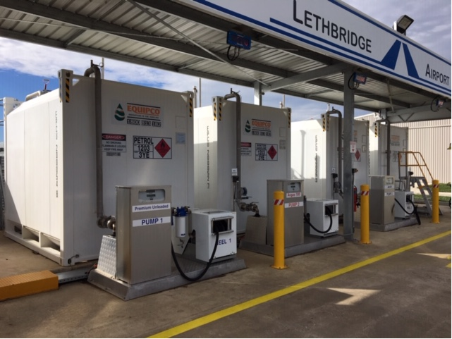

Air operators should be entitled to bring onto an airport the fuels or oils of their choice or that are mandated or specified for use in their aircraft by the manufacturer and or type certificate issued by the country of certification or are licensed by the regulator to use, according to law and all without obstruction / refusal to grant access or contractual restraint in airport rental lease documents.
Generally, Avgas powered aircraft are approaching crisis point in Australia. The USA are in a final phasing out of all leaded fuels, General Aviation, having had an environmental exemption for many years in the USA, mainly because the turbocharged larger Avgas powered aircraft (which are involved in extensive freight and passenger operations and other operations important to the nation interest – e.g. agriculture) all require tetraethyl lead (“TEL”) to achieve the required minimum octane rating for the aircraft. (See About Tetraethyl Lead and its replacement - FAA and FAA Avgas Replacement Program Updates & Reports ). The FAA has stated that “First and foremost, the use of leaded fuels is an operational safety issue, because without the additive TEL, the octane levels would be too low for some engines, and use of a lower octane fuel than required could lead to engine failure.” We are now at the stage where there is only one producer in the world (excluding China) left that produces TEL so the Avgas production situation and fuel security position in Australia is precarious. Finding a replacement “drop in” fuel in the US has taken many decades of research with unsatisfactory results until recently but trials are not yet complete. The USA FAA Piston Aviation Fuels Initiative (PAFI) was required to have candidate fuels considered and gradually reduced by elimination and a decision by 2018 but this has stalled and been deferred to mid-2020. The Chamber is aware that some developers of “drop in fuel” alternatives in the US have not been involved with the FAA PAFI program, regarding it as mis-managed and instead are obtaining their own STC for their fuel (e.g. GAMI GUL100 which the patent holders claim can be produced by any refinery with minimal changes).
Lycoming Engines ( one of the major piston engine manufacturers in the USA) has advised in its technical bulletins that seventy percent of the piston engine avgas aircraft fleet (which would include nearly all pilot training aircraft) do not in fact need Avgas 100 LL, and which the Chamber is aware is actually harmful to such engines e.g. as regards lead deposits issues, as the TEL lead percentage in the Avgas 100LL is higher than the engine type requirement. The EU has solved this issue by their aviation regulator approving any aircraft whose engine is approved by the manufacturer to run on Mogas (e.g as defined by Lycoming as:
- 93 AKI for detonation margin (hot day OAT and 500F cylinder heads).
- Vapor pressure Class A-4 to prevent vapor lock.
- No ethanol and maximum 1% oxygenates.
- ASTM D4814 Revision 09b and EN228 Revision 2008:E)
to automatically be approved by standard change form [Standard Change CS-SC202b] to use unleaded aviation fuel “Avgas UL91” (which is basically Premium Unleaded Motor Gasoline delivered in a more controlled process than to petrol stations) even though there may not be an airframe STC approval in place in the USA the country of manufacture. This Avgas UL91 fuel can be made by any refinery – without dedicated leaded facilities and is relatively cheap and meets the quality standards of the engine manufactures for Mogas (e.g. as defined above by Lycoming). Note that existing aviation piston engines cannot run with any form of ethanol mix.
Unlike the EU, in Australia and the USA, in order to use Mogas (as specified by the engine manufacturer) in an aircraft there needs to be both a Mogas regulatory approval for the engine and a Mogas STC approval for the aircraft airframe type. Because of the research effort cost in the USA of now obtaining approval per aircraft type – Mogas STCs aren’t effectively being pursued any longer as they are uneconomic to apply for and only historic FAA approvals remain. Also, as US motor gasoline now has a mandated ethanol component in it – Mogas without ethanol isn’t as readily obtainable in the USA as it has to be specially made for aviation so there is a reduced push for new STCs in the USA for mogas.
No auto fuel ethanol percentage is mandated by Australian regulation though - fortunately.
If CASA adopted the EU regulatory approach to approve all aircraft types whose engine has a manufacture’s approval to run on Mogas (that is approve a fuel from the "pump gas" production sources that is controlled well enough to provide predictable behaviour on the engine - "mogas.") and encourage for example UL 91 (or similar) production – this would allow any refinery to produce the fuel. It could be readily transported because it is not a leaded fuel and no dedicated transport and storage equipment requirement would be required and it would introduce competitors into the market. Unlike the USA which pumps its fuel all around the USA through a pipe network, Australia trucks it or ships it – so Australia is capable of having more than one type of piston aircraft fuel at airports.
The Chamber believes, based upon reports from our specialist members involved in aero-engine overhaul that Viva Energy fuel chemists have been “varying” their formula for production of 100LL at the Geelong Refinery more towards the limits of the Avgas 100LL fuel Defence Standard 91-090 AVGAS. More specifically, allegedly lowering the TEL content 20 percent and increasing the aromatic content in 100 LL to from 2 percent to about 12 percent.
There has been an alarming increase in frequency of major engine damage and failures to predominantly Robinson R-22 and R-44 helicopters, but also to some turbo-charged fixed-wing aircraft, involved in passenger operations ( e.g. Cessna 402 commuter passenger aircraft) and possibly others The BP Kwinana refinery has historically been producing Avgas 100/130 and had supplied fuel to the Northern Territory(NT), and such issues have been unknown to occur up to five years ago.
It is the Chamber’s understanding that the NT is now supplied by Viva Energy Geelong refined fuels. Our speciality member engine overhaul technician has joined the Northern Fuels Stake Holders Investigation Group (NFSHIG) which was formed in mid 2018 attributes the engine failures in the NT to both the switch to Viva Energy fuel and varying the formula – the same appearing not to be compatible in the very hot conditions of the NT. Although CASA has issued air worthiness bulletin AWB 85-024 and AWB 85-023 CASA is not responding to emails from our member engine experts and appears incapable or alternatively reluctant to resolve this issue. CASA seems to be preferring to have engineers earning revenue (paid fees for service work) rather than its regulatory task that do not bring in revenue.
Avgas inhalation in Indigenous Communities has been well reported by the ABC. It is noted that Avgas 100/130 has volatile aromatics of less than 1 percent so the fuel has historically been of no interest for inhalation. (refer Comgas report which is Avgas 100/130).
It has been well known for a long time that it is important to keep Aromatic compounds to very low levels to discourage people from partaking in the inhalation of fuel vapours for enjoyment. The level considered to be a safe maximum is about 5%..... It is not difficult to produce ASTM D910 conforming Avgas 100LL with Aromatics levels of below 5%,
Fuel inhalation issues also have potential impacts on aviation safety, with people tampering with aircraft in order to obtain Avgas. Significant damage has occurred to aircraft during o fuel theft. Since it is impossible to secure all aircraft operated into remote areas across our country so as to prevent fuel theft, and it is operationally impractical to have a grade of Avgas in the market that can’t be flown into remote communities, all Avgas sold in Australia needs by regulation to be 5% maximum Aromatics.
As regards the larger turbo-charged aircraft requiring as a minimum Avgas 100 LL (with TEL) it is unlikely given the size of the Australian Market compared to the USA of Australian refineries making unique boutique STC fuels and delivering same all-around Australia unless the regulator specified an unleaded aviation specification fuel to replace Avgas 100LL or Avgas 100/130 by regulation.
The current issues would appear to be able to be solved in the short term by a UL91 fuel or equivalent for 70 percent of the fleet and 100-130 Avgas for the remainder of the fleet until an unleaded replacement can be tested in Australian conditions and proven fit for purpose.
CASA as a matter of urgency should be directed by the Federal Government together with industry experts to implement a strategic directive taskforce and process towards verifying, testing and eventually approving a cost effective reliable alternative to Avgas and not either do nothing or rely on the USA – FAA PAFI program.
The claimed “drop in” fuel replacement GAMI G100UL (which is claimed interchangeable with Avgas 100LL and 100/130 according to the manufacturer) might for example be considered to become approved nationwide rather than an STC per aircraft type so that the General Aviation Industry can be rescued from the duopoly of Avgas production in Australia to a new unleaded fuel that is proven to work for all piston avgas engines, including the larger turbocharged engines and can be produced by any refinery. It is noted that GAMI G100UL has no aromatics and if adopted would solve the issue of aircraft fuels being stolen for “inhalation”.
The Avgas dilemma is of major nation economic importance to implement to arrest out of control aviation avgas costs and also for fuel security as TEL production could cease overnight leaving the entre GA fleet stranded.
It is noted that the Chamber’s investigations show that the cost to obtain a Commercial Pilot’s Licence in the USA is approximately one third of the cost of an Australian a Commercial Pilot’s Licence (even after taking into account the extra costs of accommodating oneself in the USA). Australia is just not internationally competitive as to pilot training and fuel cost compared to the USA is just one of the reasons.

Airports Act Case Study - Jandakot
Jandakot airport is the secondary airport pair supporting the Perth primary capital city airport by removing the aeromedical, agricultural, charter, aerial surveying, photography and other airborne work in both normal and transport category aircraft that would otherwise choke operations at Perth airport and is the primary training airport.
Jandakot Airport privatisation issues mirror Archerfield Airport with land developer difficulties. JAH changed hands and was sold to Ascot Capital, a real estate developer, in January 2006. The 2006 Ascot capital had plans to completely close the Jandakot airport site and move it 30 kilometres south so Jandakot airport could be calved up for real estate. This however was rejected by the then Federal Transport Minister Mark Vale in March 2009 – refer The Australian 17th March 2009.
Jandakot Airport Chamber of Commerce (“JACC”), in similar circumstances to the Chamber, made objection to the Jandakot Airport 2014 Master Plan in the Administrative Appeals Tribunal regarding failure to provide for future aeronautical infrastructure requirements because of a mega commercial and residential complex within a couple of hundred metres of Jandakot’s runways. The JAAC argued that
“the development of Precincts 6 and 6A will effectively prevent further aviation-related expansion to meet future expansion of non-airline air services in Western Australia, Jandakot being unique in servicing the private, non-airline and pilot training needs of the State and international operators”
JAH argued that the Master Plan was a (business) “planning instrument” and not an “operational document”.
The decision in the Administrative Appeals Tribunal, being to re-affirm the Minister’s decision to approve the Jandakot Airport Holdings 2014 Master Plan, relied upon the Westfield Decision and the Archerfield Airport Chamber of Commerce AAT decision in the relation to the 2011 Master Plan.
Westfield Management Ltd v Brisbane Airport Corporation Ltd (2005) FCA 32
Archerfield Airport Chamber of Commerce Inc and Minister for Infrastructure and Regional Development [2015] AATA 489
The Westfield decision however, by agreement between the counsels of the parties, did not address the head of power issues. Again the Robertson SC opinion, raised in detail earlier in this submission, when applied to the Jandakot plan would suggest it was beyond power to approve the non-aviation development.
The Chamber also understands from advices from the Jandakot Airport Chamber of Commerce that during their AAT case, tenants reported that they were allegedly threatened, in that if they joined the JACC their leases would not be renewed by the Airport Leasing company JAH.
Airports Act Case Study – Bankstown Airport
Bankstown Airport is the secondary airport pair for Sydney’s Kingsford Smith primary airport. Bankstown’s aviation infrastructure has been damaged by closure of the 18/36 runway, inappropriate industrial development, and the flood plain interfered with by land fill allegedly contrary to state law.
The closure of runway 18/36 was with disregard to the needs of aviation safety and such safety being relegated below the Bankstown Airport Corporation’s plan for super-profits from non- aviation industrial land development. Closure was “justified” on the basis of low “use” which shows convenient ignorance of why runways of more than one direction are required.
“Aircraft are generally required to take off or land into wind…..
An unavoidable fact of the law of physics is that the slower the airspeed of an aircraft, the more affect the wind has on “drifting” that aircraft.
Aircraft preferred for ab initio training, (that is to obtain a pilot’s license) are very slow aircraft by necessity to allow the trainee adequate time to be able to cope with the aircraft’s performance. General Aviation Aircraft (excepting business jets) do not travel at the speeds of Jet Liners and therefore General Aviation aircraft and slower ab initio training aircraft have very much greater vulnerability to drift from wind not aligned with the runway’s direction (“crosswinds”). The consequences of loss of control in crosswind landings are that aircraft could be damaged or destroyed by side loads on the aircraft or the aircraft could drift off the runway with possible consequential injury to occupants and others. Aircraft have a demonstrated crosswind component that is a limit of capability of that
aircraft type. For example if the crosswind component of the aircraft is 15 knots and the
crosswind component of conditions of the main runway is 18 knots or the aerodrome forecast is in excess of 15 knots the aircraft cannot legally conduct that flight (without making provision for additional fuel to be carried, if that is possible, of an amount to safely fly to a suitable alternate aerodrome where the component would be lower) thus affecting a flight…. In summary the unavailability of an adequate number of suitable cross runways is unacceptable to the conduct of all categories of Commercial Air Operations (Training Charter and Business)”

The 18/ 36 runway at Bankstown was particularly needed in strong cross-wind conditions (such as southerly busters). The closure of Hoxton Park airport, being the only other secondary airport that had a 16/34 similar direction runway in the Sydney basin (16/34) has meant that there are now none and distressed pilots would need to declare an emergency and divert to Mascot which was a "highly dangerous situation where distressed pilots, unfamiliar with Kingsford Smith Airport, may put lives in danger in the event of interference with large jet operations.”

The Industrial Development has impacted severely helicopter training operations at Bankstown.
“Bankstown helicopter training schools conduct their circuits at 700’ AMSL inside the
fixed-wing circuit but always with clear forced landing areas available to them. Due to
airspace congestion and inappropriate structures built by the Airport Leasing
Company [ALC], such as the Toll Distribution Centre, Bankstown helicopter
training providers now have to conduct 50% of their circuit training at Camden Airport”

Airports Act Case Study – Moorabbin
Moorabbin is the secondary airport pair in Melbourne. The Moorabbin Airport Chamber of Commerce Inc.[“MACCI”] has reported that there are safety concerns arising from Moorabbin Airport industrial developments affecting runways reduction in length and building proximity issues.
Moorabbin Airport Corporation [MAC] proposed a Major Development Plan development in 2013 originally involved the construction of a retail shopping complex to be leased by members of the Wesfarmers Group at the north-eastern portion of the Airport. The proposed shopping complex was to consist of a supermarket, a discount department store (DOS), a packaged liquor outlet, an office supplier and an auto service centre. The Federal Minister rejected the major development plan and MAC commence a review proceeding in the AAT with the Kingston City Council and City of Greater Dandenong as joined parties. The rejection decision was upheld based on the effect of the proposed development on the local and regional economy (adjoining councils), not on any grounds related to the damaging affect to aeronautical facilities. The north east area of the airport was subsequently developed but with no shopping complex with alleged degradation of aeronautical facilities. MACCI did not have the financial backing or legal resources to be represented in the AAT case.

Airports Act Case Study – Brisbane Airport
Brisbane Airport is a Commonwealth T1 airport that has been subject since the 1970’s to schedule co-ordination, then in April 2010 to domestic terminal slot allocation and from November 2012 to runway slot co-ordination - a Runway Demand Management Scheme (“RDMS”), provided for under the Airports Act legislation and run by Airport Coordination Australia. It is the Chambers belief that any airport where a RDMS has been implemented is an airport that has not provided the required infrastructure to meet the aviation demand for access and use of that airport.
The RDMS affects access and creates disruption to normal operations of air operators and therefore in consequence competition, choice and operator cost. Ultimately it adversely affects the purpose of air travel which is its time saving utility and its cost to passengers or for freight. Time saving performance of an airport should be a key performance indicator (KPI) of an airport.
Refer Courier Mail 5.7.2012 – Hours of delays, Sky High Traffic Jams. Air schedule chaos.
Operator’s request slots to land and take off from the airport up to one year in advance. With inadequate slots, the reason for the RDMS means is there are losers.
“The essence of the RDMS is that slots will be allocated firstly on the basis of historic precedence. However, the Local Guidelines limit the eligibility of ‘Non-RPT Operations’ (defined in paragraph 4 of Part 4 of the RDMS) to secure historical precedence. Non-RPT Operations include fly-in fly-out (FIFO) services, charter and freight operations”.
Additionally, private passenger carrying operations can usually only operate to and from the airport as the lowest priority (generally the middle of the day) and this adversely affects the flexibility and utility of operator’s investment in aircraft.
Pilot training operations have also been affected by this because access to the Instrument Landing System was effectively terminated by the RDMS creating a critical issue affecting general aviation operations in SE Queensland. Pilots being tested for initial issue of instrument ratings must conduct the test on an actual ILS. Training schools, approved test officers, and pilots needed 90 day ILS currency and cannot get access to the Brisbane ILS, rarely the Amberley Airforce base ILS or the Royal Australian Army Oakey Airbase ILS. This is why in the AAT case of the Chamber an ILS was included in the Chamber’s Alternative Master Plan. Without appropriate access to required facilities it is little wonder that pilot training hours have been in decline as is represented in BTRE reports.
Operationally, extra holding fuel is mandated for aircraft arrivals due to traffic congestion or the aircraft must be able to fly to an alternate if landing is unavailable at the time intended. This adversely affects the economics of flights to Brisbane as the weight of extra holding fuel reduces the commercial freight payload that can be carried and therefore the profitability of the airline route. Additionally, it costs many thousands of dollars per flight hour to operate an aircraft therefore holding is a massive extra expense for the operator and is an unsustainable cost that cannot be absorbed.
Our Chamber became aware that Cathay Pacific Airlines was seeking Federal Government permission to access Amberley Airforce Base as an “alternate aerodrome” to Brisbane Airport so it could eliminate required traffic congestion holding fuel requirements for flights into Brisbane Airport.
Our Chamber was also aware that Cathay Pacific Airlines wanted more slots for airfreight flights taking Australian produce to Asia but could not obtain the necessary flight slots out of Brisbane.
The frustration with the lack of access to Brisbane Airport was the driver behind Brisbane Wellcamp Airport West of Toowoomba being built on private land as a privately-owned airport. It was the Chamber that has been responsible for bringing together Cathay Pacific Airlines international freight operations direct from Wellcamp airport – being a unique situation from an airport without any control tower or controlled airspace.
Prior to the RDMS being implement at Brisbane Airport, IFR aircraft intending to arrive at Archerfield Airport could hold Brisbane Airport as their “alternate”. This was needed as Archerfield does not have any precision approach system (e.g. ILS) that permits operations with low cloud and low visibility. The RDMS therefore has had significant secondary impacts on flights into Archerfield as well – either being cancelled in poorer weather or aircraft having their payloads affected by requiring alternates to airports hundreds of nautical miles away.
The Chamber’s understanding is that actual BAC infrastructure development on Brisbane Airport is approximately twenty-five years behind the FAC demand projection analysis for Brisbane Airport – e.g. the second parallel runway. Further that the present Brisbane Airport was meant only to be temporary as even with the second runway FAC demand projection will eventually surpass the two parallel runways capacity.
The Airport Leasing Company’s Commonwealth lease clause 13.1 states
“13 DEVELOPMENT DURING TERM OF LEASE
13.1 Development of airport site
Throughout the Term of the Lessee must develop the Airport Site at its own cost and
expense having regard to:
(a) the actual and anticipated future growth in, and pattern of, traffic demand for
the Airport Site;
(b) the quality standards reasonably' expected of such an airport in Australia; and
(c) Good Business Practice.”

It has not just been the intransigence of Brisbane Airport Corporation (“BAC”) in the past to build the second runway that has been to blame here, it is the “light hands” approach of the Federal Government permitting the failure to develop the airport, even though the Federal Government had all the tools in paragraphs 13.2 to 13.11 of the Commonwealth Lease to enforce the construction of the secondary parallel runway infrastructure. It was not until finally former Transport Minister Anthony Albanese threatened publicly BAC that BAC proceeded with the runway construction – which required at least another 5 years just for the earthworks to settle – and decades behind schedule.
A second Brisbane Airport site (near Jacobs Well between Brisbane and the Gold Coast) of approximately 4200 hectares plus a noise control zone of 11,000 hectares (total 15,200 hectares) has been provided for in the South East Queensland Plan 2021 for years by the Queensland State Government with residential building restriction on the land.
The plans for this airport are well known to the Chamber. It is an airport that would meet the growing needs for the future for Brisbane and the Gold Coast for passenger and freight operations with no curfew, would be the largest air freight airport in the south hemisphere and the only airport in Australia to have a code “G” runway (which is required for the new High Speed Suborbital Airliners). It would also have the only CAT III runway in Queensland for landing all weather.
Additionally, it would be an airport permitting freehold purchase of land or leasehold at the operator’s discretion eliminating the leasing issues on Commonwealth Airports. This second Brisbane airport project has at various times had State Government approval but no funding, then funding and no-state government approval with change of government and currently approval but no funding. It is not surprising that BAC would be actively opposing it as it would upset their monopoly profits by creating competition / choice. Further the Chamber is aware of land developer’s active opposition to the SEQ2021 plan so that they can access the airport reserved land for their residential property development.
Further it is the Chamber’s understanding that Qantas is planning on building $400 million of new hangars for aircraft maintenance but not upon any Australian Commonwealth Leased Airports. The Hangars will be in the United States of America which is an indictment of the environment to conduct aviation business on Australian Privatised Federal Airports. Qantas’s pilot training academy will be located at the privately owned Wellcamp Airport with facilities built upon the freehold land.
All Major Capital City Airports excepting Tullamarine have not had runways and taxiways compliant to code “F” standards required for the larger airliners e.g. A380 and have been operating under a (flawed) concession. The upgrade to Brisbane Airport however will be to code 4 F. The Federal Government is a signatory to ICAO but has been prepared to bend the safety rules related to airports to cover up the fact that aviation infrastructure in our capital cities has not been up to standard.

ALOP Airports
“Following the Pacific War (1941-45), the Australian Government spent heavily in upgrading and maintaining its major airports and by the 1980s it became apparent that the Department of Civil Aviation “could scarcely cope with the growth in traffic brought by the jet age” of the 1960s and 1970s Lee (2003). The government had found itself spending more and more maintaining its nation’s aviation infrastructure with relatively mixed success. The Federal Government owned 81 airports and contributed to the maintenance of another 436 small aerodromes. And in only recovering 55 percent of the costs directly from aviation it became apparent that the administering of Australia’s airports needed to change (Bosh , Hudson and Linehan, 1984). To reduce the fiscal burden on the Federal Government, airports were handed over to local governments and private consortia via the Airport Local Ownership Programme (BITRE, 2008), shifting the funding of maintenance and development to local owners (and in turn rate payers)”.
In 1990 to 1993 ALOP Airports were “Gifted” to local councils (and some other bodies e.g. mining companies) by Federal Government – subject to a “reservation” – A Deed of Trust.
The Trust deed is made at “common law”, is an “equity law” concept with the Federal Government as a “legal person”, not under any act of Parliament.
Attached as Annexure I1 is a list of the Commonwealth ALOP airports transferred during the period 1990 to 1993.
Attached as Annexure I2 is the Transfer Deed for the Evans Head airport executed 29th July 1992 (whose clauses are the same for other ALOP airports excepting minor exceptions) and releasing / decoupling the Federal Government from providing development and maintenance grants. The ALOP Airports came with a “dowry” from Federal Government, that is, some maintenance funds. The local authority pursuant to the transfer deed clauses 2(a) to 2(r) was to operate and maintain the aerodrome to public use, permit open unrestricted and non-discriminatory access to the aerodrome airline and aircraft operators on reasonable terms and conditions, allow all operations and air traffic movements at the aerodrome, create land use zoning around the aerodrome to prevent residential and other incompatible development in areas affected by aircraft noise, and prevent introduction of activities likely to create a hazard to aircraft amongst other things.
The Federal Government felt that decisions about airstrips and therefore aviation were best determined by local government which in the Chambers view is entirely wrong. Local Government with no specialised aerodrome design engineers, runway pavement engineers or other aviation experts on staff had been handed airports, without the technical capabilities to satisfactorily and faithfully comply with the terms of the transfer deed. The Federal Government’s increasing abandonment of its federal responsibilities in relation to RRR airports has resulted in inevitable losses of regional airports and diminishment of airport infrastructure.
With respect to RRR airports in Australia the new policy steering airport ownership and investment has taken its toll. No less than 30 RRR airports closed between 2000 and 2005 (BITRE, 2008) which Doenehue et al. 2012,5) have described as a function of the decoupling of infrastructure investment from any kind of guaranteed associated income stream. That is many RRR airports were and still are, reliant on subsidies for airport maintenance and development…….. Identifying and understanding the primary concerns for the ongoing sustainability of RRR airports , be they large , medium , small or rural, will provide a valuable starting point for rethinking policy, governance and management for the RRR airports.
The Federal Government abandonment continued a decade later such that on 29th April 2003 DOTARS former Minister John Anderson signed off on allowing a “relaxation” of the transfer deeds such that the Commonwealth would no longer require compliance with clause 2(p) of the transfer deeds, that is the ALOP owner could close , lease, sell or otherwise dispose of all or any part of the land required for aerodrome purposes, excepting a hand written addition by the Minister Anderson that an ALOP airport could not be closed without the approval of the Secretary of the Department. A standard letter DOTARs sent to all ALOP airport owners on 13/1/2004 by the Acting First Assistant Secretary Mr Nick Bogiatzis reference number L2002/1883 stated:
“ The Australian Government now waives its right to enforce the relevant clause of the transfer deed that requires aerodrome owners to seek consent from the Secretary of DOTARS for alternative use of their aerodrome , except in certain circumstances. These circumstances are where the alternative use will:
- Result in the closure of the aerodrome, or
- Result in the aerodrome no longer continuing to operate as an aerodrome
In all other circumstances owners need not contact the Department for approval”
Billions of dollars of federal airports were therefore permitted to be carved up or sold by former Minister John Anderson without such decision having had any federal parliamentary or (to the Chamber’s knowledge) any federal cabinet oversight / scrutiny or payment to the Commonwealth. Further, the document that the Minister signed off on 29th April 2003 stated that the Aircraft Owners and Pilots Association (AOPA) and the Regional Aviation Association of Australia (RAAA) and the Australian Airports Association had been written to on 21st November 2002 yet both AOPA and RAAA have advised that the Minister did not contact them about the “alternative use” of the ALOP airports.
The aviation community was never really consulted about the future use of ALOPs. The changes were driven by a few local governments that wanted to be able to carve up and sell off their aerodromes for real estate development
The “relaxation” of the transfer deeds “invited” an environment for corrupt behaviour, and/or for councils to carve up their local airport for real estate as a means to balance their local council books or for councillor’s personal gain.
Some examples of ALOP airport issues follow:
Caloundra Airport
The Caloundra City Council had plans before 2005 to close the Caloundra Airport by 2014 but did not even bother to tell the Federal Government. The Federal Government wrote to the Caloundra City Council on 8th September 2005 advising that the Caloundra City Council was bound by the ALOP deed terms. Again in 2010 with allegation in the press the Sunshine Coast Regional Council was getting too close to land developers the tenants had a battle on their hands to save their aviation businesses and the airport. Caloundra Airport is a small but important airport for helicopters and fixed wing pilot training and aviation maintenance and supply facilities.
Maryborough Airport
The Fraser Coast Regional Council is another council that also tried to close its Maryborough Airport however former Federal Transport Minister Warren Truss while Minister intervened refusing to permit closure. It is noted that the airport was in his federal electorate.
Kempsey Airport
The Kempsey Counsel announced in 2009 it wanted to close Kempsey Airport and turn it into land development however only after a fly in visit / protest from 50 aircraft including Dick Smith was that quashed. Click here
Moree Airport
Councils have used the “dowry” funds for other purposes in breach of the ALOP Transfer Deed e.g. Moree airfield – the funds for a resurfacing of the runway were used to build a new Council Chambers building.
Casino Airport
The Richmond Valley Council on Casino Airport has inappropriately permitted a nursing home at the end of the runway, which is not only directly contrary to the ALOP transfer deed but a trojan horse to have the runways closed due noise. This is a well-known tactic of developers. Casino, upon ALOP transfer on 1.3.1992 to the Council of Casino was a fully license aerodrome with RPT air services however post development the runway is now truncated, and the airport has been reduced to an ALA “authorised landing area. The RPT terminal was sold for a fraction of its market value in a deal made behind closed doors with a private developer out of the public view. Additionally, contrary to the ALOP deed Car Drag Racing is permitted on the runway and model aircraft flying. Aviation businesses have been clearly compromised by these actions.
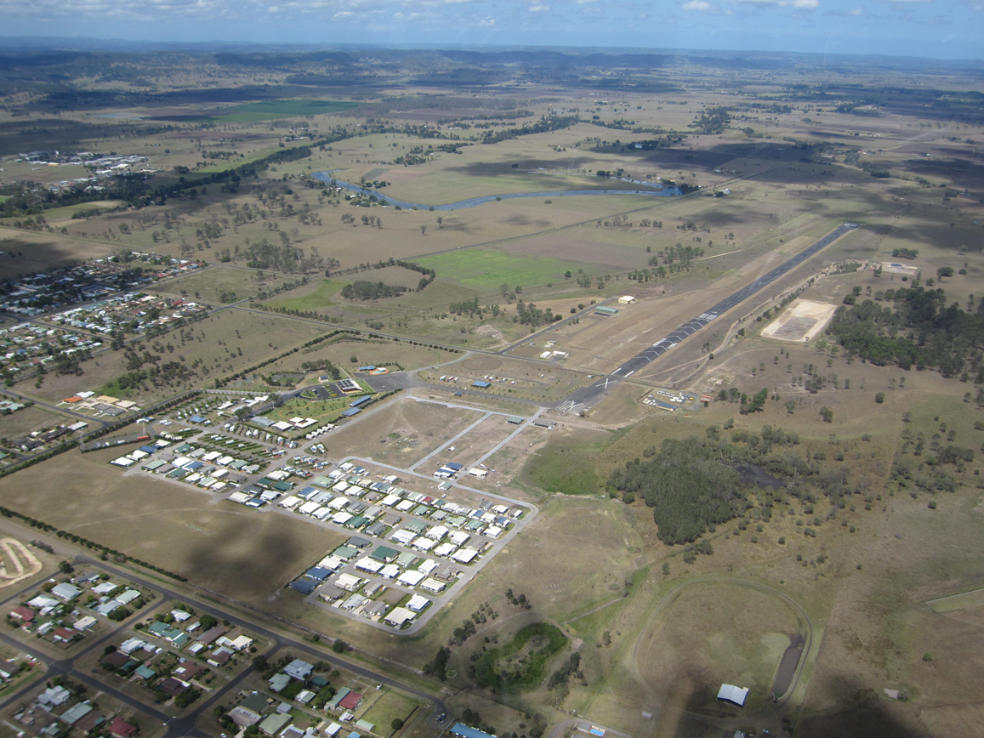
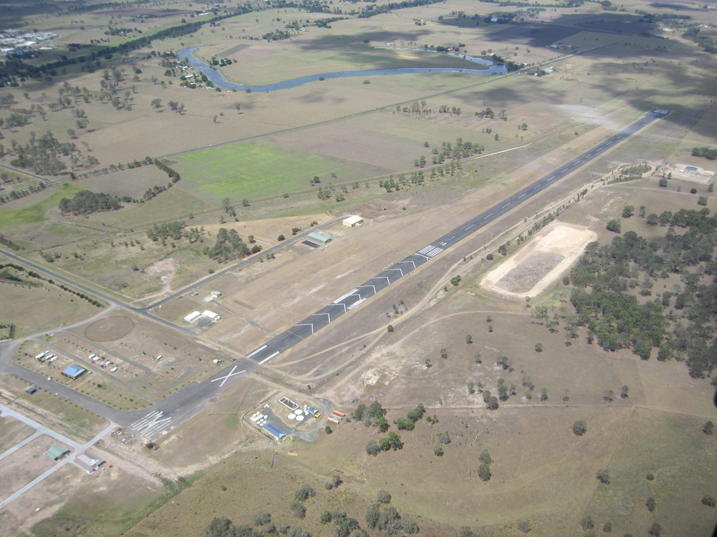

Evans Heads
The Richmond Valley Council wanted to build a retirement village (again like Casino at the end of a runway being a trojan horse for runway closure). The council tried to restrict operations to only small aircraft that is ultra-light and single engine aircraft as there would be a smaller Australian Noise Exposure Forecast (ANEF) so it could build a retirement village. However correct interpretation of the transfer document is that all aircraft that are capable of using the runways must be granted access to land there.
Further in clause 2c of the Transfer Deed “Operators” was incorrectly being interpreted as “Commercial Air Transport Aircraft (Charter and RPT) whereas the correct interpretation is any aircraft including private aircraft.
The Council wanted their retirement village on the airport land even though it is totally inappropriate per ANEF and potential future aviation use of the airfield, and directly contrary to clause 2(h) (i) of the agreement which requires them to take such action as within their power to create land use zoning around the aerodrome which will prevent residential and other incompatible in areas which are or may be adversely affected by aircraft noise. Council had to rezone the land to accommodate the retirement village and resolved to do so even though the majority of the land was incompatible for such a purpose and Council knew so. Political pressure by the developer and council at state government level lead to the rezoning of the land and the community objection was ignored. Representation by the local aerodrome committee to a joint consent authority at state level was refused by the director of the authority.
Council’s intention for many years has also been to make the entire airport “residential” as has been evidenced by public claims by council and in draft documents about the future uses of the airfield notwithstanding the fact that it is the nearest “emergency landing field” for the RAAF and its Weapons Range to the south of Evans Head, and is used extensively for water bombing by the RFS in Section 44 Bushfire Emergencies with up to six fixed wing aircraft and 4 helicopters. It has also been used for flood relief on a number of occasions during major flooding events. It is crucial aviation infrastructure for northern NSW. Council’s LEP fails to identify the aerodrome as a separate ‘infrastructure’ facility on the instruction of NSW Planning, which means it has no protection from further inappropriate development afforded by an infrastructure listing. The Evans Head Memorial Aerodrome Committee Inc. has detailed evidence of all three levels of government involvement in development at the aerodrome and has the view that there could not be a more direct breach of the intent of the Transfer Deed, that is to retain the airfield for aviation purposes.
It should be noted here that Council also attempted other means of degrading the airfield. For example it proposed to irrigate the airfield with effluent from a nearby sewerage treatment plant in such a way that the drainage system would have been destroyed and run-off areas for aircraft along runways compromised by 200mm high covers over drainage grates. An enquiry showed that the proposal would indeed compromise the aviation capacity of the airfield and the proposal was dropped. Those involved in preparing the report for the irrigation had no expertise in aviation nor had they visited the airfield for assessment.
Recently the state government’s Joint Regional Planning Panel (JRPP) approved yet another development, a Manufactured Homes Estate, on aerodrome land at the end of the original main runway notwithstanding objection from the local aerodrome committee and others including a proponent for aviation development at the aerodrome whose evidence was ignored. The JRPP approved the development based on an evaluation report provided by council. Council had a conflict of interest in the development as owner of the land. There are now problems with flooding of the airfield itself as a result of inappropriate residential development. The flooding will affect the integrity of the airstrips. Council destroyed the drainage system as part of the consent process, a drainage system built in World War II to deal with the flooding problem.
The Evan Heads Memorial Aerodrome Committee (“EHMAC”) have confirmed to the Chamber that they hold evidence supporting allegations that allegedly…
“At least 200 blocks of land were also sold by council, in breach of deed and for which no approval was obtained from Secretary of the Department of Infrastructure in breach of the transfer deed. Some of the land was sold to relatives of Councillors. Further that Council Minutes show resolutions of council with names of councillors (2) involved in the sell-off of that land and that the names of those who purchased land who were children of these councillors. One of these 'children', being a builder who is now a councillor. Additionally, regarding the status of aerodrome land which was done out of the public view and without council resolution to advantage a real estate deal. A local real estate agent asked the local state member and council GM to have the heritage curtilage and requirement for heritage support to be removed from the southern end of the Aerodrome so that land could be sold. The argument was that these were impediments to sale. The GM made the case to the NSW Heritage Council for these changes to which they agreed in July 2017. The public didn't know until November, after the fact. The land was sold contingent on development approval and then was sold again five months later for much more putting pay to the notion that heritage was an impediment. The critical aspect is that so much was done behind closed doors without it being brought to public attention involving public monies. It looks increasingly as if councillors also knew about what was happening in council 'workshops' out of the public view.”

Moranbah Airport
Moranbah, a licensed ALOP airport was handed over to BHP Australia Coal Pty Ltd on 1.6.1992. In order to fly into Moranbah the pilot of an aircraft has to now make an application to a low level administrator of BHP Billiton Mitsubishi Alliance “Airport Scheduling - Rail, Port and Infrastructure” at least three days in advance, explain why the aircraft needs to land at the airport, hand over insurance certificates with a minimum specified cover of $20million and advise the requested time of arrival and departures so a “slot” can be “allocated”. This is inappropriate from many levels.
Firstly, clause 2(a) of the transfer deed specifies that the recipient of the airport shall operate and maintain the aerodrome open to public use…. And shall permit access to the aerodrome to persons authorised either under the Air Navigation regulations or the Civil Aviation Regulations. Further clause 2(c) states “shall permit open, unrestricted and non- discriminatory access to the aerodrome by airline and aircraft operators on reasonable terms and conditions consistent with the physical limitations of the aerodrome”.
There should be no “slot times” at such a remote airport and in any case an arrival or departure can vary according to weather, passenger turn up on time and a lot of other technical issues. What is happening here is that the airport operator is trying to control the flow of air traffic. It is pilots, who are the responsible persons at law for separation of their aircraft with other air traffic and is something they are trained to do and use those skills every flying day. It is noted that there has never been a mid-air collision in uncontrolled airspace in Australia (except Moorabbin which is usually controlled).
The operator is also trying to control the airspace above the airport by specifying no night operators are permitted except for the airlines. They are not the federal government. They publish in En-Route Supplement Australia (ERSA) that the airport is a private airport and that prior permission is required for all operators and allow at least three days.
Non-Scheduled Charters (for example to send a technician crew to fix a complex item of plant) are a time critical exercise needing immediate flight action. The air operators need immediate access to the airport and should not have to spend hours on the phone trying to chase down the administrative officer of the operator (often tied up in meetings). Again this is not the granting of public access, is not timely, is unreasonable and is a breach of the transfer deed clauses.
Further, it is the air operator’s business on how much liability cover they deem appropriate or indeed it is their choice to either insure or self-insure and not the business of the airport operator.
The Chamber has also received recent member reports of a passenger aircraft making an “in-flight” diversion to Moranbah because the pilot determined that a medical urgency on board of a passenger required such diversion. It is the Chamber’s belief that upon landing at Moranbah the pilot was castigated for landing without an approval or slot and threatened with trespass and told the airport is a private airport now.
Moranbah Airport is a certified airport of high certainty of arrival because it has standby-power for runway lights and published instrument approaches. As stated at the beginning of this submission the airspace system needs to operate as a whole and an airport capable of being a suitable alternate 24/7 can not only be a lifesaver but can mean the difference of whether a flight between two other airports is able to proceed. Airports when operated as individual fiefdoms such as Moranbah diminish the utility of the airspace system as a whole. This is unacceptable economic control and over-reach. It is worth pointing out that it is the Australian Taxpayer that paid for the initial facilities of Moranbah airport.

Broome Airport
The Broome International Airport is an ALOP airport that was previously operated by the Commonwealth, has an airport tower, fire services and customs and quarantine for international operations and is serviced by regional jets of the major and regional airlines thru to piston engine non-scheduled air transport operations based on Broome Airport.
“In 1991 the Commonwealth Government offered the Broome Airport to the Shire of Broome as part of “rationalisation of the regional airport policy”.
The Shire of Broome with the then Shire President Ron Johnson “SOS” indicated that the running of the airport would be difficult and passed the airport up for sale to their mates. There was no tender process and the general feeling from the Broomee residences was against this proposal”
Annexure I 1 to this submission, being a list of transferees of ALOP airports prepared by the Commonwealth records Broome International Airport being transferred to Wallace Emery and Associates on 19th April 1991.
Annexure I5 to this submission, being a copy of the transfer and restrictive covenant dated 20th March 1992 records the sale of the airport to Airport Engineering Services Pty Ltd for the sum of $2,848,571.00.
The restrictive covenant states that
“ the Transferee:-
1. shall not carry on or permit to be carried on any portion of the land above described any trade or business whatsoever that contravenes the conditions of operating a licensed aerodrome under the provisions of the Civil Aviation Act 1988 (Cth) or is a hazard to aircraft saf'ety or would cause interference to either of' the Civil Aviation Authority’s navigational aids or the Commonwealth Bureau of Meteorology's weather recording facil1t1es; and
2. shall not introduce any rules or regulations or conduct itself in a ·manner which would operate to restrict or discriminate in respect of access to the land above described by airline and aircraft operators except: where this would be inconsistent with the Civil Aviation Authority Safety standards and conditions published in the Enroute Supplement Australia”
Before transfer Broome Airport had a main runway complex and a cross runway complex being part of the aeronautical infrastructure of the airport. Below is an aerial picture, showing the airport with both runway complexes.

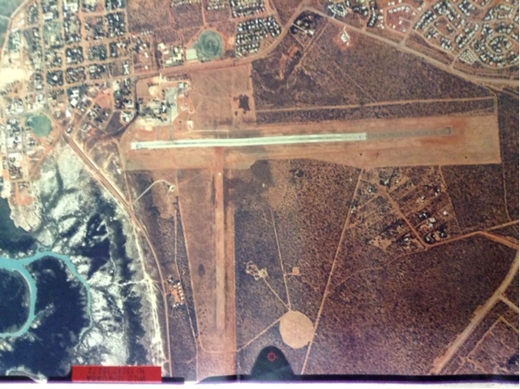
Before Runway Closure:
Below is a more recent google earth picture showing the cross runway is now closed post sale with extensive land development to the north (upon on the cross-runway land) leaving only the main runway complex available for aircraft to land. After Closure:
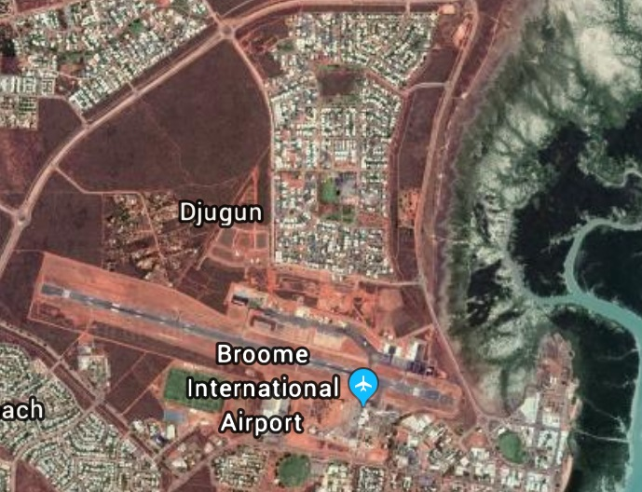
One of the aviation consequences of the loss of this runway is that the smaller non-scheduled passenger and freight air services no longer have any choice of runway and when the wind component of cross-wind on the main runway is more than 15 knots (the demonstrated cross wind capability of certain Cessna aircraft) such passenger and freight services need to be cancelled, whereas before the closure such services would not need to be cancelled as taking off from the cross runway eliminated a cross wind component or reduced it to within – limits of the aircraft capabilities.
The closing of the cross runway is a hazard to aircraft safety – particularly aircraft arriving in the circuit at Broome finding adverse wind conditions and having no suitable runway to land on and is discriminatory as to access to the airport for smaller or slower aircraft – more affected by the vector forces of crosswind. Residential land development similarly is inconsistent with the operations of an aerodrome and also appears inconsistent with the restrictive covenant made with the Commonwealth of Australia. Placing residential land development on the airport is a “trojan horse” method of shutting down an airport because residents complain of noise even though they know they bought a cheap block of land on an airport contrary to noise standards, that would be reasonably expected to have aircraft noise. Curfews on the use of the airport have been imposed post residential development. On 10th December 1997 there was a public meeting in Broome to discuss a draft plan to relocate the airport.
The statement of Former Aviation Minister Peter Morris at paragraph 12 has stated
“privatisation has allowed the monopoly position of the Commonwealth Airports to fall into private hands, and for land developers to bring their lobbying activities from adjacent airport land onto airport land itself. Privatised airports are not meeting the true requirements of users and new airports are not being built.” We submit that this is also true for ALOP airports of which Broome is a poignant example.

Federal Government Oversite on ALOP airports
From the example airports in this submission it is evident that the Federal Government has not been enforcing the restrictive covenants or transition deed clauses (except as to closure). There can only be three possibilities occurring here. Either the Federal Government is not being run competently or is permitting a “light hands” approach to regulatory or government contracts or there is official corruption and collusion occurring. Aviation is not a party to the deeds or restrictive covenants and therefore has no or limited rights as to enforcement unless the Federal Government is prepared to enforce them. This is one reason why legislation needs to be specifically implemented in relation to the ALOP airports.
The Chamber has on several occasions had briefings with Martin Ferguson when he was formerly a shadow Minister for Transport. He expressed the view that handing the control of ALOP airports to local government was a mistake as local government would not be acing in the national interest and subject to influence from local and financial pressures and land developers, did not have airport expertise and it was better if the airports were run from Canberra – in the national interest and a long way away from such local issues.
Below reproduced is a BITRE Figure of locations beyond the assumed access distance of 40 and 120 klms to air services in Australia.
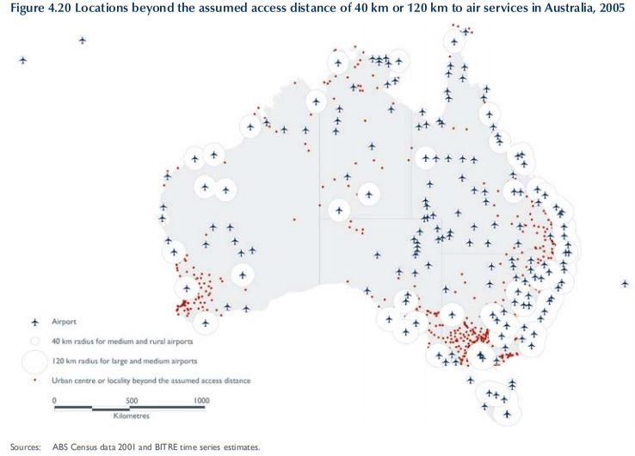
“For these regional and rural communities, air transport is not just a convenience for business or leisure but also a link to more specialised services such as health and education, and to critical functions such as emergency services. The critical role that airports play in RRR communities suggest that airports should be fostered and protected yet airports appear to be difficult infrastructures for RRR communities to maintain”.
It is clear that many such airports cannot survive on regional airline fees or general aircraft landing fees and the federal governments abandonment policy of these airports will ensure their continued demise.
The Chamber is aware that local councils do not have access to the specialist technical expertise to design and maintain aerodromes and are muddling through ignorant of the Federal MOS part 139 and aviation’s unique requirements. A few examples.
Murwillumbah Aerodrome grass runway needed maintenance of filling in depressions and some levelling. The council’s road engineers took on the task allegedly not seeking expert aerodrome engineer advise. The council, well intentioned, and with minimal budget proceeded with using gravel as fill on the centre line of the grass runway ignorant of the fact that it would be picked up by aircraft propellers potentially causing tens of thousands of dollars of damage per aircraft to their aircraft propellers. Roads are not runways. Additionally, one section of the council approved industrial buildings at the northern end of the runway without the knowledge of those in the council responsible for the aerodrome. The result being that the developments at the end of the runway reduced the effective operational length of the runway because of no Runway end safety area [RESA] and endangerment to the occupiers of the industrial building. Further one section of the council provided a development approval on the race course for a parachuting operation, yet this was on the middle of the downwind leg of the required wide circuit for the airport for noise abatement for the hospital and a safety conflict with normal air operations at the aerodrome.
The Port Macquarie airport and runway upgrade proposed by the local council was deficient in that the proposed runway width was not compliant with the Manual of Standards for the category of aircraft proposed to land at the airport (Boeing 737-400 a code 4 aircraft), nor was there any public safety area at the ends of the runways. The council was building the runway to the concession that CASA had provided other airports and not to the MOS standard itself. It was not until challenged that the council’s plans were partially corrected, however Port Macquarie runway 03/21for Boeing 737-400 aircraft is published in AIP as a code 4 airport with an inner edge Width of 150 metres whereas the code 4 requirement is an inner edge width of 300M.

The Federal Government needs to accept responsibility for oversight and maintaining ALOP airports, arrest the depletion of these national assets and prosecute councils or transferees for breaches of covenants or transfer terms and for the costs of rectification and refer corruption activity to a Federal ICAC or equivalent.
The ALOP airports were originally acquired for defence purposes and still have a defence purpose. Billions of dollars each year is spent on defence, yet the defence budget is not funding such ALOP airports. The entire township of Theodore in Queensland, was evacuated by air by military and civil helicopters in December 2010. If the Theodore airport has been adequately maintained regional airliners would have been able to perform the evacuation for considerably less federal expenditure than military helicopters. St George, whose airport has proven a lifesaver was evacuated in February 2012, with RAAF Hercules aircraft evacuating St George hospital patents to Brisbane and the Gold Coast. It was the general aviation fleet including helicopters that enabled the larger portion of the general evacuations all from the St George airport.
Additionally, the Federal Government might like to also consider the funding model of the USA Airport and Airways Trust Fund whose source of funds is in part a 7.5 percent Airline Ticket Tax for flights throughout the USA. The Airport and Airways Trust funds certain airport facilities and equipment, research, engineering and development, and operations.

Inquiry Recommendations
Aviation, the Aviation Industry and particularly General Aviation has not been served well by the Federal Government’s “abandonment of federal responsibility” approach to airports. Australia is a vast country – the size of mainland USA with a tyranny of distance. General Aviation should be prospering and growing with its costs lowering but it is not and the reason it is not rests firmly with the Federal Government. Billions of dollars federally are spent on public roads and rail infrastructure with vast kilometres of roads and highways linking towns and cities yet making sure there is at least one kilometre of MOS Part 139 compliant pavement and protected approaches in each town – called an airport, has not received equal attention or funding.
“ 11.Starting with the notorious Review of Resources ("ROR") around the time of the CAA vesting successive Federal Governments have continued the deskilling process in the aviation portfolio and we are now at the point that the Australian Government is acting as an uninformed regulator, standards setter, purchaser and protector of public interest.
12. The Federal Government agencies including CASA, The Department of Transport and Infrastructure and A TSB are de-skiIled and devoid of airports skilled professionals and has bureaucrats in key positions not technocrats, which is highly evident from the T documents as Departmental officers appear not to have asked all relevant questions and it is my belief they do not have relevant aviation qualifications and backgrounds.”
To the Chamber’s Knowledge there is
- No Airport Lighting Engineer
- No Fuel Quality Personnel
- Only one Airport Engineer with minimal credentials
within CASA. Clearly there needs to be a reversal of the deskilling process.
The Head of Power issue needs to be clarified with certainty as raised in the Robertson Opinion and referred to the High Court.
Secondary Airports should ideally be brought back into public control.
Tenants equitable interests in leases need to be recognised and renewed on similar terms as existed pre-privatisation with any buildings / hangars asset stripped by reversion returned to them with compensation, and/or substituted buildings if the building has been demolished.
An “National Aviation Infrastructure Security Act” [“NAISA”] (which may need mirroring state legislation) is needed to legislate the protection of airport infrastructure including.
- Disclosure of Airport Protected areas on all property survey plans – similar to easements etc
- The restrictive covenants over all ALOP airports legislated.
- The terms of each Commonwealth lease particularly clause 13 clauses as to the protection of the airport made into legislation.
- Making it an offence to close a runway or attempt to close a runway on an airport, downgrade an airport or lobbying activities of individuals or corporations to try to close a runway (e.g. for property development financial gain.).
- Right of airport access provisions requiring all airports not subject to a federal RDMS to accept any aircraft for the code number rating of the airport – that is the airport must be open to public aviation use and be a participant of the whole airspace system (e.g. as to alternates etc).
- Providing extensive powers for the ACCC to act for tenants or aviation users regarding
  - Lease issues including valuations and renewal and changes to use and unreasonable conditions not conducive to competition (e.g. not permitting aviation users to bring their own fuel and oils onto the airport or having to use the ALC’s preferred supplier.)
  - Aeronautical access to the airport and dealing with any rejection for access or failure to allow aeronautical facilities for aviation businesses on the airport.
  - Unconscionable conduct on and off the airport
  - Abuse of market power by the ALC.
  - Reasonable Pricing of Services (including requiring each ALC to publish their financial statements and be subject to special purpose audit or investigation )
  - Users requirements
  - Abuse of on-airport control regulations powers by ALCs or off airport developments
- Requiring all airport engineering consultants to be registered professional engineers, apply a code of conduct similar to the Queensland RPEQ legislation with mandatory exclusion requirements where there is a conflict of interest and to publicly disclose the terms of reference of any engineering work engagement by ALC’s.
- Set mandated infrastructural improvements requirements in accordance with national intertest requirements and a timeline for implementation.
- All master plans or major development plans to be subject to independent technical review by a new independent body of skilled highly qualified airport registered engineers (design, pavement, lighting, and noise specialists) plus experienced aviators with civil aviation backgrounds all such members requiring mandated endorsement by the aviation industry e.g. AOPA, RAAA Airport Chambers of Commerce etc.
- Any assessments of the usability of runways to be based upon the actual laws that an air operator needs to comply with – e.g. as to factoring, balanced field length in the event of engine failure etc, not raw flight manual data - unfactored.
- Report to the Commonwealth Parliament Public Works Committee who may also make directions under the NAISA.
- Development of a “Airport Land Use Planning Handbook” (similar to the California Airport Land Use Handbook)
- Consider readoption of the FAA Advisory Circular 150/5300-13 (Airport Design) published by the United States Federal Aviation Administration (FAA) (Refer Australian history of this in Annexure 13), and in particular for General Aviation Chapters 2 and 3 of AC 150/5325-4B related to airport design for small aircraft ( <5700kgs) and aircraft > 5700 but < 27200 kg and in table 1.3 and figure 2.1 and 2.1 .
Some of the changes needed to be made to the Airports Act 1996 and Regulations:
- Clarify beyond doubt that the present” underlying interests in the land” certification for master plan approval is required to include both legal and equitable interests.
- Require Master Plans to be in compliance of Commonwealth lease terms, not just Major Development plans.
- No decision by the Minister in relation to approving a master plan under the Airports act presently constitutes deemed approval of the ALC’s master plan. This needs to be repealed.
- Airport Master Plans are produced every five years looking forward to the next twenty years. This is too short a time-frame. Use of the airport well into the future is required to provide for the expected growth of aeronautical facilities. Further ALCs must be able to show any non-aviation use proposed on an airport will be able to be readily repurposed back to aviation use to meet long term aeronautical expansion of the airport asset.
- Objections to Master Plans need to be made to the Minister’s office not the Airport Leasing Company deal with them and fob them off.
- The Minister needs to refer objections to an independent reskilled expert technical body potentially formed under for example a “National Aviation Infrastructure Security Act” and ditch the present system where departmental bureaucrats merely act as a post office and have no skills to assess airport plans technically. This could be funded by levying filing fees for the submission of master plans or major development plans plus billing ALCs on an hourly fee basis for the expert assessment / review of the plan, investigating objections submitted in relation to the draft master plan, providing reports in relation to such objections and oversight prior to communicating to the minister such bodies recommendation about the Master Plan.n g.
- Presently there can be no objection to a noise exposure forecast prepared by an Airport Leasing company. This needs to change to allow same.
- Presently the Minister is deciding about Master Plans and Major Development Plans as an ordinary person not as an expert. Approval of master plans and major development plans needs to be made only after recommendation of an independent reskilled expert technical body formed as defined above – which can accept input from aviation user bodies such as AOPA, RAAA and the Chambers of the respective airports.
- If Airport leasing companies want to repurpose existing aviation land where aviation businesses are operating they should pay compensation at market values and factor that into their costs similar to any developer on state land.
- Each Airport be subject to an aviation user’s representative body report card every two years – such report to operate outside of the interference of Airport Leasing Companies, be confidential and submitted to the National Aviation Infrastructure oversight group and the technical group as part of ongoing monitoring of the airport’s performance in meeting the actual aviation needs and the national interest.

Source: CASA Civil Aircraft VH Register 18th October 2018
Source: Sort by “Airframe” of CASA Australian VH Register downloaded on 18th October 2018
Source: Planespotters.net October 2018
Source: CASA Civil Aircraft Register sort by Manufacturer: Boeing 199, Airbus 124, Fokker 75, SAAB 52, Fairchild 50, ATR 16, DHC 62, BAE 13.
BITRE General Aviation Study (December 2017) page 6
BITRE General Aviation Study (December 2017) page 59
Source Sort by “Fuel Type” of CASA Australian VH Register downloaded on 18th October 2018
BITRE website
Commonwealth Parliament Regional Aviation and Island Transport Services: Making Ends Meet page 74
Statement of Graham Bailey dated 9-6-13 (a former Assistant Secretary of the Department of Civil Aviation and a professional engineer)
Statement by Peter Fredrick Morris dated 30 March 2013 paragraph 11 (Attachment B1 to this report)
Senate Hansard 21-8-1996 page 2270 Senator Woodley
Refer paragraphs 41-44 and para 68 of the AAT statement of Graham Bank for details.
Explanatory memorandum to the Airports Amendment Act 2010
Refer Page 30 Archerfield Airport Information Memorandum Phase 2 Airport Sales (Attachment to AAT Statement of D Harrison)
FAC Policy Manual Volume 8 Property Policy – Section 13 Constitutional and Statutory Powers of the Corporation (Refer Statutory Declaration of Barry Thomson)
Refer para 26 of AACCI AAT Facts and Contentions and or page 6 Attachment D9 to AAT statement of D Harrison
Example OAS letter provided in AAT Statement of Manfred Cross
Page 5 of Phase 2 Airports General Information Memorandum (Attachment D9 to statement of D Harrison)
AAT Statement of Mr Desmond Harrison paras 2-11.
AAT Statement of Mr Desmond Harrison para 11
Refer Annexure A7-1_ Statement of Captain Lindsay Snell and attachment L1-L4 thereto
Refer Annexure A1 Statement Valerie Ruth Dennis dt 25.6.13 attachment B4 Commonwealth of Australia Gazette 29th October 1942
Refer Annexure B8 Statement of Ross Steele paragraphs
Refer Statement of Andrew Munro and Barry Thompson – Commonwealth and FAC renewal policy and representations
Note due to temporary monthly tenancy some fuel farm assets have not yet transferred or been removed.
Refer Annexure B9-1 Statement of Claim Sailco Pty Ltd filed in the District Court of Qld
Refer Annexure B9-2 _Sailco _Commonwealth_AAC_Deed of Release.PDF
Refer Annexure A0_1_Evidence Submission toMinisterWarrenTruss_2005.pdf
Refer Annexure A0_2_Minister Warren Truss_ YBAF 2005 Master Plan
Annexure C1_AACCI complaint to ACCC_ 16_3-2006 excluding accompanying issues paper
Annexure C2_Accc Letter to AACCI 24th March 06.pdf
Annexure C3 _ACCC Letter 6April2006.pdf
Annexure C4_AACCI letter 26April 2006 Response to ACCC letter 6-4-06.pdf
Annexure C5_ accc-Letter 18th May 2006.
Annexure D1_Sydney City Council_ 070806_COUNCIL_MINUTES_extract(pages 656 and 657) click here
Annexure D2_07-08-06_SCC_Constitutional Opinion -Tim Robertson SC
Annexure E1_ Aviator Article Sept 2009
As prepared for the Chamber’s AAT case in relation to the 2011-2031 Master Plan to FY 2013. This does not include out of ATC hours aircraft movements at Archerfield but this is not significant to trend analysis.
Refer Annexure A7-1 Statement of Captain Lindsay Snell paras 24-32
Refer Annexure G7-AAT Decision_ Hammond-Archerfield 2007-1417
AAT Statement of Mr R Sullivan dated
Statement of C Grehan dated 3 July 2013 para 6
Statement in Reply CW Whitney dated 15 Nov 13 para 5,6
Refer Annexure E2 Board of Prof. Engineers_ Let_15 May 2017 Re Sullivan
Refer attachment N to reply statement of WC Whitney dated 15 Nov 13
Refer Annexure A6 Statement of Glen Shield dated 13.11.2014
Refer Annexure A9-1 Statement of C Grehan dated 3. 7.13 para 26
Refer Annexure A9-1 Statement of C Grehan para dated 3.7.13 para 20
Refer Annexure A9-1 Statement of D Grehan para 25 and Attachment N thereto
Refer Annexure A9-1 Statement of C Grehan Attachment L
“Why we Regulate The Way we Regulate and Who Pays” AJ Emmerson (former Chief Engineer of the Civil Aviation Authority) pages 9 & 10
Refer Annexure A11-1 Statement of CW Whitney dated 24.4.13 generally and para 15d
Refer Senate Hansard Monday 26th May 2014 , Rural and Regional Affairs and Transport Legislation Committee Estimates pages 142-144, and Tuesday 27th May 2014 pages 2- 4, and answers to questions on Notice numbers 253 and 264.
Refer Senate Hansard Monday 20 October 2014, Rural and Regional Affairs and Transport Legislation Committee Estimates
Refer Annexure A13-2 FAA runway design rules AC 150/5325-4B
Refer Annexure F_ AACCI Alternative Master Plan Summary- 8 March 2013
Refer Annexure 10 Statement of Captain W J Hamilton paragraphs 4-7
Refer Annexure A7-1 Statement of Captain Lindsay Snell paras 33 & 34
Refer Annexure A7-1 Statement of Captain Lindsay Snell paragraph 27 and objection letter
Refer Annexure G2_AAC's Replies to Supplementary Hearing 16-17April14 re Underlying_Interest.
Refer Annexure B9 Sailco Claim
Refer Annexure L1_De Lassalle v Guildford.pdf
Refer Annexure L2_ L'Estrange v Graucob.pdf
Refer Annexure G1_AAT_Archerfield_Scouts_Underlying_Interest_Interlocutory_ Decision_24April_2014
Refer Annexure G5_AACCI Principal and Final Submissions_20_2_2015
Refer annexure G6_
The Commonwealth Lease for Archerfield Airport is reproduced as Annexure H2
Based upon actual bulk delivery of Jet A1 onto private helipad facilities off airport on private land and with their own above ground Jet A 1 tanks or tanker - in the Brisbane area all to the Chamber’s knowledge .
Refer http://www.autofuelstc.com/
Refer EASA mogas approvals
Refer Lycoming Unleaded Fuels Part 2
Refer Lycoming Unleaded Fuels Part 1
Refer Lycoming Unleaded Fuels Part 3
Source Murray Wilks – Senior Fuels Chemist / Aviation Technical writer and Commercial Pilot
Refer GAMI G100UL website
Refer Jandakot Airport Chamber of Commerce Inc and Minister for Infrastructure and Regional Development [2016] AATA 385 (3 June 2016) Paragraph 28
Refer Jandakot Airport Chamber of Commerce Inc and Minister for Infrastructure and Regional Development [2016] AATA 705 (12 September 2016)
Refer Annexure A12_1 John Appleton – paragraphs 10-23.
Refer “The Australian” website
Refer Annexure A7-2 reply statement of Captain Lindsay Snell – paragraph 13
Moorabbin Airport Corporation Pty Ltd and Minister for Infrastructure and Regional Development and Kingston City Council and City of Greater Dandenong (Joined Parties) [2015] AATA 77 (17 February 2015)
RAAA submission to the ACCC 15th January 2013 – page 2
“Regional and Remote Airports Under Stress in Australia, research in Transport Business and Management Baker, Douglas C & Donnet, Timothy (2012)
Refer Annexure I3_Relaxation of Deed of Transfer.
Refer Annexure I3 page 5
Source: King Leo Aviation Submission to the Inquiry
Refer Annexure I1 page 5
Refer Annexure I5_Broome Airport Transfer and restrictive CovenantE817698T page 5
Cessna 210, 6 seat passenger aircraft flight manual
Annexure B3_Peter Morris_Statement_dt 30 March 2013+ attachments – para 12&13
BTRE Air Transport Services in Regional Australia Trends and Access Report 115 page 129 (2008)
Refer ERSA ( Enroute Supplement Australia) Runway distance supplement 8 November 2018 Port Macquarie
https://www.abc.net.au/news/2010-12-28/residents-airlifted-from-flood-zone/1887830
Refer Annexure A2-1 para 11&12 and Annexure A2-2 para1
Refer Annexure A2_2 para 4

