From: David Ward
Sent: Friday, June 9, 2023 5:31 PM
To: philanthropy <philanthropy@pc.gov.au>
Cc: Judith Fiander
Subject: Philanthropy APS Submission

Good afternoon

APS in its submission included commentary on the potential role of Public Ancillary Funds including some historical data. We noted that the data for 2022 was only an estimate as one of the major PuAF had not at that time filed its 2022 AIS with the ACNC. This filing was done on 5 June and we are now able to update that graph.

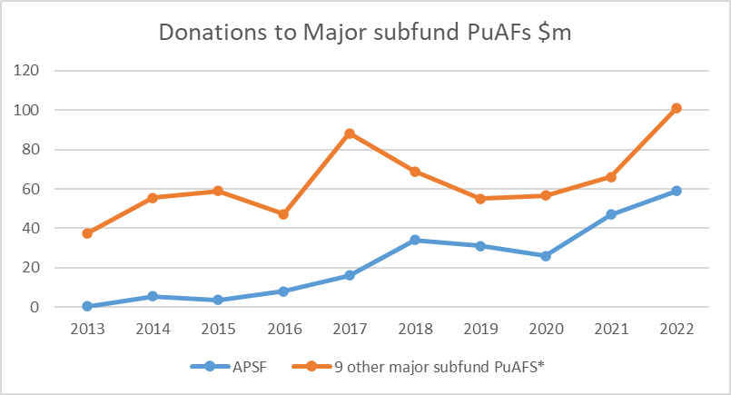

Please add this as an annex to our submission.

Regards

David Ward

David Ward​
Technical Director
Australian Philanthropic Services

W australianphilanthropicservices.com.au
Level 7, 130 Pitt Street, | Sydney | NSW | 2000


APS respectfully acknowledges the traditional owners and custodians of the land on which we work.
This email (and any attachments) is confidential and intended for the addressee only. Unauthorised use of the contents is expressly prohibited. If you have received this email in error, please advise the sender and then delete this email. Australian Philanthropic Services does not accept liability for computer viruses or problems arising from this email. Any collection of your personal information through this email is done in accordance with our Privacy Policy. If you are providing personal information on behalf of someone, you acknowledge and agree that you have their permission to provide us with their personal information.

