Submission in response to the Productivity Commission's Philanthropy Inquiry

Dear Mr Robson, Ms Abramson, Mr Seibert,
My main motivation for donating to charity is that I want to do as much good as I can. Because of that motivation, I care about which charities have the most impact. When I know the charity I’m giving to is highly effective and endorsed by organisations I trust, it gives me the confidence to donate more. I think government policies that focus on impact and increase confidence that impact is being achieved are the key to achieving the goals of this inquiry.
In this submission I raise four issues:
- The availability of DGR status for high impact cause areas (Terms of reference 2.ii, 3.ii, 5, 6)
- Removing arbitrary restrictions on Public Benevolent Institutions so they can better work across causes and support community groups (Terms of reference 2.iii, 3.i)
- The potential good that could be achieved by Australian based charity evaluation (Terms of reference 3.ii, 6.iii)
- The importance of policy advocacy by charities, including the potential to make our democracy fairer. (Terms of reference 3.i, 5, 6.iii)
Although I’m a member of the community, not a charity, my views are representative of many of my peers. Further, I think the Productivity Commission should weigh the views of community members. Community members aren’t bound by constitutions to make particular kinds of arguments and, ultimately, its members of the community like me that government wants to donate more and be more involved in community organisations.
- Animal welfare and global catastrophic risk reduction should be DGR classes (Terms of reference 2.ii, 3.ii, 5, 6)
As I see it, the most important issue is that DGR status needs to be broadened to include things that people today care about – specifically reducing global catastrophic risks and supporting the well-being of animals.
I want to engage with my community around the reduction of catastrophic disaster risks, but currently, the community organisation around these kinds of risks seems limited to things like my local volunteer fire brigade. I ofcourse support the work of the local fire brigade, but it’s not a fit for my skills and interests. If organisations working on reducing the risk of catastrophic disasters had DGR status they would be better able to find ways for me to connect with my peers and volunteer to do good. I know, post-COVID and given the war in Ukraine, myself and my peers are worried about worse future pandemics and the need to reduce the risk of a nuclear war. These are modern concerns, but DGR regulation hasn’t kept up.
In the same way, my peers and I care deeply about the welfare of animals. While the animal charities I support can be “charities” under the Charities Act, they can’t get DGR status under the Tax Act. I understand that this is because DGR status is limited to things like the short-term direct care and rehabilitation of lost or mistreated animals. While any animal suffering is a tragedy, it’s obvious to me that it would be far more effective to give DGR status to charities that are seeking to prevent animals from needing this kind of direct care in the first place. Everyone knows prevention is better than cure, so why should the law incentivise treatment over prevention?
I really think the exclusion of these two cause areas from DGR status hurts our ability to do good. These causes are recognised by sophisticated charity evaluators as being high-impact and allowed to accept tax-deductible donations internationally, but excluded here in Australia. If government wants to increase donations to charities and increase the ability of charities to build social connections, it needs to give DGR status to these high-impact cause areas that today's Australians are so passionate about.
- The Charities Act should be amended to resolve confusion about PBIs, including “dominant purpose” (Terms of reference 2.iii, 3.i)
The way Public Benevolent Institutions are regulated is outdated and should be absorbed into the Charities Act. The Law Council of Australia and the ACNC are regularly debating the meaning of the cases from the 1930s and 1940s that define how PBIs can operate. This is not helpful for organisations, communities, or their ability to do charity in an impactful way. The legal conversation has lost track of the policy intent.
An obvious example of this lack of focus on outcomes is the dispute over the meaning of “dominant purpose”. Without re-stating legal arguments, the ACNC seems to think that a charity that is a PBI has to have its PBI-purpose as its “overriding” purpose, and therefore it can’t also have other purposes from the Charities Act. The Law Council thinks this reading is a misunderstanding of the meaning of “dominant purpose” and that having a purpose from the Charities Act shouldn’t disqualify a PBI.
This is just one example, and who is “right” doesn’t matter. What matters is that having critical definitions about how a charity can do its business buried in arcane case law that doesn’t have a clear reading and isn’t aligned with the Government’s policy intent is not efficient or effective.
In the case of “dominant purpose”, it’s clear that Government policy has no concern with a charity pursuing multiple purposes. This is clear because the Charities Act allows a charity to have multiple purposes. This is common sense – no public policy purpose is served by requiring separate organisations for separate charitable purposes (indeed, the administrative inefficiencies that it creates are contrary to good public policy). And this has real-world implications for how PBIs can engage in fundraising, do impactful work, and support their communities.
“Dominant purpose” is just one example of common law that is no longer helpful. There is also confusion around other phrases like “direct relief”.
The Productivity Commission should recommend amendments to the Charities Act to override the common law and create a new charity type that is not mutually exclusive with other charity types. The precise details can be resolved by ACNC-led consultation and Government decision.
- Australian charity evaluation would build confidence (Terms of reference 3.ii, 6.iii)
I’m excited by the terms of reference about charity evaluation. I think people can be cynical about charity because it’s hard to know if your donation has actually had an impact. I’ve valued the work of overseas charity evaluators because they provide trusted rigour around impact. This is important because high-impact charities can be 10 or 100 times more impactful than average charities. Some charitable programs can even do harm.
I would encourage the Productivity Commission to review:
- Donors vastly underestimate differences in charities’ effectiveness by Caviola, L; Schubert, S; Teperman, E; et al. available online at http://hdl.handle.net/10871/122268, and

Don’t Feed the Zombies by Kevin Star in the Stanford Social Innovation Review, available online at https://ssir.org/articles/entry/dont_feed_the_zombies
The research is usefully summarised in two illustrations that depict how different the view of the impact of charity is between lay people and experts:
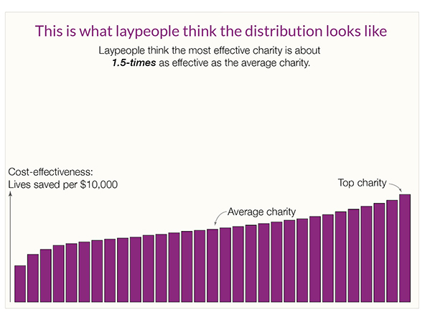
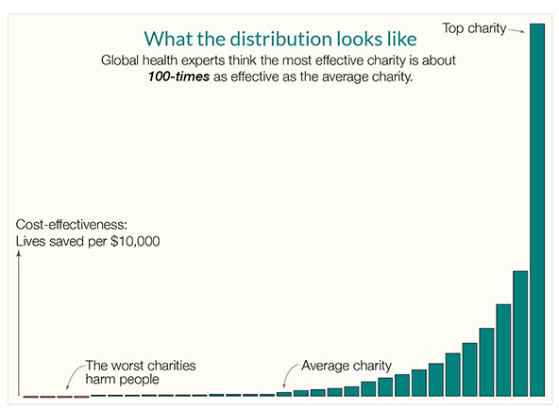
Kevin Star’s article usefully explains that there’s a kind of market failure in the charity sector, where donors aren’t part of the feedback loop and often have no meaningful way of knowing how much value beneficiaries get from their donations. The article outlines how an approach to impact-focused evaluation which he persuasively explains could achieve a “quantum leap toward a better world”.
While the above two sources focus on global health, the same effect occurs across countries and across causes. By way of illustration, Benjamin Todd’s recent article on 80,000 Hours shows a similar distribution of the impact of climate interventions (https://80000hours.org/2023/02/how-much-do-solutions-differ-in-effectiveness/) :
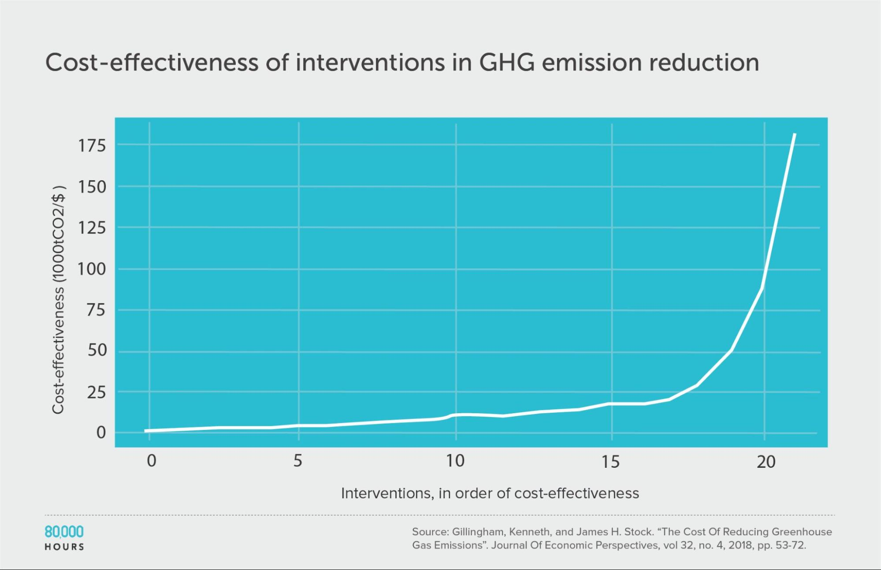
This insight is essential. While donors don’t and can’t understand how impactful their donation is, and charities have to raise funds in a market that doesn’t function, the sector will struggle. This problem is long-standing, but progress in the last 10 years on charity evaluation means it doesn’t have to continue.
Australia funding and promoting charity evaluation has the potential to fix the market failure, help Australian charities do far more good, and potentially make us a world leader.
- The DGR Status Barrier: Why Advocacy-Focused Charities Are Left Out (Terms of reference 3.i, 5, 6.iii)
I understand that the ACNC’s view is that a charity can promote or oppose a change to law, policy or practice, provided its advocacy is aligned with a charitable purpose.
That is a good policy, but it largely misses the real problem. The real problem is that DGR status is almost essential to effectively being able to raise funds and employ talented staff, but the gateways to DGR status are narrow and typically exclude any framings around policy or advocacy.
So, while it’s technically true that a charity can engage in advocacy, DGR charities largely monopolise fundraising and staff attraction, and DGR status is not available to organisations that prioritise advocacy.
In practice, this hamstrings advocacy-focused charities and creates an asymmetry in our democracy. For-profit companies have significant amounts of money to spend on lobbying and often get tax advantages for doing so. But people in the community who are passionate about certain causes often lack the bodies to organise around and certainly don’t get tax advantages. This should change, specifically by broadening out DGR classes so that advocacy-focused organisations can get DGR status. This problem is most obvious in the space of animal welfare, where DGR status is limited to certain kinds of animal rehabilitation. Charities that want to advocate for rules and approaches that mean animals don’t need rehabilitation in the first place don’t get DGR and are therefore limited in their ability to advocate.
This change would make democracy fairer, help connect communities around the things they care about, and encourage donations. I know I’d feel more confident in our democracy if there were organisations whose values I aligned with that had active and powerful voices in the policy conversation.
Government must lead the way
In addition to the above arguments, if the Australian Government wants to double philanthropic giving and increase impact, it should lead from the front.
Australia’s Overseas Direct Aid as a proportion of Gross National Income (GNI)—the official measure of development assistance—is expected to remain at the 2021–22 level of 0.20%.
This continues to place Australia well below the OECD Development Assistance Committee (DAC) country average of 0.32%.
In 2020 Australia ranked 21 out of 29 OECD DAC countries on the generosity of its aid, measured by the ODA-to-GNI ratio. On current estimates, Australia’s ODA-to-GNI ratio is expected to tail off to 0.17% by 2025–26.
The UN’s ODA target is to spend 0.7 per cent of GNI on ODA every year. If the Australian Government wants to double giving by its citizens, it should show that it means business by doubling its own giving and focusing on using evidence to double the impact of the giving that it does do.
I trust this information and perspective has been valuable to the Productivity Commission.

Kind regards,
Courtney Henry

