Productivity Commission - Philanthropic Inquiry
EAST GIPPSLAND COMMUNITY FOUNDATION SUBMISSION

- Defining Philanthropy and the Inquiry’s Scope
The East Gippsland Community Foundation Ltd (EGCF) is the Trustee for the East Gippsland Bushfire Community Bushfire Disaster Relief Fund (Trust). The trust is utilizing proceeds from Australian Disaster Relief Fund, public donations from the Black Summer Fires 2019/2020. We meet the “small and newly formed NFP organization” criteria and provide several ‘case study’ examples of challenges and opportunities in this space as we see it.

One major challenge as a community foundation is to grow our funds under management to ensure that we are sustainable beyond the current funding (trust funds). This is proving difficult in terms of obtaining DGR status and limitations with community willingness to donate funds.

Our website for further information:
Local Philanthropy & Grants Hub | East Gippsland Community Foundation (givetoeastgippsland.org.au)

We are currently pursing membership with Community Foundations Australia and are actively engaging with other members. Community foundations are small parts of a bigger whole.

- Vehicles, trends and motivations for giving
EGCF received $8.8M trust funds for East Gippsland communities impacted by Black Summer Fires. The Victorian State Government (The Department of Justice & Safety) provided an additional 10% of funds towards our operational costs. The Community Enterprise Foundation provided a further $125,000 towards operating costs. With careful use, our operational costs will last 3-4 years utilising funds conservatively. Our State Trust deed for disbursement of $8.8M is 10 years.

It is expected that to disburse funds effectively we will need 7-8 years to maximise community outcomes. There is therefore an anomaly in receiving state government funds of 3 years to operate and a funding deed of 10 years to disburse trust funds.

As a general rule of thumb, most charities operate on a minimum of 20-25%% of income going towards operating costs. This needs to be reviewed by State and Federal government – in terms of providing adequate administrative funds into community foundations to manage.

- Role of Government in Philanthropy
Community Foundations are best placed to disburse funds particularly in disaster relief situations. This has been evident for us on the back of the Black Summer Fires and also during the covid-19 pandemic.
State and Federal agencies often have little connection to grassroot communities, particularly with staff turnover, limited employment contracts and staff from big cities managing grants and funding into rural and regional areas. Community Foundations can work better with local communities as they have existing connections.

State/Federal government grants are too complicated, they take too long to assess and announce, they are risk averse and announcements often sit with Ministers to wait for a publicity opportunity to release funds.

LGA or other local government agencies can only do so much with funding and disaster relief (apart from capital infrastructure) in many aspects is outside their core function.

Rather than have government agencies disburse grant funds, we suggest these are given to Community Foundations with an administration/operating fee attached. It is assumed that it costs much more for governments to run a grant program and community foundations can do it more effectively and efficiently as they know their communities so well. Often government agencies do not get the funding disbursement in a competitive grant process ‘right”.

Example Commonwealth Black Summer Fire funding, a grant of $1,060,942 was awarded to ‘Seaspray Flood Protection Levee Upgrade Works’ (Wellington Shire). The town of Seaspray was not impacted by Black Summer Fires by more than smoke. Lakes Entrance for example was much worse off with tourism shut down for a whole summer period. The grant awarded to Seaspray was very badly received by the East Gippsland community who were heavily impacted and many community groups missed out on worthy applications.

Black Summer Bushfire Recovery Grants Program | National Emergency Management Agency (nema.gov.au)

Example of where community foundations can do it better. EGCF received funds from East Gippsland Shire Council (ESGC), these monies were provided to them by Emergency Recovery Victoria (ERV) as Bushfire Recovery Victoria transitioned and exited the area.

These funds are to be utilized to run a community events program across 2023. The fund is $170,000 to be disbursed as community grants plus a 15% administration expense towards EGCF operating costs. It is evident that this is more effective and efficient way to disburse funds.

A link to the program can be found on our website grant page and being promoted as such:

Current Grant Opportunities | East Gippsland Community Foundation (givetoeastgippsland.org.au)

FUNDS MADE AVAILABLE BY EAST GIPPSLAND SHIRE COUNCIL FROM EMERGENCY RECOVERY VICTORIA, ADMINISTERED BY THE EAST GIPPSLAND COMMUNITY FOUNDATION

We are in further discussion with EGSC & ERV at present as to whether we can take on more EGSC or ERV funds.

Additional funds allocated to community foundations can alleviate the State/Federal government burden to effectively and without prejudice disburse funds.

It is currently evident that State and Commonwealth governments are cost cutting.

An example of this is the National Emergency Management Agency currently clawing back regional employment roles and centralizing to capital cities. This is understandable given government fiscal constraints, but it will not achieve the best outcomes when disaster and emergency situations hit the regional and rural areas again, as we know they will.

The people best placed to engage with communities and assist with their needs (particularly in disaster and emergency recovery) are people living and working in these regions. Therefore community foundations are best placed to receive and distribute funds in these situations.

Tax incentives for volunteers working in community foundations.
We suggest that more needs to be done in terms of tax incentives to assist community foundations.
Can a tax deduction (or other) incentive be made for businesses to allow staff to work in a Community Foundation for say 1 day per month – e.g., community foundations could utilize accounting, legal advice and the organization providing the staff could potentially receive a tax offset?

4. The Deductible Gift Recipient (DGR) Framework
The DGR process is very complicated process to go it alone. Often applicants are small and have limited resources. It is costly, time consuming and slow. The Commonwealth legislation changes suggested in March 2022 allowing Community Foundation Australia members to access DGR status is a godsend (if and when it finally gets legislated).

Our foundation is currently working through membership with the Community Foundations of Australia to secure this access. This is potentially going to save our foundation $40-60,000 in legal and specialist advice and most likely 12-18 months of time.

There are unfortunately indications that this legislation change has stalled to the detriment of community foundations such as ours. We understand the current Minister is favorable to the change as the announcement last year had bipartisan approval. Treasury and the Australian Tax Office seem to be stalling the implementation.

Morrison Government backs Community Foundations with DGR status reforms | Treasury Ministers

Example of administration burden - When our Foundation was set up, the DGR status from the natural disaster declared on 2 January 2020 for 2 years. By the time the foundation was set up and up and running we had 4 months of the DGR status remaining. It was not possible to seek donations as a newly formed (unknown entity) as we hadn’t yet built the trusted brand we have 2 years on.
Furthermore, when funds were made available from the Community Enterprise Foundation to assist our operating costs, as we were not a Tier 1 DGR, funds had to go through another entity. We utilized the Foundation for Regional and Rural Renewal. This added to the time to set up, adding another 5 months of negotiation and paperwork to the task.

5. Other tax concessions for NFP organisations
Can we extend Public Benevolent Benefits to Community Foundations?

Can we formulate policy/legislation to find a benefit for older persons making donations, i.e., there are tax concessions (via individual tax returns) to make donations, but this is only a (tax) incentive if you are a taxpayer.

If you are retired (self-funded superannuation or pensioner), there is no financial incentive to make donations.

6. Unnecessary regulatory barriers to philanthropic giving
Refer response to Item 4.
Refer response to Item 5.

The reference to the Commonwealth legislation to allow Community Foundation Australia members to access DGR status is wonderful, albeit announced in March 2022 and still not passed through Parliament.

7. Consumer information on the effectiveness of NFP organisations
There could be more transparency of funds use when donations are received by organisations, particularly public donated funds.

Could this transparency be achieved through an existing entity – i.e. Australian Charity & Not For Profit Commission? Could ACNC registered entities be legislated to provide a listing of donations received and disbursements of those funds for public access?

Could there be a legislated limit on how much of every $1 donated is to be used on operational costs? It is possible for this to be achieved for say 20%. Community foundations are ideal to disburse donated funds as they are more effective and efficient – can scale up or down with community needs, are grassroots, have the local knowledge, and are without doubt the best people to assist their communities in need.

There is a public perception that a large portion of public donations go to offices, executive salaries or accommodation. If the use of public donations was more transparent this could alleviate donors’ reluctance to give due to lack of understanding for what funds are utilized for.
Example – As part of the EGCF trust deed with State government, we are obliged to publish our trust disbursements on our website every quarter. This is not a difficult task and is easily done. Could this be a mandated requirement for any entity accepting public donations?
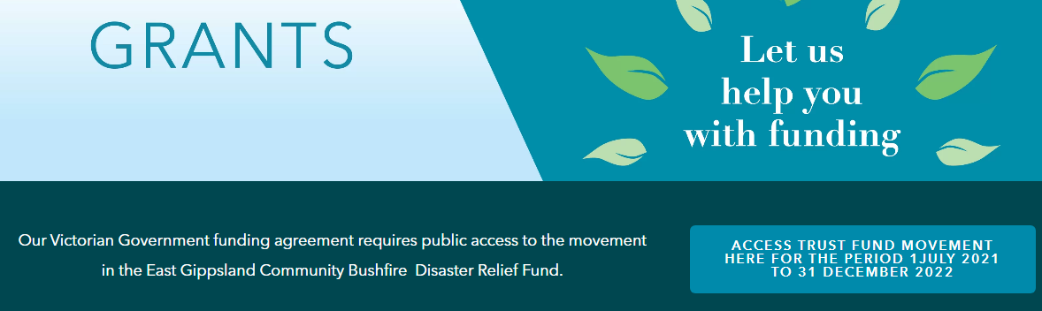
We have several videos on the effectiveness of our grants and funding programs. They will be attached to our submission.

Link to Video – Beyond the Fires
Beyond the Fires - East Gippsland Community Foundation - YouTube

Attach Video – Projects funded 2021-2022

Attach Video – Scholarships

Example - Our annual report 2021-2022 is included with our submission to highlight the effectiveness of utlilising a community foundation for funds disbursement. A snapshot of the emergency management pillars of recovery are measured and reported against (page 14):
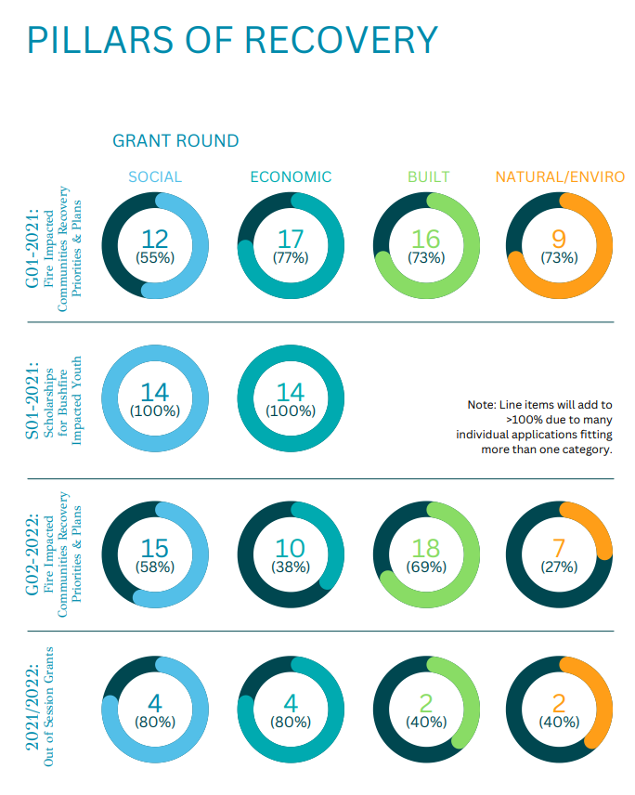
Link to EGCF Annual Report 2021-2022
ANNUAL REPORT (givetoeastgippsland.org.au)

8. Other measures to support potential donors
Better disclosure of donations use, transparency as referred to at Item 7.

Is there any avenue for a reverse mortgage donation scheme?
There is already legislation in place to manage reverse mortgages. Could something similar be developed so that potential donors can make funds available from existing assets? They could have the benefit of setting up a perpetuity of funds beyond their life span.

Example - Could a government promotional program be developed to encourage bequests? This could be funded to entities like the Community Foundations Australia. A program was run in New Zealand by the Community Foundations New Zealand. This has been extremely successful.
https://youtu.be/Av4h226qP8Y

Can there be any incentives for superannuation fund donations? We are not sure what this might look like.

9.Cost-effectiveness of public data sources
If there was more transparency on how organisations utilize donations, that would assist governments policy development and decision making. Refer response to Item 7.

Community foundations are very transparent with evidence of local outcomes and impacts. There are community wide benefits and advantages to a community foundation managing local grants and funding over larger scale national organisations who often come into the area or upscale in emergency recovery and leave soon after (with often no real connection to communities).

If any processes were changed as a result of the Philanthropic Inquiry, we suggest that an existing body manages the change – i.e. Australian Charities and Not For Profit Commission, as community foundations will already report to them as a charity/NFP.

Please do not introduce another body to collect data as this does not assist with effective use of limited operational funds.

10. Public strategies to increase status of giving
Promote Community Foundations as donation receivers. We work at the grass roots and are able to better utilize funds (efficient and effectiveness). This is an alternate to Federal and State government grant funding which is a huge resource on government and often not done efficiently and often do not achieve the best community outcomes.

Refer Item 8 – Community Foundations New Zealand public campaign to increase philanthropic donations.
https://youtu.be/Av4h226qP8Y

Thank you for the opportunity to submit our thoughts.
East Gippsland Community Foundation
Local Philanthropy & Grants Hub | East Gippsland Community Foundation (givetoeastgippsland.org.au)

Copy to the Honorable Kristy McBain MP – Minister for Regional Development, Local Government and Territories
Copy to Darren Chester MP – Member for Gippsland
Copy to Senator the Honorable Murray Watt
Copy to Tony Peace – Inspector General Emergency Management

