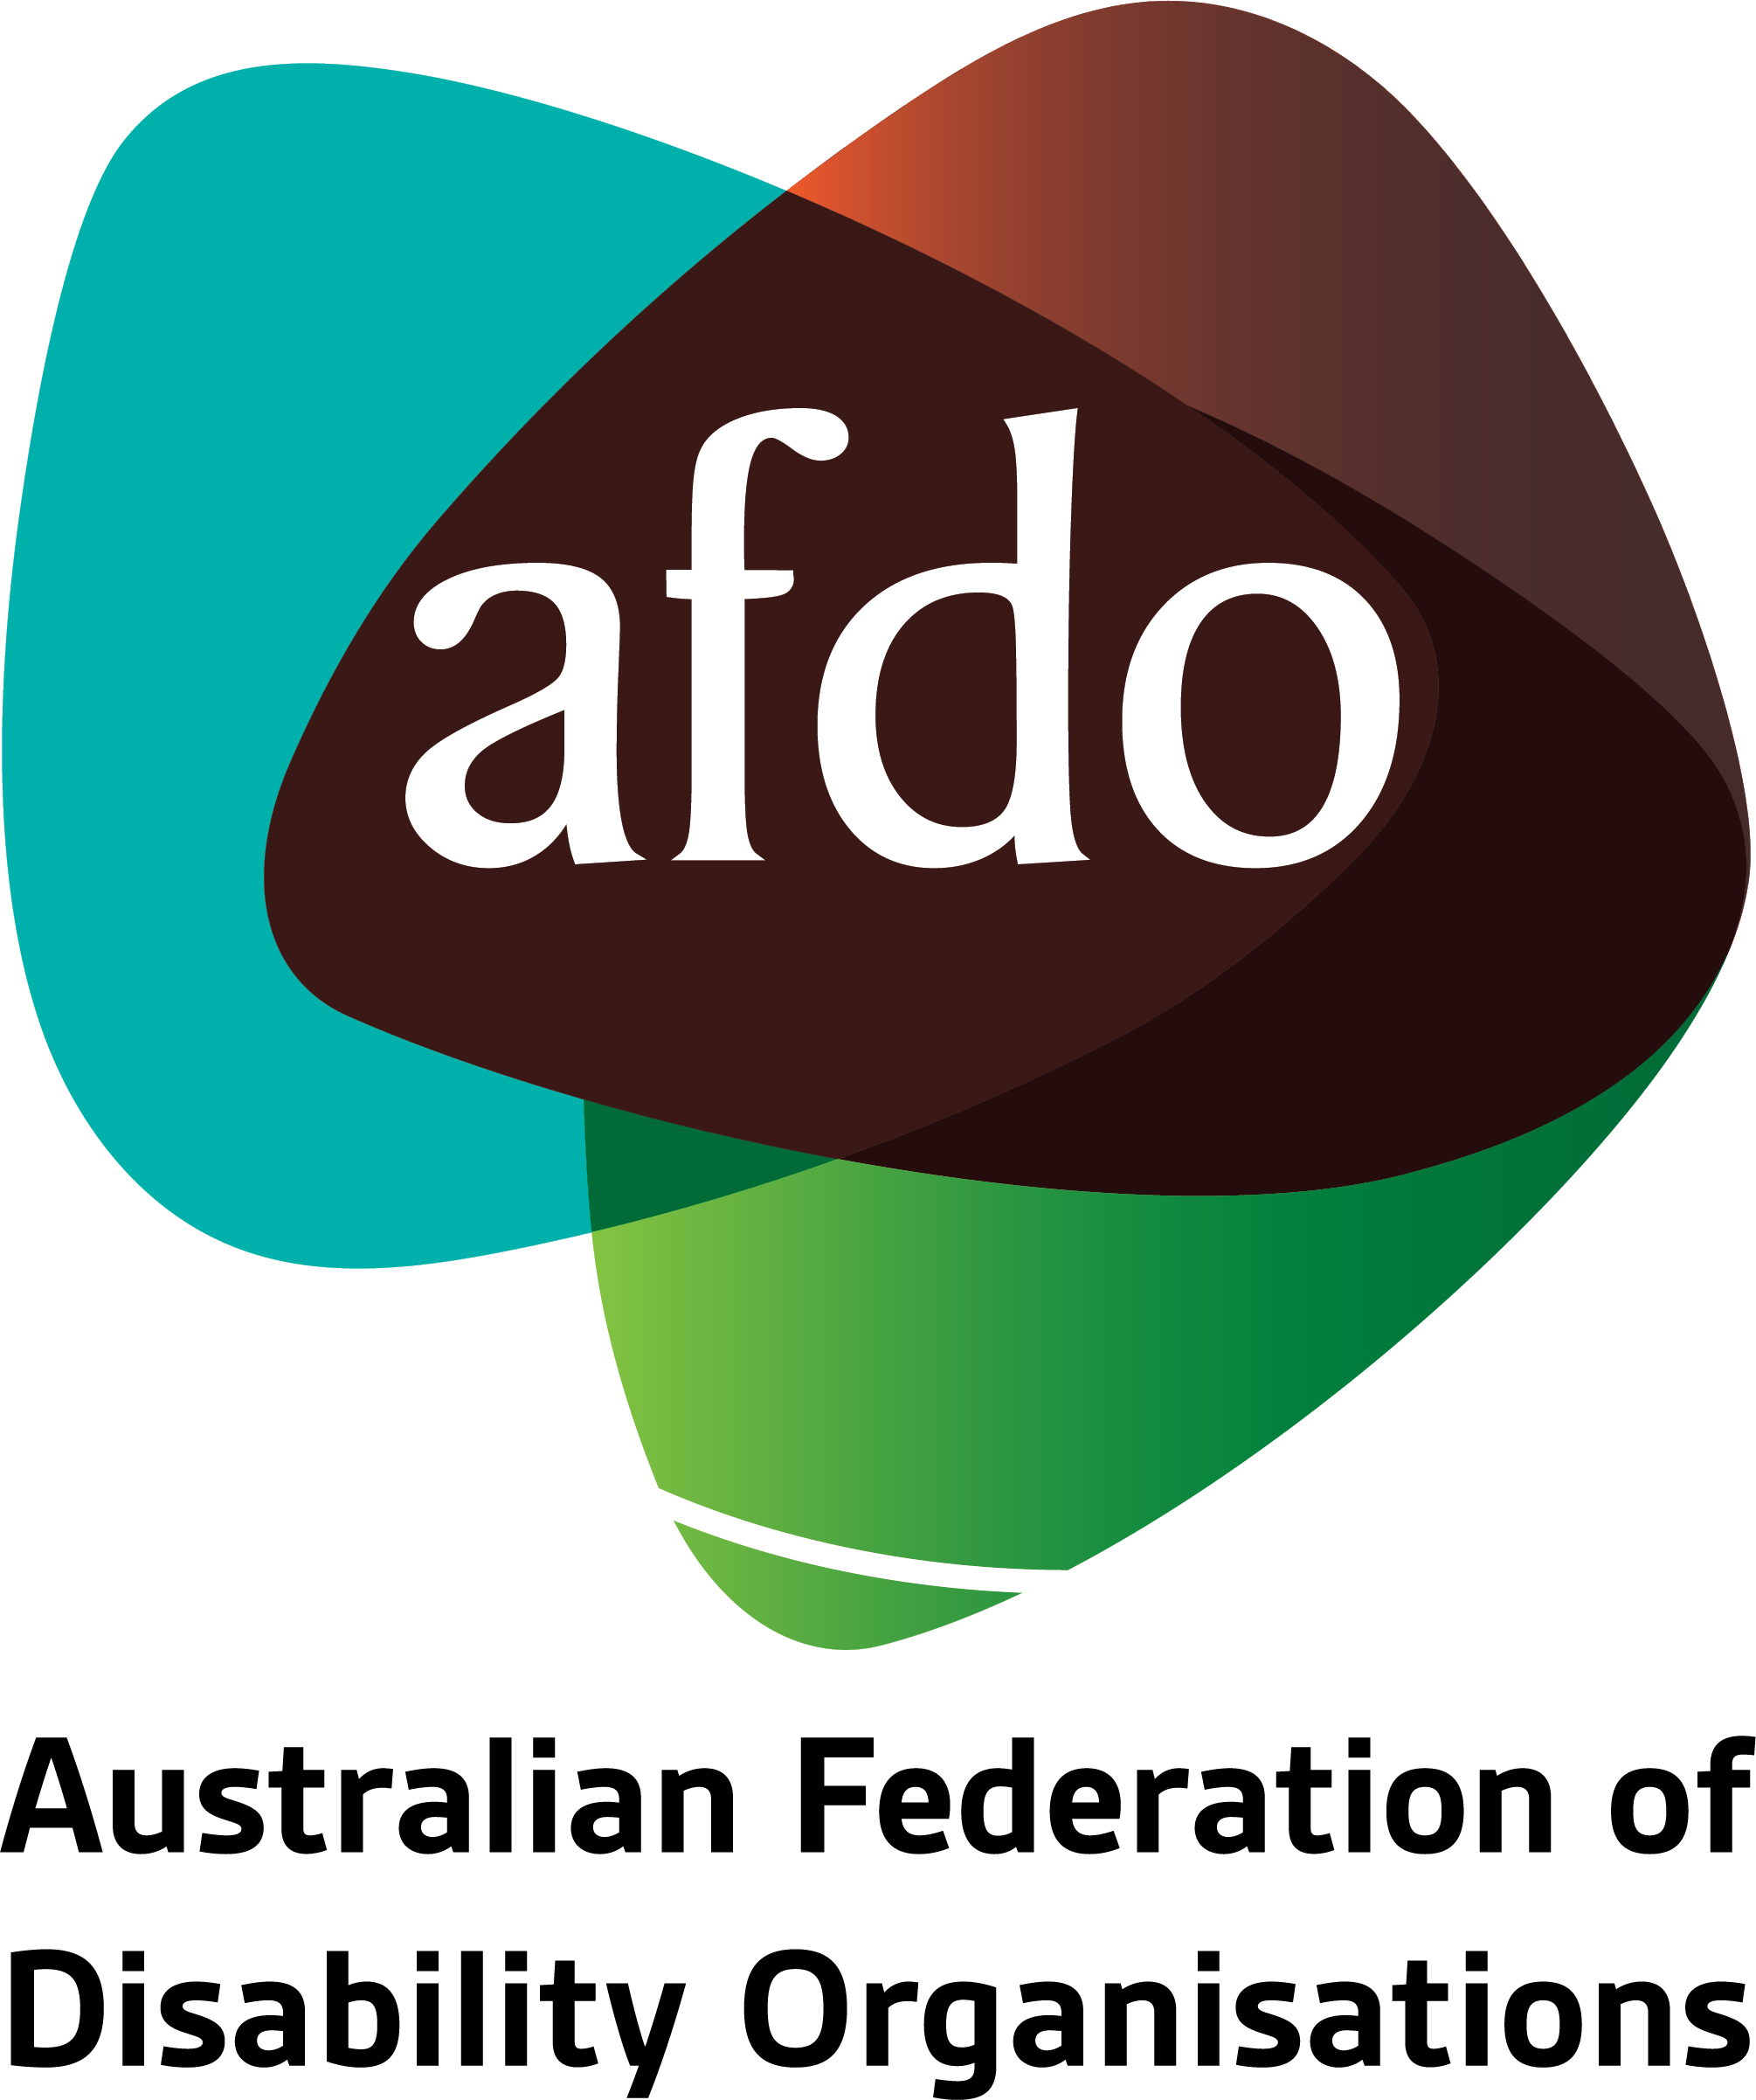

**Review of Philanthropy in Australia**  
  
Submission to the Productivity Commission

**May 2023**

Table of Contents

Table of Contents 2

About AFDO 3

Our members 4

Acknowledgements 6

Introductory comments 7

The role of systemic advocacy in improving outcomes for people with disability 8

Current funding gaps and opportunities for philanthropy 11

Social return on investment 14

Concluding comments 17

## About AFDO

Since 2003, the Australian Federation of Disability Organisations (AFDO), a Disabled Peoples Organisation (DPO) and Disability Representative Organisation (DRO), has been the recognised national peak organisation in the disability sector, along with its disability specific members, representing people with disability. AFDO’s mission is to champion the rights of people with disability in Australia and support them to participate fully in Australian life.

With our thirty-two member organisations, we are the only national peak representing disability specific and cross disability-based communities with a total reach of over 4 million Australians.

AFDO continues to provide a strong, trusted, independent voice for the disability sector on national policy, inquiries, submissions, systemic advocacy and advisory on government initiatives with the Federal and State/Territory governments.

We work to develop a community where people with disability can participate in all aspects of social, economic, political, and cultural life. This includes genuine participation in mainstream community life, the development of respectful and valued relationships, social and economic participation, and the opportunity to contribute as valued citizens.

**Our vision**

That all people with disabilities must be involved equally in all aspects of social, economic, political, and cultural life.

**Our mission**

Using the strength of our membership-based organisations to harness the collective power of uniting people with disability to change society into a community where everyone is equal.

**Our strategic objectives**

1. Represent the interests and united voice of our members and people with disability at a national and international level in all relevant forums.
2. Build the capacity, profile, reputation, and sustainability of AFDO through the strength of our member organisations.
3. Enhance the connection & influence of AFDO in international disability initiatives by policy, advocacy & engagement, focused on the Asia Pacific region.

## Our members

**Full members:**

* Advocacy for Inclusion
* Arts Access Australia
* Autism Aspergers Advocacy Australia
* Blind Citizens Australia
* Brain Injury Australia
* Deaf Australia
* Deafblind Australia
* Deafness Forum Australia
* Disability Advocacy Network Australia
* Disability Justice Australia
* Disability Resources Centre
* Down Syndrome Australia
* Enhanced Lifestyles
* National Mental Health Consumer & Carer Forum
* People With Disabilities WA
* Polio Australia
* Physical Disability Australia
* Women With Disabilities ACT
* Women with Disabilities Victoria

**Associate members:**

* All Means All
* AED Legal Centre
* Amaze
* Aspergers Victoria
* Disability Advocacy and Complaints Service of South Australia
* Explorability Inc
* Leadership Plus
* Multiple Sclerosis Australia
* National Organisation for Fetal Alcohol Spectrum Disorder
* National Union of Students - Disabilities Department
* Star Victoria Inc
* TASC National Limited
* Youth Disability Advocacy Service

## Acknowledgements

AFDO acknowledges Aboriginal and Torres Strait Islander people as the traditional custodians of the land on which we stand, recognising their continuing connection to land, waters, and community. From our head office in Melbourne, we pay our respects to the Bunurong Boon Wurrung and Wurundjeri Woi Wurrung peoples of the Eastern Kulin Nation and to their Elders past, present, and emerging. We also pay our respects to the traditional owners of all lands on which we operate or meet around the country.

AFDO acknowledges people with disability, particularly those individuals that have experienced or are continuing to experience violence, abuse, neglect, and exploitation. We also acknowledge their families, supporters, and representative organisations and express our thanks for the continuing work we all do in their support.

**Report Author:** Lauren Henley, Senior Systemic Advocate

**Reviewed by:** Ross Joyce, Chief Executive Officer

## Introductory comments

We thank the Productivity Commission for providing the Australian Federation of Disability Organisations (AFDO) with an opportunity to submit feedback to inform the Review of Philanthropy in Australia.

Our organisation exists for the primary purpose of providing systemic advocacy to improve outcomes for people with disability, their families, and carers.

Systemic advocacy is a high impact activity area that is critically underfunded by governments and is not adequately supported by the philanthropic sector. We hope our submission will highlight the important role of systemic disability advocacy, ultimately leading to an increase in philanthropic giving to support this important work.

We consider that we are well-placed to provide feedback on this issue, having previously made applications to the following philanthropic institutions:

* AMP Foundation
* Australian Communities Foundation
* Brotherhood of St Laurence
* Ecstra Foundation
* Gandel Philanthropy
* Geelong Community Foundation
* Give Where You Live Foundation
* Greater Charitable Foundation
* The Ian Potter Foundation
* Helen Macpherson Smith Trust
* Jack Brockhoff Foundation
* John T Reid Charitable Trusts
* Julia Farr MS McLeod Benevolent Funds (aka Purple Orange)
* Lord Mayor’s Charitable Foundation (Melbourne)
* Paul Ramsay Foundation
* Perpetual
* RACV Community Foundation
* Scanlon Foundation
* State Trustees
* The Frances & Harold Abbott Foundation
* The Marian & EH Flack Trust
* The Ross Trust
* William Angliss Charitable Fund
* Yarra Trams Community Partnerships.

## The role of systemic advocacy in improving outcomes for people with disability

*"Systemic advocacy works to solve an issue that affects a large group of people with disability. The sorts of issues this advocacy addresses are often a problem with the system, meaning that a lot of people are experiencing the same problem."[1]*

Around 4.4 million Australians have a disability. This number will increase as a result of population ageing, as the prevalence of disability increases with age. In fact, 50% of people aged 65 and over have a disability.[2]

Australians with disability continue to experience exclusion, discrimination, and ill-treatment in many areas of public life. These barriers prevent people with disability from safely and equitably accessing:

* Health care and health services;
* Disability services and supports;
* Social security;
* Justice;
* Education;
* Employment;
* Information and communications systems;
* Housing; and
* Transport.[3]

Systemic disability advocacy involves working for long-term social change to improve outcomes for people with disability. It is about ensuring laws, policies, and programs adequately serve the rights, needs, and interests of people with disability. In order to be effective, systemic advocacy should be informed by trends in individual advocacy and by the lived experience of people with disability at the grassroots level.

The Australian Government has signed and ratified an international treaty known as the *Convention on the Rights of Persons with Disabilities* (CRPD). This means it has made a legal commitment to uphold the rights expressed in the Convention.[4]

Systemic disability advocacy also strives to hold Governments accountable by advocating for the implementation of laws, policies, programs, and practices that align with the Convention.

Importantly, systemic advocacy also has the potential to reduce demand on individual advocacy services. It does this by addressing the exclusion, discrimination, and ill-treatment of people with disability at a systems level.

As recognised by Philanthropy Australia, it is about “…Tackling the Root Causes, rather than Just the Symptoms”.[5] This is why it is recognised as the model of advocacy that makes the greatest contribution to systemic change.[6]

**Systemic advocacy does, however, often require a sustained effort over a prolonged period of time in order to achieve results.**

**Systemic advocacy case study: Increasing access to social security for Australians with disability.**

Changes to the Disability Support Pension and the broader social security system that have occurred over the last two decades have created a range of barriers for people with disability. These barriers continue to impact upon the health, wellbeing, and quality of life of many people with disability across Australia.

They are also placing increased demand on advocacy and information services, as each case needs to be addressed at an individual level. These barriers would be most effectively overcome by addressing the root problems with Australia’s social security system. As such, our members have consistently endorsed our policy and advocacy work in relation to social security and specifically, the Disability Support Pension.

In 2022, we made a submission to the Inquiry into the Purpose, Intent and Adequacy of the Disability Support Pension. The final report from this Inquiry **mentioned AFDO fifty (50) times, and** **twenty one (21) of the thirty (30) recommendations included in the final report were consistent with recommendations put forward in our submission**. A further **four (4) recommendations were consistent with commentary that appeared in the body of our submission**.[7]

While we are pleased with this level of influence, we now need to wait for the Government to respond to the final report. This will provide us with an understanding of which recommendations the Government has accepted either in part or in full.

Based on this information, we will be able to develop an advocacy strategy to hold Government accountable. In doing so, we will advocate for the implementation of changes that will ensure Australia is meeting its obligations to people with disability under Article 28 of the Convention on the Rights of Persons with Disabilities (Adequate standard of living and social protection).

At the same time, we are driving positive change around access to social security for people with disability by:

* Convening regular meetings of the Technical Experts on Social Security group (TESS). This is an AFDO-formed group comprising several experts across the country who come together to discuss necessary reforms relating to particular aspects of the social security system for people with disability.
* Representing the needs of people with disability at meetings of the Welfare Payment Infrastructure Transformation Civil Society Advisory Group, convened by Services Australia.
* Making submissions to other relevant inquiries, such as the 2022-23 Inquiry into the Cost of Living, the 2022-2023 Inquiry into the Extent and Nature of Poverty in Australia, and the Royal Commission into the Robodebt Scheme.

## Current funding gaps and opportunities for philanthropy

*“It is hoped that in striving towards more and better philanthropy in Australia, even more philanthropic organisations will consider the benefits of funding advocacy as part of their grant-making.”[8]*

Systemic advocacy is critically underfunded by Government. While we do receive funding from the Department of Social Services, as a recognised Disability Representative Organisation (Systemic Advocacy Funding) the amount received represents less than five point two percent (5.2%) of our total income and does not cover our existing advocacy & policy team let alone any core support to operate a compliant not for profit organisation. This limits our ability to carry out our core business of improving outcomes and opportunities for people with disability through systemic advocacy.

This is not an issue that is isolated to AFDO. A report published by the NSW Ageing and Disability Commissioner in 2019 concluded that there was no long-term, sustainable funding to support systemic advocacy in NSW. This was found to limit the capacity of disability advocacy organisations to:

* Effectively advocate for systemic solutions to the barriers that are experienced by people with disability;
* Retain and upskill staff;
* Evaluate programs and measure impact; and
* Develop long-term working relationships with key influencers and decision-makers.[9]

We assert that these findings are reflective of national issues, and that the funding landscape has not changed significantly since this report was written.

**While the philanthropic sector could influence genuine social change by addressing the gap in funding for systemic advocacy, we have not been able to locate any grants that support this work.**

Previous philanthropic funding received by AFDO has been tied to specific projects. These projects have made a meaningful contribution to improving the lives of people with disability, but do not support our core business of elevating the voices of and improving outcomes for people with disability through systemic advocacy. The current funding landscape has forced organisations such as AFDO to become increasingly reliant on project-based funding as a means of remaining financially viable, which ultimately takes us further away from our core work. Furthermore, philanthropic grants will often only fund a project for 1-2 years. This limits our ability to achieve lasting social change through our project work, as we are often unable to resource a project beyond the lifespan of the grant.

It is critical for disability advocacy organisations to be able to draw on a diverse range of funding streams to ensure they are effectively resourced and remain financially sustainable. An overreliance on Government funding alone can also limit the capacity of disability advocacy organisations to advocate to Government.

A 2018 report published by Pro Bono Australia and the Human Rights Law Centre found that many Australian charities were avoiding political advocacy and “self-silencing” due to:

* Funding agreements.
* Management pressure.
* The “implied repercussions” of political speech.[10]

**Resourcing constraints and funding agreements with Governments can also force disability advocacy organisations to be more reactive, rather than proactive in their work.** This means Government is often driving the agenda, with all resources being directed towards responding to Government consultations. We ultimately believe that people with lived experience should be driving the agenda, and that we should be able to focus our advocacy work on the areas that are of most concern to people with disability at the grass roots level. As such, increased philanthropic giving to support systemic advocacy would allow organisations such as AFDO to:

* Work with our members and people with disability at the grassroots level to determine key priority areas for systemic advocacy.
* Undertake research to ensure we have an evidence-based approach to our systemic advocacy work.
* Develop targeted position statements and advocacy strategies relating to each priority area.
* Work with our members and people with disability at the grassroots level to implement each advocacy strategy.
* Speak out without fear or favour to ensure the rights of people with disability are effectively promoted, protected, and upheld.
* Monitor our social impact and effectively evaluate our work.

We would like to see the Productivity Commission capture the need for philanthropics to provide untied funds to support systemic disability advocacy – which aligns with work previously undertaken by Philanthropy Australia. Philanthropy Australia began exploring this topic in earnest during the 2017 Philanthropy Meets Parliament Summit, held in Canberra in September 2017. The summit included a range of presentations that articulated the need for, and benefits of, increasing philanthropic giving to support systemic advocacy. In 2018, Philanthropy Australia published a subsequent report entitled, 'The Power of Advocacy: Making the Case for Philanthropic Support for Advocacy’. The report:

* Outlines the rationale for philanthropy funding policy advocacy;
* Sets out the law regarding philanthropic giving to support systemic advocacy;
* Addresses some misconceptions about systemic advocacy; and
* Presents a number of case studies to demonstrate how philanthropic funding for systemic advocacy has achieved real social change.[11]

**Regrettably, we have not noticed any increase in philanthropic giving to support systemic advocacy since this work was undertaken.**

The need for increased funding from the philanthropic sector will become even more critical over the next 12 months, as the Royal Commission into Violence, Abuse, Neglect and Exploitation of People with Disability is due to provide its final report to Government in September this year.

While the disability advocacy sector has worked tirelessly throughout the life course of the Royal Commission, the real work will begin once the final report and recommendations have been published. It will be up to people with disability, through representative organisations such as AFDO, to push for the systemic change that is needed to effectively address the issues outlined in the final report. Without philanthropic support, the sector will be ill-equipped to tackle this critical work.

## Social return on investment

*“Advocacy is the basic tenet of democracy: a vital tool for surfacing the voices of marginalised or vulnerable citizens and for participation in the vital issues facing communities. It is a high-leverage, high-impact strategy with proven return-on-investment.”[12]*

While systemic advocacy aims to improve the social capital of people with disability, it often leads to broader societal and economic benefits. A cost-benefit analysis undertaken in 2017 found that independent disability advocacy delivers a significant positive net economic benefit to Australia. In fact, an estimated benefit of $3.50 is returned for every dollar spent on independent advocacy.[13]

There is also a significant economic cost associated with inaction. A recent report published by the Royal Commission into Violence, Abuse, Neglect and Exploitation of People with Disability reported that the exclusion and neglect of people with disability cost the Australian economy at least $46.0 billion in 2021-22. Of this $46.0 billion, $27.7 billion related to issues of systemic failures and neglect. These costs were associated with factors including, but not limited to:

* Avoidable deaths;
* Preventable hospitalisations;
* Extra costs arising from people living in inaccessible housing; and
* Low employment rates resulting from discrimination.[14]

**Social return on investment case study: Increasing access to assistive technology for people with disability.**

The term ‘assistive technology’ refers to any aid, equipment, or home modification that helps a person with disability perform an everyday task. Some examples of assistive technology include:

* Wheelchairs.
* Prosthetic limbs.
* Electronic communication devices.
* Home modifications such as grab rails and ramps.

While the National Disability Insurance Scheme (NDIS) has the capacity to fully fund the assistive technology that is needed by Scheme participants, the Scheme still only provides support to around 10% of people with disability across Australia. People with disability who fall outside the Scheme are rarely able to access the assistive technology they need.

AFDO has been working with a number of other organisations across the disability sector to advocate for improved access to assistive technology for the many people with disability who are still excluded from the NDIS. This would maximise the independence, wellbeing, quality of life, inclusion, and participation of many people with disability. It would also offer broad-ranging economic and societal benefits, as the timely provision of assistive technology is known to:

* Facilitate autonomy and independence, therefore minimising the burden on families and carers.
* Increase inclusion and participation, enabling people with disability to take on paid and voluntary roles in their communities.
* Improve health outcomes and the onset of secondary health conditions.
* Reduce the risk of accidents and falls.
* Reduce GP visits and hospital admissions.

Due to the above factors, research shows that for every dollar spent on assistive technology, there is an estimated conservative two-fold return on investment relating to savings on paid carers, health services and other supports. The effective provision of assistive technology can also prevent or delay entry to residential aged care, the cost benefits of which have not been included in this modelling.[15]

Additionally, systemic advocacy has the potential to advocate for solutions that may benefit the broader Australian population. This is because when steps are taken to make something more accessible for people with disability, it generally increases the usability of that product, environment, or service for other members of the community. Ramps are a very basic example of this. While the installation of ramps provides wheelchair access to a building, it is also beneficial for people using luggage or prams, elderly people, and people with a temporary injury.

**Case study on the flow-on benefits of systemic advocacy: Increasing access to voting in New South Wales.**

AFDO member organisation, Blind Citizens Australia has spent many years advocating for a system that would enable Australians who are blind or vision impaired to cast a secret, independent, and verifiable vote during local, state, and federal elections. In NSW, this led to the introduction of a system called iVote. iVote enabled voters to cast their vote either over the phone or over the internet. While it was originally introduced as a way of making the electoral process accessible to voters who are blind or vision impaired, its other benefits soon became clear. As such, the second time iVote was used, it was made available to:

* Electors who lived more than 20 km from a polling place;
* Electors who were out of the state on election day; and
* Electors who could not attend a polling place due to any form of disability.[16]

## Concluding comments

Thank you once again for providing us with an opportunity to submit feedback to inform this review. It is our hope that the review will drive an increase in funding to support systemic advocacy across the philanthropic sector.

Should you require further information in relation to any of the matters raised throughout this submission, please contact;

Lauren Henley

Senior Systemic Advocate

Reference list

Australian Institute of Health and Welfare (2022) 'People with disability in Australia, prevalence of disability', accessed 1 May 2023, retrieved from <https://www.aihw.gov.au/reports/disability/people-with-disability-in-australia/contents/people-with-disability/prevalence-of-disability>.

Brightwell, I., Cucurull, J., Galindo, D., and Guasch, S. for the New South Wales Electoral Commission (2016) 'An overview of the iVote 2015 voting system', P3.

Commonwealth of Australia, Senate Affairs Community References Committee (2022) 'Final Report from the Inquiry into the Purpose, Intent and Adequacy of the Disability Support Pension', ISBN: 978-1-76093-349-4.

Daly, A., Barrett, G., Williams, R., for Disability Advocacy Network Australia (2017) 'A Cost Benefit Analysis of Australian independent disability advocacy agencies'.

Department of Social Services (2022) 'International participation in disability issues', accessed 2 May 2023, retrieved from <https://www.dss.gov.au/our-responsibilities/disability-and-carers/program-services/government-international/international-participation-in-disability-issues>.

Department of Social Services (2010) 'Research of the Models of Advocacy Funded under the National Disability Advocacy Program', accessed 1 May 2023, retrieved from <https://www.dss.gov.au/our-responsibilities/disability-and-carers/publications-articles/policy-research/research-of-the-models-of-advocacy-funded-under-the-national-disability-advocacy-program?HTML>.

Disability Advocacy Network Australia (2023) 'What is advocacy?', accessed 2 May 2023, retrieved from <https://www.dana.org.au/how-to-advocate/>.

Layton, N., & Brusco, N. (2022) The Australian assistive technology equity studies: Improving access to assistive technology for people with disability who are not eligible for the NDIS, accessed 30 January 2023, retrieved from <https://doi.org/10.26180/21113887>.

NSW Ageing and Disability Commissioner (2022) 'Review into Disability Advocacy in NSW', P9.

Philanthropy Australia (2018) The Power of Advocacy: Making the Case for Philanthropic Support for Advocacy.

Pro Bono Australia (2018) 'Civil Voices', accessed 2 May 2023, retrieved from <https://civilvoices.com.au/

Royal Commission into Violence, Abuse, Neglect and Exploitation of People with Disability (2020) 'Interim Report Summary', ISBN 978- 0-6489418-0-4.

Vincent, J., McCarthy, D., Miller, H., Armstrong, K., Lacey, S., Lian, G., Qi, D., Richards, N., Berry, T. (2022). Research Report - The economic cost of violence, abuse, neglect and exploitation of people with disability, P4-6.

1. Disability Advocacy Network Australia 2023.
2. Australian Institute of Health and Welfare 2022.
3. Royal Commission into Violence, Abuse, Neglect and Exploitation of People with Disability 2020.
4. Department of Social Services 2022.
5. Philanthropy Australia 2018, 4.
6. Department of Social Services 2010.
7. Commonwealth of Australia 2022.
8. Philanthropy Australia 2018, 13.
9. NSW Ageing and Disability Commissioner 2022, 9.
10. Pro Bono Australia 2019.
11. Philanthropy Australia 2018, 15.
12. Daniel Lee, Levi Strauss Foundation.
13. Daly et al. 2017.
14. Vincent et al. 2022, 4-6.
15. Layton & Brusco 2022.
16. Brightwell et al. 2016, 3.