Dear Australian Government,

I feel like charity law has fallen out of step with what my peers and I care most about, and that my generation doesn’t have the same kinds of philanthropic organisations supporting us and our values as older generations do.

To achieve goals like growing donations and increasing community engagement, charity laws should build incentive structures that foster organisations that work on the kinds of issues that younger generations of Australians care the most about.

I’m writing this submission to you to discuss:

1. Expanding DGR status to the high impact cause areas that align with the values of modern Australians *(2.ii, 3.ii, 5, 6)*
2. The benefits of rigorous charity evaluation *(3.ii, 6.iii)*

**1. Animal welfare and global catastrophic risk reduction should be DGR classes (Information request 4)**

As I see it, the most important issue is that DGR status needs to be broadened to include things that young people today care about – specifically reducing global catastrophic risks and supporting the well-being of animals.

I want to engage with my community around the reduction of catastrophic disaster risks, but currently, the community organisation around these kinds of risks seems limited to things like my local volunteer fire brigade. I of course support the work of the local fire brigade, but it’s not a fit for my skills and interests. If organisations working on reducing the risk of catastrophic disasters had DGR status the would be better able to find ways for me to connect with my peers and volunteer to do good. I know, post-COVID and given the war in Ukraine, that a lot of my peers are really worried about worse future pandemics and the need to reduce the risk of a nuclear war. These are modern concerns, but DGR regulation hasn’t kept up.

In the same way, my peers and I care deeply about the welfare of animals. While the animal charities I support can be “charities” under the *Charities Act*, they can’t get DGR status under the *Tax Act*. I understand that this is because DGR status is limited to things like the short-term direct care and rehabilitation of lost or mistreated animals. While any animal suffering is a tragedy, it’s obvious to me that it would be far more effective to give DGR status to charities that are seeking to prevent animals from needing this kind of direct care in the first place. Everyone knows prevention is better than cure, so why should the law incentivise treatment over prevention?

I really think the exclusion of these two cause areas from DGR status hurts our ability to do good. These causes are recognised by sophisticated charity evaluators as being high-impact and allowed to accept tax-deductible donations internationally, but excluded here in Australia. If the Government wants to increase donations to charities and increase the ability of charities to build social connections, it needs to give DGR status to these high-impact cause areas that today's Australians are so passionate about.

**2. Australian charity evaluation would build confidence (Information request 7)**

I’m also excited by the terms of reference about charity evaluation. I think people can be cynical about charity because it’s hard to know if your donation has actually had an impact. I’ve valued the work of overseas charity evaluators because they provide trusted rigour around impact. This is important because high-impact charities can be 10 or 100 times more impactful than average charities. Some charitable programs can even do harm.

I would encourage the Productivity Commission to review:

* *Donors vastly underestimate differences in charities’ effectiveness* by Caviola, L; Schubert, S; Teperman, E; et al. available online at <http://hdl.handle.net/10871/122268>, and
* *Don’t Feed the Zombies* by Kevin Star in the Stanford Social Innovation Review, available online at <https://ssir.org/articles/entry/dont_feed_the_zombies>

The research is usefully summarised in two illustrations that depict how different the view of the impact of charity is between lay people and experts:

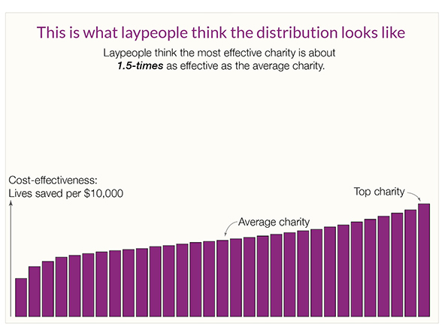

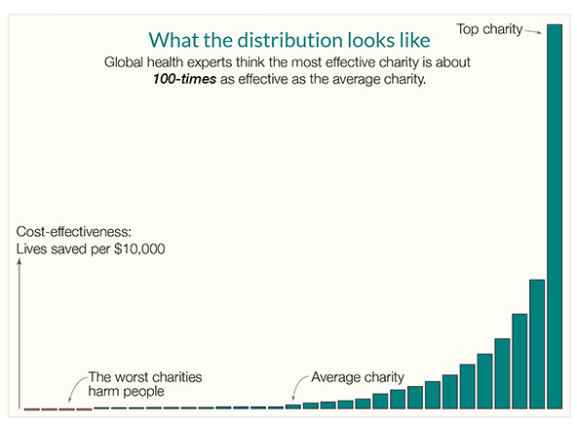

Kevin Star’s article usefully explains that there’s a kind of market failure in the charity sector, where donors aren’t part of the feedback loop and often have no meaningful way of knowing how much value beneficiaries get from their donations. The article outlines how an approach to impact-focused evaluation which he persuasively explains could achieve a “quantum leap toward a better world”.

While the above two sources focus on global health, the same effect occurs across countries and across causes. By way of illustration, Benjamin Todd’s recent article on 80,000 Hours shows a similar distribution of the impact of climate interventions (https://80000hours.org/2023/02/how-much-do-solutions-differ-in-effectiveness/) :

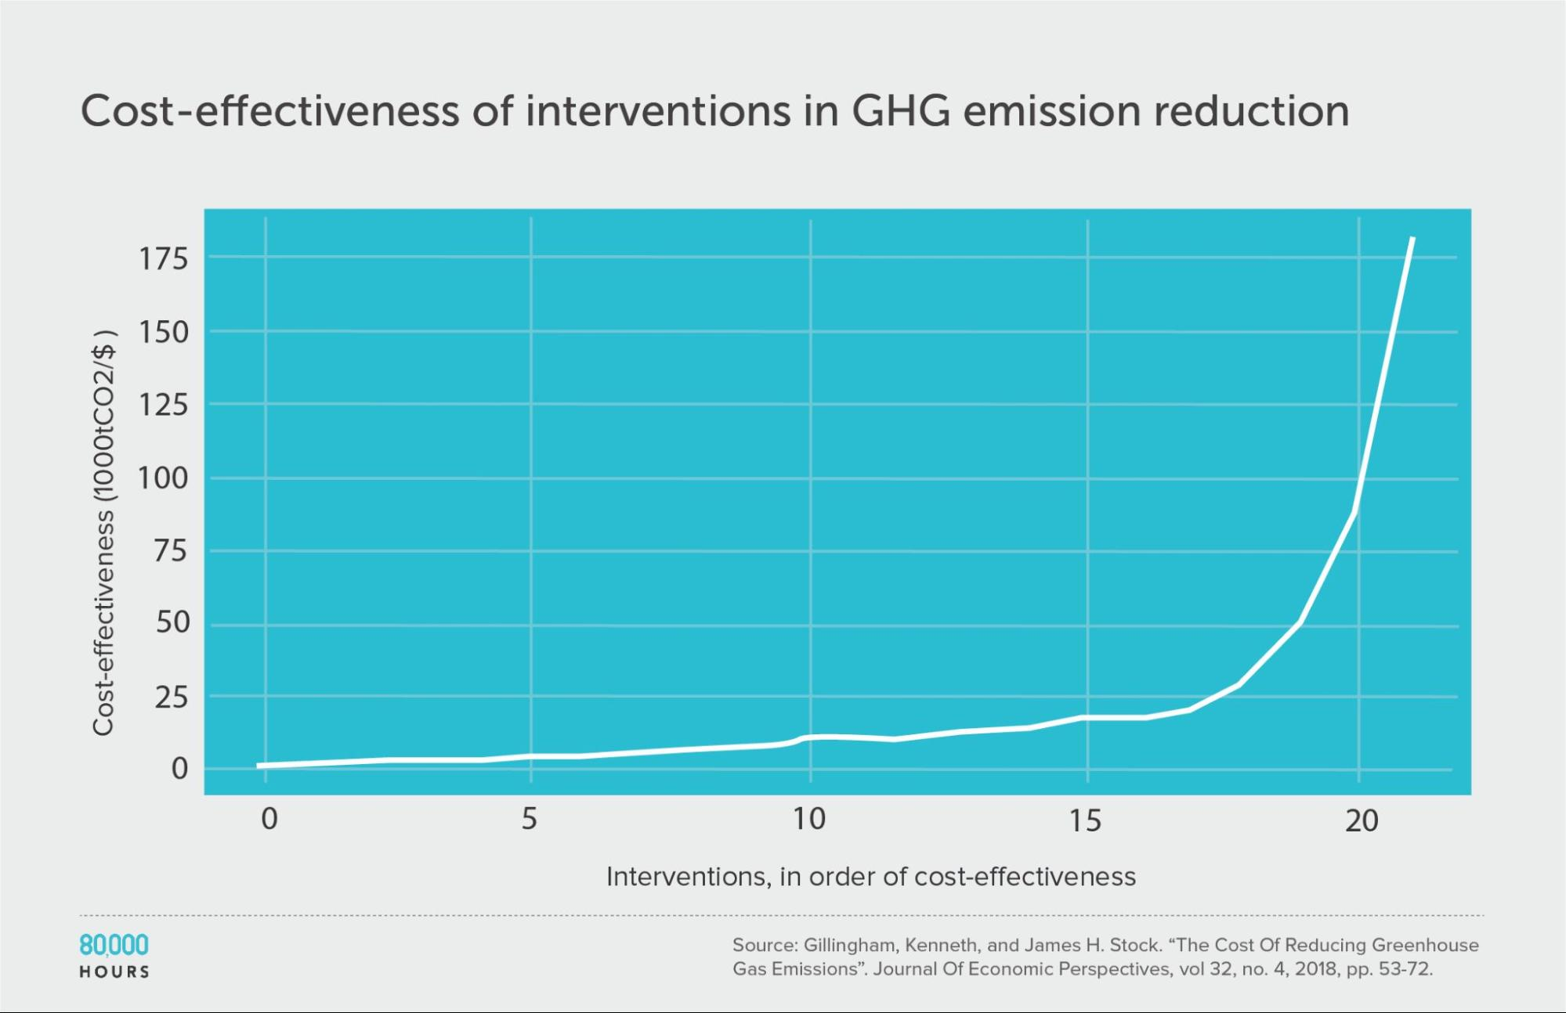

This insight is essential. While donors don’t and can’t understand how impactful their donation is, and charities have to raise funds in a market that doesn’t function, the sector will struggle. This problem is long-standing, but progress in the last 10 years on charity evaluation means it doesn’t have to continue.

Australia funding and promoting charity evaluation has the potential to fix the market failure, help Australian charities do far more good, and potentially make us a world leader.

**The Australian Government must lead the way**

In addition to the above arguments, if the Australian Government wants to double philanthropic giving and increase impact, it should lead from the front.

Australia’s Overseas Direct Aid as a proportion of Gross National Income (GNI)—the official measure of development assistance—is expected to remain at the 2021–22 level of 0.20%.

This continues to place Australia well below the OECD Development Assistance Committee (DAC) country average of 0.32%.

In 2020 Australia ranked 21 out of 29 OECD DAC countries on the generosity of its aid, measured by the ODA-to-GNI ratio. On current estimates, Australia’s ODA-to-GNI ratio is expected to tail off to 0.17% by 2025–26.

The UN’s ODA target is to spend 0.7 per cent of GNI on ODA every year. If the Australian Government wants to double giving by its citizens, it should show that it means business by doubling its own giving and focusing on using evidence to double the impact of the giving that it does do.

I trust this information and perspective has been valuable to the Productivity Commission.

Yours Charitably,

Tharun Sonti