**Submission to the**

**Productivity Commission’s Review of Philanthropy 2023**

**Submitted by Edmund D.H. Flack. B.Ec., PhD., JP(Qual)**

**Introduction**

Whilst I acknowledge that the Productivity Commission provides an important economic and market-based perspective to its inquiries, I would like to suggest that, because of the not-for-profit, often religious and/or communitarian basis of philanthropy, the Commission will need to consider not only the economics but also the philosophical, social and psychological foundations of philanthropy.

My submission is written in five sections. The first section responds to the “tendencies and motivations for Australians’ charitable giving” referred to in the scope documents of the Inquiry. It argues that too little emphasis has been given by policy makers to the psychological and moral motivations of donors for giving and has instead, emphasised the policies designed to reduce the risks of giving though oversite and regulation. I contend that this emphasis can have the effect of reducing many donors’ natural inclination for philanthropic giving. *“Do what you must but don’t disturb the horses”*.

In the second section, I argue that considerations of the “effectiveness …. of the use of donations” is largely dependent on the perspective of the assessor. I submit that philanthropic donors, economists, social scientists and government regulators are likely to have differing perspectives.

The third section responds to the references in the Terms of Reference to the “…efficiency of the use of donations”. I submit that calculations made in order to assess the efficiency of the use of donations tend to be misleading because they tend to be made using financial data from the accounts of charities. I argue that the allocation of income and expenses to cost centres such as “services”, “fundraising” and “administration” is almost impossible to regulate to ensure that there is a uniform system of allocation that would facilitate useful comparisons.

The fourth section in this submission responds to the Commission’s interest in the “ability of donors to assess and compare charities based on evidence of “….impact evaluation comparison sites.” My submission reflects the findings of the large number of international studies on the issue and argues that although some rating agencies look at transparency, governance, or fundraising practices, no one has found a reliable way to measure and report on effectiveness and quality of services that allows reliable comparisons of multiple providers.

In the fifth section, I argue that in this inquiry, greater attention should be given to policies that focus on raising and maintaining high standards of governance and “trusteeship” in the not-for-profit sector.

**Section 1 - Tendencies and motivations for Philanthropy**

The available academic research into the tendencies and motivations for charitable giving in Australia tends to focus on very practical research into charitable fundraising practice rather than the underlying philosophical and cultural basis on which philanthropic behaviours are based[1][2].

It is my submission that the Commission needs to take note of the historical and cultural understanding of “philanthropy” and the psychological and sociological motivations for giving.

It is generally agreed that the term “philanthropy” was first coined by the Ancient Greek playwright, Aeschylus (526-456 BC) in his play “Prometheus Bound”. “Philanthropy” literally means - philos - loving (in the sense of benefiting, caring for and nourishing) and anthropos- humankind, humanity or human-ness.

Early Hebrew and Christian teachings also influenced the way western society understands “philanthropy”. Christian theology emphasises the twin duties of Divine Mercy. The mercy of God the Father, characterised by benevolent steadfast love from a father figure (old Hebrew word “hesed”) and the mercy of a mother figure, characterised by tender compassion and identification with those in distress (old Hebrew word “rachamin”). To use an analogy, a majority of members of the community feel a personal duty to tender the injured at the bottom of the cliff and a joint duty to work with other citizens of goodwill, to ensure that adequate fences are built to prevent people falling.

Despite the diminished influence of the religion in modern Australian society, I submit that a significant portion of Australian society still feel the need to personally respond to people in need through personal giving when they are made aware of the need (“rachamin”). A smaller, but significant section of society, still feel obligated “to do something”, including making a gift, to ameliorate the causes of the need (“hased”)[3].

I submit that this is why most donors do not make choices based on efficiency or effectiveness but rather on a deeply held psychological, social, moral or religious need to respond to perceived need.[4].[5] Perhaps one of the best examples of rachamin-type philanthropy in Australian society today is the popularity and success of “crowdfunding” and GoFundMe fundraising platforms, where donors are facilitated in giving directly to others in need, frequently without reference to any charities involved.[6].[7].[8]

**Section 2 – “Effectiveness …. of the use of donations**”.

Defining “effectiveness” of philanthropic transactions is complex because the measures of “effectiveness” depend largely on the perspective of the assessor.

To illustrate the point, I provide three different examples of acts of philanthropy in support of people who are homeless:

Example A. My neighbour recently received a request for a donation from Rosies ([Rosies Youth Mission Inc](https://rosies.org.au/)) a charity that provides friendship and conversation for homeless people on the street. Rosies volunteers reach out with connection and conversation to those who are vulnerable and isolated. Rosies needs to raise funds for the organisation of their volunteers, transport and for the many free coffee vans that are made available in the streets across Queensland. Rosies is supported by many generous donors and by large numbers of volunteers. He decided to give a donation of $50.00

Example B. A local businessman was contacted by Vinnies to make a donation towards Cornerstone. [Cornerstone Homelessness Services](https://qld.vinnies.org.au/services/housing/specialist-homelessness-services) is operated by St Vincent de Paul Society, Queensland and provides a “housing first approach” which transitions a person or household, wherever possible, from homelessness into stable, long-term housing, with support provided where necessary to sustain the tenancy. It was explained that the funds raised would help to pay for the administration of the properties and Vinnies ability to add the “extras” that help make the services more personal and friendly. The businessman decided to give $500 again as he had been a donor during the professional “capital fundraising” campaign conducted to build the facility several years ago.

Example C. In a local shopping centre, a shopper was recently approached for a donation by a person who appeared to be homeless who said that he needed help to pay for a place to stay and “get cleaned up”. The shopper spoke briefly to the person about his situation and gave him $10.00. and wished him good luck. (despite such “begging” in a public place being illegal in Queensland – see Sect 8 of the Summary Offences Act 2005)

I submit that the assessment of the “effectiveness” of any one of these donations depends largely on the perspectives of the assessor.

If the assessment is being made by a philanthropic donor, the donor may be satisfied in their belief that they have responded in a small way to people in need and felt good that they had “done the right thing”. At the time when they made their donation it is unlikely that they would have asked themselves the questions - “Is my gift going to be effective?” or “Is my giving an efficient way to help?”

If the assessment was being made by a person who has some knowledge of the mental distress associated with homelessness, that person may prefer to support Rosies. Alternatively, a person who is aware of the current “housing crisis” may want to see more funds made available to Vinnies and their housing services.

I submit that each of these examples demonstrate the different perspectives that donors bring to their choices when challenged to make philanthropic decisions about helping homeless people in need. I submit that most people are inclined to respond philanthropically (with kindness and/or a sense of duty) without consideration of the “efficiency” or “effectiveness” of their donations.

It is also true that a donor’s consideration of “effectiveness” may, in part, be determined by the timing of that consideration. The decision to donate when asked may be different when the donor later reviewed alternatives as to where and how to donate[9].

**Section 3. “Efficiency of the use of donations”.**

There are a number of ways that parties involved in philanthropic transactions may use an economic perspective – including the perspectives of donors, charities and regulators.

I submit that for only a small proportion of donors, the economics of their donation is important, however charities themselves and government regulators are concerned to ensure that the donations that charities receive are used in an efficient and effective way.

“Agency theory”[10] proposes that donors to charities (customers) use non-profit organisations as trusted agents because customers find it costly to determine quality before or even after purchase and prefer to use non-profit rather than for-profit organisations[11].

**Agency theory**

Calls for greater levels of accountability in philanthropy are theoretically based on the economic “agency theory” – the idea that the donor (purchaser) must rely on a charity (agent) to deliver the donation (product) to the beneficiary. The agent is said to have a duty of accountability to the donor to maintain the purchaser’s level of trust in the agent’s duties as an intermediary. The agent must also be relied upon to report the effectiveness (outcome) of the transaction.[12]

From an economic perspective, the philanthropic donor has an exchange with the beneficiaries either directly or through the agency of a charity.

From the donors’ perspective, the use of a trusted agent may be an attractive alternative to an agent that has a commercial interest. The use of a commercial agent may reduce the donor’s inclination to give to a person in need or to a “good cause” since the presence of a commercial agent may detract from the donor’s confidence and therefore reduce the donor’s sense of psychological well-being.[13]

Other authoritative research finds more direct benefits to the donor referred to as “warm inner glow”[14].[15]. which are enjoyed without consideration of the characteristics of the agent.

The available literature finds that donors are motivated by a complex mix of benefits to the donor including psychological benefits, such as “walm inner glow” and reputational benefits which are difficult to measure.1 The donor may also consider the cost of the transaction. Using a charity (trusted agent) may have the additional benefit to the donor of reducing the cost of their donation through the tax concessions available to donors who give to the charity[16].

I submit that there are three issues that must be addressed in efforts to provide measures of effectiveness and efficiency – challenges in defining “effectiveness” and “efficiency” of philanthropic activities, achieving consistent measurement across multiple types of philanthropic environments, determining whether such measures encourage or discourage philanthropic transactions[17]. [18]

**Measuring the economic “efficiency” of philanthropy**

“Efficiency” when considering philanthropic transactions is generally understood in economics to mean the measure of the relationship between inputs (donations) and outputs (charitable works or charitable purposes), however there are several types of efficiency, including allocative and productive efficiency, technical efficiency, ‘X’ efficiency, dynamic efficiency and social efficiency, all of which have bearing on any consideration of “efficiency” in the philanthropic sector of the economy.

In the literature on philanthropic transactions there is a significant number of perspectives and views about the value of measurements of efficiency. Similarly, the research literature varies widely on whether the provision of efficiency measures either encourages or discourages philanthropy.3.[19].

The Industry Commission 1995 addressed the issue of making judgements about the efficiency of charities based on the cost of administration and fundraising in their report and found that there are problems with the use of such measures.[20]

There is also some evidence that the media focus on “cost of administration” in charities has had the effect of discouraging philanthropic organisations spending funds on important administrative functions such as insurance, financial and human resources management, resulting in a deleterious effect on the overall management and culture of the organisation and its capacity to deliver quality outcomes.[21] [22].

In Australia, the complexity created by the uncoordinated regulatory environment in which charities must operate, make the availability of comparative data even more difficult than in other comparable international jurisdictions.[23]. [24]

An example of the difficulties encountered when donors wish to compare charities using financial data available on the Australian Charities and Not-for-profits Commission website, is provided by an extract from the financial returns of Rosies (Example 1) and Cornerstone Homelessness Services, operated by St Vincent de Paul Society, Queensland (Example 2) are attached at Annex A. It will be noted that a comparison of the financial returns of these two homelessness charities to assess “efficiency” are not possible.

Examples of the difficulties encountered when calculating the efficiency of charities using cost centre accounting data are illustrated below.

Example D

A medium sized childcare charity runs three small suburban centres.

Traditional procedures have parents call at the desk to pay their fees on a weekly basis. One of the childcare workers at each centre processes the payments and provides receipts at the front desks.

The manager suggests that parents should in future be required to pay online so as to relieve childcare staff of the task and to employ a part-time clerk to keep the records.

The Committee has to decide whether to prevent childcare staff from being diverted from their core duties for short periods or to increase administration costs by employing a clerk.

Example E

The CEO of an international child care agency in London received an urgent satellite telephone call from the supervisor of the agency's food transport operation in Northern Kenya. The supervisor explained that the locally employed drivers of the trucks carrying food supplies to South Sudan during the famine were refusing to drive as they had not been paid in two weeks.

The CEO phoned the Chief Accountant asking for urgent action and she contacts the bank which then makes enquiries as to the cause of the problem. Several follow up calls are made to the bank which agrees to resend the funds. The Chief Accountant rang the CEO who then rang the supervisor via satellite assuring him that funds are on the way.

How should the costs of essential, services-related activities such as the satellite calls, the additional bank fees, the time of the CEO and the Chief Accountant be allocated to "services" and "administration"?

The discretion available to the preparers of a charity’s financial reports means that the costs allocated to “services” and “administration” will vary. The pursuit by preparers of low administrative costs motivated by a desire to signal “efficiency” may also distort reliable comparisons.[25]

Similarly, smaller charities are likely to encourage all staff and volunteers to help promote fundraising for their organisation. For example, a volunteer-run garage sale or a raffle designed to raise funds for the charity is likely to engage both services and administrative staff in the preparations, if not the sales event itself. It is unlikely that the costs of these fundraising events will be carefully analysed and allocated across “fundraising”, “services” and “administration” cost centres.

**Section 4. “Ability of donors to assess and compare charities based on evidence of ….impact evaluation comparison sites.”**

Despite having differing perspectives, I submit that a small minority of donors may choose to research their choices before giving by reviewing information available about the charity. In this age of on-line information about charitable causes, some donors will simply “Google” the name of the charity or the cause such as “homelessness” and discover a range of different types of information perhaps including the charity’s own web site, their Facebook site, sites such as [AAM Nation Care](https://aamnationcare.org/best-charities-to-donate-to-in-australia/), [GoVolunteer.com.au](https://govolunteer.com.au/) or “[10 Best Homeless Charities Making a Notable Impact”](https://donorbox.org/nonprofit-blog/homeless-charities) and, for those aware of government sites such as the Australian Charities and Non-profit Commission ([ACNC](https://www.acnc.gov.au/charity)), the annual returns of relevant charities.

There is some evidence of an increasing demand for information available to donors from “rating agencies”, that use a mix of data derived from the annual returns of charities to government regulators[26].

Consideration must also be given to alternative perspectives in any consideration of measuring the “impact” of charitable services in order to make comparisons.

I submit that assessments made by donors about the “impact” of their donations on the beneficiaries of the charitable cause will depend largely on the donors’ perspective. Some donors will view the services provided by charities such as “Rosies” (Example A. above) as worthy of their support when approached, because those services respond to the emotional needs of people suffering homelessness.

Other donors will respond positively to the approach from a charity like Cornerstone Homelessness Services (Example B) because the donor is of the view that services aimed at enabling selected beneficiaries to transition out of homelessness are more worthy of their support.

Some donors are more likely to respond in person to the homeless man in Example C because they are moved by the urgency of the request.

**The Role of Rating Agencies in the Market for Charitable Contributions**

Measuring effectiveness and efficiency in the philanthropic and nonprofit sectors includes a wide variety of measures.[27]

Internationally, there have been several approaches to measure efficiency based on financial data using the allocation of costs to philanthropic “services” and “overheads”. This approach has been the subject of much media attention and academic debate.[28]

One approach to the difficulties donors have in collecting and comparing “the efficiency” of charities based on financial data lodged with regulators has been the use of “rating agencies”.[29] However, authoritative research has called into question the reliability of the findings of such rating agencies.[30]

The most significant hurdle that must be overcome to allow for the generation of reliable figures for the calculation of economic efficiency is the lack of consistent classification of inputs and outputs.[31]

Charity regulators around the world have struggled to respond to calls for a consistent approach to collecting data about the efficiency of the charities they regulate. In Australia, the allocation of costs to “services”, “administration” or “fundraising”[32] has also been controversial and made more complex by a lack of consistency in the financial data used for comparisons between charities.[33].[34]

The recent initiatives to develop more defined types of disclosures of Income and Expenses in not-for-profit accounting standards, including the recommended National Standard Chart of Accounts (NSCOA[35]) and the International Financial Reporting for Non Profit Organisations ([IFR4NPO](https://www.ifr4npo.org/)) may help to define more clearly the lines of account in charity annual financial statements. However, I submit, the problem of the discretionary allocation of expenses across cost centres such as “Services” and “Administration” will persist to render comparisons between charities unreliable[36]. [37]. [38]

The problems associated with the inconsistencies in the allocation of expenses in cost centres such as “services”, “overheads” and “administration” are exacerbated by the varying contractual reporting demands of government funding agencies. Larger charities that earn most of their income from government grants and service contracts are likely to be influenced in their decisions about the allocation of service costs and administration costs by the terms of their agreements.[39]

There is an emerging interest among both academic and social services providers in assessments about the impacts of charitable services on the charity’s beneficiaries[40]. By the nature of such assessments, it is unlikely that such assessments will be useful to donors in making comparisons between service providers as the objectives, and methodologies applied in such assessments will vary.[41]

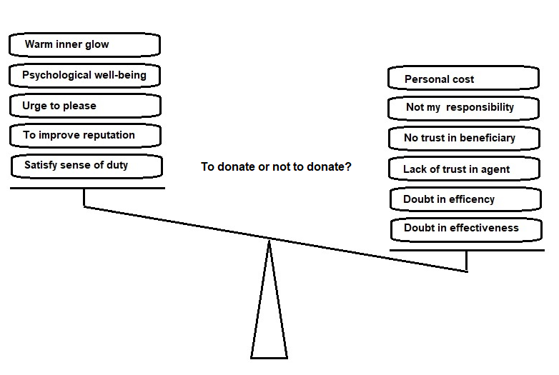**Influences in donors’ decision making**

**Section 5. The Importance of high standards of Governance and “trusteeship”.**

I submit that greater emphasis needs to be given by regulators to the promotion and regulation of good governance and ethical behaviour in charitable and not-for-profit organisations. The following examples demonstrate this need:

Example F. The Board of a suburban ex services club in Melbourne decide to hold their quarterly meeting in a hotel on Hamilton Island in Queensland as a reward for the seven volunteer members of their Board. The arrangements include air fares, three days accommodation and meals paid for by the club.

Example G. The Manager of a suburban childcare centre run by a local charity is provided with a vehicle for his private use on the grounds that he has a mobility disability. One of the parents complain to the Committee that the vehicle provided is an unnecessarily expensive make and model and that the vehicle was purchased from a firm owned by a member of the Committee.

At the heart of the governance of charitable organisations must be the legal construct of “trusteeship”. A trustee must

* *Act in the best interests of beneficiaries. This requires a trustee to act with the reasonable care, skill and diligence that an ordinary businessperson would expect.*
* *Duty to preserve trust property. A trustee must conserve the trust property (including the income and capital) against loss.*
* *Not to make a personal profit from the trust. A trustee has no right to make a profit from the trust, if any profit is made from the trust, the trustee has a duty to account for the profit to the trust and the beneficiaries.*
* *Duty to account and provide information to beneficiaries. A trustee must keep an updated and accurate record of accounts and make this available to a beneficiary upon their request.*
* *Duty to act in person. Generally, a trustee has no right to delegate their duties to a third person, there are exceptions to this rule, such as engaging accountants and lawyers to perform specific tasks. Trust deeds usually provide a list of professionals that may be appointed to assist with performing tasks under the trust.[42]*

This construction of the duties of governance responds to the need for a trusted agent in what is otherwise a “market for lemons”; in which the donor has a paucity of knowledge about the quality of the product or the reliability of their agent.

It therefore follows that the donor’s confidence and trust is likely to be influenced by a number of signals such as the popular reputation of the charitable entity and its board. Other signals such as a donor’s previous satisfactory relations with the charity and familiarity with identities associated with the charity and their standing in the community, will be important signals of quality for donors[43].

Regulatory measures such as requiring Committee members and members of Boards of larger charities to have a Director Identification Number[44] will assists in making those that serve in charities and other non-profit organisations more accountable.

Good governance of charities must include a strong ethical culture to ensure that the operations of the charity are conducted in accordance with high community standards, not just compliance with the regulatory environment.

I submit that the persistent pursuit of financial ratios by some regulators, and by a small minority of donors, as a simplistic measure of efficiency or effectiveness of charities, is flawed, has the potential to mislead and may encourage decisions that will adversely impact sound management. Further that a greater focus should be directed towards improving standards of governance in charitable organisations. It follows that increased regulation of good governance in charities is more likely to increase levels of public trust and philanthropic support.

**Recommendations:**

* That government regulators give greater emphasis to measures that promote philanthropy by:
  + Giving greater attention to the sociological influences in Australian society that support and hinder philanthropy.
* Support and encourage high standards of good governance in non-profit and charitable organisations based on trusteeship.
* Support the development of a national regulatory framework for all not-for-profit organisations.
* Support the ACNC’s on-going efforts to reduce the regulatory burden on charities and not-for-profit organisations by aligning State and Territory regulation including fundraising regulation.
* Support the progressive implementation of the International Financial Reporting Standards for Non-Profit Organisations.
* Warn against the use of “efficiency” ratios to measures and compare charities.

**ANNEX A**

**Example H**

**Example I**

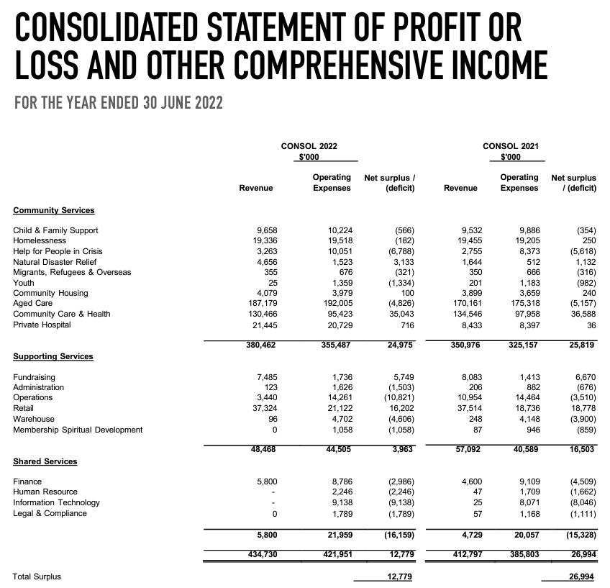

1. Bekkers, R., & Wiepking, P. (2007). Generosity and Philanthropy: A Literature Review. SSRN Electronic Journal. https://www.academia.edu/4228173/GENEROSITY_AND_PHILANTHROPY_A_LITERATURE_REVIEW
2. Bhati, A., & Hansen, R. (2020). A literature review of experimental studies in fundraising. Journal of Behavioral Public Administration, 3(1), Article 1. https://doi.org/10.30636/jbpa.31.129
3. Scaife, W., Williamson, A., McDonald, K., & Smyllie, S. (2012). *Foundations for giving: Why and how Australians structure their philanthropy*.
4. Moll, et al., (2006), MRI Studies of the human brain whilst philanthropic decision making.
5. . Breeze, B. (2013). How Donors Choose Charities: The Role of Personal Taste and Experiences in Giving Decisions. Voluntary Sector Review, 4, 165–183. https://doi.org/10.1332/204080513X667792
6. van Teunenbroek, C., Chiesa, C. D., & Hesse, L. (n.d.). The contribution of crowdfunding for philanthropy: A systematic review and framework of donation and reward crowdfunding. *Journal of Philanthropy and Marketing*, *n/a*(n/a), e1791. <https://doi.org/10.1002/nvsm.1791>
7. GOFUNDME. (n.d.). Fundraising Institute Australia. Retrieved 23 February 2023, from https://fia.org.au/gofundme/
8. Powell, R., Evans, D., Bednar, H., Oladipupo, B., & Sidibe, T. (n.d.). Using trust-based philanthropy with community-based organizations during the COVID-19 pandemic. *Journal of Philanthropy and Marketing*, *n/a*(n/a), e1786. <https://doi.org/10.1002/nvsm.1786>
9.
10. Rose-Ackerman, S. (1996). Altruism, Nonprofits, and Economic Theory. *Journal of Economic Literature*, *34*(2), 701–728.
11. *The Non-profit Enterprise in Market Economics*. (n.d.). Routledge & CRC Press. Retrieved 6 March 2023, from <https://www.routledge.com/The-Non-profit-Enterprise-in-Market-Economics/James-Rose-Ackerman/p/book/9780415866279>
12. Steinberg, R. (2008). Principal-Agent Theory and Nonprofit Accountability. Working Papers, Article wp200803. https://ideas.repec.org//p/iup/wpaper/wp200803.html
13. Curry, O. S., Rowland, L. A., Van Lissa, C. J., Zlotowitz, S., McAlaney, J., & Whitehouse, H. (2018). Happy to help? A systematic review and meta-analysis of the effects of performing acts of kindness on the well-being of the actor. Journal of Experimental Social Psychology, 76, 320–329. https://doi.org/10.1016/j.jesp.2018.02.014
14. Andreoni, J. (1990). Impure Altruism and Donations to Public Goods: A Theory of Warm-Glow Giving. The Economic Journal, 100(401), 464–477. https://doi.org/10.2307/2234133
15. Routley, C., Sargeant, A., & Scaife, W. (2007). Bequests to Educational Institutions: Who Gives and Why? *Nova Hedwigia*, *7*(3), Article 3.
16. Australian Tax Office
17. Vollmer, J. (2017). When​ ​does​ ​effectiveness​ ​matter?​ ​An​ ​experimental​ ​investigation​ ​of donors’​ ​response​ ​to​ ​effectiveness​ ​information. https://www.academia.edu/36411670/When_does_effectiveness_matter_An_experimental_investigation_of_donors_response_to_effectiveness_information
18. Connolly, C., Hyndman, N., & McConville, D. (2013). Conversion Ratios, Efficiency and Obfuscation: A Study of the Impact of Changed UK Charity Accounting Requirements on External Stakeholders. *Voluntas: International Journal of Voluntary and Nonprofit Organizations*, *24*(3), 785–804.
19. Trussel, J. M., & Parsons, L. M. (2007). Financial Reporting Factors Affecting Donations to Charitable Organizations. Advances in Accounting, 23, 263–285. https://doi.org/10.1016/S0882-6110(07)23010-X
20. Commission, Industry. (1995, June 16). *Charitable Organisations in Australia—Industry Commission inquiry report*. <https://www.pc.gov.au/inquiries/completed/charity>
21. Lecy, J. D., & Searing, E. A. M. (2015). Anatomy of the Nonprofit Starvation Cycle: An Analysis of Falling Overhead Ratios in the Nonprofit Sector. *Nonprofit and Voluntary Sector Quarterly*, *44*(3), 539–563. <https://doi.org/10.1177/0899764014527175>
22. Hung, C., Hager, M. A., & Tian, Y. (2022). Do Donors Penalize Nonprofits With Higher Non-Program Costs? A Meta-Analysis of Donor Overhead Aversion. *Nonprofit and Voluntary Sector Quarterly*, 08997640221138260. <https://doi.org/10.1177/08997640221138260>
23. Mcgregor-Lowndes, M. (2023). Are any more Recommendations worth implementing from nearly 30 years of Commonwealth Nonprofit Reform Reports? [Working Paper]. https://eprints.qut.edu.au/237821/
24. Flack, T., McGregor-Lowndes, M., Marsden, S., & Poole, G. (2014). Go your own way: Reporting of fundraising in Australian charity financial statements. *Third Sector Review*, *20*(2), Article 2.
25. Connolly, C., Hyndman, N., & McConville, D. (2013). Conversion Ratios, Efficiency and Obfuscation: A Study of the Impact of Changed UK Charity Accounting Requirements on External Stakeholders. *Voluntas: International Journal of Voluntary and Nonprofit Organizations*, *24*(3), 785–804.
26. Gordon, T. P., Knock, C. L., & Neely, D. G. (2009). The role of rating agencies in the market for charitable contributions: An empirical test. *Journal of Accounting and Public Policy*, *28*(6), 469–484. <https://doi.org/10.1016/j.jaccpubpol.2009.08.001>
27. Cordery, C. (2013). Measuring performance in the third sector. Qualitative Research in Accounting &amp; Management. https://www.academia.edu/47792160/Measuring_performance_in_the_third_sector
28. Hager, M., & Flack, T. (2004). The Pros and Cons of Financial Efficiency Standards.
29. Gordon, T. P., Knock, C. L., & Neely, D. G. (2009). The role of rating agencies in the market for charitable contributions: An empirical test. Journal of Accounting and Public Policy, 28(6), 469.
30. McConville, D., & Cordery, C. (2018). Charity performance reporting, regulatory approaches and standard-setting. *Journal of Accounting and Public Policy*, *37*(4), 300–314. <https://doi.org/10.1016/j.jaccpubpol.2018.07.004>
31. Gordon, T. P., Knock, C. L., & Neely, D. G. (2009). The role of rating agencies in the market for charitable contributions: An empirical test. Journal of Accounting and Public Policy, 28(6), 469.
32. Flack, T. (2004). *The Mandatory Disclosure of Cost of Fundraising Ratios: Does it achieve the regulators’ purposes?* [Report]. QUT. <http://eprints.qut.edu.au/4555/>
33. Flack, T., McGregor-Lowndes, M., Marsden, S., & Poole, G. (2014). Go your own way: Reporting of fundraising in Australian charity financial statements. Third Sector Review, 20(2), Article 2.
34. Ling, Q., & Gordon Neely, D. (2013). Charitable ratings and financial reporting quality: Evidence from the human service sector. *Journal of Public Budgeting, Accounting & Financial Management*, *25*(1), 69–90. <https://doi.org/10.1108/JPBAFM-25-01-2013-B004>
35. *National Standard Chart of Accounts | ACNC*. (n.d.). Retrieved 31 March 2023, from <https://www.acnc.gov.au/for-charities/manage-your-charity/national-standard-chart-accounts>
36. Phillips, S. D. (2013). Shining Light on Charities or Looking in the Wrong Place? Regulation-by-Transparency in Canada. *VOLUNTAS: International Journal of Voluntary and Nonprofit Organizations*, *24*(3), 881–905. <https://doi.org/10.1007/s11266-013-9374-5>
37. Hager, M., & Flack, T. (2004). *The Pros and Cons of Financial Efficiency Standards*.
38. Hung, C., Hager, M. A., & Tian, Y. (2022). Do Donors Penalize Nonprofits With Higher Non-Program Costs? A Meta-Analysis of Donor Overhead Aversion. *Nonprofit and Voluntary Sector Quarterly*, 08997640221138260. <https://doi.org/10.1177/08997640221138260>
39. Flack, T., & Ryan, C. (2005). Financial Reporting by Australian Nonprofit Organisations: Dilemmas Posed by Government Funders. *Australian Journal of Public Administration*, *64*. <https://doi.org/10.1111/j.1467-8500.2005.00453.x>
40. Knight, R., & Sheehan, B. (2020). *Developing an Outcomes Measurement Framework for The Love of Learning Program*. The Australian Centre for Philanthropy and Nonprofit Studies, Queensland University of Technology. <https://eprints.qut.edu.au/199824/>
41. Breeze, B. (2013). How Donors Choose Charities: The Role of Personal Taste and Experiences in Giving Decisions. *Voluntary Sector Review*, *4*, 165–183. <https://doi.org/10.1332/204080513X667792>
42. Hicks, B. (2021, February 10). *The role and responsibilities of a trustee*. JMA Legal. <https://jmalegal.com.au/the-role-and-responsibilities-of-a-trustee/>
43. Roberts, G., Raihani, N., Bshary, R., Manrique, H. M., Farina, A., Samu, F., & Barclay, P. (2021). The benefits of being seen to help others: Indirect reciprocity and reputation-based partner choice. *Philosophical Transactions of the Royal Society of London. Series B, Biological Sciences*, *376*(1838), 20200290. <https://doi.org/10.1098/rstb.2020.0290>
44. *Director identification number | Australian Business Registry Services (ABRS)*. (n.d.). Retrieved 2 April 2023, from <https://www.abrs.gov.au/director-identification-number>