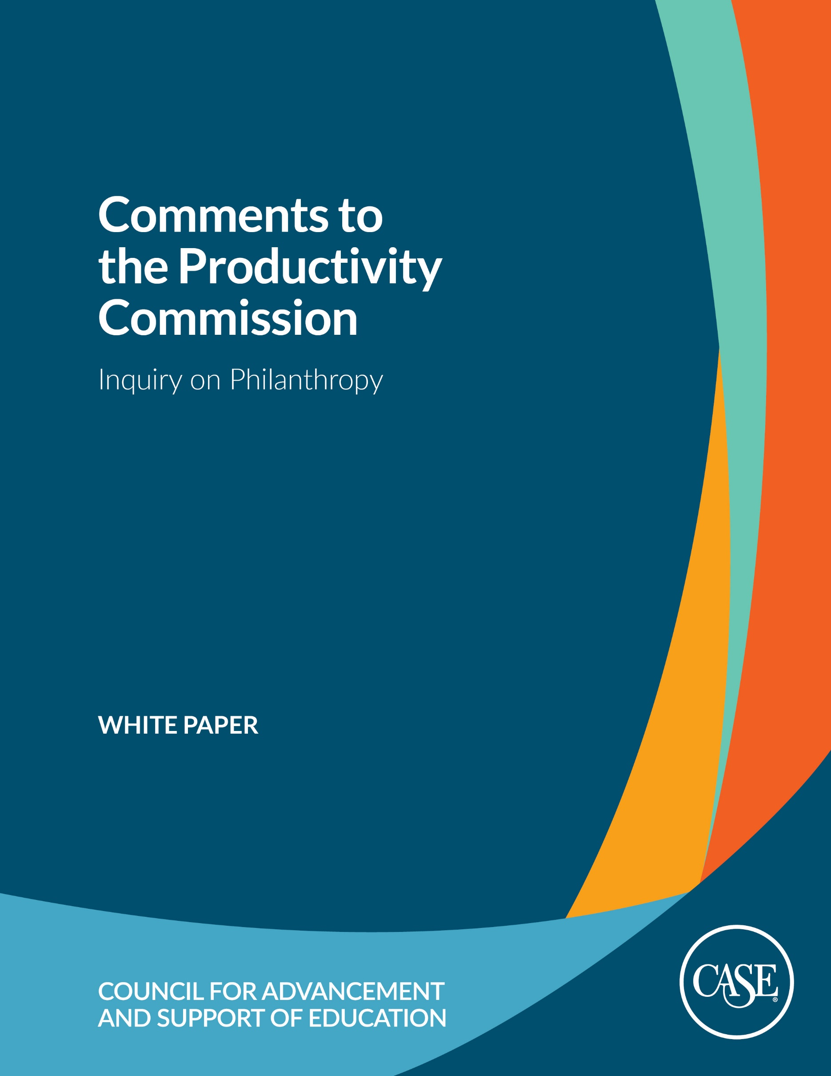

5 May 2023

**EXECUTIVE SUMMARY**

The Council for Advancement and Support of Education (CASE) welcomes the opportunity to provide comments to the Productivity Commission to aid its inquiry into how to increase philanthropic giving in Australia. We stand ready to work with the Commission and the Australian Government, as we have done in other parts of the world, to build fundraising capacity and expertise so institutions can increase philanthropy to support education and research for the betterment of Australia, our communities, and broader society.

CASE is the global association for professionals in educational advancement – alumni relations, communications, fundraising, marketing, and advancement services – who share the goal of advancing education to transform lives and society. Today, CASE's membership includes more than 3,000 colleges and universities, primary and secondary independent and international schools, and nonprofit organisations in 82 countries around the world. There are circa 97,000 advancement professionals and institutional leaders who avail themselves of CASE’s broad services. CASE helps its members build stronger relationships with their alumni and donors, raise funds for campus projects institutional priorities, market their institutions to prospective students, and foster public support of education. CASE also gathers data on giving to educational institutions around the world. We are uniquely positioned to help our member institutions not only benchmark their philanthropic giving and operations with each other but also with peers around the globe.

CASE wholeheartedly supports the Australian Government’s desire to double philanthropic giving by 2030. Our members see the impact of philanthropy at their institutions every day, with gifts providing funding of student and staff bursaries and scholarships, groundbreaking research, and new facilities and infrastructure. We also see philanthropy as helping institutions and the Government achieve the goals set out in the ongoing Australian Universities Accord.

**RECOMMENDATIONS**We encourage the Productivity Commission to consider the following recommendations to help increase philanthropic giving to educational institutions.

* **Build fundraising capacity by growing, developing, and attracting top talent**

To achieve the goal of doubling philanthropy by 2030, Australia must invest in training and professional development so educational institutions and other not-for-profits (NFPs) have fundraisers with the skills to seek and secure philanthropic gifts. Without such training, institutions will not have the talent they need to raise significant funds. The inclusion of funding for training was a key factor to the success of the UK’s Matched Funding Scheme in building philanthropic support and engagement for higher education. CASE can model the success of our partnership with the UK government to bring more training and professional development directly to universities and schools in Australia building on the programmes we already deliver in person and online.

The Australian Government should also make it easier for educational institutions and other NFPs to attract the best fundraising talent. Universities and schools in Australia have a strong tradition of bringing in top fundraising talent from the UK, Canada, US, and other countries around the globe. Any barriers to attracting talent from abroad should be lowered alongside building the profession in country.

* **Introduce a Matched Funding Program for Universities and Schools**   
  A matched funding program modeled after the successful UK Matched Funding Scheme would send an important public signal of the importance of philanthropic giving to educational institutions while also helping the Australian Government reach its doubling goal.  While all universities and schools would be eligible for the program, the match could be structured to be larger for institutions with less fundraising experience and/or resources. For universities, such a programme could be further targeted to help these institutions raise donations in support of research and innovation goals outlined in the Australian Universities Accord.
* **Liberalise fundraising rules for independent schools**

Currently, independent schools in Australia do not have full DGR status and are required to seek DGR endorsement for separate funds including a school building fund, a scholarship fund, and a public library fund. The Productivity Commission should recommend that all independent schools and school related foundations automatically receive DGR status through the Australian Charities and Not-for-profits Commission (ACNC). Such a change would liberalise fundraising opportunities for schools, allowing them to raise funds for support programmes such as STEM, art and culture, sport, wellbeing, and pastoral care programmes. It would also put Australia in line with many other countries in the world where schools and universities are treated similarly with regards to charitable status and philanthropic giving.

* **Incentivise Giving to Build Endowment**

Some universities and schools around the globe, particularly in the US and UK, have successfully built large endowments, with many funding a significant portion of their annual operating budgets through spending from endowed funds. More Australian universities and schools would benefit from building and growing their endowments. Additionally, philanthropic gifts to create endowed funds also happen to be significantly larger than other gifts since they are meant to be invested and distributed over the long-term. The Commission should consider a tax concession that incentivises donors to create endowed funds thus providing an important source of long-term support and financial stability for universities and schools.

* **Encourage Legacy Giving**    
  Australia is poised to see a significant transfer of wealth in the next decade, but legacy giving remains relatively low versus other parts for the world. The Productivity Commission should consider ways to further incentivise legacy giving, including making changes to superannuation to allow an educational institution or other charity to be named as a beneficiary.
* **Harmonise Fundraising Regulation**    
  Currently, Australian educational institutions and other charities must navigate different fundraising regulatory regimes in each of the seven states and territories. Institutions have to spend significant time and resources ensuring that they are in compliance with each of these fundraising regimes. To simplify compliance and eliminate administrative burden, the Productivity Commission should recommend the creation of a single, national fundraising regulatory regime.

As we’ve done in other parts of the world, CASE stands ready to partner with the Australian Government by providing professional development, training, and benchmarking data to track and measure success to help Australia achieve its goal.

*“As Chair of the CASE Asia Pacific Regional Council I have had the opportunity to deepen my appreciation of CASE’s work in Australia and globally. I have known CASE to provide invaluable educational programming, benchmarking, and research for institutional leaders and advancement professionals for many years. This work has served, in Australia, to support our universities and schools in building expertise and capacity in philanthropic engagement. I have encouraged this submission and know that CASE will provide excellent advice to the Commission in their important work as they have in many countries across the globe.”*

**Professor Margaret Gardner, AC  
President and Vice-Chancellor, University of Monash  
Chair, CASE Asia Pacific Regional Council**

**CASE COMMENTS TO THE PRODUCTIVITY COMMISSION INQUIRY ON PHILANTHROPY**

The Council for Advancement and Support of Education (CASE) welcomes the opportunity to provide comments to the Productivity Commission to aid its inquiry into how to increase philanthropic giving in Australia. We stand ready to work with the Commission and the Australian Government, as we have done in other parts of the world, to build fundraising capacity and expertise so institutions can increase philanthropy to support education and research for the betterment of Australia, our communities, and broader society.

CASE is active in the Asia-Pacific region with an office and team located in Singapore and in Perth, Australia. We are also incorporated in Australia, and our Executive Director for CASE in Asia Pacific is based in Perth. CASE has 83 member institutions (universities and schools) located in Australia, with seven of our 12 Council for Asia-Pacific Members based in Australia. Professor Margaret Gardner, AC, President and Vice-Chancellor of Monash University, currently serves as Chair of our Council for Asia-Pacific, while Sue Cunningham, our President and CEO, served as VP Advancement at the University of Melbourne from 2011-2015 – where she led the first phase of the Melbourne BELIEVE Campaign.

*“In the last decade Australian higher education has benefitted from attracting significant philanthropic investment which has created transformative impact in education and research. Success in obtaining philanthropic support requires a distinctive mix of expertise, technology and collaboration; CASE has played an important role in supporting Australian universities to achieve this mix and measure ourselves against global standards. CASE would be well placed to partner with government and the education sector on the ambitious but achievable goal of doubling philanthropy by 2030.”*

**Professor Carolyn Evans FASSA**  
**Vice Chancellor and President, Griffith University**

CASE wholeheartedly supports the Australian government’s desire to double philanthropic giving by 2030. Our members see the impact of philanthropy at their institutions every day, with gifts providing funding for student and staff bursaries and scholarships, groundbreaking research, and new facilities and infrastructure. We also see philanthropy as helping institutions and the Government achieve the goals set out in the ongoing Australian Universities Accord.

In that spirit, our comments will focus on:

* Role of philanthropy in Australian higher education and independent schools
* Recent trends in philanthropic giving to Australian educational institutions
* Examples of policies and initiatives from other parts of the world designed to directly increase giving to educational institutions combined with recommendations on policies the Australian government could pursue to help achieve its 2030 goal
* Recommendations, including the role that CASE would play in supporting further growth in philanthropy to the educational sector in Australia.

While our recommendations will focus on how incentivising philanthropic giving to educational institutions can help the Australian Government achieve its doubling goal, we want to reinforce that these recommendations will also benefit the wider Not-for-profit (NFP) sector. For example, many staff hired and trained as fundraisers at educational institutions go on to work at other NFP organizations. We also acknowledge that many of our recommendations tied to giving to educational institutions could be expanded or applied to other NFPs.

**GLOBAL PHILANTHROPY TO HIGHER EDUCATION AND RESEARCH**  
Philanthropy for higher education and research has an exceptionally long history.Going as far back as the establishment of Medieval European universities such as Oxford and Cambridge, there was a reliance on the benefaction of wealthy people. The University of Queensland’s history also reflects similar early beginnings with the Mayne family providing funds to buy the St Lucia site where the University’s main campus is now located. Brisbane Grammar School, an independent, non-denominational school, was founded in 1868 through the generosity of benefactors. In the United States, Harvard University began its first fundraising campaign in 1643. The list of great US universities boasts names of their founding benefactors, including Stanford and Rockefeller, who founded both the University of Chicago and Rockefeller University.

Foundations such as the London-based Wellcome Trust, founded in 1936, have had a profound impact on research in higher education in the life sciences. The trust has enabled researchers to identify clinical and public health interventions to counter the West African Ebola epidemic, examine the genetic component of type 1 diabetes, and launch the Cancer Genome Project, among other work. And foundations in Australia have proven vital partners in the growth of philanthropic engagement and impact. This includes the Ian Potter Foundation founded in 1964 whose broad focus is to benefit the community across a wide range of sectors and endeavours including improving health outcomes for the nation’s health and the more recently founded Paul Ramsay Foundation, founded in 2006, who are committed to help end cycles of disadvantage in Australia by enabling equitable opportunity for people and communities to thrive.

If universities are to continue their role at the forefront of technological, economic, and social transformation, alternative and complementary funding, including philanthropy, is more critical than ever.

This is particularly so in Australia, where research and development investment in 2018 was 1.97% of GDP (Gross Domestic Product), markedly lower than the OECD (Organization of Economic Cooperation and Development) average of 2.4%. As a result, The University of Melbourne higher education experts say: “Unfortunately, enhanced collaborations between industry and universities will be limited because Australia’s current level of business research and experimental development is low, compared to the OECD benchmark.”

Non-government funding sources, including philanthropy, provide an opportunity to address this funding disparity. While in the US, philanthropic giving represents around 10% of university expenditure (Council for Aid to Education, 2018), in Australia donations to universities totaled AU $476 million in 2019 – represented circa 1.4% of the AU $34.2 billion they incurred in expenses. While Australian universities have made great strides in the last decade to build greater philanthropic engagement, they now have the opportunity and imperative to work towards closing this gap.

Australian universities are funded through government research and teaching grants and student tuition fees supported by a government-backed loan scheme. Other funding sources include state government funding, overseas full fee-paying students, investment returns, income from contract research and consultancy, industry partnerships, and philanthropy.

Australian university research is funded through a mix of contributions from the Australian Government, state and territory governments, industry partners, and philanthropic sources. Between 2008 and 2018, the total value of funding for university research grew by 50% from AU $2.8 billion to AU $4.2 billion, as shown in the table below.

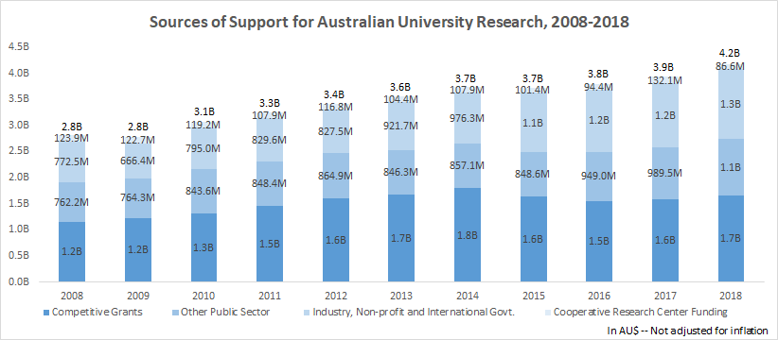

Source: Higher Education Research Data Collection, Australian Government Department of Education https://www.education.gov.au/research-block-grants/higher-education-research-data-collection

Commonwealth and state government funding for higher education as a proportion of university budgets has declined from about 95% in the 1970s, to approximately 35% today. In addition, by July 2021, international student numbers overall, were down 16.6% compared to 2020. Compared to YTD July 2020, total enrolments decreased by 17%, while commencements decreased by 27.5 percent,   
according to the Australian Trade and Investment Commission. International student fees contributed $8.8 billion to the revenue of Australian universities in 2018 (around 26% of total revenue), meaning this will leave a significant funding gap of which philanthropic funding has the potential to help close.

*“The expertise and support provided by CASE has been important in helping La Trobe University to develop a professional philanthropy program and secure significant gifts for research projects as well as programs supporting disadvantaged students. However, CASE not only supports individual organisations to develop their programs; it supports the development and capacity of philanthropy across the nation. CASE is important because it brings global insights and experience to Australian organisations and provides the expertise our nation needs to reach its philanthropy goals. In the education sector, CASE has worked with Australian schools, colleges, and universities over many years to support the significant capacity building that has already taken place in many institutions across Australia.”*

**Professor John Dewar AO**  
**Vice-Chancellor and President, La Trobe University**

With declining government funding for higher education, including research, and the recent impact COVID-19 has had on international student numbers, philanthropic contributions to the sector are becoming more critical. Philanthropy can play a role in supporting emerging research, catalysing risk-taking innovation, and widening access. By investing in fundraising infrastructure and capacity, the Australian Government can enhance the ability of higher education to deliver on these outcomes.

This is particularly true as the Government seeks to reform Australia’s higher education sector through the ongoing Australian Universities Accord. Philanthropic support will be critical to helping the Government and institutions improve access, opportunity, and affordability and deliver the innovation and research capacity to meet Australia’s future needs.

**GLOBAL PHILANTHROPY TO INDEPENDENT SCHOOLS**  
While we have a rich data set on philanthropic giving to universities in Australia, our survey does not currently include giving to independent schools. CASE is developing a global survey for giving to independent schools that will soon collect data Australian schools can use to benchmark against their peers both within Australia and across the globe.

We do know that philanthropy is absolutely vital for Australian independent schools.

Independent schools in Australia are funded through a combination of Australian Government (Commonwealth) funding, state and territory government funding, school fees, and other private contributions, such as philanthropy.

*“The development of a philanthropic culture is vital for independent schools to be able to continue to offer exceptional educational experiences to its current generation of students and the next. As government funding continues to decline and the cost of an independent education reaches new heights for parents, schools need to respond creatively in generating additional revenue streams. Philanthropy must be part of this conversation and I applaud CASE for this strong set of recommendations. The long-term sustainability of independent schools depends on increased philanthropy.”*

**Fiona Johnston**  
**Principal, St. Hilda’s Anglican School for Girls, Perth**

Recurring funding from the government for independent schools is provided through a funding model called the Schooling Resource Standard (SRS) funding model. The SRS funding model was established in 2014 following the ‘Gonski’ Review of Funding for Schooling. The SRS funding model provides base funding, which from 2020, the amount provided is dependent on the capacity of a school community to contribute to the cost of education.

The ongoing financial viability of independent schools depends on governments maintaining stable and predictable funding for the sector and the continuing commitment and capacity of parents to pay fees.

Government funding and school fees cover the cost of education, but do not always cover major capital projects or scholarships and bursaries for students in financial need, hence the need for philanthropic support.

While a public university is endorsed with Deductible Gift Recipient Status (DGR) as a whole, an independent school does not have DGR status as a whole and is required to seek DGR endorsement for separate funds including a school building fund, a scholarship fund, and a public library fund.

It is difficult to understand why universities and colleges are automatically considered as DGRs (Deductible Gift Recipients) in their entirety, but schools are not. Changing this policy to provide schools with DGR status as an entity will assist schools in attracting increased philanthropy for support programmes such as STEM (Science, Technology, Engineering and Math), art and culture, sport, wellbeing, and pastoral care, in addition to the traditional destinations around capital projects, scholarships and bursaries, and library funds.

**INSIGHTS ON GIVING TO EDUCATIONAL INSTITUTIONS**

To help educational institutions measure their effectiveness and benchmark against their peers, CASE conducts annual fundraising surveys, using standardised benchmarks worldwide, including our annual CASE Support of Education Survey, Australia and New Zealand. Our other surveys include:

* CASE-Ross Support of Education Survey, United Kingdom and Ireland
* CASE-CCAE Support of Education Survey, Canada, done in partnership with the Canadian Council for Advancement of Education
* CASE Insights on Voluntary Support of Education Survey, United States
* CASE Insights on Philanthropy in Independent Schools (United States), in partnership with the National Association of Independent Schools.

When reporting data to CASE’s set of benchmarking surveys in different countries (using consistent metrics), institutions follow the CASE Global Reporting Standards (https://www.case.org/standards), the set of common standards, guidelines, and definitions for reporting the results of educational philanthropy activities at schools, colleges, and universities across the globe. The CASE Standards help make global benchmarking possible, providing an opportunity for Australian institutions to benchmark against their in-country peers and global peers.

The Global Reporting Standards are also an example of how CASE is helping build the profession globally. The Standards ensure that institutions are reporting philanthropic contributions in ways that are ethically sound, principled, rooted in shared best practices, and guided by the wisdom of the professional community. As Australian educational institutions raise more philanthropic funds, Government and the public can be confident that they are doing so in an ethical, transparent, and efficient manner.

**GIVING TO EDUCATION IN AUSTRALIA**  
Since 2012, CASE has conducted the CASE Support of Education Survey, Australia and New Zealand.[1] The 2022 survey, measuring giving to higher education institutions in calendar year 2021, including data from 30 institutions in Australia and 4 in New Zealand. These 34 institutions raised $792m in new funds secured, with the median value of new funds secured by all institutions at $10m. The 26 institutions that participated in each of the past three years saw their combined new funds secured increase by 2% from 2021.

Data in the survey is categorized by Group of 8 (Go8) and non-Group of 8 (non-Go8) institutions. The biggest source of new funds secured is trusts or foundations[2], accounting for 36% of new funds secured. Go8 institutions saw an increase in the percentage of new funds coming from alumni (22% compared with 12% in 2020), other individuals (25% versus 11% in 2020), and other organisations (17% versus 9% in 2021). For non-Go8, other individuals was the second largest source of new funds secured, accounting for 17%, followed by corporates 15%. New funds secured from alumni and other organisations each accounted for 6%.

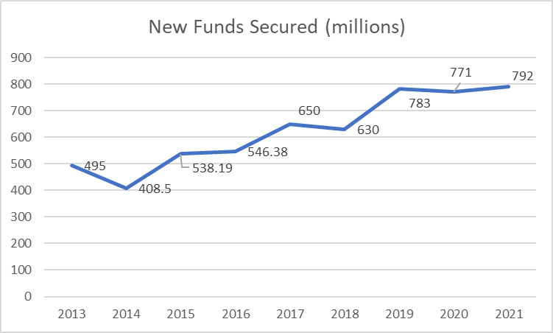

Source: CASE Insights on Philanthropy, Australia and New Zealand (2013-2021)

As the graph above demonstrates, Australian Universities have made great strides in new funds secured, growing from AU $495 million in 2013 to AU $792 million in 2021 among institutions participating in the CASE survey.

Australian donors tend be motivated by immediate concerns and needs when making philanthropic gifts. A 2021 report by McCrindle found that 60 percent of Australians are opportunity givers while 40 percent are committed givers.[3] While giving to educational institutions can be based on an immediate need or opportunity, with giving related to the COVID-19 pandemic a recent example, most giving to universities and schools is committed or regular giving. Not surprisingly, committed givers tend to be significant or major philanthropic donors and they tend to recognize the need for consistent giving to help educational institutions and other NFPs address long-term challenges and develop future solutions. To achieve the goal of doubling philanthropic giving by 2030, the Australian Government must incentivise more committed giving, and policies that incentivise giving to educational institutions would help achieve this aim.

**POLICY OPTIONS FOR INCREASING PHILANTHROPY**  
Our global focus provides CASE with an opportunity to observe and contribute to the shaping of policy related to philanthropy around the globe. Policy options employed by various countries typically fall in two broad categories: match funding programs and tax policy concessions.

**Matched Funding**When properly funded and targeted, matched funding programs can provide a valuable incentive for individual donors interested in compounding the impact of their philanthropy.

CASE was a key partner in the United Kingdom Government’s successful Matched Funding Scheme (MFS) for Voluntary giving to higher education. Between 2008-2011, the UK Government, through the then Higher Education Funding Council for England (HEFCE), invested public funds to promote increased voluntary giving to higher education providers in England. All higher education institutions and directly funded further education colleges in England were invited to participate in the scheme.

Eligible gifts to participating institutions were matched through a fund of £200 million. Such institutions received matched funding according to their place in one of three tiers, each with a different funding ratio and cap suitable for institutions with differing degrees of fundraising experience.

A critical element of the MFS was the UK Government’s requirement that participating institutions complete the Ross-CASE Survey (now known as the CASE Insights on Philanthropy in UK and Ireland in partnership with the Ross Group) to ensure there was a way of measuring impact. As the table below shows, there was an increase in the average of new funds secured by HEIs when comparing the three years prior to the MFS to the three years during the MFS. And giving to participating HEIs has continued to increase to £1.49 billion in 2021-2022 (<https://www.case.org/system/files/media/inline/CASE-Ross_Infographic_2021-22.pdf>).

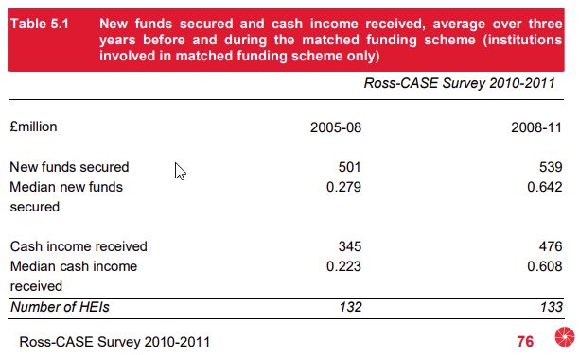

Another factor instrumental in the success of the MFS was the UK government's decision to fund professional development and training. To achieve the goals of the initiative, the UK needed to significantly grow the number of trained, professional fundraisers at institutions who could then go out and successfully raise funds to meet the match requirements. HEFCE funded CASE to provide this training, which included:

* scholarships to the CASE Spring Institute for Educational Fundraising,
* Internships,
* The establishment of the CASE graduate trainee programme (which now operates in the UK, US, Canada, and Australia),
* mentoring programmes,
* fundraising training for academic leaders, and
* the provision of resource kits.

This investment in training helped the UK build a cadre of professional fundraisers that continue to help UK higher education institutions raise philanthropic dollars to this day and several whom have moved to Australia to build the profession.

*“Australia’s universities are already at the forefront of cutting-edge research and education. Maintaining and building on this position will require ongoing collaboration between universities, industry, and government. It will also require investment in the philanthropic capacity of Australia’s universities, unlocking additional resources to increase access, affordability, and innovation. CASE is on the ground in Australia, sharing global expertise and philanthropic best practice with institutions. I commend CASE for this strong set of recommendations which if implemented will bring additional resources to bear as we work with government to achieve the goals of the Australian Universities Accord.”*

**Catriona Jackson**  
**Chief Executive, Universities Australia**

Matched funding programmes have also been successful in growing philanthropy in other countries. In Singapore, the Government is currently providing a 2.5 to 1 match for gifts from Singaporean tax residents to colleges, universities, and schools. This generous programme has been extended by the Singaporean Government through the 31 December 2026. A key objective of the Singaporean government in this matched funding is to help universities to build their endowment funds.

In the United States, several states have conducted matched funding initiatives described in [*Select Government*](https://files.eric.ed.gov/fulltext/ED497601.pdf)[*Matching Fund Programs: An Examination of Characteristics and Effectiveness*,](https://files.eric.ed.gov/fulltext/ED497601.pdf) prepared by CASE in 2004 for the Sutton Trust.[4] [Kentucky’s Research Challenge Trust Fund,](https://louisville.edu/bucksforbrains) developed in 1997, is notable for its focus on attracting and retaining renowned faculty and researchers. The Endowment Match Program creates chairs, professorships, fellowships and scholarships, and endowments for research support and for the library. State universities provide a dollar-for-dollar match by internal reallocation or by raising external funds. Between 1998 and 2019 [The University of Kentucky](https://www.research.uky.edu/news/rctf-endowment-match-program-2018-2019-annual-report) used the Endowment Match Program to create 96 endowed chairs, 216 endowed professorships, and 261 fellowships, enrichments, and mission support projects to support research and the university’s library.

**Tax Concessions**  
Many countries, including Australia, use tax policy to encourage donors to give more to educational institutions and other organisations with DGR status. While donors are primarily motivated to give because they are passionate about a cause or effort, tax concessions can impact the size and timing of gifts.

In the UK, the government incentivises giving through Gift Aid, where the government provides 25p for every £1 donated to charities, including educational institutions. Donors must complete a declaration form for the institution to claim Gift Aid. Donors who pay taxes above the basic rate can claim the difference between the tax rate they pay and the basic rate on the donation.

In Canada, the government employs a charitable donations tax credit. Canadian donors can take a 15% credit on donations up to CAD $200 and take a 29% tax credit on donation amounts above CAD $200. Canadian donors can only claim donations up to 75% of his or her net income per year.

*“The Council for the Advancement and Support of Education (CASE) has unique insights into philanthropy in the higher education sector in Australia. Their work in Australia, particularly over the last 15-20 years, has been instrumental in building the capability and capacity of the Advancement profession in tertiary education. Philanthropy is now an essential element in supporting Australian universities to deliver on their missions. I believe the submission from CASE will be most valuable to the considerations of Australian Government Productivity Commission Inquiry on Philanthropy.”*

**Professor Brian P. Schmidt AC FAA FRS  
Vice-Chancellor & President, The Australian National University**

Donors in the United States can fully deduct their charitable donations on their annual income tax return if they itemize their return. Donors cannot deduct donations exceeding 50% of their Adjusted Gross Income in any given year. Currently, only 11% of American taxpayers itemise their annual tax returns, leaving the remaining 89% of taxpayers without an incentive to give to educational institutions and other charities. CASE has been a strong advocate in the US for expanding the charitable deduction to all American taxpayers, and we are actively supporting legislation that would restore the charitable deduction for nonitemizers.

**RECOMMENDATIONS**

We encourage the Productivity Commission to consider the following recommendations to help increase philanthropic giving to Australian educational institutions and other Not-for-profits (NFPs).

* **Build fundraising capacity**  
  To achieve the goal of doubling philanthropy by 2030, Australia must invest in training and professional development so educational institutions and other not-for-profits (NFPs) have fundraisers with the skills to seek and secure philanthropic gifts. Without such training, institutions will not have the talent they need to raise significant funds. The inclusion of funding for training was a key factor to the success of the UK’s Matched Funding Scheme in building philanthropic support and engagement for higher education. CASE can model the success of our partnership with the UK government to bring more training and professional development directly to universities and schools in Australia building on the programmes we already deliver in person and online.

The Australian Government should also make it easier for educational institutions and other NFPs to attract the best fundraising talent. Universities and schools in Australia have a strong tradition of bringing in top fundraising talent from the UK, Canada, US, and other countries around the globe. Any barriers to attracting talent from abroad should be lowered alongside building the profession in country.

* **Introduce a Matched Funding Program for Universities and Schools**  
  A matched funding program modeled after the successful UK Matched Funding Scheme would send an important public signal of the importance of philanthropic giving to educational institutions while also helping the Australian Government reach its doubling goal.  While all universities and schools would be eligible for the program, the match could be structured to be larger for institutions with less fundraising experience and/or resources. For universities, such a programme could be further targeted to help these institutions raise donations in support of research and innovation goals outlined in the Australian Universities Accord.

Good data is critical for determining whether a matched funding programme is successful. Given our track record in the UK and our robust global surveys, CASE would be well-positioned to partner with the Australian Government to effectively and independently measure the impact of a matched funding programme. As was the case in the UK MFS, CASE would recommend the Australian Government require all universities participating in the matched funding programme to complete the annual *CASE Insights on Philanthropy,* *Australia and New Zealand survey*. Participating independent schools should also be required to participate in our global schools survey which is under development. CASE would provide training and assistance to ensure that institution staff know how to collect the data needed to complete the surveys.

* **Liberalise fundraising rules for independent schools**  
  Currently, independent schools in Australia do not have full DGR status and are required to seek DGR endorsement for separate funds including a school building fund, a scholarship fund, and a public library fund. The Productivity Commission should recommend that all independent schools and school related foundations automatically receive DGR status through the Australian Charities and Not-for-profits Commission (ACNC). Such a change would liberalise fundraising opportunities for schools, allowing them to raise funds for support programmes such as STEM, art and culture, sport, wellbeing, and pastoral care programmes. It would also put Australia in line with many other countries in the world where schools and universities are treated similarly with regards to charitable status and philanthropic giving.
* **Incentivise Giving to Build Endowment**

Endowment funds are philanthropic funds that offer a source of financial stability and long-term support for educational institutions. By making a philanthropic gift to form an endowment, a donor can support a particular purpose such as a student scholarship or research programme both in the short and long-term. Endowments are invested with a portion of paid out annually to support the purpose of the fund. Typically, the amount paid out by an endowment is determined by a formula that ensures that endowment spending stays stable regardless of economic circumstances.

Some universities and schools around the globe, particularly in the US and UK, have successfully built large endowments, with many funding a significant portion of their annual operating budgets through spending from endowed funds. More Australian universities and schools would benefit from building and growing their endowments. Additionally, philanthropic gifts to create endowed funds also happen to be significantly larger than other gifts since they are meant to be invested and distributed over the long-term. The Commission should consider a tax concession that incentivises donors to create endowed funds thus providing an important source of long-term support and financial stability for universities and schools.

* **Encourage Legacy Giving**   
  Australia is poised to see a significant transfer of wealth in the next decade, but legacy giving remains relatively low versus other parts for the world. The Productivity Commission should consider ways to further incentivise legacy giving, including making changes to superannuation to allow an educational institution or other charity to be named as a beneficiary.
* **Harmonise Fundraising Regulation**   
  Currently, Australian educational institutions and other charities must navigate different fundraising regulatory regimes in each of the seven states and territories. Institutions have to spend significant time and resources ensuring that they are in compliance with each of these fundraising regimes. To simplify compliance and eliminate administrative burden, the Productivity Commission should recommend the creation of a single, national fundraising regulatory regime.

**CONCLUSION**   
We appreciate this opportunity to share our comments and stand ready to assist the Commission as it prepares its report. We would also welcome the opportunity to provide additional information and testimony at upcoming Commission hearings.

Thank you for pursuing this inquiry and for your consideration of our comments herein.

1. https://www.case.org/research/surveys/case-support-education-survey-australia-and-new-zealand/results-findings-and-reports
2. Trusts or foundations include personal and family foundations and other foundations and trusts that are private tax-exempt entities operated exclusively for charitable purposes; they also include Australian philanthropic foundations and private ancillary funds. Gifts to these types of trusts or foundations would typically see a “soft credit” flow to individuals.
3. *Australian Communities, Understanding Australian givers to maximise the impact of not-for-profit organisations,* McCrindle, 2021 https://mccrindle.com.au/app/uploads/reports/Australian-Communities-Report-2021.pdf
4. https://www.suttontrust.com/our-research/select-government-matching-fund-programmes-examination-characteristics-effectiveness/