To Whom It May Concern,

Communities built on philanthropy are bedrocks of social cohesion. Historically, institutions such as RSLs and Rotary Clubs were centres of community identity. They provided an outlet for generosity, a space for altruistic activity, and a place where people feel like they belonged.

Young Australia is much less engaged with these groups. Their place in our cultural identity has slipped significantly, and unless charity incentive structures are updated to align with what motivates younger Australians, we risk losing these kinds of institutions and the community value they create.

This is not to say that philanthropy no longer plays a role in modern Australia's community structure. It just comes in a different form.  A key example of these new networks are effective altruism groups, which are now at the helm of the philanthropic community amongst young Australians, with representation in major universities and cities. Effective altruism is not alone in being connected to these demographics, “One for the World” groups are similar. While tax-deductible donations can be made to Rotary, they can’t be made to their modern equivalents.

Crucial for understanding the changing shape of the altruistic community is their shifting causes of interest. Rather than an internal or local focus, these groups consider global impacts and are concerned with long-term and catastrophic risk prevention. They also challenge the restrictive moral circles which governed historic philanthropic communities, by focusing on causes like animal welfare, the environment, and preventing human extinction.

We need reforms that seize on these trends and make sure the effective altruism clubs of today can become the Rotary clubs of the future. Strengthening community in this way requires reforming philanthropy to align with the interests and values of younger Australians. Recognising these shifting priorities is the key to both increased charitable donations and increased social cohesion.

In this Submission I raise three issues:

1. The availability of DGR status for high impact cause areas (Terms of reference 2.ii, 3.ii, 5, 6)
2. Removing arbitrary restrictions on Public Benevolent Institutions so they can better work across causes and support community groups (Terms of reference2.iii, 3.i)
3. The potential good that could be achieved by Australian based charity evaluation (Terms of reference3.ii, 6.iii)

I have donated to effective charities, and work to support local philanthropic and community groups. I’d like to do more of this over time. I think the changes I recommend in this submission would make it easier for me to be involved, and also help other Australians to donate more and participate more in their communities. The changes could almost dramatically increase the good we achieve through this work.

**Animal welfare and global catastrophic risk reduction should be DGR classes (Information request 4)**

As I see it, the most important issue is that DGR status needs to be broadened to include things that young people today care about – specifically reducing global catastrophic risks and supporting the well-being of animals.

I want to engage with my community around the reduction of catastrophic disaster risks, but currently, the community organisation around these kinds of risks seems limited to things like my local volunteer fire brigade. I of course support the work of the local fire brigade, but it’s not a fit for my skills and interests. If organisations working on reducing the risk of catastrophic disasters had DGR status the would be better able to find ways for me to connect with my peers and volunteer to do good. I know, post-COVID and given the war in Ukraine, that a lot of my peers are really worried about worse future pandemics and the need to reduce the risk of a nuclear war. These are modern concerns, but DGR regulation hasn’t kept up.

In the same way, my peers and I care deeply about the welfare of animals. While the animal charities I support can be “charities” under the *Charities Act*, they can’t get DGR status under the *Tax Act*. I understand that this is because DGR status is limited to things like the short-term direct care and rehabilitation of lost or mistreated animals. While any animal suffering is a tragedy, it’s obvious to me that it would be far more effective to give DGR status to charities that are seeking to prevent animals from needing this kind of direct care in the first place. Everyone knows prevention is better than cure, so why should the law incentivise treatment over prevention?

I really think the exclusion of these two cause areas from DGR status hurts our ability to do good. These causes are recognised by sophisticated charity evaluators as being high-impact and allowed to accept tax-deductible donations internationally, but excluded here in Australia. If Government wants to increase donations to charities and increase the ability of charities to build social connections, it needs to give DGR status to these high-impact cause areas that today's Australians are so passionate about.

**PBI rules should not hamper community building (Information request 6)**

I support Effective Altruism Australia and the work they’re doing to help effective altruism groups in universities and major cities. These EA groups are getting people excited about doing good, helping them think about impactful donations, running reading groups, and giving advice about impactful careers. But Effective Altruism Australia’s status as a “Public Benevolent Institution” limits the work of its community builders to align with EAA’s work on global health and poverty and “incidental” topics.

For instance, EAA community builders probably can’t facilitate a reading group on animal wellbeing because the wellbeing of animals isn’t “incidental or ancillary” to global poverty. I find it hard to understand why the law would stop the peak body of effective altruism in Australia from properly supporting effective altruism clubs in universities. I understand that a charity shouldn’t just be able to do anything, because that would open up the system to abuse, but supporting university clubs and city groups with the same philosophy and philanthropic goals is well within the normal operation of philanthropy. Given the Terms of Reference are framed around building social connection, it would seem a simple change for a big improvement to recommend to Government to remove narrow, PBI-specific rules around “dominant purpose” that prevent PBIs from doing work in their communities.

A change to allow PBIs to also pursue other charitable purposes would help me and my group be more involved in our community and find more ways to do good. I think effective altruism clubs and similar groups, like One For The World, have the potential to be life-long sources of connection for younger Australians. But we need regulatory changes now so that we and these organisations can grow together.

**Australian charity evaluation would build confidence (Information request 7)**

I’m excited by the terms of reference about charity evaluation. I think people can be cynical about charity because it’s hard to know if your donation has actually had an impact. I’ve valued the work of overseas charity evaluators because they provide trusted rigour around impact. This is important because high-impact charities can be 10 or 100 times more impactful than average charities. Some charitable programs can even do harm.

I would encourage the Productivity Commission to review:

* *Donors vastly underestimate differences in charities’ effectiveness* by Caviola, L; Schubert, S; Teperman, E; et al. available online at  <http://hdl.handle.net/10871/122268>, and
* *Don’t Feed the Zombies* by Kevin Star in the Stanford Social Innovation Review, available online at <https://ssir.org/articles/entry/dont_feed_the_zombies>

The research is usefully summarised in two illustrations that depict how different the view of the impact of charity is between lay people and experts:

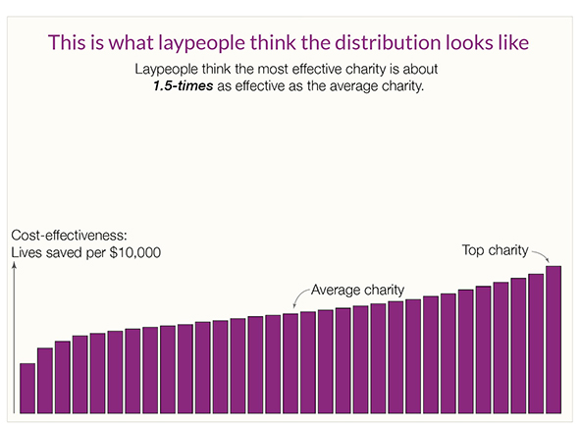

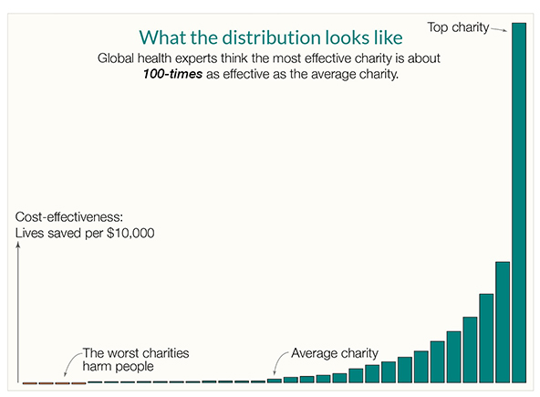

Kevin Star’s article usefully explains that there’s a kind of market failure in the charity sector, where donors aren’t part of the feedback loop and often have no meaningful way of knowing how much value beneficiaries get from their donations. The article outlines how an approach to impact-focused evaluation which he persuasively explains could achieve a “quantum leap toward a better world”.

While the above two sources focus on global health, the same effect occurs across countries and across causes. By way of illustration, Benjamin Todd’s recent article on 80,000 Hours shows a similar distribution of the impact of climate interventions (https://80000hours.org/2023/02/how-much-do-solutions-differ-in-effectiveness/) :

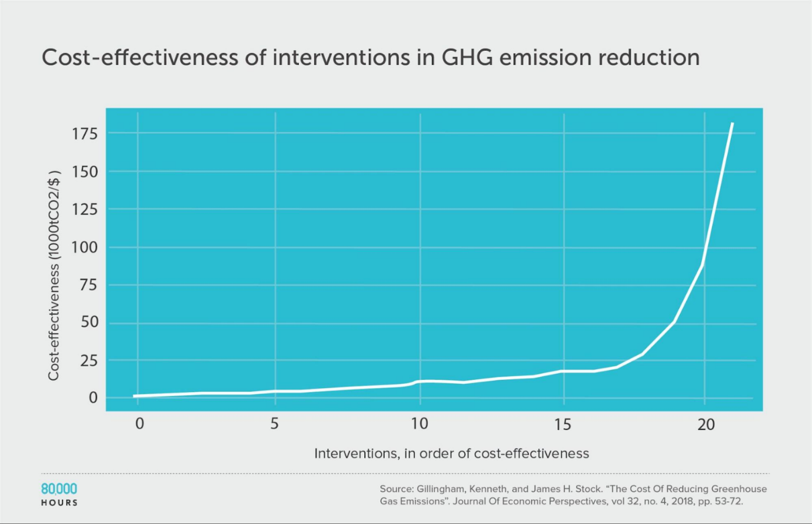

This insight is essential. While donors don’t and can’t understand how impactful their donation is, and charities have to raise funds in a market that doesn’t function, the sector will struggle. This problem is long-standing, but progress in the last 10 years on charity evaluation means it doesn’t have to continue.

Australia funding and promoting charity evaluation has the potential to fix the market failure, help Australian charities do far more good, and potentially make us a world leader.

**Summary**

Overall, Australian charity regulation has become outdated. Charities with DGR status are the lion’s share of the sector, but DGR status is not aligned with my values or the values of my peers. This means that charities aren’t focusing on many of the things I care about, and aren’t providing the community support and volunteering opportunities that are meaningful to me.

The Productivity Commission has a chance to make recommendations that realign the sector with the values of today’s Australians. Applying the lens of impact could greatly increase the amount of good that the sector can achieve, which in turn would drive donations and build the community supports that younger Australians need. I’ve seen too many talented Australians whose values align with mine leave for the UK or USA to do high-impact charity work because Australia doesn’t have a workable ecosystem for their values. This is hurting our community, our democracy and our future.