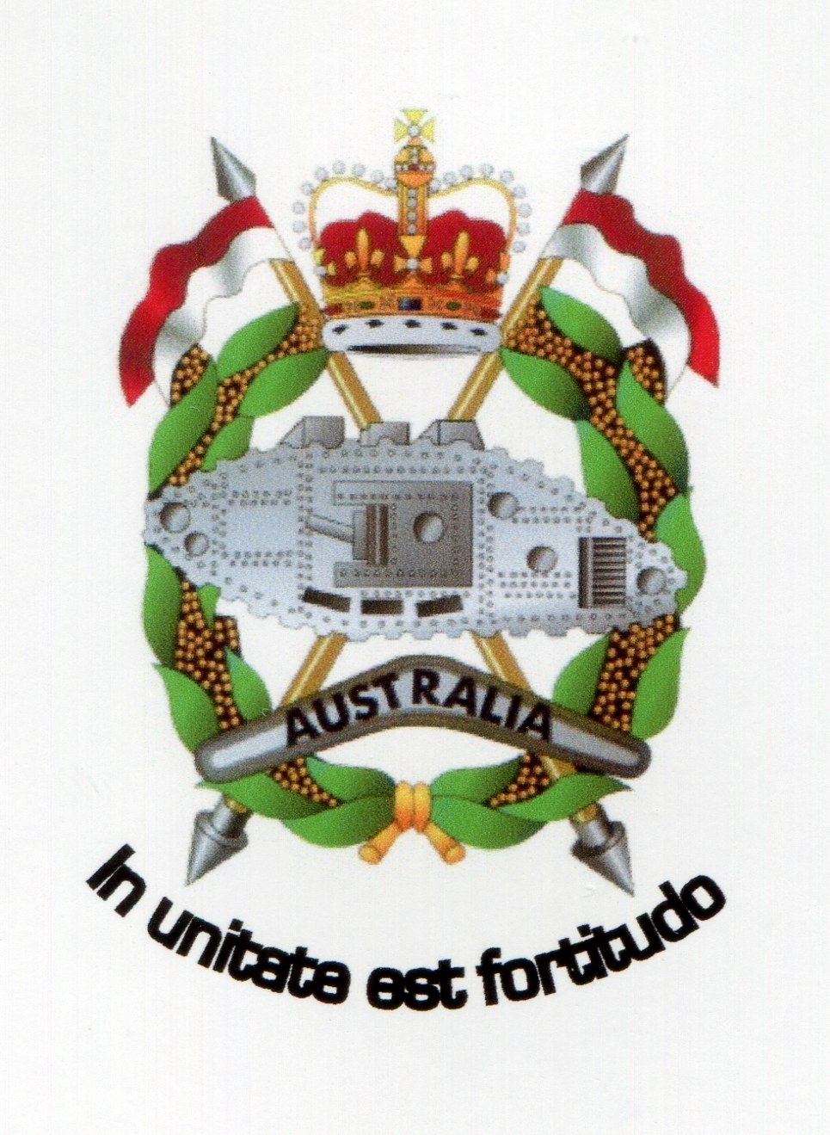

THE RAAC CORPORATION

(ACN 156 250 958)

The Committee Secretary
Joint Standing Committee on Foreign Affairs, Defence and Trade
PO Box 6021
Parliament House
Canberra ACT 2600

SUBJECT: ISSUES RELATED TO DISCHARGE PROCESSES FOR DEFENCE MEMBERS

PURPOSE

To brief you in accordance with the request of the Joint Standing Committee on Foreign Affairs, Defence and Trade has Inquiry into matters raised in the Defence Annual Report 2016-17, undertaken by the Defence Sub-Committee, Chaired by Senator Linda Reynolds CSC.

This brief attempts to answer the below Term of Reference (TOR); viz

- Transitioning from the Services.

This brief also acknowledges that the sheer depth and breadth of the subject matter may result in individual ADSO entities lodging their own submissions which may differ from this. The Corporation which is a member of the Alliance of Defence Service Organisations (ADSO) cedes as agreed, carriage to the Alliance of inter alia, conditions of service remuneration and superannuation for further comment.

TRANSITION

The discharge/retirement process for serving ADF members is a complete change from the rigours of a disciplined and structured military career requiring a different organisational and management dynamic.

Discharge may be at completion of engagement, retirement, at own request or involuntary (medical, RNI etc).

Notwithstanding the category of discharge being actioned, the discharge process is on any view and on any level, a fraught process for separating members and their families.

It means a total severing of an involvement in a life in which career, rank, status, achievement pride, camaraderie and being a part of the nation’s defence and security, is no longer the case. Discharged members find themselves as just another face in the crowd.

It is well settled that the duty owed to a discharged member ceases with immediate effect the date and time of discharge takes effect.
Unit commanders and the ADF no longer owe a former member any further duty of care as that is extinguished from the first moment of their discharge/retirement date of effect.

For some ADF members, separation from the Service can be a daunting and at times a traumatic experience.

Transition Handbook (previous)

A starting point in the discharge process is the ADF Transition Handbook.

The earlier 2015 document was a 93-page tome with a bewilderingly comprehensive array of information available to a discharging member and his or her family.

It was at first blush, a very well-thought out document which appeared to address all facets of a separating member’s requirements and provided a good set of procedural compasses to navigate the process including accessing DVA and kindred services post –discharge such as the VVCS Stepping Out Programme and DFCO web page.

It was however on drilling down into the Handbook, let down by the inability of members to access Defence hyperlinks from anything other than a Defence computer and this makes the Handbook a flawed document.
It detracts for enabling members to undertake pre-discharge admin action from the privacy of their own home.

The hyperlinks in this particular Handbook, including for example those related to transition documentation could not be accessed by a member from their home computer.

The requirement to undergo mandatory post-deployment POPS screening prevented a member at home from accessing and downloading from the relevant link.

Given the sensitivity surrounding this requirement, privacy concerns and the rights of the individual member to be able to complete such a document in the privacy of their own home should be paramount. Similarly acces was unavailable from home to the Directorate of ADF Rehabilitation and Compensation.

This was on any view an unacceptable state of affairs hampering action to enable a separating member to access such information in the privacy of their own home rather than through a third party i.e. an Administrative Officer at an ADF Transition Centre (ADFTC) computer, in order to reduce the risk of other discussing a member’s personal and psychological matters.

Again, a flaw in the transition process existed in members separating form the service, not having home computer access to entities and services hyperlinks listed in para 1.11 of the previous Handbook.

New Handbook

The new Transition Handbook is a vast improvement.
It comprises 60 pages has no hyperlinks, is well laid out and easy to follow with checklists and permitting the user to make notes at critical and logical stages in the process.

One of the most important steps in the discharge/retirement process is encouraging members to access Transition Support Services at the earliest possible time. The Defence Annual Report addresses this and it is noted the reform of TSS was undertaken(at p.98).

The new Handbook is obviously a very pleasing outcome from that reform process.

Most critically, the Corporation notes with approval, the move from a purely bureaucratic (faceless) process to one involving actual coaching and mentoring.

Defence reported (at p. 98-99):
- all ADF Transition Support Services staff commenced training for a Certificate IV in Career Development, with additional competencies in coaching and mentoring
- three launch sites (Adelaide, Holsworthy and Townsville) began trialling the transition coaching model
- the individual transition plan was improved to assist members leaving the ADF with their administration requirements, including leaving with all appropriate documentation, such as medical services and records
- a new two-day Job Search Preparation course was designed and implemented to specifically assist those ADF members leaving with less than 12 years of service
- a new post-transition survey was trialled to assess the effectiveness of transition programs and inform future initiatives, with full implementation scheduled for 2017–18.

ADF transition seminars can be attended by ADF members and their families at any time during their career to help them prepare for their transition.

The Corporation considers the human dimension in a discharge process to be absolutely fundamental in guiding members and their families through what is on a number of levels, a traumatic and life-changing time for them.

Without human interaction, the transition process is doomed to fail.

Such an initiative can have significant beneficial consequences in defusing any stress a vulnerable member may experience potentially leading to a more extreme and adverse action by a stressed member and which may also impact on that member’s family, also.

The introduction even on a trial basis of mentoring/coaching at first instance, is considered by the Corporation as being the every first step in aiming to reduce an id possible, eliminate any potential attempts at self-harm or worse, by members subject to the discharge process. The value of the coaching/mentoring continuum cannot be overstated.

Recommendation

That the Sub-committee endorse the roll-out of coaching/mentoring support service to locations other than the threw trial areas as a matter of priority.

MINISERIAL COMMENT

In a statement to Parliament in October 2017, the then Minster for Veterans’ Affairs made a Ministerial Statement in response to the report of the Senate inquiry into Suicides in which he stated inter alia:

In its report, the Committee identified a number of measures that the Departments of Defence and Veterans’ Affairs should implement without the need for review. They included recommendations that:

- the Departments align the provision of mental health care;
- the Career Transition Assistance Scheme include an option for external work experience for veterans;
- ADF members are provided DVA White Cards on discharge; and
- a two-track program be developed for ADF members leaving Defence.

The Government welcomes these recommendations and agrees to implement them. Many are already being implemented.

This is significant as coaching/mentoring should on any view, dovetail with transition coaching/mentoring. The Transition Handbook sets out the facilities available to discharging members under Future Employment Support (pp.17-20),

The recommendation for external work experience is significant as it is an initiative that could dovetail with any Wellness model DVA may initiate once it assumes relevant responsibility for ADF members with accepted or claimed war-caused or service-caused injuries, illness or diseases.

Significantly, while Defence proudly reports on the trial programmes etc.,
(pp.98-99), the Report is completely silent on discussing work experience for discharging members choosing instead to focus on work experience programmes for work applicants such as STEM graduates

The Corporation notes with disappointment that no statistics are available to gauge the effectiveness or otherwise of the take-up in the processes outlined in pp17-20 of the Transition Handbook.

In order to gauge the effectiveness of Career Transition Support Services, it is considered that Defence also report on this on this in order to measure what is effective and what is not to ensure the Budget allocation is being used to maximum beneficial effect.

CONFLICTS OF INTEREST AND DECLARATIONS OF INTEREST

The Conflict of Interest (COI) provisions provision in the current Handbook amount to a short 129-wrd paragraph with a recommendation to access online, DI(G) PERS 25–4 Notification of Post Separation Employment

The Corporation considers the paucity of information related to COI in the current Handbook to be detrimental in ensuring all discharging members are fully aware of their legal obligations in respect of COI.

The provisions relating to COI are more comprehensively addressed in the previous Handbook (at pp. 80-93) encompassing the provisions of
DI(G) PERS 25–6 (Complete Revision).

Although somewhat onerous in detail and scope, it is contended that given the genuine potential in the Defence space for a COI be it real or perceived to arise, specific and more descriptive plain-English provisions related declaring/managing etc, potential COI adapted from DI(G)PES 25-6 or later iteration, should also be included in the current Handbook.

Defence owes a duty of care to all members discharging from the ADF to ensure any employment they undertake, does not place them in a COI situation with a very real prospect of them having to either redeploy or leave that employment with subsequent loss of salary, esteem and dignity.

Recommendation
That the Sub-committee recommend to Defence that the COI provisions of the Transition Handbook be review with a view to including additional COI provisions are included to protect discharging members from being placed at risk of a COI situation. A copy of the Handbook is at Attachment A.

BRIDGING THE TRANSITION (DISCHARGE) GAP

It is well held that individuals discharged from the ADF are now on their own and are responsible therefore for taking any and all action to start a new post-ADF life.

The culture shock and stress associated with going from being a serving member to just another civilian has had catastrophic consequences of some veterans, resulting in suicide.

The sudden loss of membership of and continued connection with a very tightly-knit social and professional group, can operate to drive a veteran into isolation basically going into the woodwork and cutting off any and all ties, as a coping mechanism.

That is not unique to contemporary veterans and can be dangerous with no peer or family contact to ensure a veteran is taking care of themselves albeit medically or psychologically, with its attendant risks.

The Senate Inquiry into veterans suicides held in November 2016 noted in its report that in accordance with a MOU between Department of Defence and the Department of Veterans' Affairs for the Cooperative Delivery of Care and Support, the following respective roles were defined; viz

- Defence has the lead in caring for, and supporting, permanent members and members on [continuous full time (CTF)] service as well as members of the Reserve Forces where they are injured or fall ill as a result of rendering Defence service;
- Defence is responsible for assisting members to transition from permanent or CFT service;
- DVA has the lead in caring for, and supporting, widows/widowers and
dependants and wounded, injured or ill former serving members;
- DVA is responsible for providing compensation and other support to eligible current and former members; and
- DVA is responsible for ensuring current and former members, and where relevant their families, are kept informed of the support and services available from DVA and the processes by which such support and services may be accessed.

The roles define what Defence and DVA have carriage of and is on its face inconsistent with the perception that discharging members may have a difficulty in separating these roles thinking the Army, for example, has let them down and has cut them adrift. The MOU roles clearly do not support that perception.

The criticality of transition was acknowledged by Defence and DVA and was noted in the Senate Committee’s report; viz

Transition from a Defence perspective is largely a process by which people
leave the ADF with support to assist their future lives. From a DVA
perspective it is often the point at which responsibility starts for care and
support of those who need it.

A more holistic view would see transition in terms of outcomes for the
veteran, rather than successful completion of the transition process.
We would increasingly target our efforts towards those most in need based on
criteria such as continuity of healthcare, finding employment and social
connectedness.

Those criteria, while valid for all, are more critical for a
smaller percentage of members, including those whose transition is
significantly complicated by health considerations, including mental health
difficulties and those who separate involuntarily. Also, successful transition
should be considered to include success for the former member's family in
the areas of spouse employment, children's education, housing and financial
security.

This comment is significant. It acknowledges that transition must be outcomes-focused process and not a process-obsessed.

It is the Corporation’s view that the transition process is being improved on all the time.

Similarly, the matter of veterans seeking help post-discharge is a matter directly related to transition fro the ADF.

Post-Transition Contact

A critically important feature of support is that which can be provided by the units with whom the discharged members served. It is in this space that the ADF can in fact ways contribute significantly to its duty of care to members discharging by the provision of information to enable discharging members to reach out to unit associations. Separation from the Services has a profound effect on an individual.

According to Lane the lack of social interaction is a feature of depression leading to other issues; viz

A key part of the diagnostic criteria for depression, for example, is social withdrawal and social isolation. A key part of the diagnostic criteria for PTSD is social withdrawal and social isolation. When people withdraw socially and isolate themselves, it exacerbates the depression and it exacerbates the physical problems and their mental problems...One way of changing that is by having more support for the veterans organisations and the veterans groups and looking at treatment methods that are outside the mainstream providers of treatment such as the psychiatrists or psychologists.

This is significant. He argues inter alia, that more support for veterans organisations and groups is needed.

The preceding analysis by Lane finds support from Mates 4 Mates who contended:

In the ADF, members are constantly surrounded by like-minded individuals, rules and systems they understand and a purpose greater than themselves. When they transition from the ADF to the civilian life, they often lose their friends, their job and their understanding of how life operates. Their sense of identity, tribal connection and purpose disappears in that one moment. This can easily lead to alienation and isolation from family and civilian society which can predispose the veteran to more acutely experience trauma than if surrounded by strong social networks.

The Corporation’s stated view is that as part of transitioning out of the ADF, support in this organisation’s context derives in the first instance, from Units to Unit Associations and engaging with each other will go a long way to strengthening the ties between them, and also attract more discharged members in joining their unit associations.

The involvement of units at the march-out phase of a member proceeding on discharge, addresses Lane’s argument regarding the need for additional support for veterans organisations and groups.

In the Corporation’s sphere that has already occurred and is continuing.

In November 2017, the Corporation compiled in conjunction with the
Corps RSM, a comprehensive RAAC ESO Contact list for all 12 Member Associations.

This document will at the Corps RSM’s direction, be disseminated to he RSMs and SSMs of all Armoured units and is to be given to soldiers discharging from the RAAC. Soldiers will be strongly urged to get in touch with the relevant Association just to establish contact. The effectiveness of the type of unit/association outreach cannot be overstated.

The critical issue for any branch of the ADF is that the contact initiated is voluntary and that discharging members cannot be compelled to do it.

Similarly, there will be a percentage of ADF members discharging who are bitter about their experiences and want nothing to do with anything remotely related to ADF service.

The Corporation notes the current Transition Handbook is silent on any advice to discharging members to establish contact with a Unit Association as part of their discharge process. This is disappointing and leaves a gap in the process whereby Unit Associations are able to capture that individual and be there for that individual to support him or her post-discharge or post-retirement. The statement above by Mates 4 Mates, gives added credence to that.

The Corporation contends that the key to bridging that transition gap lies in the discharging member establishing another bridgehead between the Unit and the Unit Association. It is from within an association be it incorporated or not, or a virtual organisation, that a sense of belonging and ability to access support will go a long way to eliminating the culture shock of discharge or retirement for members and their families who bear the brunt of this as well.

Recommendation
That the Sub-committee recommend Defence review the lack of Unit Association information in the Handbook and undertake a rewrite to include advice to discharging members in respect of reaching out to Unit Association or other veterans’ organisation, as part of their transition process.

TRANSITION AND DVA

Another aspect to transition which does not appear to be addressed in the TOR is the interplay between Defence members separating from the Services and DVA.

The Corporation discussed this as part of the submission it drafted on behalf of ADSO for its submission tendered to the ANAO Review into DVA, currently under way.

Transition by Defence members and DVA are on any view, inextricably linked and need to be addressed. This is demonstrably evident through the MOU between Defence and DVA.

The fruits of this MOU are now starting to bear fruit and include the following positive developments in the pre and post-transition spaces in term of DVA’s recognition of service-related injuries and illnesses which does not form part of the Transition Handbook.

From now, any serving or former ADF member with a PMKeyS number can register through the Department’s new Digital Front Door (MyService).
This provides DVA automated information sharing with Defence through inputting PMKeyS and accessing their digital file.

The Corporation understands that changes to DVA’s IT system have been made to include an additional field to enable current and former ADF members who served before the introduction of a PMKeyS number to use their old service number to access MyService.

The White Card is automatically generated and sent to the veteran to enable early mental health treatment. Veteran Centric Reform will expand this service for all claims and soon smart cards will have all conditions loaded to streamline service with medical practitioners.

The Corporation considers the introduction by DVA of a smart card to be a significant and positive paradigm shift in DVA’s improving their business systems and processes as well as enhancing a more efficient and seamless delivery of health services and support to veterans and dependants, post-service. This is considered to be on any level, a significant game-changer.

The advantages of the automatic issue of a White Card for which the Corporation and its constituent members have campaigned collectively and individually, include:

- No stress and trauma for a veteran in navigating the legislative claims process to establish initial liability and a number of known conditions related to military service;
- Removal of one level of stress when navigating the transition process;
- Reduced instances of self-harm and worse;
- No unnecessary and lengthy delays in waiting for a liability and decision ready determinations for a service-related injury, illness or disease;
- Reinforcing the need to tell DVA only once, will eliminate a constant requirement for veterans and their families to continually have to repeat one’s experience to a new determining officer due to staff changes;
- Reducing the requirement on veterans to litigate through the appeals process; and
- Provision of ongoing treatment of a service related illness, injury or disease for life; and
- Formal acknowledge by the Government as represented by DVA, that while serving in the ADF, they did incur, accelerate or aggravate an illness, injury or disease on service be it operational or non-operational service.

It is not an exaggeration to contend that the latter bullet point is seen as being on any view, the most crucial factor in enabling all veterans, particularly those who have been involuntarily (medically) discharged, retain a level of self-esteem and dignity, which has been denied to them as a consequence of the antiquated and convoluted business model employed by DVA in years past.

The issue of a White Card for treatment of all service-related conditions while not pensionable or compensable at first instance, is seen to be the major fact at issue in veterans remaining within a Government-funded treatment continuum post-service which has in the past been a fraught process in having to start a completely new post-service pension/compensation and treatment process all over again.

The Corporation considers these changes to DVA’s business systems and processes for veterans’ through-care will operate to enhance to a significant degree the delivery of health and support services. These improvements in service delivery and veterans’ support form part of the transition process and must as a matter of priority be included in the Transition Handbook.

Recommendation
That the Sub-committee consider recommending to Defence that the improvements discussed above be included in the Transition Handbook.

GENERAL COMMENT

- The transition to civilian life of ADF members is a major activity at all levels of Defence and DVA. The coaching/mentoring role by Transition Support Centres is integral to the success of member transition.

- It is noted that the Defence Annual Report is completely silent on the effectiveness or otherwise of transition processes.

- This is surprising as a lack of such information operates to prevent Defence and to some extent DVA, analysing the strong and weak points of any such process. Such a lack of statistical information operates to prevent any remedial steps to be taken to rectify weaknesses and build on strengths.

- It is the Corporation’s contention that in order to enable the success or otherwise of transition to be measured, a need exists to collect the relevant data to measure that process. It follows that, a follow-up survey of discharged ADF members should be considered.

- Any survey should not consist of forced-choice questions and should be sent to ADF member when they reach their first six months of civilian life.

- Any such survey would be automatically computer-generated at the six-month mark.

- Transition Handbooks will need to be amended to include survey information.

- The information gained from the surveys may then be used by Defence and DVA to re-calibrate the transition process where needed.

- Without such a survey, information related to measuring the effectiveness of transition in any subsequent Defence Annual Report, is of little or no consequence.

Recommendation
That in order to monitor and measure the effectiveness of the entire transition process and programmes/agencies involved, the Sub-committee recommend to Defence, the development of a post-discharge survey to be sent to members at the six-month period of their post-service life.

CONCLUSION

- The transition process currently in place is a continually evolving creature requiring monitoring and evaluating to measure its effectiveness.

- The Transition Handbook, while a significant improvement on its predecessor is silent on a number of important material particulars that detract from its effectiveness.

- The handbook is therefore considered to be in need of additional reviewing and amending in respect of the issues canvassed in this brief.

- Defence will need to consider the inclusion of a more appropriate report on the Transition Programme in its future Annual Reports, as current reporting on this very vital issue is insufficient and hampers a considered response by ESOs, Defence members and members of the public.

RECOMMENDATION

That the Sub-committee note the above, and give favourable consideration to the recommendations contained therein.

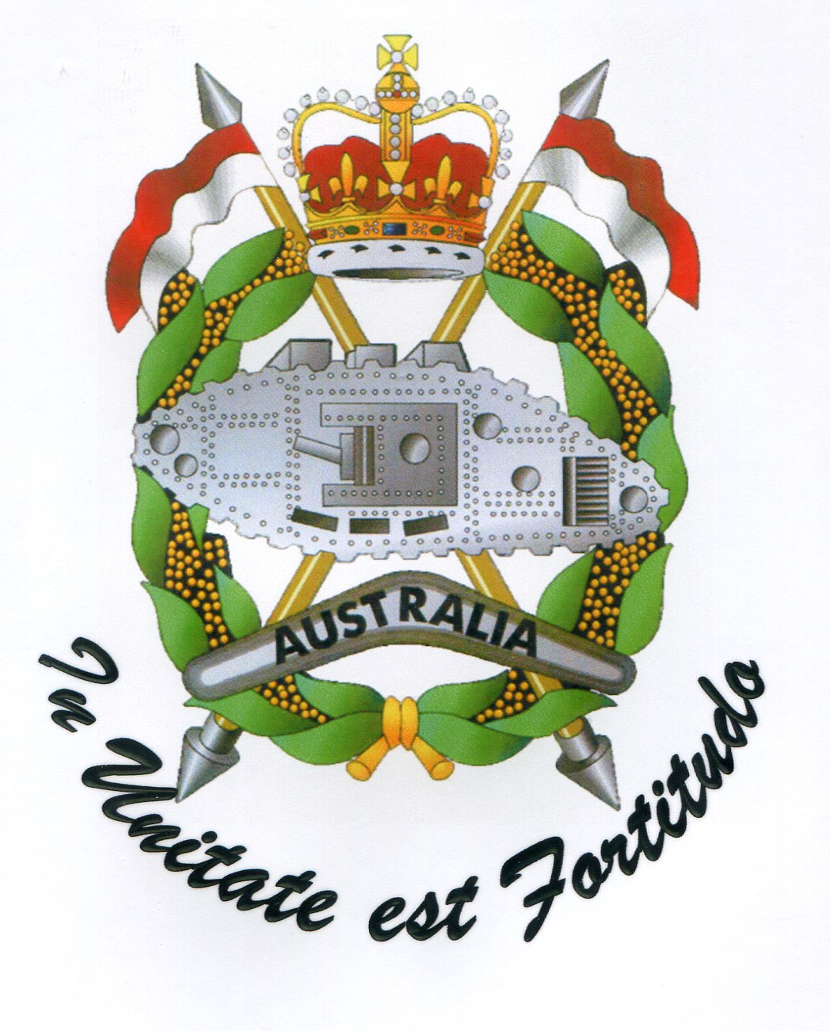

Noel Mc Laughlin
Chairman
RAAC Corporation
13 April, 2018
(via email)

ADSO provides coverage for over 90,000 members in the ex-service community. ADSO comprises The Defence Force Welfare Association (DFWA), Naval Association of Australia (NAA), RAAF Association (RAAFA), Royal Australian Regiment Corporation (RARC), Australian Special Air Service Association (ASASA), Vietnam Veterans Association of Australia (VVAA), the Australian Federation of Totally and Permanently Incapacitated Ex-Service Men and Women, the Fleet Air Arm Association of Australia, Partners of Veterans Association of Australia, Royal Australian Armoured Corps Corporation (RAACC), the National Malaya & Borneo Veterans Association Australia (NMBVAA), Defence Reserves Association (DRA), Australian Gulf War Veterans Association, Australian Commando Association, the War Widows Guild of Australia, Military Police Association Australia (MPAA), the Australian Army Apprentices Association, the Women Veterans Network Australia, and the Combat Support Association.
Statement by the Minister for Veterans’ Affairs, the Hon Dan Tehan MP, Ministerial Statement in Response to Foreign Affairs, Defence and Trade References Committee’s report on the Inquiry Into Suicide by Veterans and Ex-service Personnel, 24th October 2017, at p.4.
Attended by this writer and Col David Jamison AM, National President and Spokesman for DFWA/ADSO.
The Constant Battle: Suicide by Veterans, Senate Foreign Affairs, Defence and Trade References Committee Report, para 6.3 at 128, (207 pp).
Above, n.3, at paragraph 6.8 at 129
Above, n.4, Dr Jonathan Lane, Submission 78, p. 5. para 6.48 at 140
Above, n.4, para 6.50 at 141.
Above, n.3, at 128.

