7 February 2017

Productivity Commission
Locked Bag 2
Collins Street East
Melbourne
8003

RE: Productivity Commission Inquiry into Introducing Competition and Informed User Choice into Human Services

Thank you for the opportunity to contribute to the inquiry.

Hobart District Nursing service Inc. (The District Nurses) welcomes the prospect of showcasing the successes of the hospice@Home (h@H) project through this submission.

h@H is a model of care that delivers “wrap around” packages to all Tasmanians facing an end of life prognosis. Having now amassed over three years of research and data and delivered 2000 packages we believe we are well placed to commend this model be offered to all Australians.

h@H represents value for money, consumer choice, competition and world best practice in end of life palliative care services.

We would be pleased to make further representation to the Commission as you see appropriate.

Kim Macgowan
Chief Executive

Productivity Commission Inquiry
into Introducing
Competition and Informed User Choice
into Human Services:
The District Nurses Submission, Feb 2017

Contents

Introduction………………………………………………………………………………………………………….2

Request for Information 18…………………………………………………………………………………..3

Request for Information 20…………………………………………………………………………………..9

Request for Information 21………………………………………………………………………………….11

Conclusion……………………………………………………………………………………………………………14

“When my dear husband’s Parkinson’s was diagnosed 17 years ago, as a health professional, I knew that the coming journey would present challenges. A highly intelligent man who was once a foreign correspondent in Washington for a big newspaper, he was facing motor and possibly cognitive decline. Little did I know what I was in for.

When things did get really hard, and I was struggling, being referred to the hospice@HOME team simply changed my life. I now know that there is always someone who knows our situation and understands us, for guidance and support.

I have seen flexibility in this team which I never would have believed possible in a health organisation.
Going away for the day and need extended respite - can be arranged. Need a particular sort of carer - no problem, we’ll work to get that. I had been woken several times through the night twice in a row and need a sleep - we can get carers overnight or for a couple of nights.

I have been keen to keep us together in our home, and we are able to do this, without feeling that I am going crazy, because of support I never thought possible. I will be forever indebted to these wonderful people and their organisation.”

Doctor Jane Tolman
Geriatrician
Tasmanian Health Service

Introduction

The District Nurses (TDN), a division of the Hobart District Nursing Service (HDNS) Incorporated, is an autonomous, not for profit organisation providing professional nursing, personal care, and allied health services to the general and veteran community. HDNS is one of Tasmania’s oldest and best-loved philanthropic organisations. The organisation was founded in 1896 by the wife of the Governor of Tasmania, at a time when there was increasing concern about public health, when women were becoming more active publicly, and when nursing was beginning to be accepted as a profession.
This paper responds to the Productivity Commissions call for submissions into introducing competition and informed user choice in human services. This submission focuses on findings related to end of life care through the experience of hospice@HOME in the context of introducing more competition, contestability and informed user choice. Every Australian should have the right to die in their place of choosing and hospice@HOME is a project that delivers end of life care to anyone, anywhere.
hospice@HOME (h@H) is a highly successful model of care developed by TDN in Tasmania for people approaching end of life, and their carers. This program provides care packages that complement existing services, value-adding to them and providing clients with the services they need to enable ‘a good death’ at home (if they choose). h@H has been funded through the Australian Government’s Tasmanian Health Assistance Package, as part of the Better Access to Palliative Care Program. It allows people to take charge of their end of their life journey by providing the care and support they need to die with dignity.
“Palliative Care is complex, hospice@HOME has made complex care less complex.” [International Congress on Palliative Care, Montreal, Canada, 2016]

Request for Information 18

What types of services and settings to include in the definition of end of life care?

Research shows that approximately 70% of Australians would prefer to die at home, in a familiar place with family by their side, however only 14% achieve this wish. Beginning in 2013, TDN began developing h@H, a program focusing on the home setting, allowing people to have choice and control at the end of their life, by providing the care and support to the client and their families. These services could typically include: personal care, domestic assistance, respite (incl overnight), nursing care, GP Assist, home maintenance, transport, medication management, complementary therapies, equipment provision and less traditional services such as child care, gardening and dog walking.
h@H promotes equitable access to all people diagnosed as eligible to receive end of life care, including people living in rural and remote areas who often receive less than optimal services. In addition, clients in specific settings who may have dementia, mental health disease or those who are homeless or at risk of homelessness should receive equal consideration.
h@H packages intersect seamlessly with the current health system (within varied settings) to ensure a quality, timely and equitable response for all clients. Packages can commence immediately with no waiting period. A key aspect of the packages is collaboration with other services. h@H staff provide care coordination and end of life care navigation. A significant advantage is that these services often commence before the person receiving the package leaves an acute care facility.
“I would like to thank hospice@HOME for helping my Mum to be comfortable. To die at home was her wish and you made it come true. Without your help it would not have been possible” [extract, client correspondence, 2016].

How eligibility for end-of-life care should be defined, and who should have responsibility for determining whether a person is eligible for care

TDN support the 12 month eligibility time frame in the definition provided by the Australian Commission on Safety and Quality in Health Care. This is consistent with the eligibility criteria of h@H. TDN deem that the clients General Practitioner (GP) is the most appropriate and suitable professional to make that determination. The GP is deemed the primary provider of care for all the packages unless a request is made for the specialist palliative care service to take over that role. TDN recognise the important and valuable role of primary carer’s and family and extend the eligibility of the services provided under the program to include respite and ancillary services, which strengthens home supports and helps to build a resilient environment.
Client choice is fundamental during all aspects of the planning, coordination and delivery of supports. However, considerations must be made to ensure an effective and safe service for staff and contractors. The environment in a community setting is not always adequate. h@H has more flexibility than other

Government funded human services to enhance the comfort of the patient, family/carers and the staff by improving the working environment. In the 2015-16 financial year: 312 types of equipment were provided.
In regards to competition and contestability, end of life care is complex, though all aspects must trace back to client choice. TDN place importance on h@H’s innovative approach of complementing other supports and services and not replacing them. This is contradictory to the majority of government funded aged care or disability services, whereby packages cannot top up other services. A collaborative approach whereby services work with each other, rather than against enhances the likelihood of positive client outcomes. Additionally, collaboration strengthens existing supports, encourages innovative approaches and improves overall quality of care.
“Dad’s careplan was complex, the way everyone worked together for us was amazing, couldn’t thank them more during that difficult period.” [extract, client correspondence, 2016]

Whether care services should be considered as a ‘bundle’ or individually, and who should determine which services a person can access (the patient’s GP or the service provider, for example)

TDN support the definition of end of life care that includes services that not only support the patient, but their primary carer/families. The choices that can be made while navigating end of life care can be diverse, and meeting the needs of the client and carer/family must be handled in a holistic manner. In this respect, the services may be provided by one contracted service or by many. A service coordination/case management element to end of life care is therefore crucial if bundling services.

Once a patient is deemed eligible for end of life care by their GP and referred to the h@H Case Management Team, an assessment of needs will occur immediately. This process may involve case conferencing with those already involved in the client’s care to determine likely prognosis, health trajectory and deterioration; as well as discussions with the client and their family/carer to determine the client’s service priorities.

h@H Case Managers will then design a package of care to ensure the client’s needs are met effectively. TDN have developed the model in a manner consistent with the key principles of the Compassionate Communities framework, always placing choice at the forefront of care and ensuring best practices. h@H coordinators will source local services matched to the needs of client/carers and commence the delivery of a fully integrated and bundled package of care. The package will include continued access to the State Palliative Care service for equipment, emergency medication orders and expert advice.

Reassessment of needs either triggered by changes in the client’s acuity or as directed by the client themselves will occur, and packages are modified accordingly. After hours care is available 24/7 through the use of a contact centre, which includes advice, assessment, and possible rapid response deployment of local on-call nursing staff and medical care (via GP Assist) with the aim of avoiding unnecessary admissions to hospital. An In-Home Emergency Medication Kit (The Just in Case Box), particularly for rural and remote areas, is also available.

“hospice@HOME is a wonderful service providing, as it does, practical help at a time of crisis for which none of us is truly prepared for.” [extract, client correspondence, 2016].
How best to coordinate care across different settings and the supports needed to ensure patients remain at the centre of service provision

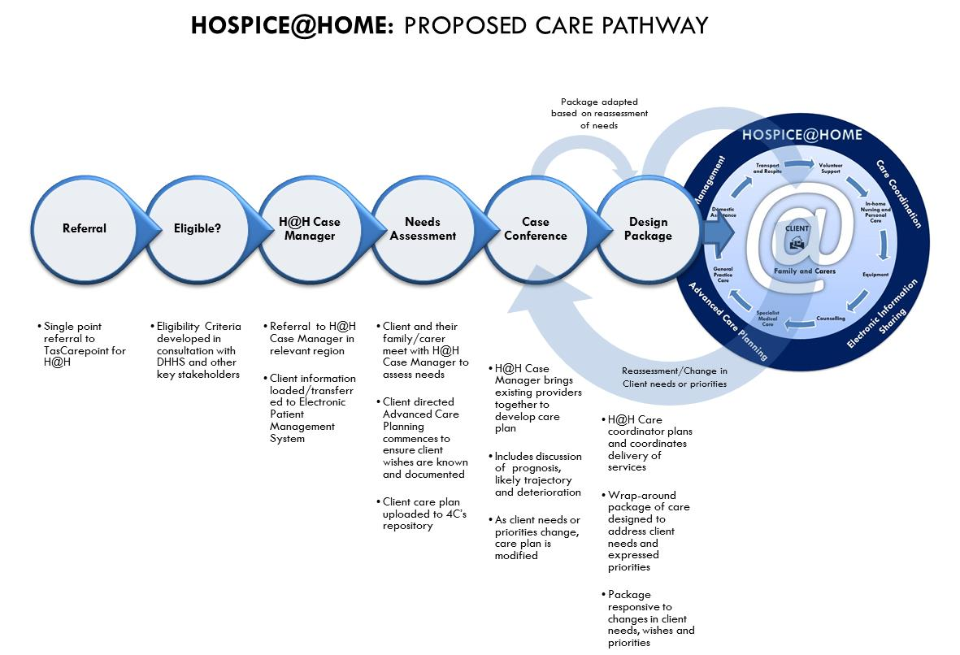
TDN embraced the challenges of integrating h@H into an already complex health and community care system. Building relationships within the sector and streamlining service delivery processes was crucial to ensure supports were properly integrated for the client across different settings. True collaboration puts aside competitive forces and places the client’s choices at the centre, while also encouraging each provider to follow best practice and improve quality of care. Careful consideration must be made if a system is going to be encouraged whereby service providers compete on an open market for end of life services – TDN have evidence to support the claim that a collaborative model is not only achievable, but is best practice for end of life care.

Collaborating with 65 partnered Tasmanian organisations required a flexible and well-coordinated approach. The h@H coordination model is successfully servicing the target population in Tasmania – demonstrated by the following patient data and population density map:

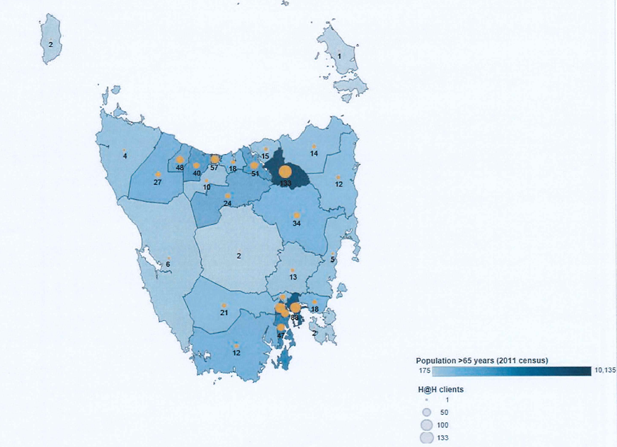
h@H staff are active participants in a ‘Partners in Palliative Care’ forum, taking a leading role in the development of a Collaborative Practice Protocol that promotes cooperation, mutual respect and a clear understanding of the respective roles of all involved.
“All the care came together seamlessly, hospice@HOME our GP and various other specialists worked together behind the scenes to make sure our needs were met.” [extract, client correspondence, 2016]

The feasibility of offering users greater choice of service, or of provider, and how this differs between regions

TDN have expanded its service delivery capacity, and grown to be a well-respected statewide provider of community care services during its 120 year duration. Continuously re-evaluating and evolving as the needs of the population changes is one aspect that makes it feasible to place user choice at the heart of service delivery.

h@H has contracted 65 aged and community service providers to provide end of life care, employing over 1,000 people across Tasmania, and contributing to social capital. This brokerage model of care offers greater choice of provider, which TDN supports as a sustainable model of end of life care. TDN understand that no single provider can offer the holistic care necessary for clients and their families during their end of life journey. TDN have spent considerable effort driving a collaborative approach towards care, understanding the value of good working relationships within the whole sector.

“Easily the most rewarding experience I have encountered as a support worker” – Denise, support worker

Brokerage arrangements are coordinated by h@H non-clinical coordinators and registered nurses who work with contracted organisations to deliver services to clients through their usual service provider (if that is their choice).

Brokerage agreements specify the quality of services to be provided, including the education and standards which are expected of the brokered workforce. This has resulted in upskilling service providers with previously no or limited experience in palliative care. TDN provide education and training to its partnered organisations in order to ensure a service that exceeds quality standards. For Tasmania, the h@H model has produced an overall increase in workforce development and capacity of home care support workers to deliver care with the palliative approach.

“Our choices were always respected, we wanted our regular worker we knew and trusted them, also they knew our environment well.” [extract, client correspondence, 2016].

The potential for greater contestability, particularly for services and regions where choice is not practical

Demographically, Tasmania has the most regional disparity and lowest socioeconomic status in Australia (Socio-Economic Indexes for Areas - SEIFA). This creates challenges and barriers to home service delivery as resources tend to be inadequate and more costly in rural areas. TDN’s view is that these areas provide the greatest potential for contestability. However, alternate service providers must be willing and available to replace those that underperform. In many of these regions there is no alternate service provider. TDN has taken the position that underperforming or substandard service provision is unacceptable. Therefore TDN have provided staff through its own private division (Team Care Tasmania) to these clients through a private contract arrangement, which is always a last resort. TDN are constantly sourcing alternate service providers that meet acceptable quality standards and subsequent monitoring. These service providers may be an organisation, group or qualified and credentialed sole trader/individual.

Clients with special needs would also benefit from greater contestability if their needs are not being recognised or met by their service provider, a carefully designed mechanism would need to exist to identify these occurrences.

h@H has continually reached out and met the needs of the Tasmanian population in the places where they reside. In 2016, h@H staff travelled 13,000 km on average each month and coordinated packages of care on the isolated Bass Strait and Bruny Islands of Tasmania, and in remote areas for people living with basic facilities and those with special needs.

As a fund holder for h@H, TDN ensure that partnered organisations face a credible threat of replacement if they underperform or if they do not meet adequate standards and best practice guidelines, with importance also placed on providing value for money. The potential for more contestability in this area does exist, as long as service providers continue to expand into rural and remote areas and value quality above cost. New providers are also important as they encourage continuous improvement and innovation and better client outcomes.

“The management always made sure that the quality of care Mum received was outstanding. From the start we were treated with respect and we knew they cared.” [extract, client correspondence, 2016].

The likely costs and benefits of greater choice or contestability, and how they should be distributed among users, their families and the wider community.

TDN maintain 65 partnership agreements with service providers across Tasmania. This ensures clients and their carers/family receive more choice and that their needs can be met in a holistic manner. These outcomes come before cost, however that consideration is also crucial in order to deliver an efficient service that is sustainable.

Ensuring that service providers are meeting standards and not underperforming remains they key to a contestable market for end of life care. Under the h@H model, this would mean a loss of brokerage contract for the provider and the likelihood to be replaced by another provider, and the potential for a loss of future contractual possibilities. Managing and maintaining a wide range of partnership agreements can be a costly exercise, particularly due to the timely nature of continuously reviewing quality. In some ways, well known providers that already deliver government funded programs are easier to review in this manner, however may not necessarily meet all a client’s needs. Universal quality standards for end of life care across Australia (including auditing) could be incorporated into existing quality controls.

The greatest benefit for increased contestability is to improve quality. An influx of providers in rural and remote areas is unsustainable, therefore would not necessarily result in a greater range of services for those regions. Additionally, the h@H model of care has been informed by the concept that fund holders should be price setters, not price takers.

“Our package of care was complicated, we had three different providers, but it came together as though they were one. We were never told that something was too costly, they were very focused on quality though.” [extract, client correspondence, 2016].

Request for Information 20

The costs and benefits to the community as a whole of providing end-of life care in different settings (such as hospitals, aged care facilities and homes)

The h@H model of care has saved the Tasmanian public health system (hospitals) an estimated $12.4 million since 2013 by freeing up hospital beds and reducing pressure on ambulance services, which benefits the community as a whole. The average cost of a h@H package is $39 per day, compared to an acute care admission of $1,645 per day (hospice@HOME, 2017 Report).

h@H outperforms national Palliative Care averages for the reduction in acute health care. Nationally, 70% of palliative deaths occur in hospital while for h@H only 49% (palliative care and acute care combined) do so. End of Life care in community settings reduces avoidable hospital admissions and helps those planning a death at home to feel supported and safe. The estimated inpatient cost of each h@H admission in the six months before death is $3,975 less than those without the service (Press Ganey, 2016). This represents h@H saving the hospital system $3.1 million per year.

h@H provides 24/7 access for clients through 1800HOSPICE (a statewide after hours service) that includes a palliative triage pathway, enabling rapid response. The after hours approach for clients in Tasmania was not previously available. In 2016, h@H published a peer reviewed paper in the International Journal of Palliative Nursing regarding the 1800HOSPICE service. The study found that clients who contacted the after hours service were less likely to contact an ambulance or present to an emergency department.

The partnership agreements that h@H maintains with its network of service providers outlines education standards that are expected, which can highlight training needs. This has resulted in an upskilling of the workforce, improved retention and increased capacity of home care support workers to provide end of life care in the community. The 65 brokerage partnerships has resulted in the employment of 1000 Tasmanians and strengthening of the workforce. In rural and remote locations the local providers are utilised, increasing the flow of capital in communities across the state.

TDN have enhanced community networks through the provision of h@H by contributing social capital, specifically keeping people in their communities and improving social inclusion. These experiences are consistent with the view of the commission and their objectives of human services provision.

“We used the afterhours service a few times and it really helped, even if was just for peace of mind.” [extract, client correspondence, 2016].

Commissioning and funding arrangements for end of life care that have proven most effective in Australia and abroad, both in urban areas and less densely populated regional and remote areas

h@H has proven to be an effective and successful model of end of life care, better enabling those who want to die at home, and allowing them to achieve their choice of place of death. The h@H model of care and the funding arrangements associated are the most effective in Australia. When comparing all h@H deaths with the national Palliative Care Outcomes Collaboration (PCOC) data, home deaths for h@H clients were almost double that of the PCOC cohort (43 % compared to 22.4 %).

In Australia, 14% of people die at home yet 70% express a preference to die at home. In 2015-2016, 43% of h@H clients died at home and 71% indicated home was their preferred place of death. Of those, h@H supported 61.7% to achieve their wish. This signifies an increase of 11.7% of deaths at home (where home was the chosen preference) since 2013-2015, indicating an overwhelming h@H project success.

Place of death for hospice@HOME patients compared to Palliative Care Outcomes Collaboration (PCOC) national averages (%)
 | hospice@HOME (2015 – 2016)  % (n = 536) | PCOC 2015  % (N = 19,829)
Home | 43* | 22.4
Palliative care ward | 30 | -
Acute hospital setting | 19 | 70.1
Other** | 8 | 7.5
* All hospice@HOME patients (i.e. includes patients who were undecided on preferred place of death or declined to answer and those wishing to die in places other than the home).
** Residential Aged Care Facilities and Multiple Purpose Centre or Group Homes

TDN’s vision for end of life care is for Australians to have a viable, sustainable and well-coordinated in home end of life care option available when that time comes (if their choice is to die at home). This option will complement other options (acute and residential care) and will see specialist palliative care services, primary health care providers, community based services, and clients formal and informal networks working together to provide client centred care. This option exists through h@H.

“Mum wanted to die at home, she felt more comfortable in her own space and we wanted to be with her – given our location we didn’t think that was possible at the start. Thanks to the hospice staff for making that happen.” [extract, client correspondence, 2016].

How existing commissioning and funding arrangements could more closely reflect population needs, better satisfy patient preferences, incentivize improved patient outcomes and provide governments with better value for money.

While dying at home used to be a common experience, most Australians now die in hospitals, often in intensive care units. Not only does this strain the hospital and ambulance systems but many people die in an environment and under circumstances that are less than optimal. This institutional approach towards dying is increasingly being questioned. Research shows that approximately 70% of Australians would prefer to die at home – in a familiar place with family by their side.
The Australian Government’s document: National Strategy for Palliative Care 2010: Supporting Australians to Live Well at the End of Life outlines four goal areas for improving palliative care: awareness and understanding of death and dying, appropriateness and effectiveness of palliative care, national leadership and governance, and enhanced capacity and capability of all relevant sectors. The operation of h@H follows this national policy direction, while reflecting population needs, high levels of patient and carer satisfaction and providing the government value for money.

Evidence of the value of money provided by h@H is KPHealth’s 2015 report (Quantitative analysis of outcomes of the Better Access to Palliative Care in Tasmania program), which shows that h@H clients are 2.7 times less likely to be admitted to ICU and have shorter stays (2.3 times less) than those not receiving h@H services.

TDN would like to see a consistent approach to co-payments and client contributions to residential and community aged care across Australia. Recent reforms have clearly outlined that Australians who can afford to pay for aged care should do so. While complex, TDN would support a well-designed co-payment system for end of life care within the community for families who can contribute to the cost of care. This is currently inconsistent within regions and various programs throughout Australia (including those within residential care). In addition, private health insurers should have a consistent approach to end of life care

in a community setting, which is currently not the case. TDN would advocate for a consistent approach to Medicare and private health insurer payments to community nursing.

“It wasn’t just the hands on care that made a difference, we didn’t have time to mow the lawns or walk the dog because Mum needed someone near her all the time.” [extract, client correspondence, 2016].

Request for Information 21

Consumer protection may need to be improved (for example, strengthened accreditation or licensing of providers of community based care)

TDN support the commission’s comments regarding the suitability of competition within certain markets. Increasing competition should be encouraged if it ensures more effective service provision and better quality services for clients. Increased competition has the potential to have the opposite effect if the safeguards are not properly designed. TDN’s experiences through h@H support the view that consumer protection is the number one priority. TDN address consumer protection through a carefully designed implementation phase, prudent contract management and quality standard controls.

The national consensus statement produced by the Australian Commission on Safety and Quality in Health Care: Essential Elements for Safe and High-Quality End of Life Care, is highly relevant to h@H. TDN services are based on the principles and essential elements of the consensus statement and are used to guide and improve the safety and quality of the end of life care for clients.

TDN understand that no single provider can offer the holistic care necessary for clients and their families during their end of life journey, and have spent considerable effort driving a collaborative approach towards care. h@H introduced a ‘Collaborative Protocol’ for its partnered organisations throughout Tasmania; this improved communication, cooperation and collaborative practices, with consumer protection a priority. The establishment of a provider network of contracted services has been a positive outcome of h@H. Many of these providers work cooperatively rather than competitively, sharing knowledge and resources with the aim of providing better quality services in the sector.

“The staff always made sure that Dad was safe and comfortable. We never had a concern that the different providers didn’t meet guidelines - It was really well done!” [extract, client correspondence, 2016].

Collection and publication of data on end of life care could be improved to support user choice and improve planning, delivery and evaluation of services

TDN support the view that the collection and publication of quality data can enhance user choice and improve the quality of care delivered in the whole sector. Research and evaluation activities are valued and supported within h@H. A Manager of State Research and a data analyst is employed to lead the implementation of the h@H research framework. Additionally, six h@H staff extended their scope of practice to take on research/data assistant roles. This has improved the type, quality and quantity of data collected, and embedded a culture of research. h@H research will continue its focus on producing high quality, reliable evidence to inform practice and ensure continual quality improvement of services, policies and programs.

An emphasis on project outcomes for the client ensures a continuous improvement focus that is instrumental in driving the future of national home based palliative care strategies. TDN are developing a strong evidence base; measuring the economic efficiency and implementation of the service, and ensuring maximum effectiveness for any future services.

h@H has established a robust client information system and research capacity, and has taken action to ensure knowledge transfer occurs through the delivery of papers at major conferences, presentations at other forums, the preparation of journal articles, and responses to requests for information.

TDN initiated research into the cost effectiveness of the h@H model in terms of reducing acute-care costs and has engaged the international benchmarking organisation: Press Ganey, to conduct in-depth client satisfaction surveys. It has developed a strong internal research capacity and has an evolving research program.

The TDN view is that user choice and the planning, delivery and evaluation of services could be improved within palliative care if participation in PCOC data collection was compulsory. This approach would ensure a true reflection of client outcomes and service delivery capacity.

“For the short time my mother required hospice@HOME I received nothing but support from all the team members. My family knew everyone was only a phone call away which made her time at home memorable. Thank you with all my heart.” [extract, client correspondence, 2016].

End of life care could be better integrated into primary care and aged care

h@H is a model of end of life care that integrates across the aged care, tertiary care, primary health care, and community and disability care systems, complementing the Commonwealth Home Support Program and Home Care Package Program. It provides an extra level of support enabling people nearing the end of life to remain at home rather than in a less familiar and more costly acute care setting. h@H provides a ‘bundled’ service model, topping up and complementing existing services and building a package around the specific needs of the client and their family.

h@H contributes to a much broader reform agenda led by the Australian Government to transform the health and community care system and deliver better health outcomes for all Australians. This includes moves to provide a more flexible model of care and develop a consumer led system. h@H packages intersect seamlessly with the current health system, centralised around General Practice and contributing to the primary health care focus of communities to ensure quality, timely and equitable responsiveness for all clients.

“Thank you for assisting Dad to write the letter, that was very important to him. He was someone who found deeply emotional things very challenging and the work you did with him helped him say some things to those he cared deeply for.” [extract, client correspondence, 2016].

Informal caregivers could be better supported to provide choice at home

h@H has no barriers when it comes to meeting the needs of eligible clients, preventing avoidable admissions to other settings and supporting primary carers or informal caregivers. Services might include nursing, personal care, home help, home maintenance, equipment and respite; or the less traditional areas of child care, gardening, dog-walking, music therapy, art therapy and massage. Assessing the carer’s needs is fundamental in development of the care plan, which is developed in conjunction with the client, carer and coordinating/case management team.

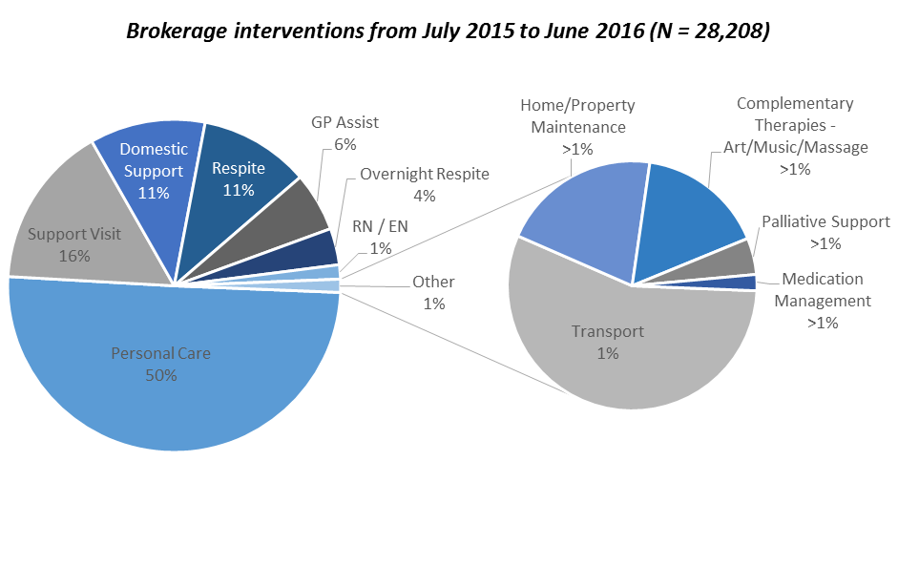
TDN agree with the view that informal caregivers can always be better supported to provide genuine choice at home. Supporting families in their role as primary carers builds on the critical role of GP’s in the community, strengthens community resilience, changes the culture of home care and reduces the economic burden of the full time caring role; allowing some carers to continue working or resuming paid work earlier. Improving health literacy, specifically around end of life care can reduce long term effects of grief and bereavement; while understanding Advanced Care Directives can improve transparency around the client’s wishes and how the h@H team can assist. TDN believe the role of the family as primary carers during the end of life journey contributes to other efficiencies created through programs such as h@H, while reducing the burden on acute care and paid support work.

“hospice@HOME was efficient and all arrangements were rapidly put into place. All of us involved are very happy.” [extract, client correspondence, 2016].

Conclusion

h@H delivers considerable savings to the healthcare system, while providing a quality end-of-life experience for clients and their families. This paper has documented the learnings and experiences of TDN gained through the provision of h@H. TDN are confident this model of care already encourages healthy competition, the opportunity for contestability and improves the manner in which users are informed and provided with choice.

TDN support a system that places user choice at the heart of service delivery and are committed to contributing to improvements in the sector. TDN look forward to sharing additional research findings with Government and the broader health and primary care sector.

