

Project Plan

CONTENTS
1 Executive Summary 1
1.1 Snapshot 1
1.2 About the project 1
1.3 The approach 1
2 The Problem 2
2.1 The need 2
2.2 Users and beneficiaries 2
3 The Solution 3
3.1 Visual: Theory of change 3
3.2 Vision: What is the change you are seeking to create? 3
3.3 Solution: What are you planning to do? 3
3.4 Rationale: What evidence do you have to support why you think it will work? 3
4 Project stages 4
4.1 Your plan 4
5 Funding required 5
5.1 Summary 5
5.2 Budget 5
5.3 Responsibilities 5
5.4 Beyond funding 5
6 Capabilities 6
6.1 The organisations involved 6
6.2 The team 6
7 riskS and assumptions 8
7.1 Key risks 8
7.2 Critical assumptions 9
8 Evaluation PLan 10
8.1 How will we know if the program has been a success? 10
8.2 Key learnings from the codesign stage 10
8.3 Evaluation capabilities 10
8.4 Your plan for ongoing learning and evaluation 10
9 Support required from Icare 12
9.1 Project sponsor 12
9.2 Support required 12

Executive Summary

Snapshot
Leveraging and optimising the existing social economy of the Mid North Coast (MNC) to nurture, educate and heal injured workers. Our project will create choices for returning to work and life through established partnerships, tested recovery programs and a community with a history of thought leadership on mental health journeys. Our holistic, wrap around solution led by The Recovery College (TRC) helps workers with psychosocial injuries to utilise local and online services, education, employment and social connections. This, then improves their quality of life, returns them to meaningful work and reduces the cost to the community and insurers of marginalised workers with a mental health issue. Consumer & Carer-led research will provide a continuous and dynamic evidence base to inform continuous improvement of the model, while providing transparent and accountable monitoring, evaluation, learning and reporting to the funding bodies.

About the project
Built on strong foundations of facilitating and supporting recovery matched with good governance, strong capabilities and appropriate resourcing, this project will be invaluable for employees injured during their work.
First line responders to mental health issues in the workplace include CEO’s/ Leaders, line managers, HR, Insurance case managers and investigators, Employer Assistance Program providers, Doctors, private Psychologists, selected state Government Health workers, community / social workers and certain community service providers. These groups form the basis of referral partners operating through existing partnerships and formalised MOU’s. Our referrer network will have information on legitimate, relevant and tested options that will facilitate a return to employment within 10- 20 weeks for 90% of a cohort (Our aim is 90%, but given the new nature of this pilot project, we feel it is best to target between 70-90%, until we get a sense of the trend arising, which will inform the Action Research Cycle of Continuous Improvement.). It is expected the project will assist up to 50 people for the first 12 months and double that number in year two, with expansion possible with additional funds.
Key to the project’s success is a valid assessment tool and intensive case management. This is supported by a recovery plan, underpinned by social inclusion, educational attainment, acceptance, respect and understanding of the emerging and dynamic nature of mental health research. This project will contribute to communities of practise and our own continuous improvement framework through TRC.
The College is a community-owned, place-based, one-stop shop for injured workers, others living with challenges and their carers, to find a non-stigmatised community of belonging, nurture and purpose. The unique and distinguishing design of the Recovery College provides a place for co-designed and co-delivered content presented by clinicians and adult educators, operating equally alongside those with lived experience of mental health challenges. The ten-week sessions offer progressive engagement with life and vocational skills leading to enhanced return-to-work choices.

The approach
Our approach is, the treatment of mental health issues for individuals injured at work via targeted, relevant education and evidence-based service delivery. Achieved through tested methodologies, partnership and intensive one to one support for people referred to our Recovery College.
Our approach involves the following phases:
- Map the social economy of MNC and environs

- Build a first phase manual system to receive, review and activate referrals; while liaising with other providers to explore the best ICT-based versions to use.

- Conduct tested case assessment trials

- Work with individuals to develop a recovery plan mapping a referral pathway to:
- Hospital to Home support program in place to ensure initial wrap-around support (Year 1)
- Enrolment at community college (tailored,10 week, repeatable) programs in the Strive Social & Emotional Wellbeing program, plus access to all existing accredited VET courses (Year 1).
- Support for consumers and carers in a community of belonging (Year 1)
- Pre-work experience activities within social enterprises via PMCC & the Maker Space (Year 1)
- Work Experience Placements and full Work Placements via Endeavour Clubhouse (Year 1)
- The original employer who received support to assist reintegration of the injured worker (rehabilitating the employer) (Year 1)
- A new employer through a RTW friendly MNC NSW Business Chamber campaign with self-nominated champion employers, and RTW Induction Programs for all parties (Year 1)
- Nominated Treating Doctors & Allied Health providing Mental Health plans that can be utilised at The Recovery College, for clinical and complimentary holistic support (Year 1)
- Micro business opportunities with business incubation & possible micro loans (Grameen Bank Australia) (Year 2)
- Established social ventures (Year 2)
- Expanded referral service to scaled community providers (Year 2)

- Educate and lead workplace reform on destigmatisation of mental health and building the business case for diversity, targeting industries with the highest claims rates and time off work. This will include identifying skillsets and micro credentials that can be considered for national scale-up, which is the primary role of our partner, SkillsIQ.

- Repeat assessments and conduct ongoing research to produce a continual evidence base, involving injured workers in their own research, with choices and opportunities for some to become peer support workers and peer researchers as vocations.

The Problem

The need
There is a need to develop connections between Employers, Insurers and Governments to limit the risks to relevant parties when an employee’s mental health is injured at work.
This project proposes an innovative, holistic response with national scalability that can reduce a range of social and economic indicators and deliver returns to Government funded programs, health expenditure, Icare scheme agents and employers. Benefits to the individual will impact their families, communities and assist in building healthier economies.
UN Sustainable Development Goal 3 Good Health and Wellbeing challenges this country to strengthen our capacity, for early warning, risk reduction and management of national and global health risks. While our health outcomes are not comparable to developing countries, we have an emerging risk in relation to increasing mental health problems, with Australians spending on average, 11 years in ill health which is one of the highest rates in OECD countries.
Some 20% of working Australians experience a diagnosable mental health issue and conditions such as anxiety and depression tend to affect people in their prime working years Access to Allied Psychological Services reports Depression was the most common diagnostic category among ATAPS consumers (44.7% of consumers) followed by Anxiety disorders (38.9%).
Answering the current gap in dealing with mental health is a locally led body that de-stigmatises RTW and collaborates separately with employers and employees, using education and awareness raising to assist RTW and remove threats to mental health in workplaces
In 2015 the Mid North Coast (MNC) had a population of 213 903 with15 688 businesses. According to Icare data, only 6 800 businesses are covered, suggesting a hidden risk to employees. 56.4% of the population are working age (15-64 years) translating to a workforce of 119 786. Within this cohort it is estimated that approximately 23 957 people have experienced a mental health issue.
The project will identify and prioritise those industries and employers in the region with higher claims and more time off. Data suggests that Manufacturing and Health and Community Services account for 42.5% of all claims in the region. The secondary market will target employers in the Construction, Retail and Utilities sector who account for 28.5% of claims. A tertiary focus will be on Finance and Insurance due to the disproportion between claims and average days off (162.5) within this sector. This project’s funding will initially assist a small percentage of those people, but its research will demonstrate a significant benefit, and its scaling up modelling and development of new methods will generate significant magnifier effects.
A return to work before 16 weeks is the objective for the project. This ensures that workers do not incur a financial disadvantage, as their payments decrease, and social isolation increases as time goes on.

Users and beneficiaries
Social economy impact:
Trauma and psychological injury in the workplace have a ripple effect from the individual to the employer, the immediate families, communities and the regional economy. Evidence shows that taking an integrated approach to mental health and wellbeing in the workplace leads to the greatest benefits. This project leverages such findings to provide a model for recovery that pulls multiple partners, programs and consumer centred research together to focus on a sustainable return to work.
Employees need better pathways to rebuild their lives after work-based injuries or trauma. Employers want effective RTW programs resulting in employees being able to reassume their role where possible. The Recovery Centre engages with both groups, to motivate an empathetic view of each other’s problems, while working practically to provide solutions.
Individual:
This project uses the World Health Organization’s definition of mental health as "a state of well-being in which every individual realises his or her own potential, can cope with the normal stresses of life, can work productively and fruitfully, and is able to make a contribution to her or his community".
Research by Beyond Blue in 2014 revealed around 90 per cent of employees think mental health is an important issue for businesses, but only 50 per cent believe their workplace is mentally healthy.
The targeted individuals for this project will be based in industries that have recorded the most significant time off and largest percentage of claims. For example, staff in the community and justice and health sectors will be targeted as research has revealed that exposure to traumatic stress and critical incidents may place ambulance, fire and rescue, corrections and state emergency services personnel at a greater risk for adverse mental health outcomes, including increased rates of depression, post-traumatic stress disorder (PTSD), burnout, stress-related anxiety, and suicide.
Organisations and Workplaces:
The complexities of modern organisations and the increased understanding and awareness of mental health and wellbeing issues has not yet translated to organisations understanding a key risk to their human capital. In addition, although anxiety and depression present as the major cause of claims and time off from work, research shows that less than half of the people experiencing these conditions seek help Organisations with a positive approach to mental health and safety have increased productivity, improved worker engagement and are better able to recruit and retain talented people. International research validates that there is decreased absenteeism, risk of conflict, grievances, turnover, disability injury rates and performance or morale problems when organisations have constructive or healthy organisational cultures. Price-Waterhouse Coopers has shown that for every dollar spent creating a mentally healthy workplace it can, on average, result in a positive return on investment (ROI) of 2.3.
Employers need to feel supported in engaging with return-to-work as a positive step, not a punitive, fee-incurring process. But they also need support in finding new ways to assist workers back into roles that may be different from their previous ones, or in totally new workplaces, without anyone feeling shamed or blamed in the process. A key element of this project is our capacity and skill in working with employers to audit and remedy issues that may affect an injured worker return to work (and act as a prevention of further injuries) meaning savings for the employer.
Families and Communities (including Government):
Increasingly government policy on disability and ageing has focused more on individualised care, social integration and regulation of quality standards to achieve sector reform. In addition, there has been a growing interest in documenting outcomes in mental health service delivery that have focused on evidence-based practice. Funding trends include increases in community mental health services and grants to non-government organisations. This project uses both tenets of emerging policy and regulation regarding individualised support through a mental health recovery plan, as well as utilising mental health clinical support options and community programs that show evidence of benefit.
Increasing demands on the primary health and rehabilitation industry to become more cost effective allow this project to move away from expert-based, pathologising, disempowering clinical-only approaches, to a more community-based recovery model that builds skills, personal agency and life choices. This project capitalises on the research that one size does not fit all.
Region:
Barriers to an integrated mental health service delivery in the MNC region include multiple and complex funding arrangements, siloed clinical fields and data streams, ever-evolving regulatory requirements, and dated infrastructure. This project targets economic growth of the region through a strong network of Educators (Community College model), Businesses (Regional Chamber of Commerce), Government (Local Area Health District) and key mental health service providers with regional coverage.
National:
Of the $9.0 billion spent nationally on mental health services in 2015–16, 59.8% ($5.4 billion) was funded by state and territory governments, 35.0% ($3.1 billion) by the Australian Government and 5.2% ($466 million) by private health insurance funds. This distribution has remained relatively stable over time, with 60.5% of national spending coming from state and territory governments, 35.5% from the Australian Government and 3.9% from private health insurance funds in 2011–12.
A 2010 Productivity Commission report stated that Australian organisations lose between $6 and $36 billion a year due to bullying with research pointing to poor organisational culture and a lack of leadership as the main drivers.
Global:
Funding, research, monitoring and the scalability of the design of the project in an increasingly globalised health services industry will help us connect and contribute to world leading health and management solutions. According to the CSIRO, improved pathways to market could encourage the development of novel and globally exportable solutions in Australia

Below is a diagram that demonstrates the linkages between the various collaborators within the project.
Establish the system
Referrer
Triage
- Initial Assessment & engagement
- Individual recovery plan established

Activate the Plan
Coach & Review  Adjust & reshape | Individual program |  |  | Employer engagement  & development
Coach & Review  Adjust & reshape | Consumer & Carer (C&C) led Peer Support & Peer Research |  | In program Wellbeing Support | Employer engagement  & development
Coach & Review  Adjust & reshape | Group program |  |  | Employer engagement  & development
Coach & Review  Adjust & reshape | Consumer & Carer (C&C) led Peer Support & Peer Research |  | In program Wellbeing Support | Employer engagement  & development
Coach & Review  Adjust & reshape | Re-skilling / new – skilling |  |  | Employer engagement  & development
Coach & Review  Adjust & reshape | Consumer & Carer (C&C) led Peer Support & Peer Research |  | In program Wellbeing Support | Employer engagement  & development
Coach & Review  Adjust & reshape | Workplace Assessment |  |  | Employer engagement  & development
Coach & Review  Adjust & reshape | Consumer & Carer (C&C) led Peer Support & Peer Research |  | Employee/ Employer Support - Clubhouse | Employer engagement  & development
Coach & Review  Adjust & reshape | Workplace trial |  |  | Employer engagement  & development
Coach & Review  Adjust & reshape | Consumer & Carer (C&C) led Peer Support & Peer Research |  | Employee/ Employer Support - Clubhouse | Employer engagement  & development
Coach & Review  Adjust & reshape | RTW |  |  | Employer engagement  & development
Coach & Review  Adjust & reshape | Consumer & Carer (C&C) led Peer Support & Peer Research |  | Employee/ Employer Support - Clubhouse | Employer engagement  & development

Evaluate
Evaluation of findings throughout the project and reporting against KPIS

The Solution

Visual: Theory of change
Include a visual representation of your theory of change

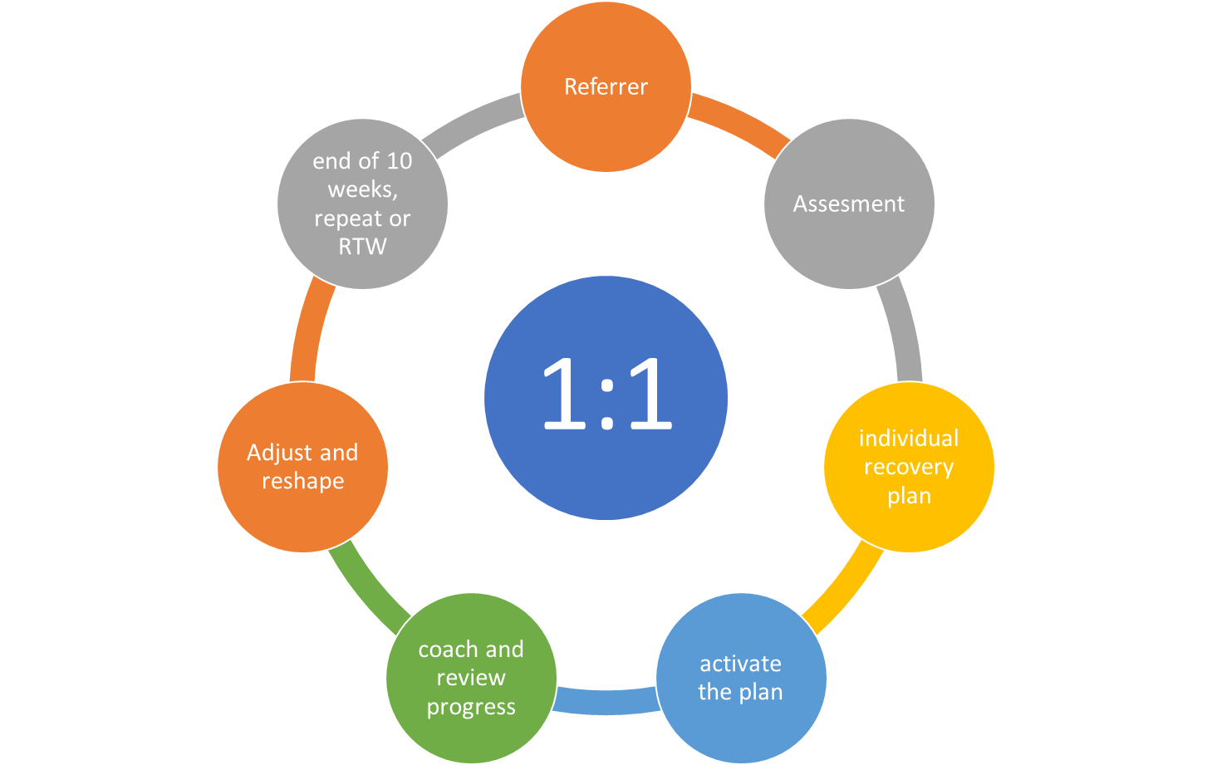

The project provides a cost-effective and evidence-backed preventative, precision-based, and digitally enabled range of health and wellbeing solutions.
The project empowers participants to manage their health by interpreting and improving their mental health literacy, reducing information asymmetry, expanding online and self-directed support services and developing consumer focused mental health solutions.
The solution lies in creating equity of access to services for all participants whilst providing intensive support individually so that our precision health solutions are underpinned by improved predictive analytics, an outcomes-based mindset, and a new set of skills for health professionals.
Considerations and assumptions:
Information management strategy:
Our project acknowledges that behavioural change is needed by all healthcare stakeholders to ensure the growing volume of personal health data is of high quality and is securely shared, collated, analysed, interpreted, and paired with action for improved health outcomes and enhanced trust in digital tools. We have a comprehensive understanding of how to support this behavioural change and will systematise the appropriate information management requirements and seek compliance through education with our stakeholders.

Ethical considerations:
Our experience in academia and mental health service provision means we are aware and cognisant of the ethical and legal and standards required to research mental health.
Our unique holistic approach to mental health means we honour everyone’s journey and understand the diversity in diagnosis and treatment of mental health issues. Of critical importance here is informed consent, this is being focused on to ensure that participants have a detailed (where possible) understanding of what they will be experiencing.
Referrer Network
We plan to have a multipronged approach to referrers, to reduce our reliance on only one referral path way, we will interact with community group such as GPs, organisations, Icare and a raft of community organisations to formalise our referrer network.
We understand how critical this is to the success of the project, and much strategizing is and will be put into this in the beginning stages of the project.
Assessment tool:
As the assessment is core to the whole program working effectively, we want first to determine if there are any suitable genuinely holistic assessment tools. If not, we want to invest resources in creating a thorough, robust truly holistic assessment that we envisage could also be used across icare’s other programs.
It would be a combination of clinical, self-assessment and resilience that expresses the holistic nature of this program and the challenges associated with RTW of individuals with a mental health injury.
Education:
PMCC will provide statements of learning and life development outcomes, plus statements of attainment for VET accredited and other competencies.
Service provision:
Service level agreements and MoUs to be signed with selected service providers. Access to online recovery program through partnership with Family Action Centre / University of Newcastle

Vision: What is the change you are seeking to create?
In the MNC region of NSW, this project will blend education, holistic and intensive mental health support services for injured workers in targeted industries.
The unique value proposition lies in the underpinning methodology of The Recovery College – a body that can rehabilitate workers and employers simultaneously to create value to individuals, workplaces, the community and the economy of the region. Research is expected to show a return on investment to icare through reduced claims, less displaced workers, less time away from work and more effective return to employment for participants and alumni of The Recovery College.
Up to 150 individuals will be assisted over 2 years to a faster and more sustainable return to some form of meaningful employment.
The change we seek is a community that demonstrates a greater understanding of and engagement with mental health recovery and its benefits, especially recognising that negative workplaces are major sources of ill health.

Solution: What are you planning to do?
Create opportunities for injured workers through an effective assessment, referral pathway and road map of services that aid recovery and return to work.
Criticality of engagement of claims managers
icare case managers with responsibility for the Mid North Coast region will be contacted and invited to a presentation of the Project, focusing on engaging all scheme agents/case managers in understanding the assessment tool (which will have been validated with case manager representatives through icare foundation coaching) The Recovery College proposes an ongoing partnership with scheme agents/case managers that involves notification to our project when a claims manager changes so our team can provide an induction to our service as part of their overall workplace induction.
Our Recovery College encourages an open and transparent referral process for claims managers and proposes regular issues and ideas video meetings with claims managers to feed research findings into their management of claims and to seek their input into our research.
Our project uses a standard engagement framework that steps out the process of providing information through to receiving buy in from claims managers and we utilise a software solution for stakeholder relationship management to ensure continuity and sustainability of the relationship with scheme agents.
Engagement and relationship management with other referrers and stakeholders
Marketing of the program to employers will occur through the supportive and established relationship with the local Chamber of Commerce who have played a leadership role in creating an RTW friendly campaign in the region. A communication plan will include a networking forum. Community engagement strategies and relevant communications for employers and will be supported by a social media campaign that expands the RTW friendly community idea.

Rationale: What evidence do you have to support why you think it will work?
In the Recovery College workers, carers and their families will benefit from better life choices and being able to reclaim their own agency in life. Employers will engage with a more positive workers compensation process, and icare will be seen to be working alongside everyone in a positive new program of recovery. Families and Communities will benefit from breaking the cycle of despondency that besets too many injured workers, have a destructive effect on morale at home. Health professionals will become more equal partners with those in recovery, rather than operating in expert silos.
Research conducted by Dr Robbie Lloyd, TRC Director, with over 60 participants living with psychosocial challenges, their carers and families, plus health professionals, (Lloyd, UWS 2010), showed that community-based, self-help, peer supported rehabilitation does produce major quality of life improvements. RTW from injury and illness requires breaking the cycle of dependence and pathologising clinical labels. This project models that approach in a place-based, locally engaged way, providing evidence of people empowering themselves, as has been occurring at the existing Sydney based Recovery College) in Kogarah, the Inner City, and now Western Sydney).
Nationally, a new approach to workforce capacity building and HR Management, based on new skillsets and micro credentials, can enhance workplace empathy, reduce toxic cultures of bullying and harassment, and show managers the bottom-line benefits of building whole-organisation culture of wellbeing.

Project stages

Your plan
January – July 2019: Planning and Development, First Phase Testing
- Appointment of TRC Coordinator;
- Finalise MoUs with all partners;
- Finalise Assessment, Research & Evaluation Processes and Templates;
- Refine & Record the process of community engagement & integrated network of business & community that PMCC has been through to get to this point of engagement;
- Connect with injured workers, primary & allied health network in the Port Macquarie Hastings community and setting up the Referral Networks to begin enrolling participants;
- Identify & Engage with local RTW Friendly Employer champions with MNC NSW Business Chamber and introduce the concept of Workplace Induction & Peer Support program;
- Engage GP Champions, primary & allied health practitioners willing to pilot this new approach to community-based recovery and rehabilitation;
- Begin induction, education & training workshop program for MNC Local Health District mangers & clinicians, involving other co-design & co-delivery Recovery College teams from around NSW; involve primary & allied health champions and practitioners ready to employ new RTW approaches;
- Develop Resources for RTW Managers & Staff Induction Program, Recovery College Staff Training & Development Program, Consumer & Carer Research Group Program;
- Refine the Consumer & Carer Research Project elements and staffing for Evidence Base Collecting & Reporting and align with icare’s MEL priorities.
July – December 2019: Introductory Testing & Full Implementation
- Engage Return-to-Work candidates and Carers/Families in the Introductory First Phase of joining a Community of Belonging & Purpose at the Community College; begin initial enrolments in programs;
- Contact connect with and Assess injured workers and their icare & allied health consultants through the Case Management process, and link with TRC programs;
- Connect with self-nominated employers in the community and engage in the RTW Friendly Program;
- Expand the Consumers & Carers Research Group to include RTW participants, and identify potential peer supporters and peer researchers for training; establish the Monitoring, Evaluation & Reporting cycle;
- Begin the Action Research cycle for further developing TRC model, as well as the education & training process for other self-nominated Community Colleges, Health Districts and Business Chambers across NSW to join this movement;
- Liaising with icare on evolving the model and adjusting target issues that have come up in their research & evaluation;
- Identify the Skillsets and Micro credentials that can arise from TRC and be trialed for national roll out; work with SkillsIQ to identify Workforce Capacity Building lessons in TRC approach;
- Annual Report, Evaluation and Learning Recommendations, including lessons from adjustments arising from first year of operation in the Action Research cycle.
2020: Follow-on Implementation and Scaling Up Preparation
- Fully functional Recovery College operating in Port Macquarie, according to the development of processes and programs from 2019;
- Education of other Local Health District Managers & Staff, Community Colleges and Business Chambers across NSW in a Roadshow/Show and Tell program;
- Mapping of Clients to this point to establish patterns and pathways of RTW and other life choices & outcomes;
- Liaise with icare to explore next stage developments;
- SkillsIQ begins to develop a new approach to advising Government & Business on Workforce Capacity Building and HR Management reform, informed by TRC experiences and Research Evidence Base;
- Commercial packaging of programs arising from TRC that can generate sustainable income or cost offsets;
- Annual Report, Evaluation and Recommendations for further adjustments after second year of operation; special focus on analysing Cost Effectiveness; Promote results in appropriate industry, health, research for a through reports, papers, workshops etc.;
- Assist other TRCs emerging elsewhere around NSW.

Ongoing
- Repeat program with adjustments from 2019-20 stages;
- Fully functioning TRC moves into mature operation;
- Statewide network of TRCs strengthens its existing Community of Practice;
- Evaluation expands to wider network of rural and regional TRCs alongside urban sites;
- Third Year TRC Report provides a final end-of-pilot Cost Benefit Analysis and Recommendations for longer-term investment by icare foundation and other partners (Health, Business, ACE sector etc) and potential for exporting the model internationally.

Stage | Description of approach and activities | Expected Delivery Date | Outcomes
1.1 – Initial Establishment | Appoint TRC Director & other relevant staff | Immediately after contract signed | Begin building TRC Team
 | Establish MoUs, Referral, Governance & Fin/Admin Reporting Structures, Policies & Protocols; Determine Case Assessment Process: F2F & on-line | Within three months of start date | TRC MoUs, Structure, Governance, P&Ps & Fin/Admin Reporting lines set up;  Referral lines identified, and stakeholders contacted to recruit
 | Conduct MNC Mapping Exercise; Liaise with Icare re access to RTW candidates; Develop R&D Program with CDS Syd Uni | Three months after start date | Social Economy of MNC mapped, and first cohort of RTW candidates identified; R&D Program & reporting lines refined
 | Communication campaigns to find RTW Champion Employers, Clinicians & Educators to join TRC; and begin outreach to Scheme Agents, Case Managers & Rehab Professionals | Three months from start date | First cohorts of partners identified and ready begin Training & Development
1.2 – Start-up TRC Partnership and Training & Development Process | Hold Foundation TRC Workshop with all relevant stakeholders | Four months after start date | C&Cs, Health, ACE (Adult Community Education), Business partners inducted into the model
 | Begin RTW Friendly MNC Campaign & Finalise Workplace Induction Program for Employers & Peer Workers | Four months after start date | RTW Employer Champions recruited; RTW Workplace Induction Program ready to trial
1.3 – Begin with RTW candidates | Enrol RTW candidates, begin Case Assessments & Individual Recovery Plans; begin C&C Research to provide MEL/Evidence Base | Six months after start date | Everyone has a recovery plan, incl. case assessment detailing supports needed; R&D/MEL Evidence Base being collected; MEL reporting underway
 | Test Referral program, H2H early support, and RTW Work Experience/Placement | Six months after start date | Referral system built, receive, review and activate; H2H & Work Experience/Placement tested
2. Full Functioning TRC | RTW candidates enter smooth system of case Assessment, program & RTW | One year after project start date | Assist up to 50 people for the first 12 months
 | R&D, MEL functioning smoothly in line with C&C Research program | One year after start date | Feedback research and preliminary results into broader mental health & Icare networks
3. Mature Pilot TRC Proves the model | Ongoing Action Research Cycle for Continuous Improvement | Two Years after project start date | Assist up to 100 people in year two
 | Reports analyse SROI and EROI; R&D/MEL provides Evidence Base to justify scaling up state-wide | Two years after start date | Facilitate a return to employment within 10- 20 weeks for 90% of a cohort at end of project.

Funding required

Summary
Total Funding Requested from icare for Life of Project: $699,998
PMCC In Kind Contribution: $475,000
Total Cost of Project: $1,174,998

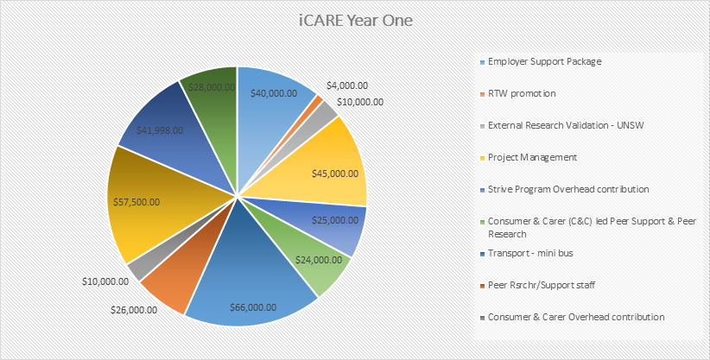

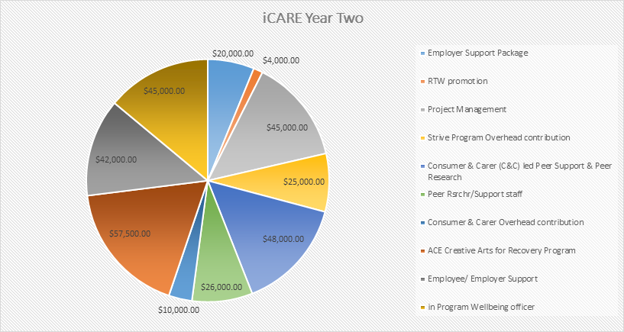

Budget
Please include your budget, with a break down by project stages and components. Please see the budget as Appendix A in this document.
This project is being managed through Port Macquarie Community College who will have overall responsibility for the management of the project finances under the management of the CEO Valerieanne Byrne.

Beyond funding
We will incorporate this into the design. As we envisage the benefits to be dispersed with each of the stakeholders, as the evaluation data comes in we will be better placed to establish our ongoing business model and exactly who would pay what within that system. We also envisage application for additional grant monies as part of this.
This is a core focus of our evaluation data, to determine the sources of benefit, thus the parties who would be most likely to be involved with user pays system.

Capabilities

The organisations involved
Boards & Committees -Mid North Coast Human Services Alliance, Mid North Coast Local Health District Ethics Committee, Community Reference Group (Health District), Healthy Communities Advisory Committee, Strategic Ageing, NSW Health Awards Panel
Organisational – Skills IQ, Centre for Disability Studies, ACES Disability Services, JSA’s, DES, TAFE, Novaskills (RTO), Octec (RTO), Etc (RTO), Tursa (RTO), Nortech (RTO), Meals on Wheels, Hastings Respite Care, Lifeline Midcoast, Endeavour Mental Health Recovery College, Port Macquarie Communicate College, Benevolent Society, Samaritan
Community - Mid Coast Connect, OmnIcare, Charles Sturt University, Hastings Secondary College, Wauchope High School, Newman College, Hastings Educational Skills Forum, Port Macquarie Hastings Council, Biripi Local Aboriginal Land Council, Chamber of Commerce, Mid North Coast Business Chamber
Region - Mid North Coast Health Department, Ministry of Health Clinical Excellence Commission, Agency for Clinical Innovation, NSW Business Chamber
National - Community Colleges Australia, Adult Learning Australia, Creating Futures Collaborative, Asia South Pacific Association for Basic and Adult Education
This is a diagram depicting the way in which each of the collaborating parties interact.

The team
Dr Robbie Lloyd– The Recovery College Leader – Port Macquarie Community College. Dr Lloyd has been working in health and human services, education and training, and innovative, person-empowering research for decades. He has specialised in Indigenous development, Disability empowerment, Mental Health & Ageing Reform, all based on serving the common good rather than private profit. He continues to work in community settings across regional and remote Australia, as well as Asia Pacific, trying to make ACE (Adult Community Education) the natural partner for reform in community-based health, education and human services.
Sue Ellen Evans – Engagement Executive - Skills IQ. Sue-Ellen has an extensive background in Workforce Planning, Adult Education Disabilities, Aged Care and managing complex projects with multiple stakeholders toward and outcome. She has successfully recruited and managed two network groups of business leaders in Community services and worked with a range of other allied human services alliances around NSW.
Yasmin King – CEO – SkillsIQ Yasmin has held several CEO and Non-Executive Director and Board positions across a range of industries. SkillsIQ is a skills services organisation effecting 50% of the Australian workforce. She is adjunct to the Australian Graduate School of Management, lecturing in Negotiation and Conflict Resolution. Previous roles include inaugural NSW Small Business Commissioner and Associate Commissioner for the Australian Competition and Consumer Commission. She is an Innovative strategic thinker who effectively engages with a diverse range of people across different backgrounds and cultures. She is outcome focused, commercially astute and intellectually able to quickly get across a broad range of complex issues and implement initiatives that meet strategic objectives.
Yasmin is a Fellow of Australian Institute of Company Directors and a Fellow Certified Practising Accountant and a sought-after public speaker and presenter. Yasmin holds a Master of Business Administration and an Honours degree in Economics. She is a Fellow of the Australian Institute of Company Directors and Fellow Certified Practicing Accountant.
Natalie Wilson – Drug & Alcohol Services – Social Worker Natalie has 20 years’ experience working in the Drug & Alcohol and Mental Health Services. She has a strong interest in the treatment of co-existing substance use and mental health conditions and has recently participated in the development of the MNCLHD Collaborative Comorbidity Strategy. She has also worked extensively in the community development field and has strong relationships with local networks, government and non-government organisations and community members.
Natalie has been instrumental in the development of the D&A Service Consumer and Carer Strategy and the formation of the D&A Consumer and Carer Committee. Consistent with the philosophies of the Social Work profession Natalie maintains a tireless passion for human rights and is a strong advocate for client centred service development and delivery. She is committed to ensuring that consumers and carers are involved in all aspects of their treatment and recovery journey and that they receive the respect and acknowledgement that they are the experts of their own lives.
Professor Patricia O’Brien – Director of Centre for Disability Studies (an Affiliate of USYD) and Professor of Disability Studies at Sydney Medical School – Patricia is an international leader in person-valuing reform of the disability sector. She promotes research that is inclusive of people with disabilities as co-researchers, as well as the promotion of access to tertiary education for students with intellectual disabilities. She is particularly interested in advocacy, deinstitutionalisation, community participation, transition, inclusive research and education, and individual supported living (ISL) arrangements. The training programs at CDS focus on Person Centred thinking and practice, leadership, facilitation, and social and community networking with an emphasis on working within the NDIS system.
Cheryl Taylor - Following many years working in health and community services, Cheryl specialised in learning support among high school students living with challenges. She then added adult education to her skillset and has combined working with vulnerable community groups with training people in individual support leading to work in disability and aged care. Cheryl has a passion for seeing everyone realise their greatest potential in ways that celebrate their difference and diversity.
John Brownsberger - After originally training in the USA as an anthropologist, John could not find work and drifted into the early computer industry, where he became a leading light before emigrating to Australia. His career then took off in a twin stranded way, combining ICT and Indigenous Studies over several decades. Later he began working with vulnerable community groups and found a passion for helping people to discover their talents with his person-valuing teaching style.
David Rogers - District Manager Drug and Alcohol Services for the Mid North Coast Local Health District. His primary discipline is nursing, in which he has worked for NSW Health for over 40 years in a diverse range of fields including Psychiatric Nursing, General Nursing, Adolescent Psychiatry, Aged Care, Acute Psychiatry and the Disability sector. He is an innovative program designer and manager, encouraging staff to pursue patient-centred, recovery-focused initiatives, and he promotes research and analysis of data to improve service delivery and health outcomes for clients requiring services.
Kellon Beard - Regional Manager for NSW Business Chamber on the Mid North Coast, where he works supporting businesses across the region from Forster-Tuncurry to Woolgoolga. Kellon has worked for the State Government and has extensive experience in business across a number of industries. He began life as an apprentice and knows how to work with young people needing a start in life. He is degree qualified and currently completing a Master of Business with Charles Sturt University, but his passion is to see all people working successfully in fields where they can excel.
Why is this the right team? The extensive existing connections and relationships at the community, regional and country level will be ultimately the thing that drives project success. With the unique and right mix of knowledge, skills and attitudes, Robbie and his team have already demonstrated incredible capability to mobilise teams to complete project outcomes in complex environments. In addition to this, the critical mixture of Academic and Practitioner and Clinical & Practical, will ensure that the best possible of all the approaches is taken within this project.
This will be the key strategy to ensuring that there are minimal risks in the relationships area, all parties know each other and have agreed to participate and support the program.

riskS and assumptions

Key risks
Risk | Likelihood | Impact | Mitigation
Referrers not understanding the program | Medium | Large | Ensure that the referrers are upskilled on program details and what is in it for them. Sign MOU ASAP.
Assessment methodology not being robust enough | Medium | Large | Utilise established professional assessments
Difficulties in identifying 50 participants | Unlikely | Large | Provided the connections to the referrers is robust,
Close Down Period | Likely | Medium | Effect on recruitment & Planning
Delays to funding allocation | Unlikely | Medium | Constant liaison with Icare and alignment of goals with Icare and the recovery college
Lack of Icare data | Unlikely | Large | This is a risk for every project, we determine what Icare have in place to mitigate
Lack of engagement from partners & collaborators | Unlikely | Medium | The existing positive relationships should be built on and strengthened to ensure this does not happen
Business Chamber not having enough RTW friendly employers | Medium | Medium | Addressed in the briefing phase of the program, clear communication and a MOU with the Chamber
Participants lacking adherence to their individual recovery plan | Likely | High | Ensure Assessment identifies individuals who may require more support through this cycle
MOU not being signed | Unlikely | Medium | Ensure that this is done at the commencement of the project

Critical assumptions
List the critical assumptions you have made in relation to how your solution will work. Also include how you have tested (or plan to test) these assumptions. How will you respond if the assumption is incorrect?

Critical Assumption | Plan for testing | Potential Adaptation
That partners will sign the MOU with accurate information being provided | Get a couple of partners to sign ASAP to test willingness | Ensure the marketing of the program and the education to the collaborators is provided
That the assessment adequately identified how effectively someone will progress through the program | There is regular feedback built in through the system, to adjust and fine tune as needed | Ensure that at each stage of the project the Individual Recovery Plan is reviewed
That workplaces are actively wanting to change following an injury | Offer support and transformational coaching to workplaces that injured workers come out of, focusing on the line managers and the CEO | Identify in advance which cultures are unhealthy where more people will be at risk
That the theory of change will effectively reduce RTW in this region | As we go through the evaluation cycle this will be tested at each phase of the 6-month reports and the final 2-year evaluation | Adapt the theory as we go, where more information and learning come into sight.
That after 13-16 weeks there will be workers who return to work within the program | This will be measured extensively, including the timeline that the individual has been on workers comp | We may find that the program is more suitable for people either in the RTW program in the early phases or later on, we can adjust we find this out

Evaluation PLan

How will we know if the program has been a success?
What are your success markers or milestones along the way?
Our program will be a success when:
- Our Consumers & Carers are fully engaged in the learning and life development program, and some choose to join our ongoing C&C Research Group, providing continual input to our continual Evidence Base collection
- As many as possible of our cohort RTW before 16 weeks
- When 90% of the cohort are RTW within 10-20 weeks
- Workplaces (managers and peer staff) agree to rehabilitate and increase their knowledge and skills in dealing with mental health injuries
- Organisations can receive reduced premiums as they have demonstrated more robust management of people returning to work, and evidence of workplace cultural reform
- The MNC Branch of the NSW Business Chamber can clearly identify people who they have supported through their RTW employers
- Insurers can have less injured workers on their books for the long-term category
- We will publish annual reports of the outcomes arising from this workplace/RTW process, as well as outcomes from the C&C Research & Evaluation process
Individuals can Return to Work at any time when they show readiness within the project cycle. Each component has an exit point that can be utilised as participants are ready. So each marker between each stage is an important part of the cycle as they are all opportunities for exit.
What stories are likely to arise from your project that might be able to be used to influence wider systems change?
We already have several individual stories from individuals completing similar cycles in the earlier version of the Recovery Plan. We have observed significant social change, increased confidence, increase in self-agency and a greater desire to Return to Work. This has been supported holistically by many community stakeholders. We expect similar stories of positive impact from this formal proof of concept.
The C&C Research Group will produce a publishable evidence base, de-identified to maintain confidentiality, showing the trends in causation, successful healing and recovery strategies, and other factors salient to C&Cs in the RTW support context of the Recovery College.

Key learnings from the codesign stage
What have you learnt because of codesign? That participatory planning of a project like this is critical to ensure that the issues are considered from a range of different alternatives. It was useful to hear all of the other ideas and evaluate them through the eyes of icare staff and scheme agents. This helped us enormously to engage with the pragmatics of effective holistic support strategies from injury to RTW.
How have you adapted your solution because of codesign? We have become much more specific because of the Codesign process. We have scoped our project down to 100 individuals in the first cohort and focused on the proof of concept idea. We have adapted the proposal to become more visual and demonstrate the project through diagrams. We have listened to icare’s needs throughout the Codesign process, and we have been able to focus on their priorities in conjunction with each of the other stakeholders and partners.

Evaluation capabilities
The Consumer Led & Carer Led Research process, which is already underway in a small trial form, will underpin our ongoing evaluation of the project from the workers’ and their families’ points of view. Due to our broad Academic connections within the project, through CDS and the MNCLHD network, we plan to ensure that the Consumer & Carer Led Research process keeps evolving and can provide a robust evidence base, as well as being integral to our ongoing practice for Year Two.
We plan to use the Most Significant Change methodology to gather stories along the life of the project, and to develop those for evaluation purposes, to inform organisational learning and to share the project’s successes with other sites, peers in the health and adult education worlds, as well as across the NSW Business Chamber’s network.

Your plan for ongoing learning and evaluation
Please include your proposed approach for measuring outcomes including method and indicators, noting that your evaluation plan will be further developed after funding is secured.
Key evaluation questions | Sub-questions | Indicator
Is the research delivering the outputs and outcomes as planned? Efficiency & Effectiveness | - C&Cs engage in finding meaning  - Agency-building improves their self-esteem & ability to grow  - Feedback to Health, ACE, icare & business shows trends in injury causes & effective interventions | - Improved quality of life for workers and families  - Health & Ace sectors hear input about what’s needed for more effective early & mid-term RTW healing & recovery strategies  - Improved practices
Have activities and their methods been effective? Process Effectiveness (Individual Learning Plans ILPs & Individual. Recovery Plans IRPs; and Quality of Life QoL) | - C&C Research Group inputs on +s/-s of existing approaches  - Case Assessment Baselines & IRPs/ILPs measure progress & changes in QoL outcomes & RTW | - Number of workers returned to work after the 10-week program  - No. RTW from 10-20 weeks  - Other outcomes in learning & life development reported six mthly
What outcomes (Individual, Family, Community, Region) has the project contributed to? Outcome | - C&CR Group provides ongoing input on personal/family change  - PMCC surveys stakeholders to assess outcomes for community & businesses | - More positive workplace cultures in local organisations to minimise numbers of injured workers  - PMCC surveys C&Cs for “course feedback” as they complete programs, measure +/-s
How has this project influenced the stakeholder and collaborators? Impact | - All partners/stakeholders surveyed & focus group interviews to refine evaluation of TRC impact  - Trends in RTW, workplace culture change tracked & issues fed back to stakeholders & icare | - Additional cohesion in broader business community in MNC  - MNC Business Chamber expands RTW Friendly Campaign each year and celebrates champions  - PMCC & Health promote TRC model with peers for scale up
Is the project on budget? Could it be done more efficiently? Efficiency | - Mthly Budget/Activity Reporting tracks cost effectiveness & steers changes as it evolves  - Quarterly Reviews assess progress & change as needed | - Overspends or underspends are identified & changes made  - Economies identified by C&Cs, clinicians & educators  - MNC Business Chamber liaise with businesses re RTW cost trends
Is their evidence that the initiative is scalable beyond the project life? Sustainability | - C&CR project indicates trends  - PMCC & Health monitor for changes to approaches to ensure feasible local scalability  - Costs/Income identified as part of the modelling, with SkillsIQ adding Training & Development packaging  - Research leads to published papers, reports, workshops etc | - Where possible, on-line and software-based assessments used to streamline & clone for scaling up  - Templates developed of all aspects to share with Health/ACE  - RTW Workplace Induction program templated for local customising  - Increased discussion in circles of power about RTW culture change
To what extent did the project meet the stakeholder needs? | - C&CR Grp inputs on the impact of the project on each level of their lives: QoL, RTW etc;  - Other Stakeholders surveyed & focus grp interviewed to assess changes in RTW experiences  - Health & ACE sectors develop new Case Assessment, Rehab & Recovery support programs  - Businesses and Funders see outcomes in cost savings | - Participants key need – Return to Work  - Organisations key need - Culture  - Community key need - Cohesion  - Regional need – Spend on regional healthcare & Training/development  - icare/Insurers – less injured workers, injured workers RTW sooner  - Business, Health, Govt – savings on budget drain from compensation, rehab support, medical recidivism
The above logic Inputs – Outputs – Outcomes will be utilised in the detailed implementation plan and the detailed Monitoring & Evaluation plan.
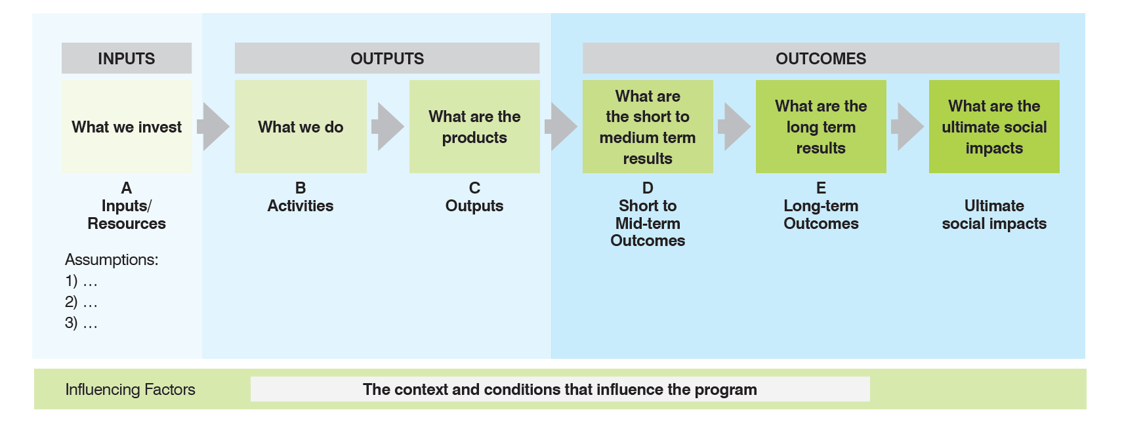

Key learnings from the codesign stage
What have you learnt because of codesign? That participatory planning of a project like this is critical to ensure that the issues are considered from a range of different alternatives. It was useful to hear all of the other ideas and evaluate them through the eyes of icare. This helped us enormously
How have you adapted your solution because of codesign? We have become much more specific because of the codesign. Scoped it down to 100 individuals and focused on the proof of concept idea. We have adapted the proposal to become more visual and demonstrate the project through diagrams. We have listened to icare’s needs throughout the codesign proposal and have been able to focus on them in conjunction with each of the other stakeholders.

Evaluation capabilities
The Consumer Led & carer led research will form a large percentage of the ongoing evaluation of the project. Due to our extensive Academic connections within the project, we plan to ensure that the Consumer & Carer-led research provides a robust evidence base as well as becomes integral into our own practice for Year two.
We plan to utilise the Most Significant Change methodology to gather stories along the life of the project and utilise those for evaluation purposes, to inform organisational learning and to share the projects successes.

Your plan for ongoing learning and evaluation
This plan is the initial framework and will be further developed in more detail as the project goes along. We understand that there will be a 6 monthly reporting cycle that we adhere to throughout the life of the project and a final evaluation.
Key evaluation questions | Sub-questions | Indicator
Is the research delivering the outputs and outcomes as planned? Efficiency & Effectiveness | Are each of the outcomes on track? | Improved quality of life for workers
Have activities and their methods been effective? Process Effectiveness | Has the Recovery College Model been effective? | Number of workers returned to work after the 10-week program
What outcomes (Individual, Family, Community, Region) has the project contributed to? Outcome | Has each stakeholder group received the desired outcomes? | More positive workplace cultures in local organisations to minimise numbers of injured workers
How has this project influenced the stakeholder and collaborators? Impact | What change have we seen with project collaborators? | Additional cohesion within the broader business community in the region
Is the project on budget? Could it be done more efficiently? Efficiency | Was the budget spent on the projected activities? | Where there any overspends or underspends
Is their evidence that the initiative is scalable beyond the project life? Sustainability | Is there a system within the project that is scalable? | How realistic would it be to automate much of the assessment cycle and system delivery in order to scale
To what extent did the project meet the stakeholder needs? | What impact did the project have on each level of stakeholder? | - Participants key need – Return to Work  - Organisations key need - Culture  - Community – key need cohesion  - Region – Spend on regional healthcare  - icare/Insurers – less injured workers, injured workers RTW sooner

Support required from Icare

Project sponsor
We have attended each session of the codesign and utilised all the coaching opportunities. These have been invaluable for the further detailed development and design of our project. We have utilised opportunities at each session to ask a range of clarifying questions, complete the exercises.
We have approached a couple of individuals to be our agreed project sponsor within icare and been given the advice that this will be negotiated internally with icare and shared with others later in the year. We would like the individual to be engaged with this project and specifically interested in this approach if that is possible.

Support required
One of the key requirements from icare is access to all relevant detailed data on mental health injuries in the workplace. We need to be able to ensure that icare can play a critical role in helping us gain access to the insurers, scheme agents and case workers to support the identification of the participants within our region and to connect us to the relevant case managers for the region.
We also raise the issue of assessment processes. We believe it is in icare’s interest to scope a specialist piece of work that assists each of the project groups to determine the assessment process. For the robustness of the data and the validity of the research it would be prudent if each group were using the same assessment tool on the front end, with a variety of interventions then demonstrating change.
To that end we believe that the allocation of the Project Sponsor is critical to ensure that the relationship between icare and ourselves progresses effectively.

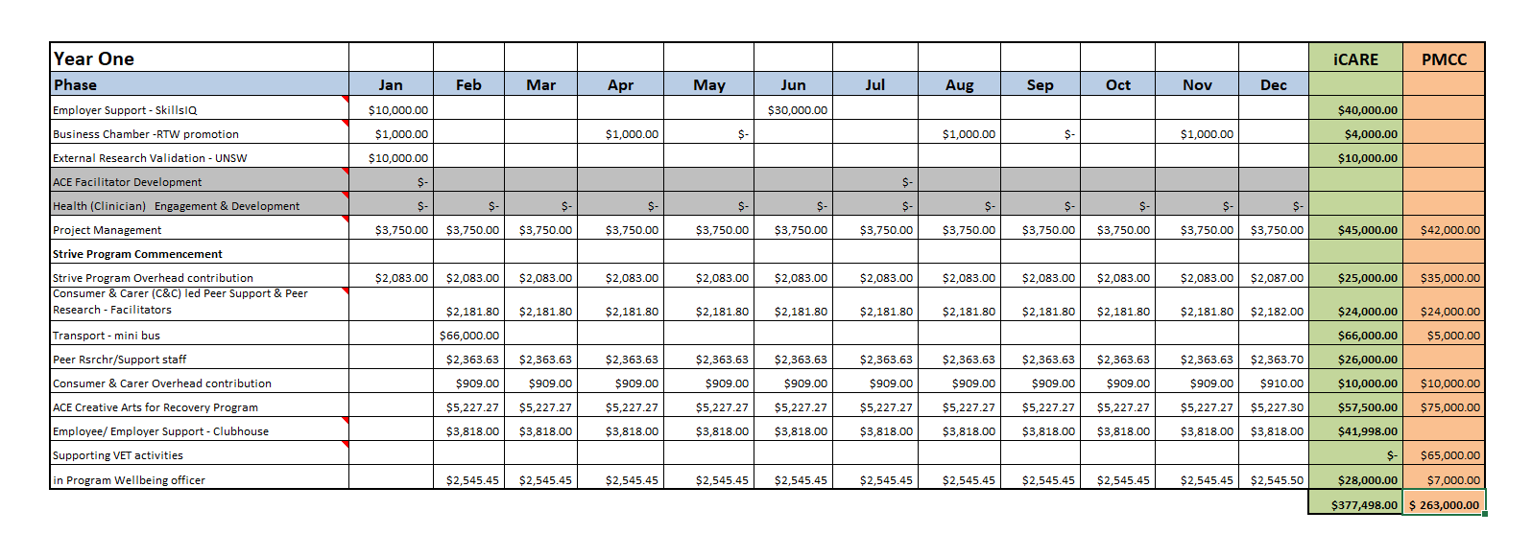
Appendix A - BUDGET

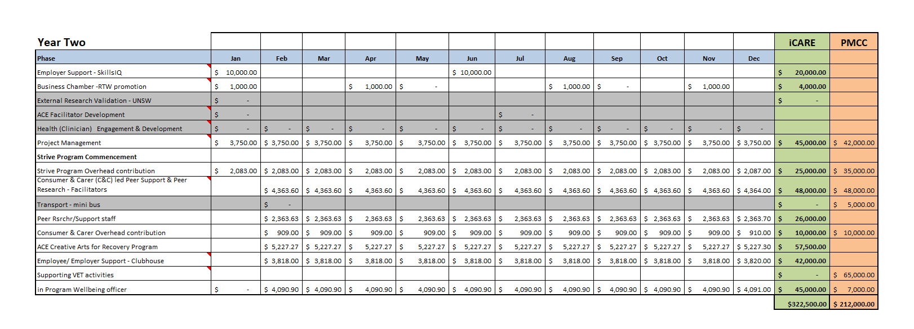

https://www.un.org/sustainabledevelopment/health/
Productivity Commission (PC) 2017, Shifting the Dial: 5 Year Productivity Review, Inquiry Report No. 84, Canberra
TNS (2014). State of Workplace Mental Health in Australia. Melbourne: beyondblue.
Australian Bureau of Statistics (ABS). (2008). National Survey of Mental Health and Wellbeing: Summary of Results, 2007. Cat. no. (4326.0). Canberra: ABS.
https://www.aihw.gov.au/reports/mental-health-services/mental-health-services-in-australia/report-contents/access-to-allied-psychological-services
http://stat.abs.gov.au/itt/r.jsp?RegionSummary&region=108&dataset=ABS_REGIONAL_ASGS&geoconcept=REGION&measure=MEASURE&datasetASGS=ABS_REGIONAL_ASGS&datasetLGA=ABS_NRP9_LGA&regionLGA=REGION&regionASGS=REGION
https://www.Icare.nsw.gov.au/employers/industry-insights/interactive-tools/#tab-tab-insights-injury
LaMontagne, AD., et al. (2014) Workplace mental health: developing an integrated approach. BMC Psychiatry, 14,131.
World Health Organisation (WHO), 2014. Mental Health: a State of Wellbeing.
1.Wang, Z., Inslicht, S. S., Metzler, T. J., Henn-Haase, C., McCaslin, S. E., Tong, H., Neylan, T. C. and Marmar, C. R. (2010) A prospective study of predictors of depression symptoms in police. Psychiatry Research, 175(3), pp. 211-216.
2. Marmar, C. R., McCaslin, S. E., Metzler, T. J., Best, S., Weiss, D. S., Fagan, J., Liberman, A., Pole, N., Otte, C. and Yehuda, R. (2006) Predictors of posttraumatic stress in police and other first responders. Annals of the New York Academy of Sciences, 1071(1), pp. 1-18.
Joyce, S., Modini, M., Christensen, H., Mykletun, A., Bryant, R., Mitchell, P. and Harvey, S. (2016) Workplace interventions for common mental disorders: a systematic meta-review. Psychological medicine, 46(4), pp. 683-697. & Rutkow, L., Gable, L. and Links, J. M. (2011) Protecting the mental health of first responders: legal and ethical considerations. The Journal of Law, Medicine & Ethics, 39(s1), pp. 56-59.
Australian Bureau of Statistics (ABS). (2008). National Survey of Mental Health and Wellbeing: Summary of Results, 2007. Cat. no. (4326.0). Canberra: ABS.
Instinct and Reason (2014) Heads up Intiative: Employer of Choice Study. Melbourne: beyondblue
Standards Council of Canada (2013). Psychological health and safety in the workplace — Prevention, promotion, and guidance to staged implementation. CAN/CSA-Z1003-13/BNQ 9700-803/2013.
Pricewaterhouse Coopers (PWC) (2014) Creating a mentally healthy workplace: Return on investment analysis. Melbourne: beyondblue
Trauer, T. (Ed) (2010) Outcome Measurement in Mental Health: Theory and practice. Cambridge University Press, UK
Productivity Commission. (2010). Performance Benchmarking of Australian business regulation: Occupational Health and Safety. Melbourne: Australian Productivity Commission.
Magee, C., et al. (2014) Workplace Bullying in Australia. Melbourne
Future of Health; Shifting Australia’s focus from illness treatment to health and wellbeing management, CSIRO Futures

