

Response To
The Australian Government Productivity Commission
Draft Report on Mental Health

Contents

I. | Executive Summary …………………………………………………………… |  | 3
 | A. | Recognizing the Problem ……………………………………………..… | 3
 | B. | Bringing an Actuarial Approach to Create a Solution ……………….. | 4
 | C. | Recommendations ……………………………………………………..… | 6
II. | Background …………………………………………………………………… |  | 8
III. | Recommendations: A Comprehensive Program to Achieve Real Results … |  | 17
IV. | Costs …………………………………………………………………................ |  | 20
V. | Profiles …………………………………………………………........................ |  | 21
VI. | Bibliography ………………………………………………………………….. |  | 24
VII. | Appendices ……………………………………………………………………. |  | 29

- Executive Summary
We have examined the Mental Health Productivity Commission Draft Report and are grateful for the opportunity to submit our comments and recommendations.
Reform Is Badly Needed
We agree with the need for substantial reform in the Australian Mental Healthcare System and applaud the Government's efforts in this historic undertaking. Many of us in the healthcare community have long been calling for reform and are grateful for the opportunity to take part in the current discourse to help guide our country towards a healthier and more prosperous future.
After examining the Productivity Commission Draft Report, we have identified a number of key targets within Reform Areas 1,2, and 5 which BrainDx can make significant contributions towards amending. We strongly believe it is time to shift away from reliance on subjective self-report and qualitative assessment of mental illness and begin using objective, scientifically proven data to diagnose and apply therapies to our patients. We are confident that adoption of the validated BrainDx system for diagnosis and tracking, along with selected psychometric measures, can help achieve many of the goals outlined in this call for reform, and to this end we offer the following proposal for your consideration.

  - Recognizing the Problem
Multiple studies (see section II. Background for all studies mentioned herein) have demonstrated that the accuracy of initial diagnoses made by primary medical providers is quite variable. Specifically, in a recent study the accuracy of psychiatric diagnosis was the highest for cognitive disorders 60%, followed by depression 50% and anxiety disorders 46%, whereas the accuracy of diagnosing psychosis was 0% (Al-Huthail, 2008). This means that over 50% of the mental health diagnoses are inaccurate, leading to extended, expensive therapies that are ineffective and can even do damage to the patient.
The underlying cause of this inaccuracy is the reliance on verbal interview and symptom checklist approaches to diagnosing instead of relying on actuarial brain science. Unlike medical diagnoses, objective neurobiological metrics are not currently used in psychology. Mental health diagnosis often is left as a clinical “best guess” trial and error approach by frontline pediatricians and family physicians and even amongst mental health providers who do have access to formal testing materials or procedures.
A second important area of reform calls for the improvement of techniques for objectively tracking and assessing the interventions themselves. Many interventions, whether they are talk-based therapies, pharmacological, neuromodulation technologies, etc., progress for some length of time before an assessment is made regarding their efficacy. If we are to adequately match consumers with the appropriate level of care, we necessarily require a process whereby the effectiveness of a given intervention can be monitored in real-time. Such a process should incorporate data relating to the experiences of both consumer and healthcare provider, as these elements cannot be considered as separate from the intervention per se.
In the following pages we will offer a proven, scientifically objective solution that has the potential to bring significant improvement in diagnosing effectiveness and treatment evaluation with consequent reductions in overall societal and financial cost.

Correct Diagnosis Is the Key
Most issues identified in the Reform Draft can be simultaneously addressed by focusing on one primary issue - misdiagnosis. The consequences of misdiagnosis are significant and have ramifications into all areas of mental healthcare, from early intervention to suicide prevention. As such, this should be the primary focus. Diagnostic accuracy literally saves lives and is a necessary requirement for any informed intervention to take place.
The 50% accuracy rate of current diagnostic protocols is simply not good enough.
For the military and civilian populations with high risk of PTSD-related suicide, it is important to recognize that not only is diagnostic accuracy critical, but a correct focus on predictive factors (suicide discriminants) is key to prevention. Research reveals that PTSD can lead to depression which then leads to suicide, but it’s the level and cluster of depressive mood symptoms that are most directly predictive. This can be thought of as PTSD symptoms lead to the RISK of depression, but it is the depression that leads to the RISK of suicide.

  - Bringing an Actuarial Approach to Create A Solution
An actuarial approach provides a statistical assessment of actual brain electrical signals (EEG) to determine the risk of imbalance and/or disorder, thereby offering higher reliability than clinical judgement alone. The multimodal integration of psychometric data with neurobiological markers derived from the scientifically-validated BrainDx quantitative EEG database provides a valid and reliable aid to diagnosis for most common mental health issues. Actuarial assessment enables problems to be identified earlier and treated more effectively.
BrainDx, LLC, and BrainDx Australia offer a new model for using advanced brain science to enable mental health providers worldwide to improve brain and physical wellness, rehabilitate developmental disorders and accelerate self-improvement for each individual regardless of age. We can bring cutting edge technology and methods to deliver real answers that work for the health care community supporting brain health.
BrainDx has secured an exclusive license to an extensive database created at the New York University School of Medicine, Brain Research Laboratories beginning in the 1970’s supported by over $50M of both public and private grant funding. It contains over 20,000 qEEG readings, has been scientifically validated and has US FDA 510K approval. It is widely regarded in the neurobehavioral community as the “best in the world”.
The results of this method have been extensively published and scientifically validated in multiple research centers around the world (abbreviated bibliography in Section VI).
BrainDx Can Identify Specific Disorders From qEEG Readings
BrainDx Australia is a partnership between BrainDx, LLC, based in Atlanta, GA, US, and Brain Training International, an Australian company. BrainDx Australia is in collaboration with the newly formed Federal Government funded ADHD Consumer Forum.
Brain DX software provides clinicians a unique productivity suite, offering improved clinical outcomes and a reduction in systemic costs.
The BrainDx software was originally developed in 2004 as a single-user, batch program based on this database, and has been in clinical use in sites around the world since then. It consists of a powerful mathematical set of algorithms that compare a current qEEG reading with historical norms and provides tools for comprehensive, discrete analysis of patterns of qEEG characteristics that allow the assessment of the likelihood that the patient is a member of populations of patients with similar profiles, including::
1. Depression
2. Bipolar Disorder
3. Alzheimer's Dementia
4. Vascular Dementia
5. Post-Concussion Syndrome
6. Schizophrenia
7. Attention-deficit/hyperactivity disorder (ADHD)
8. Autism

Active or planned studies will add specific discriminants for Obsessive Compulsive Disorder (OCD) and PTSD.

- BrainDx provides the first commercially available objective diagnostic metrics for autism, a growing problem in Australian mental health.
- It provides objective metrics for diagnosing both unipolar and bipolar depression, major indicators of suicidal thoughts.
- Using BrainDx, Alzheimer’s can be detected much earlier than will show up on an MRI.
- It works with all commercially available EEG systems.
The BrainDx system is being transitioned to a cloud-based software-as-a-service (SaaS) platform to be used by clinicians worldwide.
Studies have demonstrated that using brain data as a guide to pharmacotherapy increases positive outcome to 80% or better. BrainDx provides an objective tool for both guiding pharmacotherapy prescription and tracking of response to treatment.
BrainDX Can Contribute to Future Research and Development Opportunities
BrainDx provides a unique platform for future research and development opportunities. Because it allows for capturing both initial diagnoses and monitoring of clinical outcomes from all interventions into an anonymized database, it is uniquely positioned to provide objective measures of treatment efficacy of all therapies, not just those it recommends. Bringing this kind of clarity to the mental health care system will provide significant, lasting benefits to patients, the government and the mental health provider community.
BrainDX can also contribute to research into the effectiveness of suicide intervention strategies.
  - Recommendations
Implement an actuarial-based program of early screening using qEEG brain map readings and BrainDx analysis.
The two priority populations for early screening are school-age children and active-duty service members. For children, the earlier an individual can be identified as autistic or ADHD and therapy initiated, the more effective any intervention will be, leading to a better outcome and quality of life. Inaccurately diagnosed or undiagnosed disorders do lifetime harm. Additional screenings are recommended to gauge therapy efficacy.
For military servicepersons, screenings on entry, exit and on a regular basis and following any sustained head injury are strongly recommended. Early detection of unipolar or bipolar depression is key to identifying potential for suicides. Importantly, a BrainDx brain map screening cannot be falsified by the patient. Since it does not rely solely on subjective self-report, a BrainDX brain map can reveal objective distinctive patterns of abnormality (using classification discriminants) which often go unidentified by other methods. A brain map does not rely upon the interpretation of symptoms and therefore can reveal issues of which the subjects themselves may be unaware or don’t adequately report.
In addition to schools and the military, we recommend that the Australian National Mental Health Service adopt BrainDx screening as a primary method of diagnosing disorders and tracking therapies. This will deliver significant benefits, both by earlier recognition of high-risk patients and by providing a key tool for monitoring therapeutic efficacy.
We provide a pro-forma approach to this program in Section IV and a sample report in Appendix Item 2.
Expand the Medicare Benefits Schedule (MBS).
The MBS needs to be extended to include Medicare rebates for online assessments, qEEG assessment and neurotherapy treatments such as neurofeedback and non-invasive neuromodulation techniques. Its absence results in limited access to the most beneficial methods for diagnosing and treating mental health disorders.
Open Design of Mental Health Care Plans To Licensed Mental Health Providers
A vast number of referrals to allied health practitioners are a consequence of ‘reverse referral’, whereby consumers are required to make additional visits to a healthcare provider in order to obtain a Mental Health Care Plan (MHCP). This redundancy is a consequence of the fact that, currently, only GPs are allowed to issue MHCP’s and make referrals. GPs are mostly untrained in mental health diagnosis and treatment. Licensed mental health providers should be able to create and issue MHCP’s directly.

Potential Savings Are Large
The Commission has estimated:
“…The cost to the Australian economy of mental ill-health and suicide is, conservatively, in the order of $43 to $51 billion per year.”
We believe this estimate is too conservative, and that the actual costs are much higher. If the current diagnosing accuracy of 50% can be raised to 80% or better, the improvements in correctly targeted therapy will substantially reduce this cost, probably by 20% or better. The total program cost to implement a comprehensive early screening program for children, the military and the general population will be less than $20 million. This is a 400-to-1 return on investment.
- Background
A significant obstacle confronting mental health and neurological care in the 21st century worldwide has been the availability and adoption of tools that 1) tie the relationship of brain function to human behavior, and 2) utilize such tools in a cost-effective manner so that both the healthcare provider and the consumer can recognize objective justifications for selecting therapeutic modalities and then monitor whether these choices are yielding clear evidence of reaching improved outcomes.
The Commission reports that the cost to the Australian economy of mental ill-health and suicide is, conservatively, in the order of $43 to $51 billion per year. Additional to this is an approximately $130 billion cost associated with diminished health and reduced life expectancy for those living with mental ill-health.
Mental health issues are particularly complicated compared to many other areas of health treatment since the methods employed over the past 100 years have relied heavily on subjective clinical judgement rather than methods of actuarial data and guidance. The accuracy of initial diagnoses made by primary medical providers is frequently wrong. Specifically, in a recent study the accuracy of psychiatric diagnosis was the highest for cognitive disorders 60%, followed by depression 50% and anxiety disorders 46%, whereas the accuracy of diagnosing psychosis was 0% (Al-Huthail, 2008).
This leaves both the government and the insurance industry for healthcare in a quandary as there is no clear-cut systematic methodology being utilized to help determine effective cost-benefits ratios to justify policies and procedures.
The Key Problem
A major part of this problem stems from the system used as the foundation for defining mental health status, the symptom based DSM. In 2013, Thomas Insell, then Director of the US National Institutes of Mental Health, raised grave concerns on the utility of the new DSM 5 as it is a diagnostic manual based solely on symptoms. Most relevant to his comments on this matter is the emphasis that “mental disorders are biological disorders involving brain circuits that implicate specific domains of cognition, emotion, or behavior.” These same concerns about using such non-biological nominal level ways of defining human behavior are often lacking sufficient specificity and reliability. Dawes et al., (1989) provided a well written review of the problem with clinical approaches in health care versus actuarial approaches:
“Professionals are frequently consulted to diagnose and predict human behavior; optimal treatment and planning often hinges on the consultant’s judgmental accuracy. The consultant may rely upon one of two contrasting approaches to decision making: the clinical and the actuarial methods. Research comparing these two approaches shows the actuarial approach to be superior.”

The emergence of this statement in 1989 couldn’t be timelier, with the 1990’s designated as the Decade of the Brain. Thus, the search to integrate biomarkers that can be scientifically established became a priority as it could be used to address specific mental health disorders.
To this end, approaches focusing on quantitative brain assessment methodologies had already demonstrated valued utility. In particular, with the pioneering emergence of Quantitative EEG methods (John et al, 1977, 1980, 1988; Duffy, F., 1981) a growing body of clinical reports and scientific research articles have illustrated the applications of these tools and technologies.
Many of the early studies have helped promote qEEG methodology to receive FDA510K approval to market and use such methodologies for the purposes to provide statistical information to aid in diagnosis of brain-based disorders including a variety of psychiatric disorders and neurological disorders.
Since these historic early studies, there have been thousands of publications demonstrating applications of qEEG type measures and many of these have gone on to demonstrate powerful discriminatory and predictive capabilities for many challenging clinical disorders (John et al., 1992; Ohashi, 1994; Prichep et al, 2006; Arns et al., 2014; Neto et al., 2015; Tas et al., 2015; Babiloni et al., 2016; Chennu et al., 2017; Cheung et al., 2017; Qazi et al., 2017; Surmeli et al., 2017; Bosch-Bayard et al., 2018 (1); Bosch-Bayard et al., 2018 (2);Vecchio et al., 2018; Mumtaz W, Malik AS, 2018; Mumtaz et al, 2018; Jonas et al.,2019; Schouppe et al., 2019;).
Such measures have now been applied to provide clinical and forensic related evidence of the effects of nutritional deficiencies, toxin exposures, mild concussions, surgical procedures, medication selection, and methods of neuromodulation to reach individualized intervention-strategy goals (Thatcher et al., 1985, Fishbein et al. ,1990, Thatcher et al., 1991, Cantor et al., 1993; Saletu et al., 2002; Hansen et al., 2003; Surmeli and Etem , 2011; Surmeli et al, 2012; Lord et al., 2014; Sumeli et al, 2016).
The real power of qEEG analysis is that it provides an objective physiological referential set of metrics to determine with more accuracy, the nature of an individual’s behavioral problems and as a result, which methods of rehabilitative may be preferable on a case by case basis and a methodology to validate such methods.
In contrast to the subjective clinical methods largely used yielding approximately 50% accuracy, qEEG measures have been scientifically reported to yield anywhere from 70% to 90% accuracy in their ability to discriminate various psychiatric and neurologic disorders from normal and even to discriminate clinical conditions amongst themselves (1).
BrainDx Has Led the Field
The researchers and members of BrainDx have led the field from the early 1980’s to current times (e.g. John at al., 1980, 1988; Chabot et al., 2015). BrainDx currently has the only brain-based set of objective metrics commercially available to help with the diagnosis of autism, which has been published to demonstrate a 90% accuracy (Chabot et al., 2015). Autism is reaching world-wide epidemics proportions and historically has been defined by behavior ratings from professionals and non-professionals with no well-defined treatments individually suited to a spectrum type of problem.
This leads to our recommended model of utilizing an Internet-based standardized method of the collection of relevant medical and symptom history as well as Internet-generated psychometric test items and tasks to validate the nature and severity of the symptoms supplemented by the use of qEEG measures that have been established to further validate and define the nature of the mental health concerns and recommend appropriate options of treatment including neurofeedback, psychopharmacologic approaches, learning and training approaches, psychoeducational tools, and various forms of non-medicinal neurotherapeutic techniques.
Additionally, both the consumer and provider will now be able to track the patient’s response to treatment objectively over time to determine treatment efficacy.
As the case database continues to grow with such information, increasing empirically based treatment protocols can be identified by industry and government systems to determine more appropriate treatment protocols and polices.
BrainDx has built brain-based clinical evaluation tools derived from New York University’s historic academic activities of the Brain Research Laboratories under the direction of Drs. E Roy John and Leslie Prichep. The methodologies used to derive these databases and metrics have already met the rigor of peer-reviewed scientific journals and have translationally found their way into commercial applications in health delivery in various practices, clinics, and hospitals around the world meeting the challenge of localized clinical needs. The next stage in the evolution of this technology is to increase its accessibility and its integration with other human assessment and tracking tools through Internet platforms. BrainDx is now seeking to round off its investment needs and to acquire a pilot program setting to demonstrate how such technology can be used on a mass level to demonstrate the above described goals.

A Focus on Suicide
In 2010 the Community Affairs References Committee of the Australian Senate, after a lengthy study, published a report titled “The Hidden Toll: Suicide in Australia”, in which it recognized,
“At least six Australian lives are taken by suicide every day, however, there continues to be a lack of public awareness about the impact of suicide on the community.”
By 2020 the Australian Government Productivity Commission Report on Mental Health recognized the following:
“The cost to the Australian economy of mental ill-health and suicide is, conservatively, in the order of $43 to $51 billion per year…. The facts on suicide in Australia are stark. Just over 3000 people are lost to suicide each year in Australia, an average of more than 8 people per day. It is the leading cause of premature death in Australia’s young adults, accounting for around one-third of deaths among people aged 15-24.” (P 2, 14)
Despite the Government and the healthcare community having long since brought attention the severity of this issue, with multiple attempts to resolve it, the incidence of suicide in Australia continues to increase at an unacceptable rate. This fact alone evinces a profound failure in the current approach to suicide prevention in this country. If we are to truly remedy this issue, we need to take a deeper look at the systemic flaws in our healthcare system and be both willing and humble enough to redress our failures therein.
Suicide is recognized as a leading cause of premature death, but little progress has been made towards creating effective risk assessment tools. The risk of suicide is most often linked to a state of depression and is generally accepted that an increase in depression leads to an increase in suicide. Individuals with PTSD often are at risk for suicide but only in as much as PTSD sufferers experience depressive mood symptoms arising from their PTSD symptoms.
In Australia, the World Health Organization reported the rate of suicide in Australia at 10.4 per 100,000 people per year (age standardized). As alarming as this is, the rate of suicidality within personnel in military services is much greater.
Suicide in the Armed Services
For an example of service-related suicides, in the US Department of Veterans Affairs 2019 National Veterans Suicide Prevention Annual Report approximately 17 veterans died by suicide every day, a rate that is about 1.5 times that of nonveterans after adjusting for differences in age and sex. The US Department of Defense announced that 325 active-duty soldiers, sailors, airmen, and Marines died by suicide in 2018 which is 40 more than died in 2017 and the highest number since the department began collecting suicide statistics in 2001 (US Dept. of Defense, Dept. of Veterans Affairs, Clinical Practice Guideline For The Assessment And Management Of Patients At Risk For Suicide, 2019).
In Australia it was reported that for the 3 year rolling aggregations from 2007 to 2017, the rate of suicide among serving men was between 8 and 18 per 100,000 population while for men in the reserves was between 10 and 15 per 100,000 population and the number of ex-serving men was between 25 and 33 per 100,000 population. The Commission’s own study reveals the following:
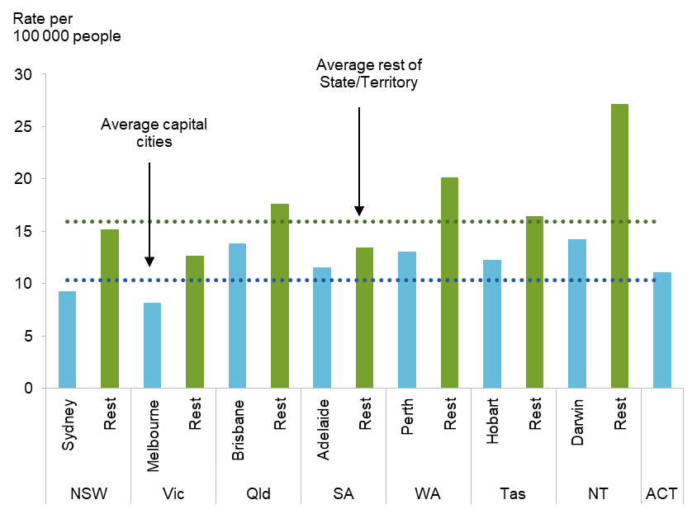

How to Identify High Risk Individuals
The ability to identify individuals at risk for suicide rests upon the tools being used to confirm depression and therefore predict suicidality. Table 1. provides a meta-analysis of the tools used to predict suicidality. A review of the tools indicates significant weaknesses for most tools with regard to sensitivity and specificity for risk accuracy.

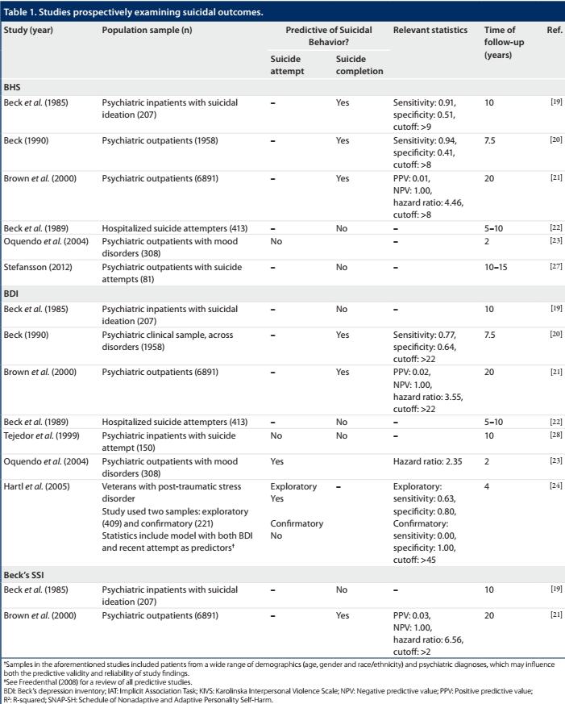
Among the tools outlined, the Beck Depression Inventory (BDI), a self-report of symptom presence and severity, appears to have the best statistical measures and with specific regard to a longer-term projection over matter of years. Research has shown that the BDI was also significantly related to outpatient completers (again many individuals do not seek or are willing to complete such inventories). In this research, the authors suggest different cutoff scores for inpatients (10) and outpatients (9) with roughly 0.45 sensitivity and 0.90 specificity. The lack of sensitivity of these instruments alone raises concerns. These statistics are akin to saying, “if there is no indication of depression there is little risk of suicide”. The mental health community needs better statistics in identifying risk rather than no risk. There is a need for more objective, easy to employ, robust measurement of factors flagging an individual at risk for severe major depression and consequently high risk for suicidality. There are substantial limitations to paper-based tools given the incentives to deny suicidal thoughts, a lack of replication and the lengthy follow-up time frames identified by most studies.

There is an extensive published literature demonstrating EEG abnormalities in major depressive disorder (MDD), the use of quantitative EEG in prediction of treatment response, changes correlated with positive response to treatment and the importance of measures of connectivity. EEG is uniquely suited to “allow estimation of neural dynamics with accurate temporal resolution, and they are therefore the most suitable techniques to non-invasively track brain interactions and information transfer” (Olejarczyk et al., 2017), important in the characterization of MDD as reflected in qEEG (Leuchter et al., 2012).

Early work in the Brain Research Laboratories of NYU School of Medicine demonstrated clear differences between two subtypes of MDD, Bipolar and Unipolar, showing very different patterns of EEG abnormalities. Topographic maps of z-scores for selected EEG features (columns) shown below demonstrate clear differences from normal population (top row) and clear differences in the pattern of deviations (significant z-scores) between subtypes (middle and bottom row). The pattern or profile of differences has been described using a multivariate discriminant function (Prichep & John, 1992), with high discriminant accuracy.

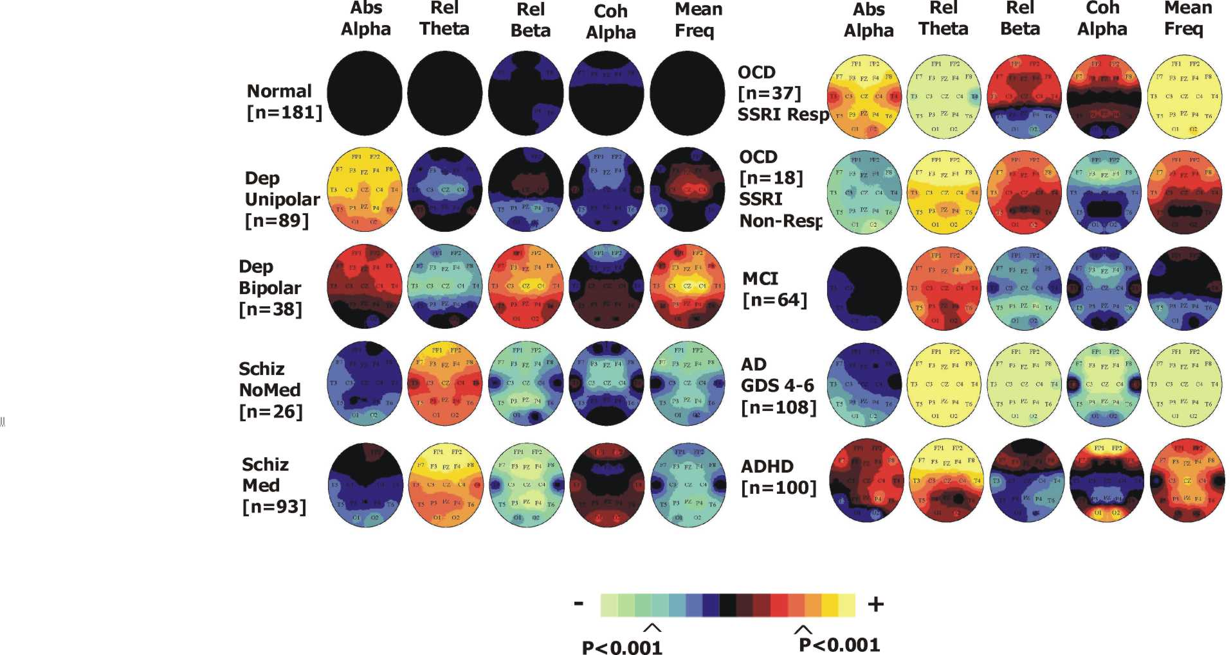

Figure legend: This figure shows the significance of the deviation from age expected formal values (where normal is the center, black, excess is toward yellow, and deficit is toward green/blue), for Normal subjects (top row), Unipolar depressed patients (middle row) and Bipolar depressed patients (bottom row). Column are examples of different EEG features in which difference between the groups can be seen.
These discriminant classification algorithms were derived using 206 subjects (95 controls and 111 patients with DSM diagnosis of Depression (MDD)). The mean accuracy of the discriminant for identifying the statistical likelihood of the profile of the patient resembling that of the population of MDD patients showed 83% sensitivity and 88% specificity, with independent replications of 93% sensitivity and 86% specificity. A further discriminant was derived to classify likelihood of Unipolar or Bipolar depression, demonstrating high discriminant accuracy in this subtype determination (n=97, with sensitivity/specificity 88%/84%, with independent replication of 94%/87%).
In the population with ages greater than 50 years, the difficulty of distinguishing between early cognitive decline and depression is difficult and addressed in a third discriminant function that distinguished between likelihood of normal, depressed or mild dementia with high accuracy (n=297, with sensitivity and specificity of 84% and independent replication with sensitivity ranging from 71%-80% and specificity ranging from 85%. These discriminant functions were incorporated into Neurometric qEEG analysis software and used in clinical practice for many years in the Neurometric Evaluation Service of BRL and championed by leaders in psychiatry such as Dr. Robert Cancro (Chair of the Department of Psychiatry for 30 years).
Table 1 (Prichep & John, 1992) in Appendix 1 shows the established and cross validated qEEG discriminants to assist with diagnostic processes for Depression and other disorders using this approach. (Not all available BrainDx discriminants are listed in this table).
Advances in neuroimaging and source localization of qEEG has led to multiple EEG and neuroimaging studies demonstrating the importance of frontocingulate dysfunction in depression (Mayberg et al, (1997); Brannan et al., 2000; Pizzagalli et al, 2001; Holthoff et al., 2004), well characterized using neurometric/BrainDx qEEG analysis. And have have provided evidence of the potential of EEG as a prognostic marker of treatment outcome in MDD (Leuchter et al., 2009; Philip et al., 2018; Zandvakili et al., 2019). The BrainDx technology is unique suited to incorporate such thinking as reflected in its current analytics.

A Focus on Autism
The Commission opted to exclude autism from its analysis and recommendations (Vol. 1, p 124). We believe this is a major omission that deserves attention. The incidence of autism, both in Australia and around the world, is substantially rising and poses a major threat to the behavioral health of our children. BrainDx has the first scientifically established metrics for detection of autism spectrum disorder and can provide major assistance to licensed medical and mental health providers in its diagnosis and treatment.
BrainDx Can Guide Pharmacotherapy
Studies have demonstrated that using brain data as a guide to pharmacotherapy increases positive outcome to 80% or better. Medication-induced changes in EEG and qEEG data have been reported for a broad range of antidepressants, benzodiazepines, stimulants, antipsychotics, lithium salts, and anticonvulsants (Herrmann et al., 1979, Itil et al., 1973, 1979; Saletu et al., 1987; Small et al., 1989; Struve, 1987; Prichep et al, 1993). These drug changes are specific in regard to effects on distinct components of the EEG pattern and are dose-dependent, reversible upon medication withdrawal, and measurable across psychiatric syndromes and in asymptomatic volunteers.
In those studies obtaining baseline, medication-free EEGs, investigators demonstrated unique QEEG features that could be used to aid in treatment guidance. For example, patients with major depressive illness with excess alpha wave magnitudes were retrospectively reported responsive to antidepressants that reduce alpha magnitude (Ohashi, 1994). Without the objective physiologically tests available to other medical specialties or clinical decision support tools such as evidence-based treatment guidelines to follow, treating physicians can only rely upon personal experience or anecdotal information.
What about when Medications Fail?
Alternative therapies utilizing brain based qEEG measures have shown promise in treating and monitoring intervention strategies for mood regulation disorders including neurofeedback approaches and various stimulation techniques.
Rural Access
BrainDx is designed to provide rural and remote access to assessment, treatment, monitoring and evaluation as hardware technologies emerge to enable it. Emerging treatment options such as neurofeedback and neuromodulation as well as current medical and allied health interventions can be delivered responsibly and reliably. In fact, even in our congested urban cities access to health care has barriers to access due to time and cost factors.

- Recommendations: A Comprehensive Program to Achieve Real Results
BrainDx Australia is pleased to offer the following recommendations:

Implement an actuarial-based program of early screening using qEEG brain map readings and BrainDx analysis.
Not just in schools and in the military but throughout the mental health community this will deliver significant benefits by earlier recognition of high-risk patients.
What we anticipate is a program wherein everyone is subjected to a baseline screening and qEEG analysis. A qEEG reading takes about 15 minutes to capture. The reading will be uploaded to the BrainDx platform and within minutes a summary report (see Appendix Item 2) will be generated for both display and print that will give clear, simple indication of whether the individual falls within the high-risk area for further treatment, and a recommendation of what course of treatment should be pursued.
For the military this screening would take place at induction, with additional screenings performed at both regular intervals and upon returning from deployment. Such a program will not only identify individuals with major depressive disorders that can lead to suicide, but also will identify Autism, ADHD, Depression (Unipolar and Bipolar), Schizophrenia, etc.
A comprehensive program will consist of the following major phases:
Negotiation and Agreement
Given the scope of such a major effort and the involvement of multiple government agencies and private companies, it will be important to reach agreement on scope, timing, costs, funding and most important, on specific responsibilities. We particularly believe creating a cross-organization team, involving organizations such as Neurodevelopment Australia, the ADHD Consumer Forum together with Mental Health Australia and other stakeholders is critical to program success.
As a part of reaching agreement, this stage should also develop program specifications and monitoring and reporting requirements.
BrainDx anticipates providing key program services, including:
    - Program definition & key participation in leadership team
    - Online services for qEEG interpretation and other psychometric testing
    - Training of program management & staff
    - Clinician training
    - Assistance in program monitoring
Assessment
The specific statistics on number of locations, number of counselors and providers currently available and current equipment for capturing qEEG readings must be obtained.
Capturing of baseline statistics for ongoing monitoring of program effectiveness is important.
Customization
Australia-specific intake processes, reporting formats and case management processes must be developed and implemented within the BrainDx platform. Most important is to achieve agreement with all stakeholders on the means of tracking program effectiveness.
The BrainDx system will be cloud-based, with the most probable processing center within Microsoft’s Canberra center.
Mobilization
Recruiting and training BrainDx Australia management staff.
Recruiting and training of program staff within National Mental Health Service.
Training of practitioners.
Creation and activation of screening procedures.
Rollout
Organizing and scheduling screenings.
Processing of readings and reports.
Actions for therapy.
Monitoring
Screening and therapy quality control.
Statistical feedback.

Expand the Medicare Benefits Schedule (MBS).
The MBS needs to be extended to include Medicare rebates for online assessments, qEEG assessment and neurotherapy treatments such as neurofeedback and non-invasive neuromodulation techniques. Its absence results in limited access to the most beneficial methods for diagnosing and treating mental health disorders.
We agree with the Commission’s suggestion that increasing the number of sessions available for consumer rebate is vital.

Open Mental Health Care Plan Design.
A vast number of referrals to mental health practitioners are a consequence of ‘reverse referral’, whereby consumers are required to make additional visits to a healthcare provider in order to obtain a Mental Health Care Plan. This redundancy is a consequence of the fact that, currently, only GPs are allowed to issue MHCP’s and make referrals. GPs are mostly untrained in mental health diagnosis and treatment. Licensed mental health providers should be able to create and issue MHCP’s directly.
This is highly inefficient and costly. Presently up to 40% of the Medicare Benefits can be spent on visits to GPs, who themselves may have no further contributions to or monitoring of the patient’s treatment. Consideration should be given to broadening access to health care by enabling other health care providers, such as psychologists, to issues MHCPs.
A deeper reform to broaden consumers’ entry pathways would promote better partnerships between medical and mental health practitioners. Many GPs would be grateful for the management to be shared.
Broader access pathways for the consumer would require healthcare providers to have an integrated system for the assistance in making diagnoses and matching consumers to appropriate levels of care and treatment services. If a broader range of healthcare professionals are assigned the responsibility to issue MHCPs, then consumers would be provided with a broader range of access points with the burden on GPs and the Medicare system reduced.
BrainDX can be integrated into the LinkMe trial, and vastly improve its efficacy. We believe that matching consumers to appropriate care is of top priority, and welcome such a collaboration.

- Costs
At this point in time the information available is not sufficient to provide a reasonable estimate for total program costs. The following are estimates for BrainDx participation in the initial stages:
- Negotiation and Agreement
Travel: AUD 75,000
Salaries: AUD 150,000
- Assessment
Travel: AUD 75,000
Salaries: AUD 225,000
- Customization
Travel: AUD 75,000
Salaries: AUD 225,000
Contract programming: AUD 500,000

- Mobilization, Rollout, Monitoring
Salaries: AUD 500,000/yr.
Services: AUD 300/initial screening + report
AUD 75/case (case management)
AUD 150/supplemental screening + report
AUD 25/supplemental report (therapy notes, etc)

Total Program Preparation: AUD 1,325,000
Ongoing BrainDx Australia staff AUD 500,000/yr
Ongoing Services TBD

- Profiles
Our Team
Chief Executive Officer: David S. Cantor, Ph.D.
Dr. David Cantor is the CEO of BrainDx, LLC. He holds a Bachelor’s Degree with Distinction in Psychology from the University of Connecticut with Honor’s work in the field of neurophysiological correlates of cross modal integration processes in attention deficit disorders. He also holds Master’s and Doctorate’s in Psychology at the State University of New York at Stony Brook where his dissertation work was on quantitative EEG correlates of Autism. He also holds a post-doctoral Masters of Science Degree in Psychopharmacology from Farleigh Dickinson University. He holds Diplomate or Fellow status with many clinical and research societies in the field of psychology and clinical neuroscience and has been a former President of the EEG and Clinical Neuroscience Society. He has been accepted for special fellowships including Congressional Fellow of the American Psychological Association and the State of New York Intercampus Fellow in the area of Brain Research. Dr. Cantor is among the pioneers in the clinical use of this technology and is a nationally recognized expert in the field. He uses the BrainDx technology in his practice in Atlanta, Georgia now, and consults with many other professionals nationally and internationally to help them use the technology more effectively. He has overseen an estimated 20,000 clinical qEEG reports spanning many clinical applications in fields of neurotrauma, neurology, psychiatry, and neuropsychology. This experience gives him a somewhat unique perspective on the potential uses of the BrainDx technology, and his management experience with his own practice and a history of businesses using qEEG helps oversee the operations of BrainDx.
Board Member and Scientific Advisor: Leslie Prichep, Ph.D.
Dr. Leslie Prichep retired as Director of the Brain Research Laboratory, Department of Psychiatry, and Research Full Professor of Psychiatry at New York University, where she also served as Director of the Neurometric Evaluation Service of the Brain Research Laboratories at New York University. During her academic career she served as chair of the Phoenix House Foundation Institution Review Board, and as a Special Review Consultant to the National Institute of Drug Abuse. Having received the Wyeth-Ayerst Award for Distinction in Psychiatry conferred at the VIII World Congress of Psychiatry, Dr. Prichep is a member of numerous national and international professional and scholarly societies including the American Psychological Association, the American Society of Evoked Potential Monitoring, the College on Problems of Drug Dependence (CPDD), the International Academy for Research in Learning Disabilities, the International Organization of Psychophysiology, the International Society for Neuroimaging in Psychiatry, American Academy of Neurology and the New York Academy of Sciences. She serves as an ad hoc reviewer for numerous professional and scholarly publications. She has served on the Board of Directors of the International Pharmaco-EEG Society and the EEG & Clinical Neuroscience Society and serves as Chair of the Ph.D. Certification Committee of the EEG and Clinical Neuroscience Society. She has additionally received multiple patents in the use of brain Electrophysiological Quantitative Data to classify and Subtype an Individual into Diagnostic Categories by Discriminate Cluster Analysis, Fetal Brain Monitor and System and Method for Guidance of Anesthesia, Analgesia and Amnesia. The author of over 150 scholarly papers published in international scholarly peer-reviewed journals, she has also authored twenty-five books, reviews and book chapters, and many other proceedings, monographs, and published abstracts. She received her BS and MS degrees from the University of Pittsburgh and a Ph.D. in Experimental Psychopathology from The City University of New York. She was elected as a Fellow of the National Academy of Inventors in 2019.
Managing Director, BrainDx Australia: Jon Hegg, MA Psych
Jon Hegg is a registered psychologist and has been practicing for close to forty-five years. He completed his Master’s degree, MA (Psych), at Sydney University in 1981. Jon worked with the NSW Inner Metropolitan Health Services Drug Advisory Service between 1976 and 1986, subsequent to which he entered private practice. Currently, Jon is the director of Brain Training International located in Deakin, ACT. His clinic specialises in Quantitative Electroencephalography (qEEG), Neurofeedback, and Neuromodulation for the improvement of a range of neuropsychophysiological impairments as well as in performance enhancement. Alongside neurotherapy Jon provides psychological counselling.
Jon is certified by the Biofeedback Certification International Alliance (BCIA) to conduct neurofeedback. During its inception and until 2019 he served on the Australian Affiliate Board (BCIA-A). He served as Board Applications Secretary between 2011-2013; Board Chair between 2013-2015; Board Immediate Past Chair between 2015-2017; and was BCIA Member at Large until 2019.
Jon is also certified in qEEG by the International qEEG Certification Board (IQCB). He is a fellow and member of the Applied Neuroscience Society of Australasia (ANSA), the peak body institute for neurofeedback in Australia, and have worked on the association’s Executive Board from 2010 to 2019. He served as ANSA Public officer between 2011-2014; President-Elect between 2014-2015; President between 2015-2017.
Jon regularly provides training and supervision for psychiatrists, psychologists, and a variety of health practitioners and educators in the practice of neurotherapy. His primary specialisation is in the treatment of ADHD, PTSD and cognitive impairment.
Mr. Hegg has worked with the Australian Institute of Sports (AIS), The Australian Defense Force Academy (ADFA), and a number of internationally recognised organisations involved in neuromodulation. In 2009 he initiated the formation of the Neurofeedback Interest Group within the Australian Psychological Society (APS) and currently has close to two hundred members. Between 2017 and 2019 he worked with the Federal Health Minister, Greg Hunt, to obtain two major grants from the Australian Government; one of $1.5 million for the Australian ADHD Professional Association (AADPA), the other of $1.8 million to form the National ADHD Consumer’s Forum. Furthermore, Jon is currently involved in a nation-wide initiative to undertake a thorough revision of the National Health and Medical Research Council (NHMRC) ADHD National Guidelines. These grants along with the guideline revisions will significantly impact the way we understand and treat ADHD in Australia. This will enable dramatic improvements in the wellbeing of children and adults throughout Australia.

Chief Operating Officer: Michael B. Lowry
Mike Lowry entered the information systems field in 1968, after attending Georgia Tech. As one of the early employees at National Data Corp. (now known as Global Payments) he wrote the data management software for the first online credit card authorization and funds transfer systems in the world.
Mr. Lowry’s subsequent career includes 50 years in the software industry, specializing in change-agent projects involving large-scale 24X7 database management systems. He has held positions as a consultant with Coopers & Lybrand, CIO of a Fortune 500 manufacturing company, and Director of Bell Operating Company Marketing for Oracle. He has also founded startups in micro-optics and in remote desktop services.
Mike Lowry is a startup mentor with the Advanced Technology Development Center (ATDC) at Georgia Tech, helping to commercialize new technologies, and founded the TechAlpharetta startup roundtable.
Mr. Lowry is active in the Alpharetta Rotary Club, is a Georgia Tech alumnus and lives with his wife, Sharon, in Roswell, GA.

- Bibliography

- Al-Huthail, YR. Accuracy of Referring Psychiatric Diagnosis. Int J Health Sci (Qassim). 2008 Jan; 2(1): 35–38
- Arns M, Cerquera A, Gutiérrez RM, Hasselman F, Freund JA. Non-linear EEG analyses predict non-response to rTMS treatment in major depressive disorder. Clin Neurophysiol. 2014 Jul;125(7):1392-9.
- Babiloni C, Del Percio C, Caroli A, Salvatore E, Nicolai E, Marzano N, Lizio R, Cavedo E, Landau S, Chen K, Jagust W, Reiman E, Tedeschi G, Montella P, DeStefano M, Gesualdo L, Frisoni GB, Soricelli A. Cortical sources of resting state EEG rhythms are related to brain hypometabolism in subjects with Alzheimer's disease: an EEG-PET study. Neurobiol Aging. 2016 Dec;48:122-134.
- Bosch-Bayard J, Galán-García L, Fernandez T, Lirio RB, Bringas-Vega ML,Roca-Stappung M, Ricardo-Garcell J, Harmony T, Valdes-Sosa PA. Stable Sparse Classifiers Identify qEEG Signatures that Predict Learning Disabilities (NOS) Severity. Front Neurosci. 2018 Jan 15;11:749.
- Bosch-Bayard J, Peluso V, Galan L, Valdes Sosa P, Chiarenza GA. Clinical and Electrophysiological Differences between Subjects with Dysphonetic Dyslexia and Non-Specific Reading Delay. Brain Sci. 2018 Sep 10;8(9).
- Cantor, D.S., Holder, G. ,Cantor, W., Kahn, P., Smoger, G., Rodgers, G., Swain, W., and Berger, H. In-utero and postnatal exposure to 2,3,7,8 TCDD in Times Beach, Missouri: 2. Impact on Neurophysiological Functioning. Proceedings of the International Symposium on Dioxin and Related Compounds. Vienna, Austria, 1993.
- Chabot, R. Coben, R. Hirshberg, L. and Cantor, D. QEEG and VARETA Based Neurophysiological Indices of Brain Dysfunction in Attention Deficit and Autistic Spectrum Disorder. Austin Journal of Autism and Related Disorders. 2015, 1(2), 1007.
- Chennu S, Annen J, Wannez S, Thibaut A, Chatelle C, Cassol H, Martens G, Schnakers C, Gosseries O, Menon D, Laureys S. Brain networks predict metabolism, diagnosis and prognosis at the bedside in disorders of consciousness. Brain. 2017 Aug 1;140(8):2120-2132.
- Cheung MC, Chan AS, Liu Y, Law D, Wong CW. Music training is associated with cortical synchronization reflected in EEG coherence during verbal memory encoding. PLoS One. 2017 Mar 30;12(3):e0174906.
- Prichep LS, John ER, Ferris SH, Rausch L, Fang Z, Cancro R, Torossian C, Reisberg B., Neurobiol Aging. 2006 Mar;27(3):471-81, Prediction of longitudinal cognitive decline in normal elderly with subjective complaints using electrophysiological imaging.
- Prichep LS, Mas F, Hollander E, Liebowitz M, John ER, Almas M, DeCaria CM, Levine RH., Psychiatry Res. 1993;50:25-32, Quantitative electroencephalographic subtyping of obsessive-compulsive disorder. _
- Prichep LS, John ER., Brain Topography. 1992;4: 249-257, QEEG profiles of psychiatric disorders.
- Dawes RM1, Faust D, Meehl PEl., Science, Vol. 24, 1989, 1668-1674. Clinical vs. Actuarial Judgment.
Abstract
Professionals are frequently consulted to diagnose and predict human behavior; optima treatment and planning often hinge on the consultant’s judgmental accuracy. The consultant may rely on one of two contrasting approaches to decision-making – the clinical and actuarial methods. Research comparing these two approaches shows the actuarial method to be superior. Factors underlying the greater accuracy of actuarial methods, sources of resistance to the scientific findings, and the benefits of increased reliance on actuarial approaches are discussed.
- Duffy FH, Brain electrical activity mapping (BEAM): computerized access to complex brain function. Int J Neurosci. 1981;13(1):55-65.
- Fishbein, D., Cantor, D.S., Thatcher, R.W. Ingestion of Carbohydrates Varying in Complexity Produce Differential EEG Responses. Clinical Electrophysiology, 1990, Vol. 21, 1, 5-11.
- Hansen ES, Prichep LS, Bolwig TG, John ER, Quantitative electroencephalography in OCD patients treated with paroxetine. Clinical Electroencephalography. 2003 Apr;34(2):70-4.
- John ER, Karmel BZ, Corning WC, Easton P, Brown D, Ahn H, John M, Harmony T, Prichep L, Toro A, Gerson I, Bartlett F, Thatcher F, Kaye H, Valdes P, Schwartz E. Neurometrics. Science. 1977 Jun 24;196(4297):1393-410.
- John ER, Ahn H, Prichep L, Trepetin M, Brown D, Kaye H., Science. 1980 Dec 12;210(4475):1255-8. Developmental equations for the electroencephalogram.
- John ER, Prichep LS, Fridman J, Easton P. Neurometrics: computer-assisted differential diagnosis of brain dysfunctions. Science. 1988 Jan 8;239(4836):162-9.
- John ER, Prichep LS, Almas M. Subtyping of psychiatric patients by cluster analysis of QEEG. Brain Topogr. 1992 Summer;4(4):321-6
- Jonas S, Rossetti AO, Oddo M, Jenni S, Favaro P, Zubler F. EEG-based outcome prediction after cardiac arrest with convolutional neural networks: Performance and visualization of discriminative features. Hum Brain Mapp. 2019 Nov 1;40(16):4606-4617.
- Leuchter, AF, Cook IA, Hunter, AM, Cai, C, and Horvath, S. Resting state eelctroencephalography reveals increased neurophysiologic connectivity in depression. PloS One., 2012, 7(2)
- Leuchter, AF, Cook, IA, Mangarell, LB, Gilmer, WS, Burgoyne, KS, Howland, RH, Triveda, MH, Zisook, S., Jain, R., McKracken, JT, Fava, M., Iosifescu, D., Greenwald, S. Comparative effectiveness of biomarkers and clinical indicators for predicting outcomes of SSRI treatment in Major Depressive Disorders: results of the BRITE-MD study. Psychiatry Res, 2009, Sept. 30; 169(2);124-31.
- Lord, R.S., Tuttle, D.M., Cantor, D.C. Adult bile acid amino transferse deficiency. Am J Case Rep, 2014; 15:63-68.
- Mumtaz W, Malik AS. A Comparative Study of Different EEG Reference Choices for Diagnosing Unipolar Depression. Brain Topogr. 2018 Sep;31(5):875-885.
- Mumtaz W, Ali SSA, Yasin MAM, Malik AS. A machine learning framework involving EEG-based functional connectivity to diagnose major depressive disorder (MDD). Med Biol Eng Comput. 2018 Feb;56(2):233-246
- Neto E, Allen EA, Aurlien H, Nordby H, Eichele T. EEG Spectral Features Discriminate between Alzheimer's and Vascular Dementia. Front Neurol. 2015 Feb 13;6:25.
- Ohashi Y. [The baseline EEG traits and the induced EEG changes by chronic antidepressant medication in patients with major depression. Early prediction of clinical outcomes solely based on quantification and mapping of EEG]. Seishin Shinkeigaku Zasshi. 1994;96(6):444-60.
- Qazi EU, Hussain M, Aboalsamh H, Malik AS, Amin HU, Bamatraf S. Single Trial EEG Patterns for the Prediction of Individual Differences in Fluid Intelligence. Front Hum Neurosci. 2017 Jan 20;10:687
- Saletu, et al., Methods Find Exp Clin Pharmacol. 2002:24 Suppl D:37-106. Schouppe S, Van Oosterwijck S, Danneels L, Van Damme S, Van Oosterwijck J. Are Functional Brain Alterations Present in Low Back Pain? A Systematic Review of EEG Studies. J Pain. 2019 Jun 28. pii: S1526-5900(19)30753-9
- Surmeli T, Eralp E, Mustafazade I, Kos IH, Özer GE, Surmeli OH. Quantitative EEG Neurometric Analysis-Guided Neurofeedback Treatment in Postconcussion Syndrome (PCS): Forty Cases. How Is Neurometric Analysis Important for the Treatment of PCS and as a Biomarker? Clin EEG Neurosci. 2017 May;48(3):217-230.
- Surmeli T, Eralp E, Mustafazade I, Kos H, Özer GE, Surmeli OH. Quantitative EEG Neurometric Analysis-Guided Neurofeedback Treatment in Dementia: 20 Cases. How Neurometric Analysis Is Important for the Treatment of Dementia and as a Biomarker? Clin EEG Neurosci. 2016 Apr;47(2):118-33.
- Surmeli T, Ertem A, Eralp E, Kos IH. Schizophrenia and the efficacy of qEEG-guided neurofeedback treatment: a clinical case series. Clin EEG Neurosci. 2012 Apr;43(2):133-44.
- Sürmeli T, Ertem A. Obsessive compulsive disorder and the efficacy of qEEG-guided neurofeedback treatment: a case series. Clin EEG Neurosci. 2011 Jul;42(3):195-201
- Tas C, Cebi M, Tan O, Hızlı-Sayar G, Tarhan N, Brown EC. EEG power, cordance and coherence differences between unipolar and bipolar depression. J Affect Disord. 2015 Feb 1;172:184-90
- Thatcher, R.W., and Cantor, D.S. Neurometric Techniques and the Assessment of Malnutrition, In J. Brozek (Ed.), Critical Assessment of Key Issues in Research on Malnutrition and Behavior, Lausanne, Switzerland: Nestle Foundation, 1985. 116-136.
- Thatcher, R.W., Cantor, D.S., McAlaster, R., Geisler, F., and Krause, P. Comprehensive Predictions of Outcome in Closed Head Injured Patients: The Development of Prognostic Equations. In R.A. Zapulla, F. Frank LeFever, J. Jaeger, and R. Bilder. Windows on the the Brain: Neuropsychology's Technological Frontiers. Annals of the New York Academy of Sciences, Vol. 620, 1991, 82-101.
- Vecchio F, Miraglia F, Iberite F, Lacidogna G, Guglielmi V, Marra C, Pasqualetti P, Tiziano FD, Rossini PM. Sustainable method for Alzheimer dementia prediction in mild cognitive impairment: Electroencephalographic connectivity and graph theory combined with apolipoprotein E. Ann Neurol. 2018 Aug;84(2):302-314
- Zandveklili, et al. Journal of Affective Disorders 252 (2019), 47-54.
Independent Studies Confirming BrainDx (NYU) Database Validity

Barbados: Ahn, et al., (1980). Science 210, 1259-1262.
Cuba: Alvarez, et al., (1987). EEG Clin.Neurophysiol. 67, 330-332.
China/Japan/Korea: Matsuura, et al., (1993). Biol Psychiatry 34, 59-65.
Germany: Verleger, et al., (1982). Psychophysiol. 19, 472-480.
Mexico: Diaz de Leon, et al., (1988). Intl.J.Neurosci. 43, 123-131.
Netherlands: Jonkman, et al., (1985). EEG Clin.Neurophys. 61, 333-341.
Sweden: John, et al., (1988). Science 293, 162-169.
Switzerland: Koenig, et al., (2002). NeuroImage 16(1), 41-48.
Venezuela: Harmony, et al., (1987). Intl J Neurosci., 31, 103-113.

- Appendices
Appendix 1
Detailed table exhibits statistical qEEG discriminants and the ability of replicability
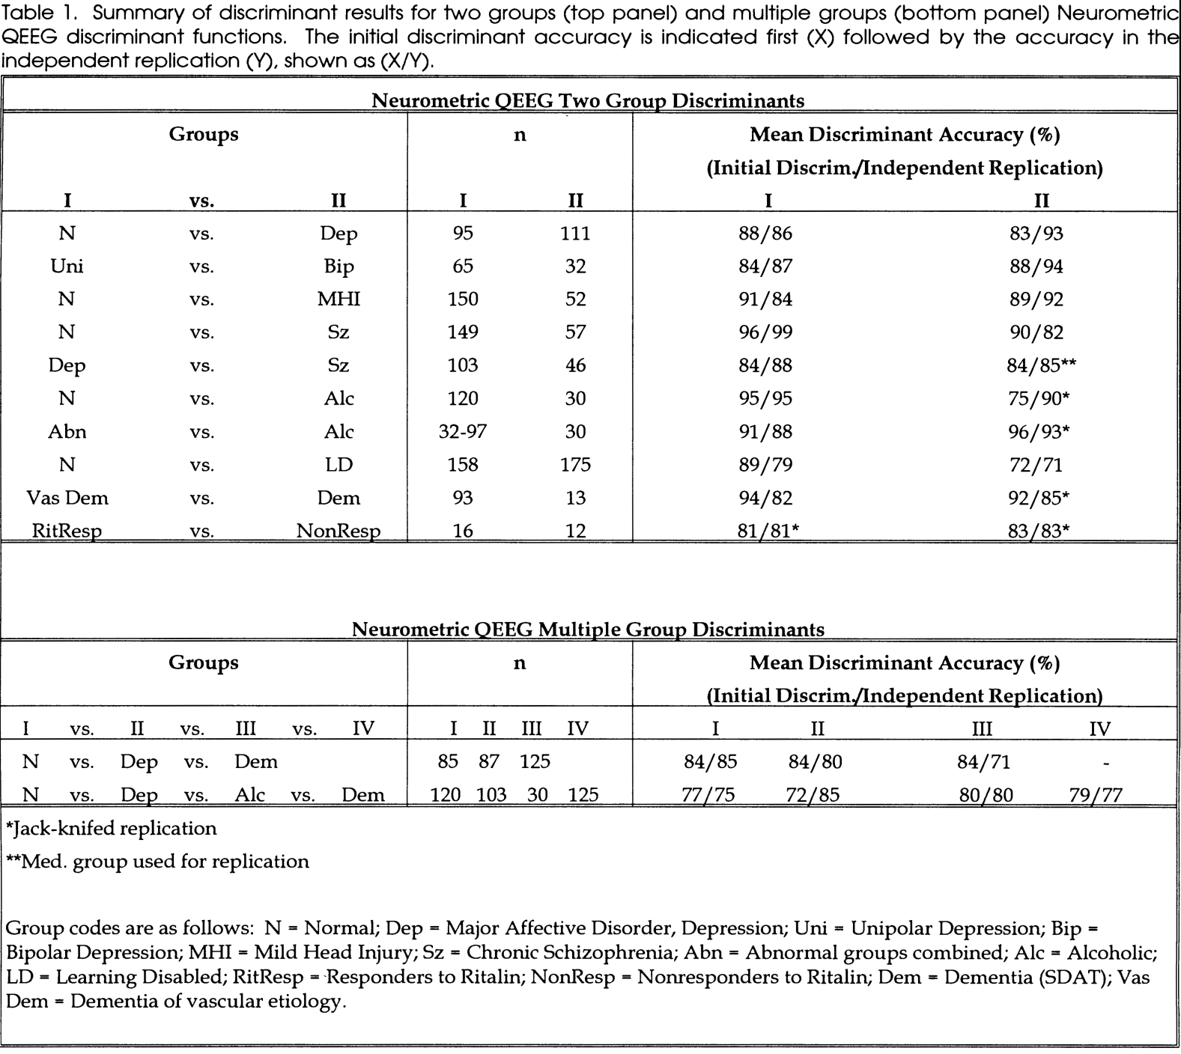

Appendix 2

Sample Patient Report


BrainDx Screening Tool

Patient ID: Sample 1

Date of Test: 06/01/2019

NOTE: The following data is for the illustration of a BrainDx Screening Tool Report and does not represent a real patient’s profile or outcome data.

Patient Information
Patient ID: 11122233
Last Name: S
Fist Name: N
Date of Birth: 04/09/1984
Initial Session Date: 05/03/2018
Age: 35.1
Gender: M
Handedness: R
Physician: Dr. RD
Medicated: Baseline- No meds
Eyes: Closed

- History and Symptoms:
This patient’s history indicates that he is having major problems with mood regulation that is sufficiently severe such that he is having difficulty coping with activities of daily living. Factors of potential clinical based on reportedly history and symptoms concern:

- Hx of Sleep dysregulation
- Hx of Poor appetite
- Hx of Lethargy
- Hx of Feeling Tired most of the time
- Hx of anxiety
- Hx of reflux since childhood
- Hx of attention dysfunction
- Hx of multiple allergies since childhood
- Fam Hx of Thyroid problems

- Initial Psychometric and Neurometric Scores:

Tools Used for this screening: Beck Depression Inventory II (BDI-II), PTSD Check List – Military (PCL-M), and BrainDxTM Depression Discriminant Value for Major Depression Disorder

These measures indicate an elevation in emotional distress/risk at baseline. Reduced scores indicate improvement as a function of interventions.

Date | BDI-II | PCL-M | BrainDx- Depression DV Score
Initial – 5/3/2018 | 22 | 35 | 99
Legend:
Normal | Mild | Moderate | Severe

Initial Neurometric Finding (5/3/2018)
The Subject was 35.14 years old with initial testing on 5/3/2018. An EEG recording of 25.1 minutes with eyes closed resting was acquired and 2.0 minutes of artifact free data was selected for analysis.

Discriminant
Discriminant functions provide a quantitative estimate of the similarity between a patient's profile and characteristic patterns found during extensive research on groups of patients with various disorders.
Classification by this algorithm is restricted to disorders relevant to the diagnosis or symptoms indicated in the patient history.

This patient's discriminant scores lie outside (p <= 0.025) of the normal limits expected for an individual of this age.
This patient's discriminant scores suggest the presence of Unipolar Depression.

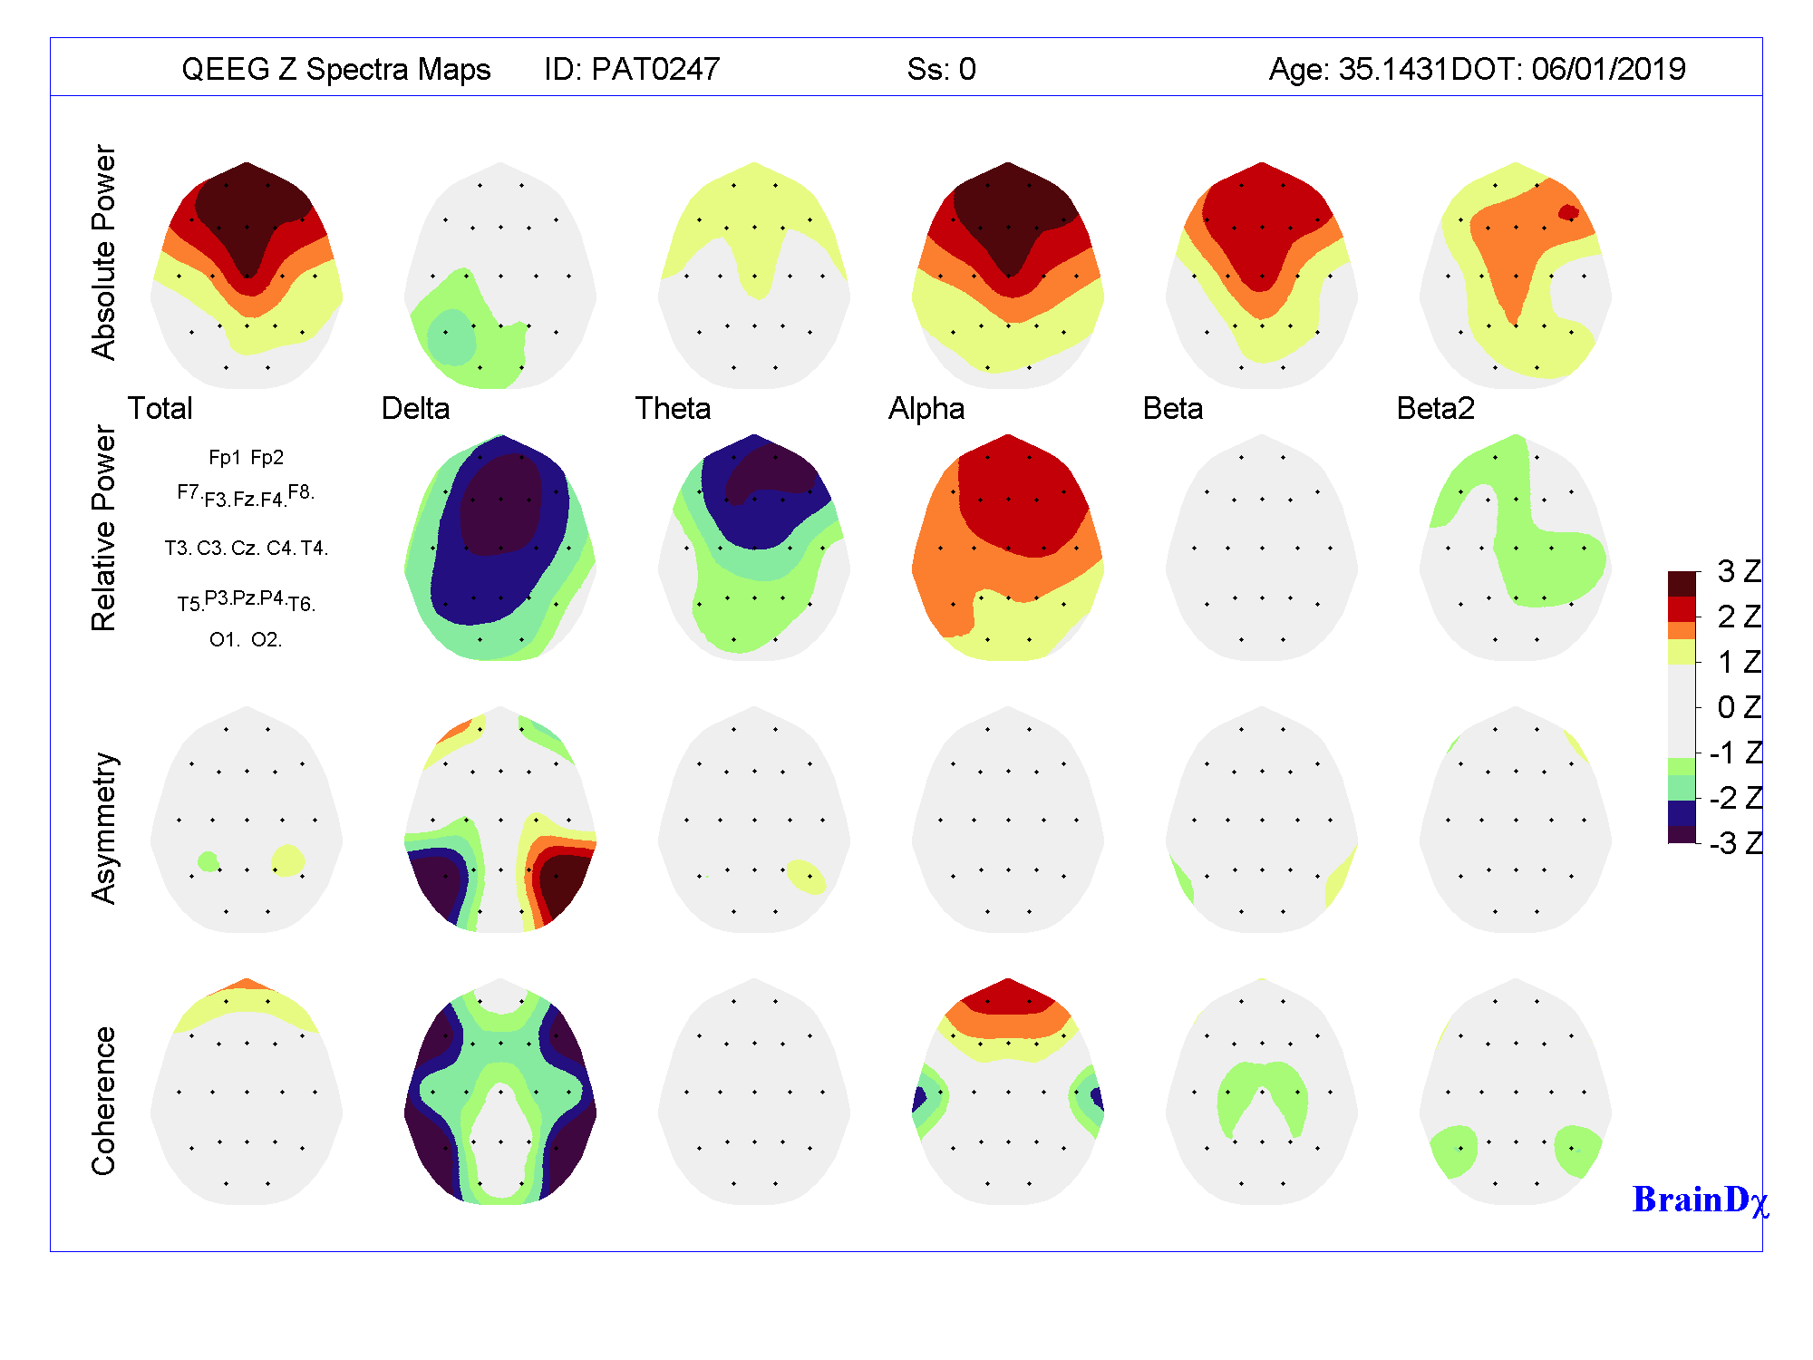
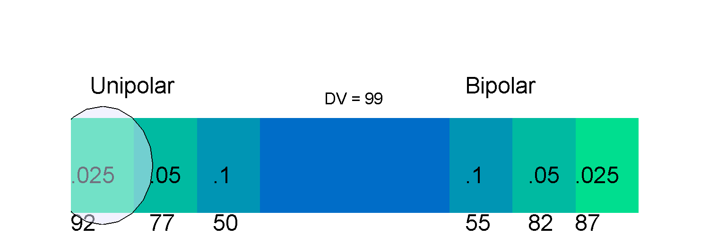
Key: Areas marked in color other than off white indicate atypical brain function for age. The darker the color, the greater the distance from normal. Darker colors toward RED indicates “excessive activity”; darker colors toward BLUE indicate deficits in functioning

Treatment Protocols:
Based on the initial screening data, this patient was indicated to be at high risk for depression/suicide and was recommended to seek professional licensed mental health provider to initiate intervention. The patient was engaged with a combination of the following interventions:

- Lexipro (20 mg qd)
- Neurofeedback Protocols
- Psychological Counseling Services Monitoring

- Psychometric and Neurometric Tracking Scores:
These measures indicate an elevation in emotional distress/risk at baseline. Reduced scores indicate improvement as a function of interventions.
Date | BDI-II | PCL-M | BrainDx- Depression DV Score
Initial – 5/3/2018 | 22 | 35 | 99
12/3/2018 | 18 | 32 | 88
3/1/2019 | 13 | 22 | 52
6/1/2019 | 9 | 16 | 45
Legend:
Normal | Mild | Moderate | Severe

The following 3-D sLORETA Neurometic Images illustrate a pattern of brain functional recovery as a result of interventions applied.

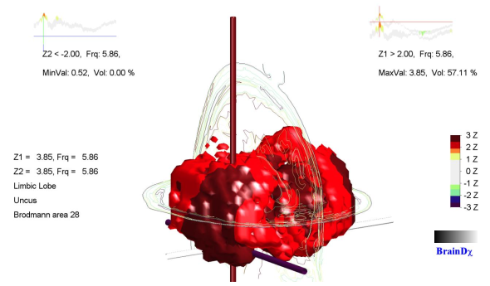

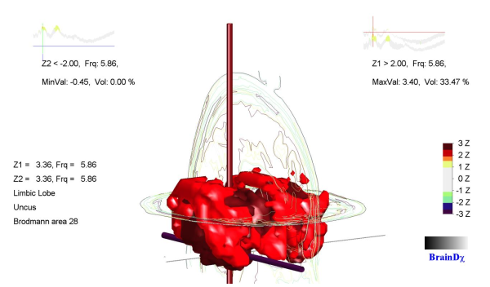

Improvement noted by decreasing Z-score value of most deviant ROI- Brodmann Area 28 – involved in emotional processing
Improvement noted by decreasing abnormal number of brain voxels over the course of recovery

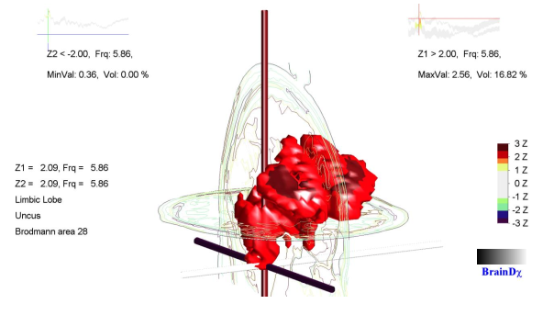

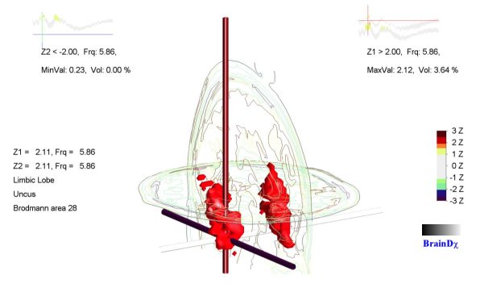

Analyses and comments provided by BrainDx, Australia. The results provide statistically deviations in electrophysiological measures of brain activity from expected values for age. Dysfunction of brain regions as indicated typically correspond to functional or behavior problems. Norm referenced cognitive performance and behavior assessment testing should be considered whenever possible to delineate functional or behavior impairments that can be correlated with these measures and to establish pre-treatment performance levels which can be used to establish treatment efficacy from follow-up treatment. This report is intended to provide a guideline for clinical use and should not be used as the sole source of information for clinical diagnosis or treatment selection. BrainDxTM will not be held responsible for any fault in the official clinical diagnosis or failed treatment resulting from statements in this report for the service provider.
Discriminant functions have been developed and published as per: John et, al, 1988; Chabot et al, 1996; Chabot et al, 2016

