**Productivity Commission 2023 Review of Philanthropy**

**Submission from**

**Lord Mayor’s Charitable Foundation**

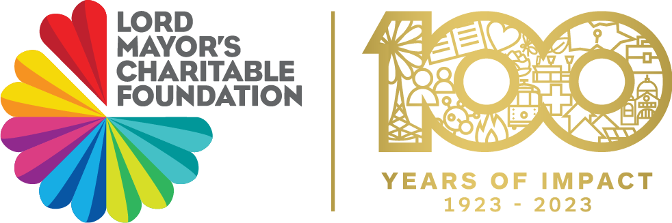

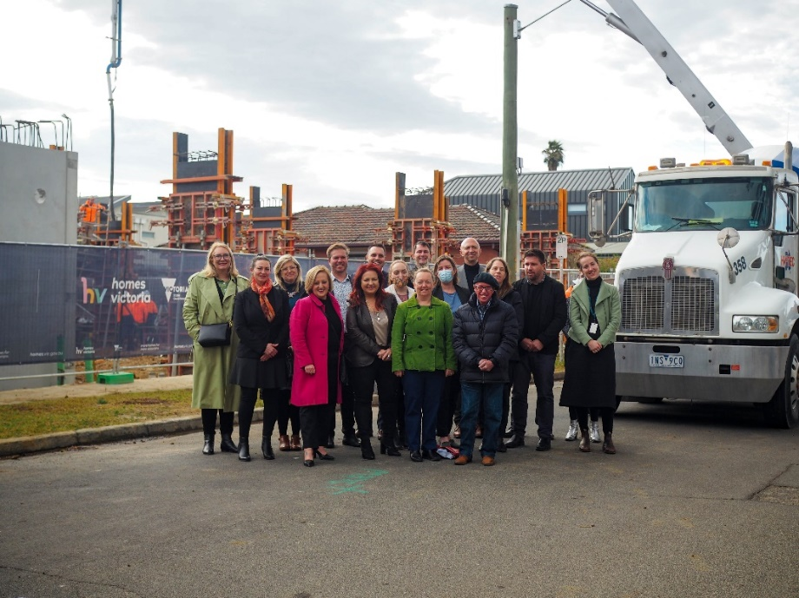

*Affordable Housing Challenge cross sector project in Present –*

*Philanthropy Australia Better Philanthropy Award 2020 (now well into construction)*

May 2023

**Information Request 1: Defining Philanthropy and the Inquiry’s Scope**

**The Foundation**

This submission is provided by the Lord Mayor’s Charitable Foundation, Australia’s largest and oldest independent community foundation. We are the community foundation for greater Melbourne and beyond. The community foundation model will be described further in our response to Information Request (IR) 2 but in summary, community foundations exist to build social and financial capital within a geographic community to address current needs and to also build endowments to cater for the needs of future generations. We are long term grant makers and investors.

We are celebrating our centenary and this has been an important moment to reflect on the generosity of many donors giving together to respond to the big issues of the day, from supporting hospitals before there was government funding and Medicare, to supporting people arriving in Australia through all the waves of migration, to responding to disasters starting with the 1926 bushfire, and health issues such as HIV AIDS and the COVID pandemic. Community foundations are ready to support the community and the charitable sector that supports it at the toughest times.

**Defining Philanthropy**

We note the Productivity Commission’s view that impact investing should not be a primary focus of this Inquiry. However, we would like to provide two reasons why impact investment should be considered as a central point.

1. *Investing for more impact*

Endowed foundations and trusts hold charitable donations as long term assets for the benefit of the community. The investment of their endowed funds can add significantly to a Foundation’s social or environmental impact.

Lord Mayor’s Charitable Foundation has been increasing the supply of affordable housing for people facing disadvantages as a key outcome in the granting program. We have granted extensively in this area and often provide early capital funding to then leverage further philanthropic and government support. The Foundation has provided a loan via SEFA to Habitat for Humanity for their low income housing program. We are also looking for other impact investments working on increasing the supply of affordable housing. This grows our impact on this very tough social challenge.

*Habitat for Humanity Case Study*

*In 2015 an Australian affiliate of an international affordable homeownership model received a $2m impact loan from the Sefa Affordable Housing Fund supported by the Lord Mayor's Charitable Foundation to provide more flexible finance than a bank loan in support of replicating their model. In total, 69 low-income ($35,000- $90,000 annual family income) partner families were able to transition into home ownership with 29 [of these 29 approximately half have done so through making regular loan repayments while the other half decided to sell their properties and move on] having fully repaid their interest free loans provided by the organisation and . The Sefa / LMCF loan directly supported the development of 13 new homes, with the new delivery model put in place as part of this impact investment facilitating an earlier refinance of the families' mortgages with a traditional bank loan - this allows the impact capital to be recycled more quickly*.

The Foundation is also active in addressing climate change, both mitigation and adaptation. Through our investments, we are also working on decarbonisation. With advice from our asset advisors Cambridge Associates, we are reviewing each asset class and working with fund managers to reduce the carbon emissions profile of our investments. Our target is to reduce net zero emission by at least 50% by 2030 and net zero emissions by 2050 or even well before. We are in discussions in relation to several emissions reduction impact investment opportunities.

Impact investing holds a special place in amplifying the impact of philanthropy. Sir Ronald Cohen recommends that every foundation around the world have should have at *least* 10% of its endowments invested in impact investments, which have a financial return and a measurable social or environmental impact. Lord Mayor’s Charitable Foundation has recently increased our impact investment allocation to 5% and we expect this to grow over coming years.

In addition, most foundations now adopt a Responsible Investment policy to better align their investments with their granting strategy. The use of endowments is critical in increasing the impact and effectiveness of philanthropy in creating a more inclusive and resilient world. “*Of course, grantmaking is only one part of the traditional philanthropic foundation’s model. There’s also the endowment of a foundation whose total investable assets are huge compared to grants. A typical foundation might invest about 95% of its money in the investment market and given away 5% each year in grants.”* Impact, Reshaping Capitalism to drive real change, (the Dawn of Impact Philanthropy), Sir Ronald Cohen, 2000, p139.

*2. Social finance continuum*

We no longer think of ourselves as purely *grantmakers*. We see ourselves as charitable funders with a range of social finance and other tools that we can use to increase our impact.

Social finance can be seen as continuum running from philanthropic grants through to loans (blended finance) and then through to impact investment and commercial investment. One example of explaining this continuum is set out below (*Across the Returns Continuum*, Stanford Social Innovation Review, Bannick M & others, Winter 2017)

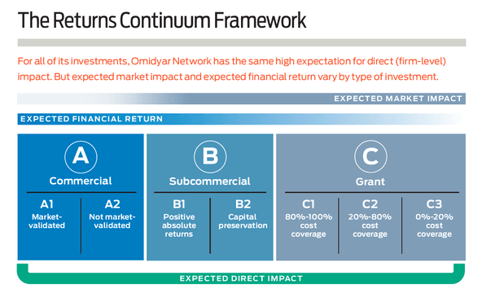

One example of where we have made an impact investment along a grant (forgivable loan) is the Melbourne City Mission Living Learning Social Impact Bond.

*Melbourne City Mission Living Learning Social Impact Bond Case Study*

*In 2020, Melbourne City Mission and the Victorian Government announced the Living Learning initiative, as part of the government’s Partnerships Addressing Disadvantage social impact investment program. The three-year program will offer education and wraparound mental health support for 144 young people aged 15 to 21 who have a mental health condition and are disengaged from employment, education and training.*

*Melbourne City Mission (MCM) is delivering the program at its Hester Hornbrook Academy, which is an independent school with specialised campuses across Melbourne, running a flexible education* *program tailored towards providing a supportive environment to young people experiencing barriers. Living Learning is designed to reduce these young people’s reliance on health and social services, while helping them experience the transformative power of education.*

*The Victorian government has committed up to $15 million for this project, with the final level of investment to be based on the results achieved. Five philanthropic foundations came on board as investors through debt, program related investment (forgivable loans) and a grant. They meet regularly with MCM to monitor progress. Outcomes are measured against the reduction in the number of admissions to emergency departments.*

**IR 2 Vehicles trends and motivations for philanthropy**

**Community philanthropy**

Community foundations are well recognised community infrastructure in other parts of the world such as the US, Canada and the UK. Community foundations build financial capital from donations and bequests to make grants now and for the benefit of future generations. They build social capital through the extensive networks they hold with donors, grant partners (charities), researchers and colleagues in philanthropy and government.

There is much more potential for community foundations like Lord Mayor’s Charitable Foundation to become critical partners in the way philanthropy responds to challenges such as climate resilience, economic and social inclusion. Community foundations have the potential to grow in size and impact. There are also parts of Australia which have stable populations, reasonable population density, well-educated populations and older potential donors with scope for a successful community foundation. This will be covered by Community Foundations Australia in their submission.

Community philanthropy has not received the same public attention as private philanthropy in Australia. However, community philanthropy through community foundations is a critical part of growing philanthropy. Community foundations will play an ever increasing role as we respond to the health and disaster impacts of climate change and prepare for other shocks such as the COVID pandemic. On the following page we expand on the importance of place-based climate and disaster philanthropy.

Community foundations stand ready to hold funds ready for times of crisis, they can hold funds that are place-based or focused on key issues of the day. They can use their knowledge of local needs and local charities to make grants with great efficiency in local communities. Government funding and public donations can be received by them. DGR 1 status for all community foundations would be beneficial. The Foundation itself received DGR 1 endorsement in 2022 and we are now developing funding partnerships and collaborations which would not have been possible without this.

The Foundation is a funder of Philanthropy Australia’s Growing Giving Initiative and strongly supports any public campaign that will grow understanding of community foundations as a knowledgeable and trusted form of philanthropy. We note Canada’s Smart and Caring Canada campaign, which was supported by the Governor General, and made matching government grants to community foundations across Canada helping grow their profile, capacity and granting.

Community foundations offer several key features which make them especially effective forms of philanthropy: efficiency, deep knowledge and strong due diligence and compliance.

*Efficiency*

Giving to and through a community foundation is cost efficient because the legal and organisational infrastructure is in place. The Foundation’s model can easily grow as more donors establish charitable fund accounts (subfunds) with the Lord Mayor’s Charitable Fund (DGR 2 public ancillary Fund) or the Lord Mayor’s Charitable Foundation (DGR 1). A donor can begin to grow a charitable fund account with as little as $2,000 and start making grant recommendations when the subfund reaches $10,000. We also hold subfunds with many millions. The idea of a community foundation is that almost everyone can be a philanthropist, whatever your capacity to give. Meeting other donors through educational and social events helps build social connectedness.

*Local place based knowledge*

The greatest strengths of community foundations is that they usually base their priorities on research and evidence of local needs. For example, Lord Mayor’s Charitable Foundation undertakes the Vital Signs report every few years to gather data on greater Melbourne. This enables us to reflect on the things to improve and the things to celebrate in our city. This informs our granting strategy. We also fund research into key challenges, such as future proofing Melbourne’s foodbowl: https://science.unimelb.edu.au/foodprint-melbourne. Again this helps inform our strategy.

The Foundation made grants of nearly $12 million in 2021-22 and similar this financial year. We made grants in 2021-22 ranging from a $1 million grant for affordable housing to small grants up to $10,000 through our Youth in Philanthropy Program. We hold knowledge about the charitable organisations we fund, especially those that deliver and have capability to increase their impact. We have developed relationships with charitable sector colleagues working in our priority impact areas: affordable housing, homelessness, social enterprise, health, climate change and inclusive economy and jobs. The knowledge held by community foundations about their local charitable sector is unique and highly valuable to supporting great granting and impact. We hold current information about the services and capability of 2,722 charities in our granting CRM database.

*Governance & risk management*

Community foundations have a strong focus on compliance and maintaining trust with donors. The Foundation’s subfunds within the Lord Mayor’s Charitable Fund are audited by RSM Bird Cameron before the full Lord Mayor’s Charitable Foundation group is audited by Deloitte. The Foundation maintains an internal audit program and also a Risk Management program, which includes a risk register and legal compliance register which are monitored closely at least every six months. Philanthropy is a regulated industry and it is important that the team includes necessary finance and legal qualifications. We are custodians of gifts from many donors over many years and these processes are critical to maintaining trust and integrity.

**Climate philanthropy**

We wish to highlight the importance of growing philanthropy that supports both climate mitigation (reduction in emissions) and climate adaptation (increased resilience to the impacts of climate change including heatwaves, disasters and other health, social and economic impacts). Lord Mayor’s Charitable Foundation introduced a climate lens across its granting in early 2016. This means we consider whether there is an opportunity to reduce emissions or increase resilience through granting in other areas, not just in the environment. For example, when we fund an affordable housing project, we require that it include energy efficient and climate safe design. When we fund in food, we now support sustainable food systems research and demonstration projects. When we fund in work integrated social enterprises, we encourage jobs in green and clean industries.

The Foundation is a member of the Australian Environmental Grantmakers Network and our climate lens case study was included in their recent Climate Lens Framework publication. <https://www.aegn.org.au/meet-our-member/a-climate-focus/>

AEGN is an example of a network aimed at increasing the effectiveness of giving to climate change and to nature. The Foundation has found our membership of AEGN very useful in establishing our environmental giving grants program ten years ago following a bequest with environment as an area of interest. We have been able to share our climate lens work with other AEGN members and through knowledge exchange, gain co-funding from philanthropic partners to support key projects that we have often seed funded.

**Disaster philanthropy**

The Foundation has responded to disasters since 1926 bushfire. We have a disaster response policy which includes providing funding at the time of a disaster but also preparing and recovery from disasters. Over the last few years we have responded to the Victorian bushfires, floods and the COVID pandemic. It has been essential that the Foundation knows local charities working on the ground and has been able to be agile in its response.

Attributing factors to the decline in trust has been the perceived lack of timely response to disasters. (<https://theconversation.com/why-has-trust-in-charities-been-declining-49825>). The instance of Celeste Barber’s gofundme campaign highlights the desire of everyday Australians to help in a time of need quickly, but often without knowing how best to support local communities.  As already noted, community Foundations have existing, hands-on experience of charities at the local level enabling quick responses to enable public donations for natural disasters and rapid granting.

**Cultural perspectives**

Greater Melbourne is a multicultural city with residents from many cultural and linguistic backgrounds. In order to better understand philanthropy from the perspective of our Asian community, The Foundation commissioned research from Centre for Social Impact Swinburne, which produced the Asian Australia Diaspora Philanthropy report. The full report can be found on our website using this link: <https://www.lmcf.org.au/getmedia/54892541-d9b2-40f6-81cf-ba85ea702eb9/LMCF_Diaspora_Report_ONLINE.pdf.aspx>. The different understandings of giving are well described in this report. While there is a strong commitment to support family, there is great potential to enhance structured giving within this group of donors.

**IR 3 The role of government in philanthropy**

**Complementing government**

Philanthropy can play some special roles vis a vis government. These relate to the independent nature of philanthropy, outside government or business and within civil society, and to the risk appetite of some philanthropy. Philanthropy is simply not of the scale to replace government and philanthropic funding should be used where it will make the most difference, especially in providing funding to test new solutions to tough social and environmental problems.

Lord Mayor’s Charitable Foundation supports both charitable sector capacity building and also early stage and innovation granting where charities want to test a new idea or service model. For example, here is a snapshot of our Innovation grants program.

*The Innovation Grants Program distributed 14 Seed and 8 Scaling Up in 2022-23.*

***First funder projects***

* *The Foundation was the first funder for 86% of Innovation Grants awarded.*

***Projects involving collaborations***

* *41% of Innovation Grants awarded involve collaboration.*

The Foundation regards itself as risk capital for the charitable sector, often going in early to back a new idea to address a tough challenge and then, if the project is proven, enabling the charity to receive government grants or impact investment to scale up or complete the project. Especially in relation to NFP social enterprises, philanthropy may support the social enterprise to reach a viable stage where it is able to attract a major service contract or impact investment.

An example is from our Affordable Housing Challenge program, where the Foundation granted $1 million grant capital to attract land from local government (City of Darebin) at a peppercorn rent for a new housing project. City of Darebin leased well located land at Townhall Avenue, Preston to Housing Choices Australia to build 40 affordable housing units in Preston. This project then received funding from the Victorian Government’s Big Housing Build. The project demonstrates energy efficient and innovative design. It is located close to services, public transport, schools and green space. It is an example of philanthropy leveraging local government and State Government support.

Turning to a social enterprise example, Good Cycles has been funded by the Foundation via a number of capacity building grants over the last ten years to test and scale up new employment generating businesses, reaching a point where they are able to enter into large contracts with the City of Melbourne to deliver city services and attract a government grant through the Social Enterprise Initiative.

**IR 4 The DGR Framework**

The DGR framework has evolved to fit changing times and changing community and government priorities. The example of establishing the Register of Environmental Organisations in 1997 is an excellent example of this.

In jurisdictions such as the UK and Canada, many charities have tax deductible donation status. This is efficient but the regulation surrounding this very special status needs to be adequate so that public donations are protected and trust is maintained. We note that an increased range of charities with DGR 1 status will require a commitment to transparency and compliance so that public trust is maintained. This may increase the workload of the ACNC.

We support the 2013 recommendations of the Not-for-profit sector tax concession working group’s *Fairer, simpler and more effective tax concessions for the not‑for‑profit sector* report (May 2013). The following extract from the report summarises this position.

*It is the view of the Working Group that DGR status should be provided to all charities that are registered with the ACNC, 31 subject to endorsement restrictions that limit the eligible activities for use of DGR funds. Charities whose purposes are principally for the advancement of religion, or the advancement of education through child care or primary and secondary education, would be permitted to be endorsed as DGRs provided that DGR funds are applied to activities which are for other charitable purposes (such as the relief of poverty) and not for activities solely for the advancement of religion, or the advancement of education through childcare or primary and secondary education. The same restrictions would also apply to any income derived from investment of these tax deductible donations. The DGR funds and associated income could, however, be applied by those charities to other activities that have a charitable purpose, such as health promotion activities. In addition, DGR status for school building or library funds, and scholarship funds, should not be affected.*

We note the establishment of Schools Plus following the Gonski review of education, which enables tax deductible donations to help close the education gap caused by disadvantage.

**IR5 Other tax concessions for not for profit organisations**

**Affordable housing**

Lord Mayor’s Charitable Foundation has had preventing homelessness and increasing the supply of affordable housing as a key priority for more than ten years.

[ERIN] Tax settings for not-for-profits, especially in housing, are complex. Social and affordable housing interfaces with many different taxes and charges:

* GST
* Capital gain tax
* Stamp duty
* Land tax
* Council rates
* Development contribution levy
* Metropolitan planning levy
* Open space levy

Within each tax area a concession or exemption tends to apply for registered charities delivering social or affordable housing. Without these concessions such housing projects are not viable, as the charitable housing provider is competing with market developers for land and construction capability. To secure funding for a social and affordable housing project the tax concessions must be certain. It is too risky to rely on a concession to support the viability of a project if the concession is uncertain. Therefore, the process of obtaining a private ruling (to get certainty) from the ATO and SRO is commonplace. However, the private ruling process takes between 12-18 months and requires specific legal assistance. It is especially challenging for anything that is new or innovative. Reforming the private ruling process, with a fast track for not-for-profits, would aid the productivity of the charitable sector. It would allow projects to move faster, gain funding sooner and reduce the transaction costs generally.

We request that the Productivity Commission acknowledge the contribution of community housing providers and other charities to provision of affordable housing and consider simpler and more effective tax concession arrangement.

**Charitable sport**

We support the establishment of a charitable purpose related to community sport. This would only be for grassroots community sport and not extend to elite or top league sports which are essentially commercial activities for private benefit. Community sport must be for public benefit. Community sport provides two essential elements to Australian society: it encourages healthy exercise and it grows social inclusion and connectedness which has positive mental health outcomes. Both have an impact on the wellbeing of our community and can be regarded as charitable purposes. Participation in community sport ould also reduce the use of government and other services.

Charitable sport is recognised by the Charites Commissioner of England & Wales if it meets two criteria:

*(i) The sport in question must be capable of improving physical health and fitness; and*

*(ii) The club must have an open membership, that is, access to the club’s facilities must be genuinely available to anyone who wishes to take advantage of them. (Charitable status and sport, Charities Commission England & Wales, April 2003, p2)*

We note that this statement focuses on physical health benefits and not mental health and wellbeing benefits. However, given the current understanding of the impacts of mental health and wellbeing, we would encourage the definition of charitable sport in Australia, if adopted, to refer to this secondary benefit. Support for equipment and uniforms should be allowed as these costs can be a barrier to participation. Climate proofing community sport facilities through solar panels, better insulation, water storage to manage drought and so on should also be allowed. Community sport would need to have:

* open membership (promote inclusion)
* promote health and
* promote social connectedness.

**IR 6 Unnecessary regulatory barriers to philanthropic giving**

**Capital work funding**

We support allowing ancillary funds greater scope to ‘spread’ their minimum distributions over five years.  This is relevant to affordable housing capital works projects, which require significant amounts of philanthropic, government and often commercial or impact funding. Capital works also require a commitment of funds while waiting for planning processes to be undertaken by local and state governments so the spread of distributions allows for the normal delays of capital works projects.

**AUSTRAC money laundering**

The Foundation notes that AUSTRAC is not mentioned in the Productivity Commission discussion paper. As recipient of donations from many sources, the Foundation is aware of the risks of money laundering and notes the very useful paper developed by AUSTRAC *Australian Not for profit Organisations – Money Laundering and Terrorism Financing,* AUSTRAC & ACNC, 2017. At a practical level, the source of any donations from foreign sources over $5,000 is checked. These are rare but the risk is present.

**IR 7 Consumer information on the effectiveness of not for profit organisations**

Trust in Australia’s not-for-profits is falling for both low and high income earners, especially with Millennials, according to the 2023 Edelman Trust Barometer. Worryingly, the gap between not-for-profit leaders being seen as dividing and unifying forces has narrowed, and not-for-profits continue to be seen as ethical, but not competent.

According to the ATO, just 26.7 per cent of the Australian population made a donation in 2018/19, a decrease from the previous year when 31 per cent of taxpayers made and claimed a gift, the lowest level since the 1970s. The COVID pandemic resulted in a further annual drop in donations at 3% and 4% in 2020 and 2021 respectively, with the income loss equating to almost $1 billion per year, according to the 2021 [JB Were NAB Charitable Giving Index report](https://www.jbwere.com.au/insights/news/2021/07/jbwere_nab_charitabl).

Virtually all charity annual reports, or impact reports as they are now termed, contain only the year’s activity or output metrics and do not show the longitudinal outcomes made to fulfil its purpose. This results in the evaluation of charities left to quantity metrics, including cost ratios, and not the quality of achievements that demonstrate the effectiveness of the agency in meeting its purpose.

We have referred to the due diligence processes of the Foundation and the recent information that we hold on 2,722 charities that has been developed due to our granting programs. We are able to identify high performing charities, including those with more potential, and are able to respond quickly in the event of disasters or other shocks, such as the pandemic. For example, we were able to fund InfoXchange to develop the Not for profit Digital Transformation Hub in the first year of the pandemic (which we have subsequently supported to scale up) and Justice Connect to develop the Dear Landlord online service to assist people already facing hardship or who had face unemployment for the first time and were unable to pay rent and needed to obtain a rent abatement.

Government could provide additional support to community foundations to add to our capacity building role, helping charities increase capability in outcome and impact measurement and reporting. Government could also use the network of community foundations to deliver funding to local communities. Opportunities to partner in this way have been demonstrated in the UK.

It is noted that the ACNC information reporting requirements have increased over the last five years and this is now a source of a great deal of information available to the public. The integration of the Ancillary Fund return with the Annual Information Statement has been a positive efficiency step. The ACNC is a trusted source of information about charities for consumers.

**IR 8 Other measures to support potential donors**

**Professional advisors**

The role of professional donors in supporting philanthropy cannot be overstated. Until professional advisors suggest charitable giving within annual tax advice and especially within bequests at the end of life, Australia’s level of giving will remain lower than our OECD counterparts. Philanthropy Australia’s submission includes this data.

There is also a perceived weighting towards family members rather than the bequestor’s charitable intent under a will. The Supreme Courts should be encouraged to uphold charitable gifts especially in the context of growing wealth inequality.

**Collective Giving**

Lord Mayor’s Charitable Foundation hosts several giving circles, including the Melbourne Women’s Fund and Impact 100, and 11 community funds, which are essential giving circles at a local government level. Through these subfunds, the Foundation provides compliance, investment and donor and grants management support to a broader group of donors. This experience is sometimes donors first experience of structured philanthropy and can lead to donors establishing their own named subfunds. Collective Giving is a powerhouse of growing philanthropy based on many efficiencies and due diligence processes.

**IR 9 Cost effectiveness of public data sources**

As mentioned the ACNC information on charities has increased. More data could be held about charitable trusts under wills and other instruments. We do not have any feedback on cost effectiveness to add.

**IR 10 Public strategies to increase the status of giving**

We have already noted the *Smart and Caring Canada* campaign which grew the profile and granting capacity of community foundations.

Australians require education and encouragement to understand the power and impact of philanthropy at all levels of giving. We believe that cultural change in respect of Australian philanthropy will happen through clear communication from trusted voices repeated often, probably for at least ten years.

We are supporters of Philanthropy Australia’s Blueprint to Grow Giving initiative. We support the need for a *national campaign to grow giving*, and note recent work by Sayers for Philanthropy Australia. This will require government support to be implemented at scale. Giving Be In it!

**IR 11 Identifying and assessing reform options**

The Foundation supports two initiatives included in Philanthropy Australia’s submission to the Inquiry. We note that community foundations are well positioned to be the recipients and managers of both of these strategies:

**Superannuation bequests**

We strongly support the ability of a person to nominate a charitable organisation as a recipient if funds remain after death. This would be efficient philanthropy and also help address wealth inequality.

**Living Legacies**

We also support donor’s establishing trusts which enable distributions for charitable purposes while also allowing income to be distributed to the donor to support the donor’s lifestyle during his or her life. This grows the commitment to philanthropy and is efficient as the trust can then distribute into the nominated charity upon the donor’s death. There are a range of models to create such a mechanism and we would be pleased to consider this further as the Inquiry progresses.

**Contact for further information:**

Dr Catherine Brown OAM, CEO