Philanthropic communities have always been fundamental to fostering social cohesion. In the past, organizations like RSLs and Rotary Clubs were instrumental in cultivating a sense of community identity by providing a space for altruistic activity, promoting generosity, and creating a sense of belonging. However, younger generations in Australia are increasingly disengaged from these traditional philanthropic groups. To prevent the loss of these institutions and the community value they provide, charity incentive structures must be updated to align with the motivations of younger Australians.

Nevertheless, philanthropy still plays a vital role in modern Australian society, albeit in a different form. Effective altruism groups, and those with similar objectives, have emerged as the new networks leading the philanthropic community among young Australians, with a strong presence in major cities and universities. While Rotary Clubs accept tax-deductible donations, their modern counterparts do not.

Understanding the shifting priorities of these altruistic communities is crucial for promoting community cohesion. Rather than focusing on internal or local causes, these groups prioritize global impacts and long-term catastrophic risk prevention. To strengthen these communities, we must reform philanthropy to align with the values and interests of younger Australians. By recognizing these shifting priorities, we can create effective altruism clubs that will become the Rotary Clubs of the future. This approach will not only increase charitable donations but also promote social cohesion.

In this Submission I raise 3 issues:

1. The availability of DGR status for high impact cause areas (Terms of reference 2.ii, 3.ii, 5, 6)
2. The potential good that could be achieved by Australian based charity evaluation (Terms of reference3.ii, 6.iii)
3. The importance of policy advocacy by charities, including the potential to make our democracy fairer. (Terms of reference 3.i, 5, 6.iii)

Although I’m a member of the community, not a charity, my views are representative of many of my peers. Further, I think the Productivity Commission should weigh the views of community members. Community members aren’t bound by constitutions to make particular kinds of arguments and, ultimately, its members of the community like me that Government wants to donate more and be more involved in community organisations.

**DGR status for the reduction of catastrophic risk (Information request 4)**

I want to contribute to the reduction of catastrophic disasters. However, due to the limited availability of Deductible Gift Recipient (DGR) status, there are not many organizations that work in this area, and those that do cannot accept tax-deductible donations.

For instance, I am particularly interested in the work of the International Campaign to Abolish Nuclear Weapons (ICAN). I believe that the risk of nuclear weapons is vastly ignored by society, despite the catastrophic consequences. Some experts suggest that the annual chance of a nuclear war could be as high as 1%, which seems alarmingly plausible given the current situation in Ukraine and elsewhere. As someone who hopes to live a long life and raise a family, a 1% chance each year of a nuclear war that could kill billions is entirely unacceptable. Despite ICAN winning a Nobel Peace Prize for its works, and being able to accept tax-deductible donations in many other countries, it cannot do so in Australia.

ICAN is just one example. Smaller organizations, such as the Alliance to Feed the Earth in Disasters (ALLFED), are also trying to reduce the risk of nuclear war and other global catastrophes. However, they similarly cannot obtain DGR status in Australia, despite being eligible to accept tax-deductible donations in other countries.

I find it perplexing that a "defence charity" can receive DGR status for repairing war memorials (Tax Act 5.1.3), but not for the prevention of a nuclear war.

I believe that organizations working to reduce global catastrophic risks should be granted DGR status. Nuclear war is one example of such a risk, but pandemic prevention and catastrophic natural disasters should also be included. More work done in these areas could have tremendous benefits for Australia and the world. My peers and I care deeply about these issues and want to support organizations working to mitigate them. However, without DGR status, donating to such organizations in Australia becomes challenging.

**Australian charity evaluation would build confidence (Information request 7)**

I am glad to see the terms of reference for the charity evaluation. In my opinion, people can be skeptical of charities because it is challenging to know if their donations are making a difference. I believe that overseas charity evaluators have provided valuable insight into the efficacy of charitable organizations. I have regularly taken advantage of them for the purposes of my own donations. This is crucial because high-impact charities can be up to 100 times more effective than average charities, and some charitable programs can even cause harm.

I would encourage the Productivity Commission to review:

* *Donors vastly underestimate differences in charities’ effectiveness* by Caviola, L; Schubert, S; Teperman, E; et al. available online at  <http://hdl.handle.net/10871/122268>, and
* *Don’t Feed the Zombies* by Kevin Star in the Stanford Social Innovation Review, available online at <https://ssir.org/articles/entry/dont_feed_the_zombies>

The research is usefully summarised in two illustrations that depict how different the view of the impact of charity is between lay people and experts:

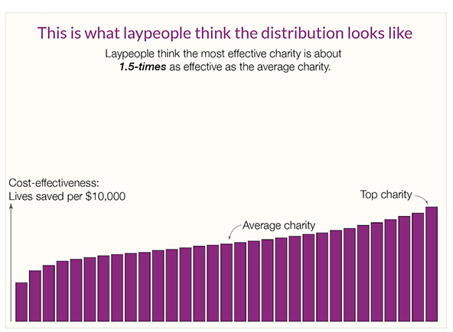

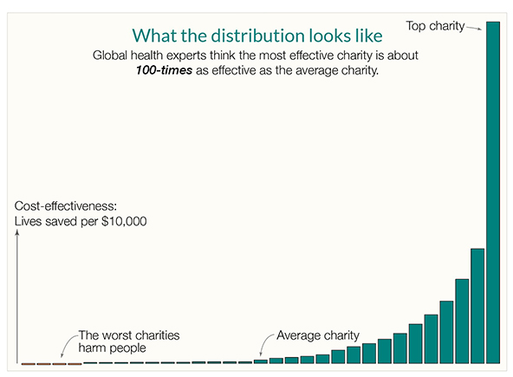

In his article, Kevin Star points out that there is a market failure in the charity sector, where donors are not part of the feedback loop, and often have no meaningful way of knowing how much value beneficiaries get from their donations. He outlines how an impact-focused evaluation approach could achieve a "quantum leap toward a better world."

Although the sources above focus on global health, similar effects occur across countries and causes. For example, Benjamin Todd's recent article on 80,000 Hours shows a similar distribution of the impact of climate interventions

(https://80000hours.org/2023/02/how-much-do-solutions-differ-in-effectiveness/) :

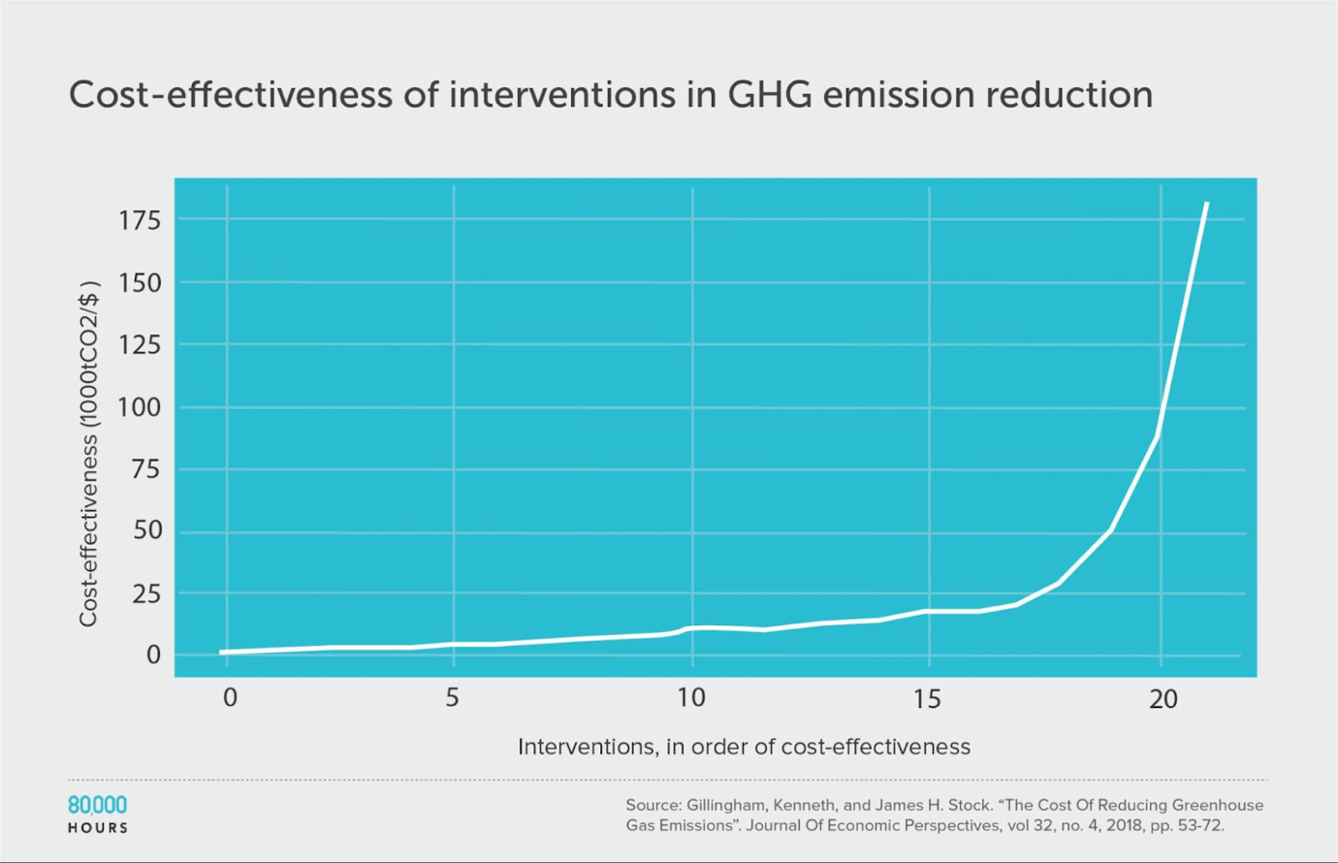

These insights are critical to understanding the efficacy of charitable organizations. Donors may not be aware of the true impact of their donations, and charities struggle to raise funds in a market that does not function effectively. However, the progress made in charity evaluation in the last decade means that this problem can be addressed.

By funding and promoting charity evaluation in Australia, we have the potential to fix the market failure, help Australian charities do more good, and become a world leader in this field.

**The Role of Charities in Shaping Public Policy (Information request 4, 5)**

In many areas, including the prevention of catastrophic risks, engaging with the government on policy is essential for achieving better outcomes for the world. For instance, while non-government organizations such as the International Campaign Against Nuclear Weapons can contribute to reducing nuclear risks, governments are the ones who hold nuclear weapons stockpiles, set rules about acquiring fissionable material and nuclear technology, and ratify international treaties.

Charities can add significant value to these conversations by investing resources in policy analysis, accessing global talent, and advancing public policy discussions. In many ways, the work of the not-for-profit sector on a topic can lessen the burden on governments. Many significant policy ideas that have shaped modern society have emerged from outside of the government, such as the 40-hour workweek or tobacco safety approaches.

However, despite being allowed to participate in policy discussions, many charities that focus on policy change as their primary means of achieving their goals are excluded from DGR status. This exclusion should be reconsidered since charities that work to prevent catastrophic disasters or promote animal welfare through policy change have a valuable role to play in the public policy conversation. Their engagement can help governments develop more effective policies and ensure better outcomes for society.

**Government must lead the way**

In conclusion, it is clear that philanthropy plays an important role in Australia's social and economic development, and there is room for significant growth in the sector. To achieve this growth, it is crucial that the government takes a leading role in promoting and supporting philanthropic giving. As noted earlier, there are several measures the government can take to achieve this, including increasing tax incentives for charitable giving and reconsidering the exclusion of charities from DGR status.

In addition, if the Australian government wants to double philanthropic giving and increase impact, it must set an example by doubling its own giving and focusing on using evidence to maximize the impact of its donations. This is particularly important in light of Australia's low ranking on the generosity of its aid compared to other OECD DAC countries. By increasing its own giving and focusing on evidence-based approaches, the government can demonstrate its commitment to philanthropy and encourage greater giving from individuals and the private sector.

I hope that the Productivity Commission finds this submission helpful in its inquiry into philanthropy, and that it will consider the various recommendations put forward here as it develops its final report. Thank you for the opportunity to contribute to this important discussion.