Productivity Commission
Prof. Alex Robson, Deputy Chair
Dr. Stephen King, Commissioner
Dr. Benjamin Mitra-Kahn, Assistant Commissioner

National Competition Policy Analysis (NCP 3.0)
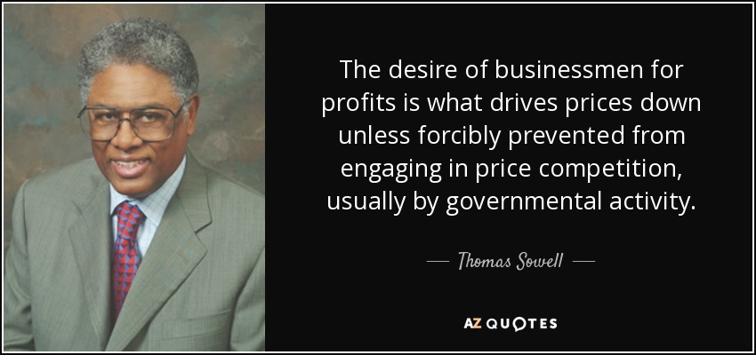
Mr. Darren Brady Nelson | Cable TV | August 2022 Prof. Thomas Sowell: https://www.azquotes.com/quote/572181
Dear Commission,
Introduction
My name is Darren Brady Nelson and I started my career in 1995 to 2005 mainly doing National Competition Policy (NCP 1.0) and related matters as a policy, regulatory and pricing economist within government, regulators and consulting. Since then, I have been an independent economist, media pundit and think tanker, who mainly works in Australia and the USA but also Canada, New Zealand and the UK. I am expert in: left, centre and right schools of economic thought; fiscal, monetary and regulatory policies; across many sectors, industries and services. I have positively written and spoken about, many times in recent years, NCP and the Productivity Commission (PC), along with competition and related matters, to American and worldwide audiences. Some of these published times form the basis of my submission.
Please accept my submission to this very important study. It is structured as per the contents table below.
Contents

Cost of Living 2
Interventions 2
Economics 3
Evidence 4
Sundry 8
Consumer Price Index 9
Original 9
Earliest 10
Latest 12
Sundry 13
Big Three Plus 13
Fiscal 13
Monetary 16
Regulatory 19
Competition 20
Sundry 22
Conclusion 23

Cost of Living
I was the Chief Economist and on the Advisory Board of the former Australian think tank of LibertyWorks from 2015 to 2020. The CPAC Network, and their annual CPAC Australia conference, has largely replaced it. During my time with LibertyWorks, I wrote many economic policy articles including, to quote the Terms of Reference (TOR) for this Study, along the lines of the following:
“The…importance of competition in lifting dynamism, productivity and wages growth, putting downward pressure on prices and delivering more choice for Australians dealing with cost-of-living pressures.”

Interventions
In the first of my trilogy of articles in 2017 on the cost-of-living (COL) in Australia, entitled The Rising Cost-of-Living is a Government Phenomenon, I reminded readers that:
“Any plan [to] address Australiaʼs ‘cost-of-livingʼ crisis and what successive governments at all three levels over many years and even decades have recklessly done to drive this crisis, whether intended or unintended. These drivers are all the plethora of government interventions that, not only increasingly skew the balance of freedom v control away from freedom, and thus necessarily reduce economic growth and jobs whilst at the same time raising costs and prices. Key amongst these drivers are the ‘four pillarsʼ of energy, tax, regulation and banking. Such a plan needs to be evidenced by proper and independent cost-benefit analysis (CBA), perhaps with the aid of the Productivity Commission (PC), Auditor-General (AG) and Parliamentary Budget Office (PBO).”
“Regarding energy, the main cause behind the almost constant upwards pressure on these prices are [local,] state and federal regulations. The two most prominent types are environmental and economic. Economic regulation of energy (transport and retail) not only helps create so called ‘natural monopoliesʼ in the first place but then regularly facilitates high prices, low quality, bad service and little innovation thereafter. This has been the case Australia-wide for decades and America-wide for over a century. Environmental regulation of energy (extraction and generation) has taken these bad effects to new levels, particularly in the past decade or so. Chief among these are the almost countless restrictions on CO2 generation and so called ‘fossil fuelsʼ extraction. Environmental regulation mainly works directly on energy supply by reducing it. Economic regulation mainly works indirectly on energy supply by reducing competition. Both put additional upwards pressure on energy prices.” [This is the case whether or not externalities are present.]
“All types of regulation in general have a major impact on ‘business climateʼ. For example, in the annual snapshot of the US Federal regulatory state entitled Ten Thousand Commandments, the Competitive Enterprise Institute (CEI) estimated ‘regulatory compliance and economic impacts at $1.88 trillion annually’ which amounts to ‘US households pay[ing] $14,976 annually on average in regulatory hidden tax’, amounting ‘to 23% of the average income of $63,784’ and households thereby spending more ‘on embedded regulation than on health care, food, transportation, entertainment, apparel and services, and savings’. The situation is no different in this country, if not worse.” [Also see CEI’s RegData Australia.]
“As for tax, higher rates are not simply ‘passed onʼ to the consumer by businesses as often wrongly stated by governments and media commentators. Greater taxation always reduces the quantity, quality and innovation of supplies as well as raise prices. This hurts businesses as well as consumers along with the broader economy, or in economic-speak tax reduces ‘producer-ʼ and ‘consumer-surplusʼ along with increasing ‘deadweight-lossʼ. The exact nature, degree and timing of this ‘painʼ is subject to factors like market competition. Reducing tax rates has the opposite effect, with the added bonus to any government of collecting greater tax revenue through the Laffer Curve economic growth dividend.” [See the Budget Transparency Portal I helped establish.]
“The final and hardest to understand ‘cost-of-livingʼ driver is banking. This primarily means the combination of the anti-competitive policy behind the ‘four big banksʼ along with the unaccountable monopoly supplier of Australian money ie the Reserve Bank of Australia (RBA). As Dr Chris Leithner pointed out in his book The Evil Princes of Martin Place, the RBA ‘doesnʼt fight inflation, it manufactures and maintains it’. To put it bluntly, the RBA prints and lends money to the ‘four big banksʼ who then in turn print and lend even more money through ‘fractional reserve banking’ which is a legalised ‘pyramid schemeʼ of sorts. As Milton Friedman concluded in The Counter-Revolution in Monetary Theory: ‘Inflation is always and everywhere a monetary phenomenon in the sense that it is and can be produced only by a more rapid increase in the quantity of money than in output.’ This results in too many dollars chasing too few goods.”
“In a ‘nut-shellʼ, counter-productive government efforts in energy, tax, regulation and banking largely restrict and distort Aussie business supply and innovation. Aussie households then feel this as a ‘double whammyʼ of the high ‘cost-of-livingʼ and low economic growth.”

Economics
In the second of my COL trilogy, entitled The Rising Cost-of-Living: Why is It So?, I explained to readers that:
“Economics is about human action – ie people acting through time and space in pursuit of ends using means, none of which are infinite or free and thus are of value. All people are individual human beings, but who necessarily interact and cooperate with others such as family, friends, employers/employees and service providers.”
“The outcome sought by all human action is profit – ie the ends achieved were worth the means including time and effort. Such profits can be any combination of monetary, material and ‘psychicʼ. Profits provide the incentives and information for entrepreneurs to provide goods and services plus jobs that wouldnʼt otherwise be provided.”
“Private property allows for the peaceful pursuit of profit (= ends – means) in cooperation [and competition] with others, often countless others around-the-world. Property is so much more than just a ‘legalʼ right to own and control land or so called ‘realʼ property. It is the ‘naturalʼ right to have the freedom to own and control oneself (including ends), oneʼs stuff (including means) and oneʼs life (including profits) in differentiation from other people.”
“Prices are the key contractual term in any exchange of property whether it is, say, money for coffee, barter for coffee or labour for coffee. Prices at the same time are an objective benchmark, along with objective quantities and semi-objective qualities of goods and services, for comparison to subjective value. Thus prices, like profits, are incentives and information intertwined. Prices, however, can be known ex ante and profits, although expected ex ante, can only be known ex post. Furthermore, because value is subjective in the ‘eye of the beholderʼ, it is possible for two people to exchange some of their property at the one price and both ‘walk awayʼ with the ‘more valuableʼ item. Hence voluntary exchange is always ‘win-winʼ, at least ex ante.”
“This brings us to purchasing-power, be it for consumers or businesses. [In microeconomic terms,] the price and purchasing-power of the unit of a product are one and the same. [In macroeconomic terms,] the purchasing-power of money [PPM] is the inverse of whatever we can construct as the price level [P] or the level of overall prices [eg CPI]. In mathematical terms: PPM = 1/P. When [PPM] decreases this means that [COL] increases.”
“Unlike tax and regulation (even income tax or energy regulation), increasing or inflating the money supply impacts on the entire economy over time as: 1) the boom-bust ‘businessʼ cycle, reflected in higher prices (and higher profits) for some in the boom; and 2) ultimately ‘inflationʼ, reflected in higher prices (and lower profits) for most if not all. By the way, tax and regulation put upwards pressure on prices and downwards pressure on purchasing-power … not through increased demand for goods and services like money does … but through decreased supply for goods and services.”
“All government policies either: A) reduce or remove market interventions; or B) add to them. ‘A’ reduces the [COL], whilst ‘B’ raises it.”

Evidence
In the third of my COL trilogy, entitled The Rising Cost-of-Living: The Evidence is Clear, I showed to readers that:
“Annual changes in nominal GDP [Gross Domestic Product] growth appear to strongly correlate with CPI … as well as, but less obviously, to M3. According to great 20th century economists like Keynes, Friedman, Mises, Hayek and Rothbard, M [money supply] inflation (as say measured by M3) drives P inflation (as say measured by CPI) which in turn drives much [overstated] Economic Growth (as say measured by nominal GDP).” [Overstated, from an economic perspective, being not driven by market ‘forces’ of competition, innovation and productivity.]
“P inflation, even as measured by the economically and statistically limited CPI, has been largely and shockingly accumulating like compound interest since the early 1970s. Free-market-oriented policies in the 1990s, like National Competition Policy (NCP), helped to take the edge off of P inflation that was being driven by M inflation.”
“As any sound economist would expect, CPI for the lightly regulated goods and services is falling whilst that for the heavily regulated ones is rising. For instance, increasingly unaffordable housing and energy, as indicated by CPI, is mainly driven by government (G) inflation on the supply-side of the respective markets and M inflation on the demand-side.”
[Sound economics here being from a free market competition perspective such as those schools of thought as Austrian, Chicago, Christian, Classical (English, French and Spanish), Public Choice and Supply Side as well as even Institutional, Keynesian and Neoclassical but not so much Behavioural, Experimental or Game Theory much less Galbraithian, Marxian or Pigouvian.]
“M inflation drives P inflation as well as facilitates G inflation like taxation and regulation. Taxation and regulation adds to P inflation mainly through: reducing efficient supply and competition – ie a shortage from eg a tax or a price ceiling regulation; and/or increasing inefficient supply and entry – ie a surplus from eg a subsidy or a price floor regulation. Both also hide behind M inflation say: increasing hidden taxation through income bracket creep; or increasing use of price ceiling regulations to supposedly deal with P inflation.”
“M inflation, as measured by say M3, is the key to properly understanding poor Australian economic performance – ie income (eg GDP) versus the cost-of-living (eg CPI). M3, according to many of the best economists, is the key measure of M supply. It essentially includes currency M (from the RBA) as well as deposits M (from the Big-5 Banks).”
“The two institutions that contribute most to M inflation, and thus P inflation as well as G inflation and yet more P inflation, are central banking (ie the RBA) and fractional reserve banking (especially the Big-5 Banks). Under this legal ‘pyramid’ system, approximately $9 extra is created by the Big-5 ‘out of thin air’ for every $1 created by the RBA.”
“M inflation by central banking (ie the RBA) and fractional reserve banking (FRB) is made worse by the cartelisation of the banking market (ie the Big-5). All three phenomenon are only possible and sustainable through government intervention.”
“The purchasing-power of money (PPM) is the inverse of the overall level of P also known as the cost-of-living. In mathematical terms: PPM = 1 / P. In a ‘nut shell’, M inflation (by the RBA + FRB) leads to PPM deflation which is the exact inverse of P inflation. In other words, the cost-of-living rises. This is made worse by the inevitable G inflation that goes hand-in-hand with it.”
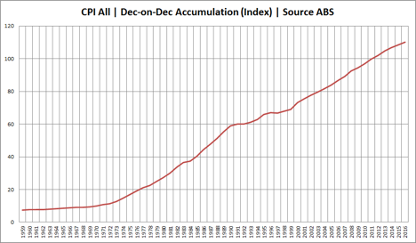
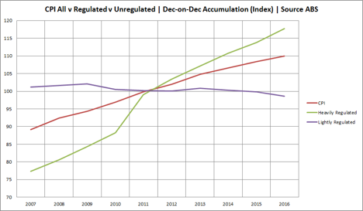
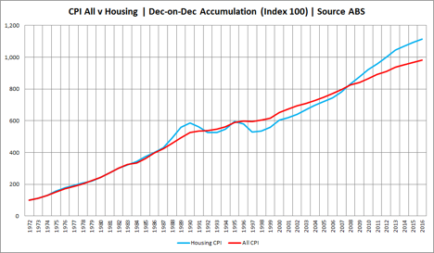
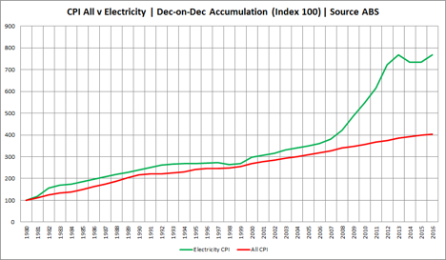
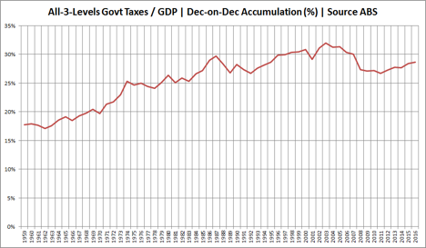
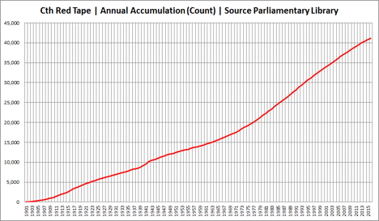
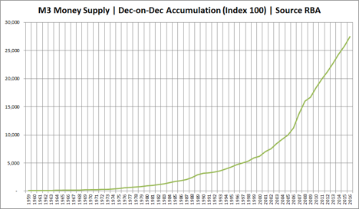
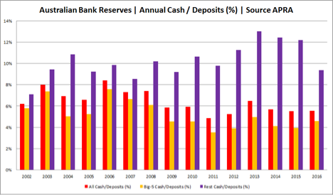
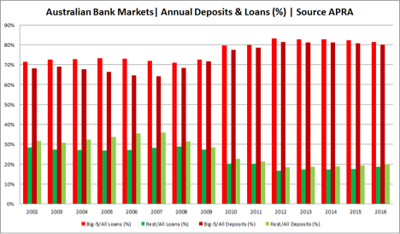
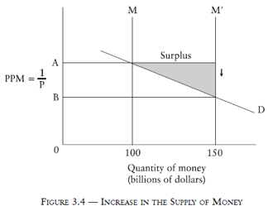

Sundry
The Institute of Public Affairs (IPA) later published a paper in March 2018 consistent with my 2017 COL trilogy, especially in terms of regulations and subsidies, entitled How Regulation And Red Tape Makes Families Poorer. An extract from that follows next along with the key chart below:
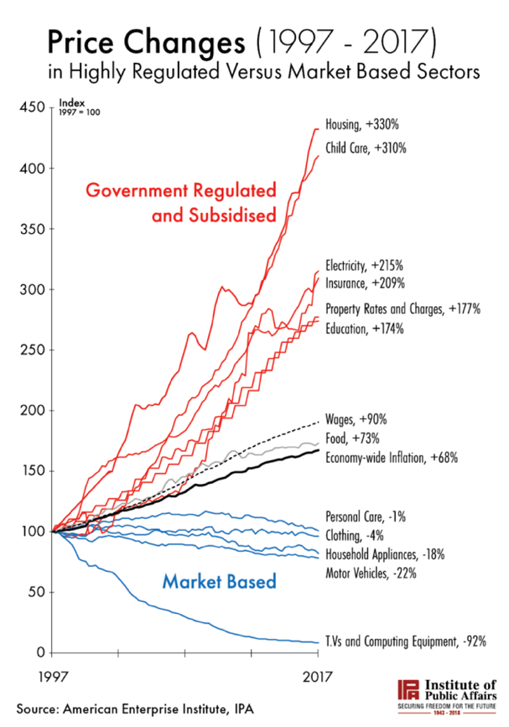
“The report finds that government regulation increases business operating costs, increases barriers to market entry, and reduces competition. These factors push up prices. At the same time, governments have been providing extensive subsidies, which further bid up demand and push up prices.”
“While wages have risen by just 90 per cent over the past two decades, the cost of housing has risen by 330 per cent, childcare by 310 per cent, electricity by 215 per cent, insurance by 209 per cent, and education by 174 per cent. These are all sectors in which we see substantial government interference.”
“What is so interesting is that prices have been declining in sectors which have little government interference and are mostly market-based. For example, the cost of televisions and computing equipment have declined by 92 per cent of the past two decades, while motor vehicles have declined by 22 per cent.”
“What is clear is that free enterprise, free trade, the rule of law, and private property are the key ingredients for a prosperous economy where the middle class can live comfortably and get ahead. A Government committed to reducing the cost of living for Australians should dramatically cut red tape in heavily regulated areas of the economy like housing, childcare and our energy market.”

Consumer Price Index
I am currently associated with competition-friendly think tanks like America’s Center for Freedom and Prosperity and write for competition-friendly publications like Europe’s Concurrences. I also have many years of experience with economic statistics and estimating. The former includes indexes like CPI. The latter includes ABC, budgeting, CBA, CPI-X, CR, elasticities, FF, LI, pricing, RDA, SCP, SMP, SVA and WACC/CAPM. The focus of the PC’s NCP Study is on “estimating the likely economy-wide and fiscal effects”. CPI is key, because prices are key. Prices reflect demand, supply and competition or lack thereof.
Industry-related Consumer Price Index (CPI) data was recently modeled and charted in Microsoft Excel by me (and provided as a supporting attachment to this submission). This data is from the Australian Bureau of Statistics (ABS) for March Quarter 2024 from Table 9. The key results have been extracted and presented below. The first set use the Original index dates for 12 industries as well as 6 infrastructure sub-industries. The various dates cluster in and around the year 2012 (but not exactly so). The second set is like the first, except the Earliest index dates are used for each component based on when data for each component was first collected. The various date ranges start in the year 1972. The third set is like the second, except all use the Latest index date of the most recent start date for a component’s data. The two dates are June 2005 and June 1998. All three sets include “All groups CPI”, labelled as just CPI, as a benchmark.

Original
As can be seen in the chart below, those industry prices rising above CPI over the past decade, from highest on down, are: Alcohol and tobacco (Alc & Tob); Health; Education; Utilities; and Housing. Alc & Tob, very much so. Those prices in line or rising below are: Insurance and financial services (Finance); Food and non-alcoholic beverages (Food & Bev); Transport; Furnishings, household equipment and services (Household); Recreation and culture (Recreation). The only relatively flat prices are Clothing and footwear (Clothing) and the only relatively declining prices are Communication.
As can be seen in the table below, the 12 industries plus CPI itself are ranked from highest (1st) to lowest (13th) from three different perspectives of: the latest index data; growth from the earliest index data to the latest; and the average index data. In terms of latest: Alc & Tob is 1st; Health is 2nd; and Education is 3rd. In terms of growth: Alc & Tob is 1st; Utilities is 2nd; and Housing is 3rd. In terms of average: Finance is 1st; Recreation is 2nd; and Health is 3rd.
As can be seen in the chart below, those infrastructure prices rising above CPI over the past decade, from highest on down, are: Gas; Postal; and Electricity. Gas, very much so. Those prices in line or rising below are: Water and Sewerage (Water & Sew); and Public Transport (Pub Tran). The only relatively declining prices are Telecommunications (Telco).
As can be seen in the table below, the 6 infrastructure sub-industries plus CPI itself are ranked from highest (1st) to lowest (7th) from three different perspectives of: the latest index data; growth from the earliest index data to the latest; and the average index data. In terms of latest: Gas is 1st; Postal is 2nd; and Electricity is 3rd. In terms of growth: Pub Tran is 1st; Electricity is 2nd; and Postal is 3rd. In terms of average: Telco is 1st; Gas is 2nd; and Water & Sew is 3rd.

Earliest
As can be seen in the chart below, those industry prices rising above CPI over the past decade, from highest on down, are: Alc & Tob; Utilities; Housing; and Food & Bev. The former two, very much so. Those prices in line are Education; and Transport. Those prices rising but well below are: Household; and Health. Those prices in line but well below are: Recreation; and Finance. The only relatively declining prices are Clothing and Communication.
As can be seen in the table below, the 12 industries plus CPI itself are ranked from highest (1st) to lowest (13th) from three different perspectives of: the latest index data; growth from the earliest index data to the latest; and the average index data. In terms of latest: Alc & Tob is 1st; Utilities is 2nd; and Housing is 3rd. In terms of growth: Alc & Tob is 1st; Utilities is 2nd; and Housing is 3rd. In terms of average: Alc & Tob is 1st; Utilities is 2nd; and Food & Bev is 3rd.
As can be seen in the chart below, those infrastructure prices rising above CPI over the past decade are Pub Tran, and very much so. Those prices rising, but still below, are Electricity, but not by much. Those prices rising, but well below, are Postal, Gas and Water & Sew. The only relatively declining prices are Telco.
As can be seen in the table below, the 6 infrastructure sub-industries plus CPI itself are ranked from highest (1st) to lowest (7th) from three different perspectives of: the latest index data; growth from the earliest index data to the latest; and the average index data. In terms of latest: Pub Tran is 1st; Electricity is 3rd; and Postal is 4th. In terms of growth: Pub Tran is 1st; Electricity is 2nd; and Postal is 3rd. In terms of average: Pub Tran is 1st; Electricity is 3rd; and Postal is 4th.

Latest
As can be seen in the chart below, those industry prices rising above CPI over the past decade, from highest on down, are: Utilities; Alc & Tob; Education; Health; and Housing. And all four, very much so. Those prices in line are Food & Bev and Finance. Those prices below but rising up to CPI are Transport. Those prices in line but well below are Household and Recreation. The only relatively declining prices are Clothing and Communication. The latter, very much so.
As can be seen in the table below, the 12 industries plus CPI itself are ranked from highest (1st) to lowest (13th) from three different perspectives of: the latest index data; growth from the earliest index data to the latest; and the average index data. In terms of latest: Alc & Tob is 1st; Utilities is 2nd; and Education is 3rd. In terms of growth: Alc & Tob is 1st; Utilities is 2nd; and Housing is 3rd. In terms of average: Finance is 1st; Health is 2nd; and Utilities is 3rd.
As can be seen in the chart below, those infrastructure prices rising well above CPI over the past decade are: Gas; Electricity; Water & Sew; and Postal. And all four, very much so. Those prices rising in line are Pub Tran. The only relatively declining prices are Telco, and very much so.
As can be seen in the table below, the 6 infrastructure sub-industries plus CPI itself are ranked from highest (1st) to lowest (7th) from three different perspectives of: the latest index data; growth from the earliest index data to the latest; and the average index data. In terms of latest: Gas is 1st; Electricity is 2nd; and Water & Sew is 3rd. In terms of growth: Pub Tran is 1st; Electricity is 2nd; and Postal is 3rd. In terms of average: Water & Sew is 1st; Gas is 2nd; and Electricity is 3rd.

Sundry
Unsurprisingly, those industries and sub-industries that have the highest and growing CPI are those that also have the greatest and heaviest government intervention. For example, the top five latest in industry above are: alcohol and tobacco, which are highly taxed; utilities, which are highly protected; education and health, which are highly government provided, regulated and/or subsidized; and housing, which is highly restricted. For example, the top three latest in infrastructure are: gas, with many restrictions; electricity with much subsidies; and water and sewerage, usually government owned or backed monopolies.

Big Three Plus
From an economics perspective, there are a Big Three Policies of Fiscal, Regulatory and Monetary. Competition policy in the past has been mainly focused on removing regulatory government barriers as well as some fiscal ones typically subsidies. This should be broadened out to potentially capture all three as all three drive up COL, even when justified by a proper CBA: demonstrating that social benefits are greater than social costs; and for reasons of market failure greater than government failure.

Fiscal
Two revolutionary papers by me were published in January 2023 and January 2024 by the Maine Policy Institute and the Heartland Institute respectively. In a world-first, I applied an Australian approach to regulating ‘natural monopoly’ prices to regulating ‘government monopoly’ budgets. That approach was CPI-X, applied to American local, state and federal levels, and where I made the following relevant points:
“The [Retail Price Index] RPI minus X, or CPI minus X (CPI-X), approach to infrastructure utilities regulation was invented by Professor Stephen Littlechild of the United Kingdom in the early 1980s. The CPI-X approach expanded around the world soon after the mid-1980s [including to Australia by the 1990s]. Law Insider defines this approach as: ‘[A] means of controlling the extent to which companies with monopoly power raise their prices. [It] prevents regulated companies from increasing their prices or revenue by more than general price inflation, less an X value determined by the regulator, over a specified period. The control protects consumers, by preventing companies with monopoly power from abusing that power through price increases’.”
“Decades of experience with this strongly suggest three things: Sustained monopoly power derives from government (fiscal and regulatory) intervention; Sustained price inflation also derives from government (monetary) intervention; Thus this form of price regulation applies more so, if not exclusively to, government itself (or the public sector) over “companies” (or the private sector).”
“The version of CPI-X detailed in this paper provides a blueprint for fiscal-minded policy makers – whether in the federal government, state government, or at the local level – to apply sound and proven economic models using the CPI as a baseline, and achieving actual spending cuts via the “X” in the equation. The X-factors in CPI-X are derived from benchmarking the spending of [the relevant government’s agencies within as well as similar governments without, both inter-nationally or intra nationally, and both historically and forecast] along 10 basic policy areas.”
“Because overspending has been a bipartisan problem in Washington, DC [and Canberra] for many decades, drastic action is needed to change the present path. Although some fiscal conservatives tout solutions like a Balanced Budget Amendment as a cure-all for the constant increases in federal spending, this is a half-baked idea because it would also likely lead to steep tax increases in order to keep the federal [or state or local] government from accruing annual deficits. On the other hand, CPI-X addresses the problem directly by actually imposing extensive and long-overdue reductions in federal [or state or local] spending.”
“When creating [government] budgets, lawmakers [and public servants] need to not only review revenues and expenditures, but also ask themselves fundamental questions of philosophy regarding the role of government. The following guiding principles for government budgets [and all government interventions follow next]:
1. Government is ultimately, whether democratic or not, a legal monopoly on force within a geographical area.
2. Government is incentivized, like any monopoly or cartel, to maximize the price tag to others and minimize the cost tag to them (e.g. quantity, quality and service).
3. Government is incentivized, like any economic agent, to maximize and concentrate their own benefits and minimize and disperse their own costs.
4. Government is incentivized, like any bureaucracy, to focus on change-resistance, empire-building and rules-proliferation (with the latter not being the Rule of Law but rather Law of Rule).
5. Government does not create, but extracts from and reduces, market-created wealth.
6. Government taxes and expenditures both, and separately, intervene in free markets.
7. Government taxes and expenditures overall should, over time, not only aim to be in balance, but minimized over time.
8. Government tax types and rates minimize distortions and maximize revenues when simpler and lower.
9. Government expenditures are not like market costs, subject to downward pressure from price, product, and profit/loss competition, thus need to be de-monopolized over time through greater competition, consolidation, downsizing, privatization, scrutiny, transparency and other innovative means.
10. Government that governs least, governs best.”
I wrote a budget committee testimony in early 2024 on behalf of the Maine Policy Institute opposing a proposed Local Option Sales Tax (LOST), where I made the following relevant points:
“The previous 26 failed attempts at a LOST are, in no small part, due to the legitimate concerns from the left, center and right. [Maine Center for Economic Policy (MECEP)] represents the center-left; [Maine Policy Institute (MPI)] the center-right. Both highlighted, in their 2019 reports, the socio-economic and geographical inequities of LOST. MECEP wrote that it ‘creates haves and have-nots’ and ‘would worsen inequality within and between communities’.”
“Context is provided by state sales tax statistics from the Maine Revenue Services (MRS). Their website includes spreadsheets with dollar revenues ($R) disaggregated into ten sources, such as restaurants and lodging, as well as into all towns and economic areas. Ideally this data would also include the price ($P) and quantity (Qn) components underlying these totals of: $R = $P x Qn. Nevertheless, MPI’s modelling shows that lodging sales tax revenues skyrocketed in the 2020s by over 200 index points, restaurants by over 100, and overall by almost 75. Given that P has been 5.5% since it ‘temporarily’ increased in October 2013 from 5.0%, the rise in R must have been driven by Q. This means lodging, and to a lesser extent restaurants, took off in the late 2010s and then boomed in the 2020s, after the one-year Covid-19 crash (as per the left-side chart below).”
“A sure-fire way to get less of something is to tax more; not to mention to potentially ‘kill the goose that lays the golden egg.’ Media pundits often claim that businesses can simply pass-forward sales tax increases to consumers. This is a half-truth. The other-half of this truth is that businesses take a hit too, so that they investment and hire less. And rather than just a 50/50 hit-split between businesses and consumers (as per the right-side graph below), economics and history show it is more like a 80/20 situation. That 80 includes a pass-backward in the supply chain. The particulars depend on the elasticities of demand and supply, given the specific choices and competition. But small-state local businesses and their employees tend to face less choices and more competition.”
“Economics and history also show that, at first, raising tax rates tend to grow government revenues but, not long after, these revenues tend to shrink at least in relative terms. This is called the Laffer Curve effect. That effect was experienced in Maine between 2013 and 2014 when the state sales tax rate was ‘temporarily’ raised from 5% to 5.5%. Overall sales tax revenues then slowed from 4.2% growth to 3.8%, with lodging-related ones shrinking from 5.3% down to 4.8%. In conclusion, LOST may not ‘kill’ the ‘golden goose’ of lodging, but it will unnecessarily wound it.”
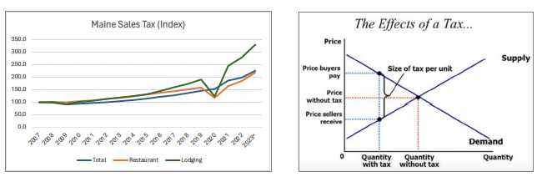

Monetary
I wrote about central bank monetary inflation in early 2023 for Spectator Australia with a very provocative title of RBA (Reckless Bank of Australia), where I made the following relevant points:
“In 2017, LibertyWorks made a landmark submission (authored by me) to the Senate Select Committee on Lending to Primary Production Customers chaired by Senator Malcolm Roberts of One Nation. This is quoted from former Treasurer Peter Costello, who said earlier that year:
‘Sometimes I wonder whether those running the banks realise how important the government [including the RBA and the Big 4 banking cartel] is to their business. Who benefits from this tightly regulated enterprise? Well, the government does, the shareholders of course, and the senior executives employed on handsome salaries to keep their operation ticking over. It’s the consumer that is feeling unloved’.”
“Two of the most highly respected economists of the 20th century of Milton Friedman and John Maynard Keynes backed this up when they wrote respectively (and quoted by me in 2021 for the Mises Institute):
‘Inflation is always and everywhere a monetary phenomenon in the sense that it is and can be produced only by a more rapid increase in the quantity of money than in output.’
‘By a continuing process of inflation, governments can confiscate, secretly and unobserved, an important part of the wealth of their citizens. By this method they not only confiscate, but they confiscate arbitrarily; and, while the process impoverishes many, it actually enriches some. The sight of this arbitrary rearrangement of riches strikes not only at security, but at confidence in the equity of the existing distribution of wealth’.”
“The Aussie and world media almost always equate inflation with the Consumer Price Index (CPI). CPI is simply one of a number of price-related statistics. It has many problems, both in principle and in practice. The main problem in principle is that it is not the cause of inflation but one of many possible effects. The main problem in practice is that it is missing many non-retail prices such as production, wholesale, and asset ones as well as government-related ones. CPI, thus, significantly and consistently downplays inflation. Despite that, the picture is still not pretty since the early 1970s after the end of the Gold Standard. However, National Competition Policy (NCP) and other great Hawke-Keating-Howard-Costello economic reforms did help to keep CPI under control in the 1990s.”
“Inflation was, is, and always will be inflation of the money supply. The Aussie money supply starts with RBA ‘printing and lending’ and ends with big banks ‘lending and printing’. Two standard measures of these are M1 and M3. The RBA’s online glossary states: ‘M1 [is] defined as currency plus bank current deposits from the private non-bank sector; [and] M3 [is] defined as M1 plus all other authorised deposit-taking institution (ADI) deposits from the private non-ADI sector, plus certificates of deposit issued by banks, less ADI deposits held with one another[.]’ The index numbers (and underlying dollar amounts and growth) for M1 and M3 are ‘eye watering’ … showing increases in the tens of thousands, not just tens or hundreds like that for CPI, GDP, etc.”
“Money supply inflation puts upward pressure on all prices eventually, including retail ones, but certain prices more immediately. The latter typically includes those in capital, equity, and property malinvestments. This is the source of bubbles and booms. Market reality ultimately corrects for these through bursting and busting. The so-called ‘business cycle’ is, thus, not a natural market phenomenon but an artificial government one. Gross Domestic Product (GDP), as a fully price times quantity measure, reflects inflation better than the partial price times quantity measure of CPI. GDP is ‘jacked up’ on the price or demand-side by money inflation and on the quantity or supply-side by government and population inflation including mass immigration (legal or not).”
“The recommended reforms from 2017 by LibertyWorks to the Senate Select Committee on Lending to Primary Production Customers are still a great place to start. These were [three including]:
‘[In the longer term], complete the comprehensive reform agenda of Australian money and banking … including National Competition Policy (NCP) style compensation and transition payments with the aid of a [statist] blue team and free market red team’.”
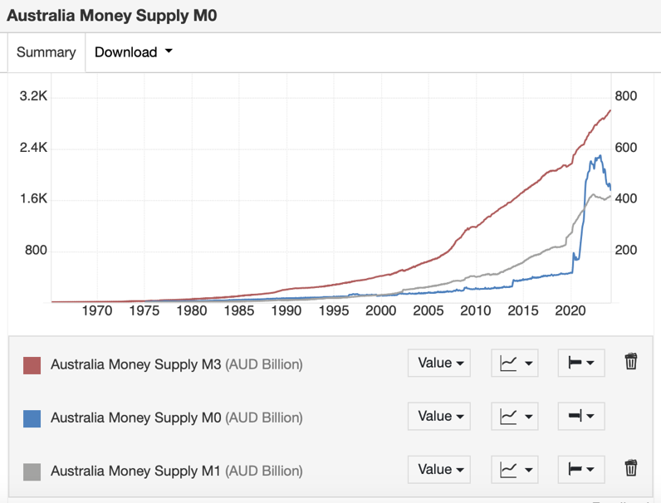
I also wrote about private bank monetary inflation in early 2023 for the Mises Institute with a not-so provocative full-title of The Bank of England: Money Creation in Their Own Words, where I made the following relevant points:
“In March 2014 the world’s oldest central bank, the Bank of England (BoE), did every advocate of sound money a big but unintentional favor by publishing first an official introduction to [entitled Money in the Modern Economy: An Introduction], and second an official detailed account of [entitled Money in the Modern Economy], unsound money.”
“The BoE sets the stage in the first paper by defining money in terms of the following three important roles:
‘The first role of money is to be a store of value—something that is expected to retain its value in a reasonably predictable way over time. ... Money’s second role is to be a unit of account—the thing that goods and services are priced in. ... Third, money must be a medium of exchange—something that people hold because they plan to swap it for something else, rather than because they want the good itself’.”
“This multidimensional definition (and other similar ones) is largely accepted by both free-market and government-centric economists alike. To its credit, the BoE expands upon the first role:
‘These functions are all closely linked to each other. For example, an asset is less useful as the medium of exchange if it will not be worth as much tomorrow—that is, if it is not a good store of value. Indeed, in several countries . . . the traditional currency has become a poor store of value due to very high rates of price inflation. ... Gold or silver that was mined hundreds of years ago would still be valuable today.’.”
“Also to its credit (pun intended), the BoE accurately and honestly describes fiat money:
‘Since 1931, [BoE] money has been fiat money. Fiat or paper money is money that is not convertible to any other asset (such as gold or other commodities)’.”
“But, to its discredit, the BoE inaccurately or dishonestly defends it as well:
‘But the Bank permanently abandoned offering gold in return for notes in 1931 so that Britain could better manage its economy during the Great Depression’.”
“In the second paper, the BoE right out of the gate happily busts the [textbook] myth about bank savings and loans [in favour of the Austrian theory of] fractional reserve banking (FRB):
‘The reality [or perhaps the mystery] of how money is created today differs from the description found in some economics textbooks: Rather than banks receiving deposits when households save and then lending them out, bank lending creates deposits. When a bank makes a loan, for example to someone taking out a mortgage to buy a house, it does not typically do so by giving them thousands of pounds worth of banknotes. Instead, it credits their bank account with a bank deposit of the size of the mortgage. At that moment, new money is created. For this reason, some economists have referred to bank deposits as fountain pen money, created at the stroke of bankers’ pens when they approve loans’.
‘Currency only accounts for a very small amount of the money held by people and firms in the economy. The rest consists of deposits with banks, as shown in Chart 1’.”
“The BoE’s introductory paper unwittingly provides a nice overview of how sound money used to work once upon a time:
‘When the [BoE] was founded in 1694, its first banknotes were convertible into gold. The process of issuing “notes” that were convertible into gold had started earlier than this, when goldsmith-bankers began storing gold coins for customers. The goldsmiths would give out receipts for the coins, and those receipts soon started to circulate as a kind of money. The [BoE] would exchange gold for its banknotes in a similar way—it stood ready to swap its notes back into gold on demand. Other than a few short periods, that was how currency worked for most of the next 250 years—the gold standard’.”
“It is not uncommon for economists in academia, government, and media to suggest that FRB is simultaneously an incredible conspiracy theory and yet a credible economic system. The BoE has happily and officially debunked [FRB as a mere] conspiracy [theory] but sadly and predictably upheld the FRB system. The latter is despite its own statistics [not to mention the RBA’s too], clearly demonstrating its failed ability to better manage its economy during or since the Great Depression that it helped create compared to the previous 250 years of the gold standard when the bank would simply exchange gold for its banknotes.”
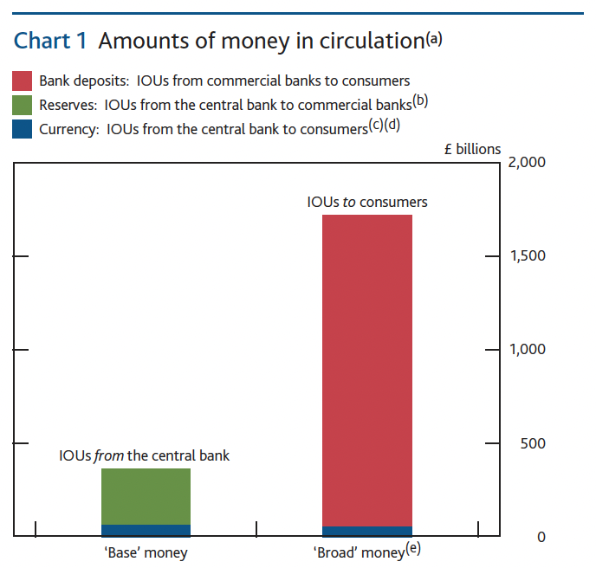

Regulatory
I wrote the segments on economic rents in a 2011 submission to the PC for an inquiry regarding the Economic Regulation of Airport Services, where I made the following relevant points:
“Decades of trying to measure abuse of significant/substantial market power in the USA, Australia and elsewhere has been fraught with danger (much less trying to ‘look under the hood’ of market power at possible locational power). The Lerner Index for example tries to measure market power through the gap between price (P) and marginal cost (MC) – ie (P – MC) / P. MC for one is nearly impossible to measure precisely on an ongoing basis at a reasonable cost (assuming one can decide between short run and long run MC, or proxies like incremental or average variable costs). MC is also a major problem in measuring predatory pricing when price is supposedly below MC. MC issues aside, market power measures such as the Lerner Index are of little use in breaking down the ‘P – MC’ gap into locational, monopoly and other forms of economic profit or rent.”
“Most of the reasons for the existence of market power are not monopoly in origin, such as success in taking entrepreneurial risks on input and transaction cost reductions, product innovation and differentiation, and even location selection and development. These successes create value (ie producer plus consumer surplus) at least in the shorter term. Some degree of market power is needed to capture the value created. This market power generally depends upon the ‘5 forces’ of: market rivalry; product substitutes and complements; market entry and exit barriers; output buyer power; and input supplier power. Some degree of market power is usually the norm in ‘real world’ markets. Significant monopoly power is relatively rare especially as a monopoly means one supplier in a well-defined market...and in most cases needs government intervention to give it this monopoly in the longer term.”
“Market power can also be looked at through transaction costs economics approach. From the customers point of view these costs are mainly driven by the time and effort of searching for alternatives, along with the agreement (formal and informal) in exchanging their patronage and payment for these services. From a service provider’s point of view these costs are mainly driven by: the degree to which a transaction is supported by transaction-specific investments (ie asset specificity); the uncertainty involved in the transaction; and the frequency or recurrence of the transactions. Asset specificity, in turn, is driven by the costs of: selecting and securing a location (ie sitespecific investments); securing machinery, equipment and plant (ie physical asset-specific investments); and education, training and development of human resources (ie human asset-specific investments. Thus, what may appear to be the generation of economic rent could actually be the accounting for the transaction costs to the exchange between airports and their customers.”
“The famous Austrian School economist Murray N. Rothbard in Man, Economy, and State with Power and Market wrote: ‘The only viable definition of monopoly is a grant of privilege from the government. It therefore becomes quite clear that it is impossible for the government to decrease monopoly by passing punitive laws. The only way for the government to decrease monopoly, if that is the desideratum, is to remove its own monopoly grants.’ Professor Rothbard added: ‘To preserve competition does not mean to dictate arbitrarily that a certain number of firms of a certain size have to exist in an industry or area; it means to see to it that [people] are free to compete (or not) unrestrained by the use of [government] force.’.”
I wrote about the economics of competition, both textbook and realworld, in 2020 for European competition lawyers who read Concurrences magazine, with a provocative title of Antitrust, Anti-competition, where I made the following relevant points:
“In standard textbooks, the performance of a well-defined market (e.g., profit) is determined by market conduct (e.g., price) which is in turn determined by market structure (e.g., competition) with the market basics of demand and supply underpinning these (e.g., natural resources). Government is treated as external but able to directly or indirectly influence any or all of these market aspects. The inbuilt bias against markets is already apparent by the wording that suggests: markets have ‘forces’ and ‘power’; monopolies are ‘natural’; and that competition needs to be ‘perfect’ otherwise it will be ‘monopolistic’.”
“Regarding textbook competition, Nobel Laureate Friedrich von Hayek (1947) wrote, ‘It appears to be generally held that the so-called theory of perfect competition provides the appropriate model for judging the effectiveness of competition in real life, and that, to the extent that real competition differs from that model, it is undesirable and even harmful.’ Hayek added to this critique of perfect competition that: ‘Competition is by its nature a dynamic process whose essential characteristics are assumed away by the assumptions underlying static analysis’ thus ‘perfect competition means indeed the absence of all competitive activities’.”
“Regarding realworld competition, Hayek (1947) wrote: ‘Competition means decentralized planning by many separate persons.’ And he added that: ‘The function of competition is to teach us who will serve us well.’ As well as: ‘The merit of competition is precisely that it gives the minority a chance to prevail.’ Regarding realworld monopoly, he wrote: ‘A monopoly based on superior efficiency [ie not government intervention or favour, unintentional or intentional] does comparatively little harm so long as it is assured that it will disappear as soon as anyone else becomes more efficient in providing satisfaction to the consumers’.”
Dominick Armentano (1986) critically presented, in great detail, a number of classic US antitrust cases over time including: nine cases regarding monopolisation; three cases regarding price conspiracy; four cases regarding price discrimination; eight cases regarding tying agreements; and six cases regarding mergers. Armentano (2007) observed: ‘It is undeniably true that the antitrust laws have often been employed against innovative business organizations that have expanded output and lowered prices.’ And hence: ‘From that perspective, antitrust regulation is just another historical example of protectionist rent-seeking legislation, the overall effect of which is to lessen economic efficiency’.”
“The antitrust authorities – like those in Australia, Europe and the US – provide some evidence of the actions they have undertaken over the years and the results of these: like winning or losing cases; and fines or damages imposed. This is nowhere near good enough to properly judge whether antitrust is a net positive or net negative over time. Clear evidence is needed to show whether freedom, competition and welfare are enhanced or not by antitrust, including sound statistics on market prices, quantities, qualities, etc.”
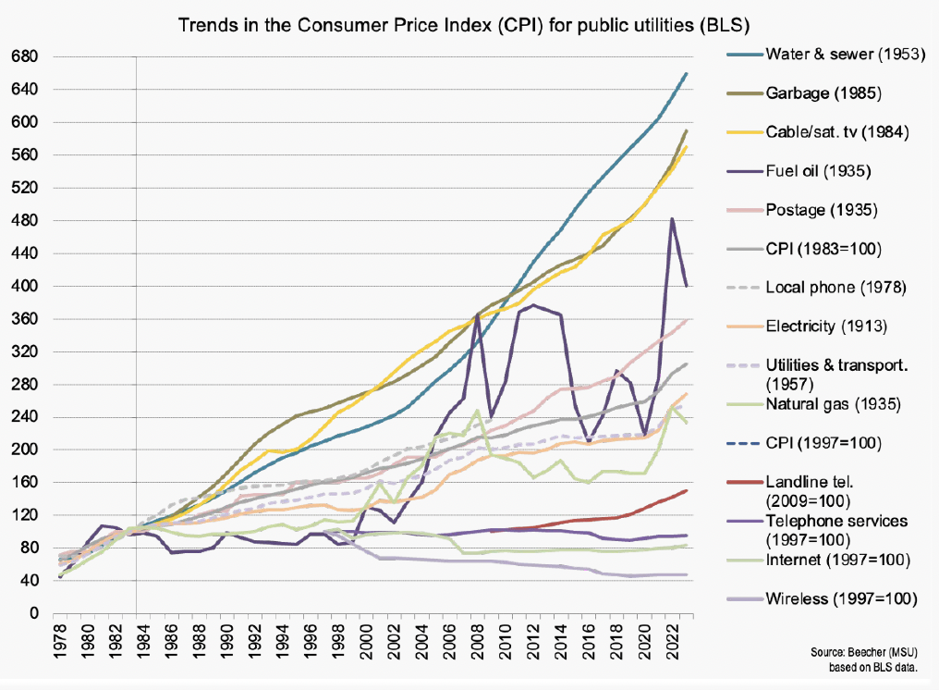
“Janice Beecher (2018) has analysed price statistics for US public utilities over time. These are subject to regular intervention as so-called natural monopolies in order to promote, not competition per se, but competition-like outcomes. This type of intervention, which has also been around for over 100 years, is of the same genre as antitrust, i.e., economic regulation. That has failed; and it is more likely than not that so too has antitrust.”

Competition
I wrote about the PC and NCP, plus other related Australian economic reforms, in 2018 for the Cayman Financial Review with a catchy title of Advance Australia Fair, where I made the following relevant points:
“The national anthem of Australia has some very pertinent lyrics to that countryʼs economic reform and performance path in recent decades. The reference to ‘free’ and ‘wealth for toil’ reflects the many positive economic reforms under Prime Ministers Hawke, Keating and Howard from the mid-1980s to mid-2000s. These were mainly in the areas of trade, finance, labour, tax, pensions and competition. Unfortunately, from the late-2000s to the present, Australia has largely stalled. Both major political parties of Labor and Liberal-Nationals share the credit until the mid-2000s, as well as the blame since.”
“Australiaʼs annual Economic Freedom Index score from 1970 to 2015, compiled by the Fraser Institute, is broadly consistent with this story. The Fraser index measures the degree of economic freedom present in five major areas: 1) Size of Government; 2) Legal System and Security of Property Rights; 3) Sound Money; 4) Freedom to Trade Internationally; and 5) Regulation. Australia had a low score of 6.06 out of 10 in 1975, which rose to 7.73 in 1990 in the wake of significant reforms in trade, finance and labor. This score rose yet further in 2000 to a high of 8.19 in the wake of significant reforms in tax, pensions and competition.”
“Since the economic reform heydays of the mid-1980s to mid-2000s, Australia has stalled in the areas of trade, finance, tax and pensions plus has regressed in the areas of labor and competition. The poster child for the latter is electricity. Climate and other environmental regulations and subsidies have artificially favored uncompetitive wind and solar power over competitive coal, gas, hydro and nuclear power. The impacts over the past 10 years on the price, quantity and quality of electricity in Australia are clearly and massively negative [see CPI]. Australia went from best on the planet to worst, in a relatively short period of time. And this was entirely of its own making, through bad economic policies at federal, state and local levels.”
I wrote about the PC and NCP, as the best model for American infrastructure reforms, in 2020 for the Heartland Institute with a descriptive sub-title of Lessons from Australia, where I made the following relevant points:
“Australia’s National Competition Policy (NCP) [was] truly unique and potentially revolutionary for the United States and much of the rest of the world. NCP was aimed at removing or minimizing the monopoly power of the numerous federal, state, and local government-owned businesses in the economy by injecting competition (in an actual, potential, or proxy sense) and, thus, shifting infrastructure systems away from monopoly and oligopoly towards competition.”
“Policymakers implemented NCP through three agreements between the federal, state, and territorial governments. Annual performance-based payments were provided to the states for nine years (see Figure 1), some of which the state of Queensland passed on to local governments for five years to incentivize NCP reform at that level. The [PC’s] 2005 assessment found there was a massive net-benefit (benefits over costs) from NCP, i.e. competition performance above competition payments. The sowing of AU$5.5 billion in taxpayer payments during the NCP decade conservatively reaped more than AU$1 trillion in additional benefits for Australian families, gained from productivity and price changes observed over the 1990s. This economic return was of biblical proportions, well over a hundred-fold.”
“Australia’s NCP reforms show market competition is the only high-quality regulator. This is true even in industries that have been considered for many decades to be natural monopolies, like infrastructure. That doesn’t mean Australia’s NCP was perfect. Far too many regulations remained in certain sectors of Australia’s infrastructure system, and many sectors eventually adopted higher-cost, socialized policies, such as renewable energy requirements.”
“The best way to fix America’s crumbling infrastructure is for U.S. policymakers to (1) embrace decentralization, from the federal government to state to local governments; (2) private sector participation; and (3) reforms that embrace free-market competition.”
[Plus incentivise governments and compensate losers on a discounted net benefit-cost basis.]
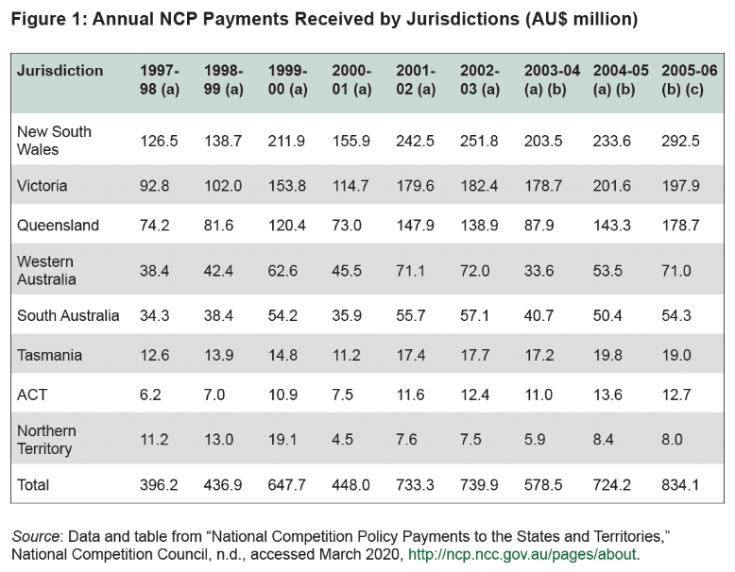

Sundry
In a lecture in mid-2023, to students at the University of Portland (UP) in Oregon (OR) USA, I summarised the nature of the Big Three Policies as follows:
“Fiscal Policy: eg taxation, expenditure, subsidies, deficits and surpluses … along with activism, bureaucracy and cronyism also known as Baptists and Bootleggers.”
“Regulatory Policy: eg legislature laws, executive regulations and judicial interpretations … along with along with activism, bureaucracy and cronyism also known as Baptists and Bootleggers.”
“Monetary Policy: eg central bank money printing and interest rates, government debt and bonds, and fractional reserve bank credit … along with along with activism, bureaucracy and cronyism also known as Baptists and Bootleggers.”
In a separate lecture in mid-2023, also in Portland OR, but this time to a state think tank, I summarised the impacts of the Big Three Policies as follows:
“Fiscal Policy Economics: Taxes decrease private sector supply and put upward pressure on prices. Spending drives taxes and crowds-out private sector supply and puts further upward pressure on prices. Spending also drives deficits/debt and crowds-out private sector lending and thus less supply and more price pressure.”
“Regulatory Policy Economics: Legislation and regulations are not Rule of Law like the Common Law is. These decrease private sector supply directly through compliance costs. These further decrease private sector supply indirectly through less competition and more monopolies/cartels.”
“Monetary Policy Economics: Printing fiat money and fractional reserve bank credit are literally inflation. Inflation increases demand both private sector and public sectors thus CPI and GDP. This makes [bad] Fiscal and Regulatory Policies more politically sustainable, but [not] less economically sustainable.”

Conclusion
The original Hilmer-inspired NCP 1.0 was a mix of regulatory and fiscal policies, but the latter was relatively narrowly focused on subsidies. The second Harper-inspired NCP 2.0 was about regulatory policy only, and very narrowly focused on competition law. The third Commission-inspired NCP 3.0 should cover regulatory, fiscal and monetary policies, but broadly so, such as: red, green and blue tape; spending, taxes and debt; as well as central banking, big banking and fiat money.
And the best place to start is with CPI to assess which industries and sub-industries are in need of competition reform, to what extent, and how to: in terms of removing unnecessary, unjustified and unsustainable government interventions. CPI is also the best place to finish in terms of the likely forecast discounted net benefits-costs to Australian consumers, taxpayers and households from lower prices, greater quantities and higher qualities as well as more productivity, innovation and jobs.
All of the above fits within the overarching policy framework of Evidence Based Policy that former PC Chairman, Professor Gary Banks AO, discussed in 2009 as follows:
“P.J. O’Rourke once said, ‘the mystery of Government is not how it works, but how to make it stop’. Also, let’s face it, within Government itself, many of us today find ourselves laughing knowingly at the antics of Yes Minister; and perhaps also cringing in recognition at how a carefully crafted policy proposal can be so easily subverted, or a dubious policy can triumph with little real evidence or analysis to commend it.”
“It is as important that we have a rigorous, evidence-based approach to public policy in Australia today as at any time in our history. As would be known to everyone here, Australia faces major long-term challenges. We should not underestimate the significance of those challenges, which place a premium on enhancing the efficiency and productivity of our economy.”
“The Commission’s modelling of the National Reform Agenda indicates that the gains from this ‘third wave’ of reform could potentially be greater than from the first and second waves. The problem is that there are few ‘easy’ reforms left. The earlier period had a lot of low hanging fruit that has now been largely harvested. Even in the competition area, rather than further deregulation, we are confronting the need for regulatory refinements which are quite subtle and complex to assess.”
Professor Banks added in his 2012 speech on Productivity Policies: The 'To Do' List that:
“As Samuel Johnson famously put it in another context, ‘the prospect of a hanging concentrates the mind’. Competition accordingly drives both innovation and ‘creative destruction’, the dual determinants of a country’s overall productivity performance. Actions that foster competitive markets — including for corporate control — must therefore be fundamental to a government’s policy agenda to enhance productivity.”
Sincerely,
Mr. Darren Brady Nelson
Independent Economist, Media Pundit & Think Tanker
Brisbane QLD AUS & Milwaukee WI USA
https://x.com/DarrenBNelson

