In 2019 my home was burnt up in the fire that ravaged through Cobargo on the south coast of NSW. I personally witnessed and was assisted by the tremendous generosity of the Australian people and was inspired to start Restore Australia Disaster Relief Fund to help rebuild my community and to inspire giving.

Upon reading your report I was troubled to see that $16.4B is currently sitting within public and private ancillary accounts. These structures, encouraged by Government policy, are purposely designed to give corporations and wealthy families a vehicle by which they can store funds in a tax free shelter in exchange for a commitment to giving “in the future”. 95% of the monies in these funds are free to be invested, apparently without scrutiny and their only requirement is that 5% per annum is to be gifted to another DGR, and this can and does include other ancillary funds. There is therefore the potential for this money to just get shuffled around from fund to fund, providing a multitude of opportunities for personal benefit to fund managers et al from these investments and never actually result in any meaningful benefit to the Australian population that most desperately needs the help. In the research that I did in trying to see where this money was going, I couldn't find one clear example of its use for affordable housing or to support the needy. Part of the difficulty is that there is actually so much secrecy afforded these funds, both in identifying the givers and the receivers. My belief is that the Australian public has effectively been duped out of the tax that would have otherwise been paid from the almost $20 B that has gone through these accounts since 2000.

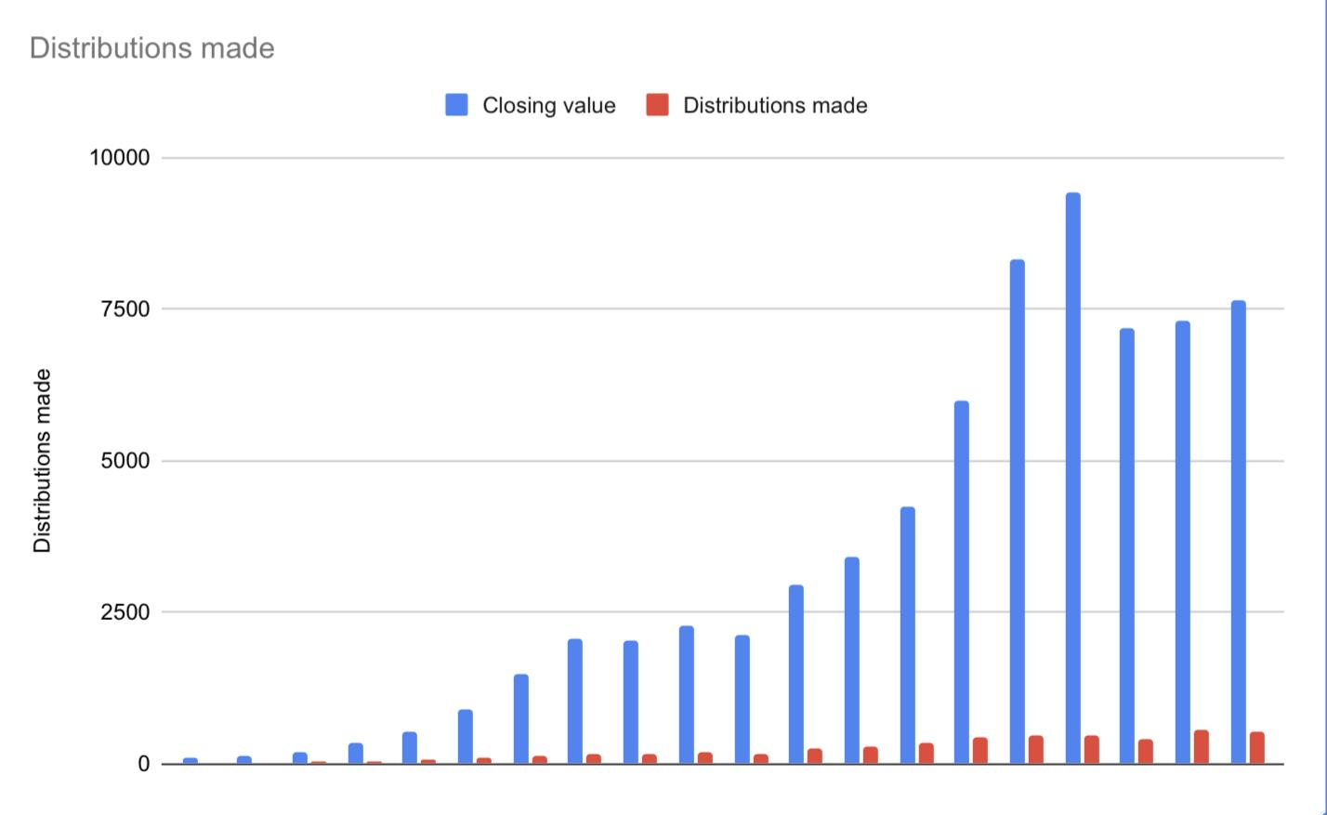

This graph was taken from data in Table 1 and displays distributions made and closing values in private ancillary funds since 2000–01.

McGregor-Lowndes, Myles, Balczun, Marie & Williamson, Alexandra (2022) Ancillary Funds 2000- 2020. ACPNS Current Issues Information Sheet 2022/1. Australian Centre for Philanthropy and Nonprofit Studies, QUT, Brisbane

If I wasn't so horrified, I could find it amusing that this report raised a concern that if the minimum giving requirement was raised to 6% it may have an adverse effect on the rate of giving into these accounts. To me, this implies that these accounts have a purpose to their owners other than the joy of giving. That if the minimum requirement of dispersal is raised, they may not be able to make enough in interest on their investments to continue the desired growth of money in the fund.

Even at a modest tax rate, the government has forfeited at least $7B in tax since 2000 by giving up front concessions to these contributions and there is no requirement to complete the distribution of funds for 20 years! That's a lot of hospitals, that's a lot of low-cost housing, that's a lot of a lot of things we never got.

In light of this, it seems most petty to be calling for the removal of the tax deductible status of school building projects and those charities that provide religious education in schools, lest some “private benefit” be obtained in the form of reduced school fees. I'm not sure exactly what proportion of funds raised come from parents of the school, but I would think that local businesses and other benefactors who don't have children at the school would also be major contributors. These people are giving so that the community benefits. Many parents, like myself have been able to afford to send their child to an alternative school because of those reduced fees, but have not contributed to the building fund. As somebody who lives in rural NSW, I know first hand the important place the catholic and Anglican schools here play in providing options for students when the one state school on offer is not a good fit for them. This seems to be especially true for those students who have special needs or emotional traumas and have come to find compassionate help from their local Christian school, even though they themselves may not be religious.

The public purse supports a wide range of charitable concerns that may be meaningless to the majority, but they have meaning to the one who is giving. Somebody who is passionate about advancing religion should be just as able to be afforded the right of DGR offsetting their taxable income that the promoters of the LGBTIQA+ lifestyle, eating insects, saving sick dairy cows or researching a rare disease that effects only a small percentage of the population. Singling out religious organisations who are are simply wanting to provide comfort and moral direction to the children of this nation seems underhandedly biast.

By revoking the tax deductible gift recipient status and making it harder for schools to grow it is presumably going to make it more expensive to attend these schools and will certainly be out of the reach of the average family. Perhaps that is your aim?

Time prevents me from going deeper into options to make volunteering more desirable, but certainly if the government is prepared to provide incentives for the richest of the rich to contribute, it could also give a little back with tax benefits to those who really could use it and who are prepared to contribute their time in a voluntary capacity. As the founder of a not for profit organisation I can certainly attest to the great value that volunteers play in our nation.