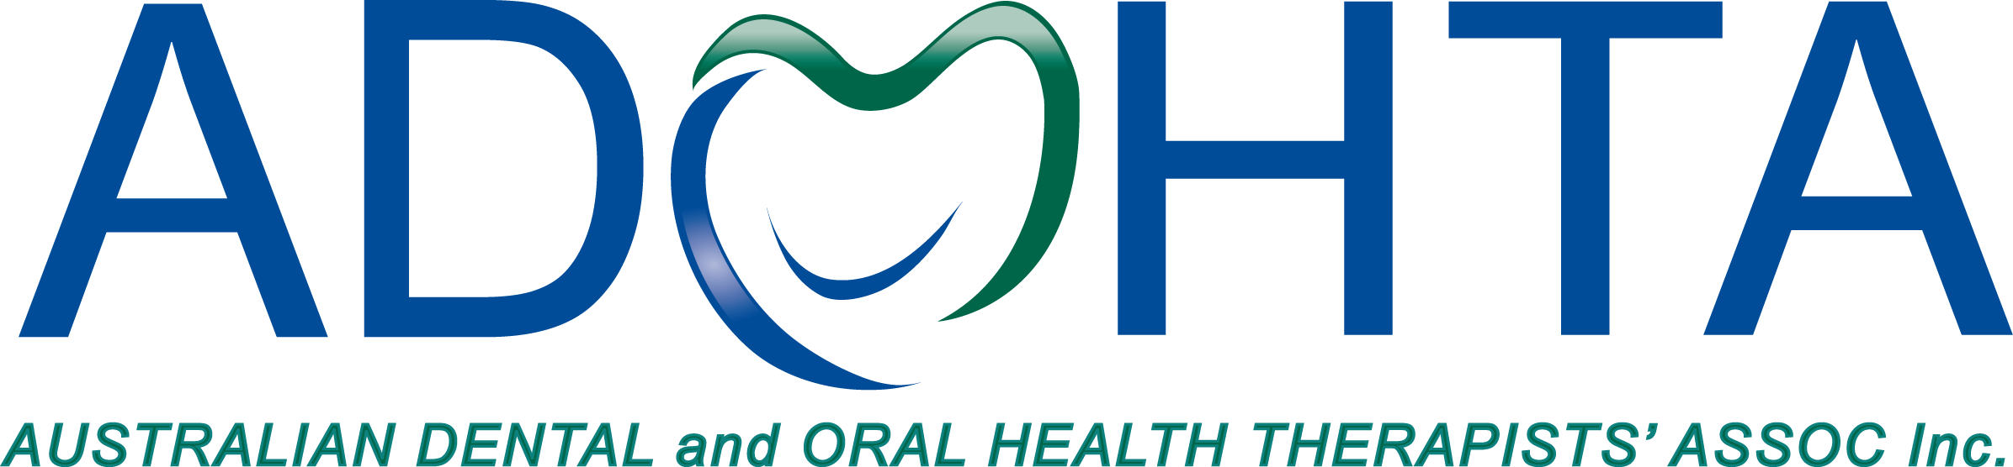

30 July 2026

Human Services Inquiry
Productivity Commission
Locked Bag 2, Collins Street East
Melbourne Vic 8003

Dear Hon. Scott Morrison,

Re: Productivity Commission

The Australian Dental and Oral Health Therapists’ Association (ADOHTA Inc) is the national representative body for dental and oral health therapists. Dental and Oral Health Therapists are oral health professionals who provide diagnostic, restorative and preventive dental care for all age groups, with growth in formal training to meet community need for providing adult restorations. They are highly valued, multi-skilled members of the dental team and they provide health education and oral health promotion to a wide range of patients.
ADOHTA provides leadership, collaboration and advocacy to enhance the profession, influence national oral health policies and programs, and deliver practical oral health outcomes for the community. Our professional association recognises the need for the Australian government to take urgent action in area of dental services as part of the Productivity Commission inquiry into human services.
ADOHTA supports the view that the constituents of improved human services include concepts of quality, equity, efficiency, responsiveness and accountability. Some examples how they can be measured are provided below in relation to dentistry:
- Quality – reduction in the number of high-risk dental practitioner notifications.
- Equity – increased number of the eligible population receiving public dental services
- Responsiveness – Reduction in the number of oral health related hospitalisation admissions
- Accountability – tracking the number of completed referrals provided by dental practitioners
ADOHTA agrees with the view that factors presented in Figure 2 reflect those that should be considered when identifying human services best suited to the increased application of competition, contestability and informed user choice.
ADOHTA argues that the human services that would have the greatest scope for improved outcomes from the increased application of competition, contestability and user choice is with regards to dental services. The total healthcare expenditure for dental services is $8.9 billion on 2013-14 at current prices (AIHW, 2015a). It is the single most expensive healthcare expenditure attributed to a specific area of primary care, and dental conditions is the second most common potentially preventable hospitalisation separations in 2013-14 (AIHW 2015b).
The dental practitioner professions of the dental hygienist, dental therapist and oral health therapist have held a long-track record in maintaining high quality of care. Our profession are fully aware of their scope of practice is a subset of those of a dentist, and refer accordingly. For example, the safety and quality of care provided by dental hygienists and dental therapists have remained at a high standard, which is evident through legislative changes in the United Kingdom. This permitted dental therapists and dental hygienists to provide dental services to patients via ‘direct access’ without the need to see a dentist under prescription (Turner et al 2012). This is despite no additional training was required to meet safety and quality standard for dental practice. Similarly within the local context, dental therapists in Victoria who formally worked with only children through School Dental Services was permitted the role expansion to practice dentistry for young adults up to 25 years old through the New Code of Practice authorised by the Dental Practice Board of Victoria in 2002 (Calache et al 2009). Currently, there are no age restrictions to practice. The scope of practice within our profession can effectively manage acute and chronic oral health conditions across the age spectrum.
Dentists primarily work in private practice (77%) compared with a more even distribution of public and private practice for dental therapists and oral health therapists combined, 42% and 58%, respectively (AIHW 2014). These statistics support efficiency can be gained through greater supply of dental therapists and oral health therapists, modelled on the efficiency goals of public sector practice. In addition, there are favourable distribution of the dental therapist and oral health therapist profession working in Australia by remoteness. For example, the ratio of dental therapists working in major cities and remote/very remote area is about 1:1 compared to the dentist ratio is 3:1. The efficiency and equity of dental services can be gained through increased utilisation of dental hygienists, dental therapists and oral health therapists.
To date, accountability and the responsiveness for the dental hygienist, dental therapist and oral health therapist is below best practice as a result of this registrable profession not being able to obtain a provider number and do not have independent practitioner status. Current competition, contestability and user choice under current policies are largely ineffective as the dentist profession traditionally have, and continue to hold authority for the billing of services rendered by the dental hygienist, dental therapist and oral health therapist with private health insurers and Medicare services billed through their provider number. Better understanding of the type of services by these dental practitioners will be supported through the provision of Medicare provider numbers.
Traditionally dental therapists have worked in the public sector, mainly within School Dental Services. Reviews of the state legislation in Victoria driven by the National Competition Policy resulted in the change for dental therapist to have restriction lifted to practice in the private sector from 2000, which was the first Australian state to finalise the review of its dental practice legislation and implement new codes of practice (Satur et al, 2008). More recently, dental therapists and oral health therapists are now able to obtain additional training to provide restorative dental services (fillings) for all age groups, formerly restricted to under 26 years of age in Victoria. This was due to a recognition that dental and oral health therapists can provide safe and quality care to all patients using their existing skills sets without a prescription of a dentist from a pilot study (Calache et al, 2011), and these dental practitioners are able to provide more cost-effective services in the public sector, particularly in rural and remote areas.
As part of the broader advocacy by ADOHTA to inform governments and stakeholders for dental services reform, we have undertaken an environmental scan of the issues related to dental services provided in Australia. Attached in this letter is an environmental scan undertaken by Siggins-Miller, outlining the opportunity for the government to engage in improving the human services regarding dental services in Australia through better utilisation of dental hygienists, dental therapists and oral health therapists.
We anticipate our feedback will greater inform the priorities for Productivity Commission.
Yours Sincerely,

Hellene Platell
President
Australian Dental and Oral Health Therapists’ Association Inc.

References
Australian Institute of Health and Welfare 2015a. Health expenditure Australia 2013–14. Health and Welfare Expenditure Series no. 54. Cat. no. HWE 63. Canberra: AIHW.
Australian Institute of Health and Welfare 2015b. Admitted patient care 2013–14: Australian hospital statistics. Health Services Series no. 60. Cat. no. HSE 156. Canberra: AIHW.
Turner, S, Tripathee, S and MacGillivrat, S 2012 Benefits and risks of direct access to treatment by dental care professionals: A rapid evidence review. Final Report to the General Dental Council. Accessed July 24th, 2016. URL: http://www.gdc-uk.org/Newsandpublications/research/Documents/FINAL%20VERSION%20of%20Literature%20Review%20on%20Direct%20Access.pdf
Calache, H, Shaw, J, Groves, V, Mariño, R, Morgan, M, Gussy, M, Satur, J and Hopcraft, M 2009 The capacity of dental therapists to provide direct restorative care to adults, Australian And New Zealand Journal Of Public Health, 33, 5, pp. 424-429.
Australian Institute of Health and Welfare 2014. Dental workforce 2012. National Health Workforce Series no. 7. Cat. no. HWL 53. Canberra: AIHW.
Satur, J, Gussy, M, Mariño, R, & Martini, T 2009 'Patterns of dental therapists' scope of practice and employment in Victoria, Australia', Journal Of Dental Education, 73, 3, pp. 416-425.
Calache, H, & Hopcraft, M 2011 'Evaluation of a pilot bridging program to enable Australian dental therapists to treat adult patients', Journal Of Dental Education, 75, 9, pp. 1208-1217.

