lack of Understanding.pdf 26/3/2019 ↓ ↓ ↓ ↓ Page 9
lack of Understanding.pdf
.E-mail me.
.*. where “Mainstream PSYCHIATRY” is defined as any form of Psychiatry that uses the DSM of <Psychiatry JIHAD.pdf>

“Mainstream PSYCHIATRY”.* is exposed as being unscientific as it has no answers to some very basic questions. These .QUESTIONS.. concern
quite well-known phenomena associated with Mental Illnesses. The Inmates are Running the Asylum - film
explanations ANSWERS

.ANSWERS..

.QUESTIONS..
explanations
.QUESTIONS..
in psychiatry ‘hearing voices’ is a someone who’s near-fully or fully enlivened their
❶ Why is it common for people suffering possible symptom of schizophrenia Throat Chakra is Clair Audient → ‘hearing voices’
..… from a Mental Illness to ‘hear voices’? - see .SUCCESSFULschizophrenia.org. is a precursor to the .2nd_Initiation.

❷ Why do people suffering from a “birth of Christ consciousness in the cave of the Heart” .1st.Initiation.
.*. - link to .QUESTION. ❹
Mental Illness think that they are a ↑ (enlivening the Heart Chakra) ↑ ❼ Psychiatry almost ignores the SUB-conscious!
“Messenger from/of God/Jesus”? I have deduced that the (Spiritual) .When someone tells me they’re having Mental.
(or “only answer to Jesus” as) Initiations are linked to the Chakras .Problems the .QUESTION*. I immediately ask is,.
(was the case with Luke BATTY’s) & so enlivening each Chakra partially .“What have you done that’s AMAZING?”.
(father – Greg ANDERSON) qualifies one for the associated Initiation. ❼a Jungian Analysts deal with the Unconscious.

❸ Why is it common for people in psychiatry ‘hallucinations’ is “perception someone who has enlivened their Throat
suffering from a Mental Illness in the absence of any stimulus” – they Chakra is Clair Audient or Brow Chakra
to have ‘hallucinations’? can be either auditory or visual OR both! is Clair Voyant -
- see Hallucinations .3rd.Initiation.

If ever there’s one single thing which exposes Psychiatry for being what it is, unscientific, it is this! “M-theory”, a respected
Principle in Cosmology where there is an infinite number of dimensions, is simply either ignored or not considered at all in this
.ANTI-science.called.Psychiatry!. The ’Mental Patient’ is simply accessing information/experience from another dimension(s).

In modern-day parlance it’s called channelling or simply being psychic!

❹ Why is it common for people who These people are highly developed already .You’d think that a Psychiatrist.
have had a Mental Illness to have and therefore they are approaching/have .would’ve noticed this correlation.
done something amazing? commenced the test for experiencing and .between Mental Problems & High.
The association between serious mental illness &
creativity first appeared in literature in the 1970s
this is predated to at least the time of Aristotle.
. .eventually recovering from Mental Illness. .Achievement. ↓ ↓ ↓ ↓
.In the shamanic view, Mental Illness signals “the birth of a healer,” ... .high_ACHIEVERS.

❺ Provide an explanation fluctuations in power (re-balancing) either
for BiPolar Disorder! within a Chakra(s) or between the Chakras .www.NaturalHumanDevelopment.com.

❻ Why do Panic Attacks generally last The physiology of each human differs and .only a certain amount of enlivenment. of the Heart Chakra,
for a set period for each individual? .Throat Chakra. or 3rd Eye/Brow Chakra, or any combination of these Chakras, is therefore possible!

…………………………………………………………  .www..  .Natural..  .Human..  .Development.  ..com.  .E-mail me. | 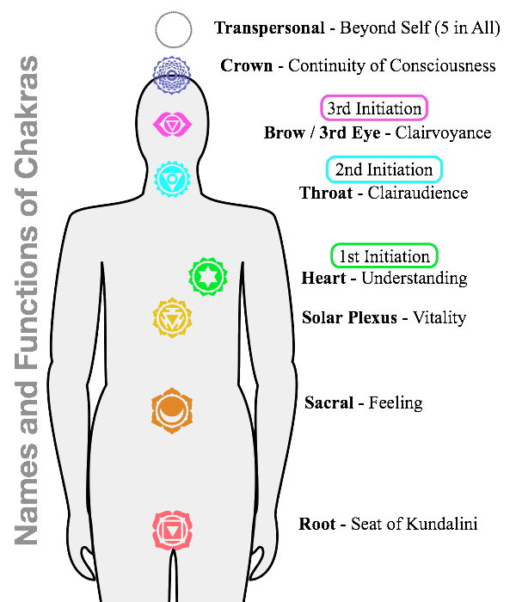

ENLARGED SECTION OF THE FIRST PAGE OF FILE

❹ Why is it common for people who These people are highly developed already
have had a Mental Illness to have and therefore they are approaching/have
done something amazing? commenced the test for experiencing and
eventually recovering from Mental Illness.

.In the shamanic view, Mental Illness signals “the birth of a healer,” ...

The association between serious mental illness &
creativity first appeared in literature in the 1970s
this is predated to at least the time of Aristotle.

.return to the First Page.
❻ Panic Attacks

I contend that there seems to be a set period for the length of these paralysing Panic Attacks for each person. Mine lasted for 20 minutes exactly before they began to diminish. The Mental Anguish was not over by any means but after this time had elapsed, since the commencement of the Panic Attack, I knew that things would improve.

Sir John KIRWIN had Panic Attacks which lasted 2 minutes. I knew someone from my Art Therapy Class who told me that his were about the same length as mine – but the first one was longer. Googling reveals that these Panic Attacks typically last for about 30 minutes. From Beyond Blue – “Panic attacks reach a peak within about 10 minutes and usually last for up to half an hour, …”. I asked one of the people working for BATYR, who was written about in a newspaper article as having experienced Panic Attacks how long his Panic Attacks lasted and he answered, “Six minutes.”

More study is required before any definitive conclusion(s) can be made between any connection between the physiology of a person experiencing a Panic Attack and the length of these Panic Attacks.

