APVMA additional submission to the Productivity Commission inquiry into Regulation of Australian Agriculture: Attachment A

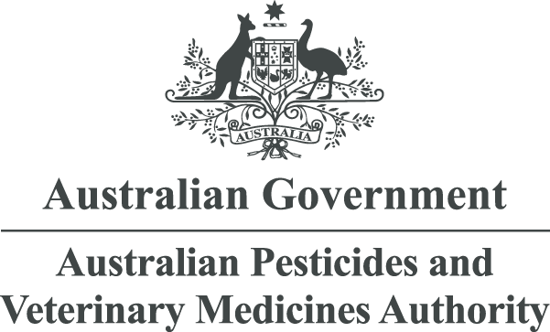
APRIL 2016
Use of International Data, Standards and Assessments
A guide for agricultural chemical products
© Australian Pesticides and Veterinary Medicines Authority 2016
ISBN 978-1-925390-30-8 (electronic)
Ownership of intellectual property rights in this publication
Unless otherwise noted, copyright (and any other intellectual property rights, if any) in this publication is owned by the Australian Pesticides and Veterinary Medicines Authority (APVMA).
Creative Commons licence


With the exception of the Coat of Arms and other elements specifically identified, this publication is licensed under a Creative Commons Attribution 3.0 Australia Licence. This is a standard form agreement that allows you to copy, distribute, transmit and adapt this publication provided that you attribute the work.
A summary of the licence terms is available from www.creativecommons.org/licenses/by/3.0/au/deed.en. The full licence terms are available from www.creativecommons.org/licenses/by/3.0/au/legalcode.
The APVMA’s preference is that you attribute this publication (and any approved material sourced from it) using the following wording:
Source: Licensed from the Australian Pesticides and Veterinary Medicines Authority (APVMA) under a Creative Commons Attribution 3.0 Australia Licence.
In referencing this document the Australian Pesticides and Veterinary Medicines Authority should be cited as the author, publisher and copyright owner.
Use of the Coat of Arms
The terms under which the Coat of Arms can be used are set out on the Department of the Prime Minister and Cabinet website (see www.dpmc.gov.au/pmc/publication/commonwealth-coat-arms-information-and-guidelines).
Disclaimer
The material in or linking from this report may contain the views or recommendations of third parties. Third party material does not necessarily reflect the views of the APVMA, or indicate a commitment to a particular course of action. There may be links in this document that will transfer you to external websites. The APVMA does not have responsibility for these websites, nor does linking to or from this document constitute any form of endorsement. The APVMA is not responsible for any errors, omissions or matters of interpretation in any third-party information contained within this document.
Comments and enquiries regarding copyright:
Director Public Affairs
Australian Pesticides and Veterinary Medicines Authority
PO Box 6182
KINGSTON ACT 2604 Australia
Telephone: +61 2 6210 4988
Email: communications@apvma.gov.au.
This publication is available from the APVMA website: www.apvma.gov.au.

Contents
1 Background 4
2 Legislative arrangements and differences 5
3 Impact for applicants 6
4 Submitting international data with an application 7
5 Accepting reviews or assessments from overseas regulators 8
6 Use of national assessments 9
7 Technical assessments and acceptance criteria 10

List of tables
Table 1: Criteria based on assessment disciplines – Chemistry 13
Table 2: Criteria based on assessment disciplines – Toxicology 14
Table 3: Criteria based on assessment disciplines – Residues 15
Table 4: Criteria based on assessment disciplines – Environment 15

Background
The Australian Government has set the guiding principle that if a system, service or product has been approved under a trusted international standard or risk assessment, Australian regulators should not impose any additional requirements unless it can be demonstrated that there is a good reason to do so.
In this user guide, criteria are presented on how international data, standards and assessments can be better utilised as part of the risk assessment that the Australian Pesticides and Veterinary Medicines Authority (APVMA) is required to undertake as part of the approval of an active constituent, registration of a product or approval of a label. It is recommended that this user guide be read in conjunction with the policy document Use of international data, assessments, standards and decisions released in 2015.

Legislative arrangements and differences
In Australia, Agricultural Chemical Products are defined in the Agvet Codes and include a broad range of products that may be regulated under different legislative frameworks and by different agencies in one country or region. For example, a biocide product in the EU is regulated by the European Chemicals Agency (ECHA) and legislated under BPR, Regulation (EU) 528/2012. Active constituents that are present in biocide products may also be regulated as Plant Protection Products under Regulation (EC) 1107/2009, and so the data requirements and assessments conducted in the EU may differ from those in Australia when such products are considered as agricultural chemical products.
For over a decade, the APVMA has participated in an Organization for Economic Cooperation and Development (OECD) Global Joint Review program, taking an active role in using international data and conducting joint assessments with the USEPA, Canadian PMRA and some EU Member states. As part of this exercise, Australia has worked with other regulators to register crop protection products by applying international best practice for assessments and registration decisions. Through this program, the APVMA has used information and assessment reports produced by other OECD regulators to build confidence in using and sharing information.
In addition, the APVMA participates in expert groups and committees such as the UN FAO and World Health Organization (WHO) panels of the JMPR (Joint Meeting on Pesticide Residues in Food) where new methodologies and best practice assessment is developed for regulatory use.
To date, much of the work in conducting joint reviews and/or sharing assessments has been for crop protection products only. Under OECD, sharing of assessments of biocide products by member governments is currently being scoped, with activities underway in relation to harmonised monograph guidance for government use for review of biocide products and dossier guidance for industry use for data submissions. Therefore the ease of availability of overseas assessments for biocide products requires further exploratory work.
Information regarding the utility of efficacy data and efficacy assessments is not included in this document.
For further efficacy-specific information, applicants are encouraged to seek advice from the APVMA.
By taking into account information from international technical bodies and other regulatory agencies with similar systems and processes, this adds to the APVMA’s knowledge and assists in quality assessments and robust decisions in relation to the health and safety standards of products supplied in Australia.

Impact for applicants
Through Global Joint Review activities and work sharing with other regulators, the APVMA has developed a sound understanding of the practices of other regulatory partners and confidence in the scientific integrity of the assessments from other OECD partners. These agencies follow the same international best practice in the conduct of hazard and risk assessments including adhering to the same principles of scientific assessment that the APVMA also follows.
In some cases, the use of overseas information available from another regulator may lead to a faster decision. However, this policy doesn’t change our legislative safety tests or the regulations associated with approvals and registrations of active constituents and products, which must still be met before a product can be registered in Australia.
As stated in the policy document, the APVMA will not accept a decision made by another regulator as the sole justification for registering or cancelling a product or active constituent approval. All decisions to grant an approval for an active constituent or to register a product must be made in accordance with the Agvet Code.

Submitting international data with an application
International data, or data generated outside of Australia, can be used for all application types where the data is relevant to the use proposed in Australia. Alongside supporting data and documentation provided by the applicant, our policy document, outlines in general terms, the hazard and risk assessments acceptable for use.
The use of international assessments or an assessment from another regulator is particularly beneficial for larger applications—typically for new chemistry or large extensions of use of existing products, namely Items, 1, 2, 10, 14, 15, 16, 17, 21, 25 and 27. In addition, international assessments from expert committees may also be used to support chemical review activities. Further information on what to include in your application is available on the APVMA website.
The applicant is required to submit a full package at the time of making an application to the APVMA. It is the responsibility of the applicant to ensure that all necessary data and assessments are available at that time, whether sourced locally or internationally. Confirmation of access from the data provider (if required) is usually included with the data submission. This is to meet Australian government requirements made through international agreements on intellectual property protection of information and use of proprietary data. It should also be noted that expert committee assessment reports such as international monographs published by the JMPR, carry clear instructions for regulators, such as:
‘Most of the summaries and evaluations contained in this report are based on unpublished proprietary data submitted for use by the JMPR in making its assessments. A registration authority should not grant a registration on the basis of an evaluation unless it has first received an authorisation for such use from the owner of the data submitted for the JMPR review or has received the data on which the summaries are based, either from the owner of the data or from a second party that has obtained permission from the owner of the data for this purpose.’

Accepting reviews or assessments from overseas regulators
The APVMA will consider an assessment from an overseas regulator, providing certain requirements regarding language and supporting data are met. Applicants wishing to use an international assessment to support all or
part of an application should discuss this with the APVMA prior to making an application, using the existing
pre-application assistance mechanism. Depending on the information (data and assessments) provided, the level of assessment may be reduced if the APVMA does not need to undertake a full hazard and risk assessment.
As explained in the policy document, hazard assessments are easily accepted between regulators, whereas risk assessments include national information and different approaches relevant to Australia, which are not the same around the world.
Questions regarding the use of reviews from regulatory agencies that are not mentioned in this user guide or policy document should be directed to the APVMA, either as an enquiry or as part of the pre-application assistance mechanism.
Where an international assessment or assessment from an overseas agency has been provided in support of an application, the APVMA will make reference to that assessment on our website, in a consultation document such as a public release summary or advice summary.

Use of national assessments
Although the policy document focusses on use of assessments sourced from outside of Australia, assessments that have been conducted by FSANZ, OGTR, TGA or NICNAS, and are relevant to a proposed application to the APVMA may also be provided for consideration.
Applicants are encouraged to consider in detail how the assessment from another Australian regulator addresses part or all of the safety criteria that the APVMA must have regard to in granting an active constituent approval or product registration.

Technical assessments and acceptance criteria
The following section outlines the types of data, assessments and standards that may be accepted by the APVMA as part of an application to approve an active constituent or register a chemical product.
For crop protection products, use of the OECD Dossier Guidance, and OECD Data Numbering System and OECD monograph format is preferred and recommended for any applications submitted to the APVMA with data and assessments from an overseas regulatory agency.
Using the OECD guidance and formats allows quick access to the Tier II summaries and the conclusions and end-points contained in any hazard assessment, reducing the need to replicate the assessment de novo or the need to go back to the underlying data. Use of standardised OECD reporting templates for various studies also assists the expert reviewers to find key information easily.
Figure 1 depicts the flow of information from OECD test guidelines and dossier guidance to completion of the Tier II summaries in the hazard assessments and finally the risk assessments and use of relevant end points for exposure assessments.
OECD test guidelines used to generate specific data can also be easily identified, providing confidence that work has been conducted according to internationally accepted test methods and guidelines, including Good Laboratory Practice (GLP) where relevant.
OECD dossier guidance and numbering also exists for biopesticide products which again is preferred for submission of assessments for biopesticide products.
In terms of assessment format, the APVMA will accept Draft Assessment Reports (DAR) prepared by EU Member States for EFSA assessments, Data Evaluation Records (DER) of studies and hazard assessments as prepared by US and Canada for NAFTA assessments and other reports formats that are made available in English. International assessments, particularly monographs that are prepared and published by the JMPR for both toxicology and residues are acceptable.
For biocide products, the APVMA has limited experience in the use of assessments from other regulatory agencies and further exploratory work with Applicants via specific applications is invited.
Assessments and reports from non-OECD regulators may be acceptable providing that they are available in English and in a format that is easy to navigate.
Figure 2 is a diagrammatic representation of an acceptance criteria hierarchy for data, assessments and standards. The first row includes all FAO, WHO and OECD test guidelines, assessments and standards which are considered as being ‘internationally acceptable’. The second row includes data, assessments and standards which are considered as ‘overseas sources of information’ and which may be acceptable, if relevant to the proposed use in Australia and the key safety criteria are addressed.

Figure 1: Schematic of OECD dossier guidance, hazard assessments and risk assessments.
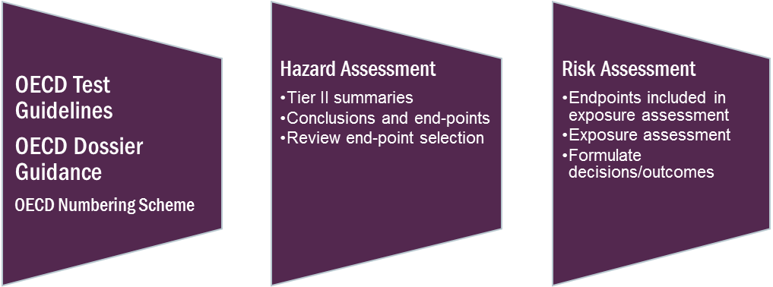

Figure 2: Draft criteria for use of international data, assessments, standards and decisions pesticide (crop rotation) products: acceptance criteria hierarchy—‘at a glance’.
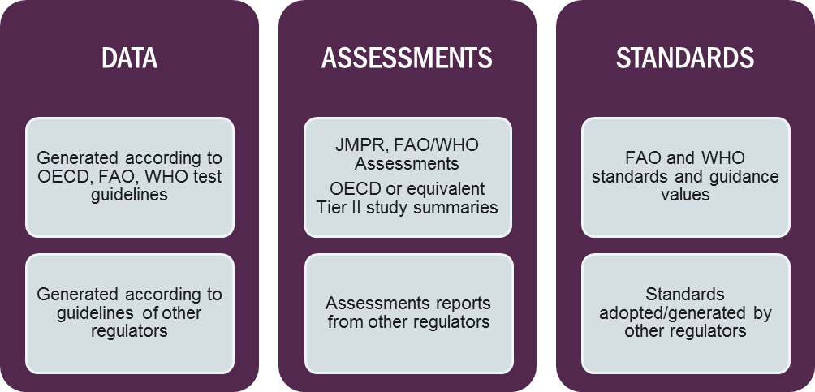
In the next section, tables are presented by assessment discipline, indicating acceptance of data, hazard assessment or risk assessment, and standards where relevant.
Worker health and safety (or OH&S) assessments are also not included in this guide, as they are exposure assessments and different methodologies for modelling exposure may be used by different regulators. This aspect of the assessment will be included in a technical manual as part of the overarching risk assessment framework. For any other assessments that are outside of those specified in the tables, Applicants are encouraged to discuss their relevance and acceptability, prior to making an application.
In the tables, ‘acceptability’ or ‘consideration’, or ‘having regard to’ various components are indicated in a general sense, as well as situations where harmonisation with an international criterion or standard may be an achievable outcome. As all applications are different, and various types of information may be provided, the criteria are written in a broad sense to cover a range of scenarios.
Criteria based on assessment disciplines
Table 1: Chemistry
Source of information | Data | Assessments | Standards
OECD test guidelines | Accept all data generated using OECD test guidelines according to Mutual Acceptance of Data (MAD) | Accept all assessments conducted using OECD data parts and numbering scheme and addressing criteria in the data parts
JMPS and FAO Specifications | Have regard to all chemistry data reviewed by JMPS, however must be the same manufacturer that provided the data to JMPS | Accept all assessments (active constituent and formulated product) conducted by JMPS. For active constituent, with provision of toxicology data from the same manufacturer | Accept and adopt FAO Specifications for active constituents. Regulation 42 of Agvet Codes specifies use of FAO Specifications as prescribed standards
OECD members and agencies (including USEPA, PMRA Canada, EU Member States, MAF Japan, MPI NZ) |  | Accept assessments from OECD member governments | Have regard to any standards established for active constituents, including impurities. For example information included in Annex I listing in EU
NICNAS |  | May have regard to new chemical assessments conducted by NICNAS where relevant. Aspects of manufacture are not considered by NICNAS, therefore the assessment may be limited in its use by APVMA

Table 2: Criteria based on assessment disciplines
Toxicology
Source of information | Data | Assessments | Standards (Health guidance values)
OECD test guidelines | Accept all data generated using OECD test guidelines according to Mutual Acceptance of Data (MAD). | Accept all assessments conducted using OECD data parts and numbering scheme and addressing criteria in the data parts.
JMPR and WHO monographs; JMPS | Have regard to all toxicology data reviewed by JMPR, however must be the same data that was provided to the JMPR toxicology panel. | Accept all assessments (active constituent and formulated product) conducted by JMPR and JMPS, with a view to harmonising end points. For active constituents and JMPS assessments, the APVMA must receive the toxicology data from the same manufacturer that provided the data to JMPS. | Have regard to endpoints determined by JMPR, with view of acceptance and harmonisation. Health guidance values (ADI and ARfD) considered and determine whether appropriate safety factors have been applied.
OECD members and agencies (including USEPA, PMRA Canada, EU Member States, FSC Japan, NZ EPA) |  | Accept assessments from OECD member governments, with a view to harmonising endpoints, where relevant. | Have regard to endpoints determined by an overseas regulatory agency. Health guidance values (ADI and ARfD) may be considered and whether appropriate safety factors have been applied.
FSANZ, TGA |  | May accept assessments conducted by FSANZ and TGA for toxicology, provided end points are available to establish relevant health guidance values.

Table 3: Criteria based on assessment disciplines
Residues
Source of information | Data | Assessments | Standards (Maximum Residue Limits)
OECD test guidelines | Accept all data generated using OECD test guidelines according to Mutual Acceptance of Data (MAD). | Accept all assessments conducted using OECD data parts and numbering scheme and addressing criteria in the data parts.
JMPR monographs | Have regard to all residues data reviewed by JMPR. However APVMA must receive the same data that was provided to the JMPR residues panel. | Accept all residues assessments conducted by JMPR residues panel, with a view to harmonising residue definition (for risk assessment and monitoring), where relevant. | Have regard to MRLs recommended by JMPR, with a view of harmonisation, where relevant to the proposed use in Australia and for trade purposes.
OECD members and agencies (including USEPA, PMRA Canada, EU Member States, MAF Japan, ACVM NZ); specialist programs  eg IR-4 | Accept residues data generated by OECD member governments, or specialist programs such as IR-4. | Accept hazard assessments from OECD member governments where the proposed uses are the same, with a view to harmonising residue definition where relevant. Dietary risk assessments are not acceptable as they rely on national or regional consumption data, which are not relevant to Australia. | Have regard to MRLs established by an overseas regulatory agency for the purposes of trade. Differences in MRLs are documented for consideration of trade criteria.
FSANZ |  | Accept dietary risk assessments conducted by FSANZ, noting if any differences between an MRL for a registered use and an import tolerance.

Table 3: Criteria based on assessment disciplines
Environment
Source of information | Data | Assessments | Standards
OECD test guidelines | Accept all data generated using OECD test guidelines according to Mutual Acceptance of Data (MAD). | Accept all assessments conducted using OECD data parts and numbering scheme and addressing criteria in the data parts.
OECD members and agencies (including USEPA, PMRA Canada, EU Member States, Japan, NZ EPA) |  | Accept hazard assessments from OECD member governments, with a view to harmonising ecotox endpoints, where relevant. | Have regard to endpoints determined by an overseas regulatory agency.

Definition of agricultural chemical product may be found in section 4 of the Agricultural and Veterinary Chemicals Code Act 1994.
Biocides in the EU include human hygiene biocide products, private area and public health disinfectants, veterinary hygiene products, food and feed area disinfectants, drinking water disinfectants, woods preservatives, slimicides, rodenticides, molluscicides, repellents and attractants, antifouling paints.

