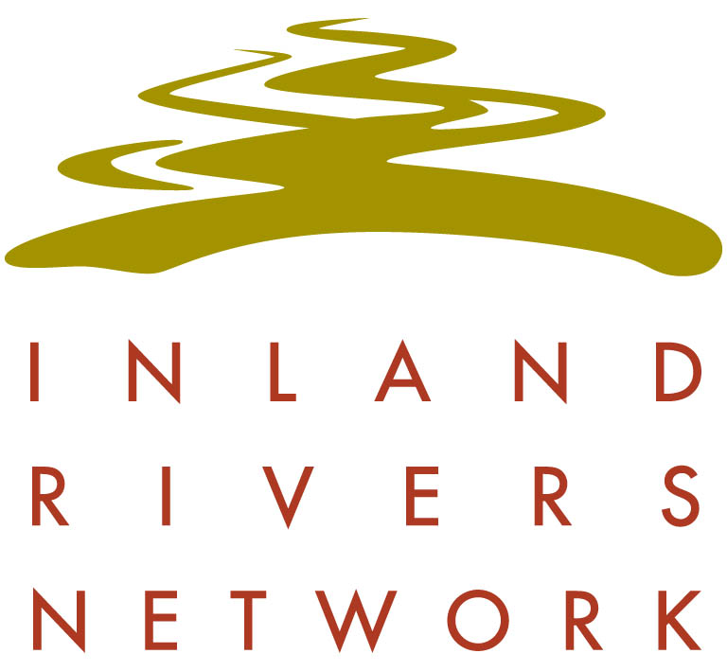

PO Box 312, Darlinghurst NSW 1300
ph 0428 817 282
ABN 34 373 750 383

National Water Reform Inquiry
Productivity Commission
GPO Box 1428
Canberra City
ACT 2601

water.reform@pc.gov.au

18 April 2017

Submission to the National Water Reform Inquiry

The Inland Rivers Network (IRN) is a coalition of environment groups and individuals that has been advocating for healthy rivers, wetlands and groundwater in the Murray-Darling Basin since 1991.
We welcome the opportunity to provide comment on the National Water Reform issues paper released in March 2017. The key focus of this submission will be on the performance of New South Wales (NSW) under the objectives of the National Water Initiative 2004 (NWI).

Firstly, IRN wishes to highlight concerns in regard to the loss of focus of the Commonwealth Government on the importance of ongoing reform to the management of water in Australia. The loss of an independent body, the National Water Commission (NWC), with the sole responsibility of providing oversight and reporting on the progress of water reform has limited the scope of research capacity and the direction of the NWI. This has reduced COAG’s capacity and focus on water reform outcomes, demonstrated through the loss of the Standing Council on Environment and Water.

There are a number of outstanding issues with NSW implementation of NWI in relation to improving environmental outcomes in water management. These include:

- Planned environmental water is described under the Water Management Act 2000 as all water left in a water source after extraction. There is no protection of planned environmental water and no targeted use of this volume for specific environmental outcomes.

- Most water sharing plans (WSP) developed in NSW have locked in existing levels of extraction with minimal rules protecting environmental flows. Some WSPs, eg the Barwon-Darling Unregulated and Alluvial WSP 2012, increased water availability for extraction.

- Basic rights use has not been brought under a licencing framework and can continue to grow at the expense of planned environmental water.

- Held environmental water, Commonwealth and State owned entitlements, is not protected from extraction.

- Floodplain harvesting licences are about to be allocated as a new property right. This will increase water entitlements above the WSP long term extraction limit in the relevant water sources, including unregulated sources.

- An amendment to the Water Management Act (WMA) in 2014 has given free, unlicensed access to rainfall runoff on irrigated land. This has further reduced available planned environmental water and favoured the irrigation industry above other users.

- The 10 year review of WSPs gazetted in 2004 has been held over and integrated into the development of Water Resource Plans. The review has not audited performance under the WSP objectives and performance criteria.

- Monitoring of environmental outcomes of WSP in NSW has been sporadic with no continuity. The State Water Management Outcomes Plan was dropped, as was the Integrated Monitoring of Environmental Flows program. There has been inadequate investment in and resourcing of rigorous monitoring programs, as required under the NWI and identified as an area with scope for improvement by the NWC.

- Water trading has not resulted in water moving to the highest value use in NSW. The bulk of water use is for flood irrigated cotton and rice which is a highly inefficient use of scarce water resources.

- The mining and extractive industries are approved with very long term impacts on water sources. Water interceptions are regulated through the purchase of licences which are then permanently retired from future productive use. There has been no assessment of the cumulative impact of intensive mining operations (eg coal mining or coal seam gas extraction) on the long-term availability of water for other industries.

- The NSW Government is encouraging growth in urban water use and stock and domestic licences at the expense of planned environmental water. Any water dependent industries should not have access to urban water supply. They should be required to purchase existing licences through the water market.

- There is no planning in NSW to manage for the risk of climate change and extreme events. The response to the Millenium Drought was to turn off WSPs and give the Minister for Water power to allocate water shares. The 2014 WMA amendments have locked in water planning using the drought of record prior to 2004. This will cause inappropriate water availability determinations and threaten long-term security of supply in regulated rivers.

- In regard to the integration of natural resource management with water management to achieve better environmental outcomes for river health, NSW has failed to implement the objectives of catchment action plans. The capacity for natural resource management has been restricted through the new arrangements with the Local Land Services model, away from catchment management.

- The NWC recommendation for NWI-consistent regional water frameworks to mitigate impacts of extractive industries on other users and the environment has not been achieved in NSW. All considerations for water sharing arrangements in NSW give priority to extractive entitlements above all other users. This has resulted in the lack of adequate water shepherding rules to protect held environmental water. It has also led to increased availability for extraction in the Barwon-Darling above Bourke at the expense of downstream towns, stock and domestic users, the management of Menindee Lakes, and has caused deteriorating water quality in the river.

IRN trusts that the Productivity Commission Review of Water Reform will recognise these critical areas of failure in NSW.

We consider that various backward steps in water reform achievements in the state have serious implications and will create very costly impacts in the medium to long-term.

NSW role as the largest water user in the Murray-Darling Basin is critical for the success, or not, of the Basin Plan to meet its environmental objectives. A very thorough investigation of NSW water management must be carried out to prevent further backsliding in the achievement of the NWI.

For more information about this submission, please contact:

Bev Smiles
Inland Rivers Network

