Victorian Government Submission

To the Productivity Commission

Public Safety Mobile Broadband
Study to meet the long term needs of Australia’s
Public Safety Agencies

Issues Paper

July 2015

Executive Summary
- Victoria’s submission to the Productivity Commission’s study into the best way to secure a mobile broadband capability reflects Victoria’s position on PSMB capability, as expressed previously during the 2013 Commonwealth Parliamentary Joint Committee on Law Enforcement Inquiry into spectrum.

- Victoria does not support development of a PSMB capability that will shift a significant and unsustainable financial burden on to state governments, local governments and communities.

- Victoria and NSW, with the support of all other states and territories, has developed the following seven principles which should guide the Commission’s study. These are:
- “Mission critical” needs should be defined by the States
- The solution should recognise the value of interoperability of Australia’s PSA resources for large-scale emergencies and the diversity of the States and Territories
- delivering public value outcomes for the community across a continuum of business-as-usual events to large-scale emergencies events is paramount
- The solution should maximise value and lower costs
- The procurement environment should be contestable and competitive
- Spectrum to support a PSMB capability should be allocated so that it is available and accessible by PSAs to meet their service requirements and to maximise public value
- A PSMB capability should be considered and, where possible, linked with other Commonwealth telecommunications initiatives.

- Victoria stands by its historical position that the Commonwealth should allocate at least 20MHz of spectrum to realise the community safety benefits from a PSMB capability.

Introduction
- Victoria welcomes the Productivity Commission’s (the Commission) study into the most effective way to secure a mobile broadband capability to meet the long-term needs of Australia’s public safety agencies (PSAs). In recent years, technical and commercial innovation has transformed the PSA sector, and there is a need to ensure that the arrangements for PSAs evolve with this changing environment.

- This Submission provides the Victorian Government’s formal response to the Commission’s Public Safety Mobile Broadband (PSMB) issues paper. The Victorian submission reiterates positions consistent with Victoria’s previous response to the Commonwealth on PSMB issues. In preparing this submission, relevant Victorian departments and agencies were consulted.

- Victoria supports the Commission's first principles approach, which will explore the costs and benefits of delivering PSMB capability across a range of potential scenarios. This approach will recognise that the Commonwealth decision to deliver a national interoperable PSMB capability, and how it can be developed and secured, will have a significant impact on telecommunications infrastructure in Australia, public safety and the future operation of Australia’s PSAs.

- Victoria encourages the Commission’s study to consider all possible reforms and approaches in recommending a particular pathway in its Final Report. However, Victoria does not support the pathways for reform that shift a significant and unsustainable financial burden on to State governments, local governments and communities.

- The Commission should be cautious in its assessment of PSMB options that require PSAs to build separate dedicated specialised networks or utilise those which rely solely on Mobile Network Operators (MNOs) to deliver communications services. The existence of, and level of, competition in the mobiles market across Australia and Victoria vary considerably with many locations (particularly in regional areas) experiencing market failure and requiring regulatory or government financial intervention.

- In this submission, Victoria responds to the Commission's issues paper by:
- first providing overarching key principles important to Victoria in establishing a PSMB capability; and
- second, responding directly to key questions posed within the Commission’s issues paper where applicable to Victoria. It should be noted that some questions are more applicable to other stakeholders who need to provide specific input to the Commission.

- Victoria welcomes the opportunity to make a submission to the Commission and looks forward to working collaboratively with the Commission and all Australian jurisdictions to develop effective and efficient PSMB arrangements.
Section A:
Victorian Governments Key Principles to Securing a National Interoperable PSMB Capability
Victoria’s changing needs and service requirements will be supported by a PSMB capability
- Police and emergency services organisations serve Victorian communities every day by managing the devastating impact of emergencies on the Victorian community. Their effective response helps to save lives, avoid injuries and minimise damage to both the built and natural environment.

- Victoria’s PSAs are being challenged by rapidly growing demand for services, the frequency of large scale emergency events and natural disasters and increasing technological capability, which is changing how the community seeks to interact with government and PSAs. The Victorian Government has endorsed emergency management reforms to improve the integration of service delivery. As explained in paragraphs 15 to 17 and 19, these reforms aim strengthen community safety and resilience.

- Over the past decade, there have been significant changes in mobile technology capabilities. The increased capacity and coverage of mobile networks and mobile data applications has driven effectiveness and efficiency gains. These improvements can deliver service innovations enabling Victoria’s PSAs to better respond to the changing needs of the community.

- Victoria’s needs are changing, with an ageing community and metropolitan population growth increasing the pressure on our health and emergency services. The security threat and the incidence and severity of natural disasters is increasing, leading to larger and more frequent impacts including loss of life, injury and property damage. As the demand for emergency services increases each year, a heavier burden is placed on our operational communications networks, systems and personnel.

- Smart mobile devices and even smarter mobile applications are increasingly embedded in our community and businesses. Many everyday activities are being performed through mobile applications, and the community is looking to our government agencies to do the same. In 2013 in preparation of Victoria’s emergency management communications planning, Deloitte found that there is a growing gap between the mobile capabilities of the community and PSAs.

- There has, and will continue to be, a fundamental shift in how people communicate, from voice-centric to data-centric communications. As a result, the emergency services sector needs to adapt and embrace the opportunities presented by the rapid evolution of operational communications or risks being left behind and not satisfying the community’s needs.

Victoria’s approach to emergency management
- Victoria is implementing an emergency management reform agenda, which aims to strengthen community safety and resilience. One strand of this transformation program is to develop a genuine ‘all-hazards, all-agencies’ approach to emergency management through improved interoperability between agencies.

- For Victoria, progress to better coordinate emergency communications across PSAs began in 2001 with the release of the Statewide Integrated Public Safety Communications Strategy (SIPSaCS). SIPSaCS represented the first cohesive approach to the delivery of shared network and commercial arrangements for police and emergency services operational communications. It focused on seven principles^{[1]} and led to significant investment to build the voice based Metropolitan Mobile Radio (MMR), the narrowband Mobile Data Network (MDN) and the Emergency Alerting System (EAS) for paging, in addition to refreshing the regional voice based StateNet Mobile Radio (SMR) network.

- In 2010, the Emergency Services Communications Strategic Framework was released, which built on the principles of SPISaCS and emphasised the need for the sector to effectively communicate with the public. It provided a broad vision for the State to drive long term planning and provision of integrated multi-agency emergency services communications for Victoria. The Framework built upon the State’s previous success with the joined-up provision of these services, and drove effective and fiscally efficient investment in long-term emergency services communications.

- Emergency Management Victoria was established in 2014 to implement the Victorian Government emergency management reform agenda by:
- maximising the ability of the emergency management sector to work together and achieve joined up outcomes that are community focused
- leading and facilitating key initiatives focused on system-wide reform with integrated policy, strategy, planning, investment and procurement
- ensuring a stronger emphasis on shared responsibility, community resilience, consequence management and post emergency recovery activities
- embedding emergency management across government, agencies and business
- leading and coordinating emergency preparedness, response and recovery with the emergency management sector and community.

- The Victorian Government notes some of Victoria’s key PSAs, such as Victoria Police and Metropolitan Fire and Emergency Services Board, have submitted their own papers to the Commission’s PSMB cost-benefit analysis. These submissions provide information on these agencies’ particular PSMB requirements whereas the Victorian Government submission considers PSMB from a whole of Government perspective, including PSA requirements, potential economic development opportunities and objectives of broader market development.

Victoria’s Emergency Management Long Term Communications Plan

- The Victorian Governments multi-public safety agency or sector approach to emergency services communications is outlined in the 2014 Emergency Management Long Term Communications Plan (referred to as the LTCP). The LTCP articulates the State’s 2025 operational communications vision for the sector, and includes a high-level plan to progressively move towards that vision. In accordance with the principles originally developed in the Emergency Services Communications Strategic Framework, Victoria’s LTCP was agreed by the sector and sets out a plan to transform operational communications to meet the future demands of the emergency management sector utilising the latest mobile radio and data technologies.

- The LTCP focuses on improving wireless operational communications between personnel in the field and with command. Currently, there are multiple voice and narrowband data networks that are accessed across the state with very limited broadband data capability with no service level guarantees available to agencies. The LTCP proposes these networks be consolidated to provide a single integrated voice and narrowband network and high quality high availability broadband data services for all agencies statewide.

- Reliable broadband data capabilities will support the exchange of timely and accurate information in the field. Integrating agency networks enables better coordination and improved service delivery outcomes for the community. Common governance and procurement services can improve service efficiency and value for money for taxpayers. Better support for our emergency services staff and volunteers will help prevent the loss of life, injury and property damage.

Victorian Government’s key principles to securing a national interoperable PSMB capability
- Victoria’s PSAs provide services for the protection of life and property. PSMB capability will make these services more efficient and effective. PSMB requires reliable and fit for purpose network services, which in turn requires spectrum, a finite public resource.

- Victoria is advocating for an allocation of spectrum that will provide states and territories with the means to deliver on their PSA service obligations with certainty of accessibility, affordability and quality of PSMB service. Arrangements need to be flexible enough to accommodate differences between states and territories and, where practical, maximise the opportunity for other economically valuable uses of spectrum. This requires a realistic assessment of the impact that policy approaches will have on procurement options and the service needs of PSA. The intersection of spectrum ownership, infrastructure availability and market conditions are very relevant to this analysis.
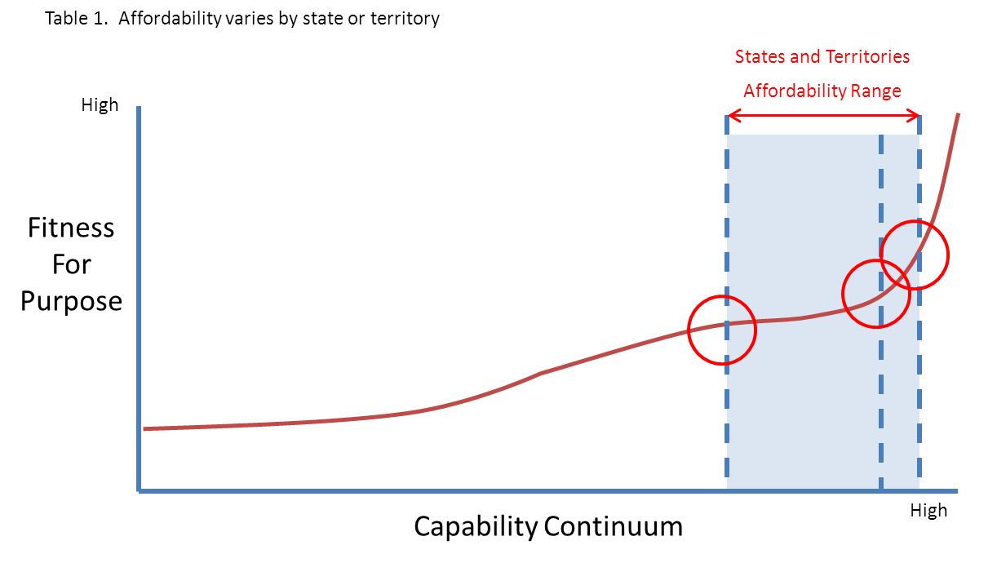

- Victoria does not support a reform pathway that will shift a significant and unsustainable financial burden on to State governments, local governments and communities.

- Key objectives for Victoria in developing a PSMB capability are:
- Nationally interoperable mission critical telecommunications
- Efficient spectrum allocation that preserves and maximises public good objectives and spectrum value options
- Fit for purpose, flexible and diverse solutions models that meet the unique requirement of the public safety sector
- International standards based, contestable and competitive procurement environment.

- To the extent that spectrum allocation is considered in the Commission’s analysis, Victoria stands by its historical position for a spectrum allocation of at least 20MHz.

- The states and territories have discussed each jurisdiction’s position on PSMB capability, and requirements for delivering a PSMB capability. From these discussions, the states and territories have developed a list of seven core principles to delivering a PSMB capability for PSAs. These are explored in detail below.
Principle 1: Mission Critical
- States and territories are only in a position to define ‘Mission Critical’. A life dependent emergency, which is mission critical, can occur at any time and in any place across a state or territory. Events commonly escalate and scale to become mission critical at any time and in any place across a jurisdiction.

- PSAs rely upon radio communications in life dependent events or where property is threatened. Narrowband data already forms part of PSAs common operating practices and all jurisdictions, both nationally and internationally, agree that broadband data will become part of the common operating environment for emergency management.

- Victoria already invests in mission critical dedicated highly resilient voice networks that provide state in-vehicle coverage of approximately 96% of the land mass and more than 99% of the population.
Principle 2: Delivering public value outcomes
- We define ‘public value’ as delivering public safety outcomes for the community, which includes protection of life and property as a paramount objective, across a continuum of daily (business as usual) occurrences to large scale and severe emergency events. In that context, we require a level of service capability that supports business as usual activities through to major large-scale, multi-agency events.

- To achieve the public value outcome of PSMB, states and territories need certainty of accessibility, affordability and quality of service.

- The Productivity Commission must recognise that the public safety sector has unique requirements that are not all met by commercial services (such as very high levels of coverage, and higher availability of service through resilient infrastructure and dedicated capacity). A future PSMB capability must support these requirements.
Principle 3: Interoperability and diversity
- Victoria recognises the value of a national, interoperable PSMB capability. Victorian PSAs participate in out-of-jurisdiction events and regularly rely upon assistance from other jurisdictions’ PSAs when events in Victoria escalate to a level beyond Victoria’s capacity to manage. Greater public value is afforded by the ability to interoperate the Nation’s PSA resources in times of large-scale emergencies.

- Victoria acknowledges that there are differences between the states and territories with regard to geography, population density and distribution, emergency and risk profile, and the depth and diversity of their existing telecommunications market and service offerings. This necessitates a framework that accommodates different solutions for different states. For example, a PSMB capability acquired through commercial provision may be a value option in an area where there is robust competition.

- The competitiveness of commercial markets and existence of state infrastructure that can be leveraged for PSMB varies materially in metropolitan and regional areas within jurisdictions. The value of existing investments will run the risk of being stranded and devalued if flexibility is not maintained in the PSMB delivery models.
Principle 4: Models to maximise value and lower costs
- Victoria considers there to be a number of ways to deliver an accessible, affordable and reliable PSMB, ranging between a dedicated PSMB network model, a commercial network model and a hybrid model.

- Victoria considers that a hybrid model provides greatest potential benefit in terms of maximising opportunity value at the lowest opportunity cost. PSMB Spectrum and dedicated capacity not utilised in periods of peak activity can be utilised by the market, so long as the appropriate commercial, regulatory and policy conditions are in place. Cost effective access to PSMB capability can be realised if the State and PSAs can share in a revenue opportunity that reduces the marginal cost of operation and allow the PSMB investments to be amortised over a broader market. This can also enable benefits from non-public safety uses of spectrum and network investments.

- Victoria considers that if a commercial or hybrid model is adopted, an appropriate regulatory environment is essential to ensure PSAs receive the service levels they require, especially during major events.
Principle 5: Contestability and competition
- The Productivity Commission should recognise the limits of the commercial mobile broadband market, which has been in place for nearly a decade, for supply of services and infrastructure. The degree of competition and the level of coverage provided by commercial networks is less than that required to provide PSAs certainty of accessibility, affordability and quality of service. The Productivity Commission cannot put the states and territories in a position where we are price-takers.

- Victoria seeks to maintain and deepen the existing market and ensure there are contestable and competitively priced service offerings.

- Victoria seeks to preserve market conditions that have contestable offerings. The procurement environment needs to be international standards based, contestable and competitive. Victoria considers it essential to unbundle procurement of network, services and terminals and avoid proprietary solutions. Fundamentally, the public safety sector and industry is moving to open standards that will support service interoperability.

- In its procurement of services, Victoria seeks to avoid commercial “lockup” and to preserve the ability respond to future opportunities, including through market, technical and regulatory developments.
Principle 6: Spectrum to support a PSMB capability
- Victoria recognises that spectrum facilitates the telecommunications capability and that the capability needs to be available and accessible within the service parameters. Equally, it must be affordable to maximise the public value. Victoria recognises that a minimum allocation is necessary to maintain a core capability to leverage for extreme events. Any allocation would require monitoring to ensure it is effectively building and supporting a core service capability.

- Spectrum should not reduce market participation across the jurisdiction’s geography; it should only be used or allocated in a manner that promotes multiple market participants.

- To the extent that spectrum allocation is considered in the Productivity Commission’s analysis, Victoria stands by its historical position that the Commonwealth should allocate at least 20MHz of spectrum to realise the community safety benefits from a PSMB capability.
Principle 7: Synergies with other Commonwealth activity
- The Productivity Commission should consider the PSMB in relation to other government programs and expenditure in closely related areas (e.g. government investment in regional areas).

- PSMB coverage, capacity and resilience could be enhanced if linked to other Commonwealth telecommunications initiatives such as the Commonwealth Spectrum Review, the Universal Service Obligation, Emergency Alert, the National Broadband Network and the Mobile Black Spot Programme. These must be examined to determine if they can be aligned to maximise efficient investment.

Options for delivering a PSMB capability

Victoria considers that there are three broad options for the delivery of the PSMB capability. These are:
Option A: Do Nothing Case – No Spectrum Allocation
The only option is to enter into commercial arrangements with incumbent mobile network operators. Australian mobile network operators have had broadband capability for nearly a decade. No market exists, with commercial public safety grade product with the necessary coverage and capacity characteristics. Current arrangements are not sustainable, the gap is growing between the mobile data capabilities available to the community and PSAs. The frequency of large-scale emergency events and natural disasters and increasing technological capability is changing how the community seeks to interact with government and PSAs. Doing nothing reduces public confidence and public value through Increased risk of loss of life and property.

Option B: Build, Buy or Hybrid - 10Mhz Spectrum Allocation
A spectrum allocation provides more optionality; however, scarcity of spectrum in emergency events drives unaffordable costs. The frequency of large-scale emergency events and natural disasters drive the need for expensive to establish and maintain overflow capacity in commercial networks. State’s and territories become price takers, which places greater regulatory burdens and compliance costs on government.

Option C: Build, Buy or Hybrid - 20Mhz Spectrum Allocation
The provision of adequate spectrum provides the most optionality, public confidence and public good, by reducing the pressure on commercial networks in times of emergency. This in turn reduces the degree of regulatory and compliance intervention. As described below,
when considering the principles outlined in this submission, Victoria considers that the hybrid, “build and buy” model will best deliver the public safety outcomes and the most benefit for the lowest cost ratio.

Conclusion

Victoria encourages the Commission to consider the proposed seven key principles detailed above
in Section A of this Submission.

Applying these principles to a recommended PSMB reform pathway, the review would:
- accommodate flexible “build and buy” arrangements, recognising the different jurisdictional current and future capability needs and affordability
- maximise the synergies between the Commonwealth related activities to the benefit of community and government
- recognise the commercial mobile market capability, which has been in operation for nearly a decade, and the unique PSMB capability and capacity requirements and consider what additional conditions need to be in place to meet PSMB needs.

Victoria looks forward to working collaboratively with other jurisdictions and the Productivity Commission to identify PSMB arrangements that will operate efficiently and effectively to maximise public value and address the current and future needs of PSAs and the community. Victoria awaits the release of the Commission's Draft Report, and reserves the right to provide a Victorian Government response to the Draft Report and any reform options and recommendations.

Section B: Victorian Government Response to the Productivity Commission’s Issues Paper Key Questions
No. | Productivity Commission Questions | Proposed Government Response
The Commission’s Proposed Approach
1 | What is the merit (or otherwise) of the proposed approach to undertaking first principles analysis in this study? | The ‘first principles’ analysis approach is an opportunity to explore all possible options to deliver the most efficient, effective and economical PSMB capability by 2020. The scope of the study must include all Commonwealth and State policy and regulatory options available.  The Productivity Commission should take into account other major international jurisdictions’ approach to the benefit of PSMB and allocation of sufficient spectrum and/or funding. Victoria considers that the focus of the analysis should be on the differential risk and delivery costs of the options.  The Public Safety Mobile Broadband Steering Committee (PSMBSC) and PSAs in various jurisdictions have already explored a number of approaches to delivering a PSMB capability and the Productivity Commission should draw upon the entire suite of work already completed to inform its cost-benefit analysis. The Victorian Government has previously provided the following documents to the Commission (to be used only to assist with the preparation of the cost-benefit analysis, and not to be made publicly available).  - 2011: Ernst & Young – Benefit cost analysis of National Broadband capacity of Emergency Services Organisations  - April 2012: GQ-AAS PSMB Reports  - GQ-AAS Reports 1 – Demand Requirements  - GQ-AAS Report 2 – Delivery Models  - GQ-AAS Report 3 – Spectrum Calculations  - GQ-AAS Report 4 – 700MHz 800MHz Comparison  - Jul 2012: Letter to Prime Minister Gillard from Premiers of New South Wales, Victoria, Queensland and Western Australian  - Oct 2012: PSMB National Implementation Plan (prepared by the PSMBSC to provide information to Ministers and ACMA)  - Feb 2013: State and Territory Joint PSMB Submission to the Standing Council on Police and Emergency Management and ACMA (further evidence)  - Feb 2013: Deloitte – Emergency Services Long Term Strategic Plan – International Public Safety Broadband  - Jun 2013: State and Territory submissions to the Parliamentary Joint Committee on Law Enforcement inquiry Spectrum for PSMB  - Jul 2013: Parliamentary Joint Committee on Law Enforcement inquiry report  - Oct 2013: Overflow Capabilities Sub Group Final Report (report to the PSMB Steering)  The documents were provided to the Commission with the following caveats:  - The documents should be notated, presented and considered in chronological order. This is important as it demonstrates how consideration of the issues was developed over time, and some of the earlier work was effectively superseded by subsequent work.  - In regards to the E&Y Benefit Cost Analysis, it is important to note that Victoria approached the cost benefit from the perspective of public value and not private value (that carriers would price broadband access on a cost plus basis).  - Information of note from the PSMB Capacity and Overflow Sub Committee (in addition to their final report) includes a specification (Statement of Requirements) and assessment of commercial and technical likelihood of receiving capability from carriers.  The Productivity Commission should consider all related government programs and expenditure in closely related areas (e.g. government investment in regional areas). Initiatives such as PSMB, the Universal Service Obligation, Emergency Alert, the National Broadband Network wireless and satellite networks and the Mobile Black Spots Programme must be examined to determine if they can be better aligned to maximise efficient investment.
2 | What domestic or international developments, reports or experiences in PSMB (or related matters) are relevant to consider in this study? | In addition to the domestic reports and studies listed above, there are a wide range of trials, studies and deployments that have already been undertaken. Two of note include:  - Feb 2013: Deloitte – Emergency Services Long Term Strategic Plan – International Public Safety Broadband. The diagram at Attachment 1 depicts a range of PSMB-related activates underway in different parts of the world.  - A 2013 Deloitte study commissioned by Victoria surveyed PSMB decisions and studies across select countries in North America and Europe. The findings of this survey indicate that other countries have concluded that a 10 MHz spectrum allocation will not provide sufficient bandwidth for incidents that occur on a daily basis, and have allocated, or are considering allocating, greater amounts of spectrum accordingly.  In the USA, PSAs were initially allocated 10 MHz in the 700 MHz band; however, in February 2012, the United States Congress passed legislation increasing the total PSA spectrum allocation to 20 MHz. Canadian PSAs are currently allocated 20 MHz of spectrum for PSMB purposes.  The European Conference of Postal and Telecommunications Administrations established a working group to investigate an allocation of spectrum for public protection and disaster relief mobile broadband. The working group undertook an analysis of typical scenarios faced by PSAs and concluded that a minimum of 15 MHz (7.5 MHz + 7.5 MHz) was required for everyday scenarios with at least 20MHz (10 MHz + 10 MHz) required for large-scale planned events. A separate study commissioned by the German Federal Ministry of Economics and Technology concluded that, in the German context, a minimum of 15 MHz (uplink) and 10 MHz (downlink) would be required.  - 2014 London School of Economics and Political Science (LSE) research highlighted reserving spectrum for communications by emergency services would improve public safety. In addition, it could yield a high socioeconomic benefit that could potentially outweigh the opportunity cost of forgoing the sale of this reserved spectrum.
3 | What are the implications (if any) of the Australian Government’s review of the spectrum policy and management framework, and ACMA’s ongoing work on spectrum allocation matters, for the delivery of PSMB in Australia? | There are interdependencies and potential overlap between the PSMB cost-benefit analysis and the Spectrum Review processes. It is important that the two processes do not occur in isolation and that the PSMB analysis should also inform the broader Spectrum Review’s principles for reform and its outcomes.  The Productivity Commission’s analysis should give broad consideration to the roles, responsibilities and powers of the Commonwealth and State jurisdictions in considering the most effective, efficient and sustainable arrangements for spectrum management and the delivery of a PSMB capability.  The analysis should consider the cost and revenue allocations across all levels of government and jurisdictions with varying arrangements / options to deliver a PSMB capability.  This is especially important in relation to spectrum, where the most effective and efficient management is found to be achieved through the delegation of responsibilities to the State or a third party.
Public Safety Agencies in Australia
4 | Are there any other PSAs that should be considered within scope in this study? To what extent are communications between PSAs and the community relevant to this study? | In line with the Terms of Reference, Victoria defines public safety agencies (PSAs) to include police, fire, ambulance and emergency services. Victorians rely on the State’s PSAs to prevent, prepare, respond to and recover from emergencies in order to mitigate their devastating impact in terms of lives lost, injuries and property and environment damage. Victorian PSAs comprise:  - Victoria Police — With a mission to provide a safe, secure, orderly society by serving the community and the law, Victoria Police are the State’s crime prevention and responder public safety agency.  - Ambulance Victoria — Ambulance Victoria provides emergency response, patient transport and retrieval services across the state.  - Victoria State Emergency Services (VICSES) — Primarily a volunteer-based agency, VICSES are the control agency for flood, storm, tsunami and earthquakes in Victoria. They also assist other PSAs in emergencies, such as road rescues, bushfires and community planning and education.  - Country Fire Authority (CFA) — The CFA is a volunteer and community based fire and emergency services organisation with the mission of protecting lives and property in all areas outside the metropolitan area (excluding Crown Land). However, they also often assist other fire agencies as required.  - Metropolitan Fire and Emergency Services Board (MFB) — With a focus on protecting the community from fire in metropolitan Melbourne, the MFB also provides assistance for other emergencies, such as their emergency medical response, which responds to medical emergencies.  - Life Saving Victoria (LSV) — A primarily volunteer-based agency, LSV’s emergency operations include surveillance of beaches and inland waterways, water rescues, and first aid.  - Department of Environment, Land, Water, and Planning (DELWP) — DELWP responds to bushfires on Crown land, such as forests and parks, and is a support agency to CFA for bushfires on private land.  - Emergency Services Telecommunications Authority (ESTA) — ESTA is not a first-responder organisation but manages community calls for all ESOs in Victoria, including emergency and non-emergency calls. This includes responding to calls, dispatching services and managing the service contracts for the State including Mobile Data Network (MDN), Metropolitan Mobile Radio (MMR) and Emergency Alerting System (EAS).  Depending on the nature of the emergency, a range of other organisations and third parties often play a crucial role in assisting with the management of, and recovery from, the incident. For example, contractors bulldozing emergency fire breaks or carrying water, local councils managing access to facilities, and relief agencies supporting community recovery. These secondary stakeholders often require interoperable communications with the traditional emergency responder agencies.  Communications between PSAs and the community is a growing area of focus within Victoria. Traditional means of communications, such as radio and television are now augmented by a range of new media including mobile apps, social media, web pages, Emergency Alert, Next Generation Triple Zero etc. Broadband communications infrastructure to reliably inform the community of vital emergency information is already regarded as a mandatory requirement, and in this regard, expectations will increase over time.
5 | How do the organisational and institutional arrangements for PSAs vary between the Australian jurisdictions? What implications (if any) does this have for the way in which PSAs procure, operate and use communications services? | Each jurisdiction has different organisational and institutional arrangements for PSAs; however, there is strong agreement on the need for interoperability including communications across jurisdictions (eg 400MHz spectrum harmonisation).  Victorian emergency management has recently been through a large reform process culminating in the establishment of Emergency Management Victoria (EMV) in July 2014. The Emergency Management Act 2013 (the Act) established EMV including :  - The Emergency Management Commissioner who is responsible for coordinating the response to major emergencies (including ensuring appropriate control arrangements are in place and operating effectively during Class 1 and Class 2 emergencies). The EMC is also responsible for co-ordinating consequence management and recovery for all major emergencies. The Commissioner delegated the recovery coordination function to the Department of Health and Human Services in 2014/15  - The Chief Executive of EMV is responsible for the day to day management of Emergency Management Victoria, and the coordination of investment planning for large scale strategic projects for the responder agencies including major procurement and communications and information systems  - Under the Emergency Management Act 2013, the State Crisis and Resilience Council is responsible for developing a three-year rolling Emergency Management Strategic Action Plan (the Plan). The 2015-2018 Emergency Management Strategic Action Plan drives the Victorian Government’s emergency management reform agenda, sets priorities, and assists in determining investment decisions. Other aspects of Victoria’s emergency management environment include:  - Five state contracts provide emergency services communications networks covering:  - Digital voice radio services in metropolitan Melbourne, used by three agencies  - Digital voice radio services in rural Victoria, currently used by one agency, but soon to be expanded  - Data services in metropolitan Melbourne, used by two agencies  - Paging services state-wide, used by three agencies  - Analogue voice radio services state-wide, used by six agencies  - Victoria recently completed its Long Term Communications Plan (LTCP) for police and emergency services operational communications. Operational communications provides the underpinning capability to allow agencies to operate and interoperate. Network investments are typically large, and the lead times to build new infrastructure are long. These investments are a prerequisite to many smaller technology efficiency projects, so must be undertaken first. As technology improves, community expectations change, and demand for emergency services increases, the communications infrastructure for the emergency services sector must evolve to address these changing requirements. The LTCP sets out a plan to transform the sector’s operational communications to meet these future demands. The four key actions from the LTCP are to:  - Leverage new State contracts to move to a single, integrated narrowband data and voice network  - Establish a statewide, sector-wide broadband capability  - Adopt a phased implementation plan, and  - Deliver the plan through EMV’s centralised governance  - Unlike other jurisdictions, Victoria operates a centralised Call Taking and Dispatch operation for its Triple Zero calls. This service is operated by ESTA, which also contract manages several of the State’s emergency services communications networks.

PSA’s current use of communications services and spectrum
6 | What is an appropriate definition of ‘mission critical’ communication systems and capability for the purposes of this study? What metrics should be used to assess whether capability is being delivered to adequate levels during mission critical circumstances? What evidence is there that existing capabilities are satisfactory or unsatisfactory? | No industry-wide definition for ‘mission-critical’ services is available today. For the purpose of this study, Victoria considers ‘mission critical’ to refer to any situation where a threat to life or significant infrastructure is present.  A life dependent emergency, which is mission critical, can occur at any time and in any place across a state or territory. Events commonly escalate and scale to become mission critical at any time and in any place across a jurisdiction.  Mission critical capability can be in the form of voice or data communications.  Several of Victoria’s existing networks are considered mission critical, and service providers are required to meet or exceed a number of strict service metrics to ensure the networks meet the required standards. These metrics cover a wide range of service characteristics, including coverage, availability, delays in network response, and service restoration times.
7 | What applications do PSAs currently use on their LMR networks that are provided for mission critical purposes? Does this differ by jurisdiction? | Today, operational communications capabilities in Victoria are comprised primarily of voice-based communications (such as radios) supported by narrowband (such as one-way messaging) and some limited broadband capabilities.  These networks are used for mission critical voice communications, covering dispatch, command, and incident communications. Other mission critical applications used on these LMR networks include duress, conveying location information, and to a limited extent for paging.
8 | How often are PSA narrowband networks (such as LMR networks) renewed or upgraded, and to what extent are different jurisdictions at different points in this process? What are the costs involved in maintaining these networks? | Victoria spends more than $150 million per annum operating the emergency services communications networks. Currently in Victoria there are over 20 duplicative networks utilised by police and emergency service agencies that are not interoperable.  The renewal period for the current Victorian PSA networks vary greatly, depending on the type of network. They can range from four years for a limited equipment update to fifteen years for a full network replacement.
9 | How do the different types of events that PSAs deal with affect their demand for communications capabilities? Can you provide examples or evidence to illustrate this? | PSAs serve Victorian communities each and every day by mitigating the devastating impact of both day-to-day and large scale emergency incidents on the community, businesses, homes and property, infrastructure and the environment. Their effective response helps to save lives, avoid injuries and minimise damage to the natural and built environment.  Different types of emergency incidents generate different demand profiles between PSAs. These range from business as usual activities, planned events and large scale emergency incidents. A great number of incidents can involve more than one PSA, ranging from road or transport accidents, to bushfires, floods, storm, public order and terrorist events. In the Feb 2013 International Public Safety Broadband report delivered by Deloitte and provided to the Parliamentary Joint Committee on Law Enforcement inquiry Spectrum for Public Safety Mobile Broadband, the data sourced from the Insurance Council of Australia demonstrated the escalating frequency and cost of emergency events over the last decade.  In Victoria, total demand has increased for all PSAs over the past ten years, with the frequency of large-scale events requiring multi-agency responses growing exponentially. There are a number of factors contributing to the demand growth for Victoria’s PSAs business as usual (BAU) activities and the large scale events requiring coordinated, multi-agency response with high risks of adverse outcomes for the community. These include:  - Demographic change, including significant growth in Victoria’s population and continued population ageing, contributing to an increase in demand for emergency services. At the same time, due to growth in life expectancy, Victoria’s population will continue to age, further increasing demand for emergency services.  - More urban development along the urban growth boundary and more demand for PSA services along the rural-metropolitan boundary also contribute to the increased demand on PSA capabilities.  - Increased severity and frequency of extreme weather events.  - Increased operational take-up of mobile data services has increased mobile data demand.  The rapidly growing demand is depicted in the diagram at Attachment 2.
What is mobile broadband?
10 | How, and to what extent, are PSAs using mobile broadband capability provided over commercial networks, and related products and applications, to support their operational activities? Are there any lessons or insights from these experiences, including the benefits that are being realised? | The mobile nature of emergency response requires wireless communications, which today is primarily made up of voice-based communications (use of radios), with limited narrowband (such as paging) and broadband capabilities (including the capacity to utilise applications, interactive maps, video).  Today, Victoria’s PSAs are making very limited use of mobile broadband capabilities. One example is Victoria Police, which is using commercial mobile broadband to a limited extent in their “BlueNet” traffic enforcement vehicles (see Attachment 3).  The adoption of open standards and investment in coverage and network capability to meet public safety needs is possible on commercial networks or a private network. The costs to achieve public safety requirements may vary dependent upon the ownership of the network.  Victoria is keen to understand more about Telstra LANES, including pricing and commercial terms and conditions. Victoria is unaware of any formal report on the performance or characteristics of LANES and its demonstration at G20, other than what has been presented in public.  Victoria recently sought to source a commercial mobile 3G or 4G service with any level of service level guarantee. A dominant supplier to the emergency services sector warranted that there were no commercial mobile services on the Australian market that offered any level of service guarantee.
11 | How do other large organisations (such as government and corporate organisations with certain requirements which may be similar to those of PSAs) currently use mobile broadband services provided on commercial networks?
12 | What lessons or insights can be taken from the previous trials of Telstra’s LANES model, including during the G20 summit in November 2014?
13 | Can commercial network solutions that involve dedicated spectrum for PSAs (and prioritised capacity in other spectrum bands during emergency incidents) allow for interoperability between networks operated by other mobile carriers and/or for end user to roam across multiple networks? Are there any technical, institutional or commercial barriers that would prevent this outcome?
Potential opportunities for PSAs to use mobile broadband
14 | What applications could PSAs use if they had access to PSMB capability? How could this be expected to vary across PSAs? | Detailed information regarding future PSA uses of PSMB is provided in the GQ-AAS report – “Public Safety Mobile Broadband Demand Requirements For Public Safety Mobile Broadband Steering Committee”, November 2011.  Broadband-enabled service innovation will allow PSAs to receive information from the public, and receive and transmit better quality and timelier information, enabling them to deploy resources more efficiently and make more informed decisions to enhance service delivery to the community.  With the rapidly changing technological landscape, data consumption has grown significantly. This has been driven predominantly by increased mobile data traffic over broadband networks as a result of faster mobile networks, greater adoption of data applications (such as video) and the proliferation of smartphones.  Today, operational communications is dominated by voice and narrowband capabilities, which in practice refer primarily to radio and one-way messaging. Consequently, PSA responders are unable to leverage broadband data capabilities that are widely available in the community to improve service delivery (and reduce the risk of impacts from emergency events). This has led to a proliferation of ‘Bring Your Own Device’ (BYOD) practices by responders, which operate outside of operational command disciplines and create security risks as well as increased network congestion. Evidence exists that PSAs personnel have already relied on their personal devices during some emergency incidents and this is expected to continue. PSA data networks (narrowband networks) that exist will see increased pressure on network capacity into the future as data traffic continues to grow, by an estimated 14-18 times over the next five years.  Broadband offers significant additional capabilities for public safety. With greater availability of mobile broadband networks, content-rich information can be shared, including real-time video, enhanced location tracking, interactive maps and two-way messaging. Increasingly, this starts to change our understanding of how we respond to emergencies, including a greater ability to source content-rich information from and to the community in real time to enable more informed decisions. Faster networks and improved end user devices provide PSAs with additional capabilities that enhance their service delivery and offer the potential to use new applications including:  - real-time video  - access to online services  - fingerprint analysis  - person and vehicle checks  - biometric monitoring  - field access to community plans and fire plans  - field access to airbourne video stream  - video conferencing between PSAs  - ambulance inventory control  - telemedicine  - handheld camera to capture and stream footage  - access to centralised information and real time data  - geospatial image display  - live traffic and weather reports.
15 | To what extent could these applications replace or supplement the capability and systems currently used by PSAs on their narrowband networks? | The capabilities outlined above are not currently provided over the narrowband networks. Some functions now performed by voice over radio such as database requests will be replaced by PSMB applications. A PSMB capability will have a dramatic impact on all government services, especially emergency services with the potential for enhanced situational awareness, faster treatment and response times, significant improvements in the efficiency of operational work practices, and potential benefits to workplace safety.
16 | How important are communications between PSAs and the community during emergency incidents? | The changing data consumption patterns have significant implications for government and emergency services, as the sector has not kept pace with technological trends and there is a rising community expectation that emergency services provide them with data-rich, real-time information accessible from anywhere. Currently, the community has superior data capabilities to PSAs, enabling them to acquire information on emergency incidents. PSAs are unable to use the information the community gathers because they do not have the capabilities to access it, especially in a timely manner.  Inability to use community intelligence, such as social media, risks the community receiving incorrect information and delays PSA response if they are unaware of a situation occurring. It also diminishes public confidence in PSAs.  Community warnings are an essential aspect of communications between PSAs and the community during emergency incidents.
Characteristics of a PSMB capability
17 | What PSMB capability characteristics should be considered in this study? | There are a wide range of PSA requirements that will be essential in any PSMB implementation. These are described in more detail in questions 22 – 41.
 | Interoperability
18 | How should ‘national interoperability’ be interpreted in this study? Does it include interoperability between networks, devices and applications used by PSA in different jurisdictions? Does it extend to integrating communications services between different local PSAs (for example, police, fire, ambulance and other responders)? | Victoria considers ‘national interoperability’ to be defined as the ability for PSAs to communicate using voice and data within individual agencies, with other PSAs (including other jurisdictional PSAs) within the state, and across jurisdictional borders when required.  Victoria considers national interoperability to include interoperability between networks, devices, data and applications and includes integrating communications services between different local PSAs.  Any consideration of ‘national interoperability’ must examine the operational practices required to support interoperability. The technical requirements and capabilities to support interoperability are relatively straight-forward, but appropriate agency specific operational practices are required to make it work in practice.  Interoperability requirements of Australia PSAs are identified in the Interoperability Continuum at Attachment 4.
19 | Does delivering a PSMB capability raise any new opportunities for achieving national interoperability? | Currently Victorian PSAs face a number of challenges that contribute to operational communications interoperability problems. Ineffective communication capabilities are driven by three key problems:  - Lack of interoperable systems between PSAs  - Different rural and metropolitan networks and devices within PSAs  - Insufficient network capacity and coverage across the sector.  This significantly impairs PSAs ability to effectively respond to community needs and enhance public safety. Specifically, evidence from the 2009 Victorian Bushfire Royal Commission 2009 and Review of the 2010-11 Flood Warnings and Response demonstrate that ineffective operational communications:  - reduce situational awareness  - create delays  - lead to inefficient allocation of resources  - force ESOs to rely on communicating through the command structure or use unofficial communication  - cause network congestion, and  - can prevent communications between PSAs and the community.  These impacts prevent timely and effective service delivery and hence put the lives of the community and PSA personnel at risk.  A PSMB capability would significantly reduce the number of networks used by PSAs and would close the metropolitan/regional divide. Achieving full interoperability would, however, be contingent upon the allocation and use of spectrum in a suitable band.  The significant task of achieving National Interoperability will be through common governance, common standard operational practices, common technology and practiced and regular use of this capability. The technical aspects of ‘national interoperability’ are relatively straight-forward.
20 | Would the benefits, costs and risks of achieving national interoperability vary under different deployment options? If so, how? | Although benefits are unlikely to differ between deployment options (assuming that the deployment options deliver comparable coverage and capability for the same cost), some options will increase the risk of full interoperability not being achieved due to either the introduction of proprietary solutions, or punitive contractual arrangements.  If the underlying technology and spectrum are common, and international standards are adhered to, then national interoperability at a technical level should be achievable.
21 | What progress has been made in putting in place arrangements to better coordinate emergency communications within and across PSAs and jurisdictions? | In Victoria, the overarching policy framework has evolved through a suite of inquiries and reforms, at both the Federal and State level, that place greater emphasis on a more joined-up “all hazards, all agencies” approach and promoting community involvement and resilience.  For Victoria, progress to better coordinate emergency communications across PSAs began in 2001 with the release of the State implemented a ten-year Statewide Integrated Public Safety Communications Strategy (SIPSaCS). SIPSaCS represented the first effort to join up the sector to deliver shared network and commercial arrangements. It focused on seven principles^{[1]} and led to significant investment to build the Metropolitan Mobile Radio (MMR), the Mobile Data Network (MDN) and the Emergency Alerting System (EAS), in addition to refreshing the StateNet Mobile Radio network.  In 2010, Emergency Services Communications Strategic Framework was released, which built on the principles of SPISACS and emphasised the need for the sector to effectively communicate with the public. It provided a broad vision for the State to drive long term planning and provision of integrated multi-agency emergency services communications for Victoria, building on the State’s previous success with the provision of these services and drive effective and fiscally efficient investment in long-term emergency services communications.  In accordance with the principles originally developed in the Emergency Services Communications Strategic Framework, Victoria’s Emergency Management Long Term Communications Plan was agreed by the sector and sets out a plan to transform operational communications to meet the future demands of the emergency management sector utilising the latest mobile radio and data technologies.  The National Strategy for Disaster Resilience (2011) aimed to support the development of a whole-of-nation, resilience-based approach to disaster management.  Emergency Management Victoria was established in 2014 to implement the Victorian Government emergency management reform agenda by:  - maximising the ability of the emergency management sector to work together and achieve joined up outcomes that are community focused  - leading and facilitating key initiatives focused on system-wide reform with integrated policy, strategy, planning, investment and procurement  - ensuring a stronger emphasis on shared responsibility, community resilience, consequence management and post emergency recovery activities  - embedding emergency management across government, agencies and business  - leading and coordinating emergency preparedness, response and recovery with the emergency management sector and community.
 | Coverage
22 | What level of network coverage do the existing networks used by PSAs (for narrowband voice and low-speed data capability) currently provide? How does this vary across jurisdictions? | Victorian emergency services currently use several voice networks (both analogue and digital) providing coverage for vehicle-mounted terminals to approximately 96% of the State’s geographic area, as well as up to 30km out to sea, and overlapping coverage into neighbouring states. These networks cover close to 100% of the State’s population, and have been designed to cover all major roads and railways, and a significant proportion of the State’s bushfire-prone areas.  In addition to the voice networks, the State also maintains a pager network for the dispatching of volunteers. This network covers approximately 97% of the State’s geographic area.
23 | What level of mobile broadband network coverage do PSAs require across metropolitan and regional Australia? Does this vary for different PSAs? | The business requirement for coverage (both voice and data) is for 100% geographic coverage of the State, in addition to 30km out to sea, overlapping coverage into neighbouring States, and in-building and tunnel coverage. It is recognised that fully meeting this requirement will never be feasible, so a risk-based analysis must be undertaken to direct coverage augmentation investments appropriately.
24 | What is the most appropriate measure of network coverage for use in this study? | Both population and geographic coverage should be used, since they each provide information that is relevant to different agencies.  Although most commercial networks use only population coverage to measure their network size, it is important to note that many PSA activities (eg, bushfire fighting, search and rescue operations), often occur in remote locations. For this reason, geographic land-mass coverage more accurately reflects the requirements of many PSAs.  The case distribution of other PSAs (eg, Ambulance) tends to closely mirror the population density distribution, so for these PSAs, population coverage is more relevant.  In addition to a percentage coverage measure (eg, 95% geographic coverage), any measure of coverage must also account for specific locations where PSAs require guaranteed service. These locations will include airports, shopping centres, transport tunnels, sports venues, tourist locations, etc.
25 | What options are there for extending the mobile coverage of commercial networks? | The Victorian Government has long advocated for improved regional mobile communications through the Regional Telecommunications Review and other submissions such as to the National Broadband Network (NBN) reviews. The Government has welcomed participating in the Commonwealth Government’s $100 million Mobile Coverage Programme (MCP) to improve both mobile coverage and mobile service competition in regional Australia. The Government has also welcomed the Commonwealth’s intention to utilise NBN infrastructure to support mobile communications development as a sensible policy response to cost effective infrastructure development in commercially thin regional markets.  The Victorian Government has strongly argued the case for improved regional mobile communications with the critical drivers being improved mobile coverage are better public safety and economic development. However, some of these markets are natural monopolies and require a different approach (subsidy and regulatory intervention) to competition settings than in urban markets that support infrastructure based competition. Levels of infrastructure competition in the longer term may never develop in extremely marginal markets.  The fundamental issue for regional markets is the cost of remote/distant infrastructure deployment including site access, spectrum, tower construction, permanent power, and provision of backhaul, relative to thin and low growth revenues – in short, natural monopoly conditions. Supply of communications into regional areas is generally characterised as being high cost and low revenue telecommunications markets.  In these circumstances innovative program design and business models are required including more cooperative approaches to leveraging multiple benefits overtime as well as multiple funding sources, including in-kind contributions such as access to sites and existing infrastructure. Innovative program design and collaboration will be required to meet multiple and potentially competing policy objectives (such as competition and coverage).  Regional markets already receive a level of government and industry based subsidy. These include:  - Telecommunications universal service obligation (USO) supporting increasingly expensive and less important copper based services  - Mandated rollout of NBN wholesale fixed wireless (LTE) and satellite with a recognised long term funding issue  - Commonwealth funded remedial and equity programs, such as the Regional Backbone Blackspot Program (RBBP) and most recently the MCP for mobile LTE.  The Victorian Government supports competition as the most likely mechanism to provide the preconditions for long-term market development and innovation. Competition can be delivered at the service as well as the infrastructure level through infrastructure access arrangements. The Victorian Government strongly supports an approach to the PSMB that utilises MCP and NBN infrastructure for mobile communications development. The Victorian Government also owns or controls access to a significant number of sites and infrastructure including towers, related facilities and FOC assets that should be leveraged to lower the cost of improving mobile coverage.  The Government’s view is that in regional and remote markets where commercial incentives for duplicated investments are weak, reflecting the natural monopoly characteristics of regional telecoms. It is highly unlikely that infrastructure competition will develop and subsidies may entrench the market power of the dominant regional MNO and not promote competition. The Victorian Government’s preference to support a PSMB capability is for the Commonwealth to regulate for more competitive regional mobile communications service outcomes.  However in noting this, the Government is concerned that the commercial MNOs do not have the required technical and operational capability, to provide PSAs with a sufficient data capability during a major urban incident. While jurisdictions acknowledge that some arrangements with commercial MNOs may be a necessary part of a PSMB capability, it is noted that commercial networks are known to present issues when congested or otherwise under duress, such as during emergency situations.  To reduce the risks associated with commercial carrier arrangements, the Commission should recommend to the Commonwealth to ensure that a sufficient regulatory framework underpins priority access, quality of service and network management arrangements with a PSMB capability provided by the commercial MNOs.
26 | Would the benefits, costs and risks associated with achieving an acceptable level of network coverage for PSAs vary under different deployment options? If so, how? And with what operational consequences? | There are potentially significant variations in the benefits, costs and risks of the various deployment options, depending on how they are implemented.  For example, if commercial carriers are used to provide coverage, this is likely to be the cheapest option, but may result in insufficient capacity being available to PSAs during major incidents, unless measures are taken (e.g. through regulation of commercial product offerings) to guarantee a level of capacity for PSAs. Also, commercial services are unlikely to meet PSAs’ resilience requirements. This could potentially have catastrophic operational consequences if, for instance, a network fails, or becomes congested, during a major emergency incident.
 | Integration of voice communications
27 | How could voice services — traditionally carried on narrowband networks — be integrated into a mobile broadband network capability? What challenges and risks need to be accounted for? Are the challenges at the local level (due to legacy factors) greater than those at the national level? | LTE standards for PSA requirements are currently being developed, and will be the key to our ability to support voice services on mobile broadband networks. The first of these capabilities will be delivered as part of LTE Releases 12 and 13. Until these standards are implemented, there is no feasible means of providing voice services over an LTE network to PSA standards, since mandatory requirements, such as direct-mode communication, and group calls are not supported on the current LTE implementations.  Once the required features are implemented, and suitable ruggedised terminals are available, there is unlikely to be any significant challenges or risks from an operational perspective, so long as the PSMB network is able to guarantee PSAs’ coverage, service availability and reliability requirements.
28 | What challenges or opportunities arise (from a technical, institutional and/or commercial perspective) from such integration, and would the benefits, costs and risks vary under different options for PSMB? If so, how? | At present, agencies rely on multiple networks (eg, voice and paging, or voice and data) to provide operational communications. If one network fails, another network can continue to support operations.  By relying solely on one network for all communications, agencies will be placing “all their eggs in one basket”. Even a temporary disruption to this network could have catastrophic consequences.  LMR networks, as is the case with Victoria’s Metropolitan Mobile Network, are designed with high levels of redundancy. Redundancy is designed into the LMR network core, handover typology and radio coverage. LMR networks therefore generally have very high availability and reliability levels, which are currently not matched by LTE networks. Before relying exclusively on an LTE network, confirmation would be required that its service levels and coverage had reached or exceeded those currently provided by LMR networks.  Having said that, there would also be significant advantages of having all data and voice communications supported on one network. These relate to both technical interoperability and the economies of scale that could be achieved by having one large network, and the simplification and rationalisation of terminal fleets.
29 | The Commission understands that there is currently work underway to develop voice applications for 4G/LTE networks for use in mission critical circumstances. When are these applications likely to become available? | Refer to answer to question 27. The required features currently missing from LTE include direct-mode communications, and group calls. It will be at least 2018 - 2020 before commercial systems using LTE Releases 12 and 13 become available.
 | Security
30 | What factors are important in ensuring the integrity and security of communications for PSAs? To what extent does this differ for different types of PSAs? | A number of factors are important in ensuring the integrity and security of communications for PSAs.  For Victoria Police, it is essential that their communications are encrypted end-to-end (Victoria has recently announced further investment in secure radio communications in regional Victoria), whereas for some other agencies such as the CFA, they specifically currently require unencrypted communications. There are a range of standards used to define the level of security required, which include the type of encryption, as well as mechanisms to prevent the location of terminals, screening of personnel, etc.  Increasing community expectations regarding information privacy is likely to result in the greater use in the future of encrypted communications by agencies, which currently do not use encryption. The Privacy and Data Protection Act 2014 will bring about new compliance requirements for Victorian agencies.  The different proposed PSMB delivery models are likely to incur different risks and challenges with regard to meeting the various PSA’s security requirements, however this is difficult to predict in any detail until the specific characteristics of each model are known.
31 | Would the costs and risks associated with ensuring the integrity and security of communications differ depending on how a PSMB capability is delivered?
32 | What methods or metrics could be used to define and/or measure the level of security provided over a network that delivers mobile broadband capability?
33 | What additional security needs do PSAs have compared to other sectors with high security requirements for their communications?
 | Capacity
34 | How should PSA demand for mobile broadband capability be estimated in this study, including their expected demand requirements into the future? | The accurate prediction of future data capacity requirements has proven to be extremely difficult and unreliable, both in the public safety and consumer mobile broadband environment. However, the November 2011 “PSMB Demand Requirements For Public Safety Mobile Broadband Steering Committee” provided comprehensive estimates of expected PSA broadband demand. It developed a number of incident case studies, which it used to predict mobile broadband demand and how PSA operational practices would differ in the future, and how these new operational models would increase mobile broadband usage.  The document concludes that in the area with the highest predicted usage (inner Sydney), the following levels of broadband uplink demand are anticipated by 2020:  - Business as usual demand of 40Mbps per 180 km² assuming 3600 units in operation;  - Planned Event demand rising to 67Mbps per 180 km² assuming 4000 units in operation;  - Large Scale Incident demand in excess of 200Mbps in an area of 50km² assuming 870 units in operation and 30% of units transmitting video during the peak periods of the incident.
35 | What methods or metrics could be used to define and/or measure the level of service capacity provided to PSAs? | The best metric to define and/or measure service capacity is uplink bits per second (bps) within a specific area (km²). Future PSA operational models predict that uplink demand will generally exceed downlink demand.
36 | What levels of capacity will PSAs need for a PSMB capability, and how will this differ between business as usual activities and large scale emergency incidents? | Refer to question 34.
37 | How might the demand for PSMB capability differ between types of PSAs? How could competing demands amongst PSAs be managed? Should particular uses be prioritised? | Different types of emergency incidents generate different demand profiles between PSAs. For instance, a bushfire generates significant demand by the fire agencies, whereas a flood or storm event generates large volumes of VICSES traffic.  Joint agency operational procedures for their communications usage must be developed to ensure all PSAs have adequate capacity to support their operational requirements. Jurisdictions with shared government networks already have these practices developed and in operation.  Emergency Management Victoria was established in 2014 to implement the Victorian Government emergency management reform agenda by:  - maximising the ability of the emergency management sector to work together and achieve joined up outcomes that are community focused  - leading and facilitating key initiatives focused on system-wide reform with integrated policy, strategy, planning, investment and procurement (including communications)  - ensuring a stronger emphasis on shared responsibility, community resilience, consequence management and post emergency recovery activities  - embedding emergency management across government, agencies and business  - leading and coordinating emergency preparedness, response and recovery with the emergency management sector and community.
38 | How would the benefits, costs and risks of ensuring sufficient capacity vary under different deployment options? | Networks that are shared amongst a large number of users (for instance, commercial mobile networks, or private government networks supporting users beyond the emergency services sector) could have a greater potential to support the capacity requirements of PSAs during emergency events, subject to adequate investment in coverage and emergency services capability and assuming adequate procedures and regulations are in place to shed non-essential users from the network during those major events. Allowing non-PSAs to use spare capacity during quiet, non-emergency periods could enable much larger capacity networks to be built economically.
 | Resilience
39 | What level of resilience do PSA narrowband networks usually provide and how does this differ from commercial mobile broadband networks? | The resilience of operational communications is crucial for all PSAs, and the level required is significantly greater than that provided by commercial mobile networks. For example, all base stations in Victoria’s Rural Mobile Radio (RMR) network have twelve hours of standby power available (batteries and/or generators). This is required since many of the base stations are located in inaccessible areas, which are vulnerable to power outages during bushfires (the very time they are needed most). It is often not possible to access these sites to restore mains power until the bushfires are contained. Commercial mobile networks generally provide no more than three to four hours of standby power, which is inadequate for fire agency operational requirements.  Resilience under emergency conditions, especially guaranteed availability during mass calling events is a requirement for all PSAs. Major emergencies such as floods, bushfires, or terrorist activities at public events all generate significant congestion of commercial mobile carriers. Depending on the type of emergency, SES, Fire, Police and ambulance will all be involved to some degree, and will all require a guaranteed level of communications to enable them to safely conduct their operations.
40 | What methods or metrics could be used to define and/or measure the level of resilience provided by the networks used to deliver PSMB? | The standard metrics used to measure the level of end-to-end resilience provided by networks include:  - Data session set-up time  - % Availability  - Grade Of Service (GOS), and  - Quality Of service (QOS).  Victoria’s existing PSA networks have strict service level metrics that must be met, with financial and contractual penalties applying to service providers that fail to meet the required standards.
41 | What priority should be given to the capacity to stand up a replacement service within a specified timeframe in the event of a physical or network based disruption? | Depending upon the nature of the event, the requirement to stand up a replacement service is critical. This is especially the case during natural disasters such as bushfires or floods, where infrastructure can easily become damaged and inoperable, so replacements are required immediately to support the ongoing operations of PSAs.  PSAs currently have mobile base station equipment in standby around the State to provide fast response to sudden demands.
42 | Are there any barriers (for example, institutional, informational and/or technological) to, or challenges associated with, delivering a resilient PSMB capability? How might this differ between different deployment options? | The two most significant barriers to the delivery of PSMB are funding and regulation. No jurisdiction is likely to obtain the capital required to build its own dedicated statewide PSMB network. Any deployment is likely to be based on a service-based payment model – either utilising dedicated or shared infrastructure (or a hybrid of the two). If carrier-based networks are used, then appropriate combination of commercial conditions, policy and regulation will be required to ensure PSAs have access to the capacity they require, especially during major incidents.
 | PSMB Sustainability
43 | How could future developments in technology, or growth in demand for mobile broadband services and capacity, affect the sustainability of PSMB capability under different deployment options? | As technology costs fall, and demand increases, dedicated government networks may become more feasible, especially in areas of higher population density. This may lead to hybrid network arrangements, where users roam between dedicated and shared networks as they move between different coverage areas.  This paper already recognises the synergies with other Commonwealth programs deploying LTE based telecommunications, including the Mobile Blackspots program, Emergency Alert and the NBN.
44 | How will the convergence of voice and data services affect the sustainability of PSMB capability under different deployment options? | The convergence of voice and data services will Increase demand, which will result in greater network usage. This, in turn, increases the feasibility of a dedicated network for PSAs.  Future LTE standards evolution will accommodate mission critical Voice Over LTE (VOLTE). Once this standard is finalised, released and commercialised, there is the opportunity to collapse the existing mission critical LMR networks onto the PSMB network. Collapsing the LMR network onto the PSMB network could deliver economies of scale and reduce total cost of ownership, thus improving the sustainability of PSMB.
45 | What challenges are involved with delivering a mobile broadband capability to PSAs by 2020? Do these differ under alternative deployment options? | As previously mentioned, the two most significant barriers to the delivery of PSMB are funding and regulation. If suitable regulations are not introduced, it will not be possible for PSAs to use shared carrier networks or the scale of economy this could offer. This will push PSAs towards dedicated networks, with potentially inherent higher costs. Also linked to this is the requirement to ensure adequate spectrum is allocated for PSA purposes.  Future LTE standards evolution will accommodate mission critical Voice Over LTE (VOLTE). Once this standard is finalised, released and commercialised, there is the opportunity to collapse the existing mission critical LMR networks onto the PSMB network. Collapsing the LMR network onto the PSMB network could deliver economies of scale and reduce total cost of ownership, thus improving the sustainability of PSMB.  The expiry dates of existing emergency services network contracts will affect Victoria’s ability to implement alternative or replacement services within specific timeframes. Transitioning from one service to another within an emergency services environment is complex and time consuming, given the level of risk mitigation required. The Commission should consider the cost of time in its deliberations, noting that other major international jurisdictions have already provided certainty of PSMB spectrum allocation and or funding.
46 | What potential obstacles exist to a mobile broadband network being fully compatible with a range of end-user devices? Does this depend on the network deployment option? | The network deployment option should not affect the compatibility of end user devices to a mobile broadband network, so long as both the network and the devices fully comply with all relevant international standards.  It is important to ensure that the standards and spectrum used for these services within Australia corresponds to the standards and spectrum used for similar services overseas, so that Australia may source the widest possible range of equipment available on the world market, noting that Australia’s total emergency services technology demand would be less than 1% of the comparable US market.
47 | How does the method of ensuring interoperability impact on the cost of the system to PSAs? | The most effective means of ensuring interoperability is to fully comply with all relevant international standards. This is likely to result in lower overall costs by reducing customisation and proprietary solutions, while maximising the proven designed LTE interoperability.
Developing specific options for evaluation
48 | What detailed options should be evaluated in this study? What underlying assumptions and key parameters would be associated with each option? | Victoria supports investigating the three options outlined in the issues paper (dedicated PSMB network, a commercial network solution, hybrid). It is important that consideration is also given to the implications of a dedicated PSA network as against a network for both PSAs and wider government use.  All options must support the specific PSA requirements detailed in questions 22 – 41, and an adequate allocation of 20MHz of spectrum is assumed.  Before any PSMB network could be extended to be used for voice applications, it is assumed that the required PSMB voice features over LTE are standardised, commercialised and accepted worldwide, and that a range of suitable PSA terminals are widely available.
49 | What (if any) assumptions or parameters should be ‘common’ across all options?
Identifying and estimating costs
50 | What are the sources of costs relevant to this study? | A number of sources of costs are relevant to this study. They include:  - Commercial broadband pricing with Quality of Service capability and Service Level Guarantees  - Network component pricing (Network Management, Backhaul, Network Infrastructure, Interfaces, Service Delivery) – schedules from suppliers  - Past broadband procurements for first responders (FirstNet estimates, “ASTRID Blue Light Mobile” Belgium, Emergency Services Mobile Communications Program UK)  - Opportunity cost of spectrum (value to commercial market of spectrum that would otherwise be used for public safety purposes)  Note that if the PSMB network is made available to non-PSA government users during non-emergency periods, economies of scale will be achieved, resulting in cheaper costs, and more capacity available during surge events.  It is appropriate to consider option values as part of the cost benefit analysis in this study. Each option will have significantly different sets of the costs identified above, so without analysing the options inclusive of all these cost components a sub-optimal decision is likely.
51 | In what ways could delivering a PSMB capability affect non PSA users? How would these effects differ across deployment options? What methods could be used to estimate these effects?
52 | Is it appropriate to consider option values as part of the cost benefit analysis in this study? If so, how? What information or data is relevant?
Identifying and estimating network costs
53 | Are the network cost elements identified in box 4 relevant for this study? What specific cost items would fall within these categories? What other network costs should be considered? What is the nature and materiality of these (and other relevant) costs under alternative PSMB options? | The network cost elements identified in box 4 are relevant for this study. In addition, spectrum licences and some system interfaces would need to be included.  Another operating cost to consider is service management. The best option might be a Mobile Virtual Network Operator (MVNO) arrangement, where multiple State/commercial networks are utilised. Other than the costs in box 4 this could include:  - development, supply and management of service SIM cards  - agreements for roaming and data travel for the networks the service utilises (existing and/or built)  The diagram at Attachment 5 depicts a breakdown of network components to be considered.  Of the cost components in the diagram above, each will need to be costed in a unique way. Some sources of costs include:  - Commercial schedules from suppliers  - Past broadband procurements for first responders (FirstNet estimates, “ASTRID Blue Light Mobile” Belgium, Emergency Services Mobile Communications Program UK)  - Public sector comparator model inputs from State investment analysis (i.e. the LTCP)  A range of data sources can be used to estimate expected PSMB traffic requirements, and the network infrastructure elements required to deliver PSMB capability under different deployment options, as well as the cost of the infrastructure, equipment and operation in delivering PSMB capability under different deployment options. These include:  - GQ AAS report – PSMB Demand Requirements  - GQ AAS report – PSMB Delivery Models.
54 | What method(s) should be used to estimate the network costs of different deployment options for delivering PSMB? What studies should inform the Commission’s thinking in this area?
55 | What network cost components are interdependent with other costs, or other parameters (such as assumptions about the amount of spectrum allocated)? What is the nature of these interdependencies?
56 | What data sources could be used to estimate expected PSMB traffic requirements, and the network infrastructure elements required to deliver PSMB capability under different deployment options?
57 | What data sources could be used to estimate the cost of the infrastructure, equipment and operation in delivering PSMB capability under different deployment options?
Opportunity costs for spectrum
58 | What is the appropriate approach (or approaches) to model the opportunity costs of spectrum under different deployment options? What issues does ‘spectrum sharing’ raise for estimating these opportunity costs, and how might they be addressed? | The Victorian Government and other jurisdictions have participated in the ACMA’s consultation processes on the opportunity cost for pricing spectrum both in 2009 and 2012. Consultation papers and submissions are available through ACMA.  The allocation of adequate spectrum is critical to how States and Territories deploy a PSMB capability and better respond to public safety events in the future. The Victorian Government has made many spectrum related submissions to the Commonwealth Government and its agencies in the past. The following points are consistent across these submissions:  - a requirement for spectrum to meet current and future state government demand  - the provision of appropriate spectrum allocations, both in quantum and band location, to deliver services and interoperability within and across state and territory boundaries  - the provision of affordable and adequate spectrum to ensure effective service delivery by the State and most importantly the safety and security of citizens.  The Victorian Government notes that the Commonwealth’s recently proposed spectrum reforms recognise the importance of spectrum’s public interest value and that the public benefit derived from spectrum must be an important consideration for an approach to spectrum allocation and pricing. The acknowledgement of the significant public benefit resulting from the use of spectrum (which is not necessarily reflected in its market value) is crucial to realising ‘highest value’ use and recognising that this cannot always be facilitated through purely a market-based approach focused on maximising spectrum’s financial return.  The Government considers, any future opportunity cost pricing method for PSMB should not be based solely on market derived prices, where the market price is determined in a commercial setting. For example, the use of the auction results for a part of the spectrum that has a high commercial value given its ability to transmit high-end entertainment products to consumers, would not be appropriate to use to determine the opportunity cost price for any spectrum allocated to government users for PSMB, which requires a similar part of the spectrum, but which has a completely different purpose when compared to a commercial application. With regards to spectrum pricing, the Commission should also note that some major international jurisdictions have already allocated spectrum at no cost for the purposes of public safety, and in these cases the valuation of spectrum has no commercial opportunity cost benchmark.  The Commission should put a value on the broader economic and social benefits of spectrum in inform its approach to PSMB spectrum. With regard to opportunity cost of spectrum, the Commission should consider:  - the higher level of operational risk to PSAs should spectrum allocation be insufficient  - the opportunity cost of additional investments by state and territory governments in building a PSMB capability with a lower spectrum allocation, prohibitive costs or inflexible terms in using spectrum  - the benefit accrued and the need for PSMB spectrum licences to be issued to jurisdictions, so as to best leverage commercial arrangements and synergies with MNOs  - the public safety benefit that a PSMB capability will provide to all Australians.  Victoria is advocating for an allocation of spectrum that will provide states and territories with the means to deliver on their PSA service obligations with certainty of accessibility, affordability and quality of PSMB service. Arrangements need to be flexible enough to accommodate differences between states and territories and, where practical, maximise the opportunity for other economically valuable uses of spectrum. This requires a realistic assessment of the impact that policy approaches will have on procurement options and the service needs of PSA. The intersection of spectrum ownership, infrastructure availability and market conditions are very relevant to this analysis.  In previous submissions to the Commonwealth and its agencies, Victoria has indicated its supports spectrum sharing as conceptually an efficient approach to maximise the opportunity for other economically valuable uses of spectrum.  Victoria does not support spectrum pricing and allocation approach that will shift a significant and unsustainable financial burden on to State governments, local governments and communities. A spectrum allocation provides more optionality; however, scarcity of spectrum in emergency events drives unaffordable costs. The frequency of large-scale emergency events and natural disasters drive the need for expensive to establish and maintain overflow capacity in commercial networks. States and territories become price takers, which places greater regulatory burdens and compliance costs.  In general, applying the opportunity cost to a PSA PSMB capability has large risks to State governments, local governments and communities. The importance of spectrum’s public interest value and the public benefit derived from the spectrum must be an important consideration for any approach to spectrum allocation and pricing.  The Commission should note that some similar commercial spectrum already allocated has not been utilised, particularly in regional and remote areas and there is the potential for spectrum hording.  The commission should also not with regards to spectrum pricing that some major international jurisdictions have already allocated spectrum at no cost for the purposes of public safety and or have provided funding for PSMB.
59 | What data sources could be used to estimate the opportunity costs of spectrum under different deployment options for PSMB? | Refer to answer in question 58.  The Victorian Government and other jurisdictions have participated in the ACMA’s consultation processes on the opportunity cost for pricing spectrum both in 2009 and 2012. Consultation papers and submissions are available through ACMA.
Other considerations in a Cost Benefit Analysis
60 | What is the appropriate discount rate, or range of discount rates, to use in this study? | The discount rate applied to an infrastructure investment depends on many factors, including the allocation of risk , and procurement model used.  For instance, in the past, Victoria has sometimes used a Public Private partnership (PPP) model for emergency services communications infrastructure. In these instances, the discount rate is determined according to the Infrastructure Australia guidelines, available at http://infrastructureaustralia.gov.au/policy-publications/public-private-partnerships/files/Volume_5_Discount_Rate_Methodology_Guidance_August_2103.pdf
61 | How far into the future should costs and benefits be measured? | The Commission should consider arrangements to deliver and maintain a PSMB capability well into the future. The Commission’s work needs to accommodate PSA future demand for mobile broadband, including practical options to allow for future capacity increases to deliver the most effective PSMB capability. With the possibility of a substantial amount of public funding likely to be committed to the future provision of mobile broadband across Australia it is important to understand the underlying economics of the public resources devoted to the PSMB.  Jurisdictions have strongly argued for a PSMB capability that caters for the increasing service demands on PSAs. Australian PSAs are delivering services in a challenging environment due to significant demographic and technology changes, more frequent emergency events and a heightened security risk. An effective PSMB capability is critical to ensuring the safety and security of all Australians into the future.  As a reference point, the independent review of the Commonwealth’s NBN¹ program evaluates broadband network scenarios over the period 2015 to 2040. The time period adopted reflects the risks inherent in investment in telecommunications infrastructure, as opposed to other infrastructure. For some infrastructure projects, such as road investments, longer periods are often used, such as 30 years.  Victoria encourages the Commission to be unconstrained in its consideration of all reasonable current, medium term, and long-term policy and regulatory options, to support the development of a national PSMB capability. The challenge for the Commission is to outline and recommend the technologies, network design, business models, and regulatory constructs that minimise the occurrence of costly trade-offs (potential benefits forgone), optimise outcomes where unavoidable trade-offs exist, and capitalise on available synergies in building the PSMB capability.  The usual characterisation of the prime trade-offs in establishing a national PSMB capability is tensions between cost, coverage, timeliness, quality (resilience) and performance (speed).  Victoria sees a number of strategic trade-offs risks facing the Commission in its analysis:  - A technology risk and a Telstra (LANES) risk,  - A competition risk and a short term focus risk, and  - A pricing risk and a policy risk.  In responding to the trade-off risks, the Commission could consider risk management strategies prior to making a recommendation on a specific PSMB pathway. At this point in time, the Commission could recommend taking a cautious approach by confirming the need and benefit of building a PSMB capability but not recommending its method of delivery. Instead of ‘betting the farm’ on a particular PSMB deliver approach as the way of the future and the risk of going down the wrong path.  The Commission could mitigate the risk by recommending that the Commonwealth and jurisdictions, at this stage, should keep options open and be a ‘fast follower’ of PSMB trends. The strategy could see the continually tracking of the global PSMB market approach to understand the fallout, risks and approaches from other countries. The Commission could also recommend mitigating the policy risks by trialling/piloting PSMB alternatives and different approaches in different markets to consider the most appropriate approach to build a national PSMB capability.  Need for better Commonwealth policy alignment  The Commonwealth is responsible for the adequacy of regional telecommunications and controls the chief mechanisms for influencing infrastructure development. State interests lie in service delivery and ensuring the most effective use of its recurrent expenditures.  Commonwealth activities need to be better co-ordinated and aligned with state initiatives in regional markets to help build the business cases for better and sustainable infrastructure. Such an integrated approach is capable of meeting multiple public and private objectives.  Regional markets receive significant government and industry based subsidies. For example, these include:  - Telecommunications universal service obligation (USO) supporting increasingly expensive and less relevant copper based services.  - Mandated rollout of NBN wholesale fixed wireless (LTE) and satellite with a recognised long term funding issue.  - Commonwealth funded remedial and equity programs, such as the Regional Backbone Blackspot Program (RBBP) and most recently the $100 million Mobile Black Spot Programme (MBSP) for mobile LTE (leveraging significant state government contributions and with a further $60 million to be provided by the Commonwealth in 2016).  Commonwealth policies and funding are disaggregated across technologies and markets.  There are policy, regulatory and coordination barriers which exist at both a state and federal level which need to be resolved to ensure that regional telecommunications policies, cross-subsidies and spend are targeted and utilised most efficiently. Coordination requires market organisers with clear forward looking objectives and with an incentive to collaborate.  Coordinated activity will enable multiple funding sources to be leveraged to support the development of a high quality telecommunications platform that meets multiple public and private objectives including equity, safety and productivity.  Efficiency principles suggest that trade-offs between government objectives (such as coverage-competition; coverage-quality; equity-development) need to be explicitly recognised and accounted for transparently. In particular, the pursuit of infrastructure competition as an objective in non-commercial regional markets needs to be re-examined when there are more efficient policy alternatives (i.e. roaming).  Public sector policy levers, funding and assets can be used effectively to overcome the limits of commercial investment, particularly where government is a major source of demand. Currently local, state and federal government programs, assets and investments are not well coordinated.  The Commonwealth is separately reviewing: the adequacy of regional telecommunications, the long-term sustainability of funding NBN wireless services, the best way of securing a mobile broadband capability to meet long term needs of Australia’s PSAs, and recently announced an additional $60 million for regional mobile black spots. It is not clear how these will be brought together to support the development of improved and sustainable regional telecommunications outcomes.  The practical effect of this lack of coordination over time is an inefficient duplication of investments such that some premises in regional communities (though not all premises) are likely to have three subsidised telecommunications platforms:  - an industry subsidised fixed line copper service (and possibly an industry and government subsidised ADSL connection)  - NBN government subsidised fixed wireless or satellite service (that may not be taken up)  - a commercial mobile service subsidised by state and federal governments.  ¹ National Broadband Network, Independent cost benefit analysis of broadband and review of regulation, Reports volume 1 & 2, August 2104
Identifying and Estimating Benefits
62 | What are the sources of benefits relevant to this study? | The benefits relevant to this study align with the benefits of providing well equipped, resourced, and trained public safety agencies. These include:  - A reduction in loss of life, injury and property damage  - A reduction in downstream economic costs, including impacts on regional economies following natural disasters, and resourcing impacts on the health, judicial and prison systems  - Direct productivity benefits from emergency responders taking less time to do the same tasks.  Scenario analysis is a useful means of estimating the potential benefits of a PSMB capability. Scenarios should be a central part of the benefits analysis, to ensure the above benefits are captured accurately for yearly emergency events, as well as potential large disaster events that occur periodically (once every 5-10 years). A range of scenarios should be constructed to ensure the benefits to all agencies are quantified. For example, a fire’s impact on fire, ambulance, police and SES and downstream impacts to recovery agencies, local economies and government institutions.  In order to value the effects of PSMB capability on PSA outcomes, the following factors should be identified for each of the major benefits of mobile broadband provision using the following methodology, quantifying where possible:  - Capability – a broad description of ‘what can be done now’, eg, traffic analysis  - Description of Change – how the change affects the emergency responder’s actions, eg,. identifies fastest route to the incident  - Improvement – how the change affects the emergency responder’s service provided (quantified, where possible), eg,. reduced time to treatment  - Benefit – summary of the benefits the change creates (quantified, where possible), eg, a reduction in loss of life, injury.
63 | How can the potential benefits of PSMB capability (in terms of PSA outcomes) be estimated? Is scenario analysis useful? How should scenarios be constructed to reflect an appropriate range of situations faced by PSAs?
64 | Can you identify any trials or pilot programs of PSMB capability? Are there any insights to draw from these experiences about potential benefits (or costs)?
65 | Can you identify evidence or examples that illustrate the effects of PSMB capability on PSA outcomes?
66 | What method(s) should be used to value the effects of PSMB capability on PSA outcomes?
67 | Is there research that considers how the costs of responding to natural disasters, crime or other events could be affected if PSAs had access to mobile broadband?

Attachment 1 – International PSMB-related activates underway
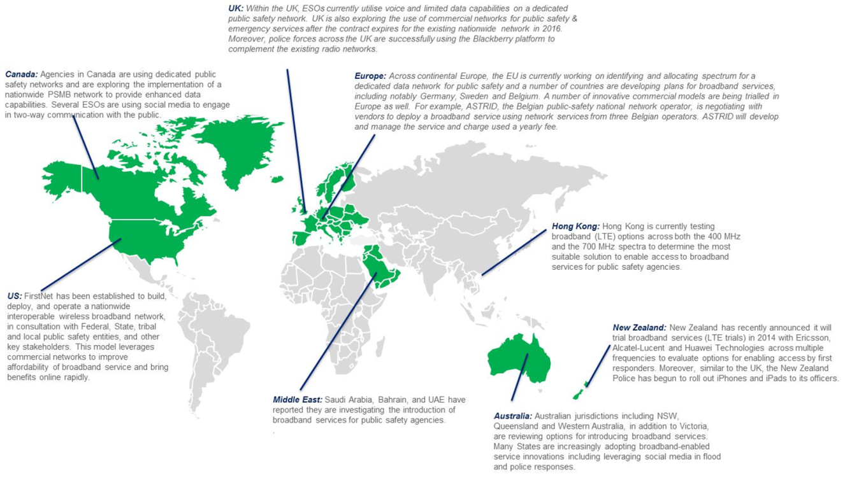
Attachment 2 – Demand growth on Victorian PSAs
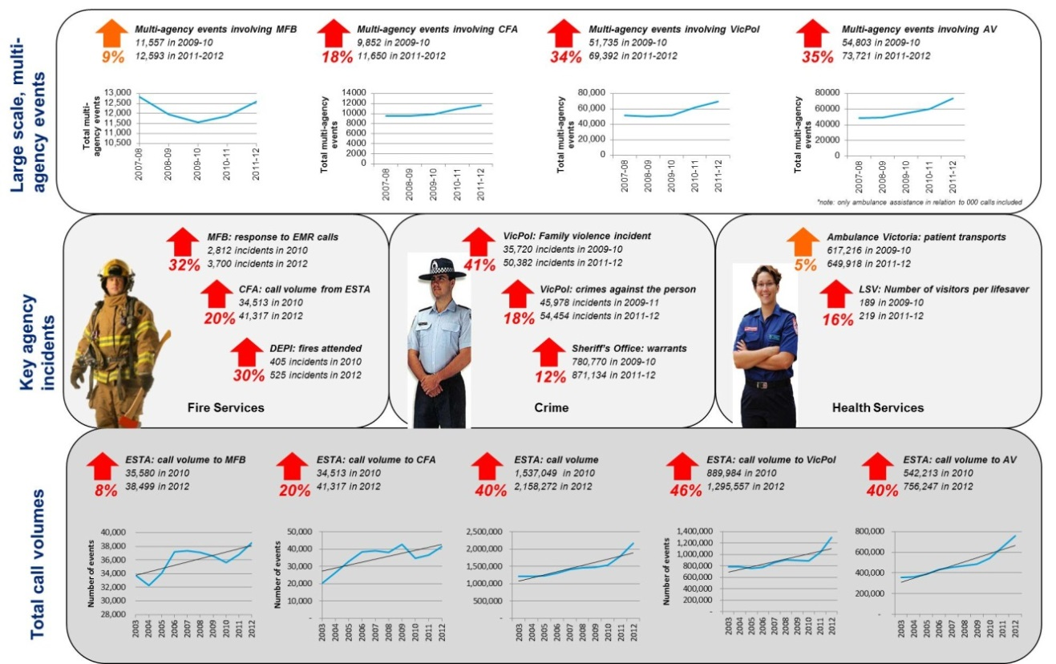
Victoria Police annual report 2011, ‘Family violence incidents attended by Victoria Police’; Victoria Police, (2012), ‘Offences recorded by offence code’, accessed 12/06/2013 via < www.police.vic.gov.au>; Department of Justice Annual Report 2011-12; MFB provided data; CFA annual reports 2010-12; Department of Environment and Primary Industry data provided; Ambulance Victoria Annual Reports 2010-12; Life Saving Victoria and Victoria State Emergency Service, 2012, Business Case: Volunteer Training Online; ESTA Annual Reports 2010-2012.
Attachment 3 – Victoria Police Mobile Law Enforcement System
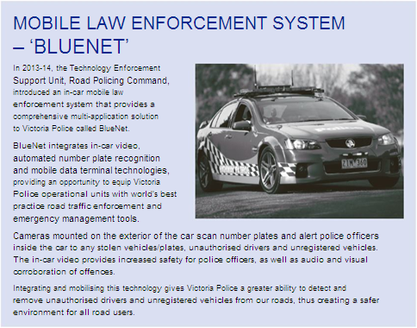
Victoria Police 2014 Annual Report.
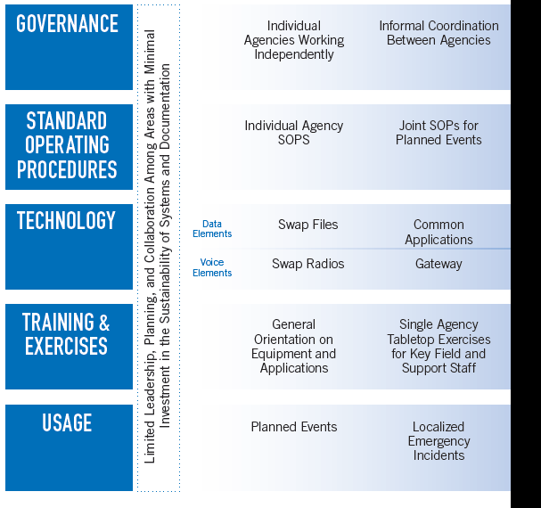
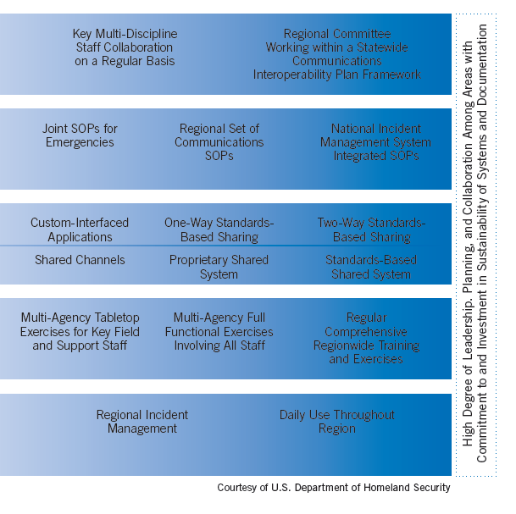
Attachment 4 – Interoperability Continuum

Source: National Coordinating Committee for Government Radio communications

Attachment 5 – Breakdown of network components

[1] Principles were: improving service delivery; designed in resilience; integrated and interoperable systems; value for money investment; phased delivery; fit for purpose communications that are proven and reliable; and systems that promote sustainable change.
Ross, N (2012), accessed June 2013 via <http://www.abc.net.au/technology/articles/2012/06/14/3524848.htm>.
[1] Principles were: improving service delivery, designed in resilience, integrated and interoperable systems, value for money investment, phased delivery, fit for purpose communications that are proven and reliable, and systems that promote sustainable change.
Refer to the Victorian Government submission to the 2011-12 Regional Telecommunications Review at http://www.rtirc.gov.au/files/2012/01/Victorian-Government-Vic1.pdf

