APVMA additional submission to the Productivity Commission inquiry into Regulation of Australian Agriculture: Attachment B
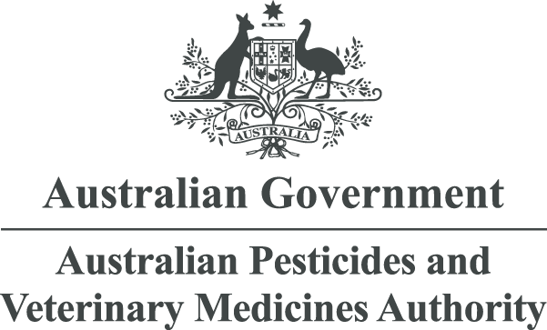

April 2016

Use of International Data, Standards and Assessments
A guide for veterinary chemical products

© Australian Pesticides and Veterinary Medicines Authority 2016
ISBN: 978-1-925390-31-5 (electronic)
Ownership of intellectual property rights in this publication
Unless otherwise noted, copyright (and any other intellectual property rights, if any) in this publication is owned by the Australian Pesticides and Veterinary Medicines Authority (APVMA).
Creative Commons licence


With the exception of the Coat of Arms and other elements specifically identified, this publication is licensed under a Creative Commons Attribution 3.0 Australia Licence. This is a standard form agreement that allows you to copy, distribute, transmit and adapt this publication provided that you attribute the work.
A summary of the licence terms is available from www.creativecommons.org/licenses/by/3.0/au/deed.en. The full licence terms are available from www.creativecommons.org/licenses/by/3.0/au/legalcode.
The APVMA’s preference is that you attribute this publication (and any approved material sourced from it) using the following wording:
Source: Licensed from the Australian Pesticides and Veterinary Medicines Authority (APVMA) under a Creative Commons Attribution 3.0 Australia Licence.
In referencing this document the Australian Pesticides and Veterinary Medicines Authority should be cited as the author, publisher and copyright owner.
Use of the Coat of Arms
The terms under which the Coat of Arms can be used are set out on the Department of the Prime Minister and Cabinet website (see www.dpmc.gov.au/pmc/publication/commonwealth-coat-arms-information-and-guidelines).
Disclaimer
The material in or linking from this report may contain the views or recommendations of third parties. Third party material does not necessarily reflect the views of the APVMA, or indicate a commitment to a particular course of action.
There may be links in this document that will transfer you to external websites. The APVMA does not have responsibility for these websites, nor does linking to or from this document constitute any form of endorsement.
The APVMA is not responsible for any errors, omissions or matters of interpretation in any third-party information contained within this document.
Comments and enquiries regarding copyright:
Director Public Affairs and Communication
Australian Pesticides and Veterinary Medicines Authority
PO Box 6182
KINGSTON ACT 2604 Australia
Telephone: +61 2 6210 4812
Email: communications@apvma.gov.au
This publication is available from the APVMA website: www.apvma.gov.au.
Contents
1 BACKGROUND 4
2 Legislative frameworks and differences 5
3 Joint Reviews and Workshare Arrangements 7
4 Impact For Applicants 8
5 Submitting International Data With An Application 9
6 Accepting reviews or assessments from overseas regulators 10
7 Use of National Assessments 11
8 Technical Assessments and Acceptance Criteria 12

Background
The Australian Government has set the guiding principle that if a system, service or product has been approved under a trusted international standard or risk assessment, Australian regulators should not impose any additional requirements unless it can be demonstrated that there is a good reason to do so.
In this User Guide, criteria are presented on how international data, standards and assessments can be better utilised as part of the risk assessment that the APVMA is required to undertake as part of the approval of an active constituent, registration of a product or approval of a label. It is recommended that this User Guide be read in conjunction with the policy document Use of International Data, Assessments, Standards and Decisions released in 2015.

Legislative frameworks and differences
Traditionally veterinary chemical products (veterinary medicines) are regulated by agencies that regulate human medicines. In Australia, Veterinary Chemical Products are defined in the Agvet Codes and include a broad range of products that may be regulated under different legislative frameworks and by different agencies in a particular country or region. For example, The rules governing medicinal products in the European Union describe specific legislation for medicinal products for human use and medicinal products for veterinary use.

The European Union
Veterinary products are regulated under a number of Directives. The general data requirements and performance of tests are included in Directive 2009/9/EC (which amends the original Directive 2001/82/EC). The Directive also provides information to sponsors or applicants on the presentation and content of the application dossier. Monographs or assessments prepared by the European Medicines Agency (EMA) addressing aspects as set out in the Commission Directive are acceptable to the APVMA.
Another difference between Australia and the EU is the use of ‘centralised’ and ‘decentralised’ procedures within and between EU Member States. The centralised procedure is via application to the EMA and is compulsory for medicines derived from biotechnology processes such as genetic engineering, advanced-therapy medicines such as gene-therapy, somatic cell-therapy or tissue-engineered medicines, and veterinary products intended for use as performance enhancers to promote growth of treated animals or to increase yield from treated animals. The centralised procedure is optional for some other veterinary medicines. The decentralised procedure allows certain types of products to be assessed and approved by Member States only, with subsequent ‘mutual recognition’ by other Member States.
Biocide products in the EU are regulated by the European Chemicals Agency (ECHA) and legislated under BPR, Regulation (EU) 528/2012. Some active constituents that are present in biocide products may be regulated as veterinary chemical products in Australia and so the data requirements and assessments conducted in the EU may differ from those in Australia.

North America
In North America, veterinary medicines are approved by the Centre for Veterinary Medicine (CVM) at the US Food and Drug Administration (USFDA), while veterinary immunobiological products are regulated by the Center for Veterinary Biologics (CVB) at the Animal and Plant Health Inspection Services (APHIS) at the US Department of Agriculture (USDA). In Canada, veterinary medicines and immunobiologics are regulated by the Veterinary Drugs Directorate (VDD) at Health Canada. Both the CVM and the VDD operate under food and drug legislation which includes human and veterinary medicines, food, devices and cosmetics.
Within the US, some products considered as veterinary medicines in Australia are treated as pesticides and are registered by the US Environmental Protection Agency (USEPA). The products considered by the USEPA rather than the USFDA are topically-applied pesticides. Numerous guidance documents are available that provide information on assessment and approval of veterinary products and registration of topically-applied veterinary pesticides.

Joint reviews and workshare arrangements
With respect to pesticides and crop protection products, for over a decade, the APVMA has participated in an Organization for Economic Cooperation and Development (OECD) Global Joint Review program, taking an active role in using international data and conducting joint assessments with the USEPA, the Canadian PMRA and some EU Member States. As part of this exercise, Australia has worked with other regulators to register crop protection products by applying international best practice for assessments and registration decisions. Through this program, the APVMA has used information and assessment reports produced by other OECD regulators to build confidence in using and sharing information.
For veterinary products, the APVMA has recently completed a joint review exercise with New Zealand and Canada for registration of an existing product for use in a food-producing species. This joint effort between the three regulatory agencies was carried out to further explore the use of assessments and work sharing, in order to ultimately reduce regulatory assessment times.
In order to achieve harmonisation in assessment outcomes between pesticide regulators, the OECD Working Group on Pesticides (WGP) has, over time, developed tools such as harmonised test guidelines and guidance documents for the design, conduct and interpretation of data submitted for approval or registration. It has also developed monograph guidance for government use for review of products and dossier guidance for industry use for the submission of data; this industry guidance provides both an agreed and harmonised format with data parts clearly specified, so that a sponsor or manufacturer can provide a single dossier that is acceptable to all OECD member regulators.
This type of harmonised guidance for data point numbering, dossier preparation and monograph preparation is not available for veterinary products. Further development work is required at an international level before work sharing and joint reviews of veterinary products become commonplace between regulatory agencies.
Internationally, test guidelines are developed by the International Cooperation on Harmonisation of Technical Requirements for Registration of Veterinary Medicinal Products (VICH), for a range of safety and efficacy tests, and these are adopted by APVMA. Similarly, the World Association for the Advancement for Veterinary Parasitology (WAAVP) has developed a series of guidelines for generation of data to demonstrate efficacy of anthelmintics and ectoparasiticides; these are also adopted in Australia. Information regarding the utility of efficacy data and efficacy assessments is not included in this document.
The APVMA participates in expert groups and committees such as the UN FAO and WHO panels of the JECFA (Joint Expert Committee on Food Additives and Veterinary Drug Residues) and the Codex Committee on Residues of Veterinary Drugs in Food (CCRVDF) where new methodologies and best practice assessment are developed for regulatory use. However, not all regulatory agencies use the same JECFA (harmonised) methodology for setting MRLs for food producing species and conducting dietary exposure assessments, leaving differences to be considered when sharing assessments between regulators. While there are differences between MRL establishment and other assessment methodologies, there can still be benefit in sharing assessments as consideration of the underlying datasets is similar. Taking into account information from international technical bodies and other regulatory agencies with similar systems and processes adds to the APVMA’s knowledge and assists in quality assessments and robust decisions in relation to the health and safety standards of products approved and supplied in Australia.

Impact for applicants
Through the use of VICH test guidelines and by participating in further work-sharing activities with other regulators, the APVMA is developing a sound understanding of the practices of other regulatory partners and confidence in the scientific integrity of their assessments. These agencies commonly follow the same international best-practice methods in the conduct of hazard and risk assessments, including adhering to the same principles of scientific assessment that the APVMA follows.
In some cases, the use of overseas information available from another regulator may lead to a faster decision, particularly where standard VICH safety guidelines have been used to generate data. However, this policy doesn’t change our application of legislative safety tests or the regulations associated with approvals and registrations of active constituents and products, which must still be met before a product can be registered in Australia.
As stated in our policy document in the use of international data, assessments, standards and decisions, the APVMA will not accept a decision made by another regulator as the sole justification for registering or cancelling a product or active constituent approval. All decisions to grant an approval for an active constituent or to register a product must be made in accordance with the Agvet Codes.

Submitting international data with an application
International data (data generated outside of Australia) can be used for all application types, provided that the data is relevant to the use proposed in Australia. Alongside supporting data and documentation provided by the applicant, our policy document, outlines in general terms, the hazard and risk assessments that are likely to be acceptable for our use.
The use of international assessments or an assessment from another regulator is particularly beneficial for larger applications—typically for new chemistry or significant extensions of use of existing products, namely Items, 1, 2, 10, 14, 15, 16, 17, 21, 25 and 27. In addition, international assessments from expert committees may also be used to support chemical review activities. Further information on what to include in an application for active constituent approval or product registration is available on the APVMA website.
The applicant is required to submit a full package at the time of making an application to the APVMA. It is the responsibility of the applicant to ensure that all necessary data and assessments are available at that time, whether sourced locally or internationally. Confirmation of access from the data provider (if required) is usually included with the data submission. This is to meet Australian government requirements made through international agreements on intellectual property protection of information and use of proprietary data. It should also be noted that expert committee assessment reports such as international monographs published by the JECFA, carry clear instructions for regulators such as:
‘The summaries and evaluations contained in this book are, in most cases, based on unpublished proprietary data submitted for the purpose of the JECFA assessment. A registration authority should not grant a registration on the basis of an evaluation unless it has first received authorization for such use from the owner who submitted the data for JECFA review or has received the data on which the summaries are based, either from the owner of the data or from a second party that has obtained permission from the owner of the data for this purpose.’

Accepting reviews or assessments from overseas regulators
The APVMA will consider an assessment from an overseas regulator, providing certain requirements regarding language and supporting data are met. Applicants wishing to use an international assessment to support all or part of an application should discuss this with the APVMA prior to making an application, using the existing pre-application assistance mechanism. Depending on the information (data and assessments) provided, the level of assessment may be reduced if the APVMA does not need to undertake a full hazard and risk assessment. As explained in the policy document, hazard assessments are easily accepted between regulators, whereas risk assessments include national information and different approaches relevant to Australia, which are not necessarily the same around the world.
Questions regarding the use of reviews from regulatory agencies that are not mentioned in this user guide or the policy document should be directed to the APVMA, either as an enquiry or as part of the pre-application assistance mechanism.
Where an international assessment or assessment from an overseas agency has been provided in support of an application, the APVMA will make reference to that assessment on our website, in a consultation document such as a public release summary or advice summary.

Use of national assessments
Although the policy document focusses on use of assessments sourced from outside of Australia, assessments that have been conducted by FSANZ, OGTR, TGA or NICNAS, and are relevant to a proposed application to the APVMA, may also be provided for consideration.
Applicants are encouraged to consider in detail how the assessment from another Australian regulator addresses part or all of the safety criteria that the APVMA must have regard to in granting an active constituent approval or a product registration.

Technical assessments and acceptance criteria
The following section outlines the types of data, assessments and standards that may be accepted by the APVMA as part of an application to approve an active constituent or register a veterinary chemical product.
Figure 1 depicts the flow of information from VICH test guidelines to completion of the hazard assessment and finally the use of relevant end points for exposure assessment and the risk assessment.
In terms of assessment format, the APVMA will accept assessment reports prepared by EU Member States for EMA assessments, studies and hazard assessments prepared by US and Canadian authorities (assessing products equivalent to those defined as veterinary products in Australia) and other report formats that are made available in English. International assessments, particularly monographs that are prepared and published by the JECFA for both toxicology and residues, are acceptable. Most reports are likely to be acceptable, providing that they are available in English and are presented in a format that is easy to navigate.
For biocide products, the APVMA has limited experience in the use of assessments from other regulatory agencies and further exploratory work with Applicants via specific applications is invited.
In relation to dual-use pesticides, any relevant data or information generated for the purposes of registration as a crop protection product is likely to be useful in addressing the safety criteria for a veterinary product. For example, a toxicological assessment for a synthetic pyrethroid which was completed for an insecticide crop protection product may be submitted to support registration of an ectoparasiticide (provided that the data can be accessed with the consent of the crop protection company). In such cases, the applicant is encouraged to consult with the APVMA prior to making an application.
Figure 2 is a diagrammatic representation of an acceptance criteria hierarchy for data, assessments and standards. The first row includes all FAO, WHO and VICH test guidelines, assessments and standards which are considered as being ‘internationally acceptable’. The second row includes data, assessments and standards which are considered as ‘overseas sources of information’ and which may be acceptable, if relevant to the proposed use in Australia and the key safety criteria are addressed.

Figure 1: Information Flow from Test Guidelines to Hazard Assessment to Risk Assessment
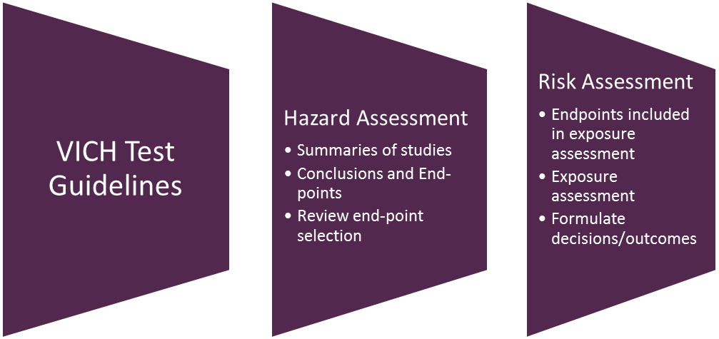
Figure 2: Draft Criteria for use of International Data, Assessments, Standards and Decisions
Veterinary Products: acceptance criteria hierarchy — at a glance
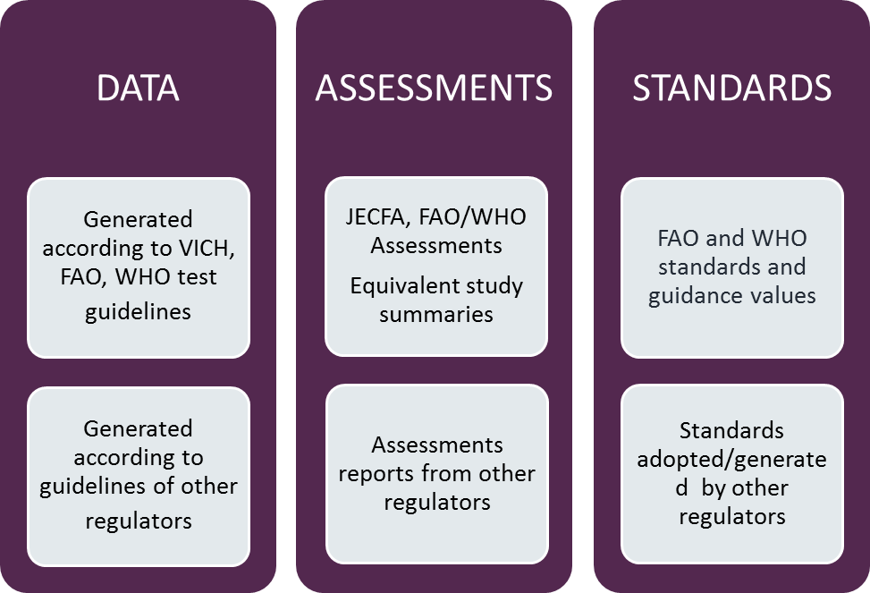

In the next section, tables are presented by assessment discipline, indicating acceptance of data, hazard assessment or risk assessment, and standards where relevant.
Worker health and safety (OH&S) assessments are not included in this guide, as they are exposure assessments and different methodologies for modelling exposure may be used by different regulators. This aspect of the assessment will be included in a technical manual as part of the overarching risk assessment framework. For any other assessments that are outside of those specified in the tables, applicants are encouraged to discuss their relevance and acceptability, prior to making an application.
In the tables, ‘acceptability’ or ‘consideration’, or ‘having regard to’ various components are indicated in a general sense, as well as situations where harmonisation with an international criterion or standard may be an achievable outcome. As all applications are different, and various types of information may be provided, the criteria are written in a broad sense to cover a range of scenarios.
Criteria based on Assessment Disciplines
Table 1: Chemistry
SOURCE OF INFORMATION | DATA | ASSESSMENTS | STANDARDS
VICH Test Guidelines | Accept all data generated using VICH test guidelines | Accept all assessments conducted using VICH test guidelines and numbering scheme in Commission Directive 2009/9/EC and addressing criteria in the data parts.
Compendial Standards | Have regard to all chemistry information available in a compendial monograph, however data must be provided. | Accept all assessments (active constituent and formulated product) published in a compendial monograph. | Accept and adopt compendial standards for active constituents. Section 14A of the Agvet Codes specifies use of compendial standards for active constituent approval (EP, BP, USP).
Veterinary agencies including EMA, CVM FDA, VDD Canada, EU Member States, MPI NZ | Drug master file information as submitted to other veterinary agencies. | Accept chemistry assessments from other veterinary agencies. | Have regard to any standards established for active constituents, including impurities.
NICNAS |  | May have regard to new chemical assessments conducted by NICNAS where relevant. Aspects of manufacture are not considered by NICNAS, therefore the assessment may be limited in its use by APVMA.

Table 2: Toxicology/biological safety
SOURCE OF INFORMATION | DATA | ASSESSMENTS | STANDARDS (Health guidance values)
VICH Test Guidelines | Accept all data generated using VICH test guidelines.
JECFA and WHO monographs | Have regard to all toxicology data reviewed by JECFA, however must be the same data that was provided to the JECFA toxicology panel*. | Accept all assessments (active constituent and formulated product) conducted by JECFA, with a view to harmonising end points. The APVMA must receive the toxicology data from the manufacturer that provided the data to JECFA. | Have regard to endpoints determined by JECFA, with view of acceptance and harmonisation. Health guidance values (ADI and ARfD) considered and determine whether appropriate safety factors have been applied*.
Veterinary agencies including EMA, CVM FDA, VDD Canada, EU Member States, MPI NZ | Accept data generated to meet requirements of referenced in Commission Directive 2009/9/EC. | Accept all assessments conducted using data parts and numbering scheme and addressing criteria in the data parts referenced in Commission Directive 2009/9/EC.  Accept assessments from stated agencies, with a view to harmonising endpoints, where relevant. | Have regard to endpoints determined by an overseas regulatory agency. Health guidance values (ADI and ARfD) may be considered and whether appropriate safety factors have been applied.
FSANZ, TGA, OGTR, NICNAS |  | May accept human safety assessments conducted by FSANZ, OGTR, NICNAS and TGA. Where relevant, acceptable assessments are those that provided end points to establish relevant health guidance values.

Table 3: Residues
SOURCE OF INFORMATION | DATA | ASSESSMENTS | STANDARDS (Maximum Residue Limits)
VICH Test Guidelines | Accept all data generated using VICH test guidelines.
JECFA monographs | Have regard to all residues data reviewed by JECFA. However APVMA must receive the same data that was provided to the JECFA residues panel*. | Accept all residues assessments conducted by JECFA residues panel, with a view to harmonising residue definition (for risk assessment and monitoring), where relevant*.  Dietary risk assessments are not acceptable as they rely on national or regional consumption data, which are not relevant to Australia. | Have regard to MRLs recommended by JECFA, with a view of harmonisation, where relevant to the proposed use in Australia and for trade purposes.
Veterinary agencies including EMA, CVM FDA, VDD Canada, EU Member States, MPI NZ | Accept data generated to meet requirements referenced in Commission Directive 2009/9/EC. | Accept all assessments conducted using data parts and numbering scheme and addressing criteria in the data parts referenced in Commission Directive 2009/9/EC.  Accept hazard assessments from stated agencies where the proposed uses are the same, with a view to harmonising residue definition where relevant. Dietary risk assessments are not acceptable as they rely on national or regional consumption data, which are not relevant to Australia. | Have regard to MRLs established by an overseas regulatory agency for the purposes of trade. Differences in MRLs are documented for consideration of trade criteria.
FSANZ |  | Accept dietary risk assessments conducted by FSANZ, noting if there are any differences between an MRL for a registered use and an import tolerance.
*Note: Information regarding a dual-use pesticide, as a monograph from the JMPR, may be acceptable if an ectoparasiticide use is being considered.
Table 4: Environment
SOURCE OF INFORMATION | DATA | ASSESSMENTS | STANDARDS
Veterinary agencies including EMA, CVM FDA, VDD Canada, EU Member States, MPI NZ | Accept data generated to meet requirements referenced in Commission Directive 2009/9/EC. | Accept environmental hazard assessments from stated veterinary agencies, with a view to harmonising ecotoxicity endpoints, where relevant. | Have regard to endpoints determined by a stated veterinary agency.

Definition of veterinary chemical product may be found in section 5 of the Agricultural and Veterinary Chemicals Code Act 1994.
Medicated Feedstuffs, Immunological veterinary medicinal products, homeopathic veterinary products, Directive 2001/82/EC
Veterinary products are included in Directive 2001/82/EC and Directive 90/167/EEC outlines the conditions for preparation and marketing of medicated feedstuffs in the EU.
Variations of authorisations are in Directive 2009/53/EC; Criteria for exemptions of certain products for food-producing animals from requiring a veterinary prescription are in Directive 2006/130/EC.
Chapter II: Presentation of Particulars and Documents, page 34, Commission Directive 2009/9/EC.
Biocides in the EU include human hygiene biocide products, private area and public health disinfectants, veterinary hygiene products, food and feed area disinfectants, drinking water disinfectants, woods preservatives, slimicides, rodenticides, molluscicides, repellents and attractants, antifouling paints.
For further efficacy-specific information, applicants are encouraged to seek advice from the APVMA.
Dual-use pesticide – commonly, this term refers to a pesticide which has agricultural and non-agricultural uses. In this case, it refers to a pesticide which has use in crop protection and in animal husbandry.

