Submission to the Productivity Commission Inquiry on Mental Health

17 April 2019

Table of Contents
Introduction 8
PART A - WentWest PHN and Our Region 9
WentWest – A Snapshot 10
Western Sydney – Our Region 13
Population Profile 13
Addressing Chronic Care Needs 15
Social Economic Status Across Our Region 15
Understanding the Region’s Mental Health Needs 17
About the Atlas 17
Summary of Findings 18
Additional Analysis on Mental Health Service Data 20
Our Approach to Mental Health Services and Reform 27
What We Have Done in Western Sydney 27
Commissioned Activities 2016-2019 28
Academic and Strategic Partnerships 32
Impact of our Work 33
What’s Worked 34
What’s Not Worked 35
Future Focus and Priorities 37
PART B 39
The Prevalence of Mental Illness 40
The State of Mental Health Care in Australia 43
Results from Integrated Atlas Studies 45
Recent Reports of Mental Health Service System 46
WA Coroner’s Report, January 2019 46
Victorian Auditor General’s Office Report, March 2019 48
A Brief Analysis of Other Mental Health Reviews 49
Summary of Analyses 50
Why Reforms Have Fallen Short of the Objectives 51
Why Do the Problems in Mental Health Care Persist? 51
The Structural Shift Needed 52
An Alternative View 52
Part C – Transforming Mental Health Care 54
Introduction 55
General Strategic Recommendations 55
Systemic Problems Require Systems Solutions 55
‘Context is Everything’ 56
The Building Block of Primary Care 57
Strategic Issues in Mental Health 58
The National Mental Health Commission Review 58
Mental Health in All Policy 58
Accountability 59
Quality Matters 59
Appendix One: The Role of PHNs 60
Appendix Two: The Integrated Atlas of Mental Health 62
Methodology 62
Appendix Three: Brief Description of New Initiatives 2016-2019 65
Appendix Four: Results of WentWest Stakeholder Consultations 68
Interviews and Group Meetings 68
Survey Results 68
Appendix Five: Inquiries into Mental Illness 70
Major National Inquiries/Reviews Since 1993 70
Federal Parliamentary Inquiries 71
Reviews by State/Territory Statutory Authorities Since 2006 72
References 75

List of Tables
Table 1 2013/14 Hospitalisations and Bed Days per 100,000 People (Age Standardised) 21
Table 2 2014/15 Hospitalisations and Bed Days per 100,000 People (Age Standardised) 22
Table 3 MBS Mental Health Provider Type by SA3, Services rate per 100,000 25
Table 4 WentWest Commissioning Activity, Mental Health 2016-19 29
Table 5 The Key Features of Complex Adaptive Systems 55
Table 6 Seven Characteristics of Complex Health Interventions 56
Table 7 Atlas Service Inclusion Criteria 63
Table 8 Major National Reviews of Mental Health Since 1993 (N=15) 70
Table 9 Federal Parliamentary Inquiries on Mental Health Since 1971 71
Table 10 Reviews Undertaken by State/Territory Statutory Authorities, 2011-2019 73

List of Figures
Figure 1 The Ten Building Blocks of High Performing Primary Care 12
Figure 2 WentWest Geographical Boundaries 13
Figure 3 The Dahlgren-Whitehead model of Social Determinants of Health 14
Figure 4 Population Health Chronic Disease Continuum 15
Figure 5 SEIFA Index Relative Socio-Economic Disadvantage by SLA Group 16
Figure 6 Risk of Psychological Distress 18
Figure 7 Pattern of Mental Health Care in Western Sydney 20
Figure 8 Hospitalisations for All Mental Health Conditions 21
Figure 9 All Mental Health Hospitalisations by SA3 2014/15 23
Figure 10 Intentional Self-Harm Hospitalisations by SA3 2014/15 24
Figure 11 Antidepressants, Rate per 10,000 by SA3 26
Figure 12 Program Funding and Population Mental Health Needs, WentWest 28
Figure 13 The WentWest Continuum of Primary Mental Health Care 30
Figure 14 WentWest Stepped Care Service Model – Principles 31
Figure 15 WentWest Stepped Care Model – Characteristics of Service Levels 31
Figure 16 – WentWest Stepped Care Model – Determining Need 32
Figure 17 The Mental Health of Australians 41
Figure 18 Suicide in Australia, 2017 42
Figure 19 Aboriginal and Torres Strait Islander Suicide, 2012-2016 42
Figure 20 Integrated Atlases of Mental Health & Chronic Care in Australia 45
Figure 21 Long Term Care Mapping Tree 64
Figure 22 Integrated Mental Health and AOD Atlas Development Process 64

Abbreviations
Abbreviation | Definition
AIHW | Australian Institute of Health and Welfare
ABS | Australian Bureau of Statistics
AOD | Alcohol and Other Drugs
ASR | Age Standardised Rate
ATAPS | Access to Allied Psychological Services
AUD | Australian dollars
COAG | Council of Australian Governments
COAG NAPMH | COAG National Action Plan on Mental Health
DESDE-LTC | Description and Evaluation of Services and Directories in Europe for long-term care
DoH | Department of Health
GP | General Practitioner
HCH | Health Care Homes
IAMHWS | Integrated Atlas of Mental Health for Western Sydney
IRSD | Index of Relative Socio-Economic Disadvantage
LGA | Local Government Areas
LHD | Local Health District
MBS | Medicare Benefits Schedule
MHC NSW | Mental Health Commission of NSW
MHNIP | Mental Health Nurse Incentive Program
NGO | non government organisation
NMHC | National Mental Health Commission
NSMHWB | National Survey of Mental Health and Wellbeing (ABS)
np | Data not available for publication
PBS | Pharmaceutical Benefits Scheme
PHIDU | Public Health Information Development Unit
PIR | Partners in Recovery
PMHC | Primary Mental Health Care services
PHN | Primary Health Network
SDH or SDOH | Social Determinants of Health
SLA | Statistical Local Area
SA3 | Statistical Area Level 3
USD | US dollars
WEF | World Economic Forum
WSPHN | Western Sydney PHN

Summary
Despite the best intentions, Australia’s approach to mental health reform through a series of centrally planned, National Mental Health Plans, has not meet the needs of the Australian community. If the strategy had been even moderately successful, this Inquiry would not be happening nor would we have seen an almost continuous stream of inquiries over the past 15 years.

Economic Impact
The World Economic Forum (WEF) in 2011 concluded that the economic impact of mental illness is the single most important contributor among all non-communicable diseases to lost productivity. The WEF estimated that a third of the total cost of all chronic diseases in the decade to 2020, would be caused by mental illness.
The 26th meeting of the Asia Pacific Economic Cooperation (APEC) in Beijing, agreed to tackling mental illness in the period to 2020. The 21 members of APEC committed to a ‘Roadmap to Promote Mental Wellness in a Healthy Asia Pacific (2014-2020) in recognition of the threat to economic prosperity posed by mental illness. APEC agreed that it has “an opportunity to lead in the promotion of innovative collaborations in mental health that provide tangible benefits for economic growth, social inclusion and the wellness of communities and workplaces”. Australia is a founding member of APEC.
Globally only about $2 USD is spent per capita on mental health promotion, prevention and service provision. In Australia, its less than $300 USD (or $400 AUD) per person. Yet estimates of the cost to the Australian economy range to just over $200billion AUD.

A Generation of Effort
Unlike many areas of health care such as tobacco related diseases, cardio vascular diseases, breast and cervical cancers, HIV and road trauma where in a generation or less, Australia has achieved very significant reductions in prevalence rates and the burdens of death and disability, twenty five years of national efforts in relation to mental illness have yielded almost no change.
From prevalence rates to life expectancy, the health status and outcomes for those with mental illnesses remain stubbornly stuck. All the measures that might be considered relevant to a contributing life, such as employment rates, socio-economic status, educational attainment, stable and secure housing and social participation, are equally unmoved. Other data such as the number of incidents involving police and emergency services, numbers of people with mental illness involved in justice and corrections or youth detention, children in state care, school suspensions and expulsions – all again point to a failure to provide access to quality mental health care across the lifespan.
The only measures where we can confidently point to improvements are in relation to awareness and an increase in access to care for some population groups and those experiencing mild levels of disability.
In the time since national mental health reform commenced in 1992, there has been a wealth of information, reports, policy documents and action plans but there has been too little focus on sustained capacity building to enable effective implementation.
If we are to see sustained improvements, the centralist planning models must be replaced by data-driven, systems approaches with regional planning informed by local contexts, evidence based practices and experiential input of those with lived experience. Funding models must be altered to focus on consumer, carer and community outcomes and reduce the siloed arrangements that divide the provider sectors and organisations.
These regionally integrated approaches will only succeed if national policy focuses on the enablers to a contributing life – tackling entrenched disadvantage and inequality, intergenerational trauma and abuse and upholding human rights. Having meaningful work (paid and unpaid), living in a safe and inclusive community and access to a healthy natural environment, are all foundations for good mental health and can be supported through both national policy and national programs.
Access to quality mental health care has not been achieved to date. ‘Islands of excellence’, as identified by the Productivity Commission in the Issues Paper, continue to be the best we have. We do not have whole region or even sub-regions where we see a fully functioning quality mental health care service. In western Sydney, WentWest and its partners, are making inroads but we are a ‘newbie’ and a relatively small player (in funding terms). We can do more and believe that regional planning and commissioning authorities, PHNs and their state counterparts LHDs, can play a leading role in transforming mental health care in Australia.
In this submission, we set out to provide the Productivity Commission with:
- An understanding of WentWest, the western Sydney region and the mental health related needs of the community, our work and its impact (Part A)
- An overview of the state of mental health care in Australia (Part B)
- Our perspective on the way forward and the role of PHNs in transforming mental health care in Australia (Part C).

Introduction

The Western Sydney Primary Health Network (WentWest) is pleased to present this submission to the Productivity Commission Inquiry (the Inquiry) into the role of improving mental health to support economic participation and enhancing productivity and economic growth.
Good mental health is a pre-requisite for any individual to lead a contributing life. A mentally healthy community is one where everyone can contribute, has a sense of belonging and can access the health care and support they need throughout their lifespan. The cost of mental illness to Australia and the western Sydney region requires a transformation in the way we address mental health needs.
WentWest has been delivering mental health services for the past nine years. We have maintained throughout this time a clear and resolute focus on developing and implementing a strategic vision for mental health for the western Sydney region. We have set out, in both short term and longer term plans to regionally commission services that will build capacity and strengthen mental health and suicide prevention service activities across western Sydney.
Our approach has been built on:
- Strengthening general practice
- Evidence-informed policy built on comprehensive data
- Applying best practice person-centred care
- Engaging and learning from the best – be they across Sydney or across the world
- Leveraging the extensive and experienced mental health workforce
- Applying systems approaches to the development of services and achieve the ‘Quadruple Aim’ in health care
The Productivity Commission Inquiry comes at a critical time in the history of mental health services in Australia. In 2014, the National Mental Health Commission laid out a compelling case for transforming mental health care in its national review of programmes and services. Unlike many previous reviews into the mental health service system, the NMHC took a whole-of-person, whole-of-life approach to mental health and wellbeing and accordingly undertook a cross-portfolio assessment of the strengths and weaknesses of the mental health system as a whole.
The NMHC’s recommended reforms were reviewed and endorsed by the Australian Government in November 2015. A critical strategic direction in the Review endorsed by Government was to extend and strengthen the role of the Primary Health Networks as the key regional architecture for equitable planning and purchasing of mental health programmes, services and integrated care pathways.

PART A - WentWest PHN & Our Region

WentWest – A Snapshot
Western Sydney PHN (WentWest) was established in July 2015 along with 30 other PHNs across Australia replacing Medicare Locals as regional primary health organisations. WentWest was among the group of PHNs that transitioned from the predecessor Medicare Local.
Indeed WentWest has navigated the journey from Division of General Practice to Medicare Local to PHN over the past 8 years without experiencing major disruptions to stakeholder relationships, business structure or corporate knowledge of the region we serve and therefore are able to focus on the business of strengthening primary care in a rapidly changing region.

Our Values in Practice
Our five values reflect WentWest’s culture, support our vision and are the essence of our organisation’s identity.
Excellence: Be the best we can be
Leadership: Inspire action
Respect: Understand others
Equity: Actively overcoming barriers
Creativity: Challenge convention

Our Vision
Healthier communities, empowered individuals, sustainable primary health care workforce and system.

Our Mission
Working in partnership to lead better system integration and coordination, strengthening equity and empowerment for western Sydney communities and the people who care for them.

Strategic Focus
Consumer Centric Shared Values | Strengthening Partnerships and Developing Workforces
Strategy Development and Innovation | System Enablers And Scalable Infrastructure
General Practice and Primary Care Development | Organisational Excellence

Health Priorities
Aboriginal Health | Mental Health
Aged Care | Population Health
Child and Family | Alcohol and Other Drugs
Chronic Conditions

Quadruple Aim
  Patient Experience of Care  - Reduced waiting times  - Improved access  - Patient and family needs met |   Quality and Population Health  - Improved health outcomes  - Equity of access  - Reduced disease burden
  Sustainable Cost  - Cost reduction in service delivery  - Reduced avoidable/unnecessary hospital admissions  - Return on innovation costs invested  - Ratio of funding for primary care: acute care |   Improved Provider Satisfaction  - Teamwork  - Leadership  - Sustainability andmeaning of work  - Increased clinician & staff satisfaction  - Quality improvement culture

Our Approach – Evidence Informed Decision Support
In our work we consistently apply systems thinking, context analysis and experiential perspectives and strive to build and strengthen ‘evidence-informed health care’. This means we look to apply a combination of:
- Evidence based medicine – or Experimental knowledge developed through Random Controlled Trials, systematic reviews and the like
- Observational cohort studies – providing richer understandings of interventions and target audience impacts
- Context Analysis – demographics and geo-spatial analysis
- ‘Evidence-based health care’ or ‘evidence-informed policy’ - through the addition of routine big data and local context information,
- ‘Knowledge-guided policy’ - through the incorporation of domain experts, both within and beyond the western Sydney region, to the data analysis process
- Experiential knowledge – the incorporation of the expertise from those with lived experience – consumers and carers
Evidence-informed, rather than merely evidence-based, healthcare policy and practice acknowledges that policy-making is an inherently political process in which research evidence is only one factor that influences decision-making.

Our Core Commitment – General Practice and Primary Care Development
In the nine years of operation WentWest has maintained an unwavering commitment to General Practice and primary health care development. Our work includes:
- Improved access to after hours primary health care services
- The Health Pathways Program
- The Patient Centred Medical Home trial with Western Sydney University
- The Health Care Homes Program
- The Integrated Care Program in partnership with Western Sydney LHD
- The Western Sydney General Practice Pharmacist Program
- The Collaborative Pairs National Demonstration Trial in partnership with the Consumer’s Health Forum and the King’s Fund UK
- ADHA Digital Health Test Beds Demonstration site
- My Health Record and Practice Nurse Shared Health Summary Pilot Incentive Program
- Health Intelligence Unit
These initiatives are just some of the recent and ongoing work WentWest is undertaking to transform primary health care in western Sydney, informed by the world’s leading primary care systems in the US, UK and NZ.
The Ten Building Blocks of High Performing Primary Care provide the framework for our work.
- The Ten Building Blocks of High Performing Primary Care
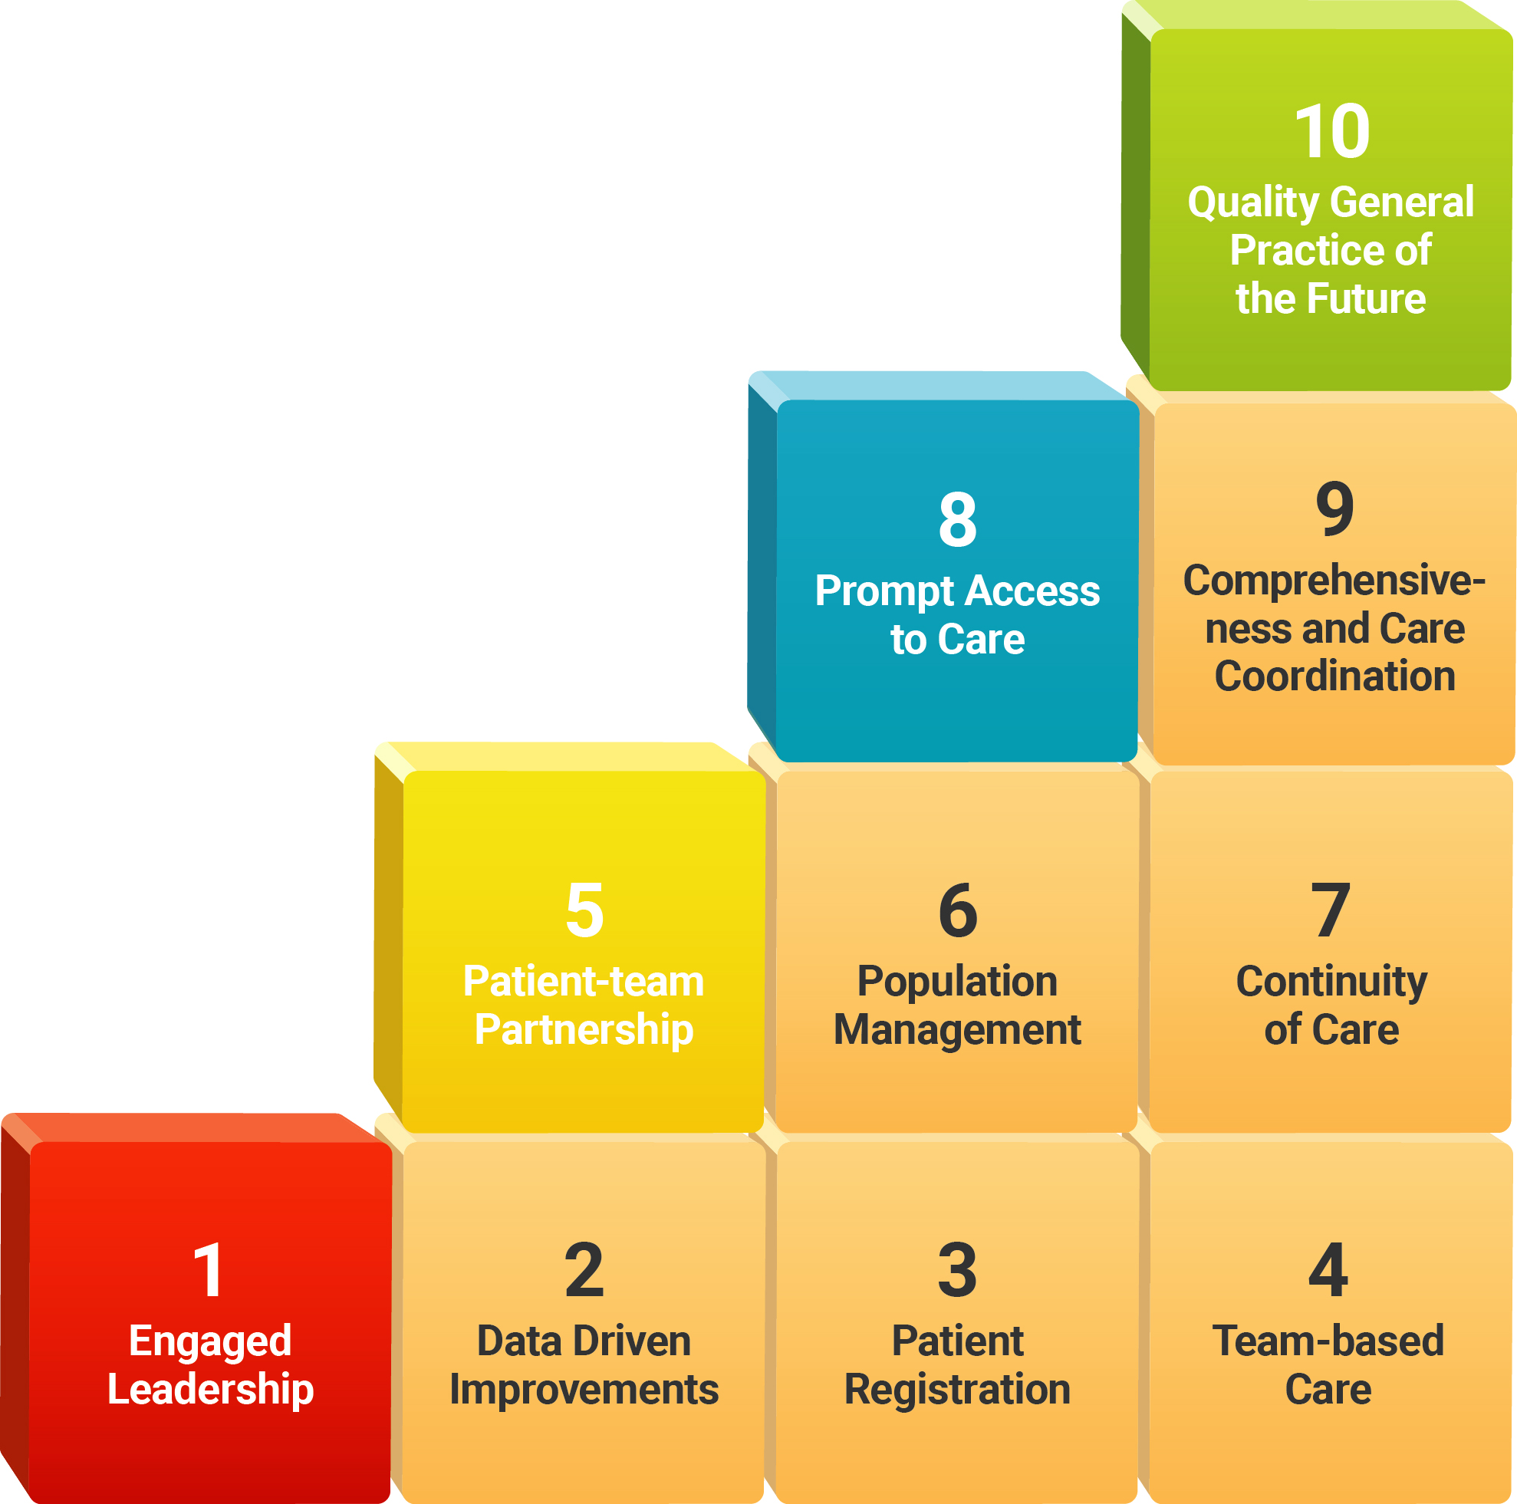

Western Sydney – Our Region
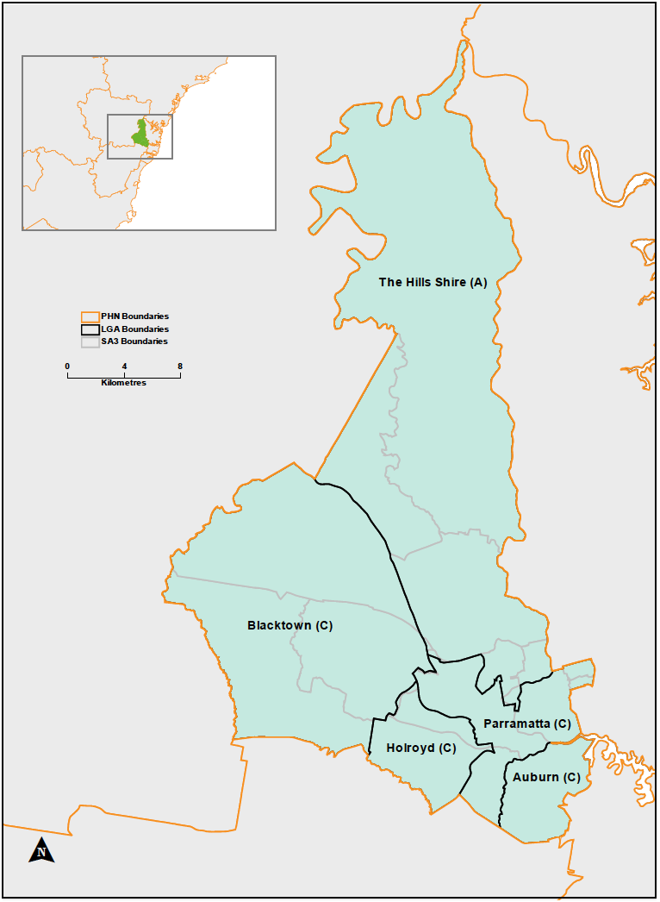
The Western Sydney PHN (WentWest) region encompasses five Local Government Areas (LGAs) and is located in the outer western suburbs of Sydney (Figure 2).
Covering an area of 766 km², the boundaries of the catchment extend from Auburn in the East to Blacktown in the West, and to the Hills in the North, encompassing an urban, outer urban and semi-rural population. This population, of over 900,000 people, is serviced by the Western Sydney Local Health District (LHD) and distributed across 12 regional towns/cities (SA3s) including:
- Auburn
- Baulkham Hills
- Blacktown
- Blacktown - North
- Carlingford
- Dural - Wisemans Ferry
- Mount Druitt
- Merrylands - Guildford
- Parramatta
- Pennant Hills - Epping
- Rouse Hill - McGraths Hill
- Ryde - Hunters Hill
- WentWest Geographical Boundaries

Population Profile
WentWest has invested significantly over the past nine years in understanding the region and the communities we serve.
Western Sydney is a diverse community and with this comes a range of diverse health needs and social circumstances. The Western Sydney PHN (WSPHN) region is closely analysed in the Population Health Commissioning Atlas. It is one important part of the planning and needs assessment role that WSPHN undertakes and shares with a broad range of health and human service stakeholders.
The 2016 edition of the Altas shows that some sub-regions of western Sydney have poor health compared to those in other parts of NSW. Many communities have high rates of chronic disease (e.g. diabetes) and mental health issues. This is underscored by high rates of obesity and smoking, low rates of cervical and breast cancer screening, and a high impact of social determinants of health and inequity. Immunisation rates are also below average.

Social Determinants
Social, environmental and economic factors play a significant role in shaping the health and wellbeing of individuals and populations and are commonly referred to as the social determinants of health (SDH) as shown in Figure 3. Evidence documenting the contribution of the SDH to population health outcomes is well established and undisputed, leading international, national and regional health authorities to act to address these factors. The links between SDH and the development of diseases such as chronic conditions are complex, although usually associated with access to opportunities and resources such as quality education, adequate and meaningful employment, safe and affordable housing, accessible transport, nutritious food, safe local environments and accessible health services. Income also plays a critical role as it provides flexibility and options, enabling people to access the SDH they need. SDH underpin health and influence the movement of individuals and populations across the Population Health Disease Continuum.
- The Dahlgren-Whitehead model of Social Determinants of Health
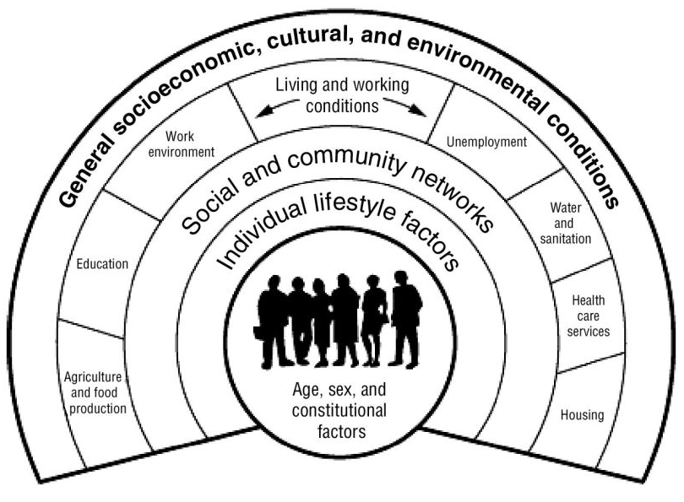

The relationship between social determinants and mental ill-health evidence dating back to the 1950s shows the impact of social determinants (education, housing, occupation and income) on an individual or community’s mental health and suicidal behaviour. It is increasingly clear that levels of mental distress among communities need to be understood less in terms of individual pathology and more as a response to relative deprivation and social injustice, which erode the emotional, spiritual and intellectual resources essential to psychological wellbeing. Disadvantage starts before birth and accumulates throughout life.
The more recent research emphasises it is not poverty per se, but relative disadvantage that impacts adversely on the mental wellbeing of individuals, families and small communities that have fewer economic, social and environmental resources. A review of the evidence in 2016 found the main individual factors shown to have a significant independent association with worse mental health were low income, not living with a partner, lack of social support, female gender, low level of education, low socio-economic status, unemployment, financial strain and perceived discrimination. The area level factors associated with mental health were neighbourhood socioeconomic conditions, social capital, geographical distribution and built environment, neighbourhood problems and ethnic composition (i.e. a lack of diversity and a high indigenous proportion of the population).

Addressing Chronic Care Needs
The diagram shown in Figure 4 has been used by WentWest to guide the development of our Population Health Commissioning Atlas. It describes the population health chronic disease continuum from a well population to the development of risk factors, through to the progression of established chronic disease patterns. It recognises the interconnections between the socio-economic and environmental conditions in which people live and that their access to health and other services has a direct impact on the health status of a population. Action to improve health status needs to occur at each level of the continuum. It recognises a wide range of collaborative partnerships with multiple stakeholders and sectors will be required to achieve improved population health and wellbeing outcomes. PHNs and Local Hospital Districts and Networks are in a prime position to drive these improvements.
- Population Health Chronic Disease Continuum
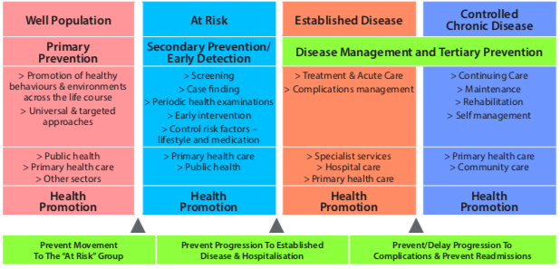

Social Economic Status Across Our region
The ABS 'Index of Relative Socio-Economic Disadvantage' is a useful summary indicator of disadvantage across regions. This summary measure provides an overview of many of the indicators of social inequality.
These indicators include low income, low educational attainment, high unemployment, jobs in relatively unskilled occupations amongst others. IRSD is a good predictor of a region's health. Low IRSD scores usually are indicative of poor health outcomes for a region.
A low IRSD score indicates a high proportion of relatively disadvantaged people in the area as highlighted by the dark red colours on Figure 5.
Overall the IRSD for the WSPHN region is 994 slightly below the Australian Average (1000) and the greater Sydney Average (1011).
All Statistical Local Area’s (SLA) have great variation when considering the Statistical Area level 1’s (SA1) within a given SLA e.g.:
- Blacktown – South-West (890 Overall score) has SA1’s with scores of as low as 480 and a maximum of 1086.
- The Hills Shire – North has the highest IRSD Score (1105) but still has SA1’s within the area with scores as low as 874 (up to a maximum 1158).
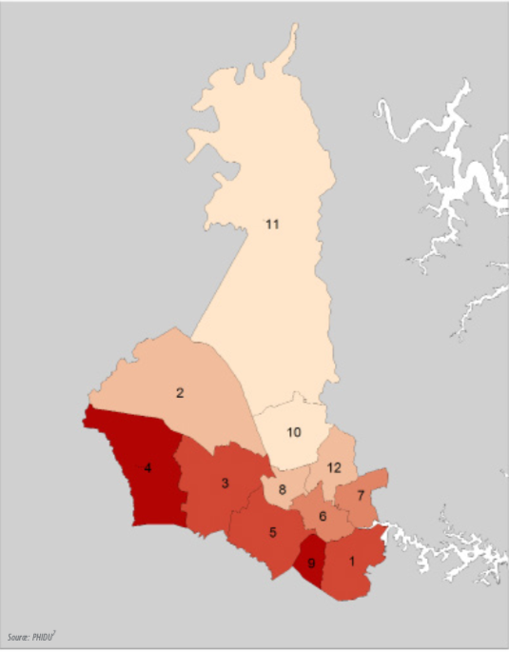
The Population Health Commissioning Atlas provides a complete analysis of facets of the SDH and health status indicators, namely: school completion, employment, household income, maternal and child health, Australian Early Development Census, national health priority risk factor status, chronic conditions, mental health and suicide. The latter are discussed in detail later in this section.
- SEIFA Index Relative Socio-Economic Disadvantage by SLA Group

Aboriginal and Torres Strait Islander Population
The WSPHN region is home to the largest urban Indigenous population in Australia. The 2016 Census indicates 1.4% of the population of the WSPHN region identify as an Aboriginal or Torres Strait Islander (13,384 people) with the main centre of Indigenous populations being Blacktown – South West.This area has highest Indigenous proportion (4.6%), and this is the highest proportion of any community in Sydney. Over 4,500 Indigenous people live in the Mountt Druitt area (Blacktown – SW) which is an area with very low socioeconomic status.
The Aboriginal and Torres Strait Islander Community is a transient community with sensitivity to completing the census. It is believed the Aboriginal and Torres Strait Islander community in Western Sydney has a population closer to 13,000-15,000.

Understanding the Region’s Mental Health Needs
In 2015, WentWest in partnership with the University of Sydney and Western Sydney University, developed the first ever Integrated Atlas of Mental Health in Australia. Since then a total of 20 atlases using this method have been completed across Australia enabling us to compare mental health needs and the range (or spectrum), capacity and distribution of services.

About the Atlas
The WHO Mental Health Gap Action Program (mhGAP) has highlighted the need for a comprehensive and systematic description of all the mental health resources available and the utilisation of these resources. It is not only important to know the numbers of services in each health area, but also to describe what they are doing and where they are located. This information also enables an understanding of the context of health-related interventions which are essential for the development of evidence-informed health.
The ‘integrated care model’ has challenged the way health-related care should be assessed and planned. It enables us to identify new routes for linked-up, consumer-centred approaches to care. Greater integration relies on a global picture of all the services available, regardless of which sector is funding them (i.e. Health, Social Welfare and Family, Employment, Criminal Justice). Such ‘systems thinking’ enable policy planners to capture the complexity of service provision holistically. It offers a comprehensive way of anticipating synergies and mitigating problems and barriers, with direct relevance for creating policies that integrate the different systems of care. This is particularly important in the mental healthcare sector, which is characterised by increasing personalisation of services and care coordination programs.
Within this context, Integrated Atlases of Mental Health are essential tools for decision making and quality assessment. These Integrated Atlases include detailed information on social and demographic characteristics and health-related needs, as well as data on service availability and care capacity. Integrated Atlases of Mental Health allow comparison between small health areas, highlighting variations of care, and detecting gaps in the system. The holistic service maps produced through an Integrated Atlas of Mental Health also allows policy planners and decision makers to build bridges between the different sectors and to better allocate services.
Integrated Atlases of Health include maps and graphics as a main form of presenting the data. As a visual form of communicating health information, they crucially bridge the gap between complex epidemiological presentations of statistics and the varied educational backgrounds represented by policymakers, other decision makers and consumers. Policy makers and health planners use the information presented in the Atlas as a visual reference point from which to quickly present and structure their ideas.
A description of the Atlas methodology is contained in Appendix 2.

Summary of Findings
Western Sydney is a large region featuring one of the most multicultural regions in Australia with a dynamic and diverse ethnic mix ranging from long-established immigrant communities to recent arrivals and refugees. Some of the largest urban Aboriginal and Torres Strait Islander communities live around Mountt Druitt and Blacktown. Unfortunately, it also has areas of extreme social and economic disadvantage, characterised by high intergenerational unemployment, low education attainment rates, poor physical health and low income.
Figure 6 shows the distribution of the risk of psychological distress in different LHDs, using Kessler scores and data from the 45 and Up study. It can be observed that the higher risk of psychological distress is concentrated around the boundaries between Western Sydney and South Western Sydney, in areas also characterized by high deprivation. These areas around Blacktown and Parramatta can be considered “hot spots” for mental health care provision.
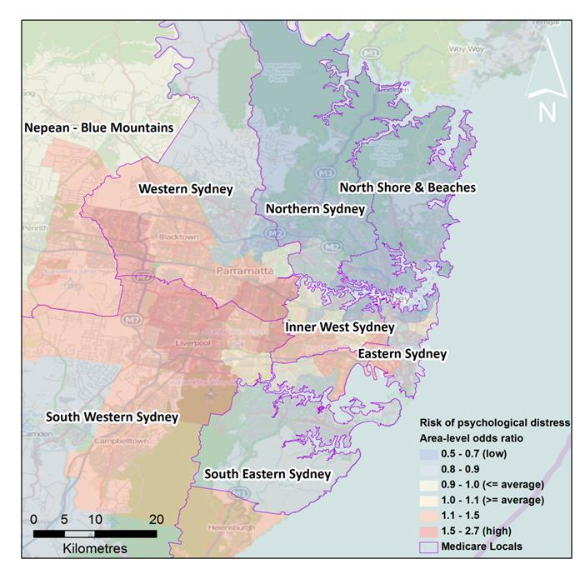
- Risk of psychological distress
Data on the available services, their capacity and location was collected in late 2014 and early 2015. A total of 121 services were identified and classified according to the internationally validated tool, the "Description and Evaluation of Services and Directories in Europe for long-term care" (DESDE-LTC).
The pattern and capacity of services (services per 100,000 residents) is shown in Figure 7.
The Atlas reveals four major gaps in the provision of mental health care in western Sydney:
- An absence of services providing acute day care (i.e. day hospitals) and non-acute day care (i.e. day centres providing structured activities to promote health and social inclusion).
- A lack of acute and sub-acute community residential care.
- Low availability of specific employment services for people with a lived experience of mental ill- health.
- A lack of comprehensive data related to availability of supported housing (housing linked to necessary, individualised supports) for people with mental health problems.
These gaps mirror the needs analysis of Partners in Recovery (PIR) program clients in western Sydney undertaken by the Menzies Health Policy Centre. An analysis of unmet needs amongst 241 PIR clients found the highest areas of need were: daytime activities 63% of clients; psychological distress 63%; companionship (social life) 58%; physical health 56%; accommodation 46% and employment and volunteering 41%.
The Atlas has also revealed some real strengths in the existing system. One of the most striking is the high availability of mobile services and services targeting the needs of specific populations, such as older people, children and adolescents, young people in transition to adulthood (i.e. 16-25 years old) and multicultural services.
The mapping of the services shows that the public funded services are located in the most populous areas of the PHN, particularly around Parramatta and Blacktown. These are also the communities identified as being at a greater risk of psychological distress and socioeconomic disadvantage. Communities in the northern area are shown to have poorer geographic access to mental health services, however levels of disadvantage and risk of psychological distress are also lower in this area.
Taken together the information in this Atlas highlights key areas for system improvement in the provision of mental health services in Western Sydney. The critical areas identified were to:
- Develop alternatives to hospitalisation, such as Day Hospitals; and residential facilities in the community, such as crisis housing.
- Develop health-related day care centres staffed with highly skilled mental health professionals that can focus on recovery oriented rehabilitation. These day care centres promote social inclusion by providing the opportunity to socialise, while offering training in skills related to the development of strategies both to manage their condition and day to day activities of living.
- Develop specific services related to employment (‘social firms’ or ‘social enterprises’) for people with a lived experience of mental ill-health to promote their recovery.
- Improve knowledge of public and community housing to allow better planning.
- Move from a reactive system to a proactive system, to increase the robustness of the system, particularly in the social sector. This implies the provision of long-term funding for the NGO sector, which stabilises operations and allows for long-term planning.
- Incorporate systems thinking into policy and planning. This will encourage the development of an integrated mental health model of care.
The recommendations from the Atlas project are in line with the recent report of the National Review of Mental Health Programmes and Services made by the National Mental Health Commission, which make the following recommendations, amongst others: 1) to develop more community-based psychosocial, primary and community mental health services, as alternatives to acute hospital care; and 2) to boost the role and capacity of NGOs and other service providers to provide more comprehensive, integrated and higher-level mental health services.
The Atlas for western Sydney, along with the other Atlas reports, provides extensive comparative data between regions in Australia and many other regions in Europe.
- Pattern of Mental Health Care in Western Sydney
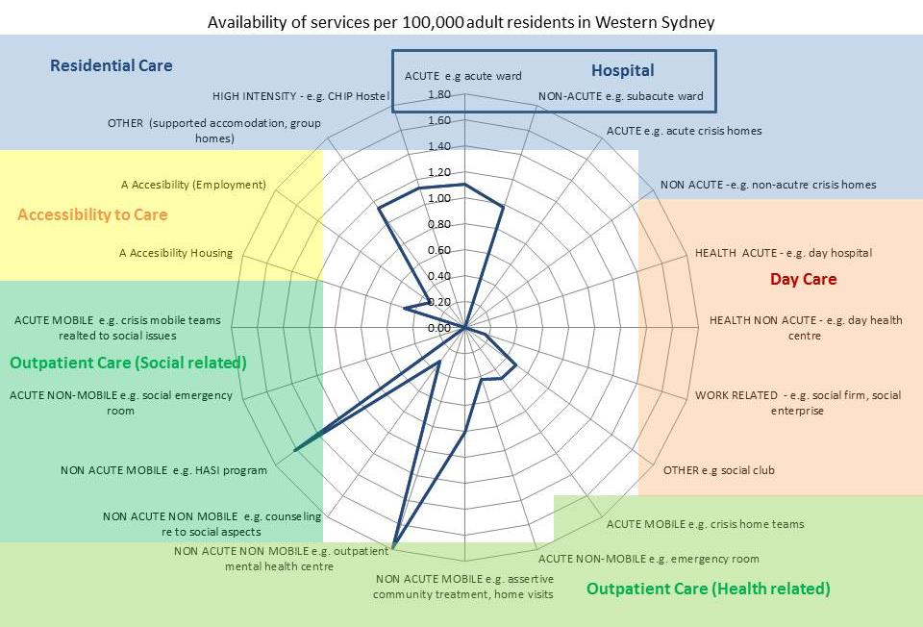

Additional Analysis on Mental Health Service Data
To compliment the Integrated Mental Health Atlas, WentWest engaged ConNetica to undertake further analysis of mental health services. This work focussed on service utilisation across hospital based services, Medicare subsided services, Pharmaceutical/medication dispensing and then specific programs such as ATAPS and MHNIP.
Comparatively, the Western Sydney PHN region has lower rates of utilisation for mental health services in the hospital health care setting, with the majority of hospitalisation rates being lower than more than half of all other PHNs nationally. In addition, the number of mental health MBS item numbers and ATAPS services has increased over the years since 2011. However, after an increase in the number of MHNIP services in 2012/13 there has since been a slight declined in utilisation of this service.

Hospitalisations
WentWest has some of the lowest rates of hospitalisations for bipolar and mood disorders and intentional self-harm. However, the region has higher rates for schizophrenia and delusional disorders and anxiety and stress disorders, compared to other PHNs.

There is considerable variation within the region in rates of hospitalisation and number of bed days for mental health admissions. For All Mental Health conditions and Schizophrenia and Delusional disorders, Auburn had the highest rate of hospitalisations and bed days (per 100,000) and these rates were both higher than the regional and national averages. The lowest rates were in Blacktown – North.
- 2013/14 Hospitalisations and Bed Days per 100,000 People (Age Standardised)
SA3 | All Mental Health |  | Schizophrenia and Delusional |  | Bipolar and Mood |  | Dementia
SA3 | Hospital  -isations | Bed Days | Hospital  -isations | Bed Days | Hospital  -isations | Bed Days | Hospital  -isations | Bed Days
Auburn | 1,099 | 30,774 | 436 | 16,538 | 110 | 3,194 | 46 | 928
Baulkham Hills | 695 | 9,898 | 53 | 1,171 | 62 | 1,206 | 32 | 315
Blacktown | 880 | 13,382 | 166 | 4,427 | 68 | 1,489 | 27 | 369
Blacktown - North | 547 | 7,965 | 52 | 1,069 | 42 | 973 | np | np
Carlingford | 870 | 15,956 | 180 | 5,458 | 62 | 1,523 | 34 | 491
Dural - Wisemans Ferry | 949 | 13,858 | np | np | 143 | 2,301 | np | np
Merrylands - Guildford | 933 | 15,301 | 226 | 6,303 | 60 | 1,413 | 46 | 632
Mount Druitt | 859 | 11,977 | 171 | 4,069 | 62 | 1,597 | 44 | 603
Parramatta | 858 | 16,883 | 149 | 5,912 | 80 | 1,742 | 50 | 526
Pennant Hills - Epping | 658 | 11,506 | 61 | 1,624 | 78 | 1,894 | np | np
Rouse Hill - McGraths Hill | 754 | 11,263 | np | np | np | np | np | np
Ryde - Hunters Hill | 752 | 18,258 | 142 | 4,760 | 87 | 1,658 | 23 | 482
WentWest | 828 | 14,719 | 167 | 5,216 | 69 | 1,616 | 38 | 484
Australia | 911 | 12,839 | 160 | 3,528 | 98 | 1,762 | 45 | 765
Source: AIHW (2014), Analysis of the National Hospital Morbidity Database

- Hospitalisations for All Mental Health Conditions
For All Mental Health conditions in 2014/15, only Auburn, Carlingford and Dural - Wisemans Ferry had higher hospitalisation rates compared to the national average. Hospitalisation rates were relatively consistent between the 2013/14 and 2014/15 reporting periods for all areas with the biggest change in rates observed in the increase in Ryde - Hunters Hill (Figure 8).
Further regional variation can be seen for hospitalisations for other mental health conditions including:
- For Anxiety and Stress, whilst Rouse Hill – McGraths Hill had the highest number of hospitalisations, Carlingford had the highest rate for number of bed days (per 100,000) (Table 2).
- 2014/15 Hospitalisations and Bed Days per 100,000 People (Age Standardised)
SA3 | Anxiety and Stress |  | Depressive Disorders |  | Drug and Alcohol |  | Intentional Self-Harm
SA3 | Hospital  -isations | Bed Days | Hospital  -isations | Bed Days | Hospital  -isations | Bed Days | Hospital  -isations | Bed Days
Auburn | 118 | 1,183 | 72 | 1,733 | 156 | 1,669 | 84 | 384
Baulkham Hills | 130 | 1,148 | 132 | 2,161 | 148 | 1,768 | 89 | 607
Blacktown | 146 | 941 | 113 | 1,542 | 186 | 1,293 | 125 | 586
Blacktown - North | 131 | 1,036 | 92 | 1,597 | 110 | 1,153 | 91 | 646
Carlingford | 159 | 2,294 | 127 | 2,298 | 203 | 1,479 | 79 | 1,223
Dural - Wisemans Ferry | 138 | 1,478 | 194 | 3,129 | 248 | 2,232 | 90 | 392
Merrylands - Guildford | 127 | 864 | 88 | 1,425 | 217 | 1,523 | 90 | 618
Mount Druitt | 126 | 1,032 | 63 | 1,035 | 223 | 1,375 | 150 | 1,006
Parramatta | 147 | 1,224 | 119 | 1,829 | 169 | 1,458 | 77 | 731
Pennant Hills - Epping | 107 | 928 | 109 | 2,101 | 115 | 1,399 | 74 | 359
Rouse Hill - McGraths Hill | 173 | 1,568 | 135 | 1,950 | 136 | 1,284 | 109 | 628
Ryde - Hunters Hill | 127 | 1,249 | 100 | 1,980 | 154 | 1,681 | 92 | 536
WentWest | 134 | 1,156 | 103 | 1,664 | 168 | 1,408 | 97 | 627
Australia | 142 | 1,239 | 118 | 1,678 | 180 | 1,369 | 161 | 838
Source: Australian Institute of Health and Welfare (AIHW) (2015), Analysis of the National Hospital Morbidity Database
- For Depressive episodes, Dural – Wisemans Ferry had the highest rates of hospitalisations and bed days (per 100,000), higher than both the regional and national average. During the same time period, Mount Druitt had the lowest rates for both hospitalisations and bed days.
- For Drug and Alcohol, Dural – Wisemans Ferry had the highest rates of hospitalisations and bed days (per 100,000), both higher than the regional and national average. The lowest rates during the same time period were in Blacktown – North.
- For Intentional Self-Harm, Mount Druitt had the highest hospitalisation rate (per 100,000) however this was lower than the national average. Carlingford had the highest rate for number of bed days (per 100,000), which was higher than both the regional and national average. (Figure 10)

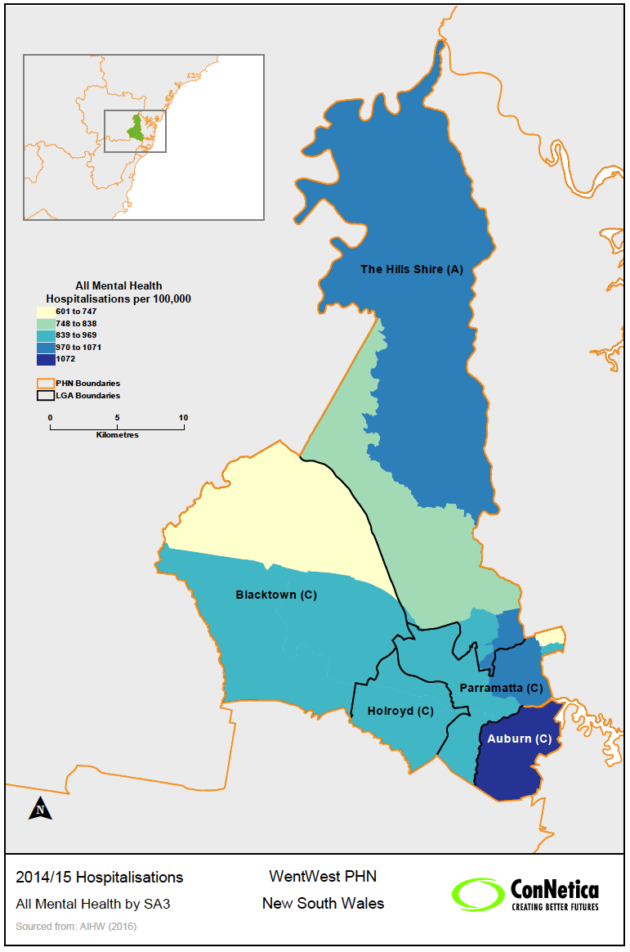
- All Mental Health Hospitalisations by SA3 2014/15

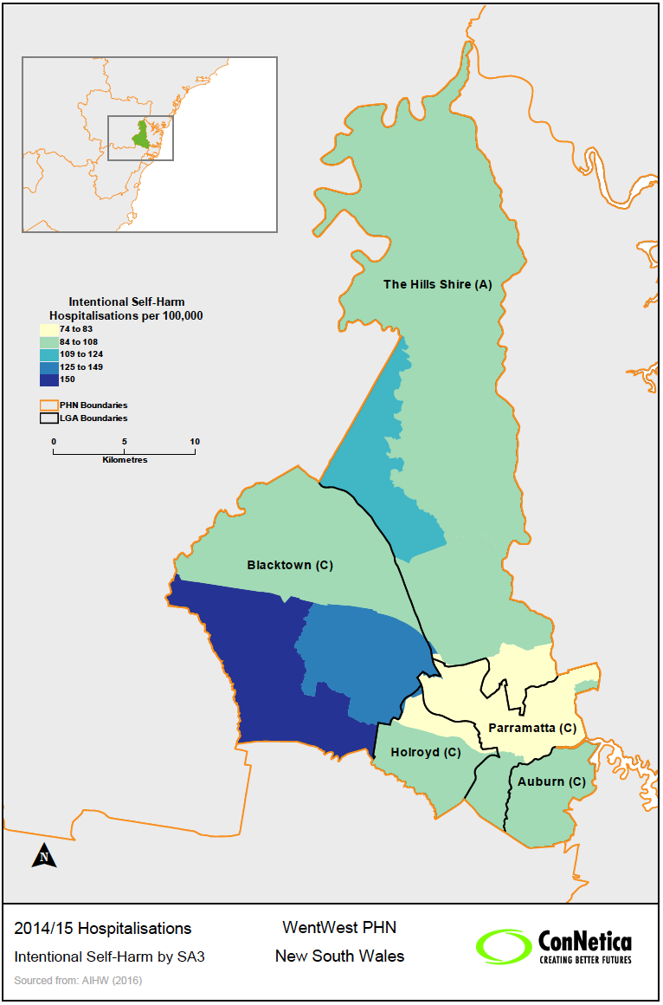
- Intentional Self-Harm Hospitalisations by SA3 2014/15

Utilisation of MBS, ATAPS and MHNIP
Across the WentWest catchment, the areas of Blacktown and Merrylands – Guildford had the highest numbers of MBS services for mental health related items and GP Mental Health Treatment Plans, Mount Druitt also had high numbers of patients and services. Table 3 shows these by SA3 for different provider types and compares them to the average for WentWest and Australia.

- MBS Mental Health Provider Type by SA3, Services rate per 100,000 (Not Age Standardised)
SA3 | Provider Type
SA3 | Psychiatrists |  | General Practitioners |  | Clinical Psychologists |  | Other Allied Health |  | Total
SA3 | 2013/14* | 2014/15† | 2013/14* | 2014/15† | 2013/14* | 2014/15† | 2013/14* | 2014/15† | 2013/14* | 2014/15†
Auburn | 6,231 | 5,388 | 7,701 | 7,792 | 3,745 | 4,041 | 9,611 | 10,018 | 27,288 | 27,239
Baulkham Hills | 10,733 | 10,900 | 10,647 | 11,110 | 7,677 | 7,841 | 10,593 | 11,066 | 39,650 | 40,916
Blacktown | 7,650 | 7,595 | 12,899 | 13,623 | 4,589 | 4,702 | 11,803 | 12,607 | 36,942 | 38,525
Blacktown - North | 6,371 | 6,378 | 11,394 | 11,555 | 6,605 | 6,500 | 10,427 | 10,529 | 34,797 | 34,964
Carlingford | 11,962 | 11,070 | 10,623 | 11,483 | 6,274 | 6,280 | 10,071 | 10,493 | 38,926 | 39,327
Dural - Wisemans Ferry | 13,317 | 12,955 | 11,738 | 12,692 | 7,753 | 7,918 | 11,686 | 11,228 | 44,491 | 44,793
Merrylands - Guildford | 8,314 | 7,706 | 10,159 | 11,352 | 4,417 | 4,601 | 10,946 | 11,750 | 33,836 | 35,409
Mount Druitt | 5,805 | 5,623 | 11,618 | 12,222 | 2,675 | 2,443 | 9,755 | 10,291 | 29,854 | 30,578
Parramatta | 10,202 | 10,371 | 11,110 | 11,751 | 6,113 | 5,992 | 10,425 | 10,612 | 37,851 | 38,726
Pennant Hills - Epping | 15,542 | 14,253 | 9,064 | 9,041 | 7,792 | 8,147 | 9,221 | 9,176 | 41,619 | 40,609
Rouse Hill - McGraths Hill | 8,647 | 8,576 | 13,537 | 14,248 | 8,090 | 7,961 | 11,109 | 11,441 | 41,382 | 42,227
Ryde - Hunters Hill | 13,184 | 12,624 | 8,686 | 8,949 | 7,742 | 7,448 | 9,406 | 8,957 | 39,018 | 37,978
WentWest‡ | 9,149 | 9,111 | 11,671 | 12,621 | 5,777 | 5,954 | 11,267 | 12,016 | 37,866 | 39,705
Australia‡ | 9,289 | 9,684 | 11,145 | 12,272 | 7,188 | 7,866 | 10,354 | 11,226 | 37,978 | 41,154
Source: Department of Health (2015b), MBS Mental Health by SA3 – Patient
* Rate calculated using ABS Population data for 2014; †Rate calculated using ABS Population data for 2015; ‡Rate Calculated using PHIDU (2017), ERP 2015. Not Age Standardised.
Access to Allied Psychological Services (ATAPS) for the last year of this program’s operation. 2015/16 shows that Blacktown had the highest number of occasions of service and Mt Druitt the largest number of patients. This reflects WentWest’s objective of targeting the ATAPS funds to areas of greatest need. ATAPS is a relatively small program in comparison with the MBS subsidised mental health services (78,205 vs 2,245,324 patients for that year across Australia.
The Mental Health Nurse Incentive Program, like ATAPS, was a comparatively small program targeting people with more severe and complex mental illnesses. In in 2014/15 there were 373 patients in the WentWest region.

Dispensing of Psychotropic Medications
As with MBS mental health services, there is a considerable variation within the western Sydney region with the access to psychotropic medications through the PBS.
Overall, Pennant Hills – Epping had the highest rates of mental health related PBS scripts, and Auburn the lowest rate. There has been only slight increase between 2014/15 and 2015/16 for most areas in relation to these prescriptions. Breaking this down further:
- Baulkham Hills and Dural – Wisemans Ferry the highest rates of Antidepressants in region, whilst Auburn the lowest rate (Figure 11)
- Pennant Hills – Epping had highest rates for Antipsychotics, Anxiolytics and Hypnotics and Sedatives, whilst Blacktown - North had the lowest Antipsychotics
- Merrylands – Guildford the lowest Anxiolytics and Hypnotics and Sedatives, and Auburn the lowest Psychostimulants
- Antidepressants, rate per 10,000 by SA3

Implications from the Atlas and MBS/other Program Data
From these analyses we have been provided clearer data for planning and commissioning services. Importantly the data shows:
- The clear relationships between IRSD index scores and access to any mental health care
- Those areas where there is poor utilisation of public mental health services are also shown to have lower access to Medicare subsidised mental health services – this is consistent with findings published by Meadows et al.
- Those areas with lower IRSD scores and lower rates of service utilisation have higher rates of intentional self-harm and suicide – again this is consistent with data published by Mendoza et al.
- Areas with higher service utilisation had the highest rates of PBS-subsidised medication use.

Our Approach to Mental Health Services and Reform
…clinical transformation must infuse mental health care into every part of the health system. It must not be rooted in an idealistic view of how things should work, but rather in how patients actually seek care.
Institute for Healthcare Improvement, Health Affairs Blog, 14 February 2019

What We Have Done in Western Sydney
WentWest has been delivering mental health services for the past nine years under the previous ATAPS program. During the period of the WentWest Medical Local, the range of mental health services was expanded by successfully incorporating additional programs such as PIR and the MHNIP.
Since their establishment, PHNs have been tasked with developing and commissioning evidence-based primary mental health and suicide prevention services that address the region’s identified needs and service gaps, reduce duplication, remove inefficiencies and encourage integration.
Appendix One sets out the role of the PHNs, and the goals and objectives prescribed by the Commonwealth Government through the Department of Health (DOH).
WentWest began commissioning services in mental health, alcohol and other drugs and other priority health areas, in 2016. The initial year of operation (2015-16), marked a period of transition from the Medicare Local and the transfer of contracts previously managed by DOH.
The services commissioned from 2016-17, aligned with international best practice person-centred stepped care approach. WentWest’s approach was informed by:
- A data informed approach based on a deep understanding of the region, its current and projected population health needs and available services across general practice, primary care, specialist care, community care and hospitals
- A strategic approach to transforming primary care through the Integrated Primary Health Care model and the Quadruple Aim model
- Engaging the western Sydney community
- Leveraging the extensive and experienced mental health workforce and services
- Engaging with academic and expert partners
Figure 12 illustrates the need for more effective use of resources in western Sydney to achieve better mental health outcomes for the region. Looking across the continuum of Commonwealth to State funded services, there are rising rates for people with mild/moderate mental illness but very low levels of access to services for what we term the ‘missing middle’.
These are the vulnerable populations with combinations of moderate mental illness and complexity; drug and alcohol, comorbid physical conditions and social issues. The previous ATAPS program, now Primary Mental Health Care (PMHC) services, provides some level of support for this population but has always been a relatively small funding pool. This has been one of the priority areas for our commissioned activities since early 2017.
WentWest has also commissioned ‘low intensity services’ to support people who are experiencing very mild levels of distress. This will support a stepped care model of service alleviating some of the more complex and face to face service for people with higher needs.
The commissioning actions have been developed in line with our strategic vision to apply a systems approach to the development of services and enables us, together with our system partners, to achieve the ‘Quadruple Aim’ of simultaneous achievement of 1) Improved population health outcomes, 2) Improved user experience of care and support, 3) Efficient use of resources, and 4) Development of a sustainable and viable provider workforce.
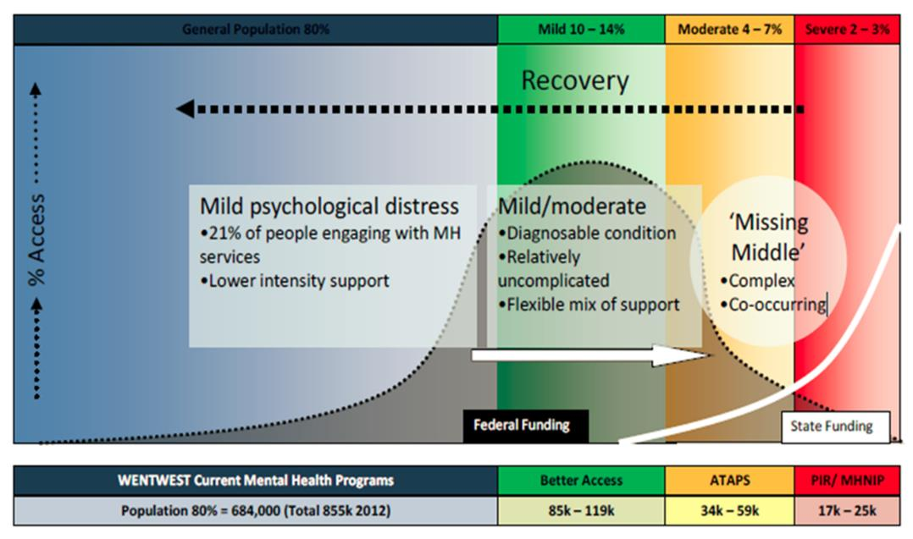
- Program Funding and Population Mental Health Needs, WentWest
The commissioning activities we have undertaken align with the DOH’s priority areas for Mental Health and Suicide Prevention. Our aim has been to align services to the most appropriate priority area with planned overlaps, which complements the implementation of a stepped model of care in the region.
The commissioning has aimed at addressing the range of need across the life course continuum based on a risk progression from a healthy and well population through progressive states of distress or disorder to manifest mental illness and its complications. This life-course continuum enables us to address all DOH’s priorities in a unified way through regional planning and stepped care service model.

Commissioned Activities 2016-2019

Commencing in 2016/17 financial year, WentWest formalised a number of commissioning projects to develop a suite of services and activities that aimed to strengthen primary mental health care and suicide prevention for the western Sydney region.
In essence WentWest’s aims were to develop a seamless process for consumers and carers to navigate the mental health system and receive quality mental health services at the right time and according to their needs. The commissioning approach aimed to 1) strengthen existing primary health services that are providing quality care and outcomes for consumers, and importantly 2), expand the range of services across key priority areas to complement the stepped care model and contribute towards a new system of mental health care for the region.
Appendix 3 summarises the services that WentWest has developed and/or commissioned from early 2017 and that have continued through to 2019. The following table lists these by the DOH priority areas.
Our aim is that this work will build the platform on which to continue to implement our longer-term strategic vision for our region with our partners and stakeholders. Figure 13 shows the planned activities and how these aim to address the continuum of mild to moderate to severe mental health needs in primary care. Figure 14-16 shows our Stepped Care service model.
- WentWest Commissioning Activity, Mental Health 2016-19
Priority Area | Commissioned Services & Activities | Future Services Researched
Low Intensity mental health services | Telephone Helpline, ‘On the Line’  Navigation planning tool, ‘No Wrong Door’  Online Support & Health Coaching  Western Sydney Recovery College
Children & Young People | headspace and headspace Youth Early Psychosis Program (HYEPP) | Examine recommendation from National Mental Health Review for the development of CHILDSPACES (headspace type services for children)
Rural & remote areas a& other underserviced and/or hard to reach populations | Primary Mental Health Care services – PMHC (previously ATAPS program) | Expand service delivery to specific target groups such as LGBTIQ, migrants, refugees and elderly
(Persons with) Severe and complex mental illness | Mental Health Nurse Incentive Program  Hospital to Home program  General Practice Support and Capability Building – Psychiatrist Liaison Model | Mental Health Nurse Credentialing
Suicide prevention | Men’s Shed  After Hours Services for Mental Health  Helpline Service | Lifespan Suicide Prevention Model  Dynamic modelling tool development
Aboriginal and Torres Strait Islander mental health | The Australian Indigenous Psychologists (AIPA)  Aboriginal & Torres Strait Islander Mental Health First Aid (MHFA) and ASIST (Suicide Prevention) Training  Cert 4 Peer Work (MHCC) | Develop Aboriginal and Torres Strait Islander health leader’s network groups to assist with ongoing planning & development of services in the region. Work in partnership with western Sydney Aboriginal Health services
Regional Planning | Integrated Mental Health Atlas & utilisation to support planning  Ongoing consultation with stakeholders/community – regional planning forum  Development of consistent reporting framework & data set | Regional Mental Health Expenditure Review  Reporting and performance measures based on consistent MDS data sets and frequent collection and review of data
Stepped model of care | Centralised Referral and Triage System  Development of a single referral form for the Stepped Care model (from all Primary Health referring agents) | Ongoing research to support effective implementation of stepped care model
In addition to existing legacy programs and services, such as headspace, a number of new activities were commissioned to address identified service gaps and build infrastructure and support for the longer term. These activities have focussed on enhancing the support available from our general practice teams and providing general practice access to adjunct services for the consumer populations.
This is consistent with WentWest’s strategy of keeping general practice at the centre of consumer support and care and working with all our providers to build a system of care that provides as seamless transition as possible for consumers between providers and services.

- The WentWest Continuum of Primary Mental Health Care

- WentWest Stepped care Service Model – Principles

- WentWest Stepped Care Model – characteristics of service levels

- – WentWest Stepped Care Model – Determining Need

Academic and Strategic Partnerships
A key aspect of WentWest’s approach has been the establishment and strengthening of academic and strategic partnerships to build the regions capacity to achieve evidence-informed health care. This has involved academic and consultant experts in mental health suicide prevention and alcohol and other drugs issues, collaborations with international centres of best practice in primary mental health care, study tours for health care providers from our region, continuous workforce professional development, continuous engagement with consumers and carers to ensure lived experience informs the design and implementation of our work, active engagement with peak bodies and ongoing research.
WentWest’s partners have included Western Sydney University, the Brain and Mind Centre University of Sydney, The Menzies Health Policy Centre, The Sax Institute, and leading consultants in mental health including Synergia, ConNetica, and David McGrath.
Notable aspects of our ongoing research and collaboration to support effective implementation of mental health and suicide prevention strategies within a stepped care model include:
- Western Sydney Health Intelligence Unit (WSHIU): support and contribute to the new shared service in the region providing an agreed and expanding range of services, including information production, knowledge management, web-based reporting and capacity building
The initiative assists the development, capture and use of knowledge to support decision making to improve the health of the patients enrolled in the Health Care Home (HCH) models of primary care, along with the greater population of western Sydney. The WSHIU works to support health professionals and system partners to make informed decisions towards better health and social care outcomes by using the evidence base of health. A wide variety of stakeholders use the WSHIU portal to monitor the health status of the community, identify health needs, develop programs to reduce risk, foster policies which promote health, plan and evaluate the provision of healthcare and manage and implement change.
- Integrated Mental Health Atlas of Western Sydney – WentWest was the first regional health authority in Australia to apply an internationally validated tool to the geo-mapping population mental health needs and the available services. This Atlas uses a standard classification system, the "Description and Evaluation of Services and Directories in Europe for long-term care" model (DESDE-LTC), to map the services. The use of a common language has allowed us to compare the pattern of mental health care provided in western Sydney, other regions across Australia and with regions in Europe and elsewhere. We continue to develop and use the ‘Mental Health Atlas’ to enable enhance our understanding of the functional mix of capacity (or spectrum and capacity of services) in the region and compare this to international benchmarks using a standard taxonomy.
The Population Health Commissioning Atlas was one application of the Atlas findings. It provides a tool by which the Western Sydney PHN can build a specific population health profile to inform health needs assessment, including information on the determinants of health, as a means to establishing priorities for service development. It also assists in the identification of key areas in which it can work in partnership with a wide range of stakeholders to strengthen the primary care.
- Suicide Prevention Research Collaboration and Systems Model: The suicide prevention research collaboration lead by the University of Western Sydney and Sax Institute, the Brain and Mind Centre at the University of Sydney and our service design partner Synergia Consulting to develop a systems modelling approach to community-based suicide prevention and suicidality attempts. The collaboration has developed a Dynamic Modelling approach to suicide prevention that incorporates the Lifespan Model from the Black Dog Institute.
The PHN will act as a local implementation partner for the research collaborative enabling the systems modelling approach to be tested in real life scenarios and enable our commissioning framework to draw on the evidence of effectiveness and impact for suicide prevention. This will address the current fragmented nature of suicide prevention activities and provide a rigorous approach to commissioning of suicide prevention services.

Impact of our Work
To inform this submission to the Productivity Commission, WentWest undertook a rapid consultation with stakeholders through key informant interviews, focus groups meetings and an online survey. In doing these consultations we wanted to be clear as to what our stakeholders believed:
- what has worked well
- what has not worked so well
- what needs to be priorities moving forward and
- the role that WentWest, and PHNs more generally, can and should play in mental health reform.
The stakeholders consisted of regional and academic partners, state wide agencies such the NSW Mental Health Commission and the peak Mental Health Coordinating Council (the peak community mental health body), commissioned service providers, GPs and other primary care providers, consumers and carers. A total of 59 individuals participated in the consultations held between 19 February and 27 March 2019.
This stakeholder feedback was largely consistent with a number of recent reports on PHNs.

What’s Worked
Stakeholders provided consistent feedback that over the past three years, WentWest had:
- Enhanced regional planning through its approach and bringing expertise to the processes.
- Established a reputation for working with a large cross section of organisations and diverse stakeholders in a respectful and mutually beneficial manner. These relationships have gained consensus around service initiatives and increased provision of integrated services.
WentWest is very embedded in the community, acquired a strong understanding of their community and built on Partners in Recovery linkages. (Consumer Advocate)
… is very good at consensus building and has achieved consensus around modelling & data approaches. (GP)
- Established effective and ongoing working relationships with a range of academic institutions. These relationships have better enabled the design and delivery of innovative and evidence based services in the region.
- Demonstrated a strong commitment to establishing and utilising robust data management systems to improve decision making in relation to service commissioning and service accountability. This use of data is better enabling the provision of proven evidence based services and more effective use of limited funding.
WentWest has a strategic approach to the use of data - they are way ahead in terms of sophistication of data systems and analytics. They use health information data and link data from various sources (Centrelink, Medicare, Hospital Admissions) to inform commissioning decisions. (Academic Partner)
WentWest has had a clear and sustained strategy for data and management systems. (State Authority)
A number of key initiatives were identified by the interviewees as examples of WentWest’s innovative approach to primary health and improved mental health service provision. These included:
- The GP-Psychiatry liaison which now has employs 2 psychiatrists across a region with few private practice psychiatrists.
- The increased focus on infant and child issues.
- The tiered response to people with an intellectual disability and health issues.
- The GP Leaders Forum which includes the LHD to share ideas, build networks and collaborate.
- The leadership program and US study tour to build health leadership and expertise in the region.
A key factor identified by interviewees in WentWest’s achievements have been strong and engaged leadership team with a clear strategic focus and expertise in health care systems. This, along with minimal turnover in the initial years have resulted in:
- Implementation of visionary thinking – thus moving from ideas to practice.
- Streamlined and effective internal WentWest operations and cohesive internal culture, including strong internal and clinical governance arrangements and a strong focus on continuous improvement.
- Continuity of external service provision and relationship building with service providers, community groups and stakeholders.
WentWest has demonstrated clear leadership. While operating in a complex system they have demonstrated clear direction and knowledge and expertise in health services. They demonstrate transparency in their use and availability of data. (Academic Partner)
WentWest has laid the foundations for what is ultimately required and adopted a systems approach to decision making. (Academic Partner)
That leadership and the capacity to partner and engage with other organisations was seen as contributing to the development of other organisations involved in western Sydney. Improved capability in service delivery, the quality of care/services, business planning, leadership and workforce capacity and capability was reported by stakeholders.

What’s Not Worked
While stakeholder feedback indicated a need to continue to improve communication and engagement in planning and commissioning, the feedback overwhelming pointed to constraints in the operating environment of WentWest and PHNs generally. A lot of feedback related to the mental health sector and the challenges organisations like PHNs confront.

The Mental Health Sector
The mental health sector in Australia was described by some interviewees as one that is highly competitive, reactionary and dominated by very strong personalities and personal agendas at the expense of collaboration, sound policy and effective service delivery. Some interviewees shared that:
… the history of mental health in Australia is one of a cycle of reaction. It is a deeply divided sector that can be described as a “Game of Mates”. (Academic partner)
Some prominent members of the mental health sector demonstrate almost pathological behaviours to protect/colonise and then expand their areas of activity. (Academic partner)
The mental health sector has many people with strong personalities, who often never agree, and they carve out a territory and fight for that rather than reform. (GP)
It was also reported that culture is one of the biggest obstacles to improved mental health services.
… hospitals are focused on themselves, individual practitioners are focused on themselves and their own aspects of care, rather than working as united care teams. (GP)
Focus group participants also reported that difficulties were caused as a result of PHNs and LHDs having different geographical boundaries. This was one of the issues the Horvath Review identified as a problem with the previous Medicare Local structure but the new PHN boundaries in many areas simply changed them again without achieving alignment.
Further reported difficulties related to the strong hospital centric nature of Local Health Districts (LHDs). LHDs also have very different timelines, policies and processes to PHNs which makes collaboration more difficult. One interviewee shared that the:
LHD Mental Health unit is the biggest laggard when it comes to care coordination. They are very poor at communication. Nothing. (GP)
A number of concerns were shared about collaboration with headspace, reflected in this comment:
headspace is a “black hole”. I refer a client and that is the end of the story. I never hear anything again. headspace is fragmenting care further. This is the view of providers in this region and in my role as an Executive representative of … (organisation’s named removed). (GP)
Feedback about the approach to suicide prevention demonstrated concern over the lack of focus on the causes of poor mental health, especially the social determinants, which is evident by too much focus on treatment rather than prevention.
The government is wasting time and money trying to solve suicide and self harm without addressing the social and economic drivers and the market failure of Medicare. It’s like “p…. on a bushfire” and expecting the situation to improve. (GP)

Impact of Department of Health
- In relation to the work undertaken by PHNs and in particular their operating framework, some interviewees reported unrealistic expectations and workloads dictated by DoH, perplexing funding decisions and a perception that in many ways DoH’s approach was reactive and disruptive to PHNs daily operations. Funding guidelines which were deemed to restrict service and were ineffective in those locations where there was a limited range of capable providers. Access to data was also identified as a constraint.
The guidance, workload and timeframes issued by DoH are consistently unrealistic. Their (DoH) decisions relating to distribution of trial sites and funding allocations and feedback, service monitoring and roll out of key learnings are unclear.
PHNs are expected to be agile and responsive to community needs but Ministerial announcements are often way ahead of action stage.
The growing interference and limitations on scope of responsibility and flexibility in funding decisions has negatively impacted service provision.
Access to data remains an impediment for WentWest and PHNs generally. Too many providers have a vested interest in withholding access to data.
The Feds needs to work out what is centralised and standardised and what is local and regional.
Treating all PHNs equally is not helpful. The Commonwealth needs to take a risk assessment approach and provide more assertive support to those PHNs that are not operating effectively.

Other Constraints Identified
- Infrastructure - the lack of consistency across PHNs in relation to information technology, industrial relations, human resources, financial systems has resulted in significant establishment costs, inconsistencies and wasted effort.
- Western Sydney’s geographical, social and service profile - Western Sydney was specifically described as a geographical area in which its residents experienced difficulty accessing care due to availability of services and capacity to pay for services.
Western Sydney represents the heart of the problems experienced when it comes to accessing health care services. There is lots of diversity amongst community members, lots of people, poor infrastructure, poor services generally and while there are high needs, service availability is low and capability to access due to service location and cost is also low. (Academic partner)
- NGOs collaboration with PHNs - the working relationships between NGOs and PHNs was also described as difficult with large national NGOs viewing 31 PHNs as too small and small local NGOs being seen by PHNs as too small.

Future Focus and Priorities
Stakeholders were asked about the priorities for WentWest and the region in relation to mental health needs and the role that WentWest and PHNs in general can play in reform. The following issues were identified as actions that will further consolidate and extend the positive impact of WentWest on mental health provision and broader PHN issues.

WentWest Specific
- Patient Centred Health Home – the program is only operating in less than 1 in 10 General Practices in the region. This program needs to cover the network of 300 General Practices.
- Local Community Expert – WentWest cannot become simply a commissioning body. Use your knowledge about local needs and expertise to better advocate government for the range of interventions that will best meet the local communities’ needs. In so doing, WentWest will become an advisory body for the local population.
- Workforce Development - Continue to educate GPs on available services, medications and pathways to care
- Dual Diagnosis Services - Increase funding for AOD services and expand the provision of dual diagnosis services in the region, in particular provision of day care programs
- Co Planning with the LHD - Encourage the LHD to commit to the recommendations included in the Integrated Atlas
- Service Access - Develop “one stop shops” that will facilitate streamlined and improved access to care, alternatives to Hospital Admission, and increase the availability of alternatives to hospital services that can meet the needs of people experiencing a crisis situation.

PHNs in General
A range of issues were identified to improve the effectiveness of PHNs generally. These included:
- Greater transparency in relation to funding decisions by DoH and PHNs
- Promote pooled funding/co-commissioning to strengthen service collaboration and minimise duplication of service provisions
- Increased capacity to attract and retain suitably skilled and experienced staff
- Increased investment in and improved data systems to ensure decisions are better informed by and evidence with an increased focus on outcomes rather inputs and greater knowledge about the effectiveness of local services. The development and use of more relational data systems to analyse the interconnectedness between different initiatives was also identified.
- Increased focus on integration of government services and more local responsibility for service provision decisions, described as “integrated decentralisation”. This included mental health services such as headspace.
- Broader and increased academic partnerships to support PHNs to be abreast of best practice
- Increased use of the 5th Mental Health Plan to provide clarity around the role of PHNs
- Extend the focus of PHNs from individuals to families and communities
- An increased focus on integrated primary care through 1) a continued expansion of the medical home model, 2) improve pathways between non mental health and mental health services so that individuals are better able to have their holistic wellbeing needs better met, particularly for those with co-morbid chronic conditions 3) innovations like the GP-Psychiatry liaison model, 4) improved collaboration between headspace, GPs and other service providers for young people
- More broad community health initiatives that facilitate happiness and positive mental health focussing on what matters to each community, rather than broad brush national projects.
Functioning communities are the foundation of good mental health. (GP)
Increase funding and resource allocation to PHNs was a consistent theme in stakeholder feedback. This included increased funding allocation to prevention and early intervention initiatives, greater focus on and provision of funding for child mental health services, increase access to direct referrals to psychologists, and increased resources allocated to research service availability across the PHNs rather than the current focus on population research, as this would better enable the provision of services tailored to the unique context of each community.
A number of issues were raised by stakeholders in relation to the Department of Health and the PHN program (these are specific actions not evident in the earlier discussion):
- DoH undertaking an analysis and impact assessment of the 31 PHNs to identify those PHNs performing well, those in need of support, and that identified best practice is shared with all PHNs.
- DoH, or another entity, providing “backbone” support for PHNs to enable better sharing of ideas and clear direction around what operations are centralised versus decentralised.
- DoH providing increased support to those PHNs that are underperforming and ensure that funding parameters are broad enough to allow PHNs the flexibility to tailor service provision to the unique needs of their communities.

PART B

This section addresses a number of issues raised in the Productivity Commission’s Terms of Reference and the Issues Paper, namely:
- The Commission should consider the role of mental health in supporting economic participation, enhancing productivity and economic growth. It should make recommendations, as necessary, to improve population mental health, to realise economic and social participation and productivity benefits over the long term.
- Examine the effectiveness of current programs and initiatives across all jurisdictions to improve mental health, suicide prevention and participation.
- Draw on domestic and international policies and experience.
- Have regard to recent and current reviews.
- (From the Issues Paper), structural issues, child protection, care/service integration, funding and monitoring and reporting outcomes.

The Prevalence of Mental Illness
The ABS National Survey of Mental Health and Wellbeing (NSMHWB) provides the most comprehensive estimates for mental disorders in Australian adults both over their lifetime and in the preceding 12 months. The survey estimated that 45 per cent of Australians had experienced a mental disorder in their lifetime, with 20 per cent experiencing a mental disorder in the previous year.
This survey was last conducted in 2007, this was the second ABS mental health and wellbeing survey, with the first survey conducted in 1997. The Department of Health confirmed at Senate Estimates in late 2018, there were ‘no plans to fund another survey on mental health by the ABS’.
In addition to the NSMHWB, there are a range of other sources, but none as complete, that can provide an indication of the prevalence and impact of mental health conditions in Australia:
- The most recent ABS National Health Survey estimated there were 4.8 million Australians (20.1 per cent) with a mental or behavioural condition in 2017–18. This was an increase of 2.6 percentage points from 2014–15 This was mainly due to an increase in the number of people reporting anxiety-related conditions. This data does not address lifetime prevalence or incidence of mental illness in the past year.
- The Australian Child and Adolescent Survey of Mental Health and Wellbeing (2014), estimated that almost 14 per cent of young people aged 4 to 17 years (or 560,000 people) experienced a mental disorder in the 12 months before the survey.
- Poor mental health is almost always associated with suicidality. According to the ABS, 3,128 people died in Australia from intentional self-harm in 2017, rising from 2,866 in 2016. Most concerning is that there is a clear and consistent upward trend in both the rate (Age Standardised Rate – ASR) and the numbers of suicide deaths in Australia in the past decade – the ASR up some 15.6% and the number up While suicidality is not confined solely to people with poor mental health, the NSMHWB estimated that 94.2 per cent of persons who attempted suicide in the previous 12 months had experienced a mental disorder in the same time period.
- Globally, suicide rates are in decline have fallen by 38% over the past 25 years. Japan, Russia, China, South Korea, India, UK and many European countries have all seen rates decline. Australia, along with the United States of America, are the big exceptions to the global trend. Suicide is the leading cause of death for males and females 15-44 and now accounts for more years of potential life lost, than any other single cause. The average age of suicide deaths has increased slowly over the past decade and is now approximately 44 years for both genders.
- Aboriginal and Torres Strait Islander suicides are approximately 2.2 times the rate for non-Indigenous Australians. The average age is also lower at 29 years.
- According to the Australian Institute of Health and Welfare’s (AIHW) Burden of Disease Study, in 2011 the Australian population lost a total of 542,554 years of healthy life as a result of mental and substance use disorders. This accounted for 12.1 per cent of the total burden of disease, making mental and substance use abuse disorders the third highest cause of burden in Australia.
The prevalence of mental illnesses in Australia is not declining and there is little evidence that despite improved access to the services, particularly through the MBS subsidised Better Access program, that the mental health and wellbeing of the Australian population is improving.
The following figures show the reality of the mental health of Australians.
- The Mental Health of Australians

- Suicide in Australia, 2017
- Aboriginal and Torres Strait Islander Suicide, 2012-2016
Note that the data in Figure 19 excludes Tasmania and Victoria and the ACT.

The State of Mental Health Care in Australia
This is the saddest case I have investigated in my time as Ombudsman. A 39-year-old woman spent over 18 months in prison, locked in her cell up to 23 hours a day, where she would scream with distress for hours on end. She had been charged with breaching an intervention order taken out by her family, who could not cope with her behaviour, and resisting police. This woman, whom we refer to as Rebecca, was found unfit to stand trial and not guilty because of mental impairment. She remained in prison simply because there was nowhere for her to go.
Victorian Ombudsman, 16 October 2018
Individual, whole of service and systems level failures in mental health care are reported to the Australian public on an almost daily basis. There is little doubt that this contributes to a collective despair across Australia. Young people consistently rate mental health and access to care as their number one concern. There is also little doubt that this contributes to stigma and prevents many people seeking the professional health care and support they need.
The Productivity Commission Inquiry must ask: why is this occurring, 23 years after mental health was declared by the Australian Health Minister’s Council as a national health priority and nearly three decades on from the start of a national mental health strategy.
Concurrent to the Productivity Commission Inquiry, there are three other major reviews of mental health underway in Australia and several major reviews have just been completed. These are discussed briefly in this section.
Indeed since the early 2000’s, a decade after the start of the First National Mental Health Plan and the completion of the Human Rights and Equal Opportunity Commission’s damming report in 1993 on human rights abuses faced by people with mental illnesses, there has been a continuous stream of inquiries and reports issued on the state of mental health care in Australia.
Appendix Three lists a total of 125 reviews or inquiries undertaken by the Australian Parliament, state and territory statutory authorities and others. Only five of these were completed prior to the commencement of the National Mental Health Strategy and the First National Mental Health Plan in 1993. The majority have been conducted in the period since the completion of the COAG National Mental Health Plan in 2011.
This equates to a major review every 84 days since 1st January 1993. Yet this is an incomplete list: it does not include inquiries conducted by any statutory authorities in Queensland, Tasmania, the ACT or NT since 2011 or by any state/territory parliaments or legislative assemblies (in any period). Nor does it include broader reviews of health services such as that undertaken in Victoria by Duckett in 2016. A brief analysis of the findings from these inquiries in outlined later in this section.
The National Mental Health Commission’s Review of Programmes and Services made it patently clear that the current investment in mental health services is yielding a poor return:
Australia’s patchwork of services, programmes and systems for supporting mental health are not maximising the best outcomes from either a social or economic perspective. Many people do not receive the support they need and governments get poor returns on their substantial investment.
The NMHC goes on to state:
Nationwide, resources are concentrated in expensive acute care services, and too little is directed towards supports that help to prevent and intervene early in mental illness.
Problems experienced by people with mental illness often are dealt with in isolation, with structural, cultural and practice barriers to integrated, wrap-around supports leading to system inefficiencies and poorer mental and physical health outcomes for individuals.
The Review found inefficiency due to issues such as lack of economies of scale …. But by far the biggest inefficiencies in the system come from doing the wrong things – from providing acute and crisis response services when prevention and early intervention services would have reduced the need for those expensive services, maintained people in the community with their families and enabled more people to participate in employment and education.
In fact, there is evidence that far too many people suffer worse mental and physical ill-health because of the treatment they receive, or are condemned to ongoing cycles of avoidable treatment and medications, including avoidable involuntary seclusion and restraint.
These challenges are compounded by a mental health workforce under pressure, with services experiencing shortages, high rates of turnover and challenges in recruiting appropriately skilled and experienced staff.
On the positive side the Review found:
At a service level, we found there are many examples of wonderful innovation and that effective strategies do exist for keeping people and families on track to participate and contribute to the social and economic life of the community. The key feature of these strategies is that they take a person-centred, whole-of-life approach.
This last point is consistent with earlier national reviews completed - the so called “islands of excellence”. Incredibly, the islands have remained just that – isolated service level or sub-regional examples of good practice. It is clear that these examples have not been scaled to whole-of-region, state or national levels despite ever increasing investment by governments and others.
Even the roll out of 110 headspace centres has not delivered on the promise of quality integrated primary mental health care for young people with reasonable consistency after 12 years. Wait times for initial sessions can vary between 1 and 99 days (average 25 days). Some researchers have also pointed to considerable variation in the clients attending headspace and whether those with a need for service are accessing care. In terms of outcomes from the services, the most recent evaluation data show that 51% of clients had no significant change, 13% had significant worsening and 36% had significant improvement in their symptoms.

Results from Integrated Atlas Studies
Another set of analyses on the state of mental health in Australia, which we would like to draw to the Commission’s attention is the development of Integrated Atlases of Mental Health, alcohol and other drugs and other chronic conditions. The Integrated Atlas methodology was first undertaken in western Sydney commissioned by WentWest in 2014. Since then a further 19 atlases have been produced covering PHNs and LHDs in Western Australia, Victoria, NSW, the ACT and Qld. Both urban and rural regions have been analysed (Figure 20). This data can be compared with regions from over 20 countries where the same methodology has been applied.
The Atlas reports focus on the universally available services – that is there is no out-of-pocket cost to accessing the service. Some of the Atlas reports include analyses of Medicare subsidised services.
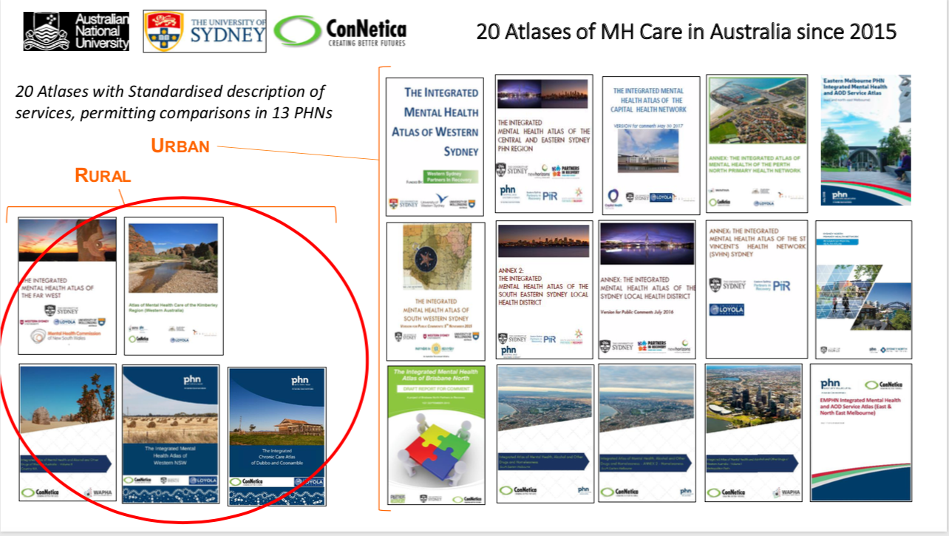
- Integrated Atlases of Mental Health & Chronic Care in Australia
While there are significant differences between the Australian regions, there are also several important consistencies evident with some types of care almost completely absent and other characteristics. These include:
- alternatives to hospital based residential services
- a shortage of sub-acute care residential services
- few employment mental health related services
- almost no structured high intensity rehabilitation day care (the exception being for veterans provided through Veterans Affairs)
- grossly inadequate child mental health services in almost all areas
- inadequate alcohol and other drug services
- a large number of small, short term funding arrangements for NGO-managed community mental health programs.
Indeed, even in rural regions, there is a high reliance on:
- acute inpatient care
- acute health related mobile outpatient care
- non acute outpatient care (mostly mobile, low intensity in nature; and
- a significant investment in accessibility – assessing needs and then trying to find services.
The distribution of the services in most regions is also mis-aligned with the locations of highest demand – meaning that consumers have to travel some distance to access care. Western Sydney is one exception in this regard.
The inequities in access to Medicare subsidised services highlighted earlier, generally compound the difficulties in accessing care and compromise the quality of care. Putting this in simple terms it means that consumers, or their carers, will all too often be unable to:
- find the range of services necessary to prevent a deterioration in their mental health
- access alternatives to an Emergency Department presentation when a mental health crisis occurs
- access longer stay residential services for recovery following a period of acute hospital-based care
- find services to enable them to return to their roles in the community – be these in undertaking training and education, employment and community social life
General Practitioners are the gateway for most consumers to access health care across Australia. GPs, but particularly those in lower socio-economic urban areas, regional cities and rural and remote locations, will have great difficulty in being able to connect their patients with skilled primary and specialist care providers, with community care services and all too often, rely on the over-extended acute care services.
The imbalance of care in the Australian mental health ‘system’ lies at the heart of the poor mental health outcomes seen in the available outcomes data. The Atlas analyses provide a clearer understanding of ‘what is’ and a sounder basis for planning ‘what needs to be’, region by region.

Recent Reports of Mental Health Service System
Two recent reports issued by independent statutory officers in Western Australia and Victoria, have been analysed here. The two statutory offices involved, have both previously issued extensive reports on mental health services and suicides within the past ten years. They have therefore, endeavoured to bring about significant improvements in mental health services and the broader responses of government previously. Their most recent reports starkly demonstrate how difficult it is to bring about systems level improvements in this area of health and social care.

WA Coroner’s Report, January 2019
In January 2019, the Western Australian Coroner, Rosalinda Fogliani, released the Inquest findings into the deaths of 13 Aboriginal children and young persons in the Kimberley region between January 2013 and March 2016. The similarities in the circumstances of each of these deaths, prompted the Coroner’s Office to examine them in one Inquest. In all but one death, the Coroner concluding the deaths were due to deliberate self-harm (suicide).
The Coroner found a lack of consultation and engagement in the design and implementation of services with Aboriginal communities, a continuing lack of coordination between agencies and a lack of accountability, a continuing failure to address the impact of intergenerational trauma and failure to tackle the social determinants of ill-health.
Coroner Fogilani made 42 recommendations mainly directed at government departments and agencies, both state and Commonwealth. Whether the Commonwealth agencies specifically identified by the Coroner acted or the recommendations, is not clear.
Coroner Fogliani summed up her findings by stating:
This Inquest has laid bare the urgent need to understand the deep inequalities giving rise to the current poor state of wellbeing of Aboriginal people in the Kimberley Region and to address the factors that elevate the risks of Aboriginal suicide at a community-led level, with genuine consultation and collaboration with Aboriginal communities.
In 2008, the then WA Coroner, Alastair Hope, reported on the deaths of 22 Aboriginal people (mainly young persons) in the Kimberley. The Inquest revealed:
- No realistic leadership and a lack of accountability from any agency in response to living conditions
- Very poor health compared to other Western Australians
- A widening ‘gap’ in wellbeing between Aboriginal and non-Aboriginal people despite funded Commonwealth and State programs targeting indigenous people
- No single individual or organisation in government responsible for achieving outcomes for Aboriginal people
- Levels of educational achievement with skills inadequate for employment in the majority of students
- Public housing in a disgraceful condition
- Aboriginal people experiencing a health crisis
- Alcohol abuse as the cause and as a result of many of the problems facing many Aboriginal people
- Serious challenges and extreme difficulty in providing comprehensive mental health and drug and alcohol care.
He stated:
That such conditions should exist among a group of people defined by race in the 21st century in a developed nation like Australia is a disgrace and should shame us all.
Coroner Hope called for urgent action to address living conditions and made 27 recommendations for multiple government agencies.
In late March 2019, media reports confirmed that in less than 3 months, 24 young Aboriginal and Torres Strait Islander people had taken their lives.
One leading Aboriginal suicide prevention expert in late 2018 heavily criticised the National Suicide Prevention Plan saying, “it is barely worth the paper it’s written on”. Gerry Georgatos said that ‘Australia will only reduce its national suicide toll if policymakers are held to account on poverty, education, bullying, and Indigenous disadvantage’. Poverty he said was a common factor in all of the deaths reported in 2019. His comments reinforce the need for real accountability and a genuine community driven and integrated policy and service response given the findings from the Inquests.

Victorian Auditor General’s Office Report, March 2019
In March 2019, the Victorian Auditor General’s Office (VAGO) released an audit report on the current 10‐year Victorian Mental Health Plan and the supporting activities committed by government and the Department of Health and Human Services (DHHS) to address known problems with access to care. The audit’s objective was ‘to determine if people with mental illness have timely access to appropriate treatment and support services’.
Like many other inquiries undertaken by independent statutory authorities over the past 15 years, the VAGO report again pointed to the failure of the relevant department to address the results of previous inquiries and reviews.
Indeed the VAGO had conducted an audit in 2009 of the response to mental health crises in the community by the Department of Health, AMHS, Victoria Police and Ambulance and found responses to these crises “are not consistently meeting the standards set out in the Mental Health Act 1986 or in agreed interagency protocols. The needs of the person in crisis at times comes second to other considerations, such as competing demands on time and resources, and historical and cultural practices”.
In 2009, the imminent gap in meeting demand for mental health services was forecast by the Department of Health in the previous decade‐long mental health plan titled Because mental health matters: Victorian Mental Health Reform Strategy 2009–2019, which stated that:
Action is needed not only to address the current needs of the Victorian population but to plan for the projected numbers of people likely to be seeking help for mental health problems in ten years’ time.
Six years into the plan, in 2015, the Department of Health and Human Services (DHHS), the agency responsible for managing Victoria’s public mental health system, acknowledged in Victoria’s 10-year mental health plan (10‐year plan), that:
...increasing and sustained demand pressure on services has not been matched with increasing resources. Shifting population and growth has left some services under even greater pressure. The result is longer waiting times to access services and higher thresholds for entry. The increased pressure on services creates a risk that people may receive treatment that is less timely, less intensive and shorter in duration than they want or need.
The conclusions reached by the VAGO in 2019 was stark, if not damming:
DHHS has done too little to address the imbalance between demand for, and supply of, mental health services in Victoria.
The lack of sufficient and appropriate system‐level planning, investment, and monitoring over many years means the mental health system in Victoria lags significantly behind other jurisdictions in the available funding and infrastructure, and the percentage of the population supported.
While DHHS understands the extent of the problem well and has been informed by multiple external reviews, the 10‐year plan outlines few actions that demonstrate how DHHS will address the demand challenge that the 10‐year plan articulates:
• there are no clear targets or measures to monitor progress in improving access
• there are no forward plans for the capital infrastructure needed
• the workforce strategy does not address the particular issues in regional and rural areas and fails to articulate specific targets
• there is no work to address barriers to access created by geographic catchment areas.
DHHS has made little progress closing the significant gap between area mental health services’ (AMHS) costs and the price they are paid by DHHS to deliver mental health services; and in addressing historical inequities in funding allocations that do not align to current populations and demographics.
The VADO highlights that numerous external reviews have failed to make an impact on the responsible lead agency’s (DHHS) capacity to plan, invest and report on system needs and reforms.

A Brief Analysis of Other Mental Health Reviews
This section summarises the results from a 2013 systematic review and synthesis of the findings of 32 National and State audits of mental health and related services undertaken by independent statutory authorities such as Ombudsman, Auditors, Public Advocates, Guardians and Commissioners. Added to that analysis, is a preliminary analysis of a further 14 reviews undertaken in 2018-2019.
In the 2013 analysis, in some cases, the reports on which the review is based were initiated by the office undertaking the review; others were prompted by public complaints, requests by a Government, Parliament or Legislative Assembly or constituted part of the office’s statutory functions (e.g. annual review of child deaths). In all cases, including the more recent reviews undertaken in 2018-19, the resulting report was undertaken independently of the government and the departments or agencies responsible for program management and/or program implementation.
The original analysis of 32 reports in 2013, was based on a systematic search of audits and reviews published by relevant statutory authorities from mid-2006 to mid-2011. This period was selected as it covered the period of the COAG National Action Plan on Mental Health (NAPMH). The COAG NAPMH was a direct response to damming assessments of the state of mental health care released by the Mental Health of Australia in October 2005 and the Australian Senate in March 2006.
The limitations of these audits and reviews are that they do not systematically analyse all aspects of the mental health care system. Nor, in the case of State and Territory focused audits do they investigate the system outside a particular jurisdiction. Moreover, when policy makers act quickly to implement the recommendations of these reports, their findings can quickly lose currency. Nevertheless, the reports represent the culmination of careful and systematic investigation of important questions by trained, independent investigators and the outcomes may be informative both as they apply to the jurisdiction and topic evaluated and for their potential applicability to other jurisdictions and topics.
To date the findings of these reports have not been synthesized by government or other researchers. The opportunity for the Productivity Commission, is that within this vast number of reviews, lie almost all of the answers to the questions it has been tasked with by the Federal Government.

Summary of Analyses
Inadequate service access included gaps in community mental health awareness and primary prevention programs and inadequate access to community-based mental health care. There were also inadequate community and hospital services in justice settings, rural and remote regions, a paucity of specialised community, crisis and hospital treatment for young people, inadequate specialised community and hospital treatment for older people, and a lack of supported accommodation for people with a mental illness. One driver of insufficient access was the inequitable distribution of the workforce across hospital and community sectors. A second was the exclusion of consumers from care unless they were in crisis.
Another limitation was a reliance on diagnosis rather than need in allocating services resulting in delays in service for consumers in clear need and the use of demand ‘management’ strategies rather than need for services (e.g., capping Access to Allied Psychological Therapies by individual GPs), thereby compromising equitable access to care.
Poor planning was regularly highlighted in reports.
Poor cooperation between agencies and inadequate continuity of care consistently compromises mental health care. This was evident across the care spectrum from prevention to accommodation with agencies failing to follow-up, share information, integrate services, undertake workforce development, agree on the division of responsibilities and develop consistency in entry criteria. For example, community mental health teams in Western Australia had shared only 19% of care plans with other professionals such as general practitioners and more than one audit implicated poor interagency communication in the subsequent deaths of young people.
Sectors nominated as requiring improved cooperation included health and mental health, emergency services, police, primary care, education, disability, child protection, housing, justice, Indigenous, family services, sport and recreation.
Human rights concerns were regularly identified in the audits among some crisis and in-patient services and denial of equitable access to supported accommodation. Examples included consumers who were not a threat to others being transferred to hospital by police vans instead of ambulances (contrary to service protocol), Crisis and Assertive Treatment Team (CATT) members requesting detention of intoxicated consumers in police cells in contravention of the relevant charter of human rights, excessive use of restraint and seclusion, consumers not informed of their rights in hospital, wrongful and extended shackling of prisoners with a mental illness in hospital, perceived organisational bias directed towards forensic inpatients, a denial of privacy in in-patient consultations in violation of the national standards and privacy legislation, and voluntarily admitted consumers placed in locked wards.
Further, it has been reported that consumers with a mental illness have been systematically denied their rights to supported accommodation. In particular, in NSW, supported accommodation was not available to people with a primary diagnosis of a mental illness. The NSW Ombudsman described this situation as a denial of ‘fundamental rights under mental health and disability legislation’. He reported that up to 60% of current psychiatric in-patients could be discharged if suitable supported accommodation were available. The responsible government Department responded that ‘if psychiatric patients were allocated the places, other people with disability would be denied places’. The Ombudsman responded that ‘it is unacceptable to trade-off the rights of people with a psychiatric disability against those of others’.
Action was consistently recommended across services and sectors to address gaps in training. Examples of the training required included de-escalation training for CATT members and police including those operating tasers, specialist training in the mental health of older people, mental health literacy training for social security and immigration staff, practical training for housing sector staff in strategies for supporting people with a mental illness, training for health staff in negotiating the housing system, and exposure of police to consumer perspectives.
Many of the audits, including the most recent reports from 2018, criticised the lack of appropriate data collection and monitoring by services and programs. Despite the commitment in the First National Mental Health Plan to develop meaningful data for planning and performance monitoring, nearly three decades later, audit reports continue to point to the lack of accessible data.
There are many groups in the community identified as being particularly disadvantaged. Groups with particular unmet need included those in the forensic/justice system, people from rural regions, those who were younger or older, people of Indigenous background, or from a culturally and linguistically diverse background, veterans, new mothers and children at risk. Disadvantage was particularly evident in forensic contexts.

Why Reforms Have Fallen Short of the Objectives
While the aims of the Second (National Mental Health) Plan (1998-2003) have been an appropriate guide to change, what has been lacking is effective implementation. The failures have not been due to a lack of clear and appropriate directions, but rather to failures in investment and commitment.
Steering Committee for the Evaluation of the Second National Mental Health Plan 2003

… mental health in Australia is a shambles … a national disgrace.
The Hon Christopher Pyne, Parliamentary Secretary, Mental Health, March 2006.

I believe the governments of Australia also owe the mentally ill an apology – a sincere and direct apology for the years of under-funding, the haphazard policy, the poor coordination, the endless excuses and evasions. I am not saying the new funding … will fix every problem. It is a huge down payment.
NSW Premier, Hon Morris Iemma, 1 June 2006,
on the announcement of $4.5Billion investment in mental health by COAG

Why Do the Problems in Mental Health Care Persist?
There are number of reasons. Despite the wealth of data in these audit reports and their potential role in mental health reform, there are typically no accountability mechanisms that ensure the responsible lead authorities change their practices to address the recommendations in these audits. Moreover, there are no formal mechanisms by which the findings and recommendations can be incorporated into national and State mental health plans or the processes of the National Mental Health Commission.
Independent evaluations of the National Mental Health Plans have repeated pointed to the need to strengthen accountability and others have argued that the failure to develop robust monitoring and reporting is a contributing factor in the failure to deliver mental health reform in Australia.
The consistency in the gaps identified in the findings from previous enquiries dating back more than two decades and the contemporary feedback from consumers, carers and providers, suggests that the areas identified require action at a systemic level and sustained over time.
The commitments by governments, sometimes by First Ministers, has never been sustained. Plans are made and agreed, but efforts falter and commitments fade away. Funding remains fixed with little real growth and little real growth in innovation or research and outcomes remain opaque if visible at all.
The need to improve access to services and accommodation, continuity of care, training, cooperation across agencies and services and to address human rights is clear as is the need to increase service access for specific groups, particularly those in forensic environments.

The Structural Shift Needed
As recent auditors and researchers have stated, while there is an abundance, indeed a bewildering number of national and state wide plans and strategy documents produced by every government on mental health and suicide prevention, there is a dearth of detail or focus on the implementation of reform. There needs to be three fundamental structural shifts:
  - The focus of mental health service planning, implementation and monitoring must move to regions. The diversity of our regions, even across the Sydney metro area, requires LHD and PHN integrated planning to be continuous and adaptive to rapidly changing community needs
  - National planning must focus on the broader policy issues that help create the conditions for mentally healthy individuals, families and communities
  - The focus on providers, peak bodies, national NGOs and professional groups – each protecting their own sectional interests – must move to a focus on OUTCOMES for the consumers of mental health services and their carers/supports.

An Alternative View
Despite the continuous process of review and inquiry into mental health care in Australia summarised here, there is an alternative view “that things are better than they were, and that’s what we should focus on”. The proponents of this view argue that there is a need to take a long-term perspective to mental health reform in Australia “informed by evidence and that does not rely on ‘crisis’-driven, ad hoc changes to service delivery”. They point to governments being ‘forced to respond to well-published examples of service failure and personal tragedy’. Indeed they point to the mental health agenda been hijacked by ‘policy entrepreneurs’.
This view fails to explain why the Abbott Government committed in 2013 to the NMHC review in the absence of any such ‘well-published’ examples of service failure or why the Andrews Government in Victoria formed the view in late 2018 that the “mental health system was broken” and establish a Royal Commission. Nor does it explain why almost every jurisdiction has now established a Mental Health Commission to independently (from Health Departments) provide greater accountability and oversight of programs and policies.
Clearly, the executive branches of government, parliaments, a range of independent statutory authorities and researchers, as well as the broader community, believe there are persistent and serious shortcomings in mental health care and that ‘the long-term approach to reform’ is not delivering.
A relevant question then to the Productivity Commission is, why have the well intentioned policy objectives repeatedly failed to be implemented? This is raised to some extent in the Commission’s Issues Paper when asking:
How effective are the governance and institutional arrangements for mental health in Australia in achieving the objectives agreed by COAG Health Council in the Fifth Plan? How can they be improved?

Part C – Transforming Mental Health Care

Introduction
WentWest believes, on all the available evidence, that with our partners we are making progress on transforming mental health care in western Sydney.
A number of recent reviews of the Primary Health Network program , support this view, notwithstanding the challenges the PHNs face.
We believe we can do much better and do it faster with some changes to national mental health policy and strategy, targeted investments in services and models of care and tackling entrenched disadvantage.

General Strategic Recommendations

Systemic Problems Require Systems Solutions
Health care is a complex business. It is well documented that health care is not like other markets in the economy. Changing health outcomes requires much more than implementing ‘EBM’ - evidence based medicine. Health care systems have many of the features of ‘complex adaptive systems’ where there is far less predictability.
‘Evidence informed health care’, based on an understanding of what works, in which context and circumstances, and for whom (rather than merely, whether it works), is far more suited to this challenge.
Centralised planning models are not well suited to complex adaptive systems such as health care and mental health care. The key features of complex adaptive systems are listed in Table 5 and Table 6 lists the characteristics of complex health care interventions. We believe these offer a more coherent and relevant basis for mental health reform going forward than a continuation of the centrally developed five year national plans and strategies.
- The Key Features of Complex Adaptive Systems
Embeddedness/nested systems: CASs are embedded within a wider context and other CASs. | Non-linearity: The magnitude of system input and agent interactions is not linearly related to the magnitude of changes in the system. A CAS can react suddenly to minor inputs or fail to change despite overwhelming external pressure.
Fuzzy boundaries: System boundaries are permeable and hard to define. | Phase changes: Where a small change in the system inputs results in a qualitative change in the system’s state.
Distributed control and self-organisation: System patterns are not created by top-down control; instead, autonomous agents interact to create outcomes. Thus, organisation in a CAS emerges naturally from local rules held by agents. | Sensitivity to initial conditions and historicism: Future agent actions are affected by past changes in the system, leading initial conditions to exert a strong influence on system behaviours.
Emergence: Interactions between agents create system outcomes that are not directly intended and are greater than the sum of the individual agent behaviours. | Non-equilibrium: CASs are characterised by continual change and do not reach equilibrium.
Unpredictability: The behaviour of a CAS cannot be predicted due to its non-linearity, sensitivity to initial conditions, and historicism. | Adaptation and co-evolution: Agents and systems evolve together, reacting to changes in the context to ensure optimal functioning and survival.
- Seven Characteristics of Complex Health Interventions
The intervention is a theory of theories. It is vital to uncover differences in stakeholders’ understandings of program theory (logic model) and try to reconcile these differences through the development of a shared theory.
The intervention involves the actions of people. Understanding human intentions and motivations, what stakeholders know and how they reason, is essential to understanding the intervention.
The intervention consists of a chain of steps or processes. At each stage, the intervention could work as expected or “misfire” and behave differently.
These chains of steps/processes are often not linear. Negotiation and feedback are involved at each stage.
Interventions are embedded in social systems. How they work is shaped by this context.
Interventions are leaky and prone to modification as they are implemented. To attempt to freeze the intervention and keep it constant would miss the point. The process of adaptation and local embedding is an inherent and necessary characteristic.
Interventions are open systems and change through learning as stakeholders come to understand them.

‘Context is Everything’
The role of context is critical in health services reform and research. The same intervention in what appears to be the same setting by the same practitioners in a different community on one side of Sydney to another, can produce different outcomes. This reality has been widely documented and greater efforts are being directed to the study of health ‘ecosystems’ lead by leading think tanks including work specifically in mental health ecosystems.
The framework presented in Part A of this submission, provides a robust alternative to the current approach to mental health reform in Australia at both national, state and regional levels.
Planning and implementation that combines:
- Evidence based medicine – or Experimental knowledge developed through Random Controlled Trials, systematic reviews and the like
- Observational cohort studies – providing richer understandings of interventions and target audience impacts
- Context Analysis – demographics and geo-spatial analysis
- ‘Evidence-based health care’ or ‘evidence-informed policy’ - through the addition of routine big data and local context information,
- ‘Knowledge- guided policy’ - through the incorporation of domain experts, both within and beyond the western Sydney region, to the data analysis process
- Experiential knowledge – the incorporation of the expertise from those with lived experience – consumers and carers
Evidence-informed, rather than merely evidence-based, healthcare policy and practice acknowledges that policy-making is an inherently political process in which research evidence is only one factor that influences decision-making.

The Building Block of Primary Care
A strong primary care system is essential to the equity, efficiency and effectiveness of the health system and improvements in health outcomes.
Russell and Dawda, Menzies Centre for Health Policy Feb 2019.
The view expressed in the quote from this recent review of PHNs, is one that has been documented many times by many of the world’s leading health organisations – WHO, Institute of Medicine, Institute of Healthcare Improvement and others.
In the Australian context, primary health care is supported through the Medical Benefits Scheme or Medicare. Approved providers receive payments for a schedule of over 5,000 services or items. The fee-for-service or occasions of service funding model supports the overwhelming majority of primary care practice in Australia. It does not readily support the exemplary primary care practices documented by Bodenheimer et al or the Institute of Healthcare Improvement, and others around the world.
Russell and Dawda (2019), Duckett (2015) and many other Australian researchers have pointed to the Medicare fee-for-service models hindering the adoption of collaborative and integrated care.
Exemplar primary care has the Ten Building Blocks described earlier in Part A of this submission. The four foundational elements – engaged leadership, data-driven improvement, ‘empanelment’ or the linking of each patient to a care team and a primary care clinician, and team based care – assist the implementation of the remaining six building blocks.
Primary care models such as the Patient Centred Health Care or Medical Home do embody these elements. In Australia, the closest model to these is the DVA ‘White’ and ‘Gold’ Health Care schemes. Nonetheless, the DVA model lacks a number of the elements described by Bodenheimer.
Fundamental reform to Medicare, and associated primary care funded programs, is required if Australia is to be able to meet the challenges of an aging and more diverse population and address the growing inequality of access to MBS-subsidised services. That reform should be driven by aligning our major funding programs to the Ten Building Blocks framework.

Strategic Issues in Mental Health

The National Mental Health Commission Review
The 2014 Review of Programmes and Services undertaken by the NMHC was the most extensive review of mental health services in a generation. The recommendations from the Review were endorsed by the Federal Government in November 2015 with responsibility for implementation assigned to the DOH. Regrettably, in our view, the Government did not assign an oversight role to the NMHC or to the expert committee that was appointed in 2015 to prepare the Australian Government’s response.
Consequently, much of the intent of the review has been lost or weakened. For example, the NMHC made a strong case for moving away from continuing to fund and manage national programs in both mental health and suicide prevention and devolve this to PHNs. National NGOs continue to be funded and hence manage, significant program expenditures. PHNs have little if any capacity to commission, integrate or contextualise these investments. PHNs continue to have little access to program metrics or outcomes data. This is counter to the recommendations of the NMHC Review and compromises community outcomes.

Mental Health in All Policy
In 2009 the National Advisory Council on Mental Health, as part of the work led by the National Health and Hospital Reform Commission, produced a discussion paper setting out a broader vision and direction for mental health policy in Australia; one focussed on creating and protecting ‘mental wealth’ across the lifespan. It had wide stakeholder endorsement at the time.
It stated:
A mentally healthy Australia is fundamental to our sustainability – economically, culturally and socially. Being mentally healthy means being in a state of complete mental, emotional and social wellbeing and this involves much more than merely ‘the absence of a mental illness’. Being mentally healthy is more than having access to a first-rate person-centred health care service where and when we need it.
Our governments’ investment in mental health need to evolve significantly: beyond the dominant focus on acute and sub-acute health care to include a more balanced emphasis on community care, a clear focus on managing the risk factors that can give rise to mental illness and a strengthening of the protective factors that prevent mental illness and promote mental health.
To be successful, investment in a mentally healthy Australia needs to be embedded across a whole-of- government national policy framework. This means that we need to reflect a focus on mental health across the board – in our approach to education, social services, housing, employment, Indigenous affairs and so on – not just in our health or mental health services
Our vision is that all Australians can live a mentally healthy life and be able to access quality mental health services and support when and where they need it.
As we have known for a long time, health outcomes, including mental health outcomes, are determined by social and environmental factors more than other factors. Policies on human rights, taxation, employment and income, transport, housing, education, parenting and early childhood, aged care, public infrastructure and the built environment, social security and immigration – all beyond the responsibility of Health Ministers and their agencies – impact positively and negatively on individual’s and community’s mental health and wellbeing.
The intergovernmental arrangements ensuring that consideration, at the very least, is given to policies in these areas -before they are implemented, and active monitoring is operating - must be given priority at the highest level of all Australian governments. Cross-portfolio and intergovernmental governance arrangements must be strengthened with greater community leadership and engagement and greater transparency.
To continue to not build health and mental health policy into all policy, will simply contribute to the challenges now so evident in the mental health and wellbeing of the Australian community.

Accountability
A consistent theme in evaluations and independent reviews of national mental health plans, has been the absence of accountability. This transcends almost every facet of mental health service provision. Too little is known about the impacts and outcomes of services and initiatives. This has to change.
Allied with the lack of accountability is the lack of access to data. De-identified service utilisation and outcomes data must be available to program planners, researchers and most importantly the Australian community to enable informed decisions – from new investments and closing services to making an informed choice of a provider. The technologies are available to make this happen and accessible to all Australians.
Governments need to consider how agencies can be held accountable if they fail to implement the changes recommended by auditors and statutory authorities.
Further, we need to develop formal processes by which the findings of independent audits are reviewed systematically, and the outcomes made available in accessible form to the Australian Health Ministers’ Advisory Council (AHMAC) and/or the Council of Australian Governments (CoAG) and to consumers and carers and those who represent them.

Quality Matters
Jorm and other researchers have pointed to the quality of mental health care as being a key factor in why there has not been any improvement in the mental wellbeing of Australians despite increased awareness and literacy and access to care. Access has been prioritised over quality of care.
The NMHC 2017 review of the ADFs and DVAs suicide and self-harm prevention services, found that Canadian and Dutch serving and former defence force members were able to access high quality, specialist mental health and suicide prevention services. Services were concentrated where defence force members live, work or have moved to and engaged primary and specialist providers who worked solely with former and serving defence force members and their families.
Scaling up the initiatives undertaken by WentWest and other leading PHNs in Australia to build quality mental health care, and borrowing and adapting from the best practices elsewhere, must be a priority moving forward.

Appendix One: The Role of PHNs

The role of PHNs has been set out by the Commonwealth Department of Health in various documents since their establishment.
PHNs were established with two overarching objectives:
- To increase the efficiency and effectiveness of medical services for patients, particularly those at risk of poor health outcomes.
- To improve coordination of care to ensure patients receive the right care, in the right place, at the right time.
The three main roles for PHNs are:
- Commission health services that meet the needs of the people in their regions and fill identified gaps in primary health care.
- Work closely with general practitioners (GPs) and other professionals to build health workforce capacity and provide the highest quality standard of care through practice support activities.
- Work collaboratively to integrate health services at the local level to create a better experience for patients as they navigate the health system, reduce waste and red tape and eliminate service duplication.
The objectives of the PHN mental health funding are to:
  - Improve targeting of psychological interventions to most appropriately support people with or at risk of mild mental illness at the local level through the development and/or commissioning of low intensity mental health services.
  - Support region-specific, cross sectoral approaches to early intervention for children and young people with, or at risk of mental illness (including those with severe mental illness who are being managed in primary care) and implementation of an equitable and integrated approach to primary mental health services for this population group.
  - Address service gaps in the provision of psychological therapies for people in rural and remote areas and other under-serviced and/or hard to reach populations, making optimal use of the available service infrastructure and workforce.
  - Commission primary mental health care services for people with severe mental illness being managed in primary care, including clinical care coordination for people with severe and complex mental illness who are being managed in primary care including through the phased implementation of primary mental health care packages and the use of mental health nurses.
  - Encourage and promote a systems based regional approach to suicide prevention including community based activities and liaising with Local Hospital Networks (LHNs) and other providers to help ensure appropriate follow-up and support arrangements are
  - In place at a regional level for individuals after a suicide attempt and for other people at high risk of suicide, including Aboriginal and Torres Strait Islander people.
  - Enhance access to and better integrate Aboriginal and Torres Strait Islander mental health services at a local level facilitating a joined up approach with other closely connected services including social and emotional wellbeing, suicide prevention and alcohol and other drug services.
These objectives will be underpinned by:
  - Evidence based regional mental health and suicide prevention plans and service mapping to identify needs and gaps, reduce duplication, remove inefficiencies and encourage integration.
  - A continuum of primary mental health services within a person-centred stepped care approach so that a range of service types, making the best use of available workforce and technology, are available within local regions to better match with individual and local population need.

Appendix Two: The Integrated Atlas of Mental Health

Methodology
The Description and Evaluation of Services and Directories in Europe for Long-Term Care (DESDE-LTC) has been utilised in the development of the western Sydney Integrated Atlas. The DESDE is an open-access, validated, international instrument for the standardised description and classification of services for long term. Whilst originally developed around health issues requiring long term care, the application of the DESDE-LTC across chronic conditions in Australia includes services across a spectrum of care intensity and duration.
The DESDE-LTC includes a taxonomy tree and coding system that allows the classification of services in a defined catchment area according to the main care structure or activity offered, as well as the level of availability and utilisation. The classification of services based on the actual activity of the service, rather than the name of the service provider, therefore reflects the real provision of care.
In research on health and social services there are typically different units of analysis, however the Integrated Atlas requires that comparisons be made across a single and common ‘unit of analysis’ group. Different units of analysis include: Macro-organisations (e.g. Local Health Networks), Meso-organisations (e.g. hospitals), and Micro-organisations (e.g. services). It could also include smaller units within a service such as care: types, modalities, units, intervention programs, packages, activities, or philosophies.
Analysis based on DESDE-LTC is focused on the evaluation of individual service delivery teams or Basic Stable Inputs of Care (BSIC).

Basic Stable Inputs of Care
A Basic Stable Input of Care (BSIC) is a team of staff working together to provide care for a group of people, often referred to as a service delivery team.
To be considered for inclusion, a team has to be stable both in terms of the longevity of the service as well as the structure of the service. The longevity of the service is related to the time period for which the service has been funded with a team considered to be stable if it has been funded three or more years or has funding secured for three years. The structural stability of a service is related to both physical and administrative parameters with a team considered stable if it has administrative support and two of the following: their own space (e.g. dedicated building or shared office); their own finances (e.g. a specific cost centre); or their own forms of documentation (e.g. data collection or service reports).

Classification of BSIC
Once a BSIC is identified utilising the criteria for inclusion, the Main Types of Care (MTC) provided are determined based on the Long Term Care Mapping Tree. Each of six main types of care (i.e. branches) are further classified depending on a range of other characteristics related to the service including acuity, mobility, intensity and access to health-related staff and/or information. The six main types of care include:
R Residential Care - facilities which provide overnight beds related to clinical and social management of client health conditions (e.g. inpatient hospital wards, crisis shelters, residential rehabilitation services and inpatient withdrawal units).
D Day Care - facilities which have regular opening hours, provide a combination of treatment options (e.g. support, social contact, structured activities) normally available to several clients at a time and expect clients to stay at the facility beyond allocated face to face contact with staff.
O Outpatient Care - services that involve contact between staff and clients for some purpose related to the management of their condition and associated clinical and social needs and are not provided as a part of residential or day services. Includes outreach services.
A Accessibility to Care - services whose main function is to facilitate access to care for clients with long-term care needs (e.g. care coordination services).
I Information for Care - services whose main function is to provide clients with information or assessment of their needs and are not involved in subsequent follow-up or direct provision of care (e.g. telephone information and triage type services).
S Self-Help and Voluntary Care - services which aim to provide clients with support, self-help or contact, with un-paid staff that offer any type of care (i.e. Residential, Day, Outpatient, Accessibility or Information).
Each BSIC is classified by using one or more codes based on the MTC they deliver. Some services might include a principal structure or activity (e.g. a Residential Care ‘R’ code) and an additional one (e.g. a ‘Day Care’ ‘D’ code).

Inclusion Criteria
To ensure consistency and comparability, both nationally and internationally, set inclusion criteria determine whether services are considered for analysis. As part of the DESDE methodology, for a service to be included it has to be geographically relevant, specialised, universally accessible, stable and providing direct care or support (Table 7).
- Atlas Service Inclusion Criteria
Criterion Description
Geographically relevant | Only service provide care within a predetermine set geographical region are included.
Specialised | Must specifically target people with a lived experience of mental illness i.e. the primary reason for using the service is for treatment of mental illness related issue. This excludes generalist services that may lack staff with specialised mental health training and experience.
Universally accessible | Regardless of whether they are publicly or privately funded, only services that do not have a significant out-of-pocket cost are included.
Stable | The service has or will receive funding for more than three years.
Providing direct care or support | Must provide direct contact to people with a lived experience of mental illness. Services that are only concerned with the coordination of other services or system improvement are excluded.

- Long Term Care Mapping Tree
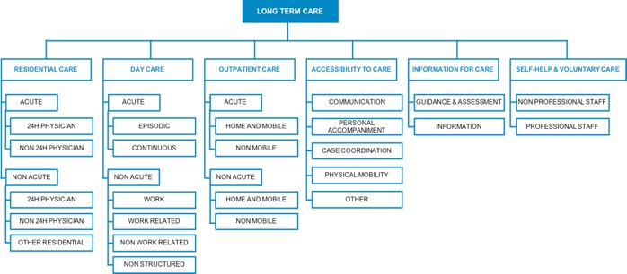
As with the other 19 Atlas reports developed in Australia, there were five key steps involved in the creation of the Integrated Mental Health Atlas for Western Sydney atlas (Figure 22).
Integration of information
Identification of available databases with local data
Data Collection
Interview service providers
Coding of services
Analysis of patterns of care
Analysis of local data
(mapping of demographic and socio-economic indicators relevant to mental health and AOD)
Identification of all MH and AOD services
Mapping of services in relation to indicators
Regular meetings with EMPHN to validate findings
Report for comment
Final Report
- Integrated Mental Health and AOD Atlas Development Process

Appendix Three: Brief Description of New Initiatives 2016-2019

Activities | Description
Helpline | A professional telephone counselling and support service, ‘On the Line’, available 24/7 as an effective low intensity service which incorporates direct telephone support, real-time counselling, call back services. Additionally, this service will allow for direct liaison with WentWest as well as the mental health professional and providers for WentWest, should the caller/ consumer disclose, or be identified as needing, face to face services.
Consumer Navigation Planning Tool (No Wrong Door | Assist people with mental health experience and their families and carers to navigate information relevant to their current mental health concerns as well as provide information regarding service delivery, service types and professional help within the region. This will assist people in their choice of services and be better informed about the services they may require. This will be a 24-hour online app that will support primary mental health care services within the region.
Online Support and Health Coaching (Anna Cares) | Assist people via an online health coach, ‘Anna Cares’, an interactive health coaching app that allows consumers to monitor and assist with their recovery as well as self-care. This app informs and supports the work of the face to face professional (psychologist) as the service is prescribed to the consumer, which provides feedback to the consumer registered with Anna Cares, and to the prescribing agent and WentWest. The technology creates an ongoing support tool for consumers after treatment is completed. This service will help patients with day-to-day activities and supports them to maintain independence.
Western Sydney Recovery College: | Peer worker led self-management groups delivered within primary care settings. The Recovery College provides a person-centred model for individuals, carer’s and families living with a mental illness as well as the opportunity for personal growth and education through the programs. These courses are unique as they are delivered by Peer Facilitators who have lived experience with their own mental illness, further strengthening the journey of recovery. Courses are co-produced by clinicians jointly with people with lived experience which encourages the development of increased individual and system wide understanding of the experience of mental illness, recovery and maintaining recovery.
Hospital to Home program: | Support for mental health consumers during hospital admission and the six to eight-week period after discharge - a time when many consumers are vulnerable and require additional support in order to return to living fulfilling and autonomous lives. Hospital to Home focuses on helping consumers to self-manage their recovery, connect with their social networks and minimise feelings of isolation
General Practice Support and Capability Building – Psychiatrist Liaison Model | An innovative model of integrated mental, physical and behavioural health within primary care supported by comprehensive mental health expertise. It is a co-located primary mental health service provided in GP clinics via a referral process. It is built on provision of a 1.0 FTE Consultant Psychiatry Liaison (CPL), embedded into the western Sydney primary care network and who will facilitate the provision of services to patients with mental health needs through coordination between GP practices and the wider primary care network. In 2019 this was expanded to 2.0 FTE CPL.  Practice teams can access CPL for support, advice and to build capability across the primary care team to support severe and complex care needs. Includes the commissioning of support and capability building for the primary care team that aligns to the Quadruple Aim and builds general practice as the Healthcare Home. The model was initially implemented across 10 general practices and has since expanded. The model includes core components of:  - Mental health services embedded to Primary Care with alignment to the Healthcare Home model  - Working in a team-based model of care in the practice  - Using and supporting electronic shared care plan (LinkedEHR) to deliver services  - WentWest will assist and coordinate referral to the psychiatrist as a regional service (in addition to practice based referrals)  In addition, it is essential the model is supported by other providers such as mental health nurses, counsellors, social workers, peer worker and addiction specialists to be liaison-collaborators.
Mental Health Nurse Credentialing | Developed in 2017. This approach supports the credentialing of nurses in primary care to provide services that support increased provision of services in general practices, for example metabolic screening, medication management and monitoring such as that required for Clozapine administration. Development of the primary care workforce via activities that support and enhance the role of practice nurses is essential to enable new and extended models of care in general practice.
After Hours Services for Mental Health | Address service availability gaps and consumer health literacy, seeking to improve and support appropriate utilisation of available western Sydney after hours primary care services and ultimately reduce low acuity and unnecessary Emergency Department presentations. Provision of incentives for primary care service’s to be opened extended hours and develop an afterhours network.
Helpline Suicide Call-back Service | 24-hour service that provides telephone and online counselling to people 15 years and over who are suicidal, caring for someone who is suicidal, bereaved by suicide or a health professionals supporting people affected by suicide. Provides immediate telephone counselling and support in a crisis and can provide up to six further telephone counselling sessions with the same counsellor scheduled at times best suited to client’s needs.
Lifespan Model for Suicide Prevention | Co-design suicide prevention services based on the evidence-based components of the Black Dog LifeSpan model, with a focus on 3-4 components of this model.  (This was further contextualised through work with The Sax Institute, Brain and Mind Centre (University of Sydney) and Synergia.)
Aboriginal & Torres Strait Islander Mental Health First Aid (MHFA) & ASIST (Applied Suicide Intervention  Skills Training) | Evidence-based training for mental health first aid and suicide prevention that aims to support people on their journey of recovery and for those involved in their care through educational sessions.
Cert 4 Peer Work (MHCC): | Training for Peer Workers via The Recovery College who can support the Aboriginal and Torres Strait Islander community via ATSI Certificate 4 peer workforce modules. This qualification is specific to workers who have lived experience of mental health problems as either a consumer or carer and who work in mental health services in roles that support consumer peers or carer peers.

 | Platform Building and Infrastructure Support
Regional Mental Health Expenditure | Significant federal expenditure on mental health is via the Medical Benefits Schedule (MBS) and the Pharmaceutical Benefits Schedule (PBS). To realise the goals and objectives in our regional plan we will need to reorient some of this spend towards supporting a different model of care and activities. This activity will be a detailed review and analysis of MBS and PBS data activity at a practice level (General Practice and Allied Health) for mental health associated expenditure in western Sydney
Centralised Referral and Triage System for primary mental health services | WentWest has maintained its established centralised intake process for client referral from the primary health sector to community and primary mental health care services.  Redesigning the referral form to assist primary care to better engage and refer to a suite of commissioned services. This supports a stepped care model and entry point for a number of services that will streamline the service for both client and provider.

Appendix Four: Results of WentWest Stakeholder Consultations

Interviews and Group Meetings
Qualitative data was collected via focus groups, one with consumers and carers and one with service providers, and key informant interviews. The purpose was to record participants views and experiences relating to WentWest’s and more generally PHNs’ operational context, performance, obstacles and areas for improvement in relation to the provision of mental health services.
In total, 12 interviews with 14 individuals were conducted. Typically, each interview’s duration was between 45–90 minutes and interviews were conducted face to face with some supplementary phone discussions to clarify shared information. Open ended questions were used to facilitate discussion around issues most relevant to each interviewee’s expertise and experiences with WentWest and PHNs. Participants were informed that all shared information would be reported anonymously.
The focus groups were two hours in duration and a total of 15 service providers and 11 consumers and carers attended these forums.
All interviews and the two focus groups were held between 19 February and 14 March 2019.
The results are summarised at the conclusion of Part A in this submission.

Survey Results

Introduction
An online survey was used to gather feedback from key stakeholders on a range of issues relating specifically to WentWest’s performance and the role of PHNs in mental health reform. Consumers, carers and service providers were invited by WentWest via existing networks to complete the survey, which was accessible March 10–27, 2019. A total of 19 stakeholders undertook the survey, one being a consumer who did not complete the survey. No carers completed the survey.

Focus of the Survey
Stakeholder feedback was sought on the National Headline KPIs set for PHNs by the DoH and:
- the alignment with PHN objectives, the availability of existing data sources, and feasibility of PHNs to influence change
- the performance of WentWest over the past 3 years in achieving these KPIs
- the quality of WentWest’s planning processes
- the organisational performance of WentWest in relation to skills-based boards and councils, population needs analysis and planning and financial management.
In addition stakeholders were asked to provide an indication of the impact of WentWest in relation to their own organisation and the region. Finally they were asked to indicate if the roles for PHNs for the next five years were in their view important and the capacity of WentWest to fulfil the specific role.

Who Participated?
- Place of work: 50% were from organisations in the private sector, 31% from the not for profit sector, and 19% the public sector
- Workforce size (FTEs): 50% were from organisations that employed less than 10, 31% more than 100, 13% 21-50, 6% 51 – 100
- Provided services - top 5 identified services that their organisations provided were: mental health (81%), alcohol and other drugs (44%), suicide prevention (38%), relationship counselling (31%), domestic violence and specialist health (both 25%)
- Targeted client groups - the least serviced groups were: children, family, aged and youth, LGBTIQ and CALD and Aboriginal and Torres Strait Islanders
- Location of service provision: 56% in WentWest catchment area and provided contracted services to WentWest and 44% in catchment area and do not provide contracted services
- Working relationship with other PHNs: 50% of the organisations do work with other PHNs.

Key Findings
- The overall impact of WentWest commissioning on their organisation’s performance and capacity was rated by a majority of respondents as between ‘slightly positive’ to ‘very positive’ in relation to: 1) ‘service delivery’ (56%); 2) ‘quality of care/services’ (60%); 3) business planning (50%); 4) ‘leadership’ (51%). 44% of respondents rated workforce capacity similarly.
- The relevance of the DoH’s ‘National Headline’ KPIs to WentWest’s context in relation to: 1) ‘preventable hospitalisations’ was rated at 93% and 2) ‘mental health treatment rates’, 85%. Respondents were least sure about ‘childhood immunisation’ and ‘cancer screening’.
- Nearly all respondents (85%) felt that it was ‘moderately to highly feasible’ for WentWest to improve ‘mental health treatments rates’. 69% felt that WentWest had a moderate to high feasibility of influencing outcomes in relation to ‘avoidable hospitalisations’.
- In relation to performance, nearly a third of respondents (31%) gave top rating for WentWest’s efforts on ‘mental health treatment rates’ and ‘preventable suicides’.
- Respondents rated the quality of WentWest planning processes highly with the highest ratings being for ‘inclusiveness of stakeholders’ and ‘communication on progress’.
- With regard to WentWest organisational performance, a majority of respondents were ‘unsure’ in relation to governance structures and financial reporting. Most positive comments related to ‘Annual plans’, ‘population needs’, and ‘community advisory committees’.
- WentWest’s impact on key attributes of mental health service in Western Sydney was assessed by only 10 respondents. The highest ratings on impact (‘moderate’, ‘high’ or ‘very high’) were: 1) ‘quality of mental health care’ (70%); 2) ‘access to mental health care’ (70%); 3) regional planning (70%); and 4) Improved mental health care patient/consumer outcomes (70%). ‘Workforce capacity’, ‘workforce capability’ and ‘collaboration between primary health care workers’ (all with 60% respondents rating as ‘moderate’, ‘high’ or ‘very high’). ‘Improved access to and availability of data’ was least known and the lowest rated element.
- WentWest’s ‘impact on developing care pathways’ was rated by only 10 respondents. The least known of the listed care pathways was that ‘between GPs and hospital services’ (60% rated as ‘unsure’) and with the least impact (30% rated impact as ‘moderate’ or ‘significant’). The most positive impact related to ‘GPs and psychologists’ (60% rated as ‘moderate’ or ‘significant’)
- WentWest capacity to fulfil the Australian Government’s goals for the next five years, only 10 completed this question. However, there was strong agreement that all goals were important and there was a high degree of confidence in WentWest’s capacity to achieve them.

Appendix Five: Inquiries into Mental Illness

A full listing of inquiries ever undertaken into mental illness and mental health is beyond the resources available for this submission. However, it is in all probability, numbers in the hundreds. The Burdekin Report in 1993, states ‘in NSW alone, there have been approximately 40 inquiries into psychiatric facilities and services since the first recorded case of mental illness in 1801’.
At the time of this submission there were no less than four major inquiries in mental health services and related matters simultaneously underway across Australia.
Given the history of mental health services in Australia, the vast majority of inquiries have been at a state or territory level, rather than national inquiries. Burdekin identifies only two national inquiries at the time of his review: A Stoller and KW Ascott (1955), Mental health facilities and need of Australia and P Eisen and K Wolfenden (1988), National mental health services policy: the report of the consultancy to advise the Commonwealth, State and Territory Health Ministers.

Major National Inquiries/Reviews Since 1993
Since the Burdekin Inquiry (1989-1993) and the subsequent introduction of the National Mental Health Strategy in 1992, there have been a significant number of major national reviews. An extensive, but incomplete, list is shown in Table 7.
- Major National Reviews of Mental Health Since 1993
Year | Organisation/authors | Title
1996 | B McKay (prepared for the Dept of Health & Ageing) | Final report: Optimum supply and effective use of psychiatrists
1999 | Australian Medical Workforce Advisory Committee | The specialist psychiatry workforce in Australia: supply and requirements, 1999-2010: summary of findings & recommendations
2004 | Mental Health Council of Australia | Out of Hospital, Out of Mind
2006 | Mental Health Council of Australia | Not for Service: Experiences of Injustice and Despair in Mental Health Care in Australia
2006 | Gavin Andrews (prepared for the Dept of Health & Ageing) | Tolkien II A needs-based, costed stepped-care model for Mental Health Services
2009 | David Dunt (prepared for Minister of Veterans Affairs) | Review of mental health care in the ADF and transition through discharge
2009 | David Dunt (prepared for Minister of Veterans Affairs) | Independent study into suicide in the ex-service community
2010 | Graham Martin & Andrew Page (prepared for the Dept of Health & Ageing) | National Suicide Prevention Strategies: A Comparison
2010 | John Mendoza et al, ConNetica | Suicide and Suicide Prevention in Australia: Breaking the Silence
2013 | Medibank Private & Nous | The Case for Mental Health Reform in Australia: A Review of Expenditure and System Design
2013 | John Mendoza et al; ConNetica | Obsessive Hope Disorder: Reflections on 30 years of mental health reform in Australia and visions for the future.
2014 | National Mental Health Commission | Contributing Lives, Thriving Communities – Review of Mental Health Programs & Services
2015 | Australian Government (prepared by Expert Reference Group) | Response to the Review of Mental Health Programmes
2016 | Australian Institute of Health and Welfare | Incidence of suicide among serving and ex-serving Australian Defence Force personnel 2001–2014
2017 | National Mental Health Commission (subcontracted to ConNetica) | Review of Suicide and Self Harm Prevention for Serving and Former members of the Australian Defence Force and their Families

Federal Parliamentary Inquiries
There has been a total of 29 Federal Parliamentary inquiries since 1971; the vast majority since the commencement of the National Mental Health Strategy in 1992. These are listed below. This list does not include inquiries dealing with alcohol and other drug issues, gambling, Indigenous wellbeing (such as The Stolen Generations), the National Disability Insurance Scheme (unless specifically on mental health matters), asylum seekers or those in offshore detention, or people in institutional care (such as The Forgotten Australians or Royal Commission into Institutional Responses to Child Sexual Abuse).
- Federal Parliamentary Inquiries on Mental Health Since 1971
Tabled date | Name of Inquiry | Committee
5/05/1971 | Mentally & Physically Handicapped People in Australia | Standing Committee on Health and Welfare (Senate)
24/11/1988 | After the march: Strengthening support for the veterans – Counselling and ancillary services for Vietnam Veterans | Standing Committee on Family and Committee Affairs (House)
5/06/1995 | Psychotherapeutic Medication in Australia | Standing Committee on Committee Affairs (House)
2/06/1997 | Aspects of youth suicide – summary report | Standing Committee on Family and Committee Affairs (House)
16/11/2004 | Provisions of the Criminal Code Amendment (Suicide Related Material Offences) Bill 2004 | Legal and Constitutional Legislation Committee (Senate)
12/05/2005 | Provisions of the Criminal Code Amendment (Suicide Related Material Offences) Bill 2005 | Legal and Constitutional Legislation Committee (Senate)
30/03/2006 | A national approach to mental health – From crisis to community: First report | Select Committee on Mental Health (Senate)
9/05/2006 | A national approach to mental health – From crisis to community: Final report | Select Committee on Mental Health (Senate)
19/06/2008 | Interim report: Mental health services in Australia | Community Affairs, Legislative and General Purposes Standing Committee (Senate)
25/09/2008 | Towards Recovery: Mental health services in Australia | Community Affairs, Legislative and General Purposes Standing Committee (Senate)
24/06/2010 | The Hidden toll: Suicide in Australia | Community Affairs References Committee (Senate)
4/07/2011 | Before it’s too late: report on early intervention programs aimed at preventing youth suicide | Standing Committee on Health and Aging (House)
31/10/2011 | Interim report: Funding and administration of mental health services | Community Affairs References Committee (Senate)
31/10/2011 | Second Interim report: Funding and administration of mental health services | Community Affairs References Committee (Senate)
1/11/2011 | Commonwealth funding and administration of mental health services | Community Affairs References Committee (Senate)
28/06/2012 | Work wanted: mental health and workforce participation | Standing Committee on Education and Employment (House)
24/06/2013 | Care of ADF personnel wounded and injured on operations | Joint Standing Committee on Foreign Affairs, Defence and Trade (House)
12/11/2013; 18/02/2014;  19/3/2014 | Interim, 2nd & 3rd reports: Care and management of younger and older living with dementia and behavioural and psychiatric symptoms of dementia | Community Affairs References Committee (Senate)
26/03/2014 | Final Report—Care and management of younger and older Australians living with dementia and behavioural and psychiatric symptoms of dementia | Community Affairs References Committee (Senate)
24/06/2015 | Adequacy of existing residential care arrangements available for young people with severe physical, mental or intellectual disabilities in Australia | Community Affairs References Committee (Senate)
12/10/2015 | 4th report: Mental health: a consensus for action | Select Committee on Health (Senate)
17/03/2016 | Mental health of Australian Defence Force members and veterans | Foreign Affairs, Defence and Trade Committee (Senate)
29/11/2016 | Indefinite detention of people with cognitive and psychiatric impairment in Australia | Community Affairs References Committee (Senate)
15/08/2017 | Provision of services under the NDIS for people with psychosocial disabilities related to mental health | Joint Standing Committee on National Disability Insurance Scheme (both)
15/08/2017 | The constant battle: suicide by veterans | Foreign Affairs, Defence and Trade Committee (Senate)
04/12/2018 | Accessibility and quality of mental health services in rural & remote Australia - Report | Community Affairs References Committee (Senate)
14/02/2019 | Accessibility and quality of mental health services in rural and remote Australia—Additional information | Community Affairs References Committee (Senate)

Reviews by State/Territory Statutory Authorities Since 2006
Griffiths, Mendoza and Carron-Arthur (2015) conducted a systematic qualitative review of all 32 audits undertaken by statutory authorities in Australia between mid-2006 and mid-2011. This period covered the years of the COAG National Mental Health Plan which saw the largest ever increase (in real terms around 20%) of mental health funding. These audits were undertaken by Offices of Auditor’s General, Ombudsman, Public Advocates, Child Safety Commissions, Human Rights Commissions, and Public Trustees. It did not include reports conducted by Coroner’s, including those examining suicide clusters.
The majority of these reports focus on mental health services or systems of care, interagency arrangements and accountability. Some, particularly those undertaken by Public Advocates and Ombudsman, address individual cases. Nonetheless, these individual cases reveal consistent, systemic problems with mental health care.
For this submission, a partial review of these websites and those of the state and territory parliaments in four jurisdictions (NSW, SA, Victoria, WA) for the period from July 2011 to March 2019, revealed another 42 reports where mental health and/or suicide prevention were a first or second order focus. The list includes only two reports from a state Health Department – they have been from South Australia and linked to inquiries by statutory offices.
Almost all the annual reports issued by these state/territory statutory agencies in the period since 2011, also contain references specifically to mental health, but have been omitted from Table 9.
- Reviews Undertaken by State/Territory Statutory Authorities, 2011-2019
Year | Name of Inquiry/Report | Organisation/Committee
2012 | Denial of rights: the need to improve accommodation and support for people with psychiatric disability. | NSW Ombudsman
2012 | Dept for Correctional Services – Restraining and shackling of prisoners in hospitals | SA Ombudsman
2013 | Addressing Homelessness: Partnerships and Plans | Victorian Auditor General
2013 | Dept for Correctional Services – Treatment of a prisoner | SA Ombudsman
2013 | Investigation into children transferred from the youth justice system to the adult prison system | Victorian Ombudsman
2013 | A Better Way. A report into the Department of Housing’s disruptive behaviour strategy & more effective methods for dealing with tenants | WA Equal Opportunity Commissioner
2014 | Investigation into ways that State Government departments and authorities can prevent or reduce suicide by young people | WA Ombudsman
2014 | Investigation into deaths and harm in custody (suicide) | Victorian Ombudsman
2014 | Mental Health Strategies for the Justice System | Victorian Auditor General
2014 | Implementation and Initial Outcomes of the Suicide Prevention Strategy | WA Auditor General
2014 | Licensing and Regulation of Psychiatric Hostels | WA Auditor General
2014 | Investigation following concerns raised by Community Visitors about a mental health facility | Victorian Ombudsman
2015 | Our Children Can’t Wait: Review of the implementation of recommendations of the 2011 Report of the Inquiry into the mental health & wellbeing of children & young people in WA | WA Commissioner for Children & Young People
2015 | NSW Health: Mental health post-discharge care | NSW Auditor General
2016 | Dept for Correctional Services – Shackling of a prisoner in hospital | SA Ombudsman
2016 | Dept for Correctional Services –Shackling of a prisoner in hospital | SA Ombudsman
2016 | Efficiency and Effectiveness of Hospital Services: Emergency Care | Victorian Auditor General
2016 | Reintegrating young people into the community after detention | NSW Auditor General
2017 | Inquiry into behaviour management in schools | NSW Ombudsman
2017 | Oakden Report: Oakden Older Persons Mental Health Service | SA Chief Psychiatrist
2017 | Dept for Correctional Services – Unlawful shackling of a mental health patient in hospital | SA Ombudsman
2017 | NSW Ombudsman Inquiry into behaviour management in schools | NSW Ombudsman
2017 | Submission to Ministry of Health’s Review of seclusion, restraint & observation of consumers with a mental illness in NSW Health facilities | NSW Ombudsman
2017 | Investigation into Victorian government school expulsions | Victorian Ombudsman
2017 | The same four walls: inquiry into the use of isolation, separation & lockdowns in the Victorian youth justice system | Victorian Commission for Children & Young People
2017 | Inquiry into FIFO work arrangements (suicide rates among FIFO workers) | WA Parliament, Education & Health Standing Comm.
2017 | Probe into potential unlawful discrimination of people with mental health issues in Victorian travel insurance industry | Victorian Human Rights Commission
2017 | Dept for Correctional Services & Central Adelaide LHN (SA Prison Health Service) – Wrongful placement & delay in providing medication | SA Ombudsman
2018 | Oakden Older Persons Mental Health Service | ICAC, SA
2018 | Final Report, Oakden Report Response Plan Oversight Committee | SA Government
2018 | Mental Health Governance Review | SA Health
2018 | The Clinical Rehabilitation Services Draft Model of Care | SA Health
2018 | Young People Leaving Care | WA Auditor General
2018 | Final Report. Managing antisocial behaviour in public housing | NSW Auditor General
2018 | Maintaining the Mental Health of Child Protection Practitioners | Victorian Auditor General
2018 | The Bullying Project, What South Australian children and young people have told us about bullying. | SA Commissioner for Children & Young People
2018 | Managing Disruptive Behaviour in Public Housing | WA Auditor General
2018 | Managing Rehabilitation Services in Youth Detention | Victorian Auditor General
2018 | The imprisonment of a woman found unfit to stand trial. | Victorian Ombudsman
2019 | Report: Inquest into the Deaths of 13 Children and Young Persons in the Kimberley Region | WA Coroner
2019 | Interim Response to the Report into Mental Health Governance in South Australia | SA Government
2019 | Access to Mental Health Services | Victorian Auditor General
A total of 125 reviews are listed here. All but 5 of these were completed prior to the commencement of the National Mental Health Strategy and the First National Mental Health Plan in 1993. The majority have been conducted in the period since the completion of the COAG National Mental Health Plan in 2011. This equates to a major review every 84 days since 1st January 1993, and yet it does not include inquiries conducted by any statutory authorities in Queensland, Tasmania, the ACT or NT or by any state/territory parliaments or legislative assemblies or broader health service reviews.

References
APEC (2014). APEC Roadmap to Promote Mental Wellness in a Healthy Asia Pacific (2014-2020). Beijing: China https://www.mhinnovation.net/sites/default/files/downloads/resource/APEC%20Roadmap%20to%20Promote%20MentalWellness%20in%20a%20Healthy%20Asia%20Pacific%20%282014-2020%29.pdf
Australian Bureau of Statistics. (2017). Estimated Resident Population 30 September 2016.
Australian Government (2015). Response to the Review of Mental Health Programmes.
Australian Institute of Health and Welfare. (2014). Analysis of the National Hospital Morbidity Database. Retrieved from: http://myhealthycommunities.gov.au/national/apc0029
Australian Institute of Health and Welfare. (2015). Analysis of the National Hospital Morbidity Database. Retrieved from: http://myhealthycommunities.gov.au/national/apc0029
Australian Parliament (2019). House of Representatives Register of Committee Reports.
Australian Parliament (2019). Register of Senate Committee Reports.
Australian Senate (2006). From Crisis to Community: Inquiry into Mental Health Services in Australia. Community Affairs Committee, Canberra
Avani Dias. ABC Triple J “Hack”. 26 March 2019.
Bate, Paul. Emeritus Professor of Health Services Management, University College London in The Health Foundation (2014). Perspectives on Context. London; UK.
Bell T, Mendoza J, Stretton A & Salvador-Carulla L. (2018). EMPHN Integrated Mental Health and AOD Service Atlas (East & North East Melbourne) – Final report. ConNetica, Sunshine Coast Qld.
Bloom DE, Cafero ET, Jané-Llopis E, Abrahams-Gessel S, Bloom LR, Fathima S, Feigl AB, Gaziano T, Mowa M, Pandya A, Prettner K, Rosenberg L, Seligman B, Stein AZ & Weinstein C. (2011). The Global Economic Burden of Noncommunicable Diseases. Geneva: World Economic Forum. Available at: http://www3.weforum.org/docs/WEF_Harvard_HE_GlobalEconomicBurdenNonCommunicableDiseases_2011.pdf
Bodenheimer T, et al (2014). The 10 Building Blocks of High Performing Primary Care. Annals of Family Med. 12(2); 166-171
Burdekin, Brain (1993). Human rights and Mental Illness: report of the national inquiry into the human rights of people with mental illness. Human Rights and Equal Opportunity Commission, AGPS, Canberra, p.5.
Currie and Thornicroft G, (2009). Evaluation of the 3rd National Mental Health Plan. DOH, Canberra
Dahlgren G and Whitehead M, (1992). Policies and strategies to promote social equity in health. Copenhagen: WHO
Department of Health. (2015a) MBS Mental Health by PHN – Patient. Retrieved from: http://www.health.gov.au/internet/main/publishing.nsf/Content/PHN-Mental_Health_Data
Department of Health. (2015b) MBS Mental Health by SA3 – Patient. Retrieved from: http://www.health.gov.au/internet/main/publishing.nsf/Content/PHN-Mental_Health_Data
Department of Health. (2015c) MHNIP Tables. Provided by WentWest.
Department of Health. (2015d) PBS Patient Count by ATC3, PHN and SA3. Provided by WentWest.
Department of Health. (2016a) MBS Items Time Series, PHN and SA3. Provided by WentWest.
Department of Health. (2016b) ATAPS Tables. Provided by WentWest.
Department of Health. (2016c) PBS Patient Count by ATC3, PHN and SA3. Provided by WentWest.
Department of Health (2018). The Report of the PHN Advisory Panel on Mental Health. DoH Canberra.
Department of Health (n-da). Primary Health Networks Primary Mental Health Care Funding. DoH Canberra
Department of Health (2018). Reform and System Transformation: A Five Year Horizon for PHNs. PHN Advisory Panel on Mental Health Report, Sept 2018. DoH Canberra.
Duckett S, Cuddihy M, Newhman H. (2016). Targeting zero: Supporting the Victorian hospital system to eliminate avoidable harm and strengthen quality of care. Report of the Review of Hospital Safety and Quality Assurance in Victoria. Victorian Government, Melbourne. Available at: www2.health.vic.gov.au/hospitals-and-healthservices/quality-safety- service/hospital-safety-and-quality-review
Duckett S, Beaumont M, Bell G, Gunn J, Murphy A, Wilson R & Crowley T (2015). Leading Change in Primary Care: Boards of Primary Health Networks can help improve the Australian health care system. At: https://ahha.asn.au/sites/default/files/docs/policy-issue/leading_change_in_primary_care.pdf
Enticott JC, Meadows GN, Shawyer F, Inder B and Pattern S. (2015). Mental disorders and distress: associations with demographics, remoteness and socioeconomic deprivation of area of residence across Australia. ANZ J of Psychiatry; 50(12). DOI: 10.1177/0004867415615948.
Ernst & Young (2018). Evaluation of the Primary Health Networks Program: Final Report. E&Y Australia.
Faust M, et al (2019). Healthcare ecosystems research in mental health: a scoping review of methods to describe the context of local care delivery. BMC Health Services Research. https://doi.org/10.1186/s12913-019-4005-5
Fogilani F (2019). Inquest into the deaths of thirteen children and young persons in the Kimberley Region, Western Australia. WA Coroner; Perth
Georgatos G. (2018). Australia’s ‘suicide prevention plan’ is barely worth the name: Where is the focus on early intervention? Accessed at https://www.policyforum.net/australias-suicide-prevention-plan-is-barely-worth-the-name/
Glass, D. (2018). Investigation into the imprisonment of a woman found unfit to stand trial. Victorian Ombudsman. Accessed at: www.ombudsman.vic.gov.au
Greaves A (2019). Access to Mental Health Services. Victorian Auditor General’s Office; Melbourne.
Griffiths, K, Mendoza J and Carron-Arthur B. (2015). Whereto mental health reform in Australia: Is anyone listening to our independent auditors? Medical Journal of Aust. 202:4.
Goodwin N. (2013) Understanding integrated care: a complex process, a fundamental principle. Int J Integr Care; 13.
Hilferty F, Cassells R, Muir K, Duncan A, Christensen D, Mitrou F, Gao G, Mavisakalyan A, Hafekost K, Tarverdi Y, Nguyen H, Wingrove C and Katz I. (2015). Is headspace making a difference to young people’s lives? Final Report of the independent evaluation of the headspace program. Sydney: Social Policy Research Centre, UNSW.
Hollingshead AB and Redlich FC. (1958). Social class and mental illness: Community study. Hoboken, NJ, John Wiley.
Hope A (2008). Inquest into the deaths of twenty two young persons in the Kimberley Region, Western Australia. WA Coroner; Perth
Horvath J (2014). Review of Medicare Locals. Dept of Health. Canberra. Available at: https://www.health.gov.au/internet/main/publishing.nsf/Content/A69978FAABB1225ECA257CD3001810B7/$File/Review-of-Medicare-Locals-may2014.pdf
Institute for Healthcare Improvement, Health Affairs Blog, 14 February 2019. Available at: https://www.healthaffairs.org/do/10.1377/hblog20190212.965975/full/
Institute for Healthcare Improvement (2015). Team-Based Care: Optimizing Primary Care for Patients and Providers. Training course, Seattle, WA.
Isaacs AN, Endicott J, Meadows G and Inder B (2018). Lower Income Levels in Australia Are Strongly Associated With Elevated Psychological Distress: Implications for Healthcare and Other Policy Areas. Frontiers in Psychiatry; https://doi.org/10.3389/fpsyt.2018.00536
Jorm AF. (2018). Australia’s ‘Better Access’ scheme: Has it had an impact on population mental health? ANZ J Psychiatry; 52(11), 1057–1062.
Jorm AF, Patten SB, Brugha TS, Mojtabai R. (2017). Has increased provision of treatment reduced the prevalence of common mental disorders? Review of the evidence from four countries. World Psychiatry;16(1):90–99.
Jorm A (2016). Headspace: The gap between the evidence and the arguments. Australian & New Zealand Journal of Psychiatry: 50(3) 195–196
Lancy A and Gruen N (2013). Constructing the Herald/Age – Lateral Economics Index of Australia’s Wellbeing. The Aust. Economic Review: 46(1); 92–102
Langner TS and Michael ST (1963). Life Stress and Mental Health. London: Collier-Macmillan.
Long KM, McDermott F and Meadows, G (2018). Being pragmatic about healthcare complexity: our experiences applying complexity theory and pragmatism to health services research. BMC Medicine; 16:94 https://doi.org/10.1186/s12916-018-1087-6
Meadows, GN, Enticott JC, Linder B, Russell GM & Gurr R. (2015). Better access to mental health care and the failure of the Medicare principle of universality. MJA: 202(4) 190-195.
Mendoza J, Bresnan A, Rosenberg S, Elson A, Gilbert Y, Long P, Wilson K & Hopkins J. (2013). Obsessive Hope Disorder: Reflections on 30 years of mental health reform in Australia and visions for the future. Technical Report. ConNetica, Caloundra, QLD.
Mendoza J, Rosenberg S and Visser V (2010). Suicide and Suicide Prevention in Australia: Breaking the Silence. ConNetica, Caloundra.
Mendoza JA, Hickie IB, and Bell T (2016). Analysis of suicide by 28 Federal Electorates, 2008-12. Media releases May 24.
Mental Health Council of Australia (2005). Not for Service: Experiences of Injustice and Despair in Mental Health Care in Australia. MHCA: Canberra.
National Advisory Council on Mental Health (2009). A Mentally Healthy Future for All Australians. Report to the Rudd Government and the National Health and Hospitals Reform Commission, Canberra.
National Mental Health Commission (2014). The National Review of Mental Health Programmes and Services. Sydney: NMHC
National Public Health Partnership (NPHP). Preventing chronic disease: a strategic framework. Melbourne: NPHP,2001
Page A, Atkinson JA, Campos W, et al. (2018). A decision-support tool to inform suicide prevention activity in Greater Western Sydney (Australia). Aust & NZ Journal of Psychiatry; 1-11: DOI: 10.1177/000486741876315
Parliament of Australia. House of Representatives Register of Committee Reports and Register of Senate Committee Reports (1970-2019). Accessed at: http://www.aph.gov.au/Parliamentary_Business/Committees & https://parlinfo/search/summary.
Pearson DD (2009). Responding to Mental Health Crises in the Community. Victorian Auditor General’s Office; Melbourne
Pickett KE, et al. (2006). Income inequality and the prevalence of mental illness: a preliminary international analysis. Journal of Epidemiology & Community Health 60(7): 646-647.
Platt S, Arensman E and Rezaeian M. (2019) National Suicide Prevention Strategies – Progress and Challenges. Crisis 40:2, 75–82 https://doi.org/10.1027/0227-5910/a000587
Public Health Information Development Unit. (2017). Social Health Atlas of Australia: Primary Health Networks. Retrieved from: PHIDU http://www.phidu.torrens.edu.au/social-health-atlases/data
Productivity Commission (2019). The Social and Economic Benefits of Improving Mental Health. Issues Paper. Australian Government. p32.
Raine R, Fitzpatrick R, Barratt H, Bevan G, et al. (2016). Challenges, solutions and future directions in the evaluation of service innovations in health care and public health. Health Serv Deliv Res; 4(16):1–136.
Rosenberg SP, Hickie IB, McGorry P, Salvador-Carulla L, Christensen H, Mendoza J, Burns J, Rosen A, Russell L and Sinclair S. (2015). Using accountability for mental health to drive reform. Med J Aust; 203(8): 328-330.
Rosenberg S & Hickie I (2018). No gold medals: Australia’s international mental health performance. Australasian Psychiatry; 1-5. DOI: 10.1177/1039856218804335.
Russell L & Dawda P (2019). The role of PHNs in the delivery of primary care reforms. Menzies Centre for Health Policy, University of Sydney.
Salvador-Carulla, L., Fernandez, A., Feng, X., Astell-Burt, T., Maas, C., Smith-Merry, J., Gillespie, J. (2016). The Integrated Mental Health Atlas of Western Sydney. Mental Health Policy Unit, Brain and Mind Centre, Faculty of Health Sciences, University of Sydney. Western Sydney Partners in Recovery, Sydney.
Salvador-Carulla, L., Lukersmith, S., Sullivan, W. (2017). From the EBM pyramid to the Greek temple: A new conceptual approach to Guidelines as implementation tools in mental health. Epidemiology and Psychiatric Sciences, 26(2), 105-114.
Salvador-Carulla, L, Faust M, Alberto Salinas J, Mendoza J, and Suontausta P. (2019). Using evidence to shape mental health care in rural areas. 15th National Rural Health Conference, Hobart.
Savigny DA, T (2009). Systems Thinking for Health Systems Strengthening. WHO: Geneve.
Silva M, Loureiro A & Cardoso G (2016). Social determinants of mental health: a review of the evidence. Eur J Psychiat; 30(4): 259-292.
WentWest (2016). Population Health Commissioning Atlas. Western Sydney PHN, Blacktown, NSW.
WentWest 2018). Values in Action: year in review 2017-2018. Western Sydney PHN, Blacktown, NSW.
Whiteford, H. Keynote Presentation, Qld Mental Health Commission Leading Reform Summit. 21 November 2018, Brisbane.
Whiteford, H, Harris, M and Diminic S. (2013). Mental health service system improvement: Translating evidence into policy. Australian & New Zealand Journal of Psychiatry; 47:8, 703-706.
Whiteford, H (2014). Does our advocacy need a crisis to be effective? ANZ Journal of Psychiatry; 48(9): 871-876.
Whiteford H, Meurk C, Carstensen G, Hall W, Hill P and Head BW (2016). How Did Youth Mental Health Make It Onto Australia’s 2011 Federal Policy. Sage Open; DOI: 10.1177/2158244016680855
World Health Organization. (2008). Scaling up care for mental, neurological, and substance use disorders: Mental Health Gap Action Programme (mhGAP). In: WHO, (ed.). Geneve.
World Health Organization & Calouste Gulbenkian Foundation. (2014). Social determinants of mental health. Geneva.
World Health Organisation Europe. (2009). Mental Health, Resilience and Inequalities. Copenhagen, Denmark, WHO
World Health Organisation (2018) Global; Health Observatory Data: suicide, 2016. Available at: https://www.who.int/gho/mental_health/suicide_rates/en/

Bloom, et al. (2011). The Global Economic Burden of Noncommunicable Diseases. Geneva: World Economic Forum.
APEC (2014). APEC Roadmap to Promote Mental Wellness in a Healthy Asia Pacific (2014-2020). Beijing: China
Lancy A & Gruen N (2013). Constructing the Herald/Age – Lateral Economics Index of Australia’s Wellbeing. The Aust. Economic Review: 46(1); 92–102 See also https://www.smh.com.au/national/the-wellbeing-cost-of-mental-health-hits-200-billion-20160909-grcxxl.html
At the time of the submission, the Productivity Commission had not indicated if alcohol and other drug issues would be included in the scope of the Inquiry and hence this is not addressed directly.
National Mental Health Commission (2014). The National Review of Mental Health Programmes and Services. Sydney.
Australian Government (2015). Response to the Review of Mental Health Programmes.
Adapted from Salvador Carulla et al. (2017). From the EBM pyramid to the Greek temple: A new conceptual approach to Guidelines as implementation tools in mental health. Epidemiology and Psychiatric Sciences, 26(2), 105-114.
Bodenheimer T, et al (2014). The 10 Building Blocks of High Performing Primary Care. Annals of Family Med. 12(2); 166-171
WentWest (2016). Population Health Commissioning Atlas. WSPHN.
Dahlgren G & Whitehead M, (1992). Policies and strategies to promote social equity in health. Copenhagen: WHO
Hollingshead AB & Redlich FC. (1958). Social class and mental illness: Community study. Hoboken, NJ, John Wiley.
Pickett KE, et al. (2006). Income inequality and the prevalence of mental illness: a preliminary international analysis. Journal of Epidemiology & Community Health 60(7): 646-647.
Langner TS & Michael ST (1963). Life Stress and Mental Health. London: Collier-Macmillan.
World Health Organisation Europe. (2009). Mental Health, Resilience and Inequalities. Copenhagen, Denmark, WHO
World Health Organization & Calouste Gulbenkian Foundation. (2014). Social determinants of mental health. Geneva.
Silva M, Loureiro A & Cardoso G (2016). Social determinants of mental health: a review of the evidence. Eur J Psychiat; 30(4): 259-292.
National Public Health Partnership (NPHP). Preventing chronic disease: a strategic framework. Melbourne: NPHP, 2001
Salvador Carulla et al (2015). The Integrated Mental Health Atlas of Western Sydney. Mental Health Policy Unit, Brain and Mind Centre, Faculty of Health Sciences, University of Sydney. Western Sydney Partners in Recovery, Sydney.
World Health Organization. (2008). Scaling up care for mental, neurological, and substance use disorders: Mental Health Gap Action Programme (mhGAP). In: WHO, (ed.). Geneve.
Goodwin N. (2013) Understanding integrated care: a complex process, a fundamental principle. Int J Integr Care; 13.
Savigny DA, T (2009). Systems Thinking for Health Systems Strengthening. WHO: Geneve.
Meadows, GN, Enticott JC, Linder B, Russell GM & Gurr R. (2015). Better access to mental health care and the failure of the Medicare principle of universality. MJA: 202(4) 190-195.
Enticott JC, Meadows GN, Shawyer F, Inder B & Pattern S. (2015). Mental disorders and distress: associations with demographics, remoteness and socioeconomic deprivation of area of residence across Australia. ANZ J of Psychiatry
Mendoza JA, Hickie IB, & Bell T (2016). Analysis of suicide by 28 Federal Electorates, 2008-12. Media releases May 24.
Page A, Atkinson JA, Campos W, et al. (2018). A decision-support tool to inform suicide prevention activity in Greater Western Sydney (Australia). Aust & NZ Journal of Psychiatry; 1-11: DOI: 10.1177/000486741876315
This includes ‘The Report of the PHN Advisory Panel on Mental Health” & the “Evaluation of the PHN Program’ E&Y.
WHO. Global Health Observatory. (https://www.who.int/gho/mental_health/suicide_rates/en/
Jorm AF. (2018). Australia’s ‘Better Access’ scheme: Has it had an impact on population mental health? ANZ J Psychiatry; 52(11), 1057–1062.
Jorm AF, Patten SB, Brugha TS & Mojtabai R. (2017). Has increased provision of treatment reduced the prevalence of common mental disorders? Review of the evidence from four countries. World Psychiatry;16(1):90–99.
Glass, D. (2018). Investigation into the imprisonment of a woman found unfit to stand trial. Victorian Ombudsman.
Duckett et al (2016). Targeting zero: Supporting the Victorian hospital system to eliminate avoidable harm and strengthen quality of care. Report of the Review of Hospital Safety and Quality Assurance. Victorian Govt, Melbourne.
National Mental Health Commission (2014). National Review of Programmes and Services. NMHC: Sydney. p.14
Ibid, p 15.
Ibid, p 14.
Mental Health Council of Australia (2005). Not for Service: Experiences of Injustice and Despair in Mental health Care in Australia. MHCA: Canberra.
Mendoza J, et al. (2013). Obsessive Hope Disorder: Reflections on 30 years of mental health reform in Australia and visions for the future. Technical Report. ConNetica, Caloundra, QLD.
DOH Officials statements, Senates Estimates Committee hearing, 10 April 2019.
Jorm A (2016). Headspace: The gap between the evidence and the arguments. ANZ J Psychiatry: 50(3) 195–196
Hilferty, et al. (2015). Is headspace making a difference to young people’s lives? Final Report of the independent evaluation of the headspace program. Sydney: Social Policy Research Centre, UNSW Australia.
Presentation by Luis Salvador Carulla at Rural Health Conference, Hobart, March 2019.
Fogilani F (2019). Inquest into the deaths of thirteen children and young persons in the Kimberley Region, Western Australia. WA Coroner; Perth
Hope A (2008). Inquest into the deaths of twenty two young persons in the Kimberley Region, Western Australia. WA Coroner; Perth
Avani Dias. ABC Triple J “Hack”. 26 March 2019.
Georgatos G. (2018). Australia’s ‘suicide prevention plan’ is barely worth the name: Where is the focus on early intervention? Accessed at https://www.policyforum.net/australias-suicide-prevention-plan-is-barely-worth-the-name/
Greaves A (2019). Access to Mental Health Services. Victorian Auditor General’s Office; Melbourne.
Pearson DD (2009). Responding to Mental Health Crises in the Community. Victorian Auditor General’s Office; Melbourne
Mental Health Council of Australia (2005). Not for Service: Experiences of Injustice and Despair in Mental Health Services in Australia. MHCA: Canberra.
Australian Senate (2006). From Crisis to Community: Inquiry into Mental Health Services in Australia. Community Affairs Committee, Canberra.
Currie C & Thornicroft G, (2009). Evaluation of the 3rd National Mental Health Plan. DOH, Canberra
NMHC Review, p30.
Rosenberg et al (2015). Using accountability for mental health to drive reform. Med J Aust; 203(8): 328-330.
Rosenberg S & Hickie I (2018). No gold medals: Australia’s international mental health performance. Aust Psychiatry.
Professor Harvey Whiteford, Keynote Presentation, Qld Mental Health Commission Leading Reform Summit. 21 November 2018, Brisbane,
Whiteford, et al. (2013). Mental health service system improvement: Translating evidence into policy. Australian & New Zealand Journal of Psychiatry; 47:8, 703-706.
Whiteford, et al (2016). How Did Youth Mental Health Make It Onto Australia’s 2011 Federal Policy. Sage Open
Productivity Commission (2019). The Social and Economic Benefits of Improving Mental Health. Issues Paper. Australian Government. p32.
Ernst & Young (2018). Evaluation of the Primary Health Networks Program: Final Report. E&Y Australia
Department of Health (2018). Report of the PHN Advisory Panel on Mental Health. DoH, Canberra.
Russell L & Dawda P (2019). The role of PHNs in the delivery of primary care reforms. Menzies Centre for Health Policy, University of Sydney.
Long KM, McDermott F & Meadows, G (2018). Being pragmatic about healthcare complexity: our experiences applying complexity theory and pragmatism to health services research. BMC Medicine; 16:94.
Platt S, et al (2019) National Suicide Prevention Strategies – Progress and Challenges. Crisis 40:2, 75–82 https://doi.org/10.1027/0227-5910/a000587
Emeritus Professor of Health Services Management, Paul Bate, University College London in The Health Foundation (2014). Perspectives on Context. London; UK.
Raine R, Fitzpatrick R, Barratt H, Bevan G, et al. (2016). Challenges, solutions and future directions in the evaluation of service innovations in health care and public health. Health Serv Deliv Res; 4(16):1–136.
Faust M, et al (2019). Healthcare ecosystems research in mental health: a scoping review of methods to describe the context of local care delivery. BMC Health Services Research.
de Savigny D & Adam T (2009). Systems thinking for health systems strengthening. WHO.
Adapted from Salvador Carulla et al. (2017). From the EBM pyramid to the Greek temple: A new conceptual approach to Guidelines as implementation tools in mental health. Epidemiology and Psychiatric Sciences, 26(2), 105-114.
Institute for Healthcare Improvement. (2015)
Duckett S, Beaumont M, Bell G, Gunn J, Murphy A, Wilson R & Crowley T (2015). Leading Change in Primary Care: Boards of Primary Health Networks can help improve the Australian health care system.
National Advisory Council on Mental Health (2009). A Mentally Healthy Future for all Australians. A Discussion Paper. November 2009. Canberra
Jorm A, et al (2017). Has increased provision of treatment reduced the prevalence of common mental disorders? Review of the evidence from four countries. World Psychiatry;16(1):90–99.
National Mental Health Commission (2017). Review of Suicide and Self Harm Prevention for Serving and Former Members of the ADF and their Families. Sydney.
Ernst & Young (2018). Evaluation of the Primary Health Networks Program: Final Report. E&Y Australia.
Ibid, p.10.
Primary Health Networks Primary Mental Health Care Funding, Department of Health
Burdekin, Brian (1993). Human rights and Mental Illness: report of the national inquiry into the human rights of people with mental illness. Human Rights and Equal Opportunity Commission, AGPS, Canberra, p.5.
Productivity Commission Inquiry on Mental Health; Victorian Royal Commission into Mental Health; Review of the Clinical Governance of public mental health services (WA); and the Medicare Review of Mental Health Items under the Better Access program.
Op cit, p.17.
House of Representatives Register of Committee Reports and Register of Senate Committee Reports (1970-2019)
This is the only report from a State Coroner included here due to the prominent national reporting and multiple deaths involved.

