


Productivity Commission Inquiry into Early Childhood Education and Care
  - Australian Government Department of Education Submission, May 2023


With the exception of the Commonwealth Coat of Arms, the Department’s logo, any material protected by a trade mark and where otherwise noted all material presented in this document is provided under a Creative Commons Attribution 4.0 International (https://creativecommons.org/licenses/by/4.0/) licence.
The details of the relevant licence conditions are available on the Creative Commons website (accessible using the links provided) as is the full legal code for the CC BY 4.0 International (https://creativecommons.org/licenses/by/4.0/legalcode)
The document must be attributed as Productivity Commission Inquiry into Early Childhood Education and Care – Australian Government Department of Education Submission.

Contents
1. Introduction 4
Glossary 6
2. Australia’s Early Childhood Education and Care System 7
2.1 Policy Objectives of Early Childhood Education and Care 8
2.2 Early Childhood Education and Care System Actors 9
2.3 Care Types 10
2.4 Child Care Subsidy Market 12
2.5 Workforce 16
3. Roles and Responsibilities of the Australian Government in the ECEC system 17
3.1 Child Care Subsidy 17
3.2 Child Care Safety Net 21
3.3 Child Care Subsidy Regulation and Integrity 24
3.4 Preschool (Year Before Full-time School) 25
3.5 National Quality Framework 27
4. Australian Government and Joint Initiatives 29
4.1 Cheaper Child Care 30
4.2 2023–24 Budget Measures 31
4.3 Australian Competition and Consumer Commission Price Inquiry 32
4.4 Closing the Gap–Commonwealth Focus Areas 33
4.5 National Vision 35
4.6 Early Years Strategy 35
5. Key Issues 36
5.1 Cost and Affordability 36
5.2 Supply and Access 39
5.3 Flexibility 41
5.4 Early Childhood Education and Care Workforce 42

- Introduction
- The Australian Government Department of Education welcomes the Productivity Commission’s Inquiry into Early Childhood Education and Care (the inquiry).
- Participation in quality early childhood education and care (ECEC) helps children learn and grow in the early years, contributing to their learning in school and later life outcomes. It also enables parents and carers to participate in the workforce, increasing labour supply and productivity.
- The Government is committed to providing all Australian children access to affordable, equitable and high-quality ECEC.
- The ECEC sector is a large and complex system, and governments of all levels play a role. The sector delivers 2 broad and overlapping service types: child care services, focused on early learning and care primarily provided to children aged zero to 12, and preschool services that administer structured, play-based learning programs.
- In Australia, ECEC services are delivered by a mix of public and private (both for-profit and not-for-profit) providers. The foundation of the system is a set of market-oriented arrangements where parents make choices about the type of service they require for their children and the price they are willing and able to pay. Fee subsidies are available to eligible families through the Australian Government Child Care Subsidy (CCS) system.
- A broad spectrum of providers deliver child care services, from large providers with significant administrative infrastructure and hundreds of services, to small providers with one or 2 services. The largest percentage of services are delivered by these small organisations. Businesses are a mixture of for-profit, not-for-profit, and sole traders. Formal child care services can be divided into 4 sub-markets (care types), including centre-based day care (CBDC), which includes long day care and occasional care; outside of school hours care (OSHC); family day care (FDC); and in home care (IHC).
- The Australian Government provides funding to state and territory governments to facilitate the delivery of preschool programs. Preschool programs are delivered by early childhood teachers to children in the year before full-time school, both in standalone preschools and CBDC environments. Some states and territories are also expanding access to preschool programs for 3-year-olds.
- The Australian Government is the main source of funding for child care services in Australia—primarily through the CCS and the Child Care Safety Net. It also funds the Australian Children’s Education and Care Quality Authority (ACECQA), to support the National Quality Framework. The Government has a central role in shaping and supporting the ECEC system through overarching policy settings and regulatory functions, including the administration of Family Assistance Law.
- Growing recognition of the benefits of quality ECEC, supported by an expanding body of developmental neurological research, has led governments across Australia to increase their investment in ECEC. In the 2022–23 October Budget, the Australian Government committed an additional $4.6 billion to increase CCS rates from July 2023. The Government will provide $55.3 billion of CCS from 2023–24 to 2026–27.
- Many Australian families use ECEC for its educational and developmental benefits, as well as the opportunities it offers parents to engage in work or study. In the September quarter 2022, 49 per cent of children aged zero to 5 and 34.4 per cent of children aged zero to 12 (as a proportion of all children in Australia) used CCS-approved child care.
- In recent years, the Government has introduced a range of initiatives to facilitate access to ECEC and support the sector. This includes lifting CCS rates, creating safeguards for the CCS against fraud and non-compliance, initiating an ECEC price inquiry by the Australian Competition and Consumer Commission, undertaking a new collaborative preschool reform agenda, and announcing multiple measures to support the National Agreement on Closing the Gap. All governments are developing a national long-term vision for ECEC through National Cabinet. The Australian Government is also developing an Early Years Strategy for an integrated, holistic approach to supporting children’s early years.
- The Government has partnered with all governments, the ECEC sector, and other key stakeholders on a 10-year national workforce strategy to provide the sector with long-term support. Addressing persistent workforce challenges is also a key focus of the 2023–24 Budget, which will deliver $72.4 million over 5 years from 2022–23 to help support the skills and training of workers in the ECEC sector.
- This submission provides an overview of Australia’s ECEC system and the role and responsibilities of the Australian Government, as well as joint initiatives between the Australian Government and jurisdictions. It also outlines key issues in the current ECEC system. This submission is principally concerned with the Australian Government’s role in ECEC.

Glossary
ACCC | Australian Competition and Consumer Commission
ACCS | Additional Child Care Subsidy
ACECQA | Australian Children's Education and Care Quality Authority
CBDC | Centre-based day care
CCCF | Community Child Care Fund
CCS | Child Care Subsidy
ECEC | Early childhood education and care
FAL | Family Assistance Law
FDC | Family day care
IHC | In home care
ISP | Inclusion Support Program
Government | Australian Government
National Law | Education and Care Services National Law 2010
National Regulations | Education and Care Services National Regulations 2011
NQF | National Quality Framework
NQS | National Quality Standard
OSHC | Outside school hours care
PRA | Preschool Reform Agreement
SNAICC | SNAICC – National Voice for our Children
the department | Australian Government Department of Education
TPP | Third-party payment
UANP | Universal Access National Partnership
YBFS | Year before full-time school

- Australia’s Early Childhood Education and Care System
Australia’s early childhood education and care (ECEC) system is designed to support the education, development, and care needs of children, while allowing parents and carers to engage in employment, education, and training.
Governments of all levels (Australian, state, territory, and local) have a role in Australia’s ECEC system—primarily through supply and demand funding, regulation and legislation, information provision, stewardship, and national policy setting. The primary role of the Australian Government in ECEC is to provide financial assistance to families—principally through the Child Care Subsidy (CCS) and Child Care Safety Net (refer to Sections 3.1 and 3.2).
The Australian ECEC sector is made up of formal and informal markets. Formal markets are regulated by Family Assistance Law (FAL) and the National Quality Framework (NQF). The NQF is jointly governed by the Australian, state, and territory governments, and administered by regulatory authorities in each state and territory. The Australian Government funds the Australian Children’s Education and Care Quality Authority (ACECQA), which works with all governments to support the delivery of the NQF (refer to Section 3.5).
Regulated ECEC services are operated by a range of for-profit and not-for-profit providers, including governments, non-government organisations, schools, community-controlled organisations, and private providers. These services employ 3 main types of workers: educators, early childhood teachers, and centre managers (refer to Section 2.5) and must base their educational programs on a national approved learning framework. There are 2 national approved learning frameworks in operation under the NQF: ‘Belonging, Being and Becoming: The Early Years Learning Framework for Australia’, and ‘My Time, Our Place: Framework for School Aged Care in Australia’ (refer to Section 3.5).
Informal ECEC markets include services such as those provided by nannies, babysitters, and play groups. Informal care also includes arrangements with grandparents, relatives, and kinship carers. Informal care plays a vital, complementary role to formal care and support services, and many families use both formal and informal care.
Preschool in Australia is a shared responsibility between the Australian and state and territory governments, with state and territory governments primarily responsible for delivery. The Australian Government provides funding to support the delivery of preschool for children in the year before school through the Preschool Reform Agreement (PRA) (refer to Section 3.4).

  - Policy Objectives of Early Childhood Education and Care
Government investment in ECEC aims to achieve the dual objectives of supporting children through their early years of development—by providing access to quality education and care—and increasing parents’ and carers’ participation in work, study, or other activities. The Government works to achieve these goals in tandem by centring the design of the ECEC system around children and families.
Boosting access to ECEC enables more children to benefit from foundational years learning. The early years are a critical period that shapes a child’s educational, health, and wellbeing outcomes. The Front Project’s analysis of the economic impact of early childhood education found that participation in quality ECEC has positive impacts on a child’s cognitive, social, and emotional capabilities, and is linked to long-term benefits, including decreased reliance on special education services, improved education outcomes, and higher lifetime earnings. Research has also shown a significant positive association between preschool attendance and Year 3 NAPLAN scores. According to The Centre for Adolescent Health, Murdoch Children’s Research Institute, children who are developmentally on track face fewer educational challenges than those with developmental vulnerabilities.
An accessible, affordable ECEC system serves as an important lever to greater workforce participation among parents and carers—especially women. Barriers to workforce participation are more pronounced for women, who are overrepresented in part-time and casual employment and twice as likely as men to be working part-time or casually from age 35. Data from the Australian Bureau of Statistics (ABS) indicates that, in 2020–21, 385,700 people were not available to work within 4 weeks or did not know when they could start a job or work more hours. Of the women in this cohort, a quarter cited child caring responsibilities as the main barrier. This was highest for mothers with children under 15 years old. Factors indirectly related to child care, including the availability of flexible or part-time work are also key determinants of parents’ and carers’ abilities to increase their workforce participation.
The Cheaper Child Care reforms (refer to Section 4.1) are designed to reduce disincentives for working additional hours and enable increased workforce participation. Treasury estimates that CCS changes coming into effect in July 2023 will increase hours worked by mothers with young children by up to 1,410,000 per week, which is equivalent to up to 37,000 full-time workers in the 2023–24 year.
  - Early Childhood Education and Care System Actors
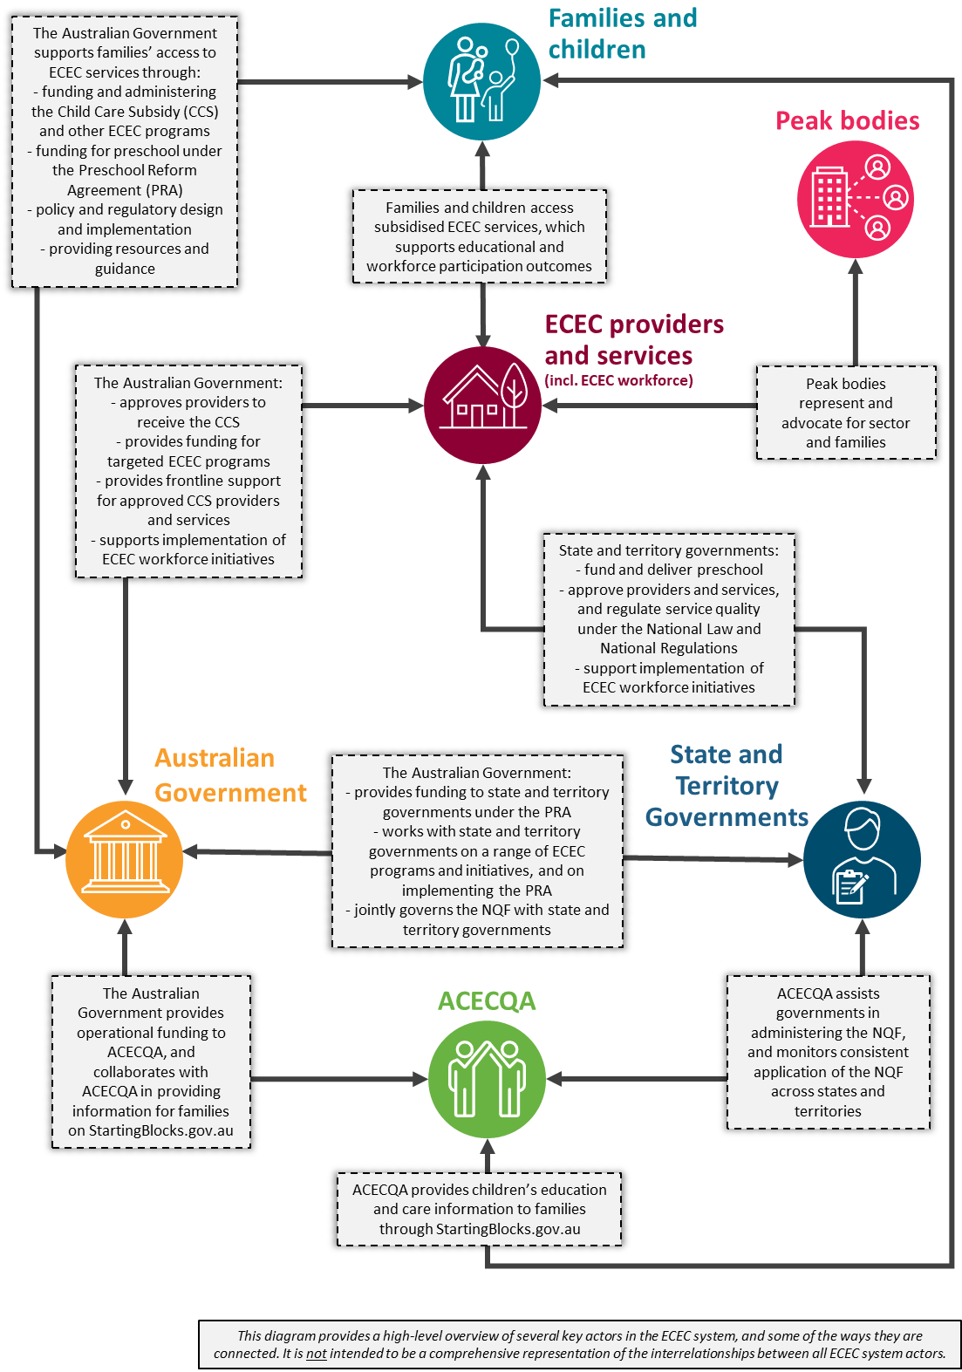
  - Care Types

Child Care Subsidy-approved care types
There are 4 care types approved to operate a service and administer the CCS in Australia. Approved providers (excluding in home care [IHC] providers) operate under the NQF, which comprises the Education and Care Services National Law Act 2010 (National Law) and the Education and Care Services National Regulations 2011 (National Regulations).

Centre-based day care
Centre-based day care (CBDC) services predominantly provide care to non-school-aged children between the ages of zero and 5. This care type operates a minimum of 48 weeks per calendar year, unless an exemption is granted.
Between the September quarter 2018 and the September quarter 2022:
- The number of children using CBDC services (of those using CCS-approved services) increased from 57.2 per cent to 58.5 per cent.
- The average weekly CBDC hours per child grew from 30.9 hours to 32.4 hours.
- The number of CBDC services increased from 7,765 services (accounting for 60.7 per cent of all services) to 8,883 services (or 62.5 per cent of all services) (refer to Section 2.4).

Outside school hours care
Outside school hours care (OSHC) services provide care primarily to school-aged children outside of school hours, such as before school, after school, and during school holidays. It operates a minimum of 7 weeks per calendar year under the same regulatory frameworks that apply to CBDC services.
Between the September quarter 2018 and the September quarter 2022:
- The number of children using OSHC services (of those using CCS-approved services) increased from 35.7 per cent to 38 per cent.
- The average weekly OSHC hours per child grew from 12.6 hours to 12.7 hours.
- The number of OSHC services increased from 4,517 services (accounting for 35.3 per cent of all services) to 4,889 services (or 34.4 per cent of all services) (refer to Section 2.4).

Family day care
Family day care (FDC) is typically provided in the home of an educator. Like CBDC, FDC services are regulated under FAL and must operate a minimum of 48 weeks per calendar year.
Between the September quarter 2018 and the September quarter 2022:
- The number of children using FDC services (of those using CCS-approved services) decreased from 10 per cent to 5.8 per cent.
- The average weekly FDC hours per child declined from 25.6 hours to 25.5 hours.
- The number of FDC services decreased from 515 services (accounting for 4 per cent of all services) to 409 services (or 2.9 per cent of all services) (refer to Section 2.4).

In home care
Typically provided in the child’s home by an educator, IHC offers flexible options where other care types are not appropriate or available. Eligibility criteria for families may include non-standard working hours, challenging needs, or geographic isolation—such as living in rural or remote regions. During the September quarter 2022, 2,150 children used IHC (less than 1 per cent of children using CCS-approved care). Though eligible for the CCS, IHC services are outside the scope of the NQF. They are regulated by state authorities in South Australia and Tasmania and by the Australian Government, by default, in all other jurisdictions.
The department has commissioned an external review of the IHC program. The purpose of the review is to ensure that the program is meeting its policy intent and objectives. This is consistent with the Government’s commitment to achieving the best possible outcomes for children and families accessing ECEC. The review will be completed by mid-2023.

Preschool (Year Before Full-time School)
In preschool programs, qualified teachers deliver early childhood education to children (typically aged between 3 and 5) for up to 2 years before primary school. Across the country, there are around 13,000 preschool services, which are delivered in CBDC facilities, standalone preschools, or preschools attached to a school. Approximately 330,000 children aged 4 or 5 are enrolled in a preschool program.
The Australian Government provides funding to states and territories (states) for the delivery of preschool, which is primarily the responsibility of state governments. Programs are known as ‘preschool’ in some states and ‘kindergarten’ in others. The age at which children commence preschool varies between states, as do funding arrangements and amounts. For example, some states fund the delivery of preschool programs in CBDC, while others do not. Under the Preschool Reform Agreement, Commonwealth funding follows the child to the setting in which they attend. Refer to Section 3.4 for further details on preschool delivery, including the settings in which it is provided.

Other care types
In addition to IHC, there are some child care services delivered by CCS-approved providers that are outside the scope of the NQF. These include 128 out of the 151 services currently funded by the Community Child Care Fund Restricted grant (refer to Section 3.2).
Families may also elect to use other care types that are not regulated and for which the CCS is not paid. These include:
- informal care provided through personal arrangements (e.g. grandparents providing ad hoc care to their grandchildren, or nannies caring for children)
- services primarily providing a disability or early intervention service
- services primarily providing instruction in an activity (e.g. sport or music)
- services that provide care, but in which the parent retains responsibility for the child while the service is provided (e.g. a play group)
- services primarily providing short-term, irregular care at premises in which the parent is a visitor or guest, and the parent is readily available (e.g. a service provided by a gym).
  - Child Care Subsidy Market
Of the 4 CCS-approved care types outlined in Section 2.3, CBDC makes up the largest share of the market by number of services, families, and children supported. This is followed by OSHC, FDC, and IHC. For-profit providers form the majority of providers in the CCS market—accounting for 69.2 per cent of the total number of providers. For-profit services also make up the majority of services—accounting for 64.6 per cent of total services.
Figure 1 outlines the market share by service type in the September quarter 2022 as a percentage of services (14,217 total services). The majority of services are CBDC, at 62.5 per cent (8,883 services), followed by OSHC services, at 34.4 per cent (4,889 services).
Figure 1: Market Share by Service Type
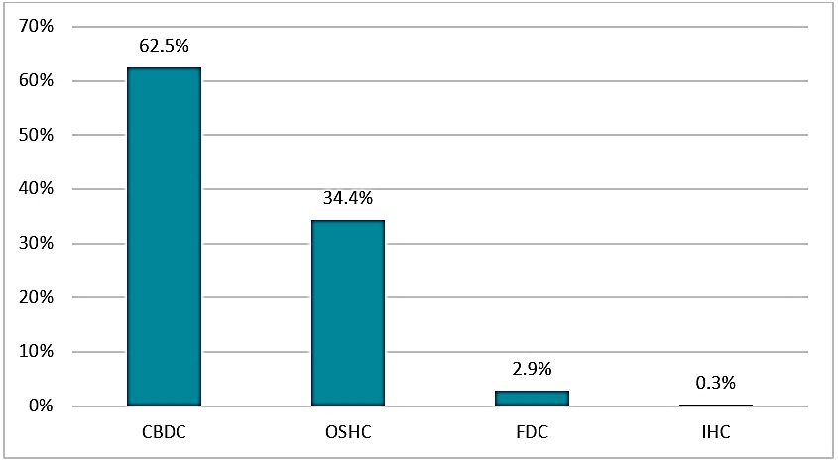
CBDC = centre-based day care; OSHC = outside school hours care; FDC = family day care; IHC = in home care.
Source: Department of Education administrative data.
Of the 990,760 families that used approved care in the September quarter 2022, 68.1 per cent (674,650 families) used CBDC services. Less than 1 per cent (1,180 families) used IHC services (refer to Figure 2).
Figure 2: Market Share of Services by Family Usage
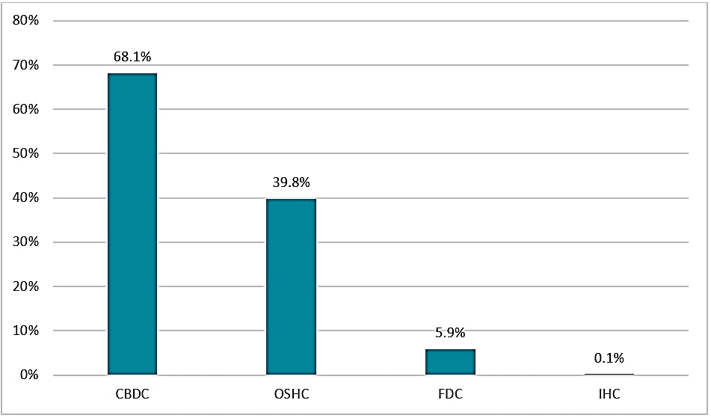
CBDC = centre-based day care; OSHC = outside school hours care; FDC = family day care; IHC = in home care.
Note: As families may use more than one service and due to rounding, the sum of the component parts may not equal the total.
Source: Department of Education administrative data.
With respect to the use of services by children in the September quarter 2022, the majority of children (58.5 per cent) used CBDC services, followed by OSHC services (38 per cent) (see Figure 3).
Figure 3: Market Share of Services by Child Attendance
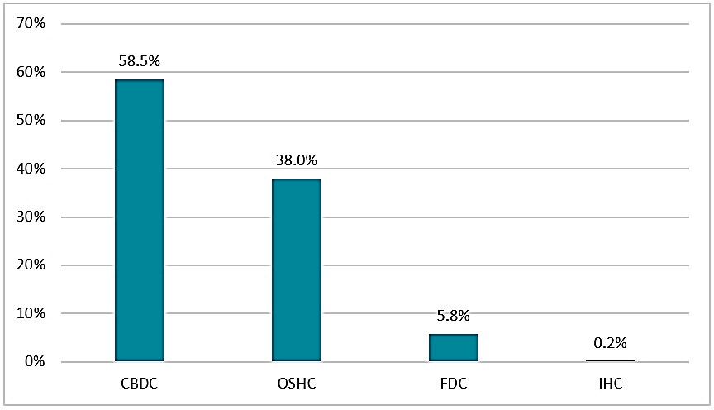
CBDC = centre-based day care; OSHC = outside school hours care; FDC = family day care; IHC = in home care.
Note: As children may attend more than one service and due to rounding, the sum of the component parts may not equal the total.
Source: Department of Education administrative data.

Growth and trends in the Child Care Subsidy market
The ECEC sector is currently responding to an increase in demand. Population growth is one variable that contributes to demand. Between the 2016 and 2021 censuses, there was an increase of just under 1 per cent of children aged zero to 5 in Australia’s population. This increase was driven by growth in the number of children aged zero, 4, and 5 (refer to Table 1).
Table 1: Number of Persons Aged Zero to 5 in 2016 and 2021
Age | Number of persons  2016 census | Number of persons  2021 census | Percentage change
0 years | 276,227 | 283,457 | 2.62%
1 years | 293,503 | 290,064 | −1.17%
2 years | 295,142 | 292,272 | −0.97%
3 years | 299,725 | 295,139 | −1.53%
4 years | 300,184 | 302,888 | 0.90%
5 years | 298,271 | 314,542 | 5.46%
Total | 1,763,052 | 1,778,362 | 0.87%
Source: ABS Census.
On average, the CCS market increases in size each year, with more ECEC services opening than closing—with the exception of FDC, where there have been more exits from the market than entries. Integrity measures aimed at addressing fraud and non-compliance in the FDC sector were introduced in the 2017–18 and 2018–19 Mid-Year Economic and Fiscal Outlooks. These measures focused on increasing compliance efforts and targeted activities to improve the integrity of payments to FDC services. The Government’s FDC integrity measures, including fraud and compliance activities, have resulted in the cancellation of more than 200 FDC services.
More CBDC services open each year than any other care type, making up a majority of entrants into the CCS market. At the beginning of the COVID-19 pandemic, there was a decrease in the number of OSHC services entering the market, while the number of OSHC services exiting the market remained steady. Figure 4 depicts service entry and exit rate trends between 2019 and 2022 by care type.
Figure 4: Service Entry and Exit Rates by Care Type
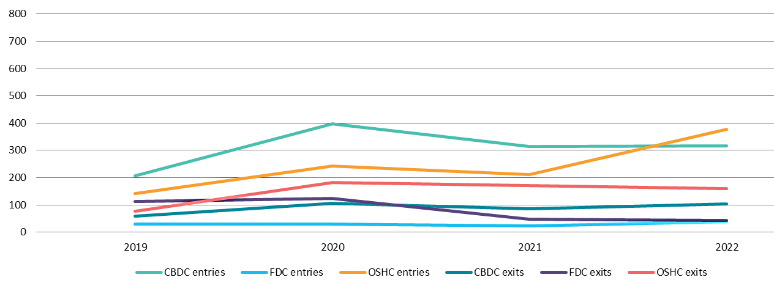 CBDC = centre-based day care; FDC = family day care; OSHC = outside school hours care.
Source: ACECQA, NQAITS Quarterly Time Series.
Figure 5 depicts percentage changes in the number of services by care type, including preschool (PSK). It shows a sharp increase in the approval of OSHC services in 2022, as well as a significant decline in the number of FDC services in recent years.
Figure 5: Percentage Change in Number of Services by Care Type
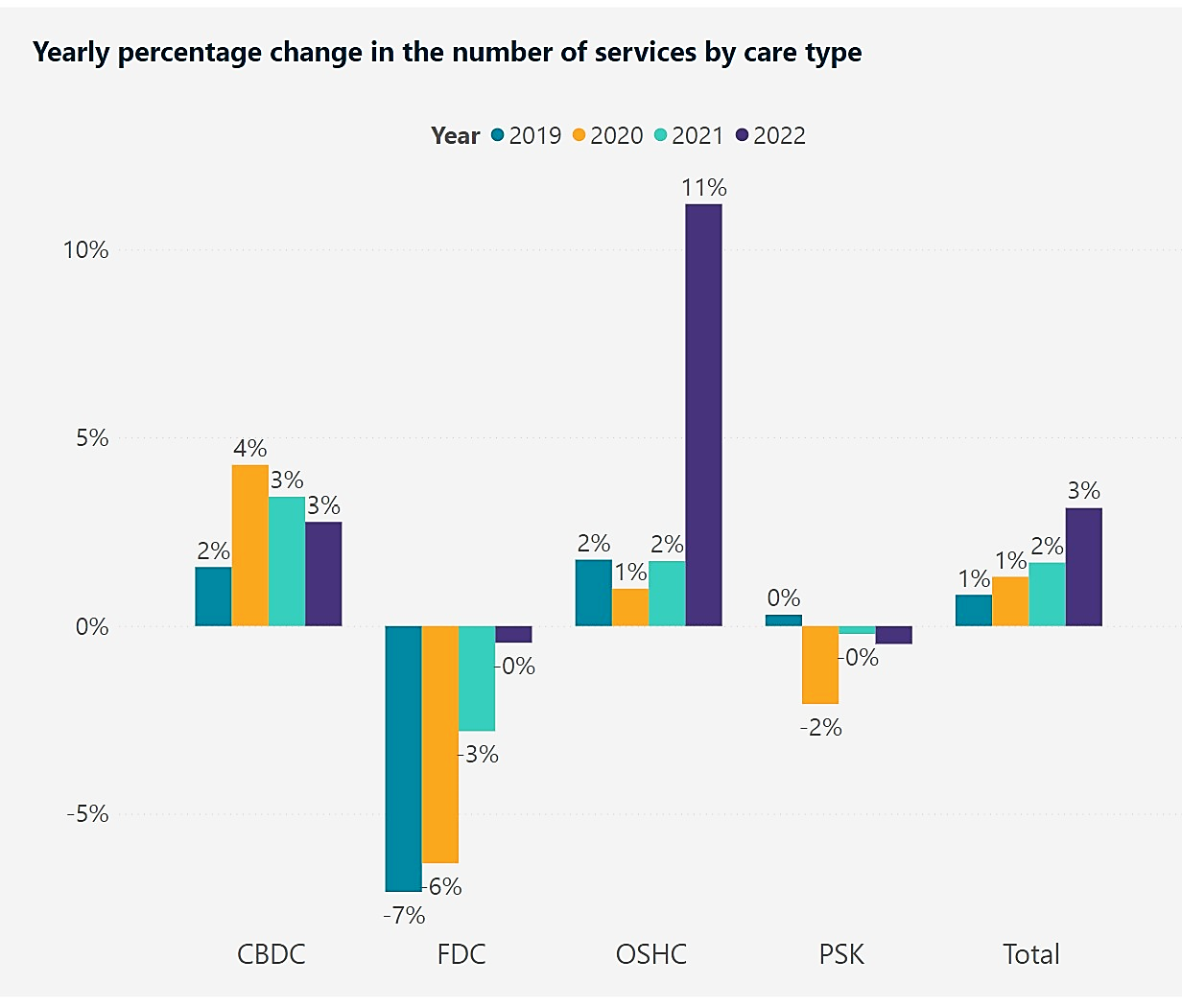
CBDC = centre-based day care; FDC = family day care; OSHC = outside school hours care; PSK = preschool.
Source: ACECQA, NQAITS Quarterly Time Series.
In terms of geographical spread, there was a significant increase in the number of inner and outer regional services registered with ACECQA during the 2022 calendar year. This increase has not been realised in remote regions.
Figure 6: Percentage Change in Number of Services by Remoteness Area
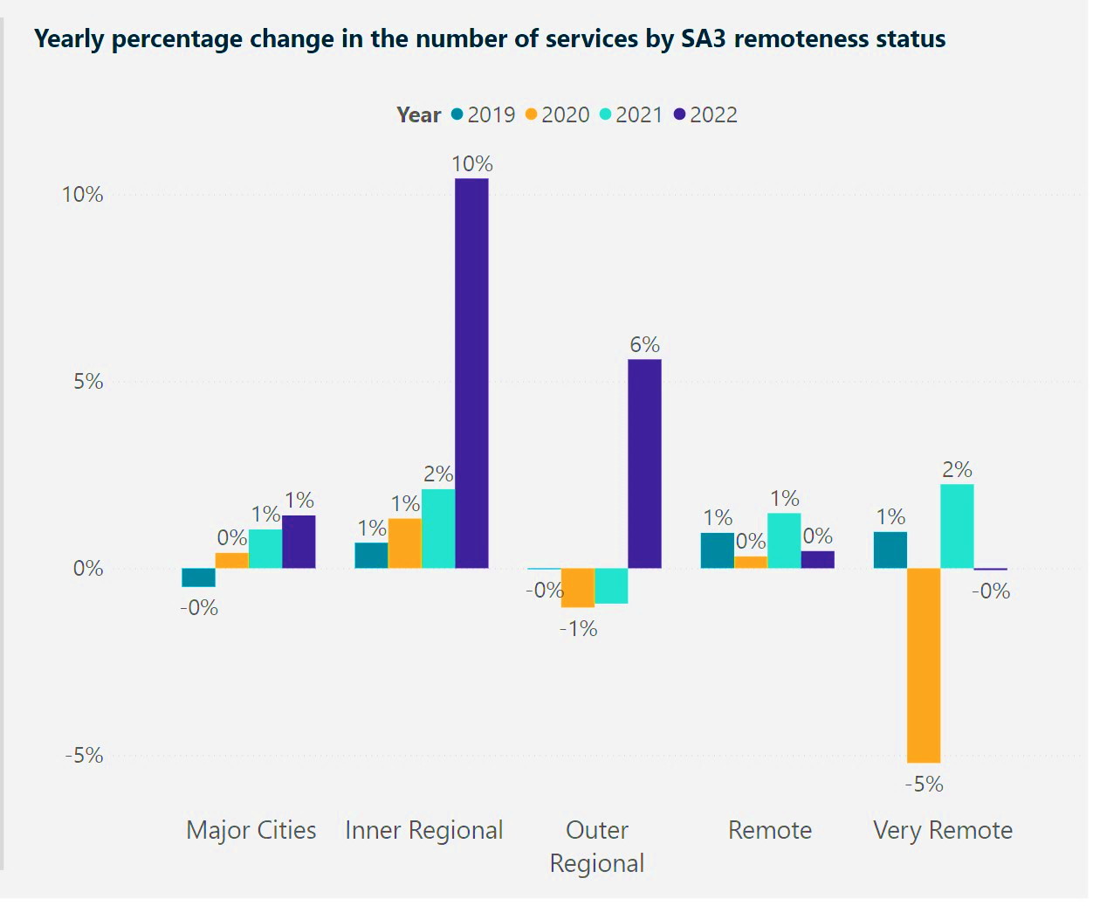
Source: ACECQA, NQAITS Quarterly Time Series.
  - Workforce
The ECEC workforce plays a fundamental role in supporting positive educational and developmental outcomes for children, as well as achieving other ECEC objectives, such as enabling greater workforce participation by parents and carers. The value of, and need for, a sustainable, high-quality workforce to support the ECEC system is the subject of the 10-year National Children’s Education and Care Workforce Strategy (2022–2031) (refer to Section 5.4).
As of February 2023, the ECEC workforce employed 261,100 individuals. In 2021, female workers made up the majority of the ECEC workforce, at 92.1 per cent (up from 91.1 per cent in 2016). The median age of the workforce was 36 for female workers and 27 for male workers.
The workforce is categorised by 3 main occupation types: educators, early childhood teachers, and centre directors. Between November 2021 and November 2026, the workforce is projected to grow by 5.9 per cent for educators, 21.6 per cent for early childhood teachers, and 21.8 per cent for centre directors—noting that these projections do not account for workforce measures announced in the 2023–24 Budget (refer to Section 4.2).
The NQF outlines staffing standards for the ECEC workforce, including the ratios of staff to children in care, and staff qualification requirements. These requirements vary between care types (CBDC, OSHC, etc.) and the jurisdiction in which the service operates. Details on qualification requirements are available on the ACECQA website.
According to the 2021 Department of Education, Skills and Employment ECEC National Workforce Census, 84.8 per cent of paid contact staff held a relevant qualification in 2021. Notably, qualifications attained through ECEC degrees vary. Depending on the degree, graduates may be qualified to teach children aged zero to 5 in prior-to-school settings; school-age children only; or children aged anywhere from zero to 12, in either setting.

- Roles and Responsibilities of the Australian Government in the ECEC system
The Australian Government’s key role in the early childhood education and care (ECEC) system is providing the main source of funding to support families’ access to ECEC services. This is achieved primarily through the Child Care Subsidy (CCS) and the Child Care Safety Net. The Government provides funding to state and territory governments to facilitate preschool access in the year before full-time school, as well as operational funding to the Australian Children’s Education and Care Quality Authority (ACECQA) to support the National Quality Framework (NQF). The Australian Government also plays a central role in shaping and supporting the ECEC system through overarching policy settings and regulatory functions, including administering Family Assistance Law (FAL) and protecting the CCS against fraud and non-compliance.
The Government fulfills its roles and responsibilities through different Australian Government departments. For example, the Department of Education has primary carriage of implementing ECEC-focused policies and programs and administering FAL. To achieve ECEC objectives, the department works closely with other agencies, including Services Australia, which is responsible for determining and paying a family’s CCS entitlements, and the Department of Social Services, which co-ordinates early child development policy and responsibilities.
State and territory governments undertake separate, complementary functions to support the ECEC system. They have primary responsibility for regulating ECEC services through the administration of the NQF. This includes ensuring compliance with the NQF, granting provider and service approvals, and assessing and rating services against the National Quality Standard (NQS). State and territory governments are also responsible for the funding and delivery of preschool services and helping support the implementation of the Preschool Reform Agreement.
  - Child Care Subsidy
The CCS is the main way that the Government helps families with the cost of ECEC fees. In the September quarter 2022, 1,478,860 children from 1,051,550 families attended a CCS-approved ECEC service.
In 2021–22, the approximate expenditure on the CCS (including the Additional Child Care Subsidy [ACCS]) was $9.8 billion, which increased to $10.6 billion in 2022–23 and $12.7 billion in 2023–24 (refer to Figure 7).
Figure 7: Child Care Fee Assistance and Children Using CCS-approved Care
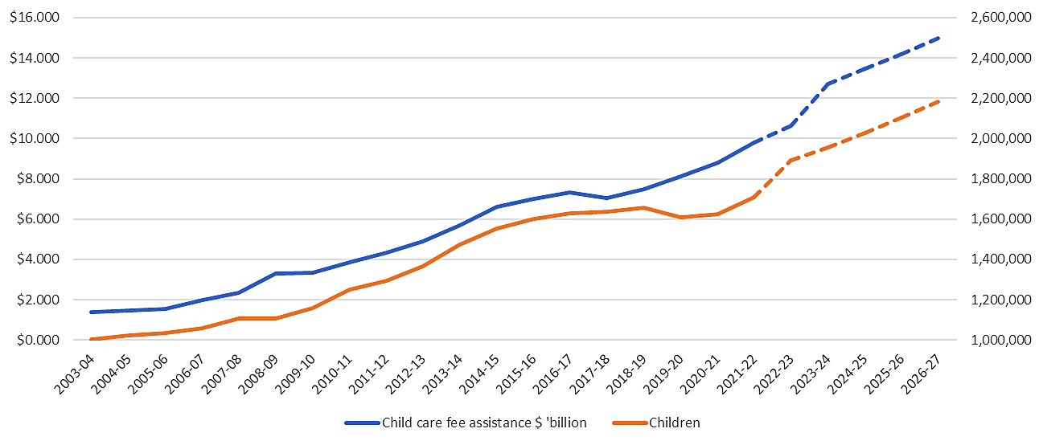
The dotted line represents the projected subsidy expense as of May 2023–24. Projections include the CCS increases included in the 2022–23 Budget’s Cheaper Child Care measure (refer to Section 4.1). The child counts are lower for 2019–‍20, as attendance data was not collected for 3 months due to COVID-19 measures.
Source: Department of Education administrative data.
To receive CCS, families must apply to Services Australia, confirm their enrolment in an approved service, and satisfy eligibility criteria. Entitlement is based on combined annual family income, which families provide as an estimate of adjusted taxable income at the beginning of the financial year. Families’ CCS entitlements are also dependent on the following:
- the activity level of the claimant and their partner, if they have one
- the type of approved service used, and whether the child attends school
- whether a family has multiple CCS-eligible children aged 5 or under.
Generally, CCS entitlements are paid directly to the service provider on behalf of the family, and the benefit is passed on as a fee reduction. In limited circumstances, families receive CCS entitlements directly—for example, where the family is entitled to a CCS top-up payment following the CCS reconciliation process, once their actual income is known (refer to Balancing (reconciliation) process).
Providers must be approved under FAL to receive and pass on CCS and ACCS payments to eligible families. To be CCS-approved, providers must meet a range of requirements, including approval under the Education and Care Services National Law 2010 (National Law), and compliance with relevant jurisdiction-based regulatory requirements. Additionally, large providers operating 25 or more centre-based day care (CBDC) services must be financially viable.
The assessment and monitoring of the financial viability of CBDC services are enabled under A New Tax System (Family Assistance) (Administration) Act 1999. As of 1 July 2023, financial viability assessments will be expanded to include all large providers with 25 or more services of any combination of care types. Providers will also be captured if they operate 25 or more services with a related provider, or plan to do so in the future. These changes form part of the Government’s commitment to greater transparency in the ECEC sector (refer to Section 4.1).

Fee liabilities
In most circumstances, families who receive CCS must make a co-contribution towards the cost of their child care fees. Families are required to pay the co-contribution, generally known as the ‘gap fee’, directly to the provider.
Where a third party makes a payment towards a family’s fee, this reduces the full fee amount and the family’s CCS entitlement reduces accordingly. Where prescribed in FAL, third parties can pay some or all of a family’s gap fee without reducing their CCS entitlement. For example, states and territories may pay the gap fee for a vulnerable or disadvantaged child or any child attending preschool without reducing the family’s CCS entitlement (refer to Section 3.4).
In addition, FAL enables providers to provide fee discounts which do not affect the CCS payable to a family. This includes where the fee discount is granted to an educator or cook engaged by the provider, or for families prevented from attending care due to an emergency.

Family income
The percentage of subsidy to which a family is entitled is based on combined annual family income. As of May 2023, families earning $72,466 or less receive the maximum CCS rate of 85 per cent. As family income increases, the rate of subsidy decreases—reaching 0 per cent at $356,756 (refer to Section 4.1 for changes to the CCS base rate due to come into effect 10 July 2023). As of March 2022, if families have more than one child aged 5 or younger enrolled in ECEC, the percentage for the second and any younger child is increased by 30 per cent (with a 95 per cent ceiling).

Activity level
The hours of subsidy per fortnight to which a family are entitled is determined by their activity level (see Table 2). A family can receive up to 100 hours of subsidy per fortnight, per child, depending on their hours of recognised activity (e.g. work, study, and training), which they must report directly to Services Australia. For couples, the member of the couple with the lowest activity test result determines the number of subsidised hours.
There are several exemptions to the activity test. For example, grandparents who are principal carers of their grandchild receive 100 subsidised hours per fortnight, regardless of activity level.
Table 2: Hours of Subsidised Care Available Based on Activity Level
Activity level each fortnight | Hours of subsidised care each fortnight
Less than 8 hours | 0 hours if you earn above $72,466  24 hours if you earn $72,466 or below
More than 8 to 16 hours | 36 hours
More than 16 to 48 hours | 72 hours
More than 48 hours | 100 hours

Table 3 outlines the number of hours accessed by families in the September quarter 2022.
Table 3: Activity Test: Maximum Hours of Subsidised Care Per Fortnight, September Quarter 2022
Subsidised hours per fortnight | Number of families | Percentage of total
0 | 8,500 | 0.9%
24 | 9,020 | 0.9%
36 | 32,450 | 3.3%
72 | 239,280 | 24.2%
100 | 666,180 | 67.2%
Missing | 35,320 | 3.6%
Total | 990,760 | 100.0%
Source: Department of Education administrative data.

Hourly rate cap
The hourly rate cap is the upper limit on the hourly fee to which the CCS rate can be applied. A family’s CCS entitlement is calculated based on the fee portion up to the hourly rate cap, and any fee portion above the rate cap is not subsidised (unless the child is entitled to ACCS). The hourly rate cap, which varies by service type (refer to Table 4), is intended to put downward pressure on fee growth. It is indexed each July, based on the Consumer Price Index for the previous December quarter.
Table 4: Hourly Rate Cap for the 2022–23 Year
Service Type | Hourly rate cap
Centre-based day care | $12.74
Family day care | $11.80
Outside school hours care (including vacation care) | $11.15
In home care | $34.64 per family
The higher subsidy rate for in home care (IHC) is reflective of the higher expense of employing an educator to provide care in a family home. It is a family rate, not an individual rate. IHC services pass on costs of providing IHC to families. The Government pays a higher subsidy for IHC to ensure that the care type is affordable for families—keeping out-of-pocket costs reasonable. An IHC family hourly rate cap of $34.64 is comparable to having 3 children in Family Day Care at an hourly rate cap of $11.80 per child, totalling $35.40.

Balancing (reconciliation) process
The CCS balancing (reconciliation) process determines whether a family has received the correct amount of CCS throughout a relevant financial year, based on their actual adjusted taxable income for that year. Families meet the balancing requirements by lodging their tax return, or by notifying Services Australia that they are not required to lodge and confirming their income. The outcome of the balancing process can be a top-up payment, nil adjustment, or a debt.

Debt
A family can incur debt when they receive more CCS than they were entitled to receive. The main reasons families incur debts are as a result of the CCS balancing process, a failure to meet balancing requirements (i.e. not submitting a tax return), and changes to entitlement. To assist families with reducing the likelihood of an overpayment after balancing has occurred, 5 per cent of their CCS entitlement is withheld each fortnight throughout the financial year. Service providers may also incur debts—for example, if they are overpaid CCS, or if they fail to pass a CCS payment on to an entitled individual.
  - Child Care Safety Net
The Government provides extra support for vulnerable children through the Child Care Safety Net to help them get a strong start in life and help their parents work or undertake other activity. The Safety Net includes the ACCS, the Community Child Care Fund (CCCF), the Inclusion Support Program (ISP), and the low-income CCS activity test exemption.
Support under the Safety Net covers a number of priority cohorts, including children with developmental delay or disability, culturally and linguistically diverse children, children from low socioeconomic status backgrounds, First Nations children and families, and children living in regional and remote locations.

Additional Child Care Subsidy
The ACCS provides additional fee help to families facing barriers to ECEC. Rather than CCS, eligible children may receive ACCS, which provides a higher rate of subsidy for up to 100 hours per fortnight. There are 4 categories of funding under the ACCS:
- ACCS Child Wellbeing: Children at risk of serious abuse or neglect may receive 100 subsidised hours (at up to 120 per cent of the hourly rate cap).
- ACCS Grandparent: Aged pensioners who are the primary carers of a grandchild can receive 100 subsidised hours (at up to 120 per cent of the hourly rate cap).
- ACCS Temporary Financial Hardship: Families who experience financial hardship can receive 100 subsidised hours (at up to 120 per cent of the hourly rate cap) for 13 weeks.
- ACCS Transition to Work: Families transitioning from income support to work can receive up to 100 subsidised hours at a CCS rate of 95 per cent.
Services Australia maintains the service delivery of ACCS programs and engages with CCS claimants, including individuals, families, and carers, to facilitate access to ACCS, including receipt and processing of claims. The majority of ACCS (child wellbeing) applications are processed by Services Australia.
The Department of Education assesses and manages applications to extend backdating in exceptional circumstances. In July 2021, extended backdating provisions were introduced—allowing services to apply to backdate ACCS (child wellbeing) applications beyond 28 days (and up to 13 weeks) in exceptional circumstances (refer to Section 4.2).
Figure 8: Children Accessing ACCS, September Quarter 2018 to September Quarter 2022
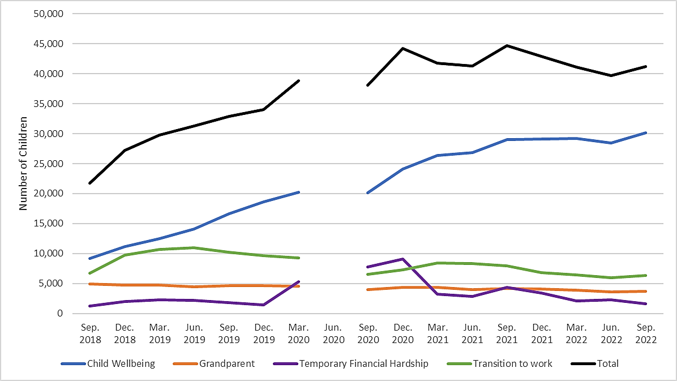Source: Department of Education administrative data.

Child Care Subsidy low-income activity test exemption
Low-income families have a base entitlement to 24 hours of CCS per fortnight (‘CCS24’), regardless of their activity levels. This is intended to ensure that economically disadvantaged children retain some access to child care to support their development outcomes. Before the CCS was introduced, departmental modelling estimated that 5.3 per cent of all families who access CCS (approximately 54,300 families) would access CCS24 in 2018–19. In December 2018, 32,110 children accessed CCS24. This figure dropped to 11,150 children (9,020 families) by the September quarter 2022.
Figure 9: CCS24 Eligible Children Accessing Child Care
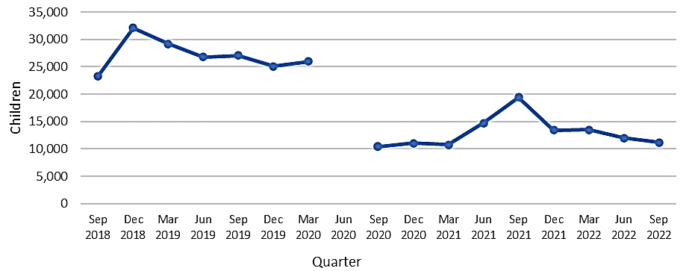
Source: Department of Education administrative data.

Community Child Care Fund
The CCCF is a grant program that supports around 900 service providers to reduce barriers to accessing child care—particularly for children and families in disadvantaged, rural, and remote communities; First Nations communities; and where services are in limited supply. The CCCF will deliver $575.1 million over 4 years to 2025–26 through a range of competitive and restricted grants:
- CCCF Open is a competitive grant that provides support for vulnerable and disadvantaged communities. In the latest round of CCCF Open, up to $18 million will be available over 2 years (to 2024–25) to assist with the establishment of new early childhood services in regional and remote areas where there is an absence, or limited supply, of CBDC and family day care (FDC).
- CCCF Restricted supports identified services in vulnerable and disadvantaged communities by supplementing their fee-income. The grant supports over 150 services, including former Budget Based Funded services, and services that are outside the scope of the NQF and state regulation, but which must comply with the Child Care Subsidy Minister’s Rules 2017 (Minister’s Rules). To ensure children and their families are delivered the best possible outcomes, an independent review of the CCCF Restricted grant will be undertaken in 2023 and is anticipated to be completed in early 2024.
- CCCF Restricted Expansion provides $29.9 million over 4 years to establish new CCCF Restricted services in remote locations to increase First Nations children’s participation in child care. The department is working with First Nations peak bodies, communities, and organisations to establish these new services, which will be delivered by Aboriginal Community Controlled Organisations where possible.
- CCCF Special Circumstances provides support to critical service providers impacted by an emergency or natural disaster by providing a one-off grant for temporary relief to maintain viability.

Connected Beginnings
Connected Beginnings is a grant program jointly delivered by the Department of Health and Aged Care and the Department of Education, which aims to increase First Nations children’s and families’ engagement with health services and support and ECEC. It improves access to existing early childhood, maternal and child health, and family support services to ensure that children are safe, healthy, and ready to thrive at school by the age of 5. The Government provides ongoing funding of approximately $27 million per year.
Connected Beginnings supports around 12,500 First Nations children and their families in 36 communities across Australia, including in metropolitan, regional, and remote locations. In August 2021, the Government committed an additional $81.8 million to expand Connected Beginnings to 50 sites by 2025. Once expanded, it is anticipated that around 20 per cent of First Nations children will be living in a community with Connected Beginnings (refer to Section 4.4 for further detail on Connected Beginnings and other early childhood Closing the Gap initiatives).
Figure 10 contains a visual representation of CCCF Open, CCCF Restricted, and Connected Beginnings sites.
Figure 10: Map of CCCF Open, CCCF Restricted and Connected Beginnings sites (as of 31 March 2023)
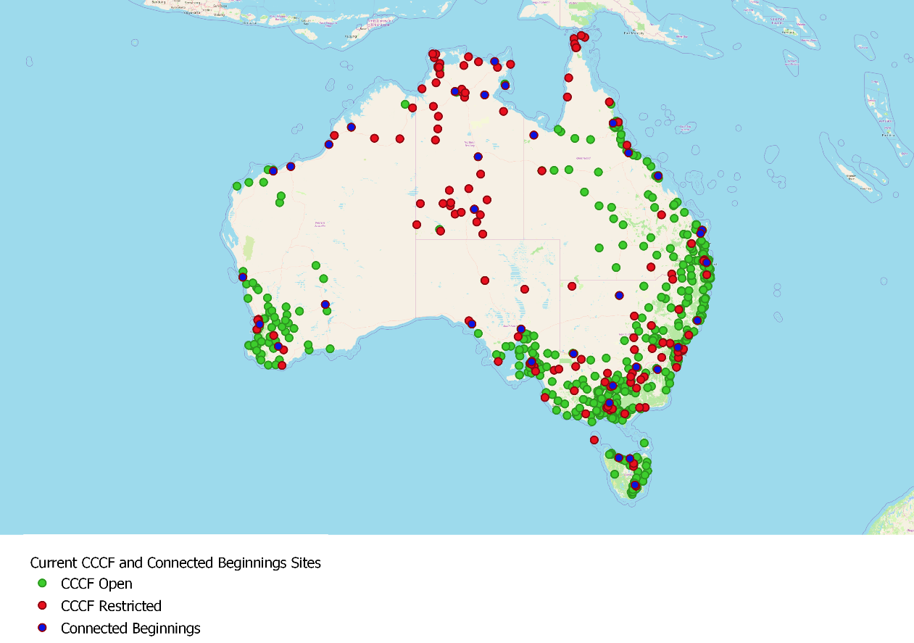

Inclusion Support Program
The Inclusion Support Program (ISP) is a $133 million-per-year program that assists approved services to include children with additional needs. The ISP provides support to eligible ECEC services to build their capacity and capability. The program plays a vital role in ensuring that children with additional needs, challenging and trauma related behaviours, and serious medical or health (including mental health) conditions are included in ECEC services alongside their typically-developing peers.
The department has commissioned a review of the ISP. The review will provide evidence-based findings to inform future accessibility. It is due to be completed by mid-2023.
  - Child Care Subsidy Regulation and Integrity
The department delivers a number of functions to support the integrity of the CCS, including:
- Provider approvals: Prospective providers must apply to the department for approval to administer the CCS.
- Compliance operations: The department takes a risk-based approach to monitoring providers’ compliance with their obligations and has a range of regulatory levers to address non-compliance, including sanctions (e.g. cancellation, suspension) and penalty notices (fines).
- Fraud operations: The department has a dedicated team of fraud investigators who work with other regulatory partners, including police, other Commonwealth and state and territory agencies (including state regulatory authorities), and the Commonwealth Director of Public Prosecutions, to identify, investigate, and prosecute fraud.
The department’s risk-based approach to managing financial integrity is set out in the Financial Integrity Strategy. The department supports the functions outlined above through the provision of a variety of resources that help providers better understand and voluntarily meet their obligations. These include the Child Care Helpdesk, information and communication products (including a provider handbook), and sector engagement. Work is also underway to establish a dedicated Learning Management System and sector-led capacity building projects to support the sector to understand and meet its obligations (refer to Sections 4.1 and 4.2 for more detail on the CCS Reforms Integrity Package).
The department’s regulatory functions help to ensure the efficient and effective use of program resources. Program efficiency is currently measured by payment accuracy, which is a key performance indicator for the CCS in the department’s Portfolio Budget Statement, with a target of at least 90 per cent accuracy. As noted in the 2021–22 Annual Report, the department achieved 93 per cent payment accuracy in 2021–22.
  - Preschool (Year Before Full-time School)
Governments of all levels support all children to reach their potential through participation in quality preschool. Each year, around 300,000 preschool-aged children in the year before full-time school (YBFS) participate in preschool programs through about 13,000 preschools. Preschool can be delivered in a range of settings, including in dedicated preschools (in schools and standalone), and in preschool programs delivered in CBDC (refer to Figure 11 and Table 5).
Figure 11: Preschool Children Enrolled by Sector, 2022
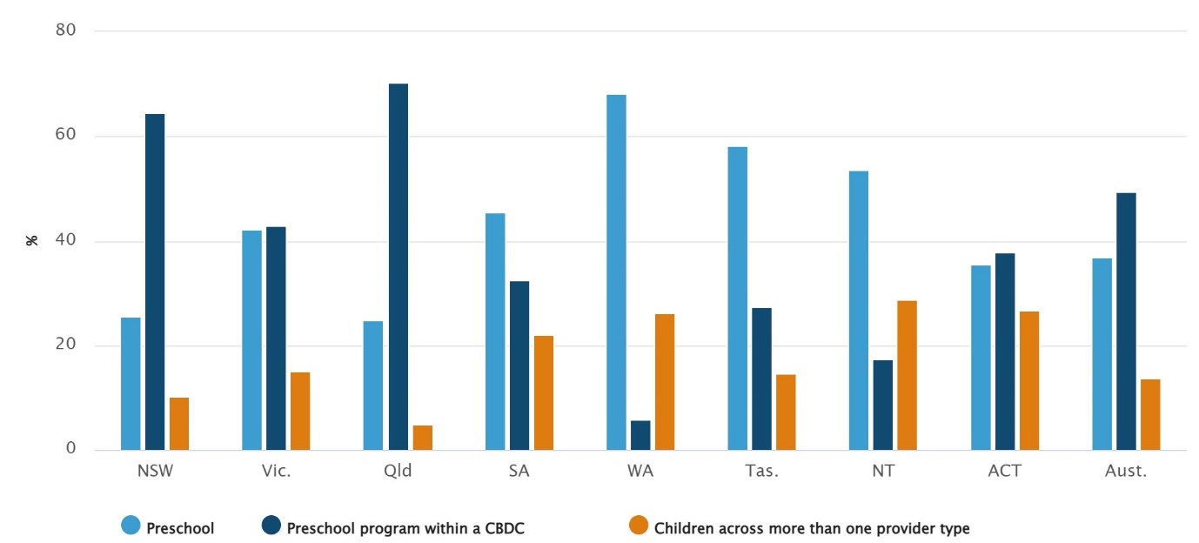
Source: Australian Bureau of Statistics (ABS), Preschool Education, 2022.
Table 5: Preschool Children Enrolled by Sector, 2022
Jurisdiction | Preschool (%) | Preschool program within CBDC (%) | Children across more than one provider type (%)
NSW | 25.4 | 64.4 | 10.2
VIC | 42.1 | 42.9 | 15.1
QLD | 24.9 | 70.2 | 4.8
SA | 45.5 | 32.4 | 22.0
WA | 68.2 | 5.7 | 26.1
TAS | 58.2 | 27.4 | 14.5
NT | 53.6 | 17.5 | 28.8
ACT | 35.4 | 37.8 | 26.7
Aust. | 36.9 | 49.5 | 13.6

Preschool delivery is primarily the responsibility of state and territory governments (states), which provide significant funding to support preschool within their jurisdictions. The interactions between child care and preschool, as well as funding arrangements, are also largely managed by states. Many states are currently increasing their investment in preschool delivery for children in the YBFS. In addition, recent reforms in New South Wales and Victoria will extend preschool to 3-year-old children.
From 2008 to 2025, the Government will have made around $6.6 billion available to states to support preschool delivery in the YBFS through a series of National Partnership Agreements. The Universal Access National Partnership (UANP) and its predecessors were in place from 2009 to 2021. Their focus was driving national consistency in the number of hours available to children in the YBFS—particularly for First Nations children and children experiencing disadvantage—by supporting access to 15 hours per week (600 hours per year) of preschool.

Preschool Reform Agreement 2022–2025
Since the first National Partnership, the national proportion of preschool-age children enrolled in 600 hours of preschool has climbed from 12 per cent to above the 95 per cent target, as measured under the UANP in 2021.
The Preschool Reform Agreement (PRA) is designed to build on these achievements. The PRA is a
4-year national agreement to strengthen the delivery of preschool and better prepare children for the first year of school. Under the PRA, the Commonwealth provides a per-child contribution to states ($1,377.83 per child in 2023).
A new collaborative reform agenda has been developed under the PRA to drive:
- enhanced funding equity through a requirement that Commonwealth funding ‘follows the child’ to the setting in which they attend—states are required to acquit this funding as part of their PRA obligations
- improvements to participation through new bilaterally agreed attendance targets to be introduced from 2025—taking states’ circumstances into account and with a particular focus on increasing participation by disadvantaged and First Nations children
- the introduction of a new preschool outcomes measure from 2025 to generate evidence for the benefits of preschool, better understand what works, and maximise the benefit of the preschool year for children.
State allocations are determined by multiplying the per-child amount by the estimated number of children in the YBFS.

Preschool delivery in centre-based day care
Families of children who attend preschool in CBDC settings (whether they are one or 2 years before full-time school) may be eligible for assistance with the cost of care through the CCS. While the Commonwealth does not provide PRA funding to support 3-year-old preschool, around 60 per cent of 3-year-olds nationally (approximately 200,000 children) receive CCS-subsidised ECEC in CBDC.
If a family has a child in the YBFS attending preschool in a CBDC service, but do not meet the activity test, they will be eligible for 36 hours of subsidised care per fortnight.
Families who are eligible for CCS generally pay a gap fee unless they are eligible for the ACCS, or the Minister’s Rules allow for a third-party payment to cover some or all of the gap (a prescribed
third-party payment, or TPP). For prescribed TPPs, CCS is calculated before the TPP is applied, so the TPP may cover some or all the gap fee.
From 1 January 2023 to 31 December 2025, in line with the PRA, the Minister’s Rules prescribe TPPs from certain state government funding schemes for children attending preschool programs in CBDC. New South Wales, Victoria, and Queensland implemented prescribed TPPs for preschool programs from January 2023.
  - National Quality Framework
Quality in the context of ECEC involves creating an environment that promotes learning, development, health, and well-being (including safety) for children, as well as supporting their families and communities.
In 2012, the NQF was established to provide a national approach to regulation, assessment, and quality improvement for ECEC and outside school hours care services. The NQF is jointly governed by the Australian Government and all state and territory governments. Education Ministers provide ongoing oversight and ultimate decision-making for the NQF.
The NQF encompasses:
- The National Law and the Education and Care Services National Regulations (National Regulations): The National Regulations govern the minimum standards and requirements that providers of regulated services must meet (including minimum qualification and educator to child ratio requirements), outline legal obligations of nominated supervisors and educators, and explain the powers and functions of state and territory regulatory authorities and ACECQA.
- The NQS: The NQS set out 7 quality areas that are important outcomes for children, including educational program and practice, children’s health and safety, and collaborative partnerships with families and communities.
- The assessment and quality rating process: Services are assessed and rated by their state or territory regulatory authority against the NQS and given a rating for each of the 7 quality areas, as well as an overall rating based on these results.
- National Approved Learning Frameworks: Services are required to base their education programs on the National Approved Learning Frameworks (‘Belonging, Being and Becoming: The Early Years Learning Framework for Australia’ and ‘My Time, Our Place: Framework for School Aged Care in Australia’—updated in early 2023).
Regulatory authorities in each state and territory administer, deliver, and ensure compliance with the NQF in their respective jurisdictions.
Regulatory authorities administer the NQF with the assistance of the independent national authority, ACECQA. The Government provides ongoing financial assistance to ACECQA for its statutory and operational functions under National Law, which include:
- guiding the implementation and administration of the NQF and monitoring and promoting consistency in its implementation and administration
- maintaining national information and registers, such as information on all approved providers, services and their ratings, and certified supervisors
- promoting and fostering continuous quality improvement by approved services
- educating and informing the sector, families, and the public through publication of guidance and information
- assessing and approving educators’ qualifications and educational course providers.

- Australian Government and Joint Initiatives
The Australian Government introduced a suite of initiatives under the 2022–23 and 2023–24 Budgets to reduce the cost of early childhood education and care (ECEC), as well as to support and inform broader reform of Australia’s ECEC system.
This includes increasing Child Care Subsidy (CCS) rates to benefit around 1.26 million Australian families using child care, providing more hours of subsidised child care for families with First Nations children, streamlining access to the Additional Child Care Subsidy (ACCS), safeguarding the CCS against fraud and non-compliance, and addressing workforce shortages in the ECEC sector to leverage the benefits flowing from CCS reforms.
The Government directed the Australian Competition and Consumer Commission (ACCC) to undertake an inquiry into ECEC prices and costs and is developing an Early Years Strategy to focus on the wellbeing, education, and development of Australia’s children.
The Government is committed to achieving the outcomes and targets in the National Agreement on Closing the Gap. The Early Childhood Care and Development Policy Partnership is bringing together governments and First Nations representatives to improve outcomes for First Nations children and families (refer to Section 4.4 for further detail on the Policy Partnership and other early childhood Closing the Gap initiatives). This work will be complemented by National Cabinet’s tasking of education and early years ministers to develop a national long-term vision for ECEC.
In addition, states and territories are undertaking various ECEC initiatives. In 2022, New South Wales and Victoria announced 10-year preschool reform programs, including expanding access to preschool for 3-year-old children. The South Australian Royal Commission is also considering universal 3-year-old preschool and, in 2022, the Northern Territory commenced a review to expand preschool education and modes of delivery.
Figure 12: An Outline of Existing ECEC Reforms
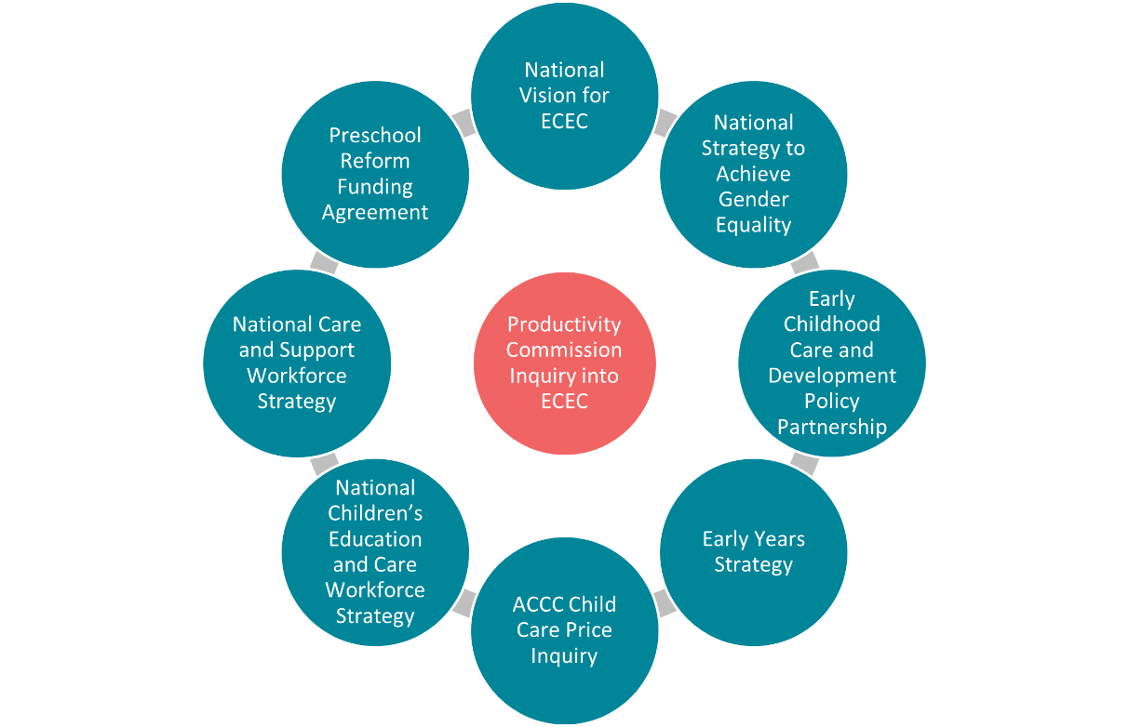
  - Cheaper Child Care
The Government’s $4.6 billion Cheaper Child Care package announced in the 2022–23 Budget comprises a suite of measures designed to make child care more affordable and reduce barriers to workforce participation.
A key element of this package is the July 2023 increase to the CCS rate. This will reduce
out-of-pocket costs for around 96 per cent of families currently using child care and increase hours worked by women with young children by up to 1.4 million per week in 2023–24.
The change to the CCS rate means that eligible families earning $80,000 or less will have their CCS entitlement lifted to a new maximum rate of 90 per cent, tapering down by one percentage point for each additional $5,000 of income. The rate reaches 0 per cent for families earning $530,000 (an increase from the 2022–23 base rate of $356,756). The existing measure that provides a higher CCS rate for families with multiple children aged 5 and under will be retained.
Figure 13: A Comparison of Current (2022–23) CCS Taper Rates and the New (2023–24) CCS Taper Rates
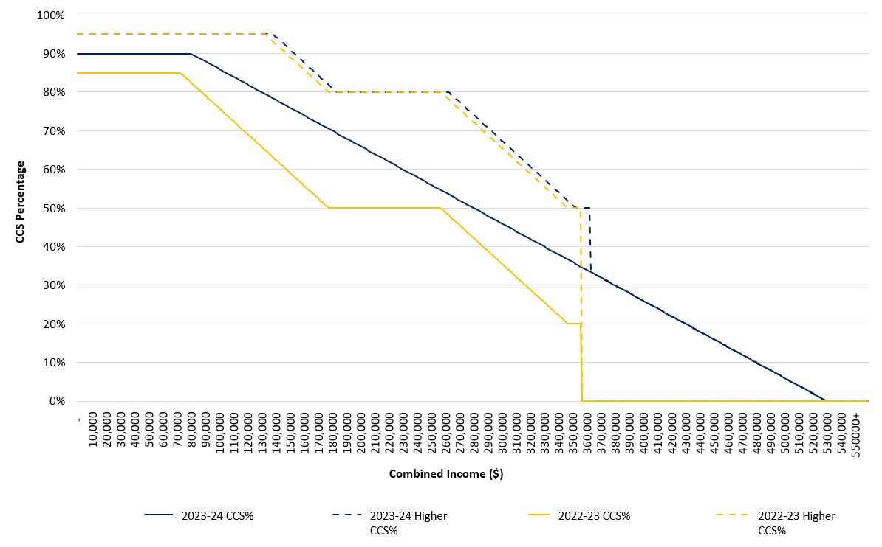
As part of this package, First Nations children will also be able to access a minimum of 36 subsidised hours per fortnight, regardless of their family’s level of activity. The measure aims to encourage new and increased engagement in ECEC for First Nations children, in response to Closing the Gap Target 4 (refer to Section 4.4).
The Cheaper Child Care package also reflects the Government’s commitment to improving transparency for families by increasing oversight and accountability of CCS-approved providers. New measures aim to place downward pressure on child care costs, assist families in making an informed decision about where to enrol children in care, and support a fairer CCS market. These measures include requiring large providers to report financial information to the department (with certain information able to be made public), displaying changes in fees over time on www.StartingBlocks.gov.au, and banning providers from offering non-educational enrolment inducements to families.
Reforms introduced through the Cheaper Child Care package will be safeguarded from fraud and non-compliance by new measures under the $47.7 million CCS Reforms Integrity Package—also announced in the 2022–23 Budget. These measures, which will help achieve $173 million in net savings over 4 years, include legislative amendments requiring electronic payment of CCS gap fees from 1 July 2023 (with some exceptions), activities to help providers better understand their regulatory obligations, and work on a digital attendance validation solution to provide real time validation and reporting of child attendance at care (refer to Section 4.2 for additional integrity measures announced in the 2023–24 Budget).
  - 2023–24 Budget Measures
The Government made further commitments in support of ECEC in the 2023–24 Budget. Through a new ECEC workforce package, the Government has committed $72.4 million over 5 years from 2022–23 to help support the skills and training of workers in the ECEC sector. Funding includes:
- $34.4 million for professional development, by providing a subsidy to enable ECEC services to backfill educators who attend mandatory and highly recommended training, with support for up to 75,000 educators
- $33.1 million to support up to 6,000 educators to complete their studies in Initial Teacher Education or post-graduate Early Childhood Teacher qualifications
- $4.8 million to connect up to 2,000 students with services to undertake practicum placements and strengthen workforce supply.
The Government is investing $2.8 million over 4 years from 2023–24 to simplify and streamline the application process to access ACCS (child wellbeing) (refer to Section 3.2). This measure, due to commence in October 2023, will reduce government red tape by consolidating all delivery of the subsidy with Services Australia, and ensures that vulnerable or at-risk children can get quicker access to essential ECEC services by reducing double handling of applications. It will also expand the circumstances in which providers can seek extended backdating for the subsidy.
The integrity of Australia’s ECEC system will also be strengthened with additional resources to help reinforce and safeguard Government investment in CCS by minimising non-compliance and fraud. The Department of Education will receive $13.3 million over 4 years from 2023–24 to support a range of activities that will further reduce fraudulent or non-compliant CCS claims, including $5.3 million to support Services Australia’s digital forensics capability. These activities will achieve net savings of $139.4 million over 4 years from 2023–24.

  - Australian Competition and Consumer Commission Price Inquiry
On 28 October 2022, the Treasurer, the Hon Dr Jim Chalmers MP, directed the ACCC to conduct a price inquiry into the market for ECEC services. The ACCC price inquiry is currently underway and is investigating the drivers of ECEC costs and the impact of these costs on child care provider viability, quality, and profits.
The price inquiry is also examining ECEC operating costs, including employees’ wages and property costs, the level of competition in the ECEC market, supply and demand, prices charged to families, and the impacts of changes in government policy. It is also considering how ECEC costs and prices differ by geographic location, provider size, types of operators, and care types.
The ACCC will also examine the prices charged since 2018 and how these have changed following changes in child care policy settings. Figure 14 details the matters that the ACCC must consider as part of its inquiry.
Figure 14: Matters to be Taken into Consideration in the ACCC Inquiry
The ACCC will deliver its interim report to the Government by 30 June 2023 and a final report by
31 December 2023.

  - Closing the Gap–Commonwealth Focus Areas
The department is collaborating with state and territory governments and the ECEC sector to support 2 of the socio-economic targets under the National Agreement on Closing the Gap.
- Target 3: Increase the proportion of First Nations children enrolled in Year Before Full-time School early childhood education to 95 per cent by 2025
- Target 4: Increase the proportion of First Nations children assessed as developmentally on track in all 5 domains of the Australian Early Development Census to 55 per cent by 2031.
Several Government initiatives contribute towards achieving Targets 3 and 4, including the Early Years Strategy (refer to Section 4.6), the Preschool Reform Agreement (refer to Section 3.4), changes to the activity test for First Nations families (refer to Section 4.1), and those outlined in Figure 15.

Figure 15: Australian Government Initiatives Contributing Towards Closing the Gap Targets 3 and 4
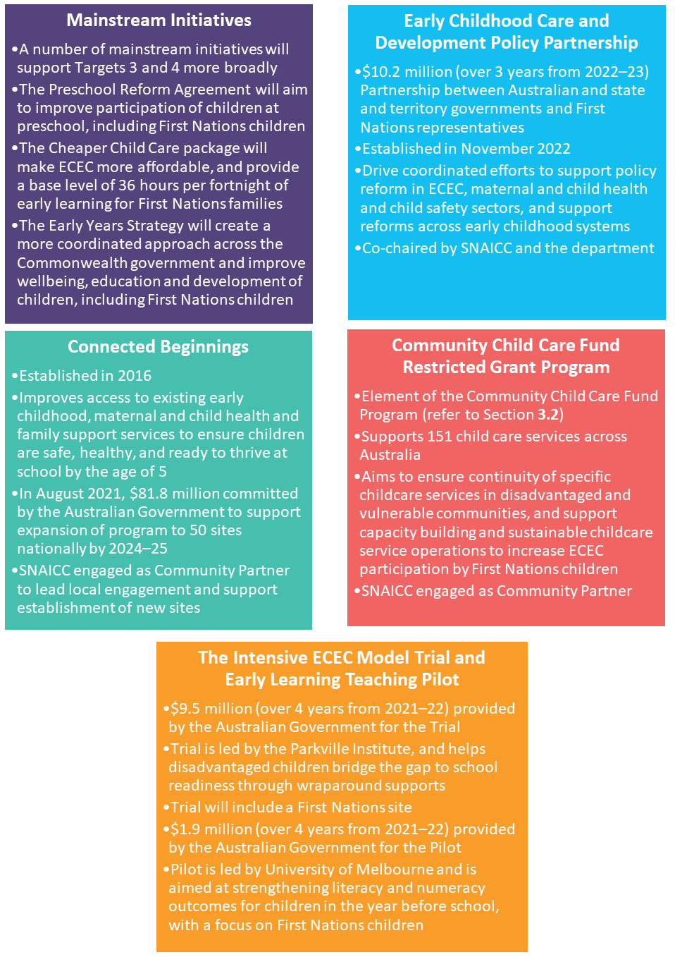
  - National Vision
In August 2022, National Cabinet asked education and early years ministers to develop a national long-term vision to support parents’ workforce participation and children’s education and development outcomes. The draft national vision outlines a shared ambition for the ECEC sector in Australia and recognises that:
- Quality ECEC has learning and development benefits for children in the most formative period of their lives, which can be especially significant for children from vulnerable and disadvantaged communities.
- An affordable and accessible ECEC system supports parents to work and study—especially women—which, in turn, supports the Australian economy to grow and prosper.
The department sought stakeholder feedback on the draft national vision between 17 March 2023 and 7 April 2023. Over 200 stakeholder groups were invited to engage via the online survey or an online submission, and in workshops and discussions with targeted stakeholders. This consultation is a joint initiative of the Australian, state, and territory governments. The national vision is due to be finalised late 2023.
  - Early Years Strategy
The Government’s ECEC reform agenda is complemented by a $4.2 million commitment to develop a whole-of-Commonwealth Early Years Strategy (the Strategy). The Strategy will help shape the Government’s vision for the future of Australia’s children and their families by creating a more integrated, holistic approach to the early years and better support the education, development, and wellbeing of Australia’s children.
While ECEC is one of the main services supporting children’s learning and development, the way children learn and grow is shaped by a range of factors and environments, including their home, family, and community. Programs and policies that support children and families in children’s first 5 years sit across different government agencies, including the Department of Social Services, the Department of Health and Aged Care, and the National Indigenous Australians Agency.
The Strategy will examine the range of Commonwealth programs and funding that directly impact early childhood development and identify ways to reduce silos across departments, better integrate and coordinate functions and activities across government, and target investments to deliver better outcomes for young children and their families. The Strategy will put children and their families at the centre of these initiatives and aim to support children’s development holistically across a range of domains, including education, health, wellbeing, safety, and family support.
The Strategy will be informed by comprehensive stakeholder engagement and consultation, which will take place throughout 2023. This was kickstarted with the National Early Years Summit held at Australian Parliament House on 17 February 2023. The Government is continuing to consult on the Strategy through surveys, a public submission process, and a series of community and expert roundtables across Australia.

- Key Issues
The Government’s investment in early childhood education and care (ECEC) has 2 key policy objectives: improving children’s early learning and developmental outcomes—particularly for children experiencing vulnerability and disadvantage—and providing parents and carers with the opportunity to join the workforce or increase their level of participation (refer to Section 2.1), engage in study, or volunteer. The current system—which, at the Commonwealth level, predominately revolves around the Child Care Subsidy (CCS)—aims to support both of these objectives.
External stakeholders and commentators have raised concerns with current policy settings and their impact on achieving these objectives, particularly in relation to access, affordability, and the activity test. Both the Women’s Economic Equality Taskforce and the Economic Inclusion Advisory Committee have raised concerns that the activity test limits early childhood access to educational services and also serves as a barrier to workforce participation—particularly for low-income and vulnerable families.
There is a lack of consensus on the optimal ECEC policy settings that balance children’s developmental and educational outcomes and workforce participation by parents and carers. This was highlighted in the 2014 Productivity Commission inquiry, which posited, as an example, that unlimited low-cost ECEC may allow parents to work more hours but may not be beneficial for the development of very young children. Evidence for full-time care is mixed, and further research is required to determine the most suitable ECEC dosage for each age group.
  - Cost and Affordability
Australia’s market-based ECEC system facilitates agility and competition—allowing market forces to determine fees.
The cost of child care is influenced by several factors. Government policy and regulations play a part in determining both costs for providers and out-of-pocket costs for families. Recent reforms to increase CCS rates from July 2023 are aimed at improving child care affordability (refer to Section 4.1). The average out-of-pocket costs per hour for centre-based day care (CBDC), outside school hours care (OSHC) and family day care (FDC) services between the June quarter 2018 and the September quarter 2022 are shown in Figure 16.
Figure 16: Average Out-of-Pocket Costs Per Hour by Service Type
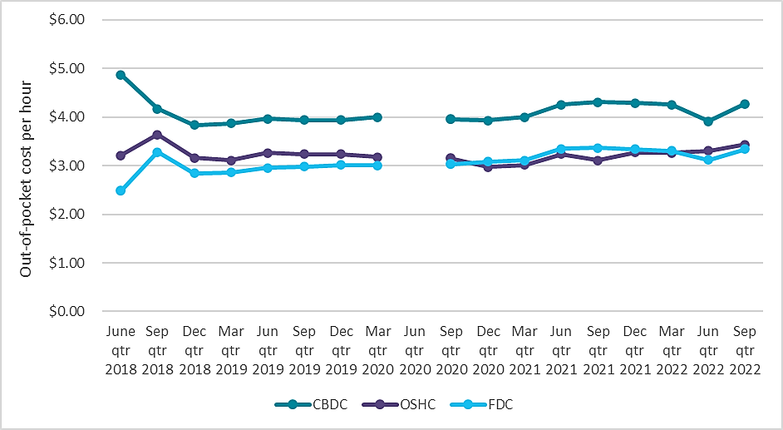
Source: Department of Education administrative data.
Out-of-pocket costs vary even within service type, with greatest differences being seen when comparing services across geographical lines. The Australian Capital Territory has the highest
out-of-pocket costs on average, while Queensland, South Australia and Tasmania have the lowest. On average, services in major cities have the highest out-of-pocket costs and regional areas have the lowest, as shown in Figure 17.
Figure 17: Average Out-of-Pocket Costs Per Hour by Remoteness
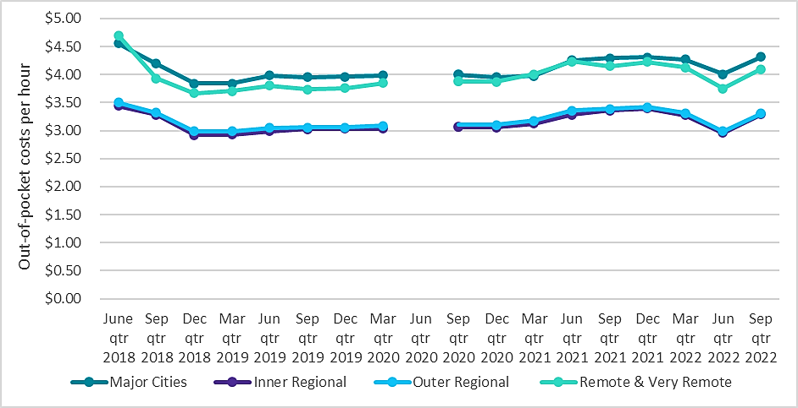
Note: in home care is excluded.
Source: Department of Education administrative data.
These differentials in cost are one of the factors being considered by the Australian Competition and Consumer Commission’s (ACCC) inquiry into ECEC prices (refer to Section 4.3).

Hourly rate cap
The CCS hourly rate cap is the maximum hourly rate that the Government subsidises for each service type (refer to Section 3.1). Hourly rate caps, along with other transparency measures, aim to put downward pressure on fees. When fees exceed the hourly rate cap, families are subject to higher out-of-pocket costs. Figure 18 shows the percentage of services charging above the hourly rate cap by service type.
Figure 18: Percentage of Services Charging Above the Hourly Rate Cap, September Quarter 2018 to September Quarter 2022
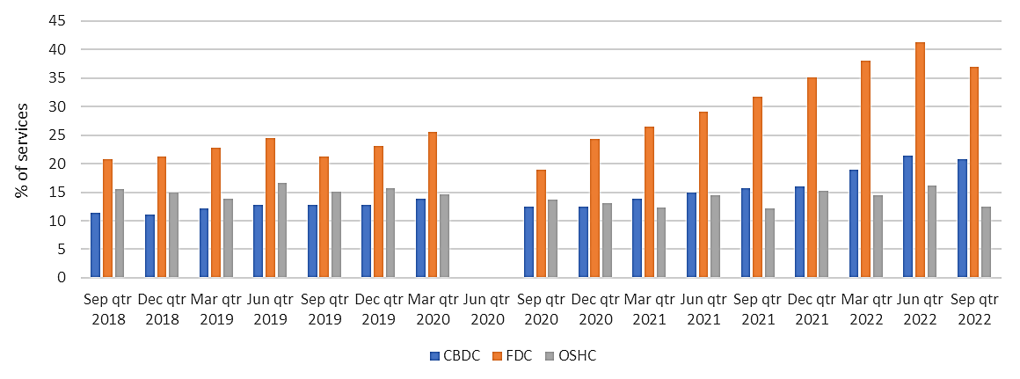
Note: the hourly rate cap is indexed at the start of each new financial year—this can increase the proportion of services charging at, or below, the cap.
Source: Department of Education administrative data.

Workforce Disincentive Rates
Intrinsic to this discussion is the impact of cost and affordability on families’ financial incentives. In the case of secondary earners within a family unit, the incentive to commence work or work additional days to earn additional income can be constrained by tax and transfer settings. This effect is measured by the workforce disincentive rate. This rate captures the proportion of earnings lost from an additional day of work due to tax and transfer settings. The cost of child care is an integral component of this measurement.
Figure 19, prepared by the Treasury Department, provides an example based on estimates of tax and transfer settings in 2023–24 to illustrate workforce disincentive rates for a secondary earner in a couple with 3 children aged 4, 8, and 10. The primary earner receives $60,000 working full‑time, while the secondary earner, working part‑time, receives a full‑time equivalent of $60,000. The rates for the secondary earner in this family exceed 60 per cent when taking up more than one day of work. Further, over 80 per cent of additional earnings are lost on the fifth day of work due to increased income tax and withdrawal of family payments, as well as out‑of‑pocket child care costs.
Figure 19: Workforce Disincentive Rates for a Secondary Earner in a Couple with 3 Children Aged 4, 8 And 10, and $60,000 Primary-earner Income in 2023–24
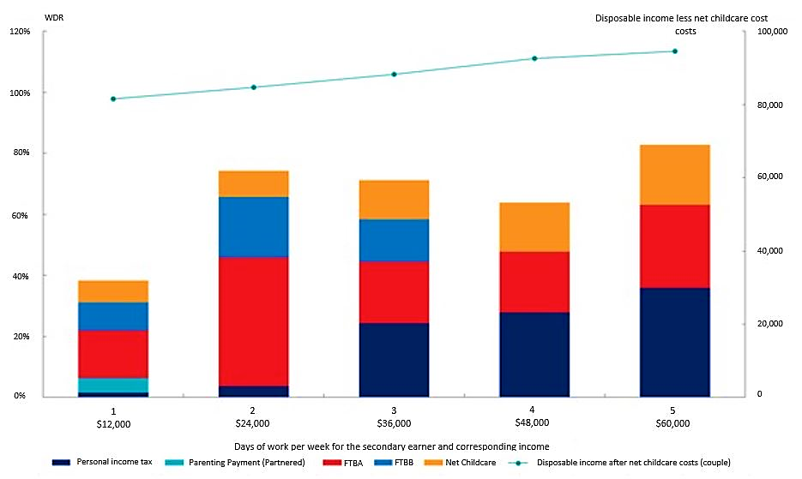
WDR = workforce disincentive rate; FTBA = Family Tax Benefit Part A; FTBB = Family Tax Benefit Part B.
Cameo is based on estimated tax and transfer policy settings for the 2023–24 financial year. Household is assumed to only receive private income from employment. Children under 6 are assumed to be in centre-based day care (CBDC) for 10 hours per day worked by the secondary earner, for 50 weeks per year, at a cost of $10.80/hr. Children over 6 are assumed to be in out‑of‑school‑hours care (OSHC) for 4 hours per day, at a cost of $7.85/hr.
Source: Treasury, Address to the Policy Research Conference.
  - Supply and Access
The supply of ECEC in Australia is market-based, which means it is influenced by the commercial decisions of providers. In addition, factors relating to cost and affordability (refer to Section 5.1), or where a family lives, for example, can affect the accessibility of ECEC services.
Thin markets occur in regions in which ECEC providers are reluctant to enter and are often found in regional and remote areas. The supply of ECEC services is heavily dependent on commercial considerations and decisions on the part of providers. Such decisions extend to, for example, the locations in which providers operate their services and how this aligns with their business model. As such, regional and remote areas are often disproportionately affected.
Table 6 shows the number of children using child care by region in the September quarter 2022. This is followed by Table 7, which shows the number of families using child care by region during the same period.
Table 6: Number of Children Using Child Care by Region, September Quarter 2022
 | Major cities of Australia | Inner regional Australia | Outer regional Australia | Remote & very remote Australia | Australia*
Centre-based day care | 626,720 | 142,490 | 50,470 | 9,130 | 825,850
Family day care | 59,650 | 15,600 | 7,090 | 530 | 82,420
Outside school hours care | 434,390 | 75,540 | 25,690 | 2,290 | 536,660
Total*# | 1,097,810 | 228,320 | 81,280 | 11,690 | 1,411,790
In home care |  |  |  |  | 2,150
Total*^ |  |  |  |  | 1,413,230
# Excludes in home care ^ Includes in home care *As children may use services in more than one state or territory, and due to rounding, the sum of the component parts may not equal the total. Note: region is based on the ABS Accessibility/Remoteness Index of Australia (ARIA), July 2016.
Source: Department of Education administrative data.
Table 7: Number of Families Using Child Care by Region, September Quarter 2022
 | Major cities of Australia | Inner regional Australia | Outer regional Australia | Remote & very remote Australia | Australia*
Centre-based day care | 517,760 | 112,220 | 40,160 | 7,030 | 674,650
Family day care | 41,070 | 11,840 | 5,420 | 400 | 58,340
Outside school hours care | 322,490 | 53,250 | 18,240 | 1,640 | 394,750
Total*# | 773,650 | 158,610 | 57,220 | 8,390 | 990,110
In home care |  |  |  |  | 1,180
Total*^ |  |  |  |  | 990,760
# Excludes in home care ^ Includes in home care *As families may use services in more than one state or territory, and due to rounding, the sum of the component parts may not equal the total. Note: region is based on the ABS Accessibility/Remoteness Index of Australia (ARIA), July 2016.
Source: Department of Education administrative data.
In addition to commercial considerations, the delivery of ECEC services depends on labour supply. Shortages appear to be most acute outside of major metropolitan regions, with approximately 10 per cent of services (as at 1 July 2021) in outer regional, remote, and very remote areas of Australia holding a temporary waiver for one or more of the staffing requirements under the National Quality Framework. This compares to approximately 6 per cent of services in inner regional areas and major cities. Stakeholder consultation conducted by the department has found that these issues are driven by a wide range of factors, including limited opportunities for career development and progression, uncompetitive wages, high levels of personal responsibility, and challenging working conditions.
Analysis undertaken by ACECQA further found that quality was lower in remote areas. The analysis also shows that there are modest differences in quality when comparing other geographical regions.
Table 8: Proportion of Services Rated Working Towards NQS and Exceeding NQS by Remoteness Classification and the Most Disadvantaged Areas
Geographical remoteness |  | SEIFA (Socio-Economic Indexes for Areas) quintile 1  (most disadvantaged)
Major cities of Australia | Working towards NQS | 24%
Major cities of Australia | Exceeding NQS | 26%
Inner regional Australia | Working towards NQS | 20%
Inner regional Australia | Exceeding NQS | 27%
Outer regional Australia | Working towards NQS | 24%
Outer regional Australia | Exceeding NQS | 27%
Remote and very remote Australia | Working towards NQS | 27%
Remote and very remote Australia | Exceeding NQS | 18%
Source: ACECQA, Quality ratings by socio-economic status of area, 2020.
First Nations children and families may experience barriers to ECEC access, such as a lack of culturally safe, holistic ECEC models. A heightened risk of experiencing multiple and complex needs, such as family stress, housing instability, and preventable health conditions can create additional barriers—as can a lack of service provision in regional and remote areas. SNAICC has highlighted the importance of high quality, culturally responsive, and, where possible, community-led and controlled ECEC for First Nations children and families, complemented by wrap around supports.
  - Flexibility
Flexible offerings (such as different session lengths, non-standard hours of care, and wrap around care) can facilitate greater ECEC access and improve workforce participation, but cost is a potential barrier to provision.
The 2018 Child Care Package removed regulatory requirements that limited flexibility, as well as those related to services’ operating hours and days. Notwithstanding this, the subsequent evaluation of the Child Care Package by the Australian Institute of Family Studies found that the reforms had little impact on the flexibility of child care provision and that parental satisfaction regarding flexibility remained unchanged. Cost was identified as the key barrier inhibiting flexible care offerings.
The session length for each service type is primarily determined by the relevant care type model. For example, the FDC business model often offers more flexibility than CBDC. Shorter sessions can be more expensive for providers to offer, which reduces the incentive to provide more flexible session lengths. If providers do choose to offer short sessions, they may offset their costs by charging above the hourly rate cap. As shown in Figure 20, families of most children in CBDC are charged for a 10–‍12-hour session, irrespective of how many hours a family is actually using or wishes to use.
Figure 20: Distribution of Average Session Length for Children in CBDC, September Quarter 2022
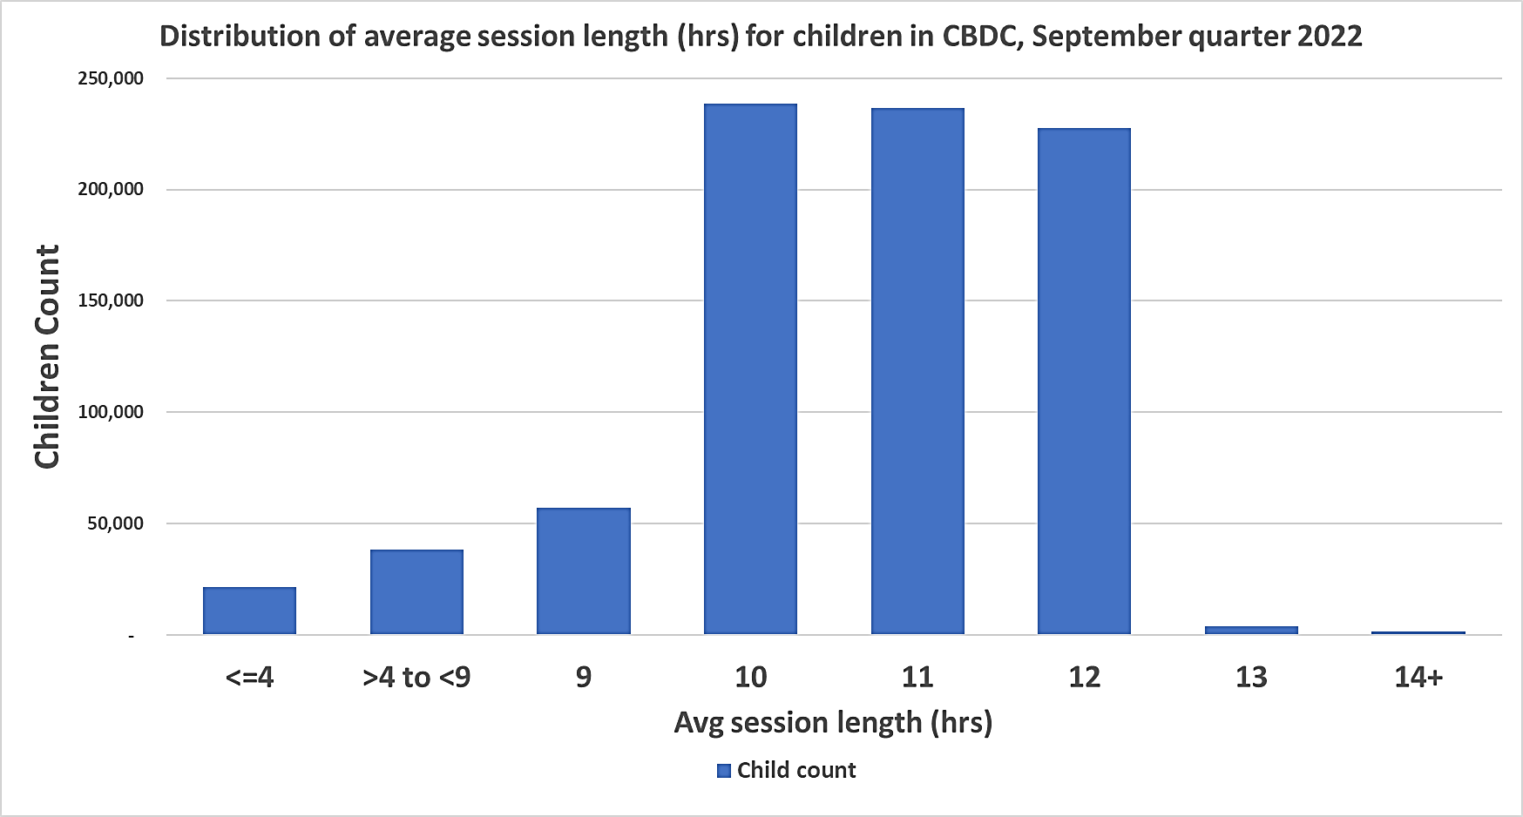
Source: Department of Education administrative data.
Very few services offer sessions during non-standard hours. Approximately 2 per cent of services offer sessions on weekends (0.8 per cent of CBDC and 40.6 per cent of FDC services). In 2022, approximately 1.7 per cent of services were open after 6:30pm on weekdays and even fewer services offered overnight care. Access to casual sessions of ECEC can also be limited for families. Although families who are already enrolled in services may be able to use casual sessions where the service has vacancies, uncertainty about the demand and uptake of casual care means that services at full capacity have limited incentive to offer casual sessions.
Prior to the introduction of the CCS, several programs to increase ECEC flexibility were trialled, including the Flexible Care Trial and the Nanny Pilot. However, a model that maintained viable service provision was not identified. Providers incurred significant costs, which meant families were charged high fees and demand was lower than expected.
  - Early Childhood Education and Care Workforce
Evidence suggests that the ECEC workforce is experiencing long term, persistent challenges, including supply and retention, which have been further exacerbated by the impacts of the
COVID-19 pandemic. Wages and conditions are among the primary concerns of workers, with many in the sector saying more can be done to support qualification attainment in remote areas.
The National Skills Commission 2022 Skills Priority List identifies current national shortages of both educators (child care workers) and early childhood (pre-primary) teachers. As shown in Table 9, vacancies for the 3 main occupation types in the ECEC sector increased by 13.84 per cent between March 2022 and March 2023. Of these, vacancies for early childhood teachers had the largest increase (30.76 per cent), followed by child care centre managers (22.05 per cent) over the same period. Workforce demographics and further information, including employment projections, are detailed in Section 2.5.
Table 9: Jobs and Skills Australia’s Internet Vacancy Index—Vacancies by Occupation
Occupation | Mar 2022 | Feb 2023 | Mar 2023 | % Change  (Mar 2022 to  Mar 2023) | % Change  (Feb 2023 to  Mar 2023)
Child carers | 4,135 | 4,022 | 4,378 | +5.88% | +8.85%
Early childhood teachers | 1,799 | 2,253 | 2,352 | +30.76% | +4.42%
Child care centre managers | 302 | 311 | 369 | +22.05% | +18.52%
Total | 6,237 | 6,586 | 7,100 | +13.84% | +7.79%
Source: Jobs and Skills Australia, Labour Market Insights, Internet Vacancy Index, April 2023.

S Fox, A Southwell, N Stafford, R Goodhue, D Jackson, and C Smith, Better Systems, Better Chances, Australian Research Alliance for Children and Youth, 2015, accessed 24 April 2023.
Australian Government Department of Education (DoE), September quarter 2022 report, DoE website, 2023, accessed 15 May 2023.
Family Assistance Law is the basis for Commonwealth child care fee assistance and consists of primary legislation and legislative instruments. Primary legislation under FAL includes the A New Tax System (Family Assistance) Act 1999 and A New Tax System (Family Assistance) (Administration) Act 1999. Legislative instruments include the Child Care Subsidy Minister’s Rules 2017 and Child Care Subsidy Secretary’s Rules 2017.
The Front Project, A Smart Investment for a Smarter Australia, 2019, accessed 24 April 2023.
Victorian Government Department of Education and Early Childhood Development (DEECD), Early Bird Catches the Worm: The Causal Impact of Pre-school Participation and Teacher Qualifications on Year 3 NAPLAN Outcomes [PDF 0.508 MB], DEECD, 2013, accessed 2 May 2023.
Centre for Adolescent Health, Murdoch Children’s Research Institute, The Effects on Schooling Outcomes of Early Developmental Vulnerabilities in Children, 2018, accessed 26 April 2023.
Australian Government Workplace Gender Equality Agency (WGEA), Wages and Ages: Mapping the Gender Pay Gap by Age, WGEA website, 2022, accessed 26 April 2023.
Australian Bureau of Statistics (ABS), Barriers and Incentives to Labour Force Participation, Australia, ABS website, 2022, accessed 26 April 2023.
Australian Government Department of the Prime Minister and Cabinet (PM&C), Towards 2025: An Australian Government Strategy to Boost Women’s Workforce Participation [PDF 1,082KB], PM&C, Australian Government, 2017, accessed 26 April 2023.
A New Tax System (Family Assistance) (Administration) Act 1999 (Cth).
Australian Government Department of Education (DoE), September quarter 2018 report, DoE website, 2022, accessed 8 May 2023; Department of Education (DoE), September quarter 2022 report, DoE website, 2023, accessed 15 May 2023.
DoE, September quarter 2018 report; DoE, September quarter 2022 report.
A New Tax System (Family Assistance) (Administration) Act 1999 (Cth).
DoE, September quarter 2018 report; DoE, September quarter 2022 report.
DoE, September quarter 2022 report.
Australian Bureau of Statistics (ABS), Preschool Education, ABS website, 2022, accessed 24 April 2023.
DoE, September quarter 2022 report.
Australian Government Jobs and Skills Australia (JSA), Child Care Centre Managers, Job Outlook and the Labour Market Information Portal (LMIP), ANZSCO ID 1341, JSA Labour Market Insights website, 2022, accessed 15 May 2023; JSA, Child Carers, ANZSCO ID 4211, JSA Labour Market Insights website, 2021, accessed 15 May 2023; JSA, Early Childhood (Pre-primary School) Teachers, ANZSCO ID 2411, JSA Labour Market Insights website, 2021, accessed 15 May 2023.
Australian Government Department of Education (DoE), 2021 Early Childhood Education and Care National Workforce Census report, DoE website, 2022, accessed 3 April 2023.
JSA, Child Care Centre Managers, Job Outlook and the Labour Market Information Portal (LMIP), ANZSCO ID 1341, JSA Labour Market Insights website, 2022, accessed 24 April 2023; JSA, Child Carers, ANZSCO ID 4211, JSA Labour Market Insights website, 2021, accessed 24 April 2023; JSA, Early Childhood (Pre-primary School) Teachers, ANZSCO ID 2411, JSA Labour Market Insights website, 2021, accessed 24 April 2023.
Australian Children’s Education and Care Quality Authority (ACECQA), Progressing a national approach to the children's education and care workforce [PDF 4.2MB], ACECQA, 2019, accessed 8 May 2023.
To the extent that it relates to the CCS, Additional Child Care Subsidy, child care providers and child care services.
Australian Government Department of Education (DoE), September quarter 2022 report, DoE website, 2023, accessed 15 May 2023.
The department forecast that 5.3 per cent of families would access CCS24, which would have been 54,291 families based on the total number of CCS families at the time (1.024 million families). The modelling did not account for behaviour change and included all families that may have received CCS24 for a minimum of one week of the year (e.g. a family who received 36 subsidised hours of care for 51 weeks, but received CCS24 for one week would be included in this figure). Given this approach to the modelling, the figure is not directly comparable to point-in-time administrative data such as the September 2022 quarter data, which only shows CCS24 recipients in that quarter.
Australian Government Department of Education (DoE), Child Care Financial Integrity Strategy, DoE, Australian Government, 2019, accessed 17 April 2023.
Parliament of Australia, Education, Skills and Employment Portfolio, Portfolio Budget Statements 2022–23: Budget Related Paper No. 1.4, Australian Government, 2022, accessed 17 April 2023.
Australian Government Department of Education, Skills and Employment (DESE), Department of Education, Skills and Employment Annual Report 2021–2022, DESE, Australian Government, 2022, accessed 17 April 2023.
In 2022, there were 12,999 service providers delivering a preschool program to children aged 3 to 6 years and 284,000 children enrolled in the state-specific year before school. Australian Bureau of Statistics (ABS), Preschool Education, Australia, ABS website, 2022, accessed 20 April 2023.
See: federalfinancialrelations.gov.au/agreements/preschool-reform-agreement.
Parliament of Australia, Budget: October 2022–23, Budget Paper No. 2, Australian Government, 2022.
Australian Government Productivity Commission (PC), Closing the Gap Information Repository, PC website, 2023, accessed 11 April 2023. Target 3 is on track to be met. Nationally in 2021, 96.7 per cent of First Nations children in the Year Before Full-time School age cohort were enrolled in a preschool program—an increase from 76.7 per cent in 2016 (the baseline year). A new Target 3, focused on enrolment and attendance, will be developed by 2025 to refresh this measurement.
PC, Closing the Gap Information Repository. Progress on achieving Target 4 declined in 2021. The proportion of First Nations children who were assessed as developmentally on track when they began school declined from 35.2 per cent in 2018 to 34.3 per cent in 2021. A similar decline can be observed when measuring all children, where the percentage of children who were assessed as developmentally on track also decreased from 55.4 per cent in 2018 to 54.8 per cent in 2021. Factors such as the impacts of COVID-19, as well as increased family stress, may have contributed to these results.
Interim Economic Inclusion Advisory Committee, 2023–24 Report to the Australian Government [PDF 1.5MB], Australian Government, 2023, accessed 1 May 2023; Women’s Economic Equality Taskforce, ‘Letter to Senator the Hon. Katy Gallagher re: Women's Economic Equality Taskforce advice for May 2023 Budget’, 2023, accessed 1 May 2023.
Australian Government Productivity Commission (PC), Productivity Commission Inquiry Report – Overview and Recommendations, PC, Australian Government, 2014, accessed 1 May 2023.
S Kennedy, ‘Employment White Paper – incentives for secondary earners and income support recipients’, Address to the Policy Research Conference, 2023, Australian Government Treasury (Treasury) website, accessed 1 May 2023.
Education Services Australia (ESA), Shaping Our Future, ESA, Australian Government, 2021, accessed 2 May 2023.
Australian Children’s Education and Care Quality Authority (ACECQA), Quality ratings by socio-economic status of areas, ACECQA, 2020, accessed 10 May 2023.
SNAICC, SNAICC Submission to the House of Representatives Standing Committee on Employment, Education and Training, SNAICC, 2020, accessed 2 May 2023.
Australian Government Australian Institute of Family Studies (AIFS), Child Care Package Evaluation: Final Report, AIFS, Australian Government, 2022, accessed 2 May 2023.
AIFS, Child Care Package Evaluation.
ACECQA, Consultation on a Ten Year National Children’s Education and Care Workforce Strategy (2021–30), ACECQA, 2021, accessed 24 April 2023.
Australian Government Jobs and Skills Australia (JSA), Labour Market Update, JSA, Australian Government, 2023, accessed 27 April 2023.
ACECQA, Consultation on a Ten Year National Children’s Education and Care Workforce Strategy.
Australian Government National Skills Commission (NSC), Skills Priority List, NSC website, Australian Government, 2022, accessed 27 April 2023.

