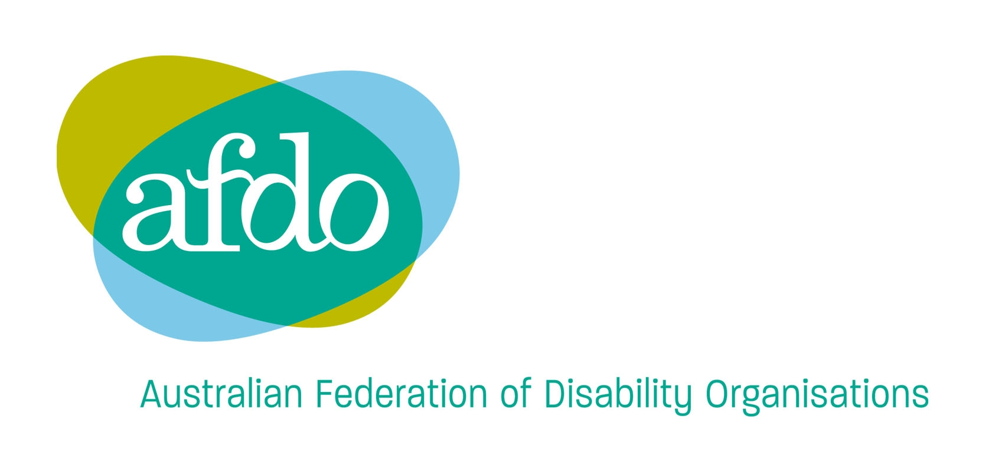
247 Flinders Lane
Melbourne, VIC, 3000
Phone: 03 9662 3324
TTY: 03 9662 3724
Fax: 03 9662 3325
Email: office@afdo.org.au
Web: www.afdo.org.au

Access to Justice
Productivity Commission
GPO Box 1428
Canberra City ACT 2601

4 November 2013

The Australian Federation of Disability Organisations (AFDO) is pleased to have the opportunity to provide a submission to the Commission regarding Access to Justice Arrangements.

AFDO has been established as a primary national voice to Government that fully represents the interests of people with disability across Australia. The mission of AFDO is to champion the rights of people with disability in Australia and help them participate fully in Australian life.

Introduction

AFDO’s work is guided the United Nations Convention on the Rights of Persons with Disabilities (the Convention). Article 13 (below) articulates Australia’s obligations in regard to people with disability having equal access to justice.

1. States Parties shall ensure effective access to justice for persons with disabilities on an equal basis with others, including through the provision of procedural and age-appropriate accommodations, in order to facilitate their effective role as direct and indirect participants, including as witnesses, in all legal proceedings, including at investigative and other preliminary stages.
2. In order to help to ensure effective access to justice for persons with disabilities, States Parties shall promote appropriate training for those working in the field of administration of justice, including police and prison staff.

The attention of the Commission should be drawn to the ‘Concluding observations on the initial report of Australia, adopted by the Committee at the tenth session, 2-13 September 2013 (The UN Report). Please see the relevant extract from the UN Report Below.

Access to justice (art. 13)
27. The Committee is concerned at the lack of training for judicial officers, legal practitioners and court staff on ensuring access to justice for persons with disabilities, as well as lack of guidance on how to access justice for persons with disabilities. It is further concerned that access to sign language interpreters or use of Augmentative and Alternative Modes of Communication (AAC) is not supported in all of the States and Territories.
28. The Committee recommends that standard and compulsory modules on working with persons with disabilities be incorporated into training programs for police, prison officers, lawyers, judicial officers and court staff. It further recommends that legislation and policy across States and Territories be amended to ensure access to justice for persons with disabilities in line with article 13.
29. The Committee further urges the State party to ensure that persons with psychosocial disabilities are ensured equal substantive and procedural guarantees as others in the context of criminal proceedings and in particular to ensure that no diversion programs are implemented that transfer individuals to mental health commitment regimes or that require the individual to participate in mental health services rather than providing such services on the basis of the individual's free and informed consent.
30. The Committee further recommends the State party to ensure that all persons with disabilities who are accused of crimes and are currently detained in jails and institutions without a trial are promptly allowed to defend themselves against criminal charges and are provided with required support and accommodation to facilitate their effective participation.

AFDO is also supportive of the National Disability Strategy, the Australian Government policy response for compliance with The Convention, which has a specific outcome area and policy directions relevant to Access to Justice.

Many of the matters the Commission is inquiring into are relevant to people with disability. People with a disability in Australia encounter many barriers in accessing justice and AFDO’s submission will discuss these. In particular our submission will cover:

- benefits to individuals and communities of access to justice,
- unmet need for support for people with disability to access justice,
- frequency of involvement of people with disability in legal disputes,
- the cost of accessing civil justice,
- simplicity and usability of the legal system,
- pursuing complaints of disability discrimination,
- access to alternative dispute resolution,
- pro bono legal support and representation

Benefits to individuals and communities of access to justice

While people with disability may encounter similar problems to other members of the community, they will often experience high levels of discrimination for which redress is sought through the justice system. At a personal level, continued discrimination can result in exclusion, social isolation and limited access to economic resources. If this discrimination can be effectively addressed through the justice system the quality of life of people with disability will improve and their participation is society increased. It is well known that discrimination, social isolation, exclusion and limited access to economic resources have a serious detrimental effect on people’s mental and physical health and wellbeing.

Communities which celebrate and embrace diversity and make serious efforts to eliminate discrimination always do better. Everyone does better in inclusive and more equal communities. A robust and easily accessible legal system which can effectively address discrimination will improve Australian society for everyone.

Unmet need for support for people with disability to access justice,

When people with disability need support to access the legal system they have a number of options. These options include disability advocacy services, state based legal aid, state of federal human rights organizations or community legal services.

Disability advocacy services in Australia are under-resourced and struggle to meet the demands placed upon them. Supporting a person with disability to access the legal system can be complex and is often beyond the capacity of the advocacy organisation both in terms of resources and expertise.

State based legal aid also has limited resources which are often directed to criminal cases rather than civil cases such as disability discrimination complaints. It is rare for legal aid to fund disability discrimination cases.

The Australian Human Rights Commission (AHRC) can provide support for people with disability to lodge complaints and provides a conciliation service. However if the complaint is not settled at conciliation, they cannot provide advocacy or legal advice as they are an independent third party. An individual can only pursue a matter in the federal court once terminated by the Australian Human Rights Commission, if they can meet the costs.
This situation can also apply to state based human rights organizations and commissions.

Community based legal services, whether specific to disability discrimination or general legal matters, also struggle to meet demand. For example a statewide disability legal service in Victoria has base funding of 2.6 EFT including administration and is unable to meet demand for their services. With some disability discrimination cases running for several years and hearings scheduled to go for one to four weeks, it is easy to see how people with a disability are disadvantaged by this lack of resources.

Frequency of involvement of people with disability in legal disputes

The number of people with disability involved in legal disputes is high. In 2011–12 the Australian Human Rights Commission received 17, 047 enquiries and 2,610 complaints. This is the highest number of complaints received over the past 10 years and 21% higher than the number of complaints received in the previous reporting year.

Of the 2,610 complaints, 37% (965) were for disability discrimination. It is our understanding that number of complaints received by state based human rights commissions relating to disability discrimination is also high. For example, Disability discrimination in all areas is the highest attribute of complaint at the Victorian Human Rights and Equal Opportunity Commission.

It is evident that large numbers of people with disability still experience high rates of discrimination and access to legal services is vital to address this.

Cost of accessing civil justice

Forty-five per cent of the two million Australians living with disability live in or near poverty, according to the Organisation for Economic Co-operation and Development. The Australian Council of Social Service has also released figures showing 620,600 people with disability in Australia are living below the conservative, internationally accepted poverty line used to measure financial hardship in wealthy countries.

High levels of poverty experienced by people with a disability means that the cost of legal services is a real barrier. These high costs are not limited to fees charged by lawyers, courts and tribunals; cost for transcripts, videoconferencing and expert witnesses are often unaffordable.

Simplicity and usability of the legal system

It is fair to say that legal language and process can be daunting and confusing. For people with a cognitive impairment (intellectual disability, learning difficulty or Acquired Brain Injury) the complexities of the justice system can seriously limit their access. Without the necessary support, people with a cognitive impairment may not be able to report a crime perpetrated against them, may not be seen as reliable witnesses and as a result are targeted by perpetrators. Statistics show an over-representation of people with a cognitive impairment as victims of crime.

In addition to this, people with a cognitive impairment may not be aware of their legal rights, may be confused at police interviews and in court which could result in a miscarriage of justice. Statistics show an over-representation of people with cognitive impairment in prison.

The issues mentioned above can also be experienced by people with psychosocial disability (mental illness). When a person with a psychosocial disability is unwell, they need intensive support to access the justice system. With under-resourcing of the mental health system, community legal services and advocacy services, it is likely people with psychosocial disability will have difficulty accessing the justice system. Statistics also show an over-representation of people with psychosocial disability in prison.

People with disability communicate in different ways and can have more complex communication needs. Access to justice can be seriously affected if people with a disability do not have access to alternate communication methods when interacting with the justice system. For example, people who are Deaf need access to Auslan interpreters, people who are non-verbal need access to electronic communication devices and people with cognitive impairment may need information in easy English or pictorial formats.

People who work in the justice system need to be familiar with the access and communication needs of people with disability and be required to undertake relevant training. This view is supported in Paragraphs 27 and 28 of the UN Report.

People with disability need to have access to information about the justice system in a format they can understand. Organisations working in the justice system must provide information in a range of formats including large print, Braille, audio, easy English and electronic formats. This is not difficult to do and setting up systems to provide information in these formats should be mandatory within the justice system.

Some people with disability have difficulty using public transport and accessing the built environment. Getting to appointments and accessing buildings may be a barrier for people who have physical or sensory disability to access the justice system. It is important that all physical infrastructure used in the justice system is compliant with Australian Standard 1428 and current Building Codes to ensure access for people with a disability.

If access to transport is an issue, people working in the justice system should have mechanisms in place to assist people with a disability to get to and from appointments.

Pursuing complaints of disability discrimination

People with disability in Australia experience high levels of discrimination. This is evidenced by the number of complaints received by the Australian Human Rights Commission (AHRC) and state human rights organizations highlighted earlier in this submission. AFDO is of the view that these complaints only represent a fraction of instances where people with disability experience discrimination. Many people with disability do not lodge complaints of discrimination for a variety of reasons. These reasons include:

- not receiving information about disability discrimination and complaints procedures
- not understanding information about disability discrimination and complaints procedures
- not having access to adequate support to understand disability discrimination and participate in complaints processes,
- lack of financial resources for legal representation or fees
- imbalance of power between them and large organizations, government or business,
- they find the process daunting and lack confidence to proceed,

The AHRC has made considerable efforts to make the process of lodging a disability discrimination complaint as easy as possible. However many people with disability still need support to lodge their complaint. This support is not always available and may result in complaints not being lodged.

The conciliation service available through the AHRC is also made as ‘user friendly’ as possible, but it can still be a daunting process. Respondents to disability discrimination complaints often attend with lawyers and people with disability who are not represented or supported experience a severe power imbalance. Once again many people with disability need support during the conciliation process and this is not readily available through disability advocacy services, legal aid or community legal services.

If the matter is not settled at conciliation, taking the matter to court is such a complex, daunting and risky process that many people with disability do not proceed unless they can afford legal representation or are represented pro bono.

The reality is that the further you go along the process to resolve a disability discrimination complaint, the more difficult it becomes. This presents a significant barrier to the resolution of disability discrimination complaints.

Access to alternative dispute resolution (ADR)

AFDO supports the less formal and less costly ADR processes. People with disability should be encouraged to use these services to resolve disputes where possible. We are concerned about the level of accessibility of ADR services for people with disability. AFDO recommends that all organizations which operate ADR services are required to develop Disability Action Plans to ensure there services, facilities and infrastructure is accessible to people with disability.

All staff involved in ADR services need to be familiar with the access and communication needs of people with disability and be required to undertake relevant training. This view is supported in Paragraphs 27 and 28 of the UN Report.

Pro bona support and legal representation

Pro bona work by legal practitioners has made a significant contribution to promoting the rights of people with disability and taking action on systemic discrimination. This pro bono work has supported individuals who have a disability to pursue disability discrimination complaints which have resulted in significant social reforms.

AFDO would like to acknowledge this pro bono work and encourage the Commission to recommend that current incentives such as the National Aspiration Pro Bona Target (35 hours per layer per year) be maintained or increased.

Should you require any further information regarding this submission, please contact me.

Yours sincerely

BILL LAWLER
National Policy Officer

