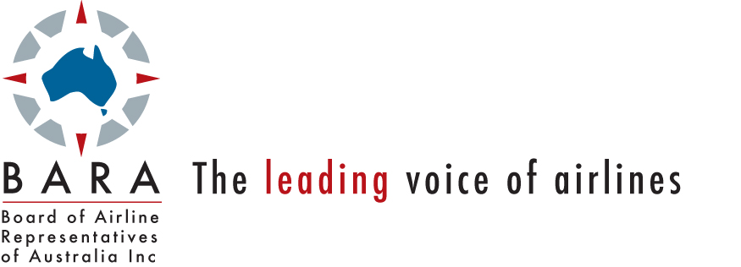

Our Ref.: Let.2057

7 July 2013

Patricia Scott
Presiding Commissioner
Review of the National Access Regime
Productivity Commission
Locked Bag 2, Collins St East
Melbourne VIC 8003, Australia

Dear Ms Scott

National Access Regime Draft Report

The Board of Airline Representatives of Australia (BARA) has reviewed the Productivity Commission’s (the Commission) draft report into the National Access Regime (NAR). BARA offers the following comments on the Commission’s draft report.

Addressing a lack of effective competition and Airport Operator pricing practices

BARA notes the Commission’s recommendation that the application of the NAR should only apply to those circumstances where there is a lack of effective competition in markets for infrastructure services due to natural monopoly. In relation to this matter, BARA re-iterates its position in its initial submission to the Commission that the NAR, is therefore, unlikely to offer any credible avenue for international airlines to pursue in response to unacceptable pricing behaviour by an Airport Operator. This is because while unacceptable price and non-price conduct by an Airport Operator may reduce the commercial opportunities for international airlines to operate and compete in Australia, it is unlikely to mean that the markets served by international airlines will be characterised as being uncompetitive.

BARA is particularly concerned that the weakening regulatory mechanism is encouraging some Airport Operators to not engage in meaningful commercial negotiations and impose unjustified increases in aeronautical charges. BARA does not accept the Commission’s view expressed in its draft report that the market power of Airport Operators is somewhat constrained by commercial pressures. To the contrary, BARA considers that the shareholders of some airports are developing an ‘entitlement’ mentality to the returns they expect to earn on their investments in aeronautical services and facilities, despite actual prevailing conditions in debt and equity markets.

BARA’s proposed Infrastructure Forum

BARA’s Infrastructure Forum was proposed in the context of those situations where the NAR would not apply. Enabling the efficient and timely provision of infrastructure services and facilities are matters that are broader than only allowing access on fair and reasonable terms. Currently, there is no structured basis for infrastructure issues outside those covered by the NAR to be assessed and recommendations made to the Australian Government.

BARA does not accept that the Commission’s position that the Infrastructure Forum ‘may end up presiding over an additional stage of review following NCC recommendations, ministerial decisions, ACCC determinations, Tribunal reviews and court judgments - further adding to the costs and uncertainty for parties to an access dispute.’ It would appear to BARA that the Commission has misinterpreted BARA’s intent, which was not to create another layer over the narrowly defined NAR. Instead, the purpose of the Forum was to provide a structured approach to the nationally important infrastructure delivery and pricing issues that occur outside the ‘core’ infrastructure industries.

Please contact the undersigned on 02 9299 9919 on matters related to the contents of the submission.

Yours sincerely

Barry Abrams
Executive Director

