

Submission by EcoTransit Sydney to the

Economic Regulation of Airport Services
Public inquiry

Prepared by EcoTransit Sydney
22 September 2011
Authorised by the Executive Committee of EcoTransit Sydney

Contact person for this submission:
Mr Gavin Gatenby
Mob: 0417 674 080
P: 02 9567 8502
E: contact@ecotransit.org.au

Contact details for EcoTransit Sydney
PO Box 630
Milsons Point
NSW 1565
E: contact@ecotransit.org.au
W: www.ecotransit.org.au

Term of Reference addressed

This submission addresses the third term of reference of the inquiry: “land transport facilities providing access to the airports”. It does so with special reference to Sydney Airport, although the general points made in relation to land transport access may be taken as having more general application to major airports, especially in Australian capital cities.

What is EcoTransit Sydney?

EcoTransit Sydney is a volunteer, not-for-profit, group operating out of Sydney. We campaign for improved public and active transport, greater use of rail for freight transport and against any new motorway projects.

Background to Sydney Airport’s land transport issues

To understand the particular problems that are being faced, and will be faced in the future at Sydney Airport, it is necessary to take account of the energy supply situation. It is now abundantly clear that the world’s oil supply has peaked and is moving into an accelerating decline.

High and rising oil prices have already had a profound effect on land transport, as shown by statistics compiled by BITRE. Total vehicle kilometres travelled (VKT) has been flat-lining in all Australian capital cities since 2003/4 (Fig 1).

Figure 1
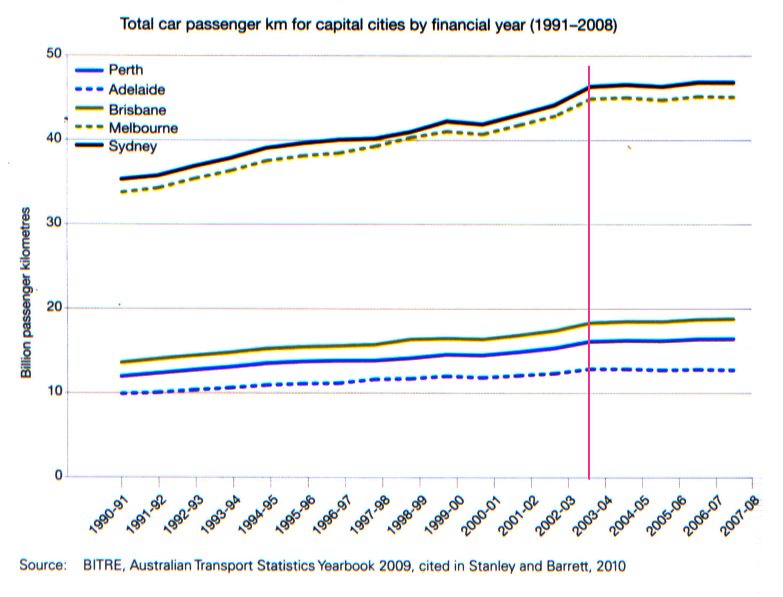

At the same time per capita VKT went into a steep decline (Fig 2). Therefore, only population increase is holding total VKT steady. This phenomena represents a historic shift away from the almost unvarying annual increase in per capita and total VKT that has characterised mobility since the end of World War 2.

Figure 2
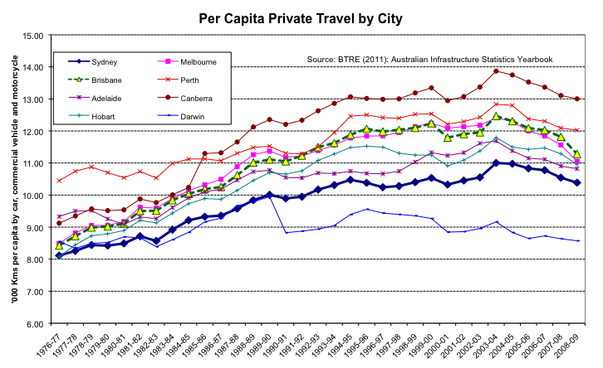
The behavioural break-point coincided with petrol prices reaching 80 – 90 cents a litre. Price rises since 2003/4 have only amplified the trend.

Moreover this change is evident in the USA as shown by total annual miles travelled as compiled by the US Department of Transportation. (Fig 3).

Figure 3
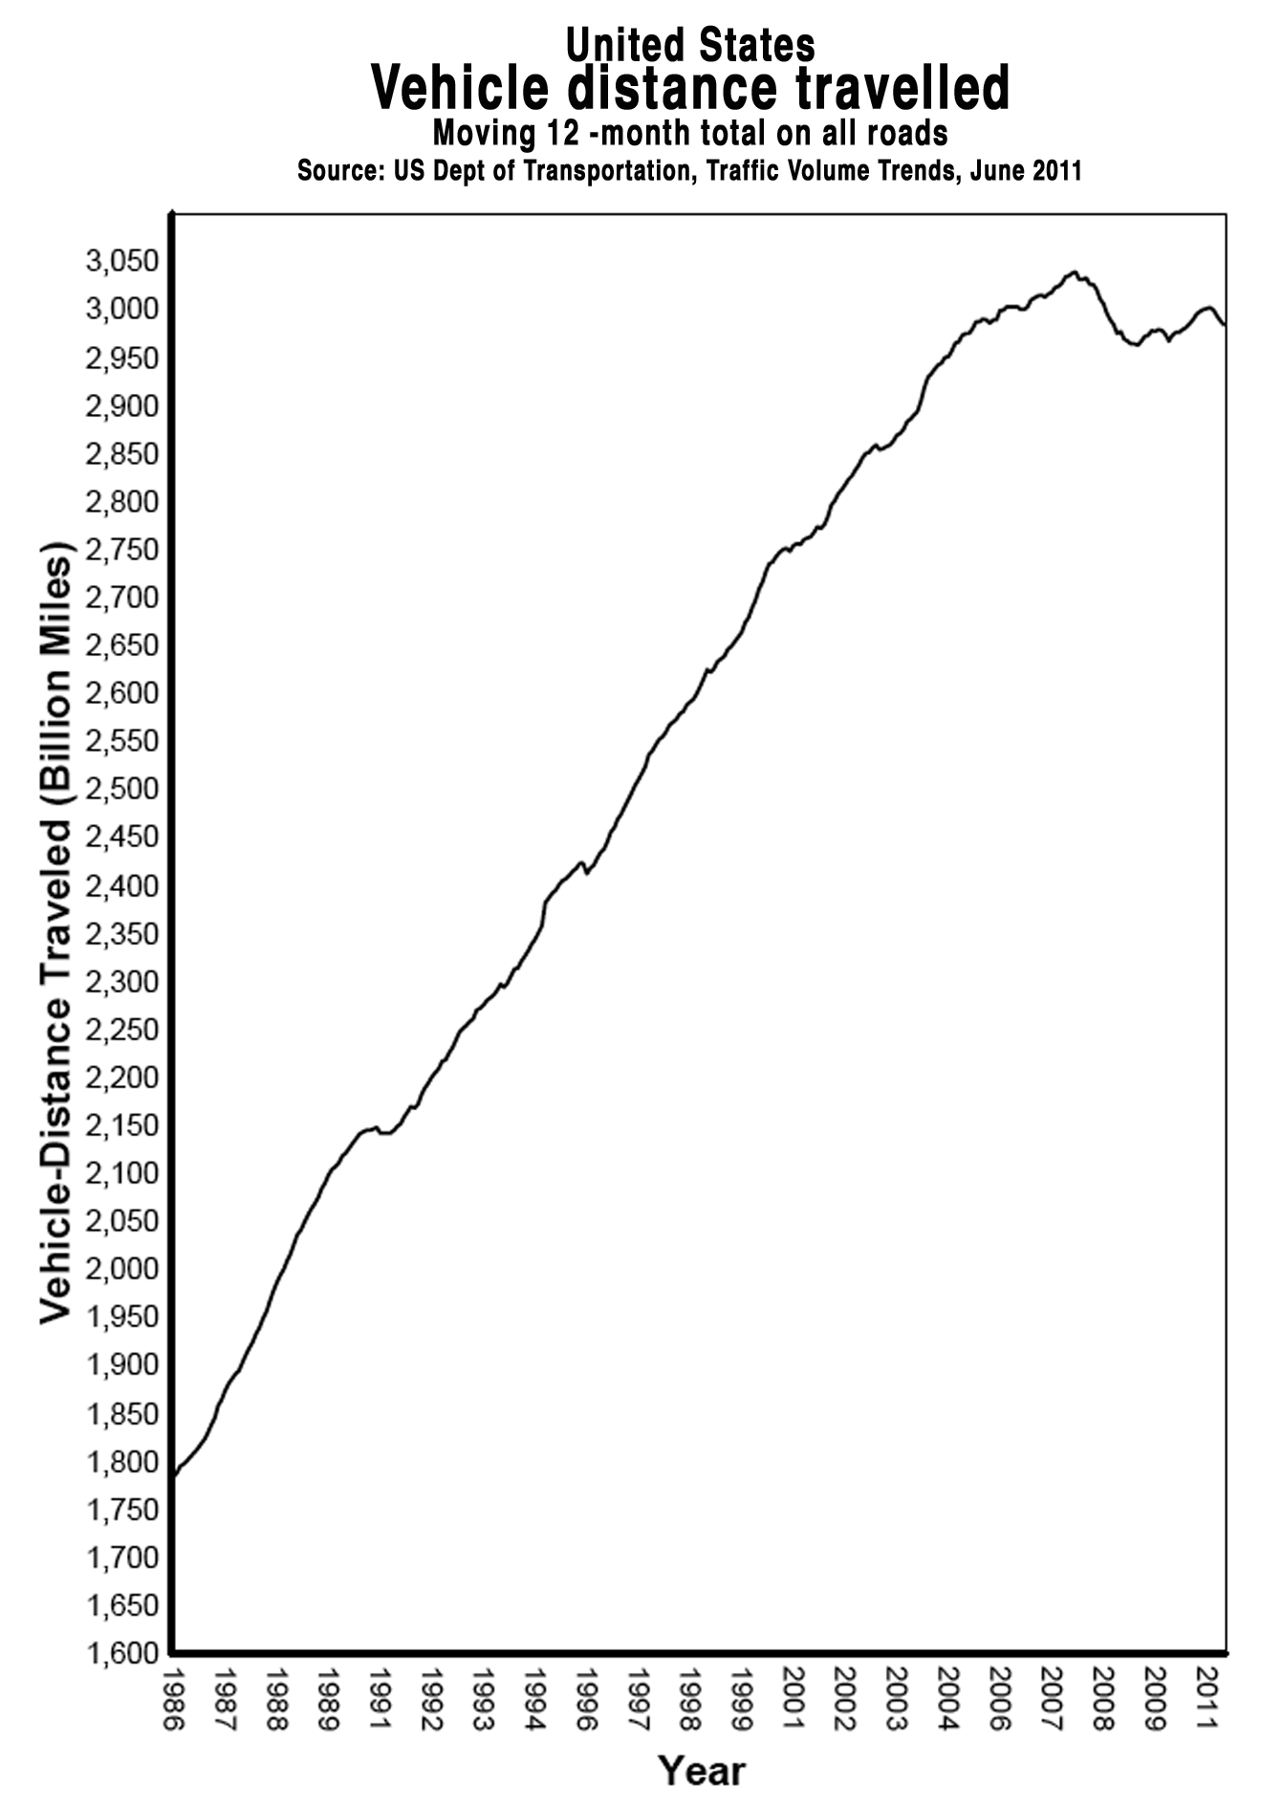

The Australian dollar’s current strength is compensating for high international oil prices. Should the dollar weaken, Australians would face even higher prices at the petrol pump.

Coinciding with the downturn in per-capita VKT, Perth, Brisbane and Melbourne experienced a sharp uptick in public transport usage (Fig 4). This reflects the fact that those cities either had spare public transport capacity, or had recently added new capacity to their systems. In Sydney, by contract, there is little or no remaining peak period capacity. People are trying to minimise their car use, an outcome advocated by state government policy – but without the funding for public and active transport infrastructure that would allow it to happen – for many years.

Figure 4
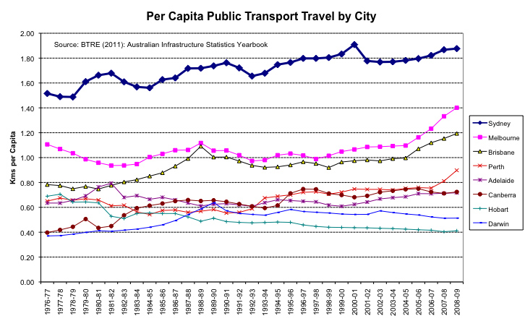

Sydney Airport solution

The road lobby is campaigning publicly for a duplication of the M5 Motorway, which runs from the vicinity of Sydney Airport towards Sydney’s south west. The cost of a full duplication has been estimated at $4.5bn.

It is EcoTransit’s contention that such investment would be entirely misdirected and that rail investment already being undertaken and alternative infrastructure projects costing a fraction of this sum are capable of significantly reducing traffic on the M5.

During the post WW2 period the characteristic response of transport planners to increased road congestion has been to invest in more road capacity. This practice was counter-productive and became increasingly controversial.

While petroleum fuels remained abundant and cheap, each addition to Sydney’s motorway network unleashed pent-up demand and resulted in a flush of induced traffic growth. Typically, the result was that the new road capacity was rapidly filled. The extra traffic generated spilled onto the remainder of the road system (which could never be satisfactorily widened or duplicated) with the result that overall road network speed declined.

However since per-capita VKT began to decline after 2003/4, we face an entirely new situation. The construction of new motorways or the amplification of existing ones might conceivably result in some temporary induced traffic growth but the more likely result will be that any work begun now and completed some years into the future will not even result in an inducted traffic effect. It will simply be misdirected, and therefore wasted, investment.

It is in this light that any investment in new or amplified motorways must be considered.

Currently, traffic speeds on the M5 are not declining and remain higher than most main Sydney arteries. Although population growth is considered inevitable in the outer south-west, the strong tendency for per capita VKT to fall (see above) will tend to balance this out, particularly the South West Rail Link, which extends heavy rail services as far as Leppington is under construction, and more and faster rail services are now possible.

Main elements of an M5 traffic reduction plan

In 2010, in response to pressure to invest in duplication the M5, EcoTransit Sydney and the Australian Conservation Foundation developed the Nine Point Plan – a basket of low-cost alternative measures and projects designed to significantly reduce traffic on the M5 and the road network around Sydney Airport generally.

It is important to note that several of these points are measures which, since the plan was made public, have already been, or are in the process of being implemented by the NSW government.

1. East-West TransLink

Centrepiece of the EcoTransit-ACF traffic reduction package is the East-West TransLink – a high-capacity double-track light rail service running from Dulwich Hill – using the spare space in the heavy rail corridor along the Bankstown line – to Sydenham station and then proceeding beside the Botany Goods line with stops at Qantas Jet Base and the Domestic Terminal before cutting through Eastlakes. At Kingsford, this line would merge with the Anzac Parade light rail route favoured by the current NSW Government (Fig 5). This project has been listed on Infrastructure Australia’s priority list.

Figure 5
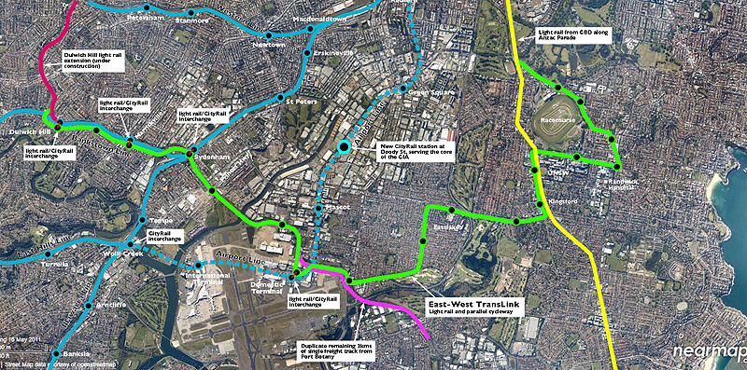

Commuters from the outer south-west would take the Macarthur/Campbelltown services, mostly going via Sydenham and change there for a fast TransLink tram service to the Randwick education and health precinct. Commuters from the inner south-west (that is, on services from Revesby inwards travelling via the Airport Line) would change to the TransLink at the Airport’s Domestic Terminal station. Those coming from the Bankstown line would change to the light rail at Marrickville station (or Sydenham); those from the Illawarra and Cronulla line at Sydenham.

An integral cycleway would take the same route as the light rail, creating, for the first time, a fast, safe way to bypass the tangle of dangerous and busy roads east of Sydenham. The cycleway can be expected to remove, initially, a thousand vehicle movements a day as workers from Leichhardt and Marrickville LGAs abandon their cars for the daily commute.

The TransLink trams would also function as a convenient way for air travellers coming from the Bankstown line axis to get to the domestic terminal (and, by changing there, the International Terminal) and for patrons to reach Randwick Racecourse, the MCG and Centennial Park.

The cost of this extension would be $500m or less, depending on variations.

Traffic reduction potential: The TransLink could be expected to remove at least 20,000 vehicle movements a day (vm/d), most of them from the M5.

Cost: $500m, depending on variations.

2. Equalise Airport Line fares

The Airport Line’s four stations (two serve the airport terminals and two located further north) are privately owned and operated. A ‘station access fee’ is charged and this is added to the standard CityRail fare prices.

The terms of the PPP under which the Airport line was constructed meant that, by 2010, Airport Line commuters were paying a station access fee of $2.60 on top of normal CityRail fares at the two non-airport stations on the line and $11.80 at the International and Domestic terminal stations. Meanwhile, motorists using the M5 Motorway were (and still are) compensated for tolls paid by the Cashback scheme. That is, public transport users were heavily penalised while car commuting was encouraged.

The Sydney Airport Corporation’s submission to the March 2010 M5 Transport Corridor Study summarises the consequences in this way:

People wanting to travel by train to or from Sydney Airport now face a price differential in excess of 400%. It is currently cheaper to travel from Central Station to distant regional destinations that are up to 119 km away such as Kiama (single adult fare $13.60 ) than it is to travel the mere 8km to Sydney Airport (single adult fare $15.40). Similar extreme price differentials exist for other fare products such as weekly, quarterly or yearly tickets. Sydney Airport believes that the magnitude of the existing price discrimination against a person who wants to travel by train to or from Sydney Airport is discouraging them from doing so. Reforming the fare structure for users of the Airport Link stations is not an option considered in the Preliminary Overview Report but should be a high priority because it will help to immediately alleviate existing (and future) traffic congestion in the M5 Corridor and on other roads in the vicinity of Sydney Airport and Port Botany. Importantly, this could be achieved quickly without a long lead time for planning approval, financing or construction as it simply involves the more efficient utilisation of public transport infrastructure that already exists.

This situation changed in late 2010 when the Kenneally Government decided to lift the station access fee at the two non-airport stations by paying it directly to the station owner. The resulting increase in patronage wildly exceeded expectations. The Booz report for Sydney Airport predicted a 17% rise at the non-airport stations and 26% at the airport stations. Since the access fee was lifted there has been a reported 50% rise at Green Square and Mascot attributed to the fee removal and a further 20% attributed to other factors.

The formula of the government paying access fees for the remainder of the period during which the stations will be privately owned, simply creates an ongoing burden to government. In the likely case that patronage at the two airport stations increases very strongly if the government undertakes to pay the access fee at those stations (or even, say, half of it) there will be an even greater ongoing burden. The simplest solution would be for the government to buy out the privately-owned Airport Line stations and apply standard CityRail fares. But in either case, it is certain that there would be a significant reduction in the M5 traffic stream that would justify the expense of either a buy-out or an ongoing subsidy.

Potential for removing traffic: On the M5, at least 5000 vm/d; more when combined with the effect of a new CityRail station at Doody Street covering the centre of the Southern Industrial Area.

3. New Airport Line station at Doody Street

Over 90 per cent of Southern Industrial Area (SIA) workers travel by car. Although the Airport Line runs directly beneath the SIA and is perfectly located to ensure access for commuters in the areas served by the M5 Motorway, access is frustrated by the fact that stations are located only at Mascot and Green Square at the southern and northern ends of the zone. Cost-cutting in the original Airport Line Project saw a potential station at Doody Street, right in the centre of the SIA, abandoned.

It’s a testament to the ease of rail travel that in spite of this huge hole in CityRail coverage, over 10,000 people – approaching half of all the SIA’s public transport commuters – use rail, rather than bus, to get to work.

A new Airport Line station at Doody Street, midway between Mascot and Green Square would cover the core of the area and take thousands of cars, daily, off the M5.

Potential for removing traffic: In combination with fare equalisation (see 2) at least 6000 vm/d. Short-haul feeder bus services meeting peak period trains, combined with secure bike-parking facilities, would further boost this figure.

Cost: $75m

4. Increase rail services from the south-west

Two types of services use the Macarthur/Campbelltown/ East Hills line: limited-stops trains running all the way from Macarthur/Campbelltown and all-stations trains originating at Revesby. Currently, operations are complicated, and services slowed down, by the need for the two types of service to share a critical two-track section of the line. However, with track quadruplication to Revesby within months of completion, this problem is close to solution. Faster, more frequent services will become possible, especially for those who live further out in the south-west. Importantly, additional fast services from the outer south-west will be able to run via Sydenham, reducing journey time by six or more minutes.

The NSW government should be planning, now, to increase services from Macarthur/Campbelltown and to run more of these services via Sydenham.

When combined with fare equalisation on the Airport line, a new Airport line station covering the core of the CIA and the East-West TransLink, giving fast access to the Randwick education and health precinct from either Sydenham or Domestic Terminal stations, we can confidently expect a rapid take-up of additional seats on the Campbelltown/East Hills line, each of which will represent a car taken off the M5.

Potential for removing traffic: Counting only express services to Macarthur/Campbelltown at least 8000 vm/d, with excess capacity to add further CityRail services on both the inner and outer sections of the line, this can be increased as necessary.

Cost: Track quadruplication and station reconstruction already budgeted for. An additional four 8-car train sets would be required at a cost of $120m. It may be possible to used refurbished older rolling stock, currently due for disposal, at a fraction of this price.

Cost: $120m or less.

5. Completion of the South-West Rail link will reduce M5 traffic

The South-West Rail Link from Glenfield to Leppington currently is under construction. When completed it will provide an attractive alternative to commuting by the M5.

Potential for removing traffic movements: Initially, upwards of 5000 vm/d.

6. Expand park-and-ride and bus-and-ride

A program of free commuter car parks designed to “soak off” M5 car traffic should be expedited. In particular, a new “last chance” car park for at least 1500 vehicles should be built adjacent to Kingsgrove station – the point where the M5 comes closest to the Campbelltown/East Hills line – with a new direct link to the station platforms. This facility would remove cars from the M5 traffic stream a kilometre before the M5E tunnel. The facility could only be entered from the eastbound lanes of the M5 and exited via the westbound lanes, thus preserving spaces for commuters from the vast swath of suburbs along the M5 which aren’t well serviced by either the East Hills or Bankstown lines.

The facility would also act as a last chance kiss-and-ride point for airport passengers and potentially as a drop-off and turn-back point for new express bus services using the M5.

Potential for removing traffic movements: Upwards of 3000 vm/d, more if express bus services are introduced.

Cost: Around $70m.

7. Get serious about railing containers from Port Botany

Successive NSW governments have never pursued seriously their long-held target of transporting 40 per cent of containers out of Port Botany by rail. As noted recently in the Sydney Morning Herald:

“For most of the decade, government policy has professed an aim to transport an increasing share of these goods by rail instead of road. Rail cuts noise and air pollution and, by taking trucks from the streets, makes them safer and less congested for regular drivers. The former transport minister, Craig Knowles, set a 40 per cent target for rail transport in 2004 that is still in place. When Knowles set the target, rail had a market share of 22 per cent. It has since slipped to 18 per cent.”

Its failure is symbolised by the fact that three kilometres of constricting single track remains between Port Botany and Sydenham, even though it will cost a pittance to duplicate. The duplicated track would be laid within the existing rail corridor and on flat, unchallenging terrain. If built according to benchmark rates used by ARTC for new track on flat terrain, it cost would be $2 million per kilometre. This missing link could be completed in weeks, allowing hundreds of container truck movements to be taken off the M5 and local roads.

A prerequisite for the increased use of rail containerisation in urban areas is a legislative initiative that would mandate the use of electric locomotives, or in the case of diesel locomotives, only those that conform to the advanced emission standards coming into effect in the European Union and the USA.

Potential for removing traffic: If 40 per cent of container volume goes by rail 800 vm/d will be removed from the road network. Higher mode splits would be possible.

Cost: $25m

8. Apply Cashback funds to public transport improvement

The M4/M5 motorway cashback rebate scheme is currently costing NSW over $100m a year. Always controversial, the scheme was conceived by the Carr government as a means of placating voters when it discovered that it couldn’t remove the tolls on the M4 and M5 motorways as it had promised before the 1995 NSW election.

Instead of serving to subsidise and entrench car-use, the funds would be better deployed in funding long-term, sustainable, public active transport projects. It would be a way of future-proofing communities by reducing their dependence on a single, and increasingly expensive, transport mode.

The funds involved are substantial. Based on figures obtained under freedom of information laws, the Sydney Morning Herald reported that the cost of the program will balloon to more than $2.39 billion by the time it ends in 2023.

We strongly suggest that, as key infrastructure elements of this plan come on stream, Cashback be phased out over a three year period with the money saved being put to practical use in further improving public transport services along the M5 corridor. The purchase of four additional 8-car train sets to provide more peak-period train capacity, the construction of the Doody Street station in the SIA and construction of the Kingsgrove ‘last chance’ park-and-ride station are examples of projects that could be funded by a staged annual reduction of the Cashback scheme.

Potential for removing traffic: depends on use to which the money saved is put. See traffic reduction potential for individual infrastructure projects outlined above.

Cost: Revenue neutral.

http://www.worldenergyoutlook.org/
http://www.energybulletin.net/stories/2010-11-11/iea-acknowledges-peak-oil
http://www.bitre.gov.au/info.aspx?ResourceId=710&NodeId=111
http://www.bitre.gov.au/publications/10/Files/BITRE_TRANSPORT_STATS_ YEARBOOK_2009.pdf
http://www.fhwa.dot.gov/ohim/tvtw/11juntvt/11juntvt.pdf
http://www.bitre.gov.au/info.aspx?ResourceId=792&NodeId=50
http://www.rta.nsw.gov.au/roadprojects/projects/building_sydney_motorways/m5/index.html
http://www.tca.nsw.gov.au/Our-Projects/Current-Projects/South-West-Rail-Link/South-West-Rail-Link/default.aspx
http://www.ecotransit.org.au/ets/ets_acf_nine_point_plan
http://en.wikipedia.org/wiki/South_West_railway_line,_Sydney
http://smh.drive.com.au/roads-and-traffic/coming-to-a-traffic-jam-near-you-20101217-190s7.html
http://www.artc.com.au/library/IRAS%20WP3%20Stage%201%20Capital%20Works%20 Costings%20090505.pdf, p. 8.
http://www.dieselnet.com/standards/eu/nonroad.php
http://www.epa.gov/oms/regs/nonroad/420f08004.htm
http://www.smh.com.au/news/national/billions-blown-in-tolls-fiasco/2008/12/30/1230399211488.html

