Submission — Airport Regulation
National Public Lobby

The following contains ideas that will facilitate improved access to Melbourne Airport.
A rail and tram link is supported on the basis that it be made accessible on a met ticket. The writer was surveyed some years ago at Melbourne Airport. He was asked if he would travel by train to Melbourne Airport if the cost was the same as a taxi. To that question he responded in the negative. He was not asked if he would travel by train if it were to be offered at Met ticket prices. Fair access to Melbourne Airport would be available if the Federal Government met its national transport obligations by closing the only interstate inter-capital gap in the National 'said to integrated' Transport Network. It should do so by fully funding three inter-capital transport corridors for Melbourne, not just two. This would include links to the Melbourne's major two airports. Canberra could then be said to be treating its people and all states fairly.

Peter Brohier

NATIONAL PUBLIC LOBBY TM PN Brohier 2010
IDEAS CHANGING LIVES TM PN Brohier 2010
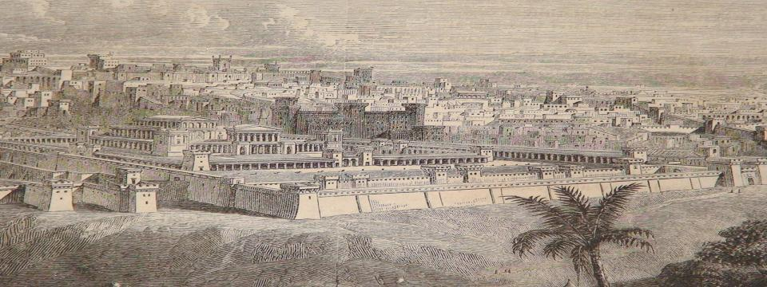
©Copyright Peter Brohier 2000
Map Tag® is a registered
trademark of Peter Brohier AUSTRALIA
NATIONAL PUBLIC LOBBY (NPL)

This site is associated with maptag.com.au and is not associated with any other entity.

FOR EXAMPLE, AN NPL MAY LOBBY TO DELIVER SOME OR ALL OF THE FOLLOWING OUTCOMES:
SAVE TIME, MONEY AND FUEL LINKING THE BAY FOR THE FIRST TIME AND BY BETTER USE OF EXISTING $200 BILLION TRANSPORT LINKS
Melbourne needs the same vision that built the Sydney Harbour Bridge
Why is there a gap in Melbourne’s ring road, between Greensborough and Bulleen, and no road and rail bridge crossing the entrance to Port Phillip Bay? These links would complete a ring road linking the “twin cities by the bay” of Geelong and Melbourne with the Mornington Peninsula. Peak hour traffic could be channelled to flow at the same time, in both directions. This would save travel time, better use existing infrastructure, ease traffic flows and spread the impact of population growth over two cities. Savings will be through much greater use of well over $100 billion of existing infrastructure, on each side of the Bay, including two airports and associated rail links, and result in a consequential reduction in the cost of the existing network by its constant adjustment. The sooner this is done the more we will save. An alternative rail and truck route between the new Port of Hastings to the airports and industrial area to west of Melbourne will provide an east- west route allowing some major traffic flows to bypass Melbourne completely. This will allow unprecedented new access travel options for those on the Bellarine and Mornington Peninsulas. It is understood that people like to live near the sea. An east-west route across the whole state would develop. The Bridge would seems to enhance the VECCI proposal for the east west route. If a ferry link to Tasmania were established through Stony Point, at the end of a suburban train link and near Hastings, the east-west route would meet the north south route to Tasmania. The bridge would allow access for all, on any side of the Bay, to the shortest practicable sea route to and from Tasmania. It would also reduce the need to develop Melbourne towards the north, and Gippsland corridor and towards the bush fire prone Dandenongs. This would reduce through traffic flows at inner-city strip shopping centres, turning these strips into motorways. Any delay in building this link will result in the needless cutting up of Melbourne. The approach to building this link should be special, and not be measured by existing traffic flows but be akin to building a cross national rail link with people and towns following. This is one instance when existing methods of infrastructure justification should not apply.
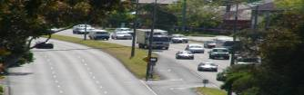 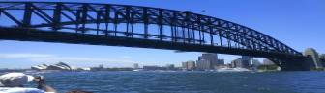
Peak hour traffic flowing in one direction could be spread over both sides of highway, reducing travel times in both directions
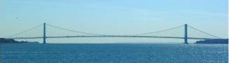
This could be Melbourne's new icon, connecting the heads at Port Phillip Bay.
WEEKEND TRIPS INTERSTATE, FAIR TRADE, ECONOMIC BENEFITS TO TWO STATES, AND PROTECTING TASMANIAN FORESTS
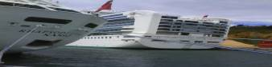
Why is there a major omission in the nation’s "integrated surface transport network”? Adelaide has justified, based on its proximity to other capitals, Federal funding for three direct interstate inter-capital transport corridors and connecting links. On the basis of Victoria’s geographical location it is entitled to three similar links. It has been given just two. A comprehensive, affordable, consistently priced, all-year basic public transport link for people, vehicles and freight, using ferries between Victoria and Tasmania needs can, subject to direction by Canberra, start to be delivered in weeks and linked to the land transport corridor to Hobart. All Australians are entitled to fair access to all states, not just some. Also, fair competition policy, advocated internationally, should apply across the Victorian — Tasmanian border to Victorian manufactured consumables sent south and international exports form Tasmania through Victorian ports. The economic impact on tourism, and other industries, of all year, consistently priced, transport equity will be significant. In Tasmania it would be expected to be large enough to preserve Tasmania’s forests. Federal funding for a complete the ring road to connect existing transport corridors to three capital cities, Adelaide, Sydney and Hobart, is fully justified and long overdue. A shorter route through Stony Point would cut the travel times and emissions. Canberra seems close to closing this gap in the national transport network but has the responsibility to lock in and deliver full National Highway equivalence. The Victorian Government asked for inclusion of this link under Auslink. This request was not met. Air links to two airports could also be covered. The Federal Government has not included the link under Infrastructure Australia.

Access to Tasmania may become a regular weekend trip just like access to Switzerland from nearby European destinations.
CATERING FOR THOSE WHO PREFER ‘CHEAP’ ACCESS TO MELBOURNE AIRPORT AND CHEAP FLIGHTS
Why is there no tram link from Airport West to Melbourne Airport? This would allow a new and affordable travel option on a Met ticket to Melbourne Airport. The impact on existing transport options may be minimal. A future high-speed rail link, if built, may not be as cheap unless funded by the Federal Government under its third link obligations. The cost of travel to the airport can often exceed the cost of the flight. The distance is about 6 km and the construction cost is expected to be low compared with a rail link. If a fast rail were introduced the tram link would remain viable as it would also service those living between the city and the airport and still provide a link used by those who would prefer to spend time traveling rather than a higher priced option. The link would provide choice especially for light luggage travellers. The total cost of traveling by air to Melbourne will be reduced, making Melbourne an even more desirable destination. If some people like cheap flights, why wouldn't some like cheap access to the airport on a regular Met ticket? The link will require only about 6 km of tram line on a full cost recovery basis may enable travel to be on a met ticket. A rail link could also result such a low fare. Airports should be seen as regular intermodal hubs, not just focused on optional, high-class travel.
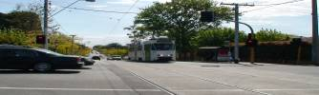

MAKING YOUR VIEWS COUNT IN CANBERRA — WITHOUT POLITICIANS
Why is there no well-funded public “think tank” and “public lobby”? This would allow effective democracy, not just the appearance of it. Ideas from professional lobbying and think tanks, including those engaged by well-funded organizations, including industry, all levels of government and others, should be balanced by ideas and views from the public that are also similarly, properly prepared and advanced. Fair and balanced decision-making, with the widest group of people is critical for a functional democracy, and can efficiently use the time of elected representatives and their officers. The process can be set up under an independent structure responsible to the parliament, in a similar way to the Auditor General’s office. The final decision, will on any issue, will remain with elected representatives. Considerable time can be saved by elected representatives though this process as ideas and complaints can be aggregated form across Australia and dealt with and enhance effectively. Access to elected officials can remain.

Is modern politics more difficult than playing a game chess?
A $2 BILLION ASSET FOR A MAJOR REGIONAL SPORTING COMPLEX AND PARK
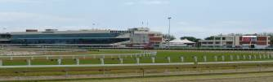
The centre of the racecourse reserve is ideal for a low-rise park — shared with racing
Why is the Caulfield Racecourse Reserve and transport hub under-utilised? State and Federal expenditure can be efficiently targeted to show off and develop this valuable public land, located at this principal activity centre. Benefits to both racing and the wider community can be maximised, including a public park, a regional shopping centre for the inner city based on public transport access and regional recreational facility. The Reserve comprises is crown land, designated for public recreation and for racing. Horse training should be retained at the Reserve and made a feature of this Reserve. The area from Stonnington to the Racecourse over the railway lines and Dandenong Road could be developed into a major low rise shopping plaza over three floors.
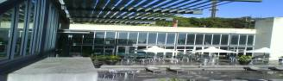
Major sporting, entertainment and shopping facilities can be built near the Caulfield Railway Station. Commuters on their way to and from work from nearby areas and as far afield as Cranbourne and Frankston would be able to stop at the Caulfield Rail, tram and bus hub, and cross the road to this centre. The benefits would flow to more effective use of public monies by reducing the need to duplicate facilities in neighbouring municipalities.

TURNING MAJOR ROADS INTO PARKS
Why haven’t canopy trees been planted over major roads? This is the cheapest and easiest way of hiding main road development, providing a more liveable environment impacting on most Victorians and changing the appearance of our cities. The canopy or air space over major roads is currently a large unused community asset
. 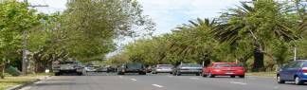
A major road with a tree canopy
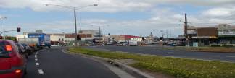
Further down the same road, without a tree canopy
ENGAGE THE UNEMPLOYED — ALSO REDUCE CRIME WITHOUT MORE POLICE
Why isn’t there a scheme that allows the Government to act as a labour hire and job placement agency and hire its unemployed pool of labour to the private sector with the unemployment benefit able to be used as wages? This optional, but innovative, employment scheme will give the unemployed the dignity of being treated as other employees and offer choice of employment. A financial return for each hour of hire, paid by employers to the Government, is expected. This amount can be set at whatever the Government can achieve through negotiation with individual employers. Part-time employment, at normal wages, for the unemployed can result. This simple proposal is based on existing commercial practice in the private sector applying to many regular workers. Unemployment is in number about half the population of Adelaide. This idea may also be an “employment led” solution to reduce crime generated from the ‘night person crime cycle', with no additional police needed. With larger numbers working during the day, under this scheme, any potential to associate with those engaged with this group will be minimised.

Savings, stimulus, revenue and dignity

ABOUT PETER BROHIER
Prime Ministers, Keating, Howard and the Rudd Government have responded to Peter Brohier’s vision, influence or lobbying for low cost access by sea to and from Tasmania.
Uncapped federal funding for Bass Strait has dramatically improved the economy of Tasmania and offered greater transport equity for people and vehicles.
Peter was awarded a major AHA Tasmania award for outstanding services to tourism and for bringing the nation a National Sea Highway. Peter graduated in law from Monash and won the CPA award for top accounting student from RMIT.
Peter, you can, and should — take personal credit for the improvements in Bass Strait fare equality. The campaign you and the National Sea Highway Committee have waged over many years has succeeded in delivering better fares for Tasmanians. Peter, I thank you for your hard work on behalf of this State. All Tasmanians must salute you for your achievements. Bob Cheek, MHA, a Former Liberal Leader of the Opposition Tasmania.
Mr Brohier has been a very strong advocate for a better deal for people on Bass Strait. I think he has done a terrific job over the last few years. Through his efforts he is probably more responsible than anybody else for the introduction of the vehicle subsidy, I would think. Paul Lennon, former Premier of Tasmania, Hansard 12 April 2002
"Senator Barnett, I and a few others met with the restaurant and catering representatives of the Australian Hotels Association-tourism and hospitality being a growth area in our home state because of the Bass Strait Passenger Vehicle Equalisation Scheme initiated by the Howard Government". Senator Abetz, Hansard 6th December 2004
Senator Colbeck said the scheme, combined with the Spirit of Tasmania ferries, was the next best thing to a highway link with the rest of Australia. He said the figures confirmed that without the decision to introduce the scheme, the ferries would not be the success they have been. The Mercury, 13th July 2004
Van Diemen's Reborn Land “Tourism is soaring, the economy is growing (the forecast is 3.5% next year), unemployment is falling and Tasmanians are no longer leaving home. Introduction of two daily ferry services from Melbourne in 2002, have fed the rush" The Economist, 17th January 2004
"Many of the world’s great and timeless stories are about the “pursuit of purpose”. I believe that these stories contain the secret to an extraordinary life. Taking ideas that can change a nation from nowhere to the highest level in the politics is very hard. Key elements of such stories are still just as highly and personally relevant today as on the very day they were written.” Peter Brohier 2009


