
 | Strengthening  economic relations  between Australia  and New Zealand
 | A JOINT STUDY · Issues paper · April 2012

The Issues Paper
The Productivity Commissions of Australia and New Zealand have released this issues paper to assist individuals and organisations to prepare submissions to the study. It contains and outlines:
- the scope of the study
- the Commissions’ procedures
- matters about which the Commissions are seeking comment and information, and
- how to make a submission.
Participants should not feel that they are restricted to comment only on matters raised in the issues paper. The Commissions wish to receive information and comment on issues which participants consider relevant to the study’s terms of reference.
Key dates
Terms of reference Issues paper Draft report Final report
21 March 2012 April 2012 September 2012 1 December 2012
Submissions are due by 31 May 2012
Details on how to lodge your submission can be found on the study website (see also attachment B ‘Have your say’).
Contacts
Administrative matters:
Australian Productivity Commission
Ph: +61 2 6240 3262 Email: transtasmanreview@pc.gov.au
New Zealand Productivity Commission
Ph: +64 4 903 5150 Email: transtasmanreview@productivity.govt.nz
Other matters:
Australian Productivity Commission
Tom Nankivell ph. +61 2 6240 3235
New Zealand Productivity Commission
Paul Conway ph. +64 4 903 5155
Website
www.transtasman-review.pc.gov.au
www.transtasman-review.productivity.govt.nz
Australian Productivity Commission
The Australian Productivity Commission is the Australian Government’s independent research and advisory body on a range of economic, social and environmental issues affecting the welfare of Australians. Its role, expressed most simply, is to help governments make better policies in the long term interest of the Australian community. <www.pc.gov.au>
New Zealand Productivity Commission
The New Zealand Productivity Commission was established in April 2011 and is an independent crown entity with a dedicated focus on productivity. The Commission carries out in-depth analysis and research on inquiry topics selected by the Government with the aim of providing independent, well-informed and accessible advice that leads to the best possible improvement in the wellbeing of New Zealanders. <www.productivity.govt.nz>

Contents
1 What have the Commissions been asked to do? 1
The Commissions’ approach 1
How you can contribute to this study 2
2 Trans-Tasman economic relations —progress to date 3
The closer economic relations agenda 3
Trends in trade, investment and migration 10
3 Economic integration and transaction costs 14
What is economic integration and what drives it? 14
Benefits, costs and risks of economic integration 15
4 Principles for a trans-Tasman integration policy 17
What rationale? 17
How far should integration go? 18
Interactions with regional, multilateral and unilateral actions 20
How should adjustment issues be dealt with? 22
5 Possible areas for further integration 24
Trade in goods 26
Services trade 28
Capital flows 29
Labour movements 30
Knowledge transfers 31
Government functions 31
6 Implementation and governance 33
Attachment A Terms of reference 34
Attachment B Have your say 36
Submissions are public documents 36
How to make a submission 36
References 37

1 What have the Commissions been asked to do?
The Prime Ministers of Australia and New Zealand have asked the Productivity Commissions of each country to conduct a joint scoping study on strengthening trans-Tasman economic relations. The Prime Ministers have requested that the study identify reforms that will boost productivity, increase competitiveness and drive deeper economic integration between the two countries.
The Commissions are to provide analysis on:
- potential areas of further economic reform and integration, including identification of the areas of reform where benefits are likely to be most significant, with particular focus on critical issues for business like investment and productivity
- the economic impacts and benefits of reform
- any significant transition and adjustment costs that could be incurred
- identification of reform where joint net benefits are highest
- the means by which they might be best actioned and
- the likely time paths over which benefits are expected to accrue.
The full terms of reference are provided in attachment A.

The Commissions’ approach
The Commissions’ approach to this scoping study will be to seek out a reform agenda that would improve the welfare of both the Australian and New Zealand communities. Initiatives promoting economic integration can have costs as well as benefits. There will, therefore, be a need to apply a ‘net benefits’ framework and to consider how gains and losses are distributed within and between countries.
The Commissions will propose directions and priorities for further trans-Tasman economic integration over a 15 to 20 year time horizon. Recommendations on specific reforms that should be made in the near term will also be made where possible.
In addition, the Commissions’ approach will recognise that:
- the study has a broad scope that allows for the consideration of deeper levels of integration than envisaged by the current trans-Tasman integration agenda
- there are interactions between efforts to promote bilateral integration and broader regional and multilateral agendas and these need to be considered
- integration is fundamentally concerned with reducing the costs of undertaking all forms of exchange. Both markets and governments influence these costs.
These issues will be further elaborated in later sections. The Commissions will also give attention to how reform should be implemented, as required by the terms of reference.
This is the first study jointly undertaken by the New Zealand and Australian Productivity Commissions. Commissioners from both agencies will lead the study, supported by a cross-agency staff team.

 | Q.1 |  | How can the Commissions ensure that this study adds most value? Where should they focus their efforts? Which issues are most important?

How you can contribute to this study
The Commissions invite submissions from organisations and individuals. Comments are welcomed on issues relevant to the terms of reference. Some particular areas where the Commissions would appreciate input are highlighted in this issues paper. There is no need to address all of the questions posed in this paper. For example, you may wish to focus on your own experience of doing business across the Tasman, addressing such questions as the following.

 | Q.2 |  | What have you found to be the major barriers to doing business across the Tasman?

 | Q.3 |  | How have these barriers affected your organisation?

 | Q.4 |  | What should governments do to reduce or eliminate these barriers?
The Commissions are seeking initial submissions by 31 May 2012. Attachment B provides information on how you can make a submission.
Drawing on the input received, and on our own analysis, the Commissions will produce a draft report by mid-September 2012. This will contain the Commissions’ preliminary conclusions, and will provide a further opportunity for participants to express their views before a final report is submitted to both Governments on 1 December 2012. An indicative timeline for the study is outlined inside the cover of this issues paper.

2 Trans-Tasman economic relations —progress to date

The closer economic relations agenda
Formal economic relations between Australia and New Zealand have a long history, with trade agreements dating as far back as 1922 (box 1). Cultural, institutional and other similarities between the two countries have assisted the development of trade links. More recently trans-Tasman economic relations have been shaped by the 1983 agreement dealing with tariffs — the Australia-New Zealand Closer Economic Relations Trade Agreement (ANZCERTA). The ANZCERTA, along with subsequent agreements, some directed towards a ‘single economic market’ (SEM), have formed the bases of a closer economic relations (CER) agenda (box 2).
At its inception, the ANZCERTA was a bilateral preferential trade agreement under which both countries agreed to extend preferential access for goods to producers from the other country. The objectives of the ANZCERTA were to:
- strengthen the broader relationship between Australia and New Zealand
- develop closer economic relations between Australia and New Zealand through a mutually beneficial expansion of free trade between the two countries
- eliminate barriers to trade between Australia and New Zealand in a gradual and progressive manner under an agreed timetable and with a minimum of disruption
- develop trade between Australia and New Zealand under conditions of fair competition (JSCFADT, 2006).
In addition, the ANZCERTA served as a means of exposing the tradeable sectors in both countries to a greater degree of international competition.
The CER agenda has since evolved to not only reduce trade barriers but also to seek greater harmonisation or integration across a wide range of issues (box 1 summarises significant agreements signed by the two countries.) As a result, the CER agenda now covers matters including: trade in goods; trade in services; investment; business environment; taxation; government procurement; movement of people and areas of social policy.
Unlike multilateral liberalisation frameworks, such as the World Trade Organization agreements, there is no formal dispute resolution mechanism for resolving differences regarding the application of CER agreements. Instead, both countries have agreed to resolve such issues through discussion and negotiation.

Box 1 A timeline of significant Australia-New Zealand integration agreements
1922 | Australia and New Zealand sign an agreement to extend ‘British’ preferential tariff rates to each other on 192 goods.
1965 | The New Zealand–Australia Free Trade Agreement comes into force, dealing with tariffs and some other trade barriers, but covering only half of the value of goods traded between the two countries.
1973 | The Trans-Tasman Travel Arrangement allows citizens of Australia and New Zealand to travel and work unrestricted in both countries.
1983 | The Australia–New Zealand Closer Economic Relations Trade Agreement (ANZCERTA) commences. Tariff and quantitative restrictions were to be eliminated by 1990, but this was achieved ahead of schedule.
1988 | The CER Services Protocol commits the countries to eliminating restrictions on the trade in services by 1989, except for prescribed industries.
 | The Protocol on the Harmonisation of Quarantine Administrative Procedures seeks to achieve consistent quarantine administration.
 | The Memorandum of Understanding on Technical Barriers to Trade commits the countries’ to harmonising the regulation of standards and other technical trade issues.
1990 | The Agreement on Standards, Accreditation and Quality aims to achieve a single system for product standards and accreditation. This led to the Joint Accreditation System of Australia–New Zealand (JAS–ANZ) in 1991.
(Continued next page)

Box 1 (continued)
1996 | The Australia New Zealand Agreement on Joint Food Standards is signed, establishing what is now called Food Standards Australia New Zealand).
1997 | The Australia New Zealand Government Procurement Agreement creates a single trans-Tasman government procurement market.
1998 | The Trans-Tasman Mutual Recognition Arrangement (TTMRA) aims to allow producers and people in registered occupations to meet only a single set of regulatory requirements in order to do business in Australia and New Zealand.
2004 | The countries agree to the creation of a single economic market (SEM), and commit to identifying and eliminating further obstructions to businesses and individuals operating in both jurisdictions. Subsequently, a Joint Statement of Intent was signed in 2009 which agreed to a framework of principles and outcomes for cross-border initiatives.
2011 | The countries sign an investment protocol designed to improve investment access in each country and grant protections for investments consistent with international law.
In recent years, a number of other less formal (non-treaty) arrangements have been agreed between the two countries, aimed at implementing the broader SEM agenda. These include areas such as business and competition law, double taxation arrangements and regulation of securities. In addition, New Zealand ministers and officials participate with their Australian federal and state counterparts in many of the Council of Australian Governments (COAG) meetings which span the Australia domestic policy agenda.

Box 2 Which terminology?
What exactly is ‘CER’? The 1983 agreement dealing with tariffs — which is formally titled the Australia-New Zealand Closer Economic Relations Trade Agreement — is the only agreement with ‘Closer Economic Relations’ in its title. However, some subsequent agreements are known as ‘protocols’ to the agreement, giving the impression of being linked to the original ANZCERTA document. Other agreements seem to stand alone, although they also cover trade-related issues. And since 2004, the concept of a single economic market (SEM) has also resulted in agreements on particular issues.
It is not clear that there are accepted definitions of, and meaningful distinctions between, labels such as ‘CER’, ‘CER and related agreements’ and ‘SEM’ (which some might consider to be a rebranding of the evolving CER agenda). Accordingly, this paper uses the term ‘CER agenda’ to refer collectively to all of these trans-Tasman initiatives.
The Trans Tasman Outcomes Implementation Group, which is jointly chaired by representatives of the Australian Treasury and New Zealand Ministry of Economic Development, is responsible for carrying forward the work program for the SEM. The current work program is centred around providing a framework such that businesses, consumers and investors can ultimately conduct operations across the Tasman in a seamless regulatory environment. The key focus is on reducing transaction costs, lessening compliance costs and uncertainty, and increasing competition. The following set of principles intended to guide the identification and analysis of options to achieve the aims of the SEM have been agreed:
- Persons in Australia or New Zealand should not have to engage in the same process or provide the same information twice.
- Measures should deliver substantively the same regulatory outcomes in both countries in the most efficient manner.
- Regulated occupations should operate seamlessly between each country.
- Both Governments should seek to achieve economies of scale and scope in regulatory design and implementation.
- Products/services supplied in one jurisdiction should be able to be supplied in the other.
- The two countries should seek to strengthen joint capability to influence international policy design.
- Outcomes should seek to optimise net trans-Tasman benefit. (Rudd and Key 2009)
The SEM focuses on business law, prudential regulation, superannuation and taxation. The Trans Tasman Outcomes Implementation Group has identified a number of areas where work is still in progress (box 3).

Box 3 Single Economic Market: Some outstanding issues
Insolvency law: Australia and New Zealand have agreed to create a single cross-border insolvency proceeding to address forum shopping, duplication and regulatory gaps. A working group has been established and is currently developing proposals.
Financial reporting policy: Australia and New Zealand have agreed that entities can use a single set of accounting standards and prepare one set of financial statements. This has been developed and implemented for publicly accountable for-profit entities, though not yet for non-publicly accountable entities and not-for-profit entities.
Financial services policy: There is agreement to enable comparable disclosures for users of financial products to lower the cost of trans-Tasman capital raising. Discussions to progress this are underway. Processes are also underway to align corporate trustee regimes for financial products, which would reduce the costs of issuing debt products in trans-Tasman capital markets.
Competition policy: It has been agreed firms operating in both markets should face the same consequences for anti-competitive conduct in order to deter firms from choosing jurisdictions with more lenient penalties. New Zealand has proposed introducing criminal penalties for cartel behaviour, which would bring all penalties in line with Australia. Additionally, Australian and New Zealand competition and consumer law regulators have agreed to share information to enhance enforcement.
Business reporting: There is agreement to standardise business performance data to reduce compliance costs and improve efficiency, though the New Zealand Government has been unable to pursue this to date. There is also a proposal for a single business identifier, with New Zealand considering the adoption of a single business number, similar to the Australian Business Number.
Corporations law: Governments have agreed trans-Tasman businesses need file company information only once to reduce compliance costs. A single entry point has been agreed by officials and work towards enabling people to search both countries' corporate registers from one webpage has commenced.
Personal property securities law: A single trans-Tasman register for personal property securities (PPS) has been agreed to enable improved risk management for trans-Tasman businesses providing credit. It is expected to be progressed now that Australia has implemented its new PPS regime.
Intellectual property law: Agreement has been reached on introducing a single regulatory framework for patent attorneys, trade mark regime, application and examination processes to save time and money for business. A regulatory framework is being developed, and an implementation plan for the single processes is in place.
Consumer law: Agreement has been reached and processes are underway to harmonise/coordinate product labelling regimes, consumer law enforcement, consumer credit requirements and enforcement, and approval/verification of weighing and measuring, to reduce costs and improve clarity for businesses and consumers.
Source: Department of the Treasury (Australia) (2011).
There have been several studies and reviews of the CER agenda since its inception (for example, BIE 1989, 1995; PC 2004, 2009c and 2010; Australian Government 2010; JSCFADT 2006; Scollay, Findlay and Kaufmann 2011). These reviews have focused on the implementation of the agenda, prospective areas of reform and assessments of its impacts (mainly on merchandise trade). The reviews have generally concluded that the CER agenda has (at least ‘on paper’) reduced or eliminated targeted barriers to trade ahead of, or on, schedule.
Notwithstanding existing reviews, there has been no comprehensive assessment of the extent to which businesses have made practical use of the concessions granted under the CER agenda and whether it has enhanced overall community welfare in Australia or New Zealand. (There are clearly difficulties in conducting such an assessment as some effects are difficult to quantify). Box 4 provides information about some of the quantitative studies that have been done.

 | Q.5 |  | From your perspective, has the CER agenda contributed to improved economic outcomes in Australia and New Zealand? If so, what have been the benefits and how substantial have the gains been?

 | Q.6 |  | What lessons for future efforts can be taken from the 30-year history of the CER agenda? What aspects of specific reforms have worked, and what aspects have not worked well? Why?

 | Q.7 |  | Has the CER agenda to date focused on the highest priority areas?

 | Q.8 |  | Are the principles underpinning the concept of a Single Economic Market sound? How could they be improved?

 | Q.9 |  | Are there adequate processes in place for evaluating reforms that have been implemented? How could they be improved?

 | Q.10 |  | Is there scope to improve the implementation of existing reforms? What would the pay-offs be?

Box 4 Past analyses on CER’s impact on merchandise trade
A number of studies have attempted to estimate the impact preferential trade agreements (including CER) have had on merchandise trade. Such studies frequently assess the degree to which agreements are:
- trade creating — where, due to reduced barriers, there is an increase in trade flows between countries
- trade diverting — where, due to reduced barriers being offered to one (or more) countries, goods imported from lower-cost suppliers are displaced by goods from higher-cost suppliers due to these suppliers facing lower barriers.
Where trade diversion occurs, it erodes the potential gains from measures seeking to increase trade openness. Whether or not trade diversion is likely to be significant depends on the differences between preferential and non-preferential tariffs and non-tariff border restrictions.
Some studies have found the CER agreement to be, on balance, trade creating:
- In 1989 the Australian Bureau of Industry Economics (BIE) examined the impact of CER on Australian manufacturing industry, concluding that CER likely had had a small trade creating effect in affected sectors. It noted that any trade diversion effects of CER were likely outweighed by the separate trade creation effects of simultaneous tariff liberalisation on a ‘most favoured nation’ basis. The modelled benefits of CER were derived principally from rationalisation within industries, and specialisation among industries.
- A 1995 study by the BIE noted there had been difficulty with some areas of the CER (such as rules of origin). Modelling results suggested only small increases in real gross domestic product for both countries, largely driven by changes in the terms of trade. However, the study noted that the modelling likely understated the full benefits of the agreement, because it did not capture scale benefits to business or productivity improvements spurred by greater import competition.
The results from other studies have suggested that the agreement has been trade diverting overall:
- An econometric study by staff at the Australian Productivity Commission (Adams et al. 2003) based on a large sample of preferential trade agreements assessed the extent to which the agreements had delivered benefits to its members. It found that a large number of the trade agreements were trade diverting, including CER. The findings of the study regarding merchandise trade effects were largely confirmed in a follow up study (DeRosa 2007).
- Another study by the Australian Productivity Commission concluded that the agreement had a small positive impact on trade between Australia and New Zealand, but a negative impact on both countries’ trade with the rest of the world (PC 2010). The analysis suggested that the presence of the agreement had altered business’ focus from one of ‘export to the world’ to one of ‘export to the other’.
(Continued next page)

Box 4 (continued)
It is important to place these empirical studies in perspective. They have mostly focused on merchandise trade, where data are more comprehensive and long-running. It is also important to recognise the problems with isolating trade agreement-induced effects in the trade data from those caused by general changes in market conditions and other policy settings. This is particularly relevant to CER, which has evolved over time to encompass other aspects of integration including services and investment, but also models of joint knowledge institutions (such as the Australia New Zealand School of Government) and joint regulators (such as Food Standards Australia New Zealand). Moreover, conclusions about trade creation or diversion are not conclusions about the overall welfare impacts of CER. That said, the studies suggest that there remains an opportunity for economic gains to the two economies by ‘multilateralising’ some of the preferential agreements.

Trends in trade, investment and migration
Data on trade, capital flows and migration are important sources of evidence on the degree of trans-Tasman integration. They may also give some indication of the effects of government efforts to promote integration. However, unravelling these effects from other influences requires more sophisticated analysis.

Goods trade
While the volume and value of trade between Australia and New Zealand have grown over time, the importance of each country in the other’s trade accounts has varied, including during the period in which CER has been in effect. Figure 1 shows that the New Zealand share of Australia’s merchandise exports increased following the introduction of the CER, but has since decreased to around 3 per cent. The New Zealand share of Australian imports reached a peak of over 4 per cent after the introduction of the CER, but has decreased in more recent years. Notwithstanding these smaller shares, New Zealand is still Australia’s fifth largest trading partner by value of imports and exports.
Figure 1 Australian merchandise trade with New Zealand
2011 prices
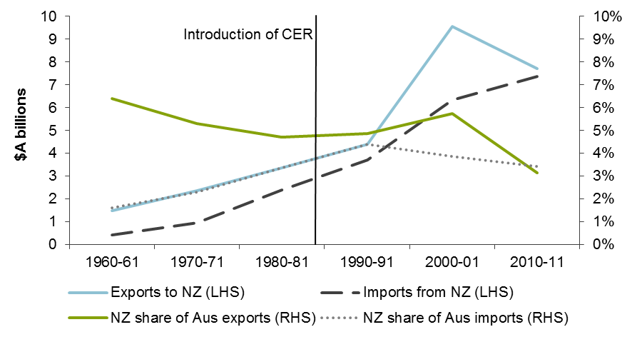
Data sources: DFAT 2002, ABS cat. no. 5368.0.
Conversely, Australia has become New Zealand’s largest trading partner. As figure 2 shows, the share of New Zealand merchandise exports destined for Australia has grown substantially since 1960, from around 4 to 22 per cent. Notably, this trend predated the commencement of CER. The share of New Zealand’s merchandise imports coming from Australia has declined since the introduction of the CER.
New Zealand’s main (merchandise goods) exports to Australia include light crude oil, gold, wine, cheese and timber, as well as a wide range of manufactured items, while New Zealand’s main imports from Australia include computer parts and accessories, medicaments, passenger motor vehicles, printed matter and refined petroleum (DFAT 2012).
Figure 2 New Zealand merchandise trade with Australiaa
2011 prices
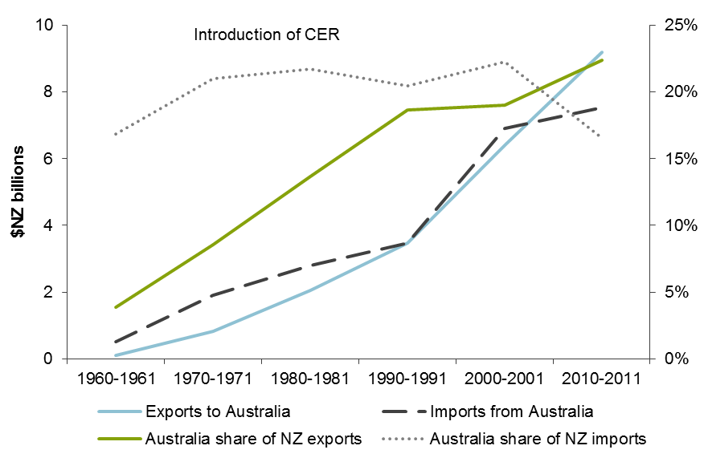
a There are inconsistencies between figures 1 and 2. Such inconsistencies can exist between bilateral import and export figures as a result of the timing of data collection and differences in the treatment of low value imports, exchange rate calculations and import valuation methods.
Data source: Statistics New Zealand Digital Yearbooks.

Services trade
Trade in services can be difficult to measure, and the available data have limitations. That said, according to the Australian Bureau of Statistics (ABS), the value of New Zealand’s services exports to Australia has grown in recent years. There is no clear trend in the value of Australia’s services exports to New Zealand (figure 3). Two way trade in services amounted to more than $A5 billion in 2010.
Figure 3 Services trade between Australia and New Zealand
2010 prices
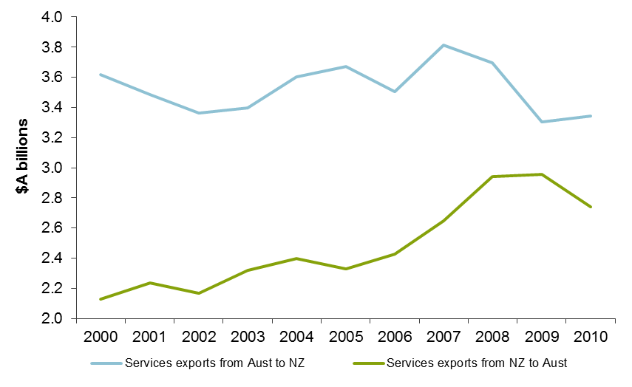
Data source: ABS (International Trade in Services by Country, by State and by Detailed Services Category, Cat. no. 5368.0.55.004).

Foreign investment
There is a strong bilateral investment relationship between Australia and New Zealand. Australia is now the largest foreign investor in New Zealand. According to the ABS, Australians held investments worth around $A74 billion in New Zealand in 2010, over half of which was classified as ‘foreign direct investment’ (FDI) (ABS 2011) — that is, investment where the foreigner creates, or gains a significant interest in, a local firm. In the other direction, New Zealand is Australia’s ninth-largest source of foreign investment. In 2010, New Zealanders held investments worth around $NZ34 billion in Australia, just under one-third of which was FDI (SNZ 2011).

Migration
People have moved between Australia and New Zealand since colonial times, with a long history of labour exchange at all skill levels (NZDoL 2010). Since the late 1960s, there has been a substantial increase in the number of New Zealand-born living in Australia, outpacing growth in the number of Australian-born living in New Zealand (figure 4).
Figure 4 Trans-Tasman born population
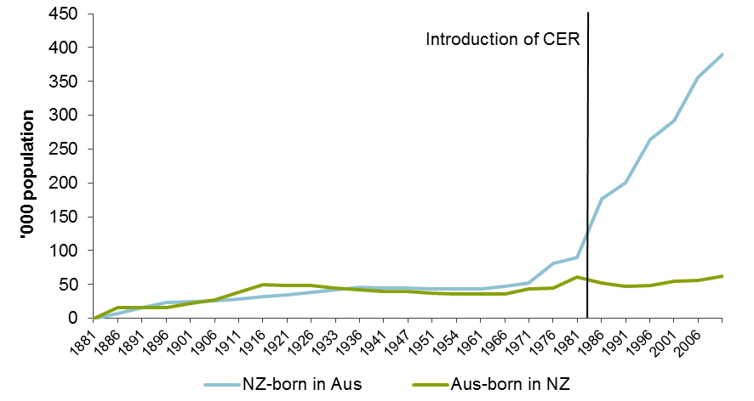
Data source: Poot (2009), p. 3.
Dumont and Lemaitre (2004) estimate that around three-quarters of all New Zealand-born emigrants live in Australia. Of the 389 000 New Zealand-born people living in Australia in 2006, around a quarter of a million were employed (NZDoL 2010). Analysis suggests that economic factors, such as greater opportunities and a higher standard of living, were more important than lifestyle or family factors in explaining the net migration flows of New Zealanders to Australia (Green et al. 2008).
3 Economic integration and transaction costs
The terms of reference refer to ‘further reforms that would enhance increased economic integration and improve economic outcomes’. It is, therefore, important to have a clear understanding of the nature of economic integration, what drives it and why it matters.

What is economic integration and what drives it?
Economic integration essentially refers to the degree of freedom of exchange of goods, services, capital, technology and other information between countries and the freedom of movement of people (including for work). A higher degree of integration could be expected to result in increased trade and factor flows. Prices for goods, services and factors of production will tend to converge in two countries that are highly integrated as the costs of exchange (or ‘transaction costs’) are lowered.
Economic integration is influenced by markets, geography, and institutional and social/cultural factors, as well as by governments. Markets reduce transaction costs in a myriad of ways — including through innovation in communications, transport and logistics, through information and insurance markets and adopting new business structures (such as the formation of multinational companies). For example, ocean freight costs fell by 70 per cent (in real terms) between 1920 and 1990, and this coincided with large increases in trade flows and economic integration around the world (IMF 2002).
Governments can directly and indirectly influence the costs of exchange in a range of ways. For example:
- reducing tariffs directly reduces the costs of international trade
- removing barriers to competition facilitates new market entrants, prompting incumbent firms to become more efficient and reduce prices
- regulations can impose transaction costs in various ways (for example, manufacturing processes may need to be modified to meet differing product standards across countries).
While governments have an important role in facilitating integration, market participants in many ways drive integration, and the efficacy of government actions depends on market responses. In some cases governments have limited influence over a market-driven integration process, but may have a role in responding to it. For example, the rise of web-based trading has greatly reduced transaction costs for consumers purchasing from overseas. Governments have played a modest role in this development, but may need to respond to new regulatory issues that it engenders, such as legal protections for consumers making such purchases, which in turn can underpin further growth in trade.

Benefits, costs and risks of economic integration
Economic integration can produce benefits for individuals and businesses. Individuals can benefit from lower prices and greater choice in goods and services. Integration may also open up new employment and travel opportunities. For firms, integration can provide access to larger markets and opportunities to reduce costs.
Economic integration drives higher productivity and improved living standards by increasing the size of markets, and thus the extent of competition and the scope they offer for specialisation. A large and diverse literature finds that market size and specialisation is important to economic performance. This relationship has a number of dimensions.
- Scale, scope and specialisation — larger markets allow firms to specialise in particular modes of production and exploit economies of scale, thus reducing the costs of production. In addition, economies of scope increase the range of goods available, often while improving their quality. Increased competition ensures lower costs translate to lower consumer prices.
- Technological progress — as firms and individuals participate in larger markets with more specialised production, the invention of new technologies, innovation on existing production methods and diffusion of new technologies tend to increase.
- Firm organisation, management practices and work arrangements — larger markets allow business to improve their efficiency by observing and learning about a range of business models. Increased competition resulting from integration can also prompt firms to intensify efforts to become more productive and this can create dynamic benefits, including through the evolution of more efficient institutions (including firms).
The benefits of greater openness are likely to be more pronounced for smaller countries. Without integration, they are likely to have smaller markets, in which firms operate below efficient scale and with more limited competitive pressures. Also, the ability to more easily adopt new technologies developed elsewhere is a benefit of integration that can be particularly important for smaller countries.
There are also costs and risks associated with integration, particularly relating to structural adjustment in the transition. By increasing the scope for specialisation, integration can lead to the decline of particular industries in a country. The process by which workers and resources move to new jobs and industries is known as structural adjustment. Integration also increases the degree to which a country is affected by fluctuations in output in other countries, which can have both costs and benefits.
There is a spatial dimension to the benefits and adjustment costs that integration can bring. Agglomeration of resources and production in particular locations can improve productivity as greater density leads to lower transport costs, greater specialisation, labour market pooling effects and knowledge spillovers. For some regions, however, this process can produce declines in population and economic activity as resources move elsewhere. Some analysts suggest that agglomeration effects and other economic geography phenomena have impacted negatively on New Zealand’s overall economic performance in recent decades (McCann 2009).
Government efforts to increase integration have often included looking for ways to more closely align regulatory frameworks. This can be achieved by making regulations uniform, harmonising aspects of them or by each country recognising the other’s regulations. There are potential benefits and costs in this process. In negotiating integration agreements governments can learn from one another and ‘borrow’ superior regulatory practices from elsewhere. Costs can result where, in an effort to increase integration, regulations that do not suit local conditions or preferences as well may be adopted.
4 Principles for a trans-Tasman integration policy
Trans-Tasman integration policy needs to be based on sound principles in order to ensure it produces worthwhile outcomes for Australia and New Zealand. Some questions about the principles that should be adopted are considered below.

What rationale?
The terms of reference state that the rationale for strengthening economic relations between Australia and New Zealand should be to ‘improve economic outcomes’. This is consistent with previous work by the Australian Productivity Commission that concluded that bilateral trade agreements should be justified primarily on economic grounds, rather than according to their possible contribution to achieving security or strategic objectives (PC 2010).
The Commissions’ interpretation is that ‘improving economic outcomes’ will generally be synonymous with ‘producing net benefits’. This economic perspective can sometimes differ from political assessments of what makes a nation better off.
For example, the reduction of a country’s own trade barriers within an international agreement is often seen from a political perspective as making a concession or incurring a loss. Economic analysis suggests the opposite. Although some producers inevitably suffer a loss because of increased competition, this is outweighed by benefits to consumers and other businesses from lower prices and greater choice.
The terms of reference refer to ‘joint net benefits’ measured at the trans-Tasman level. Trans-Tasman integration measures should produce net benefits for each country. There is a question, however, as to whether individual reforms that involve one country losing and the other gaining would still be worthwhile, and at what level.
One complication in country level assessments of net benefits is how to treat benefits accruing to citizens who are resident in the other country. For example, increased integration could provide individual New Zealanders with greater opportunity to further their careers through (temporary or permanent) migration to Australia. This could be regarded as positive for New Zealand citizens or a loss for New Zealand residents.

 | Q.11 |  | At what level should net benefits tests be applied (individual reforms, some intermediate level, or for trans-Tasman integration policy overall)?

 | Q.12 |  | When considering the benefits and costs for each country, how should outcomes for citizens of one country who are resident in the other be taken into account?

 | Q.13 |  | Are there matters other than economic factors that form part of the rationale for pursuing a trans-Tasman integration policy or should be considered when thinking about potential costs?

How far should integration go?
This study will examine the current CER agenda, but will also assess the merits of progressing beyond it to higher levels of integration.
Figure 5 presents a stylised representation of different levels of government-faciltated integration drawn from Rodrigue (2012), commencing with free trade and extending to economic and political union. None of these levels is necessarily superior to the others, as their impacts on economic outcomes can be ambiguous (for example, the common currency element of economic union can be a positive or a negative, as discussed later) and in practice will depend on how they are implemented.
In reality, countries can adopt some elements from different levels of integration. Accordingly, bilateral and regional arrangements tend to be more complicated than suggested by figure 5. For example, current trans-Tasman arrangements embody elements of free trade and a common market.
Figure 5 Five levels of economic integration
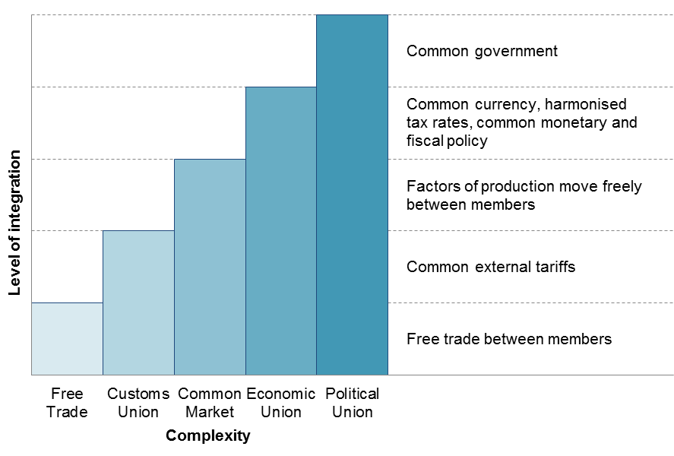
Source: Rodrigue (2012).
In many respects Australia and New Zealand are good candidates for higher levels of integration due to: similarities in culture, institutions and values; geographic proximity; and a common language. Even so, there are also some potential downsides to high levels of integration.
For example, some decisions may need to be taken above the national level and this can be regarded as unduly compromising national sovereignty. Moreover, local decision-making can provide a closer matching with local conditions and community preferences, as well as enabling greater policy responsiveness and innovation. The principle of subsidiarity accordingly posits that decisions should be made at the local level unless scale or other considerations can be shown to make higher level decision making preferable.
Currency union (an element of economic union in figure 5) is one area where the loss of local decision-making can be problematic. On one hand, there are potential benefits in avoiding the transaction costs associated with having separate currencies. On the other, where business cycles and economic changes (such as the ‘mining boom’) affect the two countries differently, there could be costs in not having independent exchange rates. The recent experience of countries in the Eurozone is instructive in this respect.

 | Q.14 |  | What is the appropriate ‘end-point’ to trans-Tasman integration?

 | Q.15 |  | Are there particular thresholds that should not be crossed in advancing a deeper integration agenda, on the grounds that they would compromise sovereignty?

 | Q.16 |  | What would be the advantages and disadvantages of implementing a currency union between Australia and New Zealand?

Interactions with regional, multilateral and unilateral actions
This study is about further economic integration of the Australian and New Zealand economies and so it has a clear bilateral focus. It is, nonetheless, important to recognise that Australia and New Zealand have also been pursuing economic integration through broader regional and multilateral arrangements, and indeed through unilateral action (box 5).

Box 5 The broader policy context
In addition to ANZCERTA, both Australia and New Zealand are members of a number of other bilateral, regional and multilateral trade agreements, and have also undertaken significant unilateral trade reform.
Both countries are members of the World Trade Organization, as well as the Asia-Pacific Economic Cooperation (APEC) forum.
New Zealand has signed a number of bilateral preferential trade agreements, including with China, Malaysia, Thailand and Singapore. It has also entered a Closer Economic Partnership with Hong Kong, and is a member of the Trans-Pacific Strategic Economic Partnership with Singapore, Brunei and Chile. (Negotiations are underway to sign on the United States, Australia, Vietnam and Peru to this agreement (the Trans Pacific Partnership negotiations). It has also concluded or is negotiating bilateral agreements with India, Korea, the Gulf Cooperation Council (GCC), Russia, Belarus and Kazakhstan.
Australia has preferential trade agreements in force with Singapore, Thailand, Chile and the United States. As well as the Trans Pacific Partnership, it is negotiating agreements with China, the GCC, India, Japan, Korea and Malaysia.
Australia and New Zealand are also both members of a trade agreement with the ASEAN nations (the ASEAN–Australia–New Zealand Free Trade Agreement) and are negotiating an extension to the Pacific Agreement on Closer Economic Relations.
As noted in the Australian Productivity Commission’s 2010 Review of Bilateral and Regional Trade Agreements, there are also many single-issue international organisations that impact on global trade levels and patterns, dealing with issues such as intellectual property, telecommunications and the internet, shipping and aviation, and environmental and conservation issues (PC 2010). Many of these groups count Australia and New Zealand amongst their membership.
It is important that bilateral approaches to integration complement these broader efforts. Bilateral arrangements can have flow-on effects on exchange with non-member countries and on the internal efficiency of economies. These impacts can be positive or negative, as illustrated by the examples in box 6. There would clearly be benefits in designing trans-Tasman integration policy so as to promote positive flow-on effects and minimise negative effects.

Box 6 Bilateral arrangements can impact on broader outcomes
Example 1: Improved customs processes (positive)
Bilateral dialogue identifies that customs processes in one of the countries is leading to unnecessary costs and delays for imports from the other country. Agreement is reached that these processes be streamlined and this has the desired effect of reducing costs and delays. This streamlining, however, reduces transaction costs for imports from all other countries, and so the reforming country achieves benefits from lower trading costs and increased integration with all countries, not just the bilateral partner.
Example 2: Trade diversion (negative)
As part of a bilateral agreement, country A reduces tariffs for imports from country B, while maintaining higher tariffs for all other countries. Imports from country B increase. This may be seen as evidence that the bilateral agreement is a success. However, this increase is offset by decreases in imports from country C, which is a lower cost (and more efficient) supplier. Country A finds that it is worse off because, while its consumers are paying a slightly lower price for imported goods, this benefit is smaller than the fall in tariff revenue. In addition, global efficiency is lower because production has shifted from a more efficient to a less efficient supplier. Bilateral harmonisation of regulations can also have negative flow-on effects because it can effectively close off opportunities to remove regulatory barriers with other countries.

 | Q.17 |  | What emphasis should be given to trans-Tasman integration policy relative to broader regional and multilateral initiatives, and to unilateral action?

 | Q.18 |  | Should trans-Tasman integration policy be designed so as to complement broader initiatives? Would there be net benefits in multilateralising some elements?

How should adjustment issues be dealt with?
As with other types of economic reform, government-facilitated integration has the potential to cause structural changes in the economies of Australia and New Zealand, and there can be costs in adjusting/transitioning to such changes. As stated by the Australian Productivity Commission:
There are costs associated with realising the benefits of reform. The process of change induced by reform usually brings about some reshuffling of resources which can take time and involve some costs. For example, displaced workers are often not re-employed immediately, and it can take time to transfer equipment to other types of production. PC (2001, p. 11)
Given that bilateral trade in goods and services has been substantially liberalised already, future adjustment costs might be relatively small. That said, adjustment costs can be concentrated in particular industries or regions and costs that might be small at a national level can appear large for particular sectors or communities.
Where a reform proposal could yield net benefits, but has the potential to generate significant adjustment costs, governments can respond by:
- relying on generally-available adjustment measures (such as government provided job search services and the social security safety net)
- accompanying the reform with specific adjustment assistance measures (for example, financial compensation to those most affected)
- modifying the reform to reduce adjustment costs (for example, phasing it in over time, thus allowing the various parts of the economy to take the changes into account in planning)
- addressing other regulatory or policy impediments to adjustment.
In some cases, adjustment costs are caused or increased by other existing policies that inhibit structural change (for example, labour market rigidities or high taxes on house purchases which discourage people from moving to obtain work). Therefore, integration can expose rigidities that impede domestic competitiveness and prompt governments to seek ways to improve the flexibility of the economy.

 | Q.19 |  | What do you see as the key causes of adjustment costs?

 | Q.20 |  | Should trans-Tasman integration policy be designed to have low adjustment costs regardless of the benefits? If so, how?

 | Q.21 |  | Should trans-Tasman integration policy be accompanied by specific adjustment assistance measures? If so, what form should they take?
Some commentators have expressed concern that adjusting to integration with Australia can lead to a ‘hollowing out’ of the New Zealand economy (for example, Shirtcliffe 2010). That is, as the extent of trans-Tasman integration increases, the process of agglomeration described earlier will result in skilled people and capital relocating from New Zealand to Australia (Skilling 2007).
Others argue that New Zealand has gained significantly from the CER reforms and that further gains could come from further integration with Australia. They note that structural pressures also come from other sources. From this perspective, the challenge for each country is to raise productivity so as to make the most of the potential benefits offered by international openness.
This study will consider whether concerns about ‘hollowing out’ should influence the development of the trans-Tasman integration agenda. In doing this it will be important to evaluate carefully the extent to which integration policy influences capital and people flows, as well as the costs and benefits of increased openness.

 | Q.22 |  | Should concerns about ‘hollowing out’ of the New Zealand economy influence integration policy? If so, how?
Participants may wish to comment on adjustment issues in general or in relation to particular areas of integration (see next section).
5 Possible areas for further integration
This section canvasses some possible areas for further trans-Tasman economic integration that have been proposed in the academic literature, government documents and preliminary visits. The Commissions are interested in views and evidence on which areas offer the greatest prospect for generating joint net benefits. This could relate to areas mentioned in this paper and/or other areas.
In very general terms, further integration is likely to be welfare enhancing in areas where the benefits (for example, from increased scale effects) are relatively large and cross-country differences in the preferred approach to regulation are relatively minor.
As outlined earlier, the scope of the study is broad. A further integration agenda would need to involve proceeding with or extending actions that are currently being pursued, as well as new areas. These could include:
- overcoming barriers to trade in goods, services and the movement of factors of production (capital and labour) (for example, reducing barriers created by differences in domestic regulations through harmonisation or mutual recognition or other means)
- trade and investment facilitation initiatives that assist with bilateral and broader reductions in transaction costs and integration (for example, improving customs procedures)
- domestic economic reforms that increase trans-Tasman integration as a by-product (for example, reforming shipping regulations in Australia and/or New Zealand such that New Zealand ships can stop at multiple Australian ports)
- integrating or coordinating government institutions and services (for example: having single regulatory agencies that cover both countries; more integrated government education and health services; and harmonisation of statistical definitions).
An organising framework for identifying and analysing potential areas for further integration is shown in table 1.
While the organising framework in table 1 provides a basis for categorising possible areas for further integration, it does not provide a framework for assessing which of these areas would generate the largest net benefits. To do this, the Commissions propose undertaking a high level assessment of each area that considers the size of existing policy-related barriers, their pervasiveness in the economy and the benefits and costs of removing them (including costs resulting from the reduced capacity to meet national preferences that might arise from measures such as the harmonisation of regulations).

 | Q.23 |  | Would this organising framework and high level assessment be likely to identify the potential areas for reform that offer the most significant gains?

 | Q.24 |  | If not, what alternative frameworks might be used?
Table 1 Organising framework, with illustrative examples of the nature of impediments
Type of exchange | Point at which impediment occurs
Type of exchange | Between the borders regulation | At the border regulation | Post-border regulation
Type of exchange | Between the borders regulation | At the border regulation | National treatment | Other
Goods | - Transport costs | - Tariffs and non-tariff barriers | - Government procurement |  | - Consumer law
Services
Mode 1: Cross-border trade
 | - Postage & tele-communications |  | - Government procurement
Mode 2: Consumption abroad
 | - Transport costs | - Migration laws
Mode 3: Commercial presence
 |  | - Foreign investment laws | - Ownership requirements |  | - Regulations affecting business establishment & operation
Mode 4: Movement of persons
 | - Transport costs | - Migration laws | - Eligibility for government programs |  | - Occupational licensing
Capital (tangible & intangible) |  | - Foreign investment laws | - Ownership requirements |  | - Prudential regulation
Labour | - Transport costs | - Migration laws | - Eligibility for government programs |  | - Occupational licensing
Knowledge | - Impediments to (or unrealised opportunities for) knowledge creation and transfers
Government functions | - Impediments to (or unrealised opportunities for) integrating government institutions and services, and learning from each other’s successes

Trade in goods
Considerable progress has already been made in removing barriers to trans-Tasman trade in goods. For example:
- tariffs and quantitative restrictions have been completely removed except for prescribed industries (such as ozone-depleting substances, agricultural and veterinary chemicals and fireworks)
- a mutual recognition agreement allows most goods that can be sold in one country to be legally sold in the other without meeting further regulatory requirements — with some notable exceptions (such as therapeutic goods and industrial chemicals)
- quarantine procedures have been largely harmonised, and customs authorities in both countries cooperate on relevant trans-Tasman issues
- neither country allows businesses to initiate anti-dumping claims against businesses of the other, leaving such matters to general competition laws.
However, there are some possible areas for further integration, such as:
- shipping regulations: the high cost of trans-Tasman shipping has been of concern over many years (Scollay et al. 2011). The Australian Productivity Commission has previously found that Australian coastal shipping regulations, particularly cabotage restrictions, add to these transaction costs (PC 2005). However, following a recent review, these provisions are to be strengthened (Department of Infrastructure and Transport 2012)
- rules of origin: under ANZCERTA, preferential tariff treatment applies only to goods that meet rules of origin requirements. These rules prevent non-partner countries transhipping products through Australia or New Zealand to obtain the lower tariff treatment. However, rules of origin create compliance costs for businesses and incentives to shift to higher cost production techniques (PC 2004)
- food regulation: the Inter-Governmental Agreement on Food Regulation and the Joint Food Standards Setting Treaty underpin the food regulatory system within Australia and between Australia and New Zealand. However, differences between the two countries remain in the enforcement of regulations, food hygiene standards, and some other areas, creating potential costs (PC 2009b)
- product standards: although there is a large degree of consistency in product standards across the Tasman there are still some differences that may be a barrier to trade, particularly in relation to regulations governing the use of goods and relatively newer areas of standard-making like energy efficiency requirements. In some cases, there are not only differences between Australia and New Zealand, but also differences between the Australian states and territories
- greenhouse gas emissions trading: the Australian Government has legislated the introduction of a fixed carbon price in July 2012, with this being converted to an emissions trading scheme in 2015. The New Zealand Government introduced an emissions trading scheme in 2008 with staged sector entry until 2015. The Australian and New Zealand Governments have agreed to link their emissions trading schemes, possibly as early as 2015. There are various potential benefits from linking, such as reducing abatement costs, and compliance costs for trans-Tasman firms, but there are also potential costs (Wilson 2009). A range of issues relating to differences in scheme design would need to be resolved.

 | Q.25 |  | What are the most important policy-related barriers to trans-Tasman trade in goods? Are there valid reasons for these barriers remaining in place?

Services trade
The ANZCERTA provides for free trade in services, except for those services specifically listed as exclusions. The exclusions list has been progressively reduced, with the remaining exclusions being in the areas of air services, broadcasting, third-party insurance, postal services and coastal shipping for Australia, and air services and coastal shipping in the case of New Zealand. Removing some of these exclusions has the potential not only to promote trade in services, but also to lower transport and communication costs between Australia and New Zealand. However, both benefits and costs would need to be taken into account.

 | Q.26 |  | Which areas currently excluded from free trade in services should be opened up to trans-Tasman competition?
Integration of banking services is an area that has received attention in the past. The Trans-Tasman Council on Banking Supervision was established to promote a joint approach to banking supervision, so as to deliver a seamless regulatory environment in banking services. The Council has not aimed to align regulatory objectives, rules and approaches but rather allow the two countries’ regulatory frameworks and regulators to operate with fewer points of potential friction (Doan et al. 2006).
The Joint Standing Committee on Legal and Constitutional Affairs (JSCLCA) reported that progress had been made towards joint trans-Tasman banking supervision between the prudential regulators. However, evidence was noted from the ANZ Bank that there are still material differences between the Australian and New Zealand regulatory environments that require operations to be duplicated and extra expenses to be incurred. The JSCLCA recommended the legal harmonisation of the Australian and New Zealand banking regulation frameworks in order to foster a joint banking market (JSCLCA 2006).

 | Q.27 |  | Should Australian and New Zealand banking regulation frameworks be more closely aligned? If so, how would this best be achieved?

Capital flows
Bilateral capital flows are influenced by a range of government policies, including investment screening regimes, tax treatments, industry-specific regulations, and consumer and competition laws.
Australia and New Zealand signed an Investment Protocol to ANZCERTA in February 2011, which is currently being developed by officials for domestic implementation. Under the Protocol, both Australian investors into New Zealand and New Zealand investors into Australia, will be subject to a preferential monetary screening threshold for investments in business assets. For New Zealand firms investing in Australia, the screening threshold will increase from $A231 million to $A1.005 billion. For Australian firms investing in New Zealand, the threshold will increase from $NZ100 million to $NZ477 million. These thresholds will be updated annually based on growth in GDP.
Each country’s tax system also influences bilateral investment. The Review of Australia’s Future Taxation System (known as the Henry Review) recommended that in order to further economic integration between Australia and New Zealand, consideration could be given to the appropriate degree of harmonisation of business income tax arrangements between the two countries (Commonwealth of Australia 2009).
Mutual recognition of imputation credits has been a key taxation issue between the two countries. Currently, imputation credits in Australia and New Zealand are available only for domestic company tax not foreign taxes, potentially creating a bias against offshore investment. The Henry Review found that mutual recognition of imputation credits would have the potential to improve the allocation of investments between the two countries and reduce barriers to competition between Australian and New Zealand companies. It could also reduce incentives for firms to engage in profit shifting between Australia and New Zealand. This would probably be to New Zealand’s net benefit (Commonwealth of Australia 2009). However, mutual recognition of imputation credits would have fiscal and initial distributional implications, particularly for Australia.
The movement of financial capital between Australia and New Zealand can also be constrained by a number of regulations and reservations to the OECD Code of Liberalisation of Capital Movements (OECD 2011a) — many of which are specific to certain industries. For example, investment in airlines is affected by limitations on foreign ownership of both Qantas and Air New Zealand. More broadly, investment across industries is affected by regulations, including consumer and competition laws in each country. There are a number of reforms underway in these areas (box 3).

 | Q.28 |  | What would be the costs and benefits of mutual recognition of imputation credits?

 | Q.29 |  | What other policy-related barriers are there to trans-Tasman capital flows? What should be done about them?

Labour movements
Australian and New Zealand citizens are free to enter the other country to visit, live and work without seeking authority. However, there are a number of barriers that may deter people from moving to the other country to work. For example, the portability of superannuation, although agreed, is yet to be legislated in Australia. And, despite the Trans-Tasman Mutual Recognition Arrangement, occupational licensing is still a barrier for certain occupations, both between Australia and New Zealand and across the Australian states and territories. (For example, nearly 100 occupations are licensed by the states and territories for consumer protection reasons, with over one-third licensed in only one or two jurisdictions (PC 2008).) Variations and impediments to efficiency in employment laws and workplace standards such as occupational health and safety may also increase the regulatory burden on trans-Tasman businesses.

 | Q.30 |  | What policy-related barriers are there to trans-Tasman labour mobility and the movement of people more generally? Are there valid reasons for these barriers remaining in place?

Knowledge transfers
Knowledge spillovers between firms are an important source of dynamism and economic growth within an economy and between economies. To some extent impediments to the flow of knowledge would be captured under the previous headings. Capital flows can involve transfers of new technologies and improved work practices. Improved technologies can be embodied in traded goods and knowledge can be transferred through the movement of people. Nonetheless, it is worth considering knowledge flows as a separate category, given their importance in increasing productivity and living standards.
Possible areas where knowledge creation and flows could be enhanced through a trans-Tasman integration agenda include:
- integration in the higher education sector, government-owned research institutes and science policy agencies
- facilitation of business information sharing
- establishment of joint research facilities
- introducing a single regulatory framework for patents and trademarks.

 | Q.31 |  | How could Australia and New Zealand enhance the creation and transfer of knowledge between the two countries to mutual benefit?

Government functions
Most of the areas just discussed are about trying to lower transaction costs for market-based exchanges of goods, services and factors of production. But given the large role of the public sectors in both economies — expenditure by governments constitutes approximately 35 per cent of GDP in Australia and 40 per cent of GDP in New Zealand (OECD 2011b) — measures to improve the efficiency of government functions could also be of mutual benefit. These include regulatory functions and the production of government services. Some possible areas for further integration are considered below.
Trans-Tasman regulators: There may be areas where moving to a single trans-Tasman regulator would create efficiencies. For example, this is the rationale behind the planned creation of the Australia New Zealand Therapeutic Products Agency, which is to absorb the existing country-specific regulators.
Integration of government services: Governments have innovated in developing different systems (or ‘technologies’) for the production of government services, including school education, hospital services and police services. Integration activities in this area could range from informal exchanges of information to adoption of systems, or elements of them, used in the other country. (Since many government services in Australia are provided by state and territory governments, they would need to be involved.)
International positioning: Australia and New Zealand have many interests in common within international economic forums. While there has been a high level of cooperation in many areas, there may be opportunities to work more closely together to further common trade and other interests.

 | Q.32 |  | In which areas (if any) would the adoption of a single trans-Tasman regulator yield net benefits (through more efficient delivery of the regulatory function and/or lower costs for regulated businesses)?

 | Q.33 |  | What scope is there for government services to be integrated in a way that produces net benefits?

 | Q.34 |  | What opportunities are there for Australia and New Zealand to work more closely to further common economic interests in international forums?
There are a number of existing avenues through which the Australian and New Zealand Governments are able to learn about successful policy innovations in the other country. However, there may be unrealised opportunities to improve policy through adapting ideas that originated across the Tasman.

 | Q.35 |  | Are existing mechanisms for learning from one another’s policy innovations working well? How could they be improved?
6 Implementation and governance
There are two main sets of issues regarding the implementation and governance of trans-Tasman integration policy. The first concerns the sequencing and timing of reforms. The second relates to institutional and governance arrangements for managing the policy agenda.
Currently, implementation and monitoring of the CER agenda is through a range of forums, including joint official working groups and Ministerial Councils. As mentioned earlier, there is no formal dispute resolution mechanism for resolving differences regarding the application of CER agreements.
The study will explore whether governance frameworks could be made to perform better in setting strategic directions, establishing priorities, monitoring progress, evaluation, dispute resolution and managing the overall integration agenda.

 | Q.36 |  | What are the most important considerations regarding the sequencing and timing of integration policy reforms?

 | Q.37 |  | Are the current governance frameworks around the CER agenda adequate? If not, how could they be improved?

Attachment A Terms of reference

Impacts and Benefits of Further Economic Integration of the Australian and New Zealand Economies — Joint Scoping Study by the Productivity Commissions of Australia and New Zealand

Purpose of the study:
The Governments of Australia and New Zealand are firmly committed to strong economic relations between Australia and New Zealand, including boosting productivity through reducing the regulatory burden on business, increasing competition and encouraging closer economic cooperation, and to strengthening those relations further. The two countries have a long history of working together through the Australia New Zealand Closer Economic Relations Trade Agreement which first came into effect on 1 January 1983 and has involved successive rounds of integration of the Australia and New Zealand economies. This has been highly beneficial to both countries.
At their annual leaders meeting, the Prime Ministers of Australia and New Zealand agreed that, to promote further reform and economic integration, the Productivity Commissions of each country would conduct a joint study on the options for further reforms that would enhance increased economic integration and improve economic outcomes. The Commissions’ final report should be completed by 1 December 2012 in order to inform the next meeting of leaders, expected to take place in early 2013.
With 2013 marking 30 years of the operation of the Closer Economic Relations Trade Agreement, the Commissions’ report will help advise the Australian and New Zealand Governments on next steps in economic integration.
The report should identify specific areas for further potential reform, the ways in which they might be best achieved, the likely impacts of potential reforms, any significant transition and adjustment costs that could be incurred and the time scale over which impacts are likely to accrue.

Scope of report
The Commissions’ report to leaders should provide analysis on:
- potential areas of further economic reform and integration, including identification of the areas of reform where benefits are likely to be most significant, with particular focus on critical issues for business like investment and productivity;
- the economic impacts and benefits of reform;
- any significant transition and adjustment costs that could be incurred;
- identification of reform where joint net benefits are highest;
- the means by which they might be best actioned; and
- the likely time paths over which benefits are expected to accrue.

Methodology
The Commissions should provide an explanation of the methodology and assumptions used in its analysis. The Commissions should also provide guidance concerning the sensitivity of results to the assumptions used and bring to leaders’ attention any limitations or weaknesses in approaches to reform evaluation.

Consultation and timing
In the course of preparing the report, the Commissions should consult and hold public hearings as appropriate. While these consultations would inform the Commissions’ assessment, responsibility for the final report would rest with the two Productivity Commissions.
The Commissions should produce both a draft and a final report. The Commissions’ final report should be submitted to leaders, through the Treasurer of Australia and the Minister of Finance of New Zealand, by 1 December 2012. The reports will be published.
Attachment B Have your say
The Australian and New Zealand Productivity Commissions invite interested parties to make a written submission. Submissions should be lodged with the Commissions by 31 May 2012.
Submissions may range from a short letter outlining your views on a particular topic to a more substantial document covering a range of issues relevant to the study’s terms of reference (attachment A).

Submissions are public documents
To facilitate the consultation process, each submission will be published on the Commissions’ joint website shortly after receipt. These will remain online indefinitely as public documents.
Under certain circumstances, the Commissions can accept sensitive material on a confidential basis — for example, if it was of a personal or commercial nature, and publishing the material would be potentially damaging. You are encouraged to contact the Commissions for further information and advice before submitting such material. Any material supplied in confidence should be provided under a separate cover and clearly marked.
Copyright in submissions sent to the Commissions resides with the author(s), not with the Commissions.

How to make a submission
Each submission should include a completed cover sheet, containing your contact details. (For privacy reasons, this cover sheet will not be published.) The cover sheet, along with complete details on how to lodge your submission, can be found on the study website.
Joint website:
www.transtasman-review.pc.gov.au
www.transtasman-review.productivity.govt.nz
For advice on how to make a submission, or for any administrative queries relating to this study, please contact Christine Underwood on (+61 2) 6240 3262 (Australia) or Robyn Sadlier on (+64 4) 903 5167 (New Zealand).

References
ABS (Australian Bureau of Statistics) 2011, International Investment Position, Australia: Supplementary Statistics, Calendar year 2010, Cat. No. 5350.2, Canberra.
—— 2012 International Trade in Goods and Services, Australia, Cat. no. 5368.0, ABS, Canberra.
Adams, R., Dee, P., Gali, J. and G. McGuire 2003, The Trade and Investment Effects of Preferential Trading Arrangements — Old and New Evidence, Productivity Commission Staff Working Paper, Canberra, May.
Australian Government 2010, Trans-Tasman Time Release Study: A joint project of Australian Customs and Border Protection Service and New Zealand Customs Service, October, http://www.customs.gov.au/webdata/resources/
files/Trans-TasmanTimeReleaseStudy2010LowRes.pdf
BIE (Bureau of Industry Economics) 1989 Trade Liberalisation and Australian Manufacturing Industry: The Impact of the Australia–New Zealand Closer Economic Relations Trade Agreement, Australian Government Publishing Services, Canberra.
____ 1995, Impact of the CER Trade Agreement: Lessons for Regional Economic Integration, Australian Government Publishing Services, Canberra, Canberra.
Commonwealth of Australia 2009, Australia’s Future Tax System (The Henry Review), (Henry, K.,Harmer, J., Piggott, J., Ridout, H. and Smith, G.), Report to the Treasurer, Canberra, December.
DFAT (Department of Foreign Affairs and Trade) 2002, Direction on Trade Time Series 2000–01, One Hundred Years of Trade, Market Information and Analysis Unit, Canberra, http://dfat.gov.au/publications/stats-pubs/one-hundred-years-of-trade-1901-to-2001.pdf (accessed 3 April 2012).
—— 2012, New Zealand Country Brief, Canberra http://www.dfat.gov.au/geo/new_zealand/nz_country_brief.html (accessed 3 April 2012).
Department of Infrastructure and Transport, 2012, Shipping Reform, http://www.infrastructure.gov.au/maritime/shipping_reform/index.aspx (accessed 2 April 2012).
Department of the Treasury (Australia) 2011, ‘Single Economic Market Outcomes Proposals as at 14 July’,web page http://www.treasury.gov.au/ttoig /content/outcomes_proposals.asp (accessed 17 February 2012).
DeRosa, D. 2007, ‘The Trade Effects of Preferential Trading Arrangements: New Evidence from the Australian Productivity Commission’, Peter G. Peterson, Institute for International Economics, Working Paper Series, WP 07-1, Washington.
Doan, C., Glanville, V., Russell, A., White, D. 2006, Greater international links in banking – challenges for banking regulation. Economic Roundup, Spring 2006, Canberra.
Dumont, J-C. and Lemaitre, G. 2004, Counting Immigrants and Expatriates in OECD Countries: A New Perspective, OECD Social, Employment and Migration Working Paper Series, No. 25, New York. http://www.un.org/esa/population/migration/turin/Symposium_Turin_files/P09_Dumont&Lemaitre.pdf (accessed 3 April 2012).
Green, A.E., Power, M.R. and Jang, D.M., 2008, ‘Trans-Tasman migration: New Zealanders’ explanations for their move’, New Zealand Geographer, vol. 64, no. 1, pp. 34–45.
IMF (International Monetary Fund) 2002, ‘Globalisation: The Story Behind the Numbers’, Finance and Development: A quarterly magazine of the IMF, March, Volume 39, Number 1. Washington.
JSCFADT (Joint Standing Committee on Foreign Affairs, Defence and Trade) 2006, A Review of the Australia–New Zealand Closer Economic Relations (CER) Trade Agreement, Canberra, December.
JSCLCA (Joint Standing Committee on Legal and Constitutional Affairs) 2006, Harmonisation of legal systems, Canberra, December.
McCann, P. 2009, ‘Economic geography, globalisation and New Zealand's productivity paradox’, New Zealand Economic Papers, vol. 43, no. 3, pp. 279-314.
MFAT (Ministry of Foreign Affairs and Trade) (New Zealand) 1995, The Australia–New Zealand Closer Economic Relationship, Wellington, http://mfat.govt.nz/downloads/foreign-relations/australia/anzcer-cep.pdf (accessed 2 April 2012).
NZDoL (New Zealand Department of Labour) 2010, Working across the ditch — New Zealanders working in Australia, Wellington.
OECD 2011a OECD Code of Liberalisation of Capital Movements, OECD, Paris.
OECD 2011b Government at a Glance 2011. OECD Paris.
Poot, J. 2009, ‘Trans-Tasman Migration, Transnationalism and Economic Development in Australasia’, Asian and Pacific Migration Journal, vol. 19, no. 3. pp. 319-342.
PC (Productivity Commission) 2001, Structural Adjustment — Key Policy Issues, Commission Research Paper, Canberra.
—— 2004, Rules of Origin under the Australia–New Zealand Closer Economic Relations Trade Agreement, Research Report, Canberra.
—— 2005, Review of National Competition Policy Reforms, Report no. 33, Canberra.
—— 2008, Review of Australia’s Consumer Policy Framework, Final Report, Canberra.
—— 2009a, Annual Report 2008-09, Annual Report Series, Productivity Commission, Canberra
—— 2009b, Performance Benchmarking of Australian and New Zealand Business Regulation: Food Safety, Research Report, Canberra.
—— 2009c, Review of Mutual Recognition Schemes, Research Report, Canberra.
—— 2010, Bilateral and Regional Trade Agreements, Research Report, Canberra
Rodrigue, J.P. 2012, Levels of Economic Integration. Hofstra University, New York http://people.hofstra.edu/geotrans/eng/ch5en/conc5en/economicintegration.html (accessed 27 February 2012).
Rudd, K. and Key, J. 2009, Joint Statement’ by Prime Ministers Rudd and Key, 20 August, http://www.beehive.govt.nz/release/joint-statement-prime-ministers-rudd-and-key (accessed 15 March 2012).
Scollay, R., Findlay, C. and U. Kaufmann 2011, Australia New Zealand Closer Economic Relations Trade Agreement (ANZCERTA) and Regional Integration, Institute of Southeast Asian Studies, Singapore.
Shirtcliffe, G. 2010, ‘Single economic market has risks’, Chapman Tripp news article, 20 January 2010, http://www.chapmantripp.com/news/Pages/Single-economic-market-has-risks.aspx (accessed 26 March 2012).
Skilling, D. 2007, Competing and cooperating: Growing New Zealand’s economic relationship with Australia, Essay, The New Zealand Institute, Auckland http://www.nzinstitute.org/Images/uploads/hot-topics/Competing_and_cooperating_-_220307.pdf (accessed 3 April 2012).
SNZ (Statistics New Zealand) 2010, Comparing the income gap between Australia and New Zealand: A 2025 Taskforce analytical report 2010 update, Statistics New Zealand, Wellington http://www.stats.govt.nz/browse_for_stats/ economic_indicators/productivity/comparing-income-gap-aus-nz-2025-taskforceupdate.aspx (accessed 3 April 2012).
—— 2011, Balance of payments and international investment position: year ended 31 March 2011, 22 June, Statistics New Zealand, Wellington http://www.stats.govt.nz/browse_for_stats/economic_indicators/balance_of_payments/info-releases.aspx (accessed 3 April 2012).
Wilson, P. 2009, ‘To harmonise or not to harmonise, should that be the question? Emissions trading schemes in New Zealand and Australia’, Policy Quarterly, vol. 5, no. 14, pp. 3-12.

There are also forces that work against agglomeration, such as congestion costs and technologies that reduce the need for colocation.
Greenhouse gas emissions are categorised here as a good because they are a physical input to production. The creation of a market for this input into production leads to an accounting for its cost in production. To the extent that emission trading is considered from the angle of being a government policy that sets up a market, and there might be some scope to make some gains in creating an integrated NZ-Aus market, it could be also classified in the government functions section.

