cc.
Her Majesty The Queen
Buckingham Palace
London SW1A 1AA

His Excellency Lieutenant General The Right Honourable Sir Jerry Mateparae
Governor-General of New Zealand
Government House
Private Bag 39995
Wellington Mail Centre
Lower Hutt 5045

Her Excellency Ms Quentin Bryce AC CVO
Governor-General of the Commonwealth of Australia
Government House
Dunrossil Drive
YARRALUMLA ACT 2600

RE: Strengthening the Economic Relationship between Australia and New Zealand.

Under the constitution of Te Tiriti o Waitangi we act on behalf of all New Zealand/Nui Tirini citizens and Treaty Partners for and behalf of their best interest.

Maori hapu have traded nationally and internationally for centuries and have had and still do have trade across the Tasman.

It was King William IV Statute 1832 -Acknowledgment by House of Lords & Commons recognises the Independent Maori Sovereign Nation, and National Flag & Ships Register
– International Alliance established. Some hapu still hold this register, and that many hapu whanau still use this flag today (Figure 1).

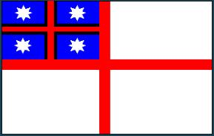

Figure 1 : The Declaration of Independence Flag 1835 of the Confederated Hapu(s) of New Zealand

Pre 1830 Maori hapu had their own banks, mail service, and news papers, along with trading ships, and flour mills. Unfortunately, after the Treaty was signed, these businesses were confiscated or forced to close. Maori traded in multiple currencies due to various nation ships visiting our country.

In 1832, King William IV promise Maori Rangitira he will send his personal trading flag which will be recognised in 60 ports and that they may enjoy all the privileges and protections that go with that flag, and he would make arrangements for it to reach our shores This is our first dealings sovereign to sovereign.

1834 The King's promise is kept. The English flag is piped ashore from the H.M.S. Alligator to a 21 gun salute, normal for the time recognising Sovereign to Sovereign, King William IV to the Maori people. Maori personalise the flag adding the blue background to represent
and include the sea mass in which the land sits. The repetitive star pattern, 4 in total, indicates Nga Hau E Wha, that all 4 corners of this country is accorded all protection and privileges. The red cross represents every bloodline. The 8-points represent the 7 Waka, the 8th being the protection we accorded any non-Maori, should they be in our territories as traders or settlers, or if war with another nation should brake out.

1835 Maori having had their meetings around the country, traditionally recorded for all time in waiata, draw up their Declaration of Independence and proclaim it to the World, on the 28 October 1835. Access to the ports, the privileges and protections promised by the English Monarch, King William IV, implicit in the Flag, is cemented in writing and in perpetuity ( see http://www.nzhistory.net.nz/media/interactive/the-declaration-of-independence ).

1840 Te Tiriti o Waitangi signed between Queen Victoria and Maori Rangatira from Hapu.
(See http://www.nzhistory.net.nz/politics/treaty/read-the-treaty/english-text )

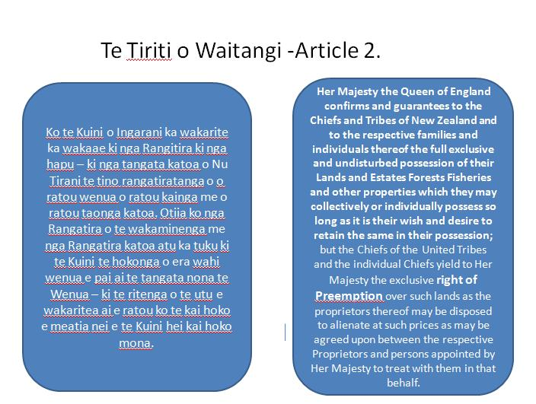

Figure 2: Article 2 of the Treaty of Waitangi.

As Treaty of Waitangi Partners with Her Majesty the Queen of England, Nga Hapu o Niu Tireni (Figure 3) are concerned at the very undermining of the Treaty relationship by those who seek as an agenda that will result in the undermining of the mana and tino rangatiratanga of Her Majesty the Queen of England and the Rangitira , nga Hapu and whanau under Te Tiriti o Waitangi (Treaty of Waitangi).

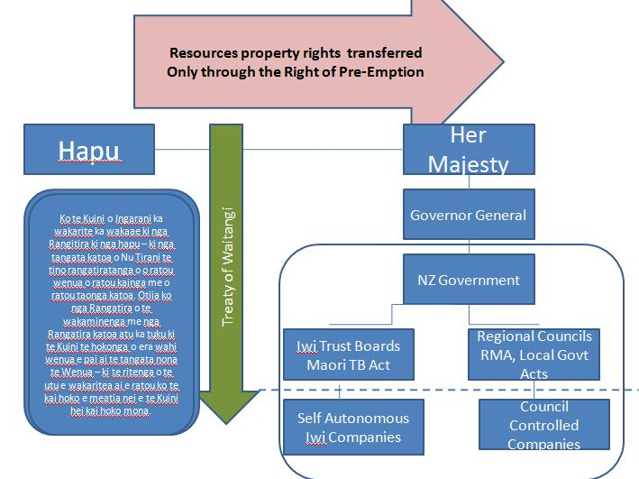

Figure 3: Relationship of Hapu to Her Majesty the Queen, Governor General, New Zealand Government, Iwi Trust Boards, etc.

We do not agree with the merging of the economies or crrencies between Australia and New Zealand, and the control of it by any self -autonomous foreign governance agencies in any other free trade or International Agreement outside our national borders, as this will severely impinge on the Maori Hapu mana and tino rangitiratanga over their own possessions.

We are not pleased that no hapu representative on behalf of Maori have been included on the Productivity Commission, and that hapu have not been consulted properly kanohi ki kanohi (face to face), or agreed to anything. This is a breach of Article 2 of Te Tiriti o Waitangi. And we do not want consultation to be hijacked by the iwi trust boards, as they are not hapu.

For decades hapu have shared their country with new immigrants bought here under Te Tiriti o Waitangi (The Treaty of Waitangi), thinking that their rights under the Treaty will be protected.

Unfortunately, we have seen our land, water bodies, forestry, biodiversity, minerals, fisheries, coastal resources, and cultural loss through various dubious means by Crown agents, and Acts of Parliament (Table1) for which we have not been fairly compensated for. Unfortunately the iwi trust boards and other business interest groups have been used to manufacture consent for resource alienation, for which Hapu (the Treaty partners) have been ignored on the most part.

Inequity in NZ society is so unfair that 19 out of 20 working taxpaying Maori do not reach retirement age, and do not benefit from Superannuation for which they paid for, and equally as bad statistics in other socio-economic indicators of health and education.

Maori are more than twice as likely to be persistently deprived due to inequity and implementation of policy that they have do not have a part in forming,
(Fallow, B. 2012: New Zealand Herald http://www.nzherald.co.nz/brian-fallow-on-the-economy/news/article.cfm?c_id=1502863&objectid=10806354).

Table 1 : Summary of some of the NZ legislation that has resulted in loss of Hapu assets, lands, resources, and intellectual property.

- New Zealand Settlement Act Native Land Act,
- Resource Management Act Municipal Incorporations Act
- Ratings Act Land Act
- Public Works Act Public Domain Act,
- Tohunga Suppression Act. NZ Settlements Act,
- Crown minerals Act Petroleum Act,
- Maori Trustee Act Maori Trust Boards Act
- Treaty of Waitangi Act Patents Act
- Plant Varieties Rights Act Customs Act
- Trademarks Act Trans Tasman Proceedings Act
- ElectricityAct

We see this attempt to merge economies, currencies, markets, and carbon emission trading schemes as another way to alienate resources through the establishment of self autonomous Trans-Tasman regulatory or governance boards by way of gaining Market Sovereignty.

In our opinion, this is a Treaty breach as we are not able to self determine the allocation or management of our own resources, due to the formation of “Market Sovereignty” over national sovereignty, in which international market speculators, predatory foreign investment funds, and multinational corporations can exploit and use the invisible hand of the market to take our resources. For example the Carbon trading scheme if merged could be manipulated to take our land.

From the experience of the Treaty of Waitangi signing, Maori know exactly how corporate businesses, government agents, and judiciary exploited loopholes to allow for resource grabs just after it the signing of the Treaty.

We do not wish this exploitation to be repeated.

Already, we have seen major breaches with the formation of the Trans Tasman Food Standards Authority which undermines the mana and tino rangatiratanga of Hapu and whanau management of their own food in our home, farms, businesses, and marae, and also the Trans-Tasman Agency on Therapeutic Products which affect hapu and tohunga to practice our traditional medicines without consultation to hapu. This imposes foreign policy on Hapu and whanau for that does not facilitate our own values, customs, and control of our own possessions. Our cultural customs of koha, food preservations, cooking, harvesting, seed saving, and sharing are being affected by the imposition of the new Food Bill.

We are also upset how the predatory foreign investment funds are given more rights than New Zealand investors under Free Trade Agreements with China and Australia, affecting the sustainability of home affordability for New Zealanders, and then them allowing to exploit holes in natural resource management for which Maori hapu have a significant interest. We are opposed to any regime that allows our rivers, water bodies, mountains, forests, oceans, air, fisheries, biodiversity, cultural heritage sites, to be traded in a single economic market. As much of our natural resource economy is “non-market” to allow the reasonable beneficial use, wellbeing, and pleasure of every citizen in New Zealand.

These Trans-Tasman or global governance regulatory authorities only seek to benefit large multinational companies, and not local business who provide local employment for our families, nor community organisations, or charitable groups. There is no representation of Hapu at any of these Trans Tasman governance organisations as to our knowledge protecting our rights.

We agree with Prof Peter Lloyd statement that:

“The implication is that A Single Economy would severely handicap policymaking in New Zealand in particular. It would forgo two major instruments of independent national policymaking, namely an independent monetary policy and a wages policy relating to minimum and award wages.”
(Prof Peter Lloyd,20/5/2012: Submission to the Productivity Commission, http://transtasman-review.productivity.govt.nz/sites/default/files/sub005-transtasman-review.doc)

We are very concerned that monetary policy and wages will be manipulated and affect the wellbeing of Maori and other New Zealanders to their detriment of New Zealand homeowners, businesses, farmers, and workers.

We question why there is an attempt to bring in the failed economic policies and structures of the European Union in order to form a single economic market, which assisted in the downfall of Greece, Italy, Spain, and Iceland, and loss of their sovereign status to technocratic banking regimes.

As spectators of the meltdown in Europe we watched the privatisation of their public utility companies, the failure of the carbon market, mass unemployment, rise in trans national crime syndicates, very little border protection against biosecurity risks, excessive immigration in communities or countries that could not cope with increased numbers, rise in unemployment, and general disharmony. We are very concerned for all New Zealanders if our nation is merged into a single economic market with other nations.

We are concerned that our indigenous rights to our taonga, wahi tapu, indigenous knowledge, privacy of information, whakapapa, our land, water, fisheries, forestries, biodiversity, food, possessions, way of life, and customs will be removed under such arrangements, and that unknown foreign policy makers will be dictating policy that impede our sustainability as a people, whilst breaching the Tiriti o Waitangi.

He manaaki aroha,

Whiti Awarau Catherine Pioletti
MSc(Tech)Hon/MMS(Distinction)

