
The costs & benefits of mutual recognition of imputation & franking credits

NZIER and CIE final report
August 2012

About NZIER
NZIER is a specialist consulting firm that uses applied economic research and analysis to provide a wide range of strategic advice to clients in the public and private sectors, throughout New Zealand and Australia, and further afield.
NZIER is also known for its long-established Quarterly Survey of Business Opinion and Quarterly Predictions.
Our aim is to be the premier centre of applied economic research in New Zealand. We pride ourselves on our reputation for independence and delivering quality analysis in the right form, and at the right time, for our clients. We ensure quality through teamwork on individual projects, critical review at internal seminars, and by peer review at various stages through a project by a senior staff member otherwise not involved in the project.
Each year NZIER devotes resources to undertake and make freely available economic research and thinking aimed at promoting a better understanding of New Zealand’s important economic challenges. NZIER was established in 1958.
About CIE
The Centre for International Economics is a private economic research agency that provides professional, independent and timely analysis of international and domestic events and policies.TheCIE’s professional staff arrange, undertake and publish commissioned economic research and analysis for industry, corporations, governments, international agencies and individuals.While TheCIE endeavours to provide reliable analysis and believes the material it presents is accurate, it will not be liable for any party acting on such information.
Authorship and acknowledgements
This paper was prepared at NZIER by Chris Nixon and John Ballingall. The modelling was carried out by Lee Davis, Jason Soon and Tingsong Jiang of the Centre for International Economics, Australia. The report was quality approved by Jean-Pierre de Raad.
Guidance was provided by the ANZ Leadership Forum Project Steering Group. Chaired by Murray Jack, Chairman of Deloitte New Zealand, the Group comprised representatives from Business Council of Australia and BusinessNZ with support on technical tax and related issues from the New Zealand Inland Revenue, pwc, the New Zealand Treasury and Robin Oliver. Their input is gratefully acknowledged. Discussions with the New Zealand an Australian Productivity Commissions have also been valuable and we thank them for their input.
This report has been prepared with financial assistance from a range of New Zealand and Australian businesses and we thank them for their generous support. The companies include Fletcher Building, Fonterra, Westpac, Bank of New Zealand, ANZ Bank, Air New Zealand, ASB Bank, Auckland International Airport, Telecom New Zealand, IAG Group, Sky City Entertainment Group, Woolworths, Wesfarmers, Origin Energy, Orica, Macquarie Group, BusinessNZ.
The analysis and opinions put forward in this report are those of the authors alone and do not necessarily represent the views of those organisations acknowledged above.
Keypoints
A continuing issue for businesses operating across the Tasman is the lack of mutual recognition of imputation and franking credits.
To assist in the further consideration of the matter, this study provides a basis for assessing the potential economic implications of a move to a system of mutual recognition.
Under the central scenario modelled, a system of mutual recognition of franking credits would be likely to deliver net benefits to both Australia and New Zealand. In Net Present Value terms trans-Tasman GDP could rise by around NZ$5.3 billion by 2030. Trans-Tasman welfare is estimated to improve by NZ$7.0 billion.

The problem: double taxation = inefficient resource allocation
Currently some NZ$7.4 billion of trans-Tasman equity investment dividends could potentially be taxed twice – first via company tax in the destination country and secondly via personal tax regimes in the investor’s economy. Australian equity investors in New Zealand face an effective tax rate of some 60%, and New Zealand investors in Australia face an effective tax rate of 53%.
The existing regime can be seen as a form of tariff on trans-Tasman investment flows. As with a tariff, the result is that resources are not allocated efficiently. Trans-Tasman investment decisions are being made at least in part to minimise tax payments, rather than on a purely economic basis.
Firms may not be growing their trans-Tasman activities as much as they might do in the absence of such a distortion and are spending scarce management resources on minimising tax rather than boosting growth. Case studies in this report support this perception.

A solution: mutual recognition of imputation credits
One option for addressing this inefficiency would be for New Zealand and Australia to adopt mutual recognition of franking credits (in Australia) and imputation credits (in New Zealand).A franking or imputation credit is a way of providing credit against tax on dividends received by domestic shareholders for tax paid at the company level.
To date, mutual recognition has been resisted primarily due to concerns about the tax that would be forgone. Yet little attention has been paid to estimating the potential economic benefits of such a scheme.

We estimate the costs and benefits of mutual recognition using a global computable general equilibrium model
This report uses the internationally-recognisedCIEG-Cubed model of the global economy that incorporates forward-looking investment expectations and explicitly considers the links between fiscal policy and economic growth and household welfare to estimate the potential costs and benefits of introducing a mutual recognition scheme.
Recognising that concerns over forgone tax have been a stumbling block in the past and the current tight fiscal environments facing both governments, our modelling approach is revenue neutral for both governments. When mutual recognition is introduced, the tax forgone is regained by small increases in other taxes on households.
We conduct sensitivity analysis around key assumptions related to: the share of Australian investments in New Zealand that are in Australian superannuation funds and thus face a concessional tax rate; the proportion of dividends distributed; and the tax instrument used to replace the initial forgone tax revenue.

The trans-Tasman economy would expandby NZ$5.3 billion by 2030 from mutual recognition with both countries gaining
Under our central modelling scenario, after mutual recognition is introduced, the trans-Tasman economy grows by NZ$5.3 billion (net present value) above baseline by 2030. This is due to both countries facing a lower cost of capital as post-tax returns on trans-Tasman increase after mutual recognition is introduced, as well as higher household disposable income. Household consumption – our preferred measure of welfare – increases by NZ$7.0 billion.
New Zealand gains proportionately more from mutual recognition. This would be expected given the far larger share of New Zealand’s equity investment that comes from Australia than vice versa. However, even though Australia’s gains are small, this study finds they are indeed net gains rather than losses, that is even after taking into account the initial tax forgone.
Dynamic productivity gains would increase these benefits
We have taken a conservative approach to our modelling and looked only at the allocative efficiency gains from mutual recognition. We would expect – and our case studies agree – that mutual recognition would also generate dynamic productivity gains from increased competition and innovation, and reduced management time spent on tax avoidance.
Estimating the magnitude of these gains is beyond the scope of this report. However, their existence would boost the net benefits of a mutual recognition scheme above the figures reported here.

The results are robust to sensitivity analysis
The overall story that mutual recognition delivers net benefits for both economies does not change under sensitivity testing.
The sensitivity analysis indicates, as expected, the GDP gains from mutual recognition are slightly higherthe larger the proportion of dividends distributed and the higher the share of Australian investment in New Zealand accounted for by superannuation funds. Both of these scenarios see a larger proportion of trans-Tasman capital being cheaper, which boosts economic activity and household spending.
The choice of household tax used to replace the initial tax forgone has very little impact on the results.

Next steps
As with any economic modelling, especially in a relatively new field of study, many assumptions are required and there are many avenues for further research. Particular areas of interest are how dividend distribution might change under mutual recognition and what the share of superfund Australian investment in New Zealand might be.
However, the empirical analysis and case studies in this report, when combined with the theoretical benefits from mutual recognition, suggest that this is an initiative that would stimulate business and deliver a significant net benefit to the trans-Tasman economy.

Contents
1. Introduction 1
2. Investment is the missing link in the SEM 2
3. Trans-Tasman investors are double taxed on dividends 3
3.1 The double tax problem 3
3.2 Mutual recognition is like removing a bilateral tariff 4
3.3 So why hasn’t mutual recognition been introduced? 5
3.4 The distorting and costly impacts of double taxation in practice: two case studies 6
4. Proposed changes 9
4.1 Mutual recognition 9
4.2 Alternatives 9
5. Costs and benefits of mutual recognition 11
5.1 The cost benefit framework 11
5.2 Not all impacts can be quantified 11
5.3 Counterfactual 11
5.4 Affected parties 12
5.5 Costs to trans-Tasman economy 12
5.6 Benefits to trans-Tasman economy 14
5.7 What we quantify 15
6. Modelling approach 17
6.1 Introduction 17
6.2 The CIEG-Cubed model 17
6.3 Modelling shocks 18
6.4 Timing of MRIC introduction 19
6.5 A word of caution 20
7. Results 21
7.1Headline results 21
7.2 The mechanisms through which MRIC affects the economy 21
7.3 Economic activity and welfare 22
7.4 Savings and investment 24
7.5 Foreign investment 25
8. Sensitivity analysis 28
9. Conclusions 31
10. References 32

Appendices
Appendix A Developing the modelling shocks 33
Appendix B Tax burden considerations 39

Figures
Figure 1: Steps to trans-Tasman integration 2
Figure 2 Production and welfare gains 22
Figure 3 Economic activity and welfare impacts 23
Figure 4 Savings and investment impacts 25
Figure 5 Foreign investment impacts 26

Tables
Table 1 Status quo: Australian direct investment into New Zealand 3
Table 2 Status quo: New Zealand direct investment into Australia 4
Table 3 Summary of approaches 10
Table 4 Short term fiscal costs of mutual recognition 13
Table 5 Which impacts are quantified? 15
Table 6 Increase in real GDP above baseline under changed assumptions 29
Table 7 After tax value of Australian share of New Zealand corporate profits 34
Table 8 Potential revenue lost by Australian government from MRIC 35
Table 9 Changes in post-tax returns from Australian investment in New Zealand under status quo and MRIC 36
Table 10 After tax value of New Zealand share of Australian corporate profits 37
Table 11 Potential revenue lost by NZ government from MRIC 38
Table 12 Changes in post-tax returns from NZ investment in Australia under status quo and MRIC 38
Table 13 Marginal excess burdens of Australian taxes 39

Introduction
Australia and New Zealand have made significant steps to fully integrating their economies. According to the WTO the integration process has developed“… one of the world’s most comprehensive trading arrangements” and this has been done at least cost.
One area where progress has not been as impressive is investment.Currently, Australia has an equity investment stock of NZ$37.5 billion in New Zealand, and New Zealand has a NZ$20.8 billion stock of equity investment in Australia. The dividends generated from these investments are being taxed twice before they end up in households’ pockets.
The current double taxation regulations act as a barrier to the free flow of trans-Tasman investment. This causes economic inefficiencies for New Zealand and Australia as investment flows are at least partially determined by tax policy rather than economic fundamentals.
A way of eliminating this barrier on investment is to adopt mutual recognition offranking credits (in Australia) and imputation credits (in New Zealand) [henceforth MRIC]. The purpose of this report is to provide acostbenefit analysis (CBA) of implementing a mutual recognition scheme.
The ideaof MRIC has been around for some time. It has been the subject of various reportsbut these studies have been either conceptual or largely confined to the question of tax. Indeed, the debate has been dominated by concerns over lost tax revenue. To our knowledge, no research has quantified the benefits from MRIC.
We have taken a fresh look at the problem to explain why this is not just a tax issue but an important component of the SEM. To provide an independent trans-Tasman approach the New Zealand Institute of Economic Research (NZIER) has partnered with Sydney’s Centre for International Economics (CIE) to develop a systematic economic appraisal that details the quantifiable and non-quantifiable costs and benefits of MRIC.
The analysis is intended to give policymakers an indication of the likely magnitude of costs and benefits to assist in a decision on whether or not to progress with MRIC and to inform the business debate on the topic. However, it needs to be acknowledged that this is a complex area of policy to model and that there are data gaps. As such the modelling results should not be seen as precise forecasts, but indications of the potential direction and size of impacts.
In our modelling, we have drawn on publicly available data wherever possible. Where comprehensive data is not available, we have used our professional judgement and drawn on the views of experts to inform our analysis. We have used sensitivity analysis to test the influence of key assumptions on the results.

Investment is the missing link in the SEM
Both countries are committed to the SEM. To reinforce this goal the then Australian Prime Minister Kevin Rudd and the New Zealand Prime Minister John Key issued a joint statement in March 2009 that outlined their ambition. They stressed (emphasis added):
”…we are committed to accelerating regulatory harmonisation and alignment in order to stimulate business and create jobs.To that end, we have agreed on a framework of principles and a range of shared medium term practical outcomes for developing cross border economic initiatives.
The outcomes framework supports an aspirational Single Economic Market (SEM) agenda, and will in the short-term drive pragmatic initiatives and set clear timelines for the work programme. A key element within the framework is a deliberate move from consideration purely of national benefits in policy development, to consideration of the net trans-Tasman benefit.”
We interpret this quote – and especially the last sentence – tomean that the aim of the SEM is to maximise Australian and New Zealand welfare. Part of this process is to allow business people to make locational decisions on the basis of economic factors rather than policy constraints. Therefore, removing the tariff on trans-Tasman investment flows is potentially an important element of “accelerating regulatory harmonisation and alignment”in the two economies as depicted in Figure 1.
Figure 1: Steps to trans-Tasman integration
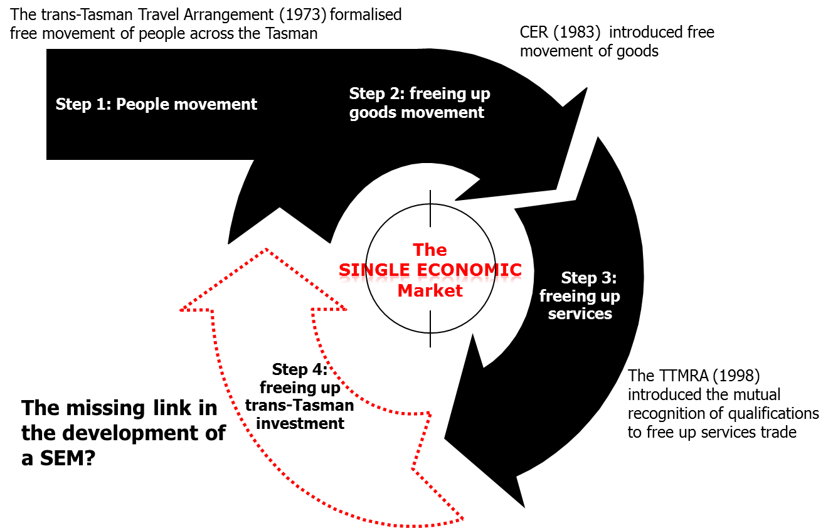
Source: NZIER

Trans-Tasman investors are double taxed on dividends

The double tax problem
Currently, dividends from Australian companies in New Zealand that are repatriated to shareholders in Australia are taxed twice: once via company tax in New Zealand and once via the personal tax system in Australia.
The impact is set out in Table 1 for an Australian shareholder (on the top personal tax rate) in a New Zealand company.Under the status quo the effect of double taxation is evident when compared with a situation “with” MRIC. The effective tax rate on Australian shareholders drops by nearly 40% with the introduction of MRIC.
Table 1 Status quo: Australian direct investment into New Zealand
Dollars
Australian shareholder in a New Zealand company | Status quo | “with” MRIC
Company Income | 100 | 100
Tax Paid | 28 | 28
Australian shareholder
Taxable dividend | 72 | 100
Personal tax @ 45% | 32.4 | 45
Franking credit | 0 | 28
Net personal tax | 32.4 | 17
Net income | 39.6 | 55
Effective tax rate | 60.4% | 45%
Increase in post-tax dividends |  | 38.9%
Source: New Zealand Inland Revenue
This table implies that under the status quo, company income would approximately have to be $140 to generate the equivalent "with" MRIC post tax return of $55.
A similar situation exists with New Zealand shareholders investing in Australia (see Table 2). Under MRIC the increase in post-tax dividends would be 42.9%.
Table 2 Status quo: New Zealand direct investment into Australia
Dollars
New Zealand shareholder in anAustralian company | Status quo | “with” MRIC
Company Income | 100 | 100
Tax Paid | 30 | 30
New Zealand shareholder
Taxable dividend | 70 | 100
Personal tax @ 33% | 23.1 | 33
Imputation credit | 0 | 30
Net personal tax | 23.1 | 3
Net income | 46.9 | 67
Effective tax rate | 53.1% | 33%
Increase in post-tax dividends |  | 42.9%
Source: New Zealand Inland Revenue
This table implies that under the status quo, company income would have to be $143 before it generateda return equivalent to the "with" MRIC post tax return of $67.
The implication of the current taxation system is that an investment opportunity in the destination country has to offer a far higher return than a similar opportunity in the home country to make it of equivalent commercially viability and compensate for the double taxation.
This creates a home bias in investment decisions: even though from a pure economic perspective an investment opportunity looks a better bet in the destination economy, the impact of the tax policy determines that it makes sense to forego that opportunity and put money into a potentially less efficient investment domestically.
As a result, trans-Tasman resource decisions are distorted: resources are not being allocated to their optimal locations.

Mutual recognition is like removing a bilateral tariff
The development ofa MRIC framework on tax imputation and franking credits isanalogous – albeit not perfectly – toa reduction in goods tariffs under CER.
Tariffs distort trade and reduce economic welfare by raising import prices above the domestic price. This reduces the competitive pressure on domestic producers, leading to inefficient firms remaining in business. This limits the ability of truly competitive domestic firms to access scarce resources. Tariffs also reduce households’ purchasing power as they pay more for imported goods than they would do under freer trade.
The removal of a tariff on a good tends to lead to an improved allocation of resources in the importing country and improved household welfare.It also leads to a drop in tariff revenue, but this cost is more than offset by the efficiency gains across the economy.
This line of reasoning has been accepted by the vast majority of New Zealanders and Australians as both countries have been through extensive unilateral, bilateral, regional and multilateral tariff reductions in recent decades.In the CER negotiations there were few concerns on either side of the Tasman about the loss in tariff revenue from liberalisation. Governments were more concerned about the economic opportunities that CER would create.
Since the current double taxation of dividends on trans-Tasman investment pushes up the price (return required) of foreign investments relative to domestic investments, the tariff analogy seems appropriate. It also seems logical then to expect that removing double taxationis likely to improve trans-Tasman welfare by allowing trans-Tasman investment to flow to where it can be put to its best economic use (mainly an allocative efficiency gain).
These gains, in turn, enhance the potential for higher growth in output and incomes. It is these benefits from MRIC that need to be traded off against any short term loss in tax revenue on trans-Tasman dividend flows.
Following the trade policy analogy the introduction of bilateral MRIC can be thought of as being ’investment-creating’within CER (Viner 1950). Flows of investment are likely to be redirected to more efficient uses due to MRIC. This improved efficiency is likely to lead to further new investment/trade flows (see Romer 1994).
MRICwill also have ‘investment-diverting’ effects for third countries. The bilateral investment tariff preference that mutual recognition offers Australia and New Zealand will reduce the attractiveness of investments in third countries. This may make third countries worse off. However, given that we assume – as per the Joint Prime Ministers’ statement in section 1 – theaim of the SEM is to improve trans-Tasman welfareover time, not world welfare, we do not focus on these third country effects in this report.
In short, from a conceptual basis we would expect that – relative to the status quo – over timeMRIC will result in the trans-Tasman economy being better off.

So why hasn’t mutual recognition been introduced?
Trans-Tasman tax systems have evolved relatively independently,although both imputation systems were introduced in the late 1980s. However, it was not until the success of CER became apparent that efforts were made to negotiate a MRIC agreement.
The major stumbling block has been the short term loss of tax revenue by both governments. However, from an economywide perspective the short term loss in tax revenue is not a cost but a transfer to householdsthat will generate more tax since funds are likely to be re-invested or consumed within the trans-Tasman economy. This is looked at in more detail in section 5.5.
The issue has remained on the political and business agenda for many years. The recent announcement that both countries’ governments have tasked their respective Productivity Commissions to carry out a joint study into the impacts of further economic trans-Tasman integration provides an opportunity for MRIC to be explored in more detail.

The distorting and costly impacts of double taxation in practice: two case studies
As part of this project pwcprovided us with a number of actual examples of the problems Australian and New Zealand firms have with the investment tariff. We have included two of these case studies below (names changed to preserve anonymity) to illustrate these problems.
Practical experiences like this do become well known and can rapidly spread around, causing businesses, particularly SMEs, to be very cautious before expanding across the Tasman.

Case study 1 – NZ manufacturer wanting to expand in Australia

Facts
NZ manufacturer (NZ Co) is a midsized company (total assets circa $NZ200m) with a substantial share of the NZ market. NZ Co identifies an opportunity to acquire a competitor company based in Australia (Aus Co). Purchase price $NZ100m.

Preferred structure
- NZ Co to fund the acquisition using $20m in retained earnings and $80m in debt from its NZ bankers
- acquire 100% of the shares in Australian Co.

Problems with preferred structure
- no NZ tax relief for tax paid in Australia on Aus Co’s profits
- as a result, although dividends from Aus Co to NZ Co are tax exempt, when NZ Co pays these dividends to its NZ shareholders double tax arises
- aggregate tax rate on Aus Co profits is 53.1% compared with 33% on NZ profits
- tax paid return from a corporate NZ investment is 42.9% higher.

Potential solutions
- establish Australian Limited Partner (ALP) to purchase Aus Co’s assets
- wind-up Aus Co
- ALP to be owned directly by NZ Co’s shareholders so that tax paid in Australia can be offset against NZ Co’s shareholders NZ tax liability.

Problems with proposed solutions
- after expending substantial sums (total in excess of $200k) in investigating the Australian and New Zealand legal and tax implications of the proposed structure the following problems are identified:
- the ALP structure is not suitable for trading in multiple states in Australia
- a solution would be to limit trading to a single state but this negates the commercial objective of the acquisition
- the proposed structure involves shareholders owning assets directly in Australia as well as owning their shares in NZ Co. Because management of the operation needs to be combined, the legal structure is inconsistent with the necessary management structure. Significant administration costs will arise as a result
- ALPs are not widely accepted or used by Australian businesses, so NZ Co is counselled that they will be less attractive in the market than competitors using conventional structures
- Australian stamp duty and other costs in winding up Aus Co are substantial.

Ultimate structure adopted
- NZ Co establishes new Australian holding company (Aus Co Hold) to purchase Aus Co
- Aus Co Hold borrows the maximum amount in respect of which interest is able to be deducted under the Australian thin capitalisation rules and debt funds the acquisition
- balance is subscribed in equity from NZ Co
- significant additional funding costs are incurred due to Aus Co Hold having to borrow through Australian facilities leaving existing NZ facilities undrawn
- some of Aus Co’s functions are transferred to NZ Co to enable adjustments to be made to transfer pricing of stock to maximise profits in NZ and minimise profits in Australia. The overall cost of conducting these operations in NZ is higher than previously because it results in duplication of some facilities and functions.
- In addition, NZ Co loses some key staff who are unwilling to relocate to New Zealand. NZ Co management are also worried about having key management at a distance from their major growth market (Australia). However, the tax advantage of avoiding double tax outweighs the commercial inefficiency from duplication of operations and loss of experienced management.

Case study 2 – Tax trips up existing trans-Tasman operation

Facts
Aus Co is a midsized (total assets $500m) entity involved in the supply of heavy equipment. A number of Aus Co’s Australian customers have NZ operations. Aus Co starts exporting equipment directly to these operations. Sales to NZ increase rapidly, and as a result Aus Co has a number of Australian based executives travelling across the Tasman to meet customers, enter into preliminary negotiations on contracts and have follow up service and maintenance meetings. The operations continue on this basis for 4 years.
No NZ tax has been paid because Aus Co is thought to have no NZ tax presence. Tax is paid in Australia on Aus Co’s profits, including those arising from sales in NZ.

Problem
NZ’s Inland Revenue Department investigates Aus Co and concludes that it maintains a ‘permanent establishment’ in New Zealand as a consequence of the extent of its presence. In particular, Inland Revenue notes that some of the executives have been concluding contracts in NZ, and have been operating out of an office maintained by one of Aus Co’s major customers. Inland Revenue assesses Aus Co for NZ tax on profits for the last 4 years.
The implications of the above are:
- significant NZ tax payable. Although this is able to be claimed by Aus Co as a credit against its Australian tax, because the NZ tax is not able to be used to frank dividends the reduction in Australian tax payable by Aus Co means that it has overdrawn its franking account
- as a result Aus Co is exposed to a retrospective tax bill of several million dollars
- the costs of the investigation, analysis of technical issues and attempts to persuade Inland Revenue to withdraw its position amount to $500k.

Solution
Aus Co concludes that itcannot justify operating in New Zealand if it is to suffer double tax resulting in a 39% reduction in return relative to a situation with mutual recognition. It withdraws from the New Zealand market.

Proposed changes

Mutual recognition
The most recent review of Australia’s tax system stated that the dividend imputation system should be kept in the short- to medium-term. It also suggested that if an imputation system were to be kept, the favoured approach for further investment integration with New Zealand is through MRIC.The impact of such a system is set out in Table 1 for an Australian investor in New Zealand on the top marginal tax rate (45%).
Put simply, a franking (in Australia) or imputation (in New Zealand) credit is a way of providing credits against tax on dividends received by domestic shareholders for tax paid at the company level.
While it is beyond the scope of this report to examine how a MRIC scheme would be implemented, a simple approach would be for New Zealand to treat franking credits as imputation credits and Australia to accept imputation credits as franking credits.

Alternatives
Other methods could also address some of the issues associated with double taxing of dividends.

Streaming
Streaming of credits has been suggested as a way around double taxation of investor dividends. This would allow firms to stream income from domestic investments with imputation/franking credits to New Zealand/Australian shareholders who can make use of the imputation/franking credits and income from foreign investments with no imputation/franking credits to foreign shareholders.
The basis of an imputation system is to ensure that domestic tax is collected on income of non-residents sourced from New Zealand and also the worldwide income of residents. Streaming would undermine both these imputation design features. However, we would expect that the impact would vary widely depending on the circumstances of the firms involved.It is also worth noting that the Henry Review firmly rejected dividend streaming as long as the imputation system is retained.

Unilateral recognition of imputation/franking credits
Unilateral recognition at face value seems like a logical approach to the imputation problem. This would work by Australia and New Zealand allowing imputation tax credits on dividends from all domestic and foreign sources of investment.
Such a system would encourage trans-Tasman investment efficiency, and if imputation systems were adopted around the world it would lead to improved global investment efficiency. The problem is that imputation systems areused in very few jurisdictions so while Australia and New Zealand would be providing imputation/franking credits for foreign taxes, there would be no corresponding imputation credits provided by foreign governments to citizens who are investing in Australia and New Zealand. Third countries, to take advantage of the scheme would have to develop imputation credit schemes. This is unlikely for a number of political and legal reasons.
In the absence of other countries providing reciprocal benefits, allowing imputation credits for foreign taxes is unlikely to be in either New Zealand’s or Australia’s national interest. It would encourage firms to invest in ways which maximise pre-tax incomes and to be indifferent between paying income at home or abroad.Since taxes paid at home are part of national income whereas taxes paid abroad are not, this could lead to negative domestic welfare impacts.
The Henry Review firmly rejected the unilateral approach for practical reasons. Of particular concern was verifying whether firms had paid tax in a foreign jurisdiction. This could be difficult given the varying degrees of institutional quality around the world.

Summary
Table 3shows our summary assessment of the strengths and weaknesses of regulatory tools that could be used to address the double taxation issue.

Table 3 Summary of approaches
 | Simplicity | Certainty | Durable | Feasible
Streaming | √x | X | ? | X
Unilateral recognition | √ | X | X | X
Mutual recognition | √ | √ | √ | √
Source: NZIER
All approaches have positive attributes. Streaming credits is relatively straightforward (although not as straightforward as unilateral and MRIC). But it creates uncertainty because it undermines the principles of the imputation system. Therefore, it is not feasible and because of this there is a question mark over its durability.
Unilateral recognition is simple to implement in theory. However, there would be practical difficulties in ascertaining how much company tax has been paid in many cases. Moreover, it would mean providing credits for foreign taxes and encouraging offshore investment without any reciprocal benefit.
This leaves MRIC as the most feasible option to address the inefficiencies caused by the current system (as suggested by the Henry Review). It is relatively simple to implement, creates certainty (e.g. it eliminates attempts to circumvent double taxation) and is durable since it likely to generate additional economic activity.

Costs and benefits of mutual recognition

The cost benefit framework
We have used a cost benefit framework, incorporating computable general equilibrium (CGE) modelling, to obtain an estimate of the potential value of MRIC.
CBA is a long-established technique intended to identify the economic efficiency of a proposed project or policy change. Efficiency is broadly about maximising outputs obtained from available inputs, but there are different variants used in economics. In particular, we are interested in allocative efficiency which refers to the ease with which resources can move across the trans-Tasman economy to their most productive use.
If the introduction of a MRIC scheme allows the shift of resources to their most productive use then clearly it will improve allocative efficiency. It may also impact on dynamic efficiency since better matching of resources may generate new products and services that would not have otherwise been developed.
A cost benefit analysis proceeds by comparing effects and outcomes associated with the introduction of MRIC against what would have occurred under a counterfactual without the proposed change. This counterfactual can be described as a projection of the status quo into the future.

Not all impacts can be quantified
This is a ‘partial’ cost benefit analysis,recognising that some effects will be too difficult to reliably quantify. For instance, an important benefit may well be the ability of New Zealand and Australian small and medium sized businesses not only to export to each other’s market but also through this process learn the skills to export to third markets.
While we can identify these benefits, it is not feasible to value them in economic terms, given available information, time and resources. For practical reasons the analysis has concentrated on quantifying effects that are readily quantified and valued, and describing in a qualitative way the effects that cannot be readily quantified or valued.

Counterfactual
The counterfactual is the status quo where dividends are double taxed.
This means that:
- some barriers to trans-Tasman investment would remain
- the SEM would not be a fully functioning single market
- additional investment that would potentially go to Australia/New Zealand from New Zealand/Australia would remain in the domestic market.
This scenario becomes the baseline from which we measure changes that occur if Australia and New Zealand were to develop MRIC regulations. The following sections set out this preliminary analysis.

Affected parties
We have identified – based on feedback from various stakeholders and published material – a numberof costs and benefits of a MRICscheme that need to be considered in the CBA, whether they can be quantified or not. These costs and benefits accrue to four key groups:
- shareholders in Australia/New Zealand investing in New Zealand/Australia will pay tax only once, freeing up funds for the consumption of other goods and services
- businesses will direct trans-Tasman investment to its most economically efficient location rather than spending valuable time trying to minimise tax payments
- trans-Tasman governmentswill see the tax take from trans-Tasman dividends drop, but could still benefit in the medium term due to increased tax revenue from a stronger, more efficient economy
- third country shareholders and businesses may be slightly disadvantaged because MRIC will favour investors in Australia/New Zealand investing in New Zealand/Australia rather than third countries.

Costs to trans-Tasman economy

Tax forgone
The immediate static fiscal costs are borne by governments as tax forgone on franked/imputed dividends received in Australia and New Zealand. In Table 4we use some generic assumptionsto set out an approximate short term fiscal cost from trans-Tasman MRIC.
Under a central scenario where 50% of dividends are distributed, , the short term fiscal costs are estimated to be NZ$494 million for Australia and NZ$156 million for New Zealand. Proportionally, the tax forgone is higher for New Zealand, although the level is larger for Australia. The combined drop in trans-Tasman tax revenue under our central scenario would be 0.15% of the total tax take.
Table 4Short term fiscal costs of mutual recognition
$NZ millions
 | Australian tax revenue |  | NZ tax revenue |  | Combined CER tax revenue
Dividend distribution assumption | Loss | % of total | Loss | % of total | Loss | % of total
100% | 988 | 0.26% | 312 | 0.61% | 1300 | 0.30%
75% | 741 | 0.20% | 234 | 0.45% | 975 | 0.23%
50% | 494 | 0.13% | 156 | 0.30% | 650 | 0.15%
25% | 247 | 0.07% | 78 | 0.15% | 325 | 0.08%
Source: CIE, NZIER, Statistics New Zealand, ABS

Implications for cost benefit analysis
From a cost benefit analysis perspective, the figures estimated in Table 4 are not costs in the true sense but transfers from government to those who receive dividends. The value of the tax forgone isn’t lost to the economy – it is just recycled in a more direct way. Rather than the government buying goods and services on behalf of households and firms (i.e. through government expenditure), shareholdersspend the money themselves.
By itself, this transfer might be expected to improve national welfare, because the deadweight losses associated with tax collection are reduced. And this is before taking into account the dynamic efficiency benefits discussed below.
However, the question then becomes what the government decides to do to address the drop in tax receipts. It has four broad options:
- Raise taxes from elsewhere in the economy to maintain a constant tax revenue and government spending profile
- Reduce government spending
- If it is in deficit, borrow to maintain government spending without raising taxes
- If it is in surplus, reduce the level of that surplus.
Each of these options has different costs.
In our modelling scenarios, we assume that the first option above is followed. This is a standard ‘closure’ assumption in CGE modelling. Each government maintains government spending as a share of GDP and replaces the investment dividend tax forgone from other taxation sources. As the economy grows, tax revenue also grows to ensure that government spending holds steady as a share of GDP.
This assumption reflects the current tight fiscal environment, with both governments committed to returning to budget surplus as soon as possible. When both governments are running surpluses, they will have greater policy space to consider alternative tax and spending options.

Benefits to trans-Tasman economy

Improved bilateral efficiency of investment
Currently investment by Australian/New Zealand firms in New Zealand/Australia requires a higher pre-tax rate of return than similar domestic investments to overcome the double taxation problem. This suggests investment inefficiency. By removing this bias MRIC is likely to boost productivity and competitiveness on both sides of the Tasman.

Improved product market efficiency
With improved investment allocative efficiency we would expect further product market efficiency. The importance of the linkage between investment efficiency and product market efficiency should not be underestimated (Scrinivasan 2006). Selling products or services in an export market normally requires substantial investment in marketing infrastructure.
The current situation stifles the entry of competitors and constrains innovation. MRIC will remove a home market investment bias for tax reasons and potentially drive further innovation that will in turn promote productivity and further growth. In particular, we are likely to see more exporting from both countries – inthe short run to each other’s market but longer term there is a potential for additional third market exporting.

Reduced compliance and administrative costs
Complying with the current double taxation system imposes compliance costs on businesses and administrative costs on government.
The status quo encourages small and medium sized businesses to set their business up in a way that may be tax efficient but not necessarily economically efficient. As the case studies in section 3.4 demonstrate, there are examples of Australian and New Zealand businesses developing complex structures, increasing their debt to equity ratios and developing other unusual schemes to avoid the existing double taxation regime.
Setting up these schemes involves scarce management time that would be better directed towards more productive activities. Such schemes also attract attention from tax authorities (and thus soaks up government resources) on both sides of the Tasman. A MRIC scheme will help to avoid these issues.

Removing profit streaming devices
The status quo encourages firms to locate their most profitable business units in the domestic market i.e. to shift profitable functions of the firmsto where they are taxed the least.
The status quo also incentivises firms to pay most of their tax in the country where the final shareholders of that company reside. Therefore a New Zealand/Australian subsidiary of an Australian/New Zealand parent company is encouraged to stream its profits to Australia/New Zealand. These activities are engaged in solely for tax reasons and maintaining them represents a deadweight loss to both economies.

Enhanced stability and effectiveness of tax system
Australian and New Zealand tax systems are characterised by high tax collection rates. MRIC will reinforce this position by removing attempts by firms to avoid the investment tariff (examples of which are set out in sections 3.4and 5.6.4).

Logical progression of SEM and demonstration benefits
After the success of CER, the attention of trans-Tasman regulators has moved to behind the border barriers to trade. While there are number of issues on the table, the existing tariff barrier on investment flows is a key obstacle to the SEM.
MRIC therefore is a logical extension of a single market. If there are no barriers to investment flows between Perth and Brisbane or between the North and South Island in New Zealand then it makes economic sense for trans-Tasman investors in a single trans-Tasman market to operate with a similar tax credit system.
A strong SEM not only allows for a strong base for trans-Tasman exporters but also sets a blueprint for further integration in the Asian region. It demonstrates to Asian nations that deeper integration is possible and can be replicated at relatively low cost.

What we quantify
We cannot put monetary values on all of the costs and benefits discussed above. Table 5 summarises what we do and don’t quantify in our modelling work.
Table 5 Which impacts are quantified?
Cost/benefit | Quantified?
Costs
Short term fiscal costs | Yes
Benefits
Bilateral investment efficiency | Yes
Product market efficiency | No
Reduced compliance and admin costs | No
Removal of streaming | No
Tax system effectiveness and stability | No
SEM progression and demonstration | No
Source: NZIER
The benefits in the bottom five rows of the table can be seen as forms of dynamic productivity gains from greater economic integration. These dynamic gains stem from the greater competition and innovation that can be attributed to firms operating in a more open trading environment, and are in addition to the standard allocative efficiency gains that result from improved resource allocation between countries and industries.
It seems reasonable to think that MRIC might lead to some degree of dynamic productivity gains to New Zealand (in particular) and Australian firms. However, given the similarity between the business environments of the two economies and the high degree of integration already present, it is difficult to estimate how large such gains might be in the case of MRIC.
Therefore we take a conservative approach and do not incorporate these dynamic gains, but note that they would occur in addition to the modelling results reported in sections 7 and 8. That is, the net benefits we present from MRIC in this report are likely to be under-stated.

Modelling approach

Introduction
The two key impacts from the implementation of MRIC are the following:
- A reduction in taxation revenues collected by the governments of New Zealand and Australia. This is because New Zealand investors in Australia (and vice versa) who receive dividends from the companies they invest in will be able to claim tax credits for corporate taxes already paid before the distribution of profits by these companies.
- An increase in the after tax rate of return to Australian investors in New Zealand and New Zealand investors in Australia. The tax credits mean that New Zealand (Australian) investors will pay less tax on the dividends received from their investments in Australia (New Zealand), resulting in a higher after tax return to their investment. The paying of less tax gives rise to the above impact.
Faced with higher after tax returns, New Zealand and Australian investors could be expected to increase their investment in Australia and New Zealand respectively. However, additional investment needs to be funded, giving rise to the issue of how will any additional bilateral investment be funded?
There are three avenues through which additional investment could be funded, namely:
- A diversion of investment from other countries to Australia/New Zealand
- A diversion of investment from the local economy to Australia/New Zealand, with any shortfall of available funding (domestic savings) for local investment being met be increased foreign investment
- An increase in the domestic savings rate, with the additional savings being used to fund investment in Australia/New Zealand.
Each of these avenues for funding additional investment in Australia/New Zealand would have different economic and welfare impacts for the investing country.
There are therefore three key issues to consider when investigating what MRIC could mean for Australia and New Zealand, these being:
- How much additional investment is likely to occur?
- How will any additional investment be funded?
- What will be the impact of taxation revenue losses?

The CIEG-Cubed model
We analyse these questions using the CIEG-Cubed dynamic computable general equilibrium (CGE) model.,
The advantages of using CIEG-Cubed include:
- It identifies trade flows between countries/regions
- It identifies investment flows between countries/regions
- It incorporates the real and integrated financial sectors (comprising money, bonds, interest rates, lending, borrowing, expectations, financial flows, and wealth)
- It is a fully dynamic model that can capture the time path of adjustment for each of the economies/regions modelled
- Consumers and producers are allowed to borrow and lend money over time, with decisions influenced by the return on capital versus other assets
- It includes capital adjustment costs and expectations.
This chapter describes the approach to modelling the economic impacts of MRIC. The results of the economic modelling are presented in the next two sections.

Modelling shocks
The central modelling simulation sees:
- An increase in the after tax rate of return on the share of dividends distributed of almost 43 per cent for New Zealand investors investing in Australia, and of almost 39 per cent in the case of Australian investors investing in New Zealand
- A 0.30 per cent reduction in taxation revenue collected by the New Zealand Government and a 0.13 per cent reduction in taxation revenue collected by the Australian Government (see Table 4).
These modelling shocks are premised on:
- Dividends distributed to New Zealand and Australian investors being taxed at the top marginal tax rates (33 and 46.5 per cent respectively), reflecting the assumption that investors belong to the higher income groups
- 20 per cent of Australia investors are superannuation funds facing a concessional tax rate of 15 per cent while the remaining 80 per cent are personal investors facing the marginal income tax rate of 46.5 per cent on their dividends
- The dividend distribution rate for companies in Australia and New Zealand is 50 per cent.
The assumption regarding the marginal tax rate of investors appears reasonable. However, there is some uncertainty about the share of Australian investment in New Zealand that is attributable to superannuation funds.Our 20 per cent estimate is consistent with Australian Taxation Office statistics. The assumption that companies distribute 50 per cent of profits as dividends is based on this being the (approximate) midpoint of New Zealand Inland Revenue’s view.
Given the uncertainty surrounding the share of investment attributable to Australian superannuation funds and dividend distribution rates, these two areas are subjected to sensitivity analysis (see section 8).
Finally, the economic modelling has been conducted such that government expenditure, as a share of GDP, is held constant. Hence a decline in government revenue from one source needs to be matched by an increase in revenue from another source. This ‘revenue neutrality’ type modelling closure means that the initial fiscal cost of MRIC — a decline in government revenue — is addressed.
There are two broad means by which this decline in taxation revenue can be recouped from households– via an increase in direct taxes on Australian and New Zealand households or viaan increase in the broad based indirect taxes of Australia and New Zealand.
We assume for our central scenario that the revenue gap from MRIC is compensated for by an increase in direct taxes on households.Later in the sensitivity analysis we also report results for the scenario where the revenue gap is filled by an increase in broad based indirect tax.

Timing of MRIC introduction
In our modelling simulations, we introduce MRIC in 2012. Clearly this is unlikely to take place. However, given the long run focus of the modelling – out to 2030 – theprecise start date is largely irrelevant from an economic perspective. In addition, most of the results are reported as percentage deviations from a baseline, so the starting level is not critical.
Given the time required for investors to shift their investments between countries, there would likely need to be some degree of lag between the announcement to implement MRIC and it coming into force. We do not incorporate this announcement to implementation lag into our modelling, although firms’ adjustment to the introduction of MRIC does take a period of years.
The choice of starting point is perhaps more relevant from a political economy viewpoint. If both countries are in fiscal surplus within a few years, they will have more leeway to consider policy changes thataffect tax revenue and government spending.

A word of caution
While we believe that CIEG-Cubed is the best available global economic model for this analysis, it must be appreciated that the CIEG-Cubed model, like all computable general equilibrium models, is not perfect. By definition, economic models are a simplification of reality and rely on numerous assumptions about economic parameters, behaviour and relationships.
As such, modelling results should only be used to infer the outcome of MRIC (positive or negative) and the magnitude of such impacts (small or large). That is, only broad insights, messages and trends should be taken from the modelling results.

Results

Headline results
- Under the central scenario, a move to mutual recognition of franking/imputation credits would deliver net benefits to both Australia and New Zealand. The modelling suggests GDP and welfare (measured as household consumption) would improve in both countries relative to the baseline
- In Net Present Value terms, trans-Tasman GDP rises by around NZ$5.3 billion by 2030. Trans-Tasman welfare improves by NZ$7.0 billion
- The GDP gains are greater for New Zealand (NZ$3.1 billion) than for Australia (NZ$2.2 billion), reflecting the far larger share of New Zealand’s foreign investment that comes from Australia than vice versa. However, the welfare gains are larger for Australia (in levels terms)
- Any dynamic productivity gains associated with improved trans-Tasman competition and innovation would be additional to these results
- Sensitivity testing around the share of Australian investment held in superannuation funds, dividend distribution ratios and the type of household tax used to replace the initial tax forgone does not change the overall story: MRIC benefits both economies, even after taking into account the initial forgone tax

The mechanisms through which MRIC affects the economy
Before turning to the modelling results, it is helpful to first consider the two main mechanisms through which MRIC could impact on the Australian and New Zealand economies.
Implementation of MRIC would see a reduction in the tax on repatriated profits from Australian investments in New Zealand, and vice-versa. The main economic impact of reducing the tax burden on repatriated earnings is that it lowers the cost of capital. The cost of capital is given by the rental rate (or risk adjusted rate of return) plus taxes. If taxes on capital are reduced, then the cost of that capital also falls. Hence MRIC sees one factor of production — capital — now being cheaper. Lower capital costs would be expected to improve the competitive position of the Australian and New Zealand economies, and result in an increase in economic activity.
The second channel of impact is through higher disposable household income. The introduction of the tax credit to trans-Tasman investment introduced by the MRIC in effect involves swapping some of the revenue from a narrower, more distortionary tax on foreign income to households in return for more revenue collected from a broader based tax on household disposable incomes.
The reason that this leads to an increase in welfare (household consumption) even though households are merely swapping a tax increase for a tax cut is that the tax swap increases the rate of return from trans-Tasman foreign investment which in turn boosts GDP in Australia and New Zealand. The resulting increase in household disposable income because of this increase in GDP exceeds any direct reduction in disposable income (and hence consumption) attributableto the increase in direct tax liability for households.

Economic activity and welfare
Figure 2 and Figure 3 show the estimated impacts of MRIC on economic activity (real GDP) and welfare (real household consumption).
The monetary value of the GDP and consumption gains for Australia and New Zealand over 2012 to 2030 is reported in Figure 2. Results are presented in Net Present Value (NPV) terms using a real discount rate of 5 per cent. The NPV allows a value to be placed on impacts that may not be experienced until some time in the future.
The NPV of GDP increases from MRIC is NZ$5.3 billion for the trans-Tasman economy. Australia’s GDP increases by NZ$2.2 billion and New Zealand’s by NZ$3.1 billion.
The welfare gains from MRIC are a combined NZ$7.0 billion. Theselarger gains for Australia mainly arise because Australia is more heavily taxed than New Zealand and by extension, the introduction of a tax credit has a more significant consumption boosting impact in Australia.
Figure 2Production and welfare gains
Net present value, 2012 dollars, $NZ billions
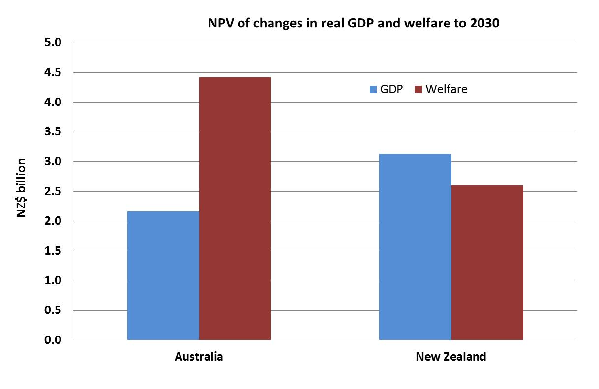
Source: CIEG-Cubed modelling simulation
Figure 3 shows these results year-by-year between 2012 and 2030. As can be seen, the modelling suggests that both Australia and New Zealand will benefit from MRIC.
Implementation of the MRIC means that the cost of capital in Australia sourced from New Zealand and the cost of capital in New Zealand sourced from Australia will get cheaper. This is beneficial for GDP in both countries as one of the factors of production is now cheaper, which leads to an increase in GDP in both Australia and New Zealand. The GDP growth leads to higher after tax household income and therefore increases household consumption.
After reaching GDP peaks in 2019 for Australia and 2022 for New Zealand, GDP begins to fall back to baseline levels. This largely reflects what is happening on the investment front (see below).
Figure 3Economic activity and welfare impacts
% deviation from baseline
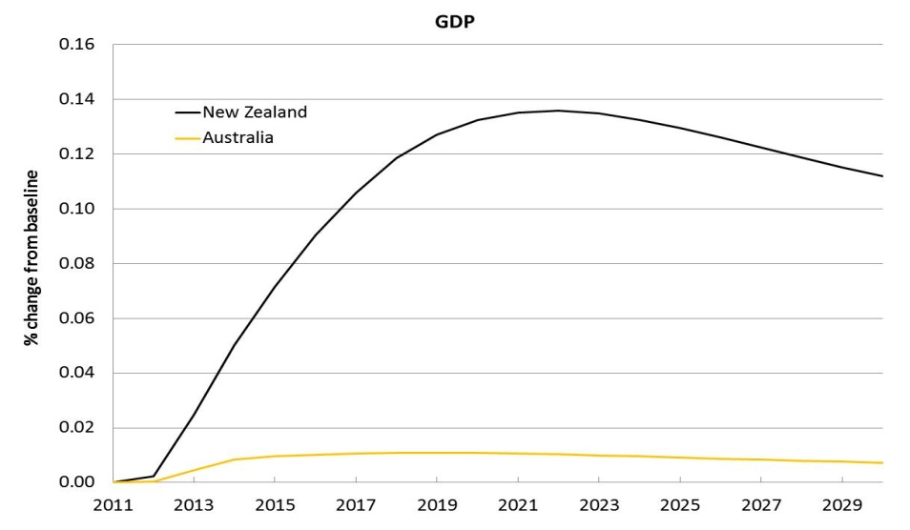
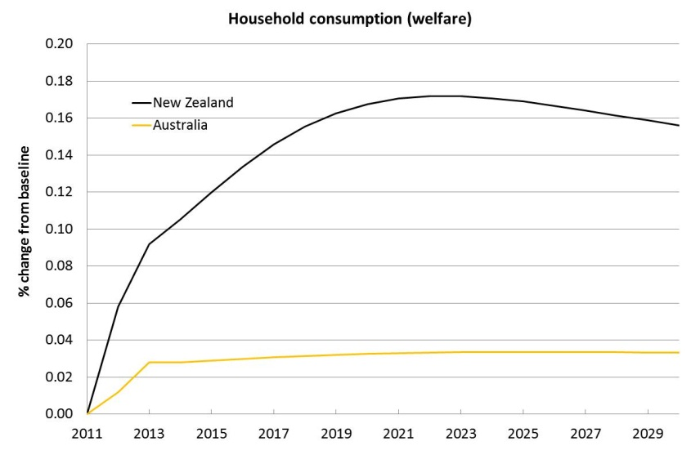
Source: CIEG-Cubed modelling simulation
This difference in impacts between the economies is not surprising. Australia accounts for around 64 per cent of foreign direct equity investment in New Zealand, while New Zealand accounts for less than 1 per cent of foreign direct equity investment in Australia. As the direct equity being affected by MRIC is larger in New Zealand than in Australia, we would expect the economic impacts on the New Zealand economy to be many times the impact on the Australian economy.
Of the two impacts from MRIC we have discussed (cost of capital and increased household disposable income due to tax cuts), the contribution of the cost of capital impact is higher over the period when the boost in consumption is at its peak. For instance, of the increase in consumption in New Zealand in 2022 of 0.172 per cent, 0.088 per cent was due to the cost of capital effect and 0.084 per cent was due to the overall tax cut effect. In other words, the cost of capital effect accounts for slightly more than half of the consumption increase. The contribution gradually tapers down thereafter.
A somewhat different pattern prevails in Australia where the cost of capital effect contribution to the increase in consumption is negligible. The main factor accounting for the difference in impact on consumption between the two countries is the existing large size of Australian investment in New Zealand compared to New Zealand investment in Australia.This means that considering the impacts of the tax cut on FDI in isolation, increased Australian consumption arising from increased New Zealand investment is substantially smaller than increased New Zealand consumption arising from additional Australian investment.

Savings and investment
Compared to the baseline, MRIC is estimated to see an increase in both savings and investment for New Zealand and Australia though the magnitude of Australia’s gains are smaller (see Figure 4 overleaf).
Savings are higher in New Zealand due to the need to fund greater investment in Australia (see below; brought about by New Zealand capital in Australia now earning a higher rate of return under MRIC). Initially, savings cannot increase by the required amount to fund the outward investment in Australia, so there is a redirection of savings invested domestically to those savings being invested in Australia.
The shortfall between domestic savings and investment in New Zealand is met by increased foreign investment. Over time households adjust their savings/consumption patterns and save more. After 2019 savings in New Zealand begin to return to its baseline level. The increase in investment in New Zealand is driven by cheaper capital sourced from Australia, and a general increase in needed investment arising from greater household disposable income.
Figure 4Savings and investment impacts
% deviation from baseline
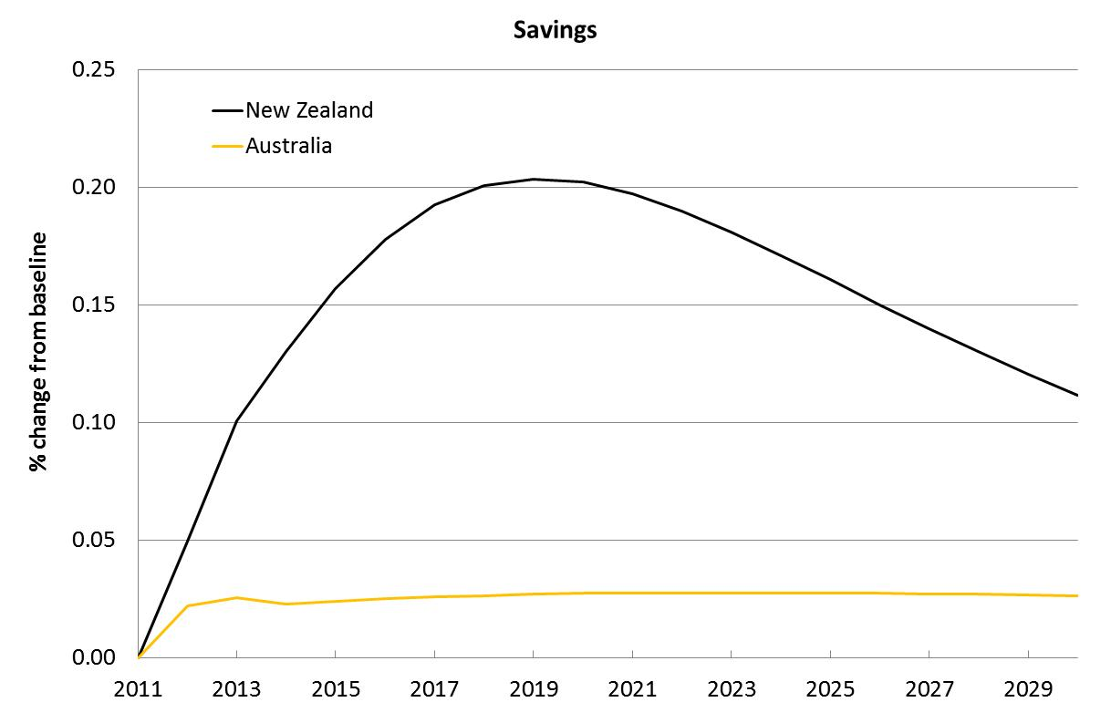
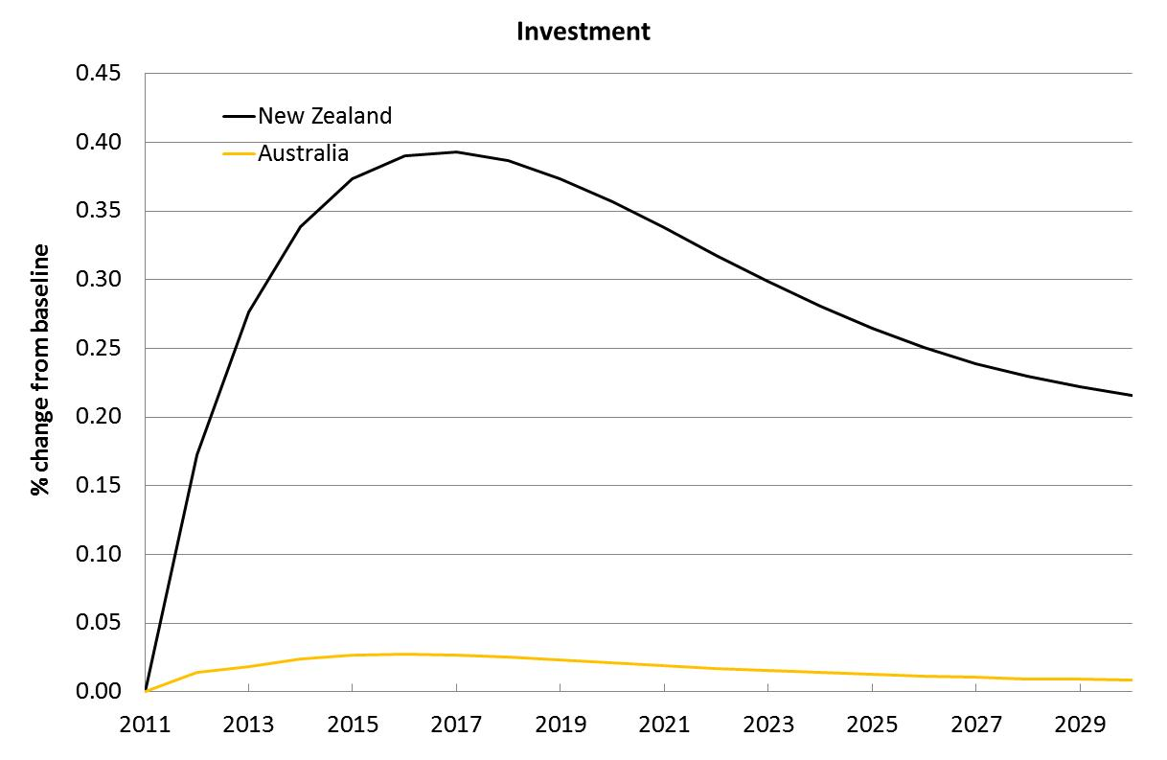
Source: CIEG-Cubed modelling simulation

Foreign investment
Implementation of MRIC is expected to see around a 0.6 per cent increase in total foreign direct investment in New Zealand, but only a negligible change in Australia. However, the bilateral positions are expected to increase, with New Zealand investment in Australia increasing by over 3 per cent while Australian investment in New Zealand is estimated to increase by almost 2 per cent (see Figure 5).
The change in the bilateral position exceeds the changes in total foreign investment from other countries. Though more of Australia’s and New Zealand’s investment is being directed towards each other as a result of implementing MRIC, this does not occur at great expense to Australia’s and New Zealand’s investment in the rest of the world – third country investment diversion impacts are very small.
Figure 5Foreign investment impacts
% deviation from baseline
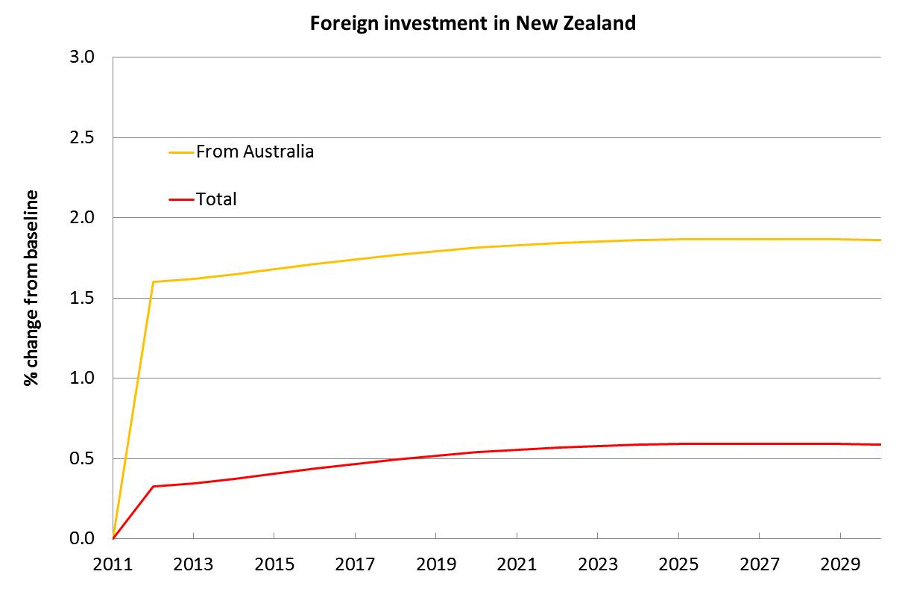
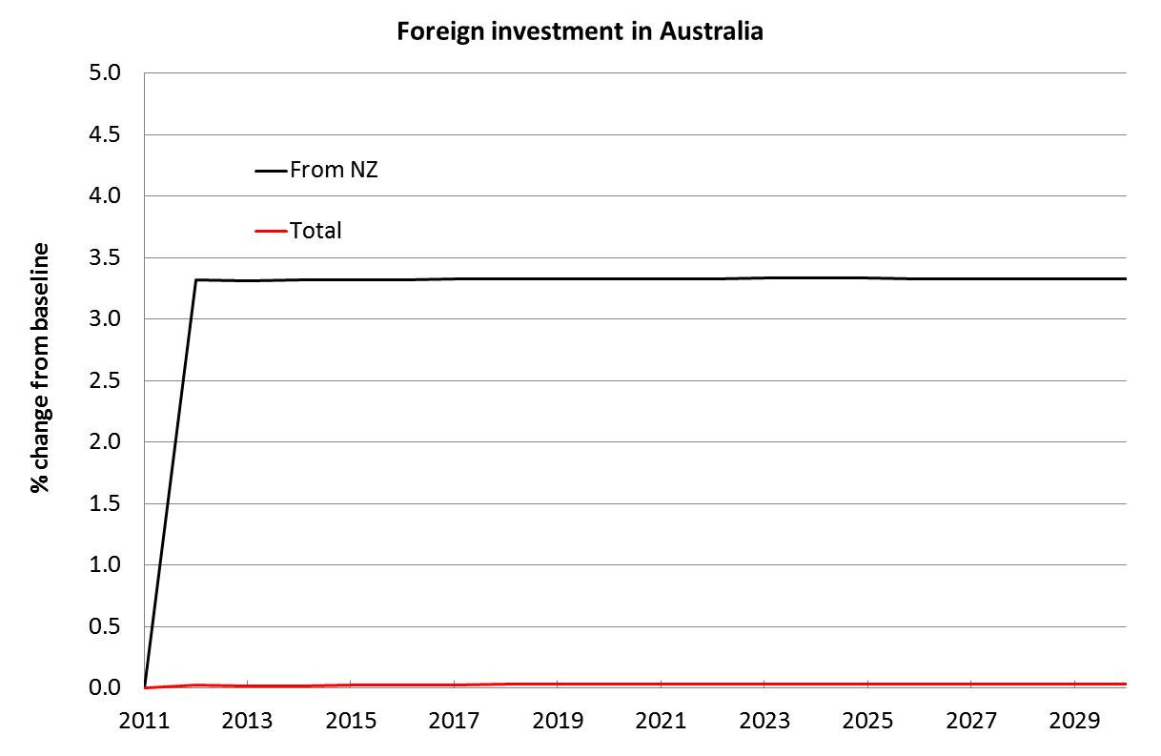
Source: CIEG-Cubed modelling simulation
This is because Australia’s increased investment in New Zealand is initially funded through reduced domestic investment (that is, Australian investment in Australia) but after six to seven years, Australia’s increased investment in New Zealand is funded through an increase in domestic savings in Australia. There is very little redirection of Australian investment towards New Zealand away from the rest of the world.
In New Zealand the response is slightly different. The increased New Zealand investment in Australia is funded primarily through reduced New Zealand local investment. This is maintained over the period of study though the magnitude of this reduction in domestic investment diminishes over time. As a result, New Zealand’s investment in the rest of the world does not notably change.
We note that the change in New Zealand investment in Australia looks constant because of the relative insignificance of second round impacts (i.e. ‘multiplier’ type effects arising from additional GDP growth following the initial increase in investment). The first round foreign investment impacts of the tax credits will, by the nature of the modelling assumptions, show up as a constant shock. However, if second order effects are important (as they are in the case of Australian investment in New Zealand), this exogenous increase will be dominated by the second order impacts, resulting in less constant increases over time. This is the case with the pattern of increases in Australian investment in New Zealand. Second order impacts dominate the initial constant first order impacts more because of the size of Australian investment in New Zealand.

Sensitivity analysis
As discussed previously, there are two potential areas of uncertainty in our modelling scenarios.
The first relates to the share of Australian investment in New Zealand that is attributable to superannuation funds. Superannuation funds enjoy a concessional tax rate of 15 per cent on earnings, so the higher the share of Australian superannuation funds in New Zealand investment, the lower the currently applicable weighted average income tax rate on Australian investments.
While we are reasonably confident that our estimate of 20 per cent is a good one and it is consistent with Australian Taxation Office statistics, we have tested our estimate by modelling scenarios where the share of Australian superannuation fund investment in New Zealand are 10 per cent and 30 per cent.
The second area of uncertainty relates to the distribution of profits by Australian (New Zealand) companies invested in by New Zealand (Australian) investors. For our central scenario we assumed a 50 per cent distribution of profits as dividends based on the (approximate) midpoint of New Zealand Inland Revenue’s view. We have tested this estimate by modelling scenarios for 25 per cent and 75 per cent distribution.
In addition we also test the impact of changing our assumption regarding the use of an increase in the direct tax on households to fund the revenue shortfall from the MRIC by modelling a scenario where the revenue shortfall is made up for by increasing indirect taxes.
In total this gives rise to six scenarios including the central scenario:
- Central scenario – 20 per cent Australian super fund share of Australian investment in New Zealand and 50 per cent profit distribution by Australian and New Zealand companies
- Super fund variation 1 – 10 per cent Australian super fund share of Australian investment in New Zealand and 50 per cent profit distribution by Australian and New Zealand companies
- Super fund variation 2 - 30 per cent Australian super fund share of Australian investment in New Zealand and 50 per cent profit distribution by Australian and New Zealand companies
- Profit distribution variation 1 – 20 per cent Australian super fund share of Australian investment in New Zealand and 25 per cent profit distribution by Australian and New Zealand companies
- Profit distribution variation 2 - 20 per cent Australian super fund share of Australian investment in New Zealand and 75 per cent profit distribution by Australian and New Zealand companies
- Revenue variation 1— 20 per cent Australian super fund share of Australian investment in New Zealand, 50 per cent profit distribution by Australian and New Zealand companies, revenue shortfall funded by increasing indirect taxes.
Below we set out our results for each country from the central scenario compared with the results for each sensitivity simulation.
The results for the central scenario are in bold. As can be seen, changing assumptions about the extent of Australian super fund investment in New Zealand and the degree of profit distribution by Australian and New Zealand companies does not change the overall story — economic modelling suggests that MRIC is beneficial for both countries.
In levels terms, an additional 0.01% of GDP in Australia in 2016 is worth around A$111 million in today’s currency. The 0.09% increase in New Zealand in 2016 is worth around NZ$168 million.
Table 6Increase in real GDP above baseline under changed assumptions
Scenario | 2016 | 2021 | 2026
 | % change | % change | % change
20% share of Australian super fund investment in New Zealand, 50% profit distribution
Australia | 0.01 | 0.01 | 0.01
New Zealand | 0.09 | 0.14 | 0.13
10% share of Australian super fund investment in New Zealand, 50% profit distribution
Australia | 0.01 | 0.01 | 0.01
New Zealand | 0.09 | 0.13 | 0.12
30% share of Australian super fund investment in New Zealand, 50% profit distribution
Australia | 0.01 | 0.01 | 0.01
New Zealand | 0.10 | 0.14 | 0.13
20% share of Australian super fund investment in New Zealand, 25% profit distribution
Australia | 0.01 | 0.01 | 0.01
New Zealand | 0.09 | 0.13 | 0.12
20% share of Australian super fund investment in New Zealand, 75% profit distribution
Australia | 0.02 | 0.02 | 0.01
New Zealand | 0.14 | 0.20 | 0.19
20% share of Australian super fund investment in New Zealand, 50% profit distribution, increase in indirect taxes
Australia | 0.01 | 0.01 | 0.01
New Zealand | 0.09 | 0.13 | 0.12
Source: CIEG-Cubed modelling simulation

The results for the sensitivity simulations are consistent with what we would expect.
A higher share of Australian super fund investment in New Zealand leads to a slightly higher increase in real GDP for Australia and New Zealand (aside from the 2016 New Zealand GDP figure, these increasesare too small to be reflected in the table which only reports percentage increases to two decimal points) with the implementation of MRIC because the concessional 15 per cent tax rate applies to a larger share of Australian investments in New Zealand while a smaller share of Australian super fund investment leads to a slightly smaller increase in real GDP for both countries.
A higher dividend payout rate also leads to a higher increase in real GDP ofAustralia and New Zealand with the implementation of the MRIC because it increases the amount of dividends subject to favourable tax treatment under the MRIC.
Finally, we found that filling the revenue gap by increasing indirect taxes rather than increasing direct taxes on household led to marginally smaller increases in GDP for New Zealand. This result arises because, in comparison with the direct tax on household labour, a broad-based consumption tax effectively taxes the output of both labour and capital. Therefore there is a very subtle change (only detected when our results expressed in terms of percentage change are taken to two decimal points) in the incentive to invest in capital intensive industries. This culminates in a very slight reduction in investment and subsequently slightly lower GDP and consumption.
Of the three kinds of changes explored, changing the rate of profit distributed as dividends appears to have the largest impact on results. For instance, changing the rate of profit distribution to 75 per cent increases the projected real GDP increase in New Zealand in 2026 by 0.06 percentage points (0.19 per cent versus 0.13 per cent in the central scenario). Given the large degree of variation associated with changing the assumed profit distribution parameter, a future avenue of research for the Australian and New Zealand Productivity Commissions could be investigating the most appropriate assumption for the profit distribution rate for Australian and New Zealand companies.

Conclusions
This report has examined the potential costs and benefits to New Zealand and Australia of introducing MRIC. To our knowledge, it is the first attempt at quantitatively estimating the benefits as well as the initial fiscal costs of MRIC.
Our empirical analysis suggests that MRIC would be beneficial for the trans-Tasman economy, and for Australia and New Zealand individually, even after taking into account the initial tax forgone from removing the double taxation of dividend income. These net trans-Tasman gains amount to some NZ$5.3 billionof additional GDP between now and 2030, and around NZ$7.0billion of additional consumer welfare. Any dynamic productivity gains would be in addition to these figures.
These results, alongside the case studies presented, provide support to the conceptual economic arguments that suggest the introduction of MRIC would producenet benefits to both economies – namely that investment would be directed to where is it most economically efficient, rather than most tax-efficient.
Given the statement by both countries’ Prime Ministers that they are committed to taking steps to “stimulate business” and deliver “net trans-Tasman benefits”, the introduction of MRIC would seem to be a sensible way of moving New Zealand and Australia closer to becoming a Single Economic Market.

References
Australian Productivity Commission and New Zealand Productivity Commission. (2012). Strengthening economic relations between Australia and New Zealand. Joint Study Issues Paper, April 2012.
Australia’s Future Tax System. (2010).http://taxreview.treasury.gov.au/content/.aspx?doc=html/consultation_research.htm
Dunbar, D. (2005).’ Trans-Tasman Tax Reform: The Real Story’. eJournal of Tax Research, vol 3 no. 2 pp 170-205.
McKibbin, W. J. and P. J. Wilcoxen. (1999). ‘The theoretical and empirical structure of the G-Cubed model’. Economic Modelling, Vol. 16 (1), pp.123-148.
New Zealand Ministry of Foreign Affairs and Trade and Chinese Ministry of Commerce. (2004). A joint study report on a Free Trade Agreement between China and New Zealand.http://www.mfat.govt.nz/downloads/trade-agreement/china/chinanzftastudy.pdf
Romer,P.(1994).‘New goods, old theory, and the welfare costs of trade restrictions’. Journal of Development Economics 43 (1994) 5-38 North Holland.
Scrinivasan, S. (2006).‘How do marketing investments benefit brand revenue premiums?’ The A. Gary Anderson School of Management, University of California, Riverside.
Shewan, J. (2008). PricewaterhouseCoopers Australia and New Zealand and other submissions to the review Australia’s Future Tax System. October 2008.
Viner,J.(1950).The Customs Union Issue, Carnegie Endowment for International Peace, New York.

- Developing the modelling shocks
  - Australian investment in New Zealand
Total Australian equity investment in New Zealand in the 2011 financial year was NZ$37.5 billion. This was comprised of NZ$31.9 billion of direct equity investment and NZ$5.6 billion of portfolio equity securities. Note that foreign direct equity investment by Australians in New Zealand dominates portfolio equity investment.
Under the current approach for treating the taxation of dividends received by Australian investors in New Zealand companies, the pool of New Zealand corporate profits from which these dividends are received is taxed twice — once in the applicable company tax rate of 28 per cent in New Zealand and then again in the hands of Australian investors at the applicable marginal personal income tax rate in Australia.
What would change under MRIC is that these Australian investors would be able to claim a credit against their personal income tax liabilities (from the Australian Government) based on the share of the corporate tax already paid (to the New Zealand Government) on the distributed profits they receive.
In order to calculate the revenue loss to the Australian Government from the implementation of the MRIC, we need to firstly estimate the amount of the corporate tax paid to the New Zealand Government on dividends distributed to Australian investors. From this amount, we can identify the aggregate value of imputation credits that would be claimed in Australia by Australian investors in New Zealand companies under MRIC. A similar principle applies to quantifying the revenue loss of the New Zealand Government from MRIC.
The above approach suggests two main steps in estimating the potential revenue loss to the Australian Government from MRIC:
- Firstly we estimate:
- the value of the ‘pool’ of New Zealand corporate profits that is owned by Australian investors
- the amount of corporate tax paid in New Zealand on this pool
- by implication the after (corporate) tax amount of this pool that could be distributed as dividends to Australian shareholders in New Zealand companies.
- We then estimate for different dividend distribution scenarios (100 per cent, 75 per cent, 50 per cent and 25 per cent):
- the aggregate value of personal income tax liabilities that these Australian investors would incur because of the dividends they receive from this pool of New Zealand corporate profits; and
- the value of the imputation (or franking credits) that these Australian investors could claim against their tax liabilities under MRIC.
In the 2011 financial year, NZ$7.7 billion in company tax revenues was collected by the New Zealand Government. This means that total taxable corporate profits in New Zealand for that year were approximately NZ$27.6 billion.
The share of these profits that in effect ‘belong’ to Australian investors and could potentially be distributed to them as dividends depends on the share of New Zealand company equity that is owned by Australians. To calculate this share we divided the value of Australian owned equity in New Zealand ($NZ 37.5 billion) by the estimated total value of equity in New Zealand.,
According to this approach, the total value of the pool of New Zealand corporate profits owned by Australian investors after tax (based on their share of New Zealand equity, which is estimated to be 21 per cent) is approximately NZ$4.2 billion. More details on this calculation are provided inTable 7.
Table 7After tax value of Australian share of New Zealand corporate profits
$NZ millions, 2011
 | Value
Australian share of New Zealand corporate profits | 5,903
Total company tax in New Zealand paid on Aust. share of corporate profits | 1,653
After tax value of Australian share of New Zealand corporate profits | 4,250
Source: Statistics New Zealand, Goldman Sachs, CIE estimates
The precise amount of revenue loss to the Australian government from the implementation of MRIC will depend on how much of this ‘pool’ of $NZ4.2 billion profits will be distributed to Australian investors as dividends (which these investors can then claim franking credits on), and what marginal tax rates these Australian investors are on.
According to New Zealand Inland Revenue (IRD), the distribution of profits is under 70 per cent and may be as low as 20 per cent. The lower the distribution rate, the lower the level of revenue loss. The IRD also notes that a large share of Australian investment in New Zealand companies is by superannuation funds rather than individual investors and the applicable tax rate is therefore the concessional rate of 15 per cent.
It is estimated that the share of Australian investment in New Zealand equities undertaken by Australian superannuation funds is approximately 19 per cent. For simplicity we assume that the share is 20 per cent. This is likely to be an underestimate as it does not take account of the recent proliferation of self-managed superannuation funds which are also subject to the concessional tax rate of 15 per cent.
For simplicity we assume that the remaining 80 per cent of investors who are personal investors will face the top Australian marginal tax rate of 46.5 per cent (the top marginal tax rate includes the Medicare levy of 1.5 per cent).
Based on the above, we derive a weighted average income tax rate faced by Australian investors in New Zealand. Varying the share of Australian investment in New Zealand equities undertaken by Australian superannuation funds will change this weighted average tax rate and therefore change the estimated loss of government revenue. The resulting revenue loss scenarios to the Australian Government based on these different sets of assumptions will form an input into the economic modelling.
As an illustration, revenue loss calculations for the original scenario of a 20 per cent share of Australian investment in New Zealand by Australian superannuation funds is summarised inTable 8. This revenue loss ranges from 0.1 per cent to 0.3 per cent of Australian government taxation revenues.
Table 8 Potential revenue lost by Australian government from MRIC
$NZ millions, 2011
Dividend distribution share scenario | Value
100% distribution | 988
75% distribution | 741
50% distribution | 494
25% distribution | 247
Source: Statistics New Zealand, Goldman Sachs, CIE estimates
By drawing on the data from above, it is possible to calculate the post-tax rate of return to Australian investors from investing in New Zealand equities before and after the implementation of MRIC. This is summarised below for a range of dividend payout rates and applicable marginal income tax rates for the Australian investor.
The results show that there is a consistent and far from negligible increase in the rate of return due to the implementation of MRIC. This is because the avoidance of double taxation of company income received by shareholders in the form of dividends. According to our calculations, the post tax rates of return of Australian investment in New Zealand equity is raised by a constant percentage after the implementation of MRIC.
We note one significant caveat in interpreting these estimates. Because this rate of return is defined as the total post-tax dividend income available to Australian investors as a share of total Australian equity investment, it will depend on dividend payout rates. Thus, if in a particular year, New Zealand companies on average choose to retain a higher share of their earnings, then this will necessarily be reflected in a lower rate of return. However, this does not take into account the possible higher capital gains to those shareholders because of the decision to retain earnings.
Table 9Changes in post-tax returns from Australian investment in New Zealand under status quo and MRIC

Equity ownership and dividend distribution scenario | Current rate of return, % | Rate of return under MRIC, %
10% super fund, 90% personal investor
100% distribution | 6.4 | 8.9
75% distribution | 4.8 | 6.7
50% distribution | 3.2 | 4.5
25% distribution | 1.6 | 2.2
20% super fund, 80% personal investor
100% distribution | 6.8 | 9.4
75% distribution | 5.1 | 7.1
50% distribution | 3.4 | 4.7
25% distribution | 1.7 | 2.4
30% super fund, 70% personal investor
100% distribution | 7.1 | 9.9
75% distribution | 5.4 | 7.4
50% distribution | 3.6 | 5.0
25% distribution | 1.8 | 2.5
Source: CIE estimates
  - New Zealand investment in Australia
The value of total New Zealand equity investment in Australia in 2011 was approximately NZ$20.8 billion. This was comprised of NZ$4.8 billion of direct equity investment and NZ$16 billion of portfolio equity investment. Note that this pattern of investment differs from Australia’s where direct investment dominates portfolio investment.
In order to estimate the potential revenue loss to the New Zealand government from the implementation of the MRIC, we adopted the same approach that was used in estimating the Australian government’s revenue loss.
Firstly we calculated New Zealand’s share of equity investment in Australia and total Australian corporate profits, which then allowed us to estimate the value of the ‘after (corporate) tax’ value of this pool that could potentially be distributed as dividends to New Zealand shareholders. We estimated that NZ$1.5 billion of Australian corporate profits is owned by New Zealand investors based on their share of total Australian equity investments., After corporate tax, the value of this pool is NZ$1.09 billion which could be potentially distributed back to New Zealand shareholders as dividends. Our calculations are summarised in the table below.
Table 10After tax value of New Zealand share of Australian corporate profits
$NZ millions, 2011
 | Value
New Zealand share of Australian corporate profits | 1 552
Total company tax in Australia paid on New Zealand share of corporate profits | 466
After tax value of New Zealand share of Australian corporate profits | 1 087
Source: ABS
As was the case when estimating revenue loss to the Australian government, the precise amount of revenue loss to the New Zealand government from the implementation of MRIC will depend on how much of this ‘pool’ of NZ$1.09 billion profits is distributed to New Zealand investors as dividends which these investors can then claim franking credits on, as well as what marginal tax rates these New Zealand investors are on.
For simplicity we assume that the applicable personal income tax rate for New Zealand investors in Australia is the top marginal rate of 33 per cent. In the table below we set out estimates of possible revenue lost by the New Zealand government (based on 2011 revenues) if MRIC were implemented for a range of possible distribution scenarios under this 33 per cent rate. This revenue loss ranges from 0.2 per cent to 0.6 per cent of New Zealand government taxation revenues.
Table 11Potential revenue lost by NZ government from MRIC
$NZ millions, 2011
Dividend distribution share scenario | Value
100% distribution | 312
75% distribution | 234
50% distribution | 156
25% distribution | 78
Source: CIE estimates
By drawing on the data from above, we are also able to calculate the post-tax rate of return to New Zealand investors from investing in Australian equities before and after the implementation of MRIC.
Because this rate of return is estimated as the total post-tax dividend income available to New Zealand investors as a share of total Australian equity investment, it will of course be dependent on dividend payout rates. This is summarised below for a range of dividend payout rates and applicable marginal income tax rates for the New Zealand investor. As was the case for our analysis of Australian investments in New Zealand, similar caveats apply regarding the interpretation of these rates of return which do not account for possible future capital gains to investors from a higher rate of retained earnings.
Table 12Changes in post-tax returns from NZ investment in Australia under status quo and MRIC

Dividend distribution scenario | Current rate of return, % | Rate of return under MRIC, %
33% tax rate
100% distribution | 3.5 | 5.0
75% distribution | 2.6 | 3.8
50% distribution | 1.8 | 2.5
25% distribution | 0.9 | 1.3
Source: CIE estimates

- Tax burden considerations
For simplicity, we do not assume any differences in the tax burdens associated with collecting the three key taxes considered in this report (taxes on trans-Tasman investment income, indirect broad based consumption taxes and direct taxes on households).
The table below, which is reproduced from the KPMG Econtech study commissioned as part of the Henry Tax Review, shows, there is an extraordinary range in the marginal excess burden (MEB) imposed by various Australian taxes. The MEB of a tax represents the economic harm from a small increase in that tax, estimated in terms of the cents lost per dollar of additional revenue collected.
Table 13Marginal excess burdens of Australian taxes
Cents of consumer welfare per dollar of revenue
Tax | MEB
Tobacco excise | -8
Import duties | -3
Petroleum resource rent tax | 0
Municipal rates | 2
GST | 8
Land taxes | 8
Alcohol excises and WET | 9
Fuel taxes | 15
Stamp duties other than real property | 18
Luxury car tax | 20
Labour income tax | 24
Conveyancing stamp duties | 34
Motor vehicle registration | 37
Motor vehicle stamp duties | 38
Corporate income tax | 40
Payroll tax | 41
Insurance taxes | 67
Royalties and crude oil excise | 70
Gambling taxes | 92
Source: KPMG Econtech 2010, CGE Analysis of the current Australian tax system
The KPMG study did not calculate values specifically for the taxation of foreign investment income so we are unable to examine how the ‘tariff’ on trans-Tasman investment compares to direct or indirect household taxes in terms of MEB.
However, given that we have assumed revenue neutrality in implementing the MRIC either through an increase in direct or indirect tax, the MEB figures are important insofar as:
- If the taxation of foreign investment income has a higher MEB than either of the replacement taxes used, then the revenue lost from the rate cut in foreign investment income tax can be recouped with a lower than equivalent tax collection effort from these taxes; or
- If the taxation of foreign investment income has a lower MEB than either tax, then the revenue lost from the rate cut in foreign investment income tax will need to be recouped with a higher than equivalent tax collection effort from these taxes.
This means that if the taxation of foreign investment has a higher MEB than either of the replacement taxes, then the magnitude of welfare and economic gains from moving to MRIC will be higher than we have estimated. If on the other hand the taxation of foreign investment has a lower MEB than either of the replacement taxes, then the magnitude of welfare and economic gains from moving to MRIC will be lower than we have estimated.

If both governments were in a position of fiscal surplus – as they are expected to be within a few years – they would have more options available to them regarding tax cuts and spending.
See http://www.wto.org/english/tratop_e/tpr_e/tp44_e.htm
This is despite the signing of the Investment Protocol to the New Zealand Australia Closer Economic Relations Trade Agreement in 2011. This Protocol focused on lifting the screening thresholds on bilateral investment in business assets and improving investor certainty about access to and transfers of investment funds.
Notably Australia’s Future Tax System (2010) (otherwise known as the Henry Report), Dunbar (2005) and Shewan (2008).
http://www.beehive.govt.nz/release/joint-statement-prime-ministers-rudd-and-key
The tariff comparison is not completely analogous though. Theory suggests that the unilateral removal of a tariff is generally beneficial for the home country, even if other countries maintain their tariffs. The unilateral recognition of franking credits, however, is not. It would encourage offshore investment displacing domestic investment without any reciprocal benefit. This would tend to lower national income.
It could be argued that implementing mutual recognition might be more effective as part of a wider set of trans-Tasman business harmonisation initiatives. While we do not disagree with this view, it is outside the scope of this report to look at any of these broader packages.
Australia’s Future Tax System (2010) – known from here on as the Henry Review. http://www.taxreview.treasury.gov.au/Content/Content.aspx?doc=html/home.htm “Dividend imputation continues to provide benefits such as neutrality around financing and entity choices. It also enhances the integrity of the tax system by reducing the benefits of minimising company income tax. These benefits mean that dividend imputation should be maintained in the short to medium term” (p.42)
Our analysis focuses solely on addressing the problem of double taxation of dividends. We acknowledge that there is a suite of alternative policy settings that could be envisaged under the broad heading of ‘business harmonisation’.
For example, European Court of Justice rulings have led to the abandonment of the imputation systems in Europe. The rulings essentially concluded that existing imputation systems were discriminatory and contrary to encouraging the free flow of capital in the EU.
Conceptually one could also consider a different ‘factual’ that aimed to quantify the costs and benefits of a fully harmonised trans-Tasman business environment, and compare these results to those for mutual recognition only. However, given the time and resources available, this was not feasible for this research. In addition, it is difficult to speculate on what full harmonisation might look like.
In keeping with the sentiment of the Joint Prime Ministers’ statement shown in section 1, our cost benefit analysis focuses on the impacts on Australia and New Zealand and we do not analyse these third country investment diversion effects in any great detail.
See Appendix A for details of calculations.
This distribution proportion is an important determinant of the initial tax impacts. However, there is little data available to verify with any certainty what a suitable share is for our modelling scenarios. Based on advice from New Zealand Inland Revenue, we are of the view that 50% seems a reasonable central assumption, and we conduct sensitivity analysis around this value in the modelling section.
We assume that all distributed dividends go to shareholders living in Australia and New Zealand. To the extent that some shares are held by non-resident Australian and New Zealand shareholders, these mutual recognition agreement fiscal costs (and the concomitant benefits) may be somewhat overstated. However, we have no official data on non-resident shareholders to adjust our estimates with. Note that the sensitivity analysis around the distribution proportion considers a lower tax forgone scenario.
See page 7 of the Australian and New Zealand Productivity Commissions’ Joint Study Issues Paper for a list of outstanding issues.
A point on nomenclature: the CIE-GCubed model is ‘dynamic’ in that it looks at how the economy changes over time and incorporates forward-looking investment expectations. However we have chosen not to explicitly build into the scenarios ‘dynamic productivity gains’ from investment liberalisation.
For a technical overview of the basic G-Cubed model structure, see McKibbin and Wilcoxen (1999). Note that the CIEG-Cubed model has undergone a series of improvements since this basic model was developed, including to its treatment of investment flows. Further details are available from CIE.
In an ideal and non-resource constrained world, this type of analysis would employ a detailed global tax model that links micro-level tax policy settings to the real economy in a dynamic general equilibrium framework (i.e. captures links between households, government, firms and the global economy, over time). However, we are not aware of such a model and believe that CIEG-Cubed is the best approximation currently available.
Recall that we also assume that all shareholders are residents.
In practice, dividend distribution rates may change as a result of mutual recognition but exactly how is uncertain. Inland Revenue has suggested possible payout ratios of between 20 and 70 per cent. For simplicity, we assume in our base case a constant 50 per cent payout rate for companies in both countries.
We do not explicitly examine the relative ease with which these different taxes are able to be collected. However, we acknowledge that there are likely to be differences. See Appendix B for further discussion.
A change in taxation method may also have distributional impacts on households. Our focus is on the macroeconomic impacts of MRIC, so we do not analyse any such effects.
The revenue gap could also be addressed through raising other taxes, such as company tax. In order to limit the number of possible modelling simulations, we have had to limit the number of possible ‘revenue gap filling’ scenarios modelled. As it is households that are thought to (ultimately) benefit from MRIC, it was considered that an increase in direct taxes on households to address the taxation revenue gap was most appropriate and hence used in the central modelling simulation.
Extending the analysis out past this date would have very little impact on the overall results from a Net Present Value perspective.
Staying with our tariff analogy, it could be argued that MRIC might be phased in gradually, as occurs with WTO or FTA tariff reductions in sensitive sectors where domestic firms need time to adjust their production methods in response to increased competition from foreign firms. However, it is difficult to see how this would work in practice and is unlikely to make sense from an administrative perspective – the tax regimes would need to be adjusting their guidance to firms every year, which would likely cause confusion and high compliance costs.
By definition, MRIC will not apply to total Australian investment in New Zealand and total New Zealand direct investment in Australia that is not equity based (most notably, this includes investment in the form of debt financing). For instance, only 62 per cent of Australian direct investment in New Zealand is equity based so only this 62 per cent will be subject to the tax-reducing impact of the MRIC. Any potential growth benefits to firms from using more equity instead of debt as a result of MRIC are not captured by our modelling. Another factor which is not addressed in the modelling is what happens if all profits are not distributed as dividends. The effect of profit retention in the long run would be to increase the value of shares in the businesses being invested in, which would mean higher capital gains for owners who sell these shares. However this impact is not captured by our model.
We recognise that the New Zealand Treasury recommends using a real discount rate of 8% for its CBA and that there is an ongoing debate regarding what the most appropriate level should be. Using an 8% discount rate delivers NPVs of NZ$4.1 billion for GDP and NZ$5.5 billion for welfare.
For instance, under the central scenario, implementation of MRIC is estimated to see the tax on repatriated profits from Australian investment in New Zealand falling by nearly 17 per cent. Hence MRIC will reduce the tax on Australian direct equity investments in New Zealand, with these investment types accounting for around 62 per cent of Australian direct investment in New Zealand (the rest being debt and other financing). Hence on average, the tax on total Australian investment in New Zealand is estimated to be around 10.5 per cent lower under MRIC (given by 17 per cent * 62 per cent).
There is some evidence to suggest that the share might be higher. See for example http://www.rba.gov.au/publications/bulletin/2010/sep/4.html. There may be value in the Joint Productivity Commissions examining this issue in more depth.
As explained in Appendix B, we do not take into account the marginal excess burden of these different taxes. If we had done, given that indirect taxesare generally less ‘harmful’ than direct taxes, the very minor decrease in GDP impacts reported in Table 6 could be reversed.
For both Australia and New Zealand we only consider equity investments as this is the form of investment that is most relevant to the MRIC (which impacts on rates of return from investment which may yield dividend income). Other forms of investments such as debt securities and financial derivatives are excluded from the analysis even though these fall under the definition of foreign investment in both countries.
We note that there are some discrepancies between Australian investment in New Zealand as reported by the Australian Bureau of Statistics and Australian investment in New Zealand as reported by Statistics New Zealand. We have chosen to adopt the investment as reported by the agency in the country where the investment is located. Hence we use Statistics New Zealand data to analyse Australian investment in New Zealand and Australian Bureau of Statistics data to analyse New Zealand investment in Australia.
New Zealand Treasury 2011,Pre-electioneconomic and fiscal update, Table 10.
For convenience we have a assumed a 28 per cent company rate for the entire year, although the 28 per cent rate only came in from 1 April 2011.
Specific data requested from Statistics New Zealand.
Statistics New Zealand does not produce a full set of financial accounts and so data on the total value of New Zealand equity was not directly available. However we were able to extrapolate the total value of New Zealand equity based on (i) the value of foreign equity investment in New Zealand, which has been estimated by Statistics New Zealand and (ii) the share of equity in New Zealand which is foreign owned, estimated by Goldman Sachs (Equity Strategy, 2 September 2011) at approximately 36 per cent. One caveat regarding the estimate of the foreign owned share of equity is that it is only based on portfolio and not direct equity in New Zealand. This calculation resulted in an estimate 21 per cent share of total New Zealand equity owned by Australian investors.
As discussed previously, based on the NZ$7.72 billion figure for company tax revenue collected by the New Zealand government, we were able to estimate the total value of New Zealand profits at almost NZ$27.6 billion. Taking a 21 per cent share (as estimated in the previous footnote) of this figure results in a pre-tax figure of NZ$5.9 billion for the Australian share of New Zealand corporate profits as reported in the table above.
According to data from the Association of Superannuation Funds of Australia, 24 per cent of Australian superannuation assets were allocated to international shares. We assumed that within this 24 per cent, the share of Australian superannuation investment abroad that went to New Zealand was similar to the share of total outward Australian portfolio investment that went to New Zealand. The resulting percentage was applied to the value of total Australian superannuation assets ($A1376.1 billion) to derive the estimated value of Australian superannuation fund investments in New Zealand. This was then used to calculate the share of Australian equity investments in New Zealand that consisted of investments by Australian superannuation funds.
Because the ABS collects a complete set of international financial accounts (ABS 5232.0, Australian National Accounts: Financial Accounts) we were able to use the figure they recorded of total Australian equity rather than deriving our own indirectly as was the case with our estimate of total New Zealand equity. We estimated that the New Zealand share of equity in Australia based on the $NZ20.8 billion figure for New Zealand equity investment in Australia cited earlier was 0.61 per cent.
According to Australian Bureau of Statistics 2011, Taxation revenue, Australiatotal company tax paid in Australia in 2011 was NZ$76.4 billion which means that total company profits in Australia for that year was NZ$254.65 billion. A 0.61 per cent share of this was NZ$1.5 billion.
The figure for New Zealand tax revenue was obtained from the New Zealand Treasury’s Financial Statements of the Government of New Zealand for the year ended 30 June 2011.

