THE EFFECT OF THE CHANGES TO THE TRANS TASMAN TRAVEL
AGREEMENT ON THE PACIFIC ISLAND AND MAORI
COMMUNITIES IN QUEENSLAND

Prepared by Ofa Fukofuka and Shona Doyle

Strengthening Trans Tasman Economics
Submission in response to Discussion Draft

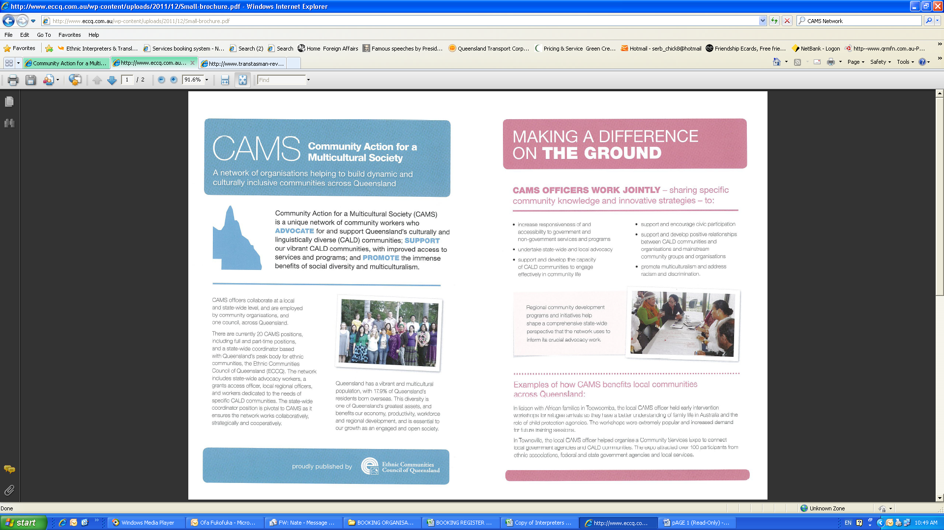


The Effect of the Changes to the Trans Tasman Travel Arrangement (TTTA) in 2001, On Pacific Island and Maori Communities in Queensland

Submission recommendations:
- New Zealanders with non-protected Special Category Visas (SCV), can access HECS-HELP for education and training
- Develop alternative pathway to Australian Permanent Residency (PR) and/or citizenship for long term non –protected SCV residents. These SCV Residents are employed fulltime, pay taxes and Medicare levies, but do not have access to some government services and payments such as unemployment benefit, HECS-HELP and struggle to achieve permanent residency due to circumstances which can be controlled or changed.

The effect of the amendment to the Trans Tasman Travel Arrangement (TTTA) on 26th February 2001, has been a concern for the Pacific Island and Maori communities in Queensland since the changes occurred. In response to this concern MultiLink Community Services Inc. in partnership with The University of Queensland undertook two studies, one for North Queensland in Cairns and Townsville, the other in South East Queensland.
The first study in Northern Queensland (NQ) was to document the experiences, which allowed us to gain insight into the social impact of the 2001 changes to the TTTA on Pacific Islander Migrant families who had settled in this region. There was a specific focus on youth and their families (Taylor, Hewson, Smith & Cowley; 2011), and the project aimed to highlight experiences of social and structural barriers to participation, integration and wellbeing for these families. Specifically, these experiences are closely related to employment, broader community participation, and education and social security benefits.
The second study in South East Queensland (SEQ) was also to illustrate how the Amendment to the TTTA has shaped the experience of Pacific Islander and Maori youth in South East Queensland specifically in the Logan and Gold Coast areas. The study worked within the cultural conception of youth, and to highlight the experiences of eighteen to thirty-year-olds, also focusing on education, employment and community (Andersson, Latta,Leonard,& Stock; 2011).
The methodology used for the research in North Queensland was to collect qualitative data pertaining to participants’ lived experience. This would give an understanding of how the terms of the TTTA impact on the lives of those participants affected. This is referred to as Interpretive Phenomenological Analysis (IPA), which consisted of in depth, semi-structured interviews with community members of significance i.e. families and youth within the Cairns and Townsville areas.

This research documented how the 2001 amendment to the Trans Tasman Travel Agreement has shaped Pacific Islander and Maori youth experiences of community, education and employment in Logan and the Gold Coast. The goal was to provide useful evidence in order to illustrate the impacts of this amendment on Pacific Islander and Maori communities in Australia. Drawing on a qualitative Participatory Action Research approach, this research will use content analysis to evaluate the collected data and make the findings of Pacific Islanders and Maori experiences in Logan and the Gold Coast Regions.

Findings
Overall, the findings from the study in North Queensland (NQ) support the contention that Pacific Island People are disadvantaged by the 2001 changes to the TTTA in a number of areas, these being most significant in housing, education, and employment. Furthermore, it was found that Pacific Islanders coming to Australia via New Zealand post 2001 were often unaware of the 2001 changes, and the subsequent impact. From these findings, a number of recommendations have been developed in an attempt to improve the experiences of Pacific Islander migrants. Similarly the findings of the study in South East Queensland (SEQ) suggest that the Amendment has not sought to encourage equal opportunities in education and employment for the Pacific Islander and Maori community. Youth aspired to become educated, however, the cost of education made this opportunity out of reach. Lower educational opportunities had a flow on affect to the type of employment Pacific Islander and Maori people experienced, whereby limited opportunity for skill development was available. Youth disadvantage is a significant barrier to the community’s socio-economic development and over time may create social and economic costs for Australia.

Education
Cost of Education
The SEQ study found a combination of the high cost of education and financial pressures in the home may result in Pacific Island children prematurely leaving formal education without a graduate certificate. When Family Assistance Benefits expire at the age of 16, youth face pressure to leave school and are encouraged to assist support the family financially. When students remain in school, participants recalled instances of young people working shift work to support their families which negatively affected their performance at school.
In other cases where the child does finish high school, the upfront fees required for tertiary education are not financially achievable for most families, especially those with more than one child. It was mentioned that some youth feel unsuited to the academic environment and feel they could excel in a workplace, however they, unlike Australian youth, are ineligible for Australian Apprenticeship supported placement once they have left school.

Supporting the Aspirations of Young People
Participants felt that the Amendment has negatively shaped the aspirations of Pacific Islander and Maori youth. Even though they initially seek to become skilled and educated, the Amendment reduces their opportunity to achieve these goals due to the huge financial barriers they face. Participants felt that limiting access to education has reduced the opportunity for youth to have purposeful employment experiences. Most youth and parents reported a positive experience of high school. However, high rates of misbehaviour and low attendance rates were attributed to the students feeling frustrated within their high school environment, their social situation and family circumstances.
Educational Resilience in the Community
Despite these barriers, some families are creating alternative pathways to education. Families adopted several strategies in order to maximize their child’s high school experience, for example, the extra assistance and support offered by private schooling. Overcoming the financial obligations of tertiary education is more difficult. There are few scholarships for tertiary education available for Pacific Islander and Maori youth. However, some find a way into university by excelling at sport and receiving scholarships. Some participants chose to move back to New Zealand with their child to attend university.
The NQ study also found that Pacific Island community is impacted dramatically by their inability to access higher education due to associated costs. Under the terms of their visas they must pay fees which are up to three times higher than the domestic equivalent. This lack of access results in high school students becoming disillusioned with their future prospects and some graduates seeking casual work in order to afford higher education. There was evidence of a disparity of educational opportunities for those who had arrived before and those who had arrived after 2001. Those who have arrived before 2001 have been termed “the lucky ones”, indicative of the ease they experience in accessing education. Interview responses indicate that the policy changes have led to frustration and feelings of helplessness amongst those arriving after 2001. It is ironic as many respondents indicated that they had migrated to Australia to access greater educational opportunities.
Multiple participants discussed the effectiveness of the community liaison officer in schools, whose role includes engaging Pacific Islander youth in education. Since the introduction this role, the numbers of secondary school expulsions among Pacific Island males, particularly in one area of Far North Queensland, have been reduced. This shows that given support, Pacific Islanders will choose to be engaged with the education system, and therefore should be encouraged as much as possible in order to meet these desires.
“One example family is one who arrived two years ago with seven children. One parent is working in a factory, the two older boys had finish grade 12 in New Zealand and one had finished a year of IT at Technical College (equivalent to TAFE). However both boys cannot continue their education due to the high costs, so are working in a factory to allow the two sisters to study at TAFE, one doing Hospitality and the other Social Work”.

Employment
Forms of Employment
A recurring theme of the SEQ study was that young Pacific Island and Maori people were working in less-skilled and low wage jobs. Participants described the type of work typically undertaken by youth in these communities as ‘anything we can get’ or ‘survival jobs’ and the most common job mentioned was factory work. One participant explained that:” Many Pacific Islanders work in factories because there are no education possibilities and they are more family oriented, so they do not have the ability to become educated when they have to mainly provide for their family”.
Participants also reported concern that Pacific Island and Maori youth are more likely to be working in physical jobs, with a high risk of injury.

Pathways and barriers to employment

Many participants were concerned that there is a hidden and increasing unemployment rate amongst Pacific Island and Maori people. Employment services have few incentives to offer support to Pacific Island and Maori youth because as Stream 1 job seekers, they recieve a total budget of $80 in comparison to Stream 4 job seekers who have a budget of $8000. The increasing number of youth with no high-school certificate, apprenticeship or tertiary certification was also seen to contribute to growing levels of unemployment in these populations. As English may not be their first language or the language most often spoken in the home, participants mentioned language difficulties in the job interview process, as well as at work. Some participants also felt racially discriminated against in the selection process. However, the community has overcome these barriers to employment to some extent. Many participants referred to the fact that often Pacific Island and Maori youth are able to find employment by using their kinship networks such as family, friends or friends of the family. It is not unusual to find many people in the same family working in the same factory.

The N Q Study also found that the reduction of government support to recently arrived Pacific Islanders is having significant detrimental effects within communities. Pacific Islanders face barriers to employment due to:
- The Terms of the non-protected SCV
- Limited/unrecognised qualifications

Access to training or further education could potentially alleviate this situation, however their visa status disallows participation in government funded programs. These barriers result in people undertaking short-term, seasonal jobs which are sometimes long distances from their home. One example is people moving from areas in Queensland to Broome to gain employment on a pearl farm because of the lack of employment opportunities in North Queensland. This is of particular concern for school leavers. When asked about apprenticeship opportunities for students after school participants stated, “For Cairns, not very good. There are approximately two thousand students competing for the same thing”. Not being able to participate in employment causes a sense of frustration at not achieving within mainstream society, and another stated, “until they can find employment... they’re not able to participate... in the wider community”.

As well as the removal of training opportunities the changes to the TTTA have eliminated the provision of government support or unemployment benefits to those recently settled or looking for work. Health and disability payments are also limited and participants described cases where people have arrived without realising they are not entitled to disability pensions. As reported by respondents this can encourage risky behaviour.

Community Issues
Miscommunication

Many people base their decision to migrate to Australia on potentially inaccurate information from friends and family. In the words of a Maori youth:
“I heard that Australia was easy money and that money grows out of the tree pretty much, but it doesn’t look like it.”
For many participants, there was a tendency to think that opportunities are much better in Australia, as they are unaware of their limited access to services. Some people did not know they were ineligible for a HECS-HELP until they went to apply. Stories such as this one recounted by a mother were repeated by many parents:
“My son was really determined to go to uni, we applied for the fees and that didn’t go through, so we were like okay yep, we couldn’t do anymore cause we didn’t save enough money to send him there cause we were paying half for private school, so we left it at that cause we didn’t think we could get help from anywhere else, so that was it.”
Another lady indicated that her son wanted to go to university to do Social Work but is now working in a factory. The communities also felt that broader Australian society was misinformed about the situation of the Pacific Islander and Maori community. The participants reported that they felt like they were labelled as ‘dole-bludgers’ and a burden on society, even though they are not eligible for unemployment benefits.

Family and community challenges

The Amendment has caused financial strain, identity confusion and inter-generational conflict. Participants reported that people perceived their ‘relative deprivation’ as a fault of their family. Sacrifices made for education and family pressures have had an effect on family relations. Several participants also felt that due to lack of access to social services the Amendment has placed them as ‘second class citizens’. While most people felt accepted into Australian society, some participants mentioned that they felt less sense of community or felt it was difficult to anchor themselves in a community here in Australia compared to New Zealand.
Participants reported that there have been changes in the community since 2001 with increased of incidents of drug use, alcohol, boredom, homelessness, suicide, teen pregnancy and depression, as well as instances of prostitution and anti-social behaviour. Service providers in Logan and Ipswich reported a higher incidence of people from Pacific Island and Maori communities accessing food parcels since the Amendment.

Despite the difficulties the NQ study found that a recurrent theme was the resilience of the Pacific Island community and its capacity to remain “hardy” despite financial challenges. Two factors were identified as contributing to this resilience. The first was internal support networks created by Pacific Islanders themselves. As expressed by participant, “The way in which Pacific Islanders support one another through hardship is both a cultural norm and performed out of mutual respect”. The second was the support provided by various church groups. They have played a significant part in both financially and socially sustaining the community, who build networks and relationships through involvement in the Church. For example one participant, stated his church had financially assisted three people to attend university and seven people to attend TAFE. It must also be noted that all interview participants expressed a concern that the wider Pacific Island community in both Cairns and Townsville experience significant stress associated with assisting new migrants to the community who are not able to financially support themselves. Participants identified the way in which the effects flow into the broader community with one referring to it as, “the domino effect” and the other as a case of , “more arms reaching out and out for support” (See Figure A).
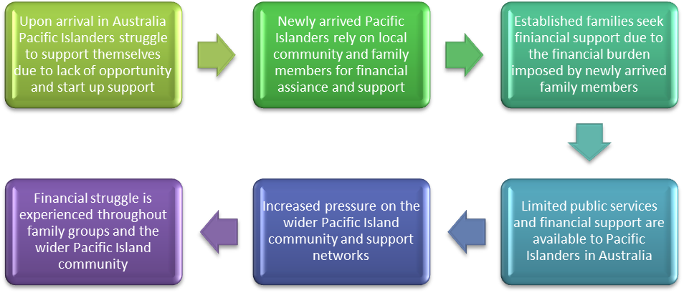
Figure A: The “Domino Effect”
Misrepresented nationality records in official Australian government data are considered to be a significant barrier to dealing with the problems experienced by this community. Most Pacific Islanders enter into Australia as New Zealand citizen: For this reason all government records identify them as New Zealanders. Additionally many Pacific Islanders believed it necessary to describe themselves as ‘New Zealanders’ on the Australian Census and other official documents. It was argued that that such a scenario made this group “hidden by the system” and “invisible to government bodies”.

Conclusion
Based on the findings the impacts of the TTTA have significant flow on effects for Pacific Islanders, contributing to a cycle of disadvantage. Recommendations which may help people to escape this cycle as informed by the participants and analysis by the research team are also shown in Figure C (See below).
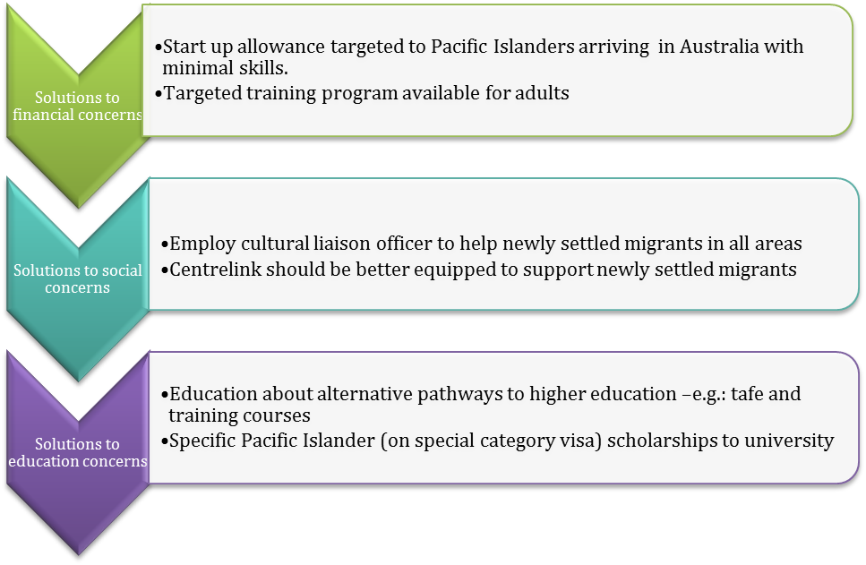
Figure C: Recommendations to solve the ‘Cycle of Disadvantage’

There is a strong desire in the Pacific Islander community to build upon skills and qualifications and in some cases gain higher education, but the costs make it extremely difficult. If the Australian Government were to take initiative and support these students through specially designed training programs, the long term potential benefits and positive outcomes for Queensland and Australia would be far greater than leaving these people to work seasonal jobs, slipping through the cracks of the system, and remaining in a cycle of hardship.

The SEQ study indicates that from the data gathered the findings suggest that the Amendment to the TTTA has had a number of negative impacts on the Pacific Island and Maori population in SE Queensland. The younger generation experience barriers to education, which in turn constrains employment opportunities and exacerbates social problems within families, communities and ultimately broader Australia. The results of this study shows there are disadvantages experienced by Pacific Island and Maori migrating to Australia through the TTTA after February 2001. The results are organized into the following categories; education, employment, community as per our research question. Themes which emerged within the higher order categories are outlined below in italics and appeared as the dominant narratives through the coding process. These themes highlight the multidimensional nature of the Amendments impact.

Discussion

The results indicate that the Amendment has had a detrimental impact on Pacific Island and Maori youth’s experiences of education, employment and community. The results suggest that the high cost of education has constrained opportunities and shaped the employment choices of the Pacific Island and Maori youth in SE Queensland. Furthermore, this has affected family dynamics and exacerbated negative social outcomes in these communities. The Amendment contradicts the aims of the National Agreement for Skills and Workforce Development which states the national imperative that;
“Individuals are assisted to overcome barriers to education, training and employment and are motivated to acquire and utilise new skills” (Council of Australian Governments 2010:4).

Ethnic minority groups are often denied equitable access to informal employment information because they belong to social networks of people of similar backgrounds (Braddock and McPartland 1987; Brown 1995; Harvey 2000) quote Andersson et al. This is particularly salient, given research illustrating 40 percent of businesses use informal networks to recruit employees (Wooden and Harding 1998) quote Andersson et al. In relation to the findings, this could illustrate why constrained employment opportunities are socially reproduced. Children often immigrate with their families at a young age and complete their formative education in Australia. Participants found that formal classroom settings were not always amenable to diverse cognitive styles or learning strategies, and so ‘hands-on’ vocational work was often cited as an attractive career option. Furthermore, participants described the scope of costs imposed with the re-framing of Pacific Islander and Maori as international students. For example, a Diploma program offered at a Brisbane TAFE service would cost $3,128 for a locally supported student, as compared with $16,560 charged to an international student. As one of the participants stated, “and for a Diploma, why would you bother?”

Two key informants reported that Pacific Island and Maori now comprised the majority of young adults presenting at Youth Justice Conferencing Services in the cities of Ipswich and the Gold Coast. Given the multidimensional nature of antisocial and criminal activity, these developments cannot be attributed solely to the impact of the Amendment, however the findings demonstrate that additional pressures placed on families may constrain their ability to adequately respond to these issues. The literature (Dwyer et al. 1990, Alan and Newman 2000, and Aizer 2003) quote Andersson et al supports the anecdotal evidence from participant families that minority groups experiencing financial pressure, often work multiple jobs leaving young people unsupervised who are then more likely to engage in unsafe and antisocial behaviour.
In response to a growing recognition of the issues faced by Pacific Islander and Maori young adults, as a result of the Amendment, State and Local governments at the ‘coalface’ have had to respond through the initiation of local programs, such as employment support. Through the focus groups and interviews there was strong evidence of positive cooperation between communities, political representatives and local Councils. However, given the reliance of State and Local governments on inter-governmental grants, program funding is often regional and periodic. Recently we have seen the withdrawing of State funding for work training which was accessible by youth from Maori and Pacific Island communities.

Recommendation 1:

Enable access to tertiary and vocational skilling pathways.

Participants identified access to higher education as the greatest disadvantage produced by the Amendment. Specifically, participants felt that the government should enable access to HECS-HELP loans for non-protected SCV holders who have lived in Australia for two years. Commonwealth and State Government support should also extend to apprenticeships and vocational training with a focus on individuals who leave their secondary education without a senior certificate. While the overall experiences of the education system are positive, without easing financial burdens on families, any initiatives to promote vocational and higher education will likely experience limitations due to existing socio-economic issues and cultural blocks in the prioritisation of familial needs over individual pursuits.

Recommendation 2:

Equitable pathways to permanent residency and citizenship.

Families who have lived and worked in Australia for a long period of time cannot get permanent residency because their particular skills are not currently prioritised. Participants felt that citizenship would increase a sense of belonging for their communities, but the cost of applying for this was too high. The proposed changes to Permanent Residency and skilled migration, with the introduction of an Expression Of Interest (EOI) process, is welcomed, however this does not necessarily encourage employer-sponsored visas nor does it reduce the financial barriers for low-income earners to have their skills recognised by an assessing authority in line with the Skilled Occupation Lists (SOL). New pathways to permanent residency could be pursued by developing alternative criteria, potentially based on employment, character and length of stay, for non-protected SCV holders or by extending HECS/HELP programs to enable individuals to meet the requirements of the SOLs and sub-class 485 visas.

Recommendation 3:

Increase awareness of the exisiting provisions of the TransTasman Travel Agreement

Providing greater accessibility in terms of information to government agencies, service providers, migration agents, and citizens in New Zealand prior to migration about the services they will and will not receive. Furthermore, an increased awareness about the conditions of the Amendment for those already living in Australia who are affected would enable families to better strategize ahead of potentially dire situations. Further, existing programs to increase the cultural competency of service providers, teachers and police working with Maori and Pacific Islanders is a welcomed initiative, although these are currently sporadic and coordinated by state and local governments. Initiatives to improve the cultural competency of ‘mainstream’ society are critical to achieving a multicultural society.

Recommendation 4.

A Commonwealth review of the 2001 Amendment to the TransTasman Travel Agreement (Cth).

The Commonwealth of Australia should undertake an independent review and evaluation of the Amendment. Specifically, an evaluation should focus social outcomes of the Amendment in the context of national policy objectives and Australia’s obligations to human rights treaties, such as the International Covenant on Economic, Social, and Cultural Rights.

References
Andersson, T., Latta, R., Leonard, J. and Stock, J. (2011). Out of Reach, Out of Sight — Unequal Opportunities Across the Tasman, unpublished report University of Queensland: Brisbane
Taylor L., Hewson G., Smith I., Cowley S.( 2011). Report of the effect of the 2001 Changes to the Trans-Tasman Travel Arrangement on Pacific Islander Immigrants in Townsville and Cairns, unpublished report University of Queensland: Brisbane

