SUBMISSION

FROM

NATIONAL BULK COMMODITIES GROUP INC

TO

PRODUCTIVITY COMMISSION

REGARDING

STRENGTHENING ECONOMIC RELATIONS BETWEEN AUSTRALIA AND NEW ZEALAND

DISCUSSION DRAFT PAPER B: TRANSPORT SERVICES

18 OCTOBER 2012

INDEX

Section Title Page
1.0 Overview 3
2.0 The NBCG 4
3.0 Crew remuneration rates in Australia 4
4.0 The relationship between freight rates and wage remuneration 6
5.0 Consequences of higher freight rates 9
6.0 Conclusion 9
7.0 Addendum “A” List of NBCG members 11

- Overview
1.1 The National Bulk Commodities Group’s (NBCG) comments are in response to the Australian and New Zealand Productivity Commissions’ (Australian Commission and New Zealand Commission) discussion paper entitled “Strengthening Economic Relations between Australia and New Zealand” and, in particular, the Commissions’ Draft Discussion Paper B: Transport Services.
1.2 The focus of the NBCG’s response to the discussion paper will be to identify the impact on dry bulk shippers, receivers and ship operators attributable to the introduction of the Federal Government’s shipping reform package, which came into effect on 1 July 2012.
1.3 Prior to the introduction of Australia’s shipping reform package the NBCG made a number of submissions to government administrations advancing the proposition that the reforms failed the NBCG’s financial analysis. Based on this failure the NBCG sought to have the reforms reviewed by the Australian Commission. Government administrations consulted were:
- The Department of Infrastructure and Transport (DIT)
- The Senate’s Economics Legislation Committee
- The House of Representatives’ Infrastructure and Communications Committee
- Fair Work Australia (FWA).
1.4 The NBCG argues the new 1 July 2012 licensing arrangements, which strengthen the developed of a coastal cabotage regime, lead to:
- Significantly increased freight costs with no productivity offsets
- Enshrining the power of Australian maritime unions through anticompetitive employment practises that have resulted in EBA negotiated wage rates nearly doubling FWA’s listed Seagoing Industry Award Part A rates.
1.5 This submission will comment on Box B.14 (Support for Australian shipping industry) as the NBCG does not endorse the conclusions reached by the quoted sources.
1.6 The NBCG has been unable to cost the productivity improvements agreed to by industry and maritime unions, following the compact agreement, but anecdotally savings appear to be illusionary.
1.7 The NBCG strongly supports:
- A different policy approach to coastal shipping in Australia (and New Zealand)
- A comparative review of impacts that the current Australian and New Zealand approach has on their respective economies and on trans-Tasman trade.

2.0 The NBCG
2.1 The NBCG is the peak national body representing Australia’s bulk commodity shippers and consignees. The aim of NBCG is to represent the collective interests of its members on issues connected with the production, transportation, storage, loading/discharging and shipment of Australia’s dry bulk commodities – both domestically and internationally.
Importantly, the principal focus of the NBCG is the promotion of efficient and quality maritime services that are available to Australian shippers at internationally competitive prices as well as safe, efficient, equitable and consistent national and international regulatory arrangements for shipping. In addition the NBCG promotes adequate and reliable rail and road access to bulk commodity exporting and importing ports, as the Group recognises that such arrangements contribute to logistical efficiency.
Over the past decade Australian Maritime Safety Authority (AMSA) records confirm that dry bulk carriers make up over forty per cent (40%) of all foreign flagged vessels calling at Australian ports.
2.2 Membership of the NBCG is made up of dry bulk industry representatives who control businesses involved in the transportation of dry bulk commodities through:
- Australian licensed vessels
- Foreign flagged permit vessels
- Domestic dry bulk charterers
- Shippers and consignees of international and domestic dry bulk commodities.
3.0 Crew remuneration rates in Australia
3.1 Since 1 July 2012 coastal shipping has been structured through the Federal Government’s new shipping reform package. The package contains the following Bills:
- Coastal Trading (Revitalising Australian Shipping) Bill 2012
- Coastal Trading (Revitalising Australian Shipping) (Consequential Amendments and Transitional Provisions) Bill 2012
- Shipping Registration Amendment (Australian International Shipping Register) Bill 2012
- Shipping Reform (Tax Incentives) Bill 2012
- Tax Laws Amendment (Shipping Reform) Bill 2012.
3.2 The NBCG is not aware of any independent financial evaluation of the Bills. The NBCG has undertaken its own evaluation and the outcome supports the Australian Commission’s statement that the negative impact of the reforms is likely to be material.
3.3 The Navigation Act 1912 permitted foreign flagged vessels crewed by foreign nationals to carrying domestic (dry bulk) cargoes provided the vessel operator sought and was granted permission to do so by the Commonwealth Government. Up until 31 December 2010 the crew were reimbursed under an appropriate International Transport Federation (ITF) Award. Since 1 January 2011, following changes to the modified Fair Work Act crews were paid for the period their ship was deemed to be within Commonwealth waters at Seagoing Industry Award (SIA) Part B rates. Crews employed on Australian registered vessels were reimbursed at SIA Part A rates. Since the introduction of SIA Part A rates in July 2010 seagoing employees have had their remuneration increased (EBA Negotiated Rates) by a factor of approximately 1.7, as a consequence of the Australian maritime unions’ monopoly of labour despite an unprecedented fall in international shipping’s freight / daily hire rates during this period.
3.4 To illustrate the argument made in Para. 3.3 the NBCG has prepared two graphs – the first for a mini dry bulker (less than 10,000 Deadweight Tonnes) with a crew of 12 and the second for a handysize (between 10,000 and 35,000 Deadweight Tonnes) with a crew of 18. The graphs illustrate daily: ITF, SIA Part B, SIA Part A and EBA Negotiated Rates. All rates illustrated were valid on 1 July 2012.

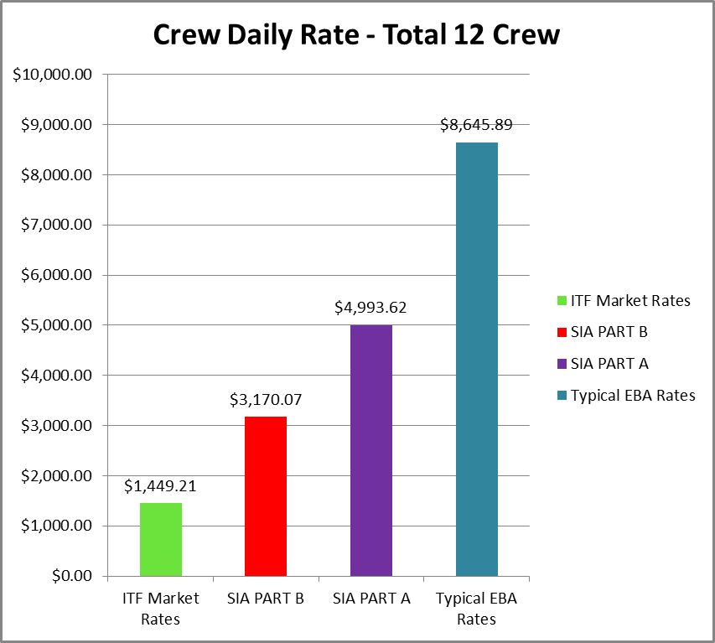

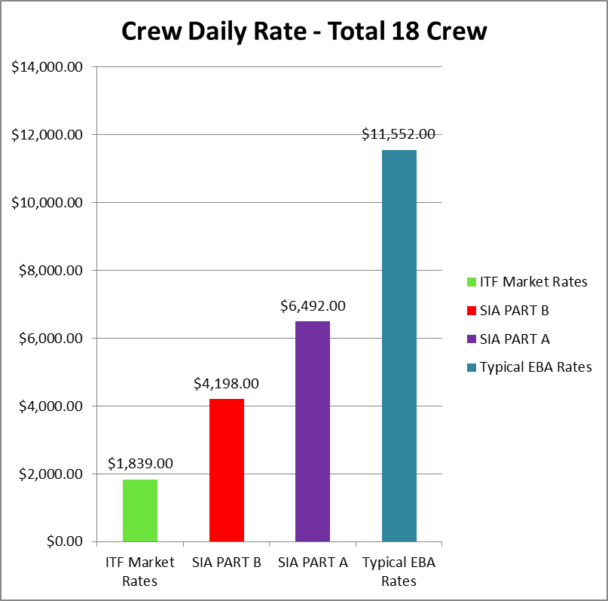

4.0 The relationship between freight rates and wage remuneration
4.1 Australian dry bulk shippers and receivers compete with international suppliers as well as domestic logistic alternatives i.e. road and rail.
4.2 NBCG members are reluctant to provide precise costs as this information is useful to competitors and therefore fall within the “commercial-in-confidence” category. However the NBCG has put together its own financial models, which demonstrates the differential between ITF rates and EBA negotiated rates lead to a freight increase of A$16.38 per tonne for a mini bulker and A$8.74 for a handysize bulker on known voyages.
4.3 The following graphs illustrate the influence crew wages has on operating costs – prior to 31 December 2010 and after 1 July 2012.

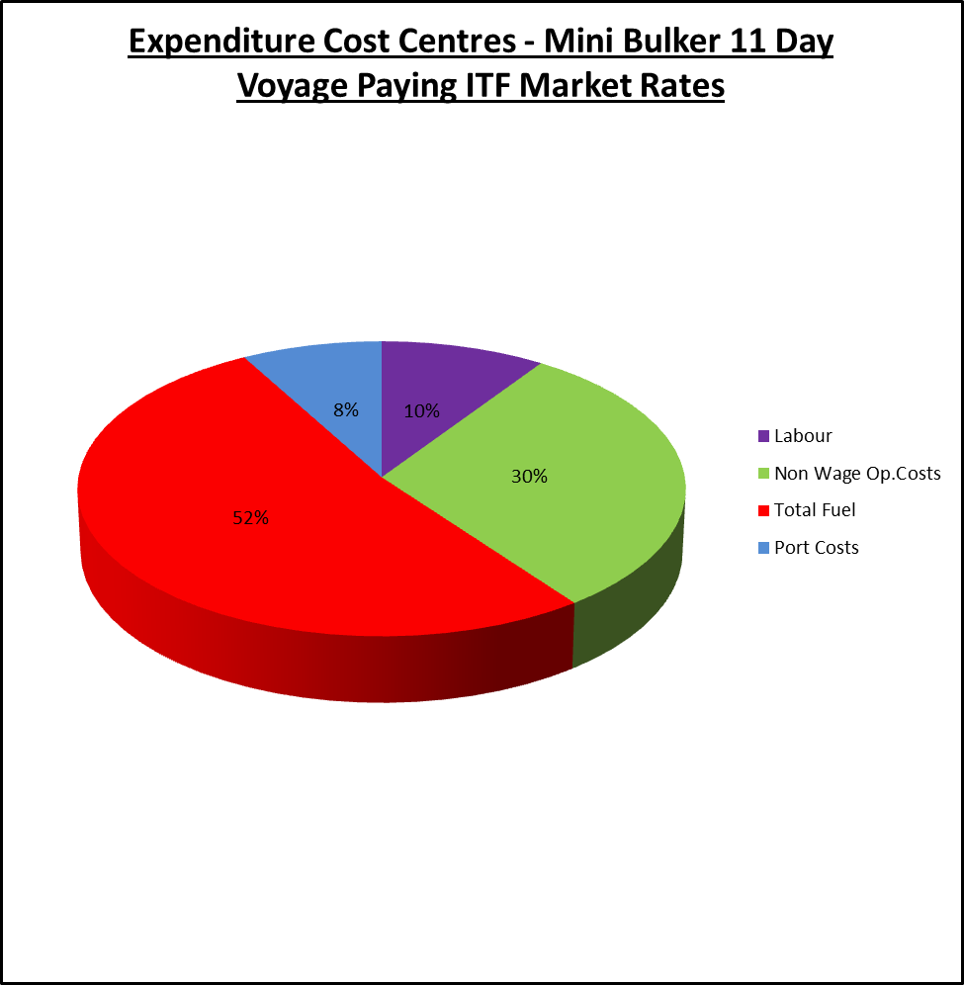

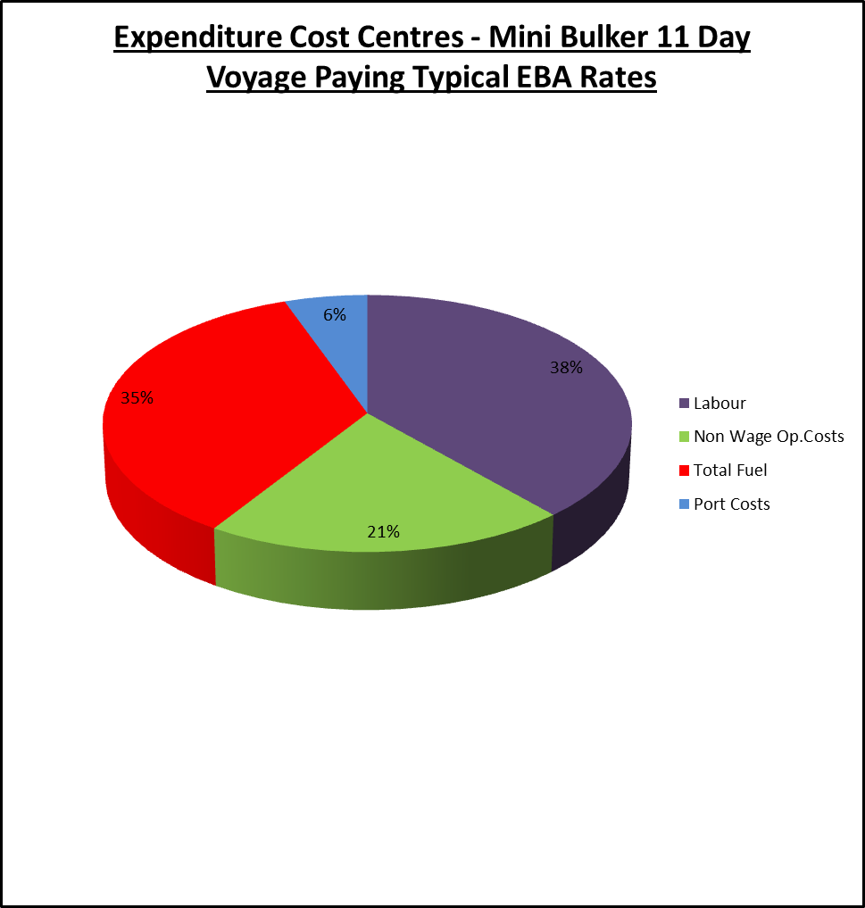

5.0 Consequences of higher freight rates
5.1 When conducting the following benchmarking exercise (Para 5.2) the NBCG used as its reference point a trading “break-even” point, which eliminated the perception of any unreasonable profit margin.
5.2 A number of NBCG members are facing import substitution or domestic transport challenges, which are not apparently understood by Government. The following table illustrates this point (exchange rate USD1.00 = AUD0.98):
Cargo details | Logistics chain | Delivered cost
Soda Ash ex Adelaide | Ship to Newcastle paying ITF wages to crew, road transport to receiver | A$399.13 per tonne
Soda Ash ex Adelaide | Ship to Newcastle paying SIA Part B wages to crew, road transport to receiver | A$402.88 per tonne
Soda Ash ex Adelaide | Ship to Newcastle paying SIA Part A wages to crew, road transport to receiver | A$406.81 per tonne
Soda Ash ex Adelaide | Ship to Newcastle paying EBA negotiated rates to crew, road transport to receiver | A$417.51 per tonne
Soda Ash ex Adelaide | Road transport to receiver | A$405.17 per tonne
Soda Ash ex Portland Oregon | Ship to Newcastle road transport to receiver | A$405.58 per tonne
Table 1 - Source: NBCG
5.3 Table 1 illustrates that the current shipping reform package when applied to dry bulk carriers are unlikely to provide a net public benefit and will eventually result in either import substitution or use of alternative logistic providers.
6.0 Conclusion
6.1 For Australian based dry bulk shippers, receivers and ship owners / operators the shipping reform package will not provide a net public benefit and should be redesigned to ensure the package provides production and investment certainty for manufacturers and ship owners / operators.
6.2 The NBCG supports New Zealand’s removal of cabotage.
6.3 The model the NBCG wishes the Australian Government to adopt with respect to dry bulk shipping is the current passenger ship model where passenger ships carrying domestic passengers on inter-State or intra-State voyages are not required to apply for a temporary licence or pay their crews SIA Part B wages. They are permitted to continue pay their crews contract rates of pay. However the NBCG would agree to pay their crews ITF rates of pay.
6.4 The NBCG questions the validity of the claim that the shipping reform package is necessary for other strategic purposes, as the major Western powers go to international markets to source their shipping requirements during a national emergency.
6.5 Young Australians wishing to acquire maritime skills still have a number of options available to them – including serving time on highly reputable foreign flagged ships.
6.6 The NBCG contends that the Australian International Ship Register (AISR) will lack support, because its cost structure is not competitive for dry bulk shippers and ship operators given the majority of Australia’s dry bulk exports are sold Free-on-Board (FOB), a commercial arrangement which empowers the buyers to nominate a ship or ships. Should an AISR vessel not be able to compete on freight or hire rates with other foreign flagged vessels, then it is difficult to understand why a buyer would charter an AISR vessel. Should a shipper sell Cost and Freight (CF) then the nomination of a vessel would be the shippers’ responsibility and a case could be made to charter an AISR vessel. Such a decision would be made easier if the shipper and ship operator were the same entity. In this case the outcome could be largely policy driven.
6.7 Industry notes it is possible for overseas domiciled ship operators to avoid FWA audits when audits are conducted to ensure SIA Part B wages are being paid to the crew employed on a temporary licensed vessel. FWA auditors conduct audits to ensure Australian based operators of temporary licensed vessels reimburse their crews in accordance with SIA Part B wage scales; however FWA auditors have no power to conduct follow-up audits if the operator is domiciled overseas. Such arrangements provide an overseas operator with an opportunity for a commercial advantage if subsequent wage payments can be adjusted to meet employers / employees contractual obligations.

APPENDIX ‘A’

NATIONAL BULK COMMODITIES GROUP INC

List of Members:
Minerals Council of Australia
Queensland Sugar Limited
CSL Australia
Inco Ships Pty Limited
List of Associate Members:
Australasian Institute of Marine Surveyors
Fertilizer Industry Federation Australia
Gladstone Ports Corporation Limited
Inchcape Shipping Services Pty Ltd
North Queensland Bulk Ports Limited
Pacific Basin Shipping (Australia) Pty Ltd
Penrice Soda Products Pty Ltd
List of Industry Supporters
Cement Industry Federation

