Drive Energy Analysis for 5.5t Delivery Van

The following is an analysis of the energy required by a 5.5t delivery van and is intended to justify the use of a small 650cc engine with variable compression and capacity as part of a hybrid or range extender powertrain for this vehicle. The base vehicle is already configured as a full electric vehicle and thus has a fully spec’d traction motor and energy management system. The new drive system will be a series hybrid, therefore the existing traction motor will provide the required torque to maintain the existing excellent performance levels. The small engine is thus only required to provide average power to either supplement the energy from the batteries or to charge the batteries as determined by the energy management system. Any energy peaks would be provided by the battery/Ultra Capacitor storage system.

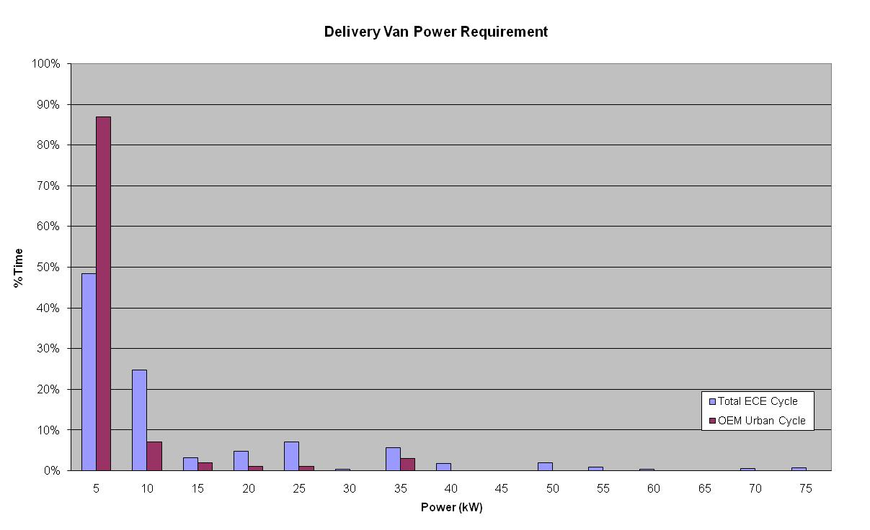
The engine has a maximum power output of 60kW when turbocharged. However the intent is to run the engine typically at a much lower power at a low speed with a high level of boost. This is to ensure that vehicle refinement is not compromised and to match the energy consumption as detailed below. The following is an analysis of the energy requirement for a vehicle of this size over two different drive cycles. The first is the ECE cycle and the second has been created by a major OEM based on real world data from fleet surveys of urban delivery vehicles. The OEM cycle is an urban cycle only with a maximum speed of 90kph with a high number of acceleration periods, whilst the ECE cycle is a more uniform cycle with fewer accelerations but it also includes a 120kpm extra urban element.

Since the vehicle has an electric drive there will be no energy consumption when the vehicle is at rest. Therefore both cycles have been analysed only based on the vehicle being in motion. In addition no consideration has been made for energy recovery during braking etc. The chart below breaks down the power requirement of the two drive cycles into 5kW bands against the percentage of time spent at each power band. For the purposes of this analysis the two cycles have been rationalised into steady state speed periods. The purpose of this is to demonstrate that even for a large vehicle the steady state power requirement is very low. The ECE cycle shows a higher percentage at the higher power settings due mainly to the extra urban element of the drive cycle.

A full energy analysis is shown in the table below. This shows that whilst there is a considerable difference between the two cycles with regard to the split in the energy (steady state vs acceleration) the average power requirement is fairly similar. Furthermore the analysis demonstrates that even for a 5.5t vehicle (the analysis is with the vehicle fully laden) a power output of just 20kW (coupled with an energy storage system to act as a buffer) will be adequate to power the vehicle on an urban delivery cycle.

The calculated energy usage has been compared to the existing vehicle range to verify the data. Based on the OEM cycle the vehicle would have a range of approximately 74miles whilst with the ECE cycle this drops to around 65miles. The existing vehicle has a stated range of between 50 to 100miles depending on load and duty cycle. The analysis is therefore thought to correlate well with actual usage.
 | Cycle
 | ECE | OEM
Cycle Time (vehicle moving) | 887 | 1589 | secs
Total steady state energy | 3.3 | 1.5 | kW.hr
Total accel time | 215 | 839 | secs
Total Accel Energy | 1.2 | 5.7 | kW.hr
Total Cycle Energy | 4.5 | 7.2 | kW.hr
Average Power | 18.2 | 16.1 | kW

