# Australia’s Automotive Manufacturing Industry (by John Lyons)

## *Product engineering rather than vehicle assembly should be supported*

### Synopsis

Product engineering rather than vehicle assembly should be supported. Price competition has forced the multinational automotive manufacturers to separate product engineering, component manufacture and vehicle assembly and to seek optimum locations for each. Australia is cost competitive in product engineering but very uncompetitive in component manufacture and vehicle assembly. Product engineering is where the bulk of well qualified jobs are while component manufacture and vehicle assembly are normally located in countries with minimal education levels.

### The New Global Automotive Manufacturing Strategy

The automotive manufacturing industry consists of three distinct parts:

1. Product engineering (including research and development and testing).
2. Component manufacture.
3. Vehicle assembly.

The multinational automotive companies recognise that to maximise profit, the three parts must be located in countries where the minimum work force educational requirements are met at the minimum cost.

#### Product Engineering

This requires a well-educated work force and is best located in a country with high education levels. A PhD is required for many jobs. This is prestigious work and tends to be located in the company’s country of origin.

#### Component Manufacture

The primary requirement is for a cheap work force. Minimum educational requirements are little more than basic literacy. When the wage levels rise along with the standard of living and education the operation will be relocated to the next location reaching the minimum education levels.

### Vehicle Assembly

The primary requirement is for a cheap work force. Minimum educational requirements are little more than basic literacy. When the wage levels rise along with the standard of living and education the operation will be relocated to the next location reaching the minimum education levels.

### Australia’s Automotive Industry

Australia’s automotive industry grew up in an earlier era of stand-alone capability. Unique, optimised vehicles were designed, components manufactured and vehicles assembled within a single country.

Until fairly recently the Australian industry has been protected by tariffs. Now, with the reduction of the general automotive tariff to 5% and the free trade agreements with Thailand (particularly) and Malaysia, the Australian industry is exposed to the lowest priced component manufacture and vehicle assembly operations in the world. Our component manufacture and vehicle assembly operations are totally uncompetitive. When announcing the 2016 Ford production closure, Bob Graziano said manufacturing in Australia was four times the cost of Asia.

### Do Not Subsidise a Vehicle Assembly Operation

If the Australian government agrees to subsidise an Adelaide style vehicle assembly operation after 2016, that is all it will get. No product engineering. No component manufacture.

More than likely it will be an overseas designed world car assembled from imported components. This is of minimal value to Australia only offering mostly unskilled jobs and no beneficial flow on effects.

There will be no export opportunities because other world markets can be supplied with the same car at less cost from other locations.

Then why and how do the German car companies assemble vehicles in Germany? They do it at a cost penalty because “Made in Germany” is a worthwhile product differentiation (Das Auto etc.). They do it by having all components and modules preassembled in the cheapest locations in the world prior to shipment to Germany for final assembly. In contrast, the French manufactures do not see a similar value of manufacturing in France and apart from top of the range models, assemble their vehicles in low cost locations. (Chiappini , R. 2011, *Offshoring and export performance in the European automotive industry*)

### Subsidise and Support Vehicle Product Engineering

Australian product engineering is cost competitive. The multinational car companies recognise this.

The product engineering of the Ford Ranger / Mazda BT-50, manufactured in Thailand was done by Ford Australia and in August 2013, Ford’s CEO, Alan Mulally said *“We are committing to Australia being one of our product development centres of excellence, where designers and engineers (develop) vehicles and technologies for the world”*.

*“The Toyota Technical Centres have their core R&D Centre in Japan, and full-scale technical and design development facilities in the United States, Europe, Thailand and Australia that operate in a ‘hub’ formation.” “TTC-AU in Melbourne, Australia performs specialised operations and is a key contributor to the development of innovative vehicle designs for Toyota’s global regional markets, while also involved in fine tuning models for the particular needs of Asia and Australia.”* (Toyota website)

Australia has excellent proving grounds (in Victoria) at Lang Lang, You Yangs and at Anglesea. It has temperatures and roads suitable for hot testing during the northern winter and snow during the northern summer. It has roads suitable for all forms of suspension development including 4WD. Australia is a ready-made vehicle development location, able to work alone or in conjunction with northern hemisphere product engineering centres.

Vehicle product engineering offers roles for the best and the brightest in engineering and other fields. Many product engineering jobs require PhDs. Australia has excellent universities and vehicle product engineering has acted as a goal for many aspiring young engineers, whether they ultimately worked in this area or not.

Australian product engineering is cost effective. The only reason vehicle manufacturers may not use Australia for their product engineering is their patriotic desire to keep this work in their home countries. Perhaps only minimal incentives would be required. Subsidies and government contracts are possibly the only available way of rewarding those using Australia.

However, Australia could badge itself as a centre for automotive product engineering and ensure that all obstacles to successful vehicle design and testing are removed if and when they are identified.

### Measuring Product Engineering Activity

The level of product engineering activity of a company is possibly most readily reflected by the number of professional engineers employed. The professional engineers (4 year degree or higher) could be simply counted. Or, a point system designed with points allocated to different qualifications (TAFE Cert through to PhD).

### Preserving Existing Testing Facilities

The pictures below show Holden’s and Ford’s proving grounds, left and right respectively. Both these facilities include performance and calibrated durability (established relationship with field usage) testing surfaces. These pictures are circa 1991 and there have been considerable additional performance testing road surfaces added at the Ford proving ground since. Other additional facilities have been added to both.

These are extremely important assets for Australian vehicle product engineering. If they are lost, the cost to replace them would possibly be too high. They must be preserved.

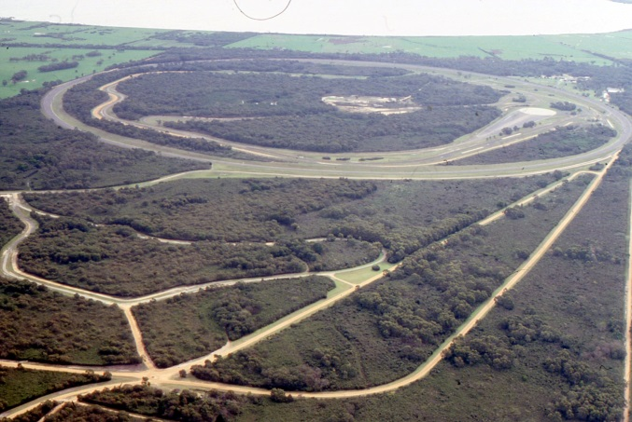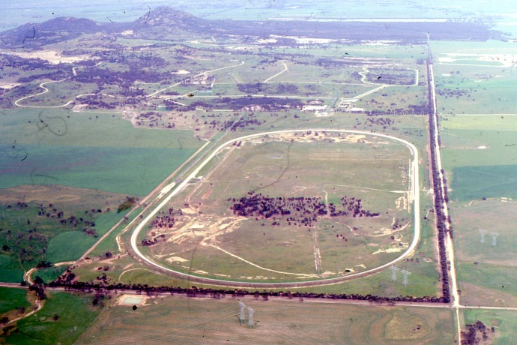

### Author

John Lyons, MEng, MBA, MIEAust, CPEng. (Retired auto industry employee)