Productivity Commission submission 23/11/13

Dear Sirs

I have read the submissions and in particular support the Futuris submission. I would like to make a brief extra couple of comments.

Recently, the productivity commission cited needing to raise the age of pension entitlement to 70 due (according to news reports) the large fiscal deficit impact. In the chart below (chart1.1) you can see the impact of car imports.

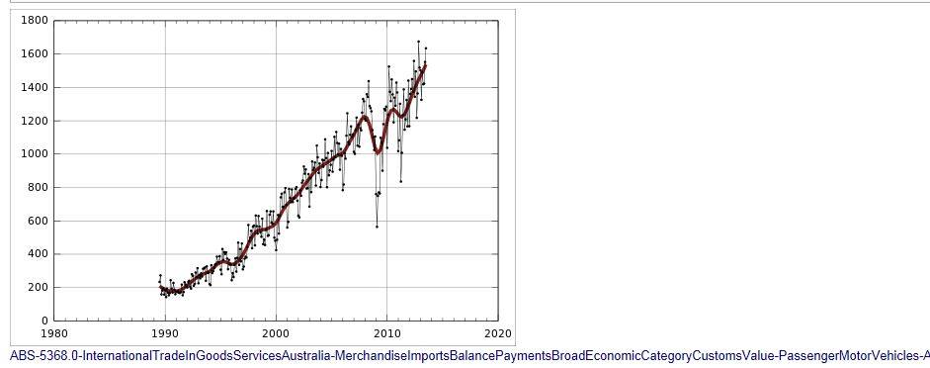

The impact of allowing 100% import of motor vehicles will be even more significant on the Deficit. Yet Australia has the minerals, expertise in build and design to actually produce the majority of motor vehicles in this country and export excess production providing a positive effect on our balance of payments. Both GM and Ford have stated publically that the engineering and design centers are world class.

This impact needs to be considered before assuming that cheap cars are beneficial for Australia.

As commented in the Futuris report the FTAs and other so called global agreements are one sided. The majority of Countries all supports their industry and in fact find mechanisms to successfully encourage Car Manufacturers to manufacture and assemble vehicles in their countries. Even the USA used different forms of encouragement, including political, to encourage the ‘Transplant’ manufacturers from Japan and other countries to set up assembly plants and employ Americans rather than just open the door to so called ‘cheaper’ imports.

Recently in the ‘The Economist’ a report detailed how Brazil has used limiting imports from Mexico as a means to encourage local investment with the reported result that Ford invested heavily in their local operations to increase production and commented, as stated in the report, that they were flexible to changes.

Australia has about the 15th largest market in the world and those with larger markets provide incentives to maintain manufacture and assembly of motor vehicles well knowing to positive effect overall to their economies. In the opinion of the writer it is not what the global car manufacturers want that will protect our car industry, they are happy to import, it is a need for the government to let them know that they will not have open access to our large market without reciprocal employments and production of cars at an acceptable level.

In the 1990s, Holden was considered a jewel in the GM crown for productivity and profit. What has drastically changed now? Many of the so called differentials between countries were still there.

Fundamentally, the writer believes we need a level playing field; the same barriers can be applied to importing countries as they apply to Australian built vehicles. Incentives should be offered for production and design input on new vehicle sizes, as import replacement such as small cars, SUVs and other types with extra incentive if these vehicles are exported.

The writer hopes the PC reviews all other countries policies in an open macro way and makes recommendations on what would be needed for the car industry to grow into a size that enables a positive effect on our balance of payments, employs and trains Australians and generates satisfactory profit for the manufacturers themselves.

Yours Sincerely

David Wylie