



Michael McLean FAICD, FAOQ, JM
Managing Director

PO Box 703 NSW 1710 Australia

Submission to Productivity Commission Review of the Automotive Industry

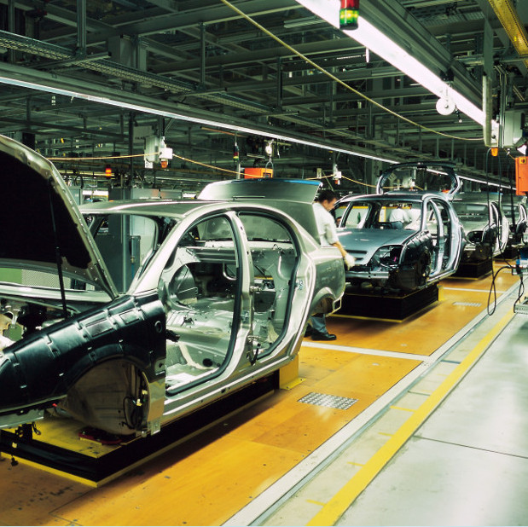 | 
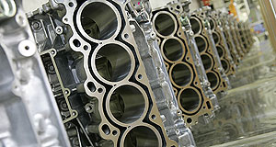 | 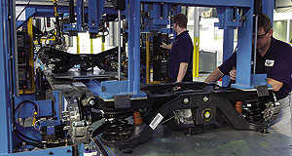

Current State of Australian Auto Sector

Issue | Situation | Guidance
Mix of Australian-made vehicles to new car sales | - Private buyers: An imported car, Mazda 3 dominates as a total value proposition with Holden Cruze #4  - SUV's largest growth with small cars  - Large family sized GMH Commodores, Falcon and Territory not selling to private buyers - Ford leaving Australian manufacturing operations in 2015/16. Territory is crowded market for type and engines; 6 cyl eng not EURO 5 compliant  - Fleet:  - Mazda do not sell into Fleet market  - Holden Commodore major market focus but Camry and Camry hybrid growing sales  - Camry Hybrid has 3 month waiting list for both Fleet and Private Market  - Hyundai targeting Fleet with wide range of petrol and diesel engine models  - Top selling cars by cost (RACQ (2013) drive.com.au  The Australian 16-17/11/2013 page 16 | - With over 73 vehicle makes available to Private and Fleet buyers, Australian-made cars are diminishing in face of better value [function divided by price] of imports  - Fleet buyers are choosing more reliable and lower running cost imported cars  - Taxi industry has started to place more Camry Hybrids into their fleets; Holden Statesman is limo market leader but Chrysler 300C is encroaching on Statesman market share  - Police Highway Patrols currently Commodore V8 based - Holden continues to produce USA bound Police Pursuit Vehicle as a minor export
  Model | Made | 5 yr cost
  Camry | AU | $56.4k
  Commodore | AU | $55.1k
  Mazda 3 | Import | $45.9k
  Cruze | AU | $44.9k
Tri-level Government vehicle purchase / leasing mix between Australian-made and imported vehicles | - Until recently, automotive parts supplier organisation, FAPM and others have advocated the policy for where suitable, tri-level government policies like that of the USA, direct their leasing and or purchases to Australian -made vehicles.  - estimates of such increased Australian-made vehicle sales resulting from this policy vary from 20,000 to 50,000 | - Current Queensland Government has not supported this policy  - VIC and SA support local policy as at 16 Nov 2013 and will endorse such in next COAG meeting  - The USA and UK are demonstrating their in-country made vehicle purchases / leases by their government entities
Employer of Choice impacting Australian-made vehicles sales / leases | Both public and private sector employers have endorsed and actively pursue Employer of Choice ratings which allow the employee to Novate their vehicle lease and hence select for the most part, an imported vehicle | Changing this is problematic as a market intervention and also personal choice. However, USA and UK government taxation and employment incentives have overcome such impediments
Australian vehicle [OEMs] not compete on cost | Göran Roos 16/11/13 - "Australia manufacturing sweet spot is low-volume, high-variability, high precision, M-H complexity and high value-add products ..........that no-one else makes" | B Dunstan - VIC Centre for Advanced Materials Manufacturing - must adapt, develop IP, change mgt focus

Australian supplier development programs and status.

From the OEM programs it can be seen that they have been most supportive of the Tiered Suppliers.

All Automotive Suppliers are at a minim ISO9001: 2008 certified with most now certified the Technical Standard f TS 16949.

For the most part, supplier realise that their 'processes' must be stable, lean and capable of meeting the automotive performance metrics.

The problem lays in suppliers whom have documented their QMS (be it ISO9001 or TS1949) by the heading of the various standards or TS instead of their Business Processes as the standards require.

The reason for this aspects in this PC Review is that now as can be seen by Toyota's requirement for some $3,800 cost reduction from their vehicle and that is to come and requested form the suppliers.

Without a Process Based Quality Management System, the suppliers will not be able to find such cost downs. Secondly, most only have Standard Costing Accounting Systems and not Activity Based therefore any cost reduction efforts will be functionally based and sub-optimal and not process oriented.

The Automotive "Core Tools" from the AIAG USA emphasise Process Management, Control, Assurance and Improvement and GM "Quality Systems Basics" courtesy of Lear USA is linked:
http://www.lear.com/user_area/extranet_files/lear-74-GM_Quality_System_Basics_Overview.pdf

For compliance, GMH and Toyota require their suppliers to conduct the auto industry "Layered Process Audits" http://notasdecalidad.files.wordpress.com/2010/11/gm-1927-36-quality-system-basic-marzo-2009-lpas.pdf. As mentioned, these 'process' requirement is not always possible because the Australian automotive suppliers and their supplier "Quality Plans" are not based upon processes but on the ISO9001 and / or TS16949 standard clauses.

This then is problematic for Australian suppliers. The requirement to not only make cost reductions but also invest in New Product Development through R&D; resourcing Innovative Products, Processes and Practices and embracing new technologies and materials to then be part of a Global Platform for Toyota and GMH is constrained through these structural and management system issues.

Australian Auto Program | Source and findings | Status
ASEA | 2011 report found | Key restrainers from ASEA Supplier participants were:  - Management and Leadership 34%  - Manufacturing and Quality 32%
Toyota | Supplier QA Program utilises South African Supplier Development Program  http://www.gibs.co.za/SiteResources/documents/Toyota%20presentation.pdf | SQA based upon "Price then Delivery and then finally Quality" which is contrary to public documentation and publications citing "Quality, Cost then Delivery"
 | TMCA requires more supplier Cost Reductions.  "the company also made it known that costs per vehicle had to be reduced by an ambitious $3,800. The company needs to make its production costs cheaper to renew an export deal for Camry vehicles with Middle East countries, The Australian reports today.  " | "Cost cutting, including from suppliers, necessary for Toyota Australia's survival 21 November, 2013 Brent Balinski  http://www.manmonthly.com.au/news/cost-cutting-including-from-suppliers-necessary-fo
GM Holden | "Quality Systems Basics"  Trained all its Tier 1 and 2 Suppliers in QSB. Emphasis in AIAG TS16949 QMS and Core Tools.  http://www.lear.com/user_area/extranet_files/lear-74-GM_Quality_System_Basics_Overview.pdf  Use Shainin "Drill Deep and Wide" Problem Solving | Supports ASDCP Federal Government initiative to develop suppliers and seeks external consultancy support for all Controlled Shipping I and II suppliers.  Has also used Federal Government program to support external consultancies to train and correct poor quality suppliers with the training and consulting on Design and Process Failure Mode an Effects Analysis

International research points to supporting automotive and manufacturing sectors

Today, 27 November 2013 a link was obtained to this Author and his views on manufacturing which gaining resonance here and has direct implications and warnings for Australia.

"This Is the Man Bill Gates Thinks You Absolutely Should Be Reading". By Clive Thompson @% November 2013
http://www.wired.com/wiredscience/2013/11/vaclav-smil-wired/?cid=co14941644#!

"Let’s talk about manufacturing. You say a country that stops doing mass manufacturing falls apart. Why?
In every society, manufacturing builds the lower middle class. If you give up manufacturing, you end up with haves and have-nots and you get social polarization. The whole lower middle class sinks.
You also say that manufacturing is crucial to innovation.
Most innovation is not done by research institutes and national laboratories. It comes from manufacturing—from companies that want to extend their product reach, improve their costs, increase their returns. What’s very important is in-house research. Innovation usually arises from somebody taking a product already in production and making it better: better glass, better aluminum, a better chip. Innovation always starts with a product.
Look at LCD screens. Most of the advances are coming from big industrial conglomerates in Korea like Samsung or LG. The only good thing in the US is Gorilla Glass, because it’s Corning, and Corning spends $700 million a year on research.
American companies do still innovate, though. They just outsource the manufacturing. What’s wrong with that?
Look at the crown jewel of Boeing now, the 787 Dreamliner. The plane had so many problems—it was like three years late. And why? Because large parts of it were subcontracted around the world. The 787 is not a plane made in the USA; it’s a plane assembled in the USA. They subcontracted composite materials to Italians and batteries to the Japanese, and the batteries started to burn in-flight. The quality control is not there.
He goes onto IT and prospects for that sector to take up manufacturing and where Australia sees itself as a 'Smart Manufacturer" - it seems not in the USA either.
Can IT jobs replace the lost manufacturing jobs?
No, of course not. These are totally fungible jobs. You could hire people in Russia or Malaysia—and that’s what companies are doing.
Restoring manufacturing would mean training Americans again to build things.
Only two countries have done this well: Germany and Switzerland. They’ve both maintained strong manufacturing sectors and they share a key thing: Kids go into apprentice programs at age 14 or 15. You spend a few years, depending on the skill, and you can make BMWs. And because you started young and learned from the older people, your products can’t be matched in quality. This is where it all starts.
You claim Apple could assemble the iPhone in the US and still make a huge profit.
It’s no secret! Apple has tremendous profit margins. They could easily do everything at home. The iPhone isn’t manufactured in China—it’s assembled in China from parts made in the US, Germany, Japan, Malaysia, South Korea, and so on. The cost there isn’t labor. But laborers must be sufficiently dedicated and skilled to sit on their ass for eight hours and solder little pieces together so they fit perfectly.
But Apple is supposed to be a giant innovator.
Apple! Boy, what a story. No taxes paid, everything made abroad—yet everyone worships them. This new iPhone, there’s nothing new in it. Just a golden color. What the hell, right? When people start playing with color, you know they’re played out.

Lessons for Australian Automotive Sector - work with Australian and International OEMs Global Platform and forefront of the design of systems and modules and out of the price/cost down parts and component producing supply side

As Roland-Berger's 2006 "Strategies for profitable growth in the global automotive supply industry" and other consultancies have conducted research into the automotive sector in various countries (References and links to many others are appended) "Automotive suppliers are under pressure: price reductions and weak volumes are seen as the major challenges"

- http://www.rolandberger.com/media/pdf/Roland_Berger_Global_Automotive_Supplier_Study_20130917.pdf
- http://www.cisco.com/web/about/ac79/docs/wp/ctd/Auto_Trends_WP_FINAL.pdf
- http://www.deloitte.com/assets/Dcom-Kazakhstan/Local%20Assets/Documents/dtt_research_globalautomotive_021203(1).pdf
- http://www-935.ibm.com/services/fr/igs/pdf/automobility-winning-a-different-race.pdf
- http://www.atkearney.com.au/news-media/news-releases/news-release/-/asset_publisher/00OIL7Jc67KL/content/a-t-%C2%A0kearney%E2%80%99s-15th-annual-automotive-study-indicates-u-s-auto-sales-volumes-will-trend-back-to-historical-levels-by-2013/10192

The ILO Switzerland has view too:

- http://www.ilo.org/wcmsp5/groups/public/---ed_dialogue/---sector/documents/meetingdocument/wcms_161510.pdf

Europe too has similar issues to Australia and Australia is the closest to the world's largest market being Asia, ASEAN and 'CHINDIA" as Philip Kotler et al coined in "Think ASEAN" (200&) as it heads towards the ASEAN Community 2015.

Australian Automotive Sector Costs

Cost of Wages in the Auto Sector perceived constraints to growth

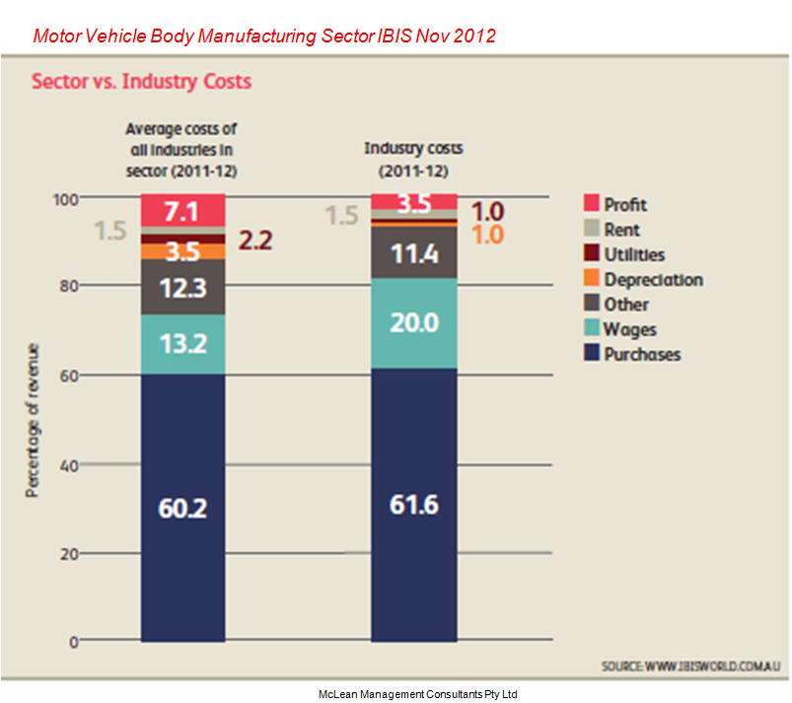
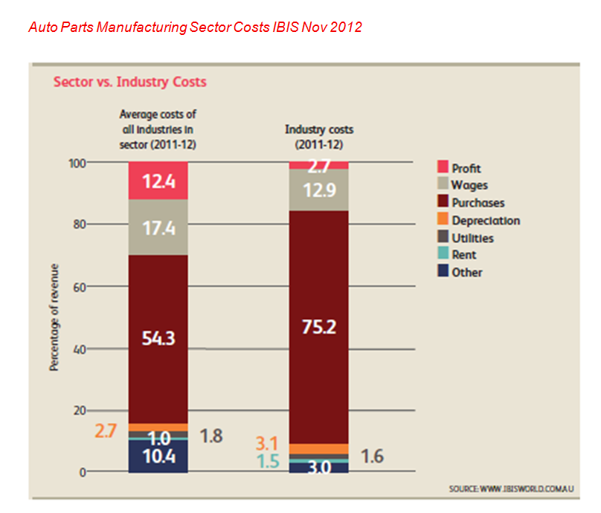

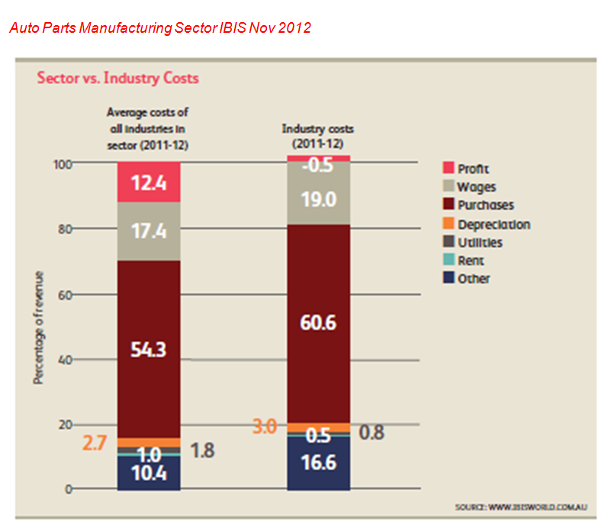

The ASEA Australian Auto Suppliers Report 2011

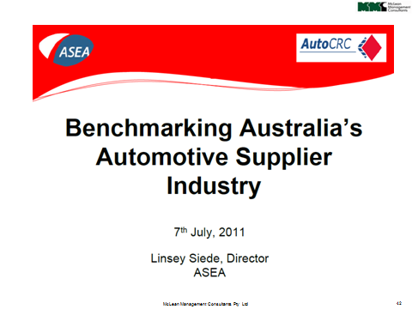

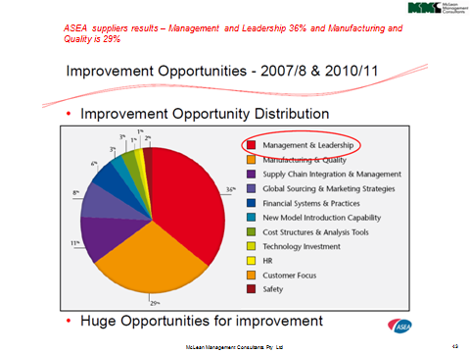
How FAPM c suppliers and member - courtesy of MMC Pty Ltd from Aug 2012

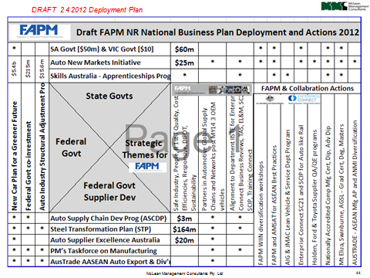

MMC Automotive Manufacturing experience

HQ, Engines and Vehicles VIC and SA. www.holden.com.au/forms/subscribe-to-holden  Nature of work: Business Planning, Operations Planning, Functional Manager Action Planning; Indirect Efficiency Improvement, Structural and Process Cost Reduction; New Business Model and Planning; Quality Management System Review; Root Cause Analysis, Plastics Plant, HR and Training Strategic Planning and integration with HRIS PeopleSoft ERP, Process Failure Mode and Effects Analysis for Risk Reduction; Engine Operations “Plan-on-a-Page”; Finance Six Sigma Workshops and Projects. Indirect Productivity improvement >25%; Engines delivery Right First Time >99%; High Feature V6 D&PFMEA Zero Defects at launch |   BHP www.bhpbilliton.com BlueScope Steel http://www.bluescopesteel.com.au/  Nature of work: Stakeholder analysis and main site re-development business plan with “Plan-on-a-Page”; Rod and Bar Steel Operational Excellence and TQC strategy and project based learning systems; High-Carbon Steel Quality Function Deployment; Ok Tedi Mining Coy PNG Business Planning and “Plan-on-a-Page”; GEMCO TQC Management Plan and Operational Excellence
 Automotive http://www.mtmauto.com/home  Nature of Work:  APQP + Control Plan; Design and Process FMEA for Plastic Molded parts, components and modules for all Australian and international automotive OEMs |  Vehicles Wacol (QLD)  http://www.volvotrucks.com/trucks/australia-market/en-au/Pages/Home.aspx  Nature of Work: Design, tailor and conduct the Process FMEA, Flow Process Charting, Process Root Cause Analysis and Process Control Plan workshops
 Automotive Seating Adelaide South Australia. http://www.futurisautomotive.com/  Nature of Work: GM Holden ‘Sportwagon’ new rear split folding seat Design FMEA, Design for Manufacture and Assembly – launched with Right 1st Time / Zero Defects; Process FMEA and Process Control Plan |   Launceston. TAS. Nature of Work:  Business Planning,  ISO/TS 16949 Auto QMS Design |   Utilux/GPC Electronics Kingsgrove NSW. Nature of Work:.Automotive QA Program
Orrcon Steel (Hills Group) Salisbury QLD. www.orcon.com.au  Nature of work: Sales and Operations Planning; ERP Planning; Operational improvement and engineering strategies; Integrated Management Systems; Root Cause Analysis; Process Control Planning (Galvanising Plant) stabilised and increased process capable production operations |   Power Systems, Melb. VIC  Nature of Work:  On behalf of GM Holden Supplier Quality Engineering and QA: Quality Management, Control and Stabilization | Adelaide SA  Nature of Work:  Lean Management and Systems

MMC Automotive Manufacturing experience
Michael McLean (FAICD) previously HR, OH&S and Quality Improvement Manager for National Springs / Tenneco Monroe Alexandria NSW

Melbourne Victoria.  Nature of Work: Quality Management, Control and Stabilization for GM Holden Supplier Quality Engineering and Assurance |   Clayton Victoria.  Smyrna Tennessee USA.  Tokyo and Opama Japan.  Nature of Work: Automotive QA Program and Japan - USA and Australian Nissan Benchmarking program
  Austrim Nylex Elizabeth SA, Empire Rubber Bendigo VIC.  Nature of Work: Fuel Systems PFMEA, Process Layered Audit and RPN Reduction under the Federal Government Automotive Supplier Capability Development Program with GM Holden. New Product Development process for Rubber impregnated steel automotive suspensions parts and components; Solving Problems in Quality (TS16949), Cost, DIFOT and Safety Management Systems |     Tenneco Monroe. Elizabeth SA.  Nature of Work: Process FMEA and RPN reduction for GM Holden Suspension parts

MMC provided the Technical Specialist for the AusAID ASEAN Automotive Development Program for 10 ASEAN Nation benchmarking to support their mutual development to contribute as a viable value-adding sector for the "AEC 2015" [ASEAN Economic Community 2015] . Project Managed by AMSAT International Canberra, ACT. The Australian Automotive Sector can learn and engage more with ASEAN

Published academic peer reviewed research in the International Journal of Quality and Reliability Management  http://www.emeraldinsight.com/journals.htm?articleid=1889610&show=abstract  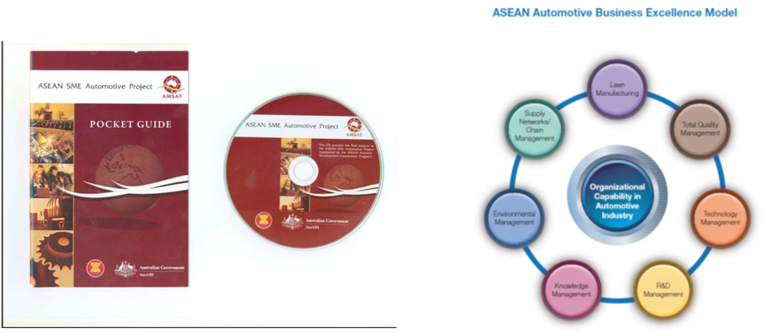 | Purpose – The primary objective of this research is to explore whether total quality management (TQM) firms execute various quality management practices significantly differently from non-TQM firms in the Association of South East Asian Nations (ASEAN) automotive supply chain. The study also aims to analyze differences between different tiers of this supply chain and to examine the relationship between the implementation of quality management systems and adoption of TQM.  Findings – The results show that firms that have successfully implemented the concept of work standardization or process-approach through quality management systems (QMS) certification have tended to pursue TQM as the subsequent stage in their quality journey. In addition, the study found that all seven TQM practices – leadership; strategy and planning; customer focus; information and analysis; people management; process management; and supplier involvement – were significantly higher in TQM firms than in non-TQM firms. Finally, the study found that tier 3 suppliers were less likely to implement TQM practices compared with higher tiers (1 and 2), except in supplier involvement.

