Submission to the Productivity Commission’s Review of the Automotive Manufacturing Industry in Australia

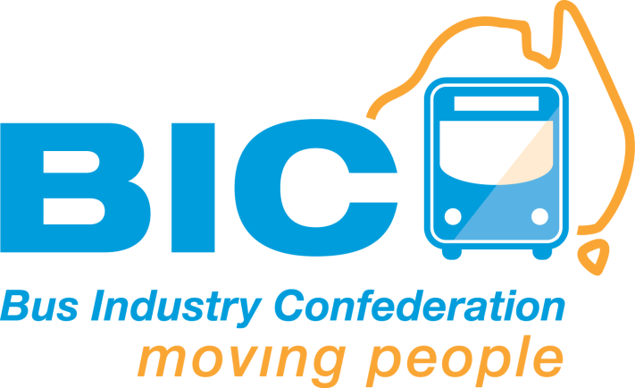**Submission by the Bus Industry Confederation**

|  |  |
| --- | --- |
|  |  |

**November 2013**

Introduction

The Bus Industry Confederation (BIC) is the peak national body representing the bus and coach industry in Australia.

As the primary voice of the bus and coach industry in Australia the BIC works with all levels of Government, regulatory authorities, the industry and the community to:

* Encourage investment in public transport infrastructure and services.
* Coordinate and make more effective existing Federal, State and Local Government policies and programs that relate to public transport.
* Improve public understanding of the contribution made by the bus and coach industry to Australia’s economy, society and environment.
* Ensure that the accessibility and mobility needs of Australians are met, regardless of where they live or their circumstances.
* Ensure that buses and coaches operate safely and effectively.

About this Submission

This submission highlights the importance of the Australian bus manufacturing industry to the economy and the retention of a base of heavy vehicle manufacturing skills and knowledge within Australia.

The Australian Bus Manufacturing Sector

The Australian bus and coach industry encompasses bus body manufacturers, bus chassis suppliers, suppliers of fully built buses and bus component manufacturers servicing the Australian market. The Australian bus manufacturing sector employs directly and indirectly more than 10,000 people.

The value of the Australian bus sector, with an average delivery of more than 1,500 large buses (12 and a half metres and above and more than 26 seats) a year is estimated to be almost $500 million a year.

Figure 1 presents an overview of the total market for large buses from 2004 to February 2013.

Market Trends

Recent years have seen a trend toward fully built vehicles being delivered to the Australian market.

Fully imported vehicles are sourced from China, Japan, Korea, Brazil and Malaysia, with a number of overseas manufacturers entering the Australian market continuing to grow. In Australia prior to 2005 one hundred per cent of new buses were being built in Australia. Figures 2, 3 and 4 highlight the change in the in the market over time.

In 2012 40 per cent of the total market and 80 per cent of the school/charter bus market were made up of imported vehicles. The local manufacturing industry is operating in a highly competitive, relatively small sales environment with low cost imports having a significant impact on the market and local industry.

Figure 1: Total Market Trend 2004-2013 Australian Bus Market

**Source: Volgren 2013**

Figure 2: Australian Manufactured vs Fully Imported Buses 2007-2011 Trend

**Source: Scania Australia, 2012**

Figure 3: Total School and Charter Market vs Imported 2006-2012

**Source: Volgren 2012**

Figure 4: Total Market vs Imported Buses 2006-12

**Source: Volgren, 2012**

A Unique Skills Set

The Australian bus manufacturing sector retains a unique skills set in heavy automotive manufacturing within Australia.

The Australian bus manufacturing sector is a niche sector within a global market and has the potential and capacity to widely diversify into a range of areas.

In addition to delivering Australian made buses to the market Australian bus manufacturers can deliver a range of essential vehicles including:

* Military vehicles
* Emergency services vehicles
* Armoured security vehicles

Australian bus manufacturers retain a capacity to deliver large quantities of these vehicles locally at times where sudden increases in production are required and ensure the knowledge of how to manufacture these vehicles is maintained in Australia.

Whilst the industry is open to competition and the BIC represents both Australian and overseas bus manufacturers in our advocacy, the retention of the unique skills set within Australia is important for future self-reliance.

Local bus manufacturers have design capability in Australia. Like the automotive industry, local bus manufacturers require sufficient scale to be profitable and maintain Research and Development programs through skilled workforce. Once lost, this design capability and workforce would be very difficult to regain.

The local bus manufacturing industry, unlike the automotive industry receives no Government assistance.

The recent entry of large global organisations (Marco Polo and Alexander Dennis) taking ownership of the 2 largest local bus manufactures which account for some 70% of the local bus manufacturing industry bring significant expertise in innovation, business practices and management. The local organisations are being trained in these skills which will have a spill-over effect into other industries.

It is vital that this unique and local skill set and workforce is retained to ensure heavy vehicle automotive manufacturer excellence and to ensure it is available to other related industries.