



Michael McLean FAICD, FAOQ, JM
Managing Director
McLean Management Consultants Pty Ltd
PO Box 703 NSW 1710 Australia

W: www.mclean-mc.com.au

Submission to Productivity Commission Review of the Automotive Industry
13 February 2014

Current State of Australian Auto Sector

Since the initial 2013 Automotive PC Review preliminary submissions and interim findings the 2017 closure of GM Holden and Toyota Motor Company Australia, have now framed this submission.

We cannot change these decisions but we would like to provide some research, surveys and findings along with opportunities closer to Australia in ASEAN and also lessons learned from the UK Automotive Supplier organisation (SMMT) which may provide a pathway for Australian Suppliers and their association to consider, adapt and adopt.

We will provide insights to what is the legacy of the automotive strategies, policies, processes and even tools and techniques that are being implemented in non-automotive industries here in Australian forms to make them competitive.

Ironically today – two items underpin the importance of management, building in not inspecting in quality standards, and European 2nd Tier Research by Boston Consulting Group.

Industry Week USA

“Toyota Recalls 1.9 Million Prius Cars”

http://www.industryweek.com/safety/toyota-recalls-19-million-prius-cars?NL=QMN-01&Issue=QMN-01_20140212_QMN-01_84&YM_RID=mwmclean@optusnet.com.au&YM_MID=1449578&sfvc4enews=42&cl=article_1_b

Boston Consulting:
“Assessing the Risks for European Automotive Suppliers” A Light Breeze or the Perfect Storm?
January 08, 2014

https://www.bcgperspectives.com/content/articles/automotive_cost_efficiency_asset_optimization_light_breeze_perfect_storm_assessing_risks_european_automotive_suppilers/

Australian supplier development programs and status.

From the OEM programs it can be seen that they have been most supportive of the Tiered Suppliers.

All Automotive Suppliers are at a minim ISO9001: 2008 certified with most now certified the Technical Standard f TS 16949.

R&D

R&D – Engineering – once OE mfg stops, there is nothing compelling anyone to look here for product engineering or R&D – unless it is cost or some unique technology. On cost front, ATS enables our engineering to be “as cost effective as Shanghai” so suppliers may need encouragement for that to remain, otherwise engineering will stop as well. Complication as we know is that as volumes go down so does ATS assistance to suppliers. Can something be done about the 3 year rolling average (probably means new legislation) to bring forward the payments, as suppliers need that help now, not in the 3 years after 2017?

For the most part, supplier realise that their 'processes' must be stable, lean and capable of meeting the automotive performance metrics.

The problem lies in suppliers whom have documented their QMS (be it ISO 9001 or ISO TS1949) by the heading of the various standards or TS instead of their Business Processes as the standards require.

The reason for this aspects in this PC Review is that now as can be seen by Toyota's requirement for some $3,800 cost reduction from their vehicle and that is to come and requested form the suppliers.

This was alluded to in “Toyota in Machete Time”.
http://www.businessweek.com/stories/2001-04-08/japanese-auto-makers-machete-time

Without a Process Based Quality Management System, the suppliers will not be able to find such cost downs. Secondly, most only have Standard Costing Accounting Systems and not Activity Based therefore any cost reduction efforts will be functionally based and sub-optimal and not process oriented.

The Automotive "Core Tools" from the AIAG USA emphasise Process Management, Control, Assurance and Improvement and GM "Quality Systems Basics" courtesy of Lear USA is linked:
http://www.lear.com/user_area/extranet_files/lear-74-GM_Quality_System_Basics_Overview.pdf

For compliance, GMH and Toyota require their suppliers to conduct the auto industry "Layered Process Audits" http://notasdecalidad.files.wordpress.com/2010/11/gm-1927-36-quality-system-basic-marzo-2009-lpas.pdf.

As mentioned, the 'process-approach' requirement is not always possible because the Australian automotive suppliers and their supplier "Quality Plans" are not based upon processes but on the ISO9001 and / or TS16949 standard clauses.

This then is problematic for Australian suppliers. The requirement to not only make cost reductions but also invest in New Product Development through R&D; resourcing Innovative Products, Processes and Practices and embracing new technologies and materials to then be part of a Global Platform for Toyota and GMH is constrained through these structural and management system issues.

Australian Auto Program | Source and findings | Status
ASEA | 2011 report | Key restrainers from ASEA Supplier participants were:  - Management and Leadership 34%  - Manufacturing and Quality 32%
Toyota | Supplier QA Program utilises South African Supplier Development Program  http://www.gibs.co.za/SiteResources/documents/Toyota%20presentation.pdf | SQA based upon "Price then Delivery and then finally Quality" which is contrary to public documentation and publications citing "Quality, Cost then Delivery".  - Toyota’s New Goal in 2001 which they did achieve and in 2007 began the largest vehicle recalls and models in automotive history.  - As the 13 February 2013 Industry Week news item publicized, their recalls continue – by management and their sourcing decisions, not the workforce nor Unions:  - Raise World Wide Market Share From 10% To 15%  - Essentially, Toyota Wants To Increase Its size & reach by 50%  - Executive Vice President in 2001 from Toyota Australia: “evaluating world’s best parts will be on a ‘total cost’ basis, where QCD (Quality, Cost and Delivery) are evaluated in their totality and suppliers must have global affiliations to meet technology, design, quality and lead time performance”
 | TMCA requires more supplier Cost Reductions.  “The company also made it known that costs per vehicle had to be reduced by an ambitious $3,800. The company needs to make its production costs cheaper to renew an export deal for Camry vehicles with Middle East countries, The Australian reports today.  “ | “Cost cutting, including from suppliers, necessary for Toyota Australia’s survival 21 November, 2013 Brent Balinski  http://www.manmonthly.com.au/news/cost-cutting-including-from-suppliers-necessary-fo
GM Holden | “Quality Systems Basics”  Trained all its Tier 1 and 2 Suppliers in QSB. Emphasis in AIAG TS16949 QMS and Core Tools.  http://www.lear.com/user_area/extranet_files/lear-74-GM_Quality_System_Basics_Overview.pdf  Use Shainin “Drill Deep and Wide” Problem Solving | Supports ASDCP Federal Government initiative to develop suppliers and seeks external consultancy support for all Controlled Shipping I and II suppliers.  Has also used Federal Government program to support external consultancies to train and correct poor quality suppliers with the training and consulting on Design and Process Failure Mode an Effects Analysis

Lessons for Australian Automotive Sector – work with Australian and International OEMs Global Platform and forefront of the design of systems and modules and out of the price/cost down parts and component producing supply side

As Roland-Berger’s 2006 “Strategies for profitable growth in the global automotive supply industry” and other consultancies have conducted research into the automotive sector in various countries (References and links to many others are appended) “Automotive suppliers are under pressure: price reductions and weak volumes are seen as the major challenges”

- http://www.rolandberger.com/media/pdf/Roland_Berger_Global_Automotive_Supplier_Study_20130917.pdf
- http://www.cisco.com/web/about/ac79/docs/wp/ctd/Auto_Trends_WP_FINAL.pdf
- http://www.deloitte.com/assets/Dcom-Kazakhstan/Local%20Assets/Documents/dtt_research_globalautomotive_021203(1).pdf
- http://www-935.ibm.com/services/fr/igs/pdf/automobility-winning-a-different-race.pdf
- http://www.atkearney.com.au/news-media/news-releases/news-release/-/asset_publisher/00OIL7Jc67KL/content/a-t-%C2%A0kearney%E2%80%99s-15th-annual-automotive-study-indicates-u-s-auto-sales-volumes-will-trend-back-to-historical-levels-by-2013/10192

The ILO Switzerland has view too:

- http://www.ilo.org/wcmsp5/groups/public/---ed_dialogue/---sector/documents/meetingdocument/wcms_161510.pdf

Europe too has similar issues to Australia and Australia is the closest to the world’s largest market being Asia, ASEAN and ‘CHINDIA” as Philip Kotler et al coined in “Think ASEAN” (2007) as it heads towards the ASEAN Community 2015.

Australian Automotive Sector Costs

13 February 2014 Australian Financial Review page 8. If “Toyota had almost made the $3,800 cost down” then the question comes to mind, why is there a focus on the Enterprise Agreement and that the Unions were a constraints to Toyota continuation and that future investment is undermined?

From MMC Pty Ltd consulting assignments with an Automotive OEM, the Target “Manufacturing Cost” in Australia for a 6 cylinder vehicle in 2001 was $2,450 by 2008, GMH achieved it? So if Cost of Wages in the Auto Sector perceived constraints to growth. Source: IBIS World and ABS.

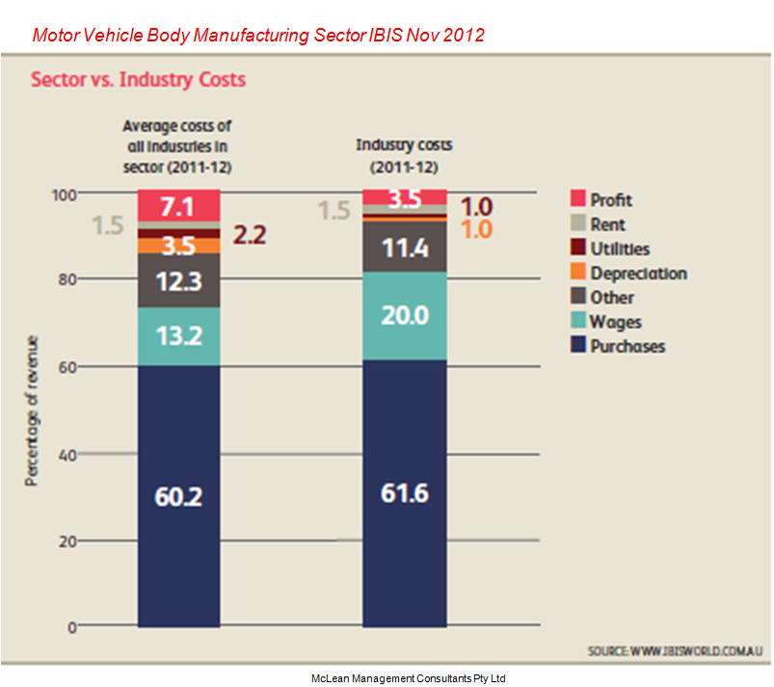 | 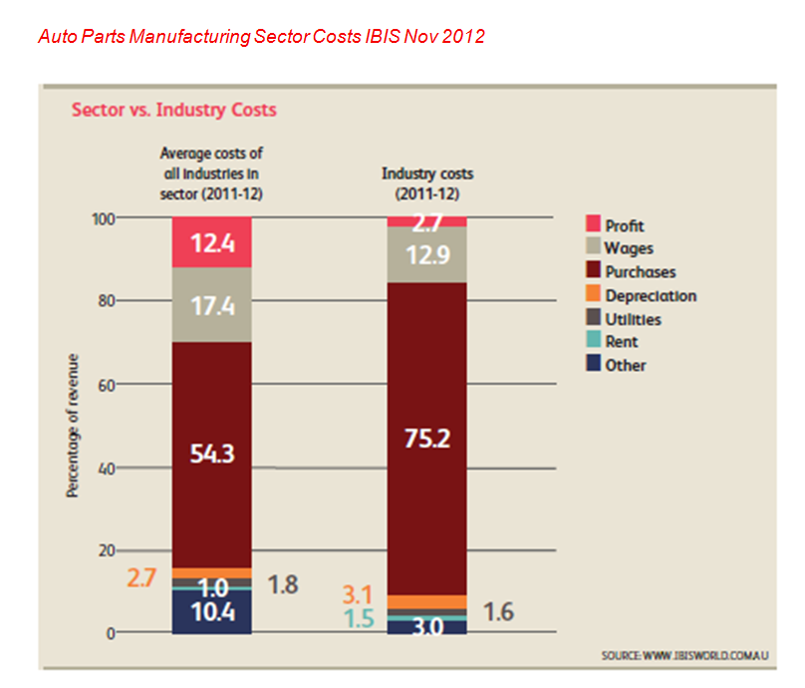
- A supporting research by Keki Bhote ex –Motorola USA on supply chains: “Labour has shrunk to 5% of Sales whilst purchased materials to 50% and Accounting spend 6% to control and monitor the 5%!” Source: K.R. Bhote “Strategic Supply Management”
- And it has not only been about costs: “Quality will be the key to our effectiveness in converting opportunities into realities for everyone at Holden”. Peter Hanenburger Chairman and MD, GM Holden April 2001
If TMCA has a capability and GMH did in their foundry and engine plant, it would have been consistent with world research best practice:
‘Engines represent the crucial battleground”. Source: MIT Voices from the Engine Plants 2000

So why is a labour cost and enterprise agreement mutual condition for performance of such prominence of the public press, business and political narrative? It maybe a generic ‘Unions’ and not a specific “Union” which is the focus and not the management who both accepted and approved the registered Enterprise Agreement

The ASEA Australian Auto Suppliers Report 2011

Similarly, the ASEA Research after all the interventions and programs, the research across all FAPM and non-FAPM member automotive Tiered Automotive Suppliers is interesting and would suggest that the ASEA Programs did not support or focus on the areas the auto suppliers should improve.

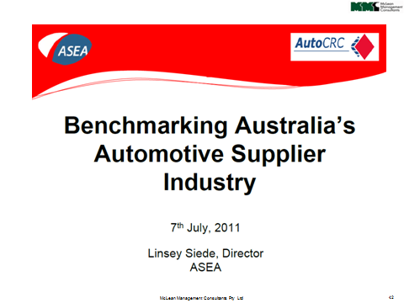 | 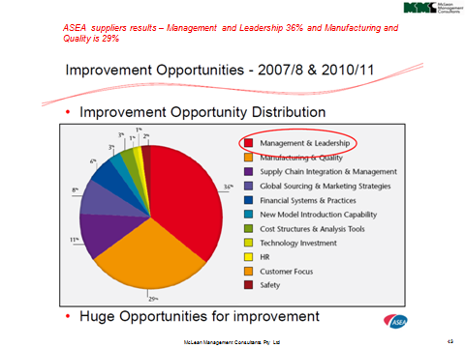

Bywater McLean Australia – FAPM Research and Benchmarking to UK’s SMMT 256 Automotive OEM’s and Tier 1 and 2 automotive suppliers.

ASEAN – there are still opportunities there not just Europe and USA.

ASEAN Reports

http://www.slideshare.net/FrostandSullivan/frost-sullivan-asean-automotive-markets-potentialthe-final-frontiernovember2011

http://businessmirror.com.ph/index.php/en/business/asean-economic-community/13499-the-automotive-industry
WITH the implementation of the ASEAN Economic Community (AEC) 2015, ASEAN will reach a prominent position to attract foreign investment. As ASEAN is set to become the world’s sixth-largest automotive market by 2018, it is expected that regional sales will double to nearly 4.7 million vehicles from 2.4 million last year
ASEAN Auto Integration Protocol:

http://www.asean.org/news/item/asean-sectoral-integration-protocol-for-automotives

ASEAN is yet to release its Automotive Roadmap and if not already - timely Jim reengages with them:

http://asean-business-news.com/philippines/economy/dti-still-not-prepared-to-issue-auto-roadmap/

http://www.abs-cbnnews.com/business/04/14/13/ph-still-lags-asean-vehicle-production
Local vehicle assemblers in the country have been waiting for the release of the road map for the automotive industry, which is expected to provide fiscal and non-fiscal measures to support the growth of the sector.
http://www.philstar.com/business/2013/10/09/1242997/govt-urged-finalize-automotive-roadmap
Philippines Govt recent post to 'revise their Auto Roadmap'
MANILA - A roadmap aimed at reviving the country’s automotive manufacturing sector hit a roadblock after President Benigno Aquino III ordered the Board of Investments (BOI) to draft a “different” program for the industry.
Latest industry data show that the market share of locally made units declined to 34 percent in the first half of this year from 39 percent last year.
Imported vehicles -- mainly from neighbouring Thailand, which is ASEAN’s automotive manufacturing hub, as well as Japan and South Korea -- have dominated local car sales with a 66-percent market share—the highest-ever—at end-June.
Local assemblers could no longer compete head on with their counterparts elsewhere in ASEAN, which have bigger domestic markets and where production costs are cheaper than in the Philippines. The cost to assemble a car in Thailand, for instance, is 14-percent lower than in the Philippines.
http://www.gmanetwork.com/news/photo/20849/mahathir-asean-needs-to-modernize-to-compete-with-west

Former Malaysian PM Dr. Mahathir Mohamad underscores the need for sophisticated machines for ASEAN countries to be able to surpass the economies of western countries, during a lecture at the UST Medicine Auditorium in Manila on Monday.

ASEAN Automotive Federation:

Overview from Korea http://www.uia.org/s/or/en/1100042639

Slide share Pareto Chart - shows Thai largest auto producer http://www.slideshare.net/ulikaiser/asean-automotive-2013

Others:

http://www.abc.net.au/news/2012-08-08/car-industry-encouraged-to-manufacture-in-thailand/4186590

http://www.boi.go.th/index.php?page=opp_automotive
THAILAND: THE DETROIT OF ASIA
Thailand’s economy has shown record impressive growth over the past decade. The combination of a sound economic foundation and renewed growth makes this vibrant Southeast Asian economy fertile ground for future automotive investments.
The automotive industry is a vital sector for the country’s economy as it contributes greatly to exports and trade inflows. It is Thailand’s second-largest export industry, after computer parts and components. Thanks to continuous government-led support, automotive has evolved into an industry with vibrant foreign original equipment manufacturer (OEM) competition and an extensive network of supporting industries. Thailand’s long experience with automotive manufacturing has equipped the country with a comparatively low-cost yet experienced labor force for the sector.
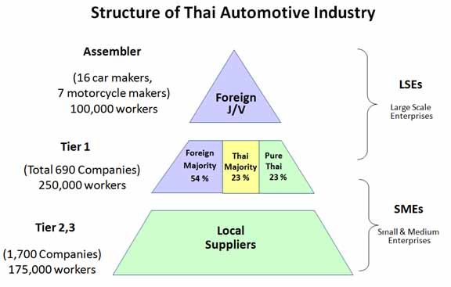
Source: Thai Autoparts Manufacturers Association

From the Japan AMA

http://www.jama-english.jp/asia/news/2011/vol42/article1.html
ASEAN Automotive Industry and JAMA Takes Up Issues of ASEAN
Background
In November 2010, the ASEAN Automotive Federation Technical Committee 3 (AAF/TC3), one of the implementing working groups under the ASEAN Sectoral Protocol to harmonize technical regulations and certification systems of automotives in the Southeast Asia region, held a dialogue session with JAMA’s automotive regulations and type approval experts to exchange ideas on ways to resolve issues impeding technical harmonization, and ways to promote the harmonization process.

The research on ASEAN Automotive Sector benchmarked against the Australian Auto OEM’s and the Tiered Suppliers

http://www.emeraldinsight.com/journals.htm?articleid=1889610&show=pdf

“A study of quality management practices in TQM and non-TQM firms: Findings from the ASEAN automotive industry” showed that quality management is the one foundation metric and strategy that does and will equip Australian automotive suppliers need to resource and support to achieve exports. Diversification into other sectors required as the research showed, that the ISO TS16949 and USA AIQG “Core Tools” are required foundations. One author was from Australia, MWMcLean.
Author(s): | Prattana Punnakitikashem, (College of Management, Mahidol University, Bangkok, Thailand), Tritos Laosirihongthong, (Department of Industrial Engineering, Thammasat University, Bangkok, Thailand), Dotun Adebanjo, (Operations Management and E-business, The University of Liverpool Management School, Liverpool, UK), Michael W. McLean, (Department of Learning and Education, Queensland University of Technology, Brisbane, Australia and McLean Management Consultants Pty Ltd, Sydney, Australia)
Citation: | Prattana Punnakitikashem, Tritos Laosirihongthong, Dotun Adebanjo, Michael W. McLean, (2010) "A study of quality management practices in TQM and non-TQM firms: Findings from the ASEAN automotive industry", International Journal of Quality & Reliability Management, Vol. 27 Issue: 9, pp.1021 - 1035
Purpose – The primary objective of this research is to explore whether total quality management (TQM) firms execute various quality management practices significantly differently from non-TQM firms in the Association of South East Asian Nations (ASEAN) automotive supply chain. The study also aims to analyze differences between different tiers of this supply chain and to examine the relationship between the implementation of quality management systems and adoption of TQM.
Design/methodology/approach – A total of 165 datasets collected from ASEAN automotive Original Equipment Manufacturers (OEMs) and their tier 1 and 2 suppliers in five ASEAN countries were tested by using cross-tabulation analysis and ANOVA with post hoc test.
Findings – The results show that firms that have successfully implemented the concept of work standardization or process-approach through quality management systems (QMS) certification have tended to pursue TQM as the subsequent stage in their quality journey. In addition, the study found that all seven TQM practices – leadership; strategy and planning; customer focus; information and analysis; people management; process management; and supplier involvement – were significantly higher in TQM firms than in non-TQM firms. Finally, the study found that tier 3 suppliers were less likely to implement TQM practices compared with higher tiers (1 and 2), except in supplier involvement.
Originality/value – The study presents an insight into TQM constructs evolution in the ASEAN region, which has gained increased prominence and world impact as a result of international outsourcing. It therefore addresses a significant gap in the literature about how quality management is deployed in this important region of the world.
And an additional academic peer reviewed article explored similar issues.

http://ieeexplore.ieee.org/xpl/login.jsp?tp=&arnumber=5372982&url=http%3A%2F%2Fieeexplore.ieee.org%2Fxpls%2Fabs_all.jsp%3Farnumber%3D5372982

Authors: Punnakitikashem, P. ; Coll. of Manage., Mahidol Univ., Bangkok, Thailand ; Laosirihongthong, T. ; Adebanjo, D. ; McLean, M.W. QUT Australia

The objective of this research is to explore if TQM firms execute various organizational management practices significantly different from non-TQM firms in the ASEAN automotive supply chain. Datasets were collected from ASEAN automotive original equipment manufacturers (OEMs) and their Tier 1 and 2 suppliers. Then, datasets were tested by using statistical analysis. The results show that seven TQM practices including leadership, strategy and planning, customer focus, information and analysis, people management, process management, and supplier involvement are significantly higher in TQM firms than Non-TQM firms. ASEAN OEM suppliers in the automotive industry can use the results of this study to select and deploy suitable TQM practices to enhance their competitiveness in the first instance in the automotive sector and then to other value-adding sectors. This study also indicates that automotive industry and others need to consider TQM practices, as an organizational innovation or organizational development intervention, along the entire supply chain.

Australia’s automotive sector issues are similar to what ASEAN Member countries.
According to Vicente Mills Jr., president of the Philippine Automotive Federation and the ASEAN Automotive Federation, it is imperative that this transformation take place to address the declining share of locally manufactured vehicles (LMV) in the domestic market and allow the industry to access and meaningfully participate in the soon to evolve ASEAN common market.
http://chinabusinessphilippines.com/index.php?option=com_content&view=article&id=1414:pacci-unveils-competitiveness-road-map-for-auto-manufacturing-industry&catid=35:peopleevents&Itemid=129

Summary:

- ASEAN and “CHINDIA” (Kotter) is the focus not Europe and USA for Australian automotive tiered suppliers and after-market suppliers
- Forge ASEAN Automotive Federation MOU’s
- Design and implement learning and development, cross-industry and AQF accredited skills and competencies like Competitive Systems and Practices from Certificate III, IV, Diploma, Advanced Diploma to Vocational Graduate Certificate
- Support FAPM marketing and volume increasing objective from Indonesia, Malaysia, and Thailand
- FAPM, FCAI, Department of Industry Enterprise Connect to commission a revised Automotive Quality Assurance Program strategy and learning’s to upgrade automotive suppliers to be competitive in the targeted markets – align to AIAG USA “Coe Tools”
- Reverse Automotive Leasing and Fringe Benefit Tax offset program from Gillard/Rudd governments
- Conduct a skills assessment and inventory of Ford, GMH, TMCA and their Tiered Suppliers operators, staff, managers, and engineers
- Urgently seek where Australian automotive manufacturers have capacity and capability to build or sustain volumes as FAPM President Richard Riley suggested on 11 February 2014 [ABC Breakfast]
- Utilize Enterprise Connect Business Reviews to assess the auto suppliers and benefit from their recommendations to improve and grow their business – suppliers will receive up to 50% Federal Government funding for Supplier Continuous Improvement Programs I and II with UK SC21 EFQM Benchmarking and IBIS World Reports (Source is ABS)
- FAPM and FCAI forge a link and MOU for skills and strategies from UK an Europe experience to assist an Australian suppliers ‘3 Horizon Strategy’ to ASEAN

