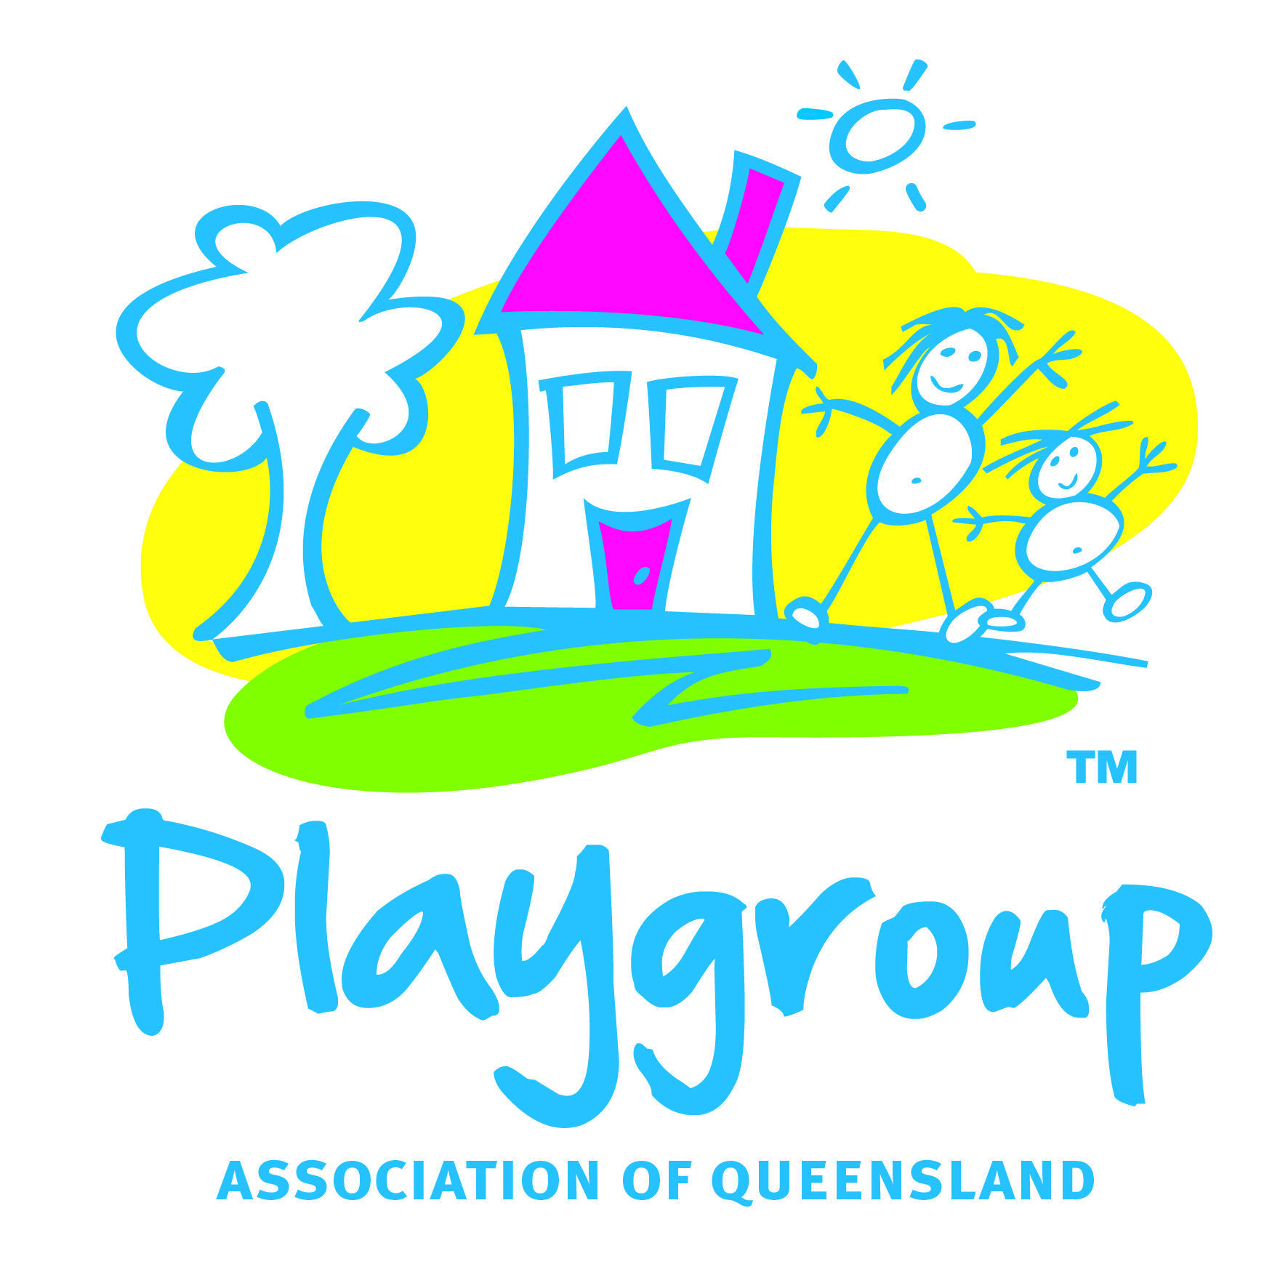
Playgroup Association of Queensland Inc
Secretariat: 86 Orchid Street, Enoggera Qld 4051 Phone 07 3855 9600

Introduction
We commend the Australian Government on its increased investment and commitment to early childhood learning and care and appreciate the opportunity to play a proactive role in collaboration and consultation within our sector and with the Government at large.
Playgroup Queensland is committed to the aim of providing children with the best possible start in life, whilst acknowledging parents as first teachers, through the effective planning, development and provision of services that improve outcomes for parents, carers and children in areas of health, education and care.
Although we have contributed to submissions from our National Peak Body, Playgroup Australia and other alliances such as the Queensland Children’s Services Alliance (QCSA) in formulating a coordinated approach to the Productivity Commission Inquiry, there are some additional perspectives we would like to submit that further demonstrates the diversity of the role of Playgroups in the early year’s sector.

About Playgroup Queensland
The Playgroup Association of Queensland Inc. (Playgroup Queensland) is a registered charity with the ACNC. Playgroup Queensland (PGQ) is the peak body for the Playgroup movement within Queensland. Specifically, PGQ works closely with Government, non-Government and community partners to support and establish Community Playgroups and deliver quality prevention and early intervention programs and services for families with young children, both state wide and nationally. PGQ also acts as a voice to Government and the wider community on early childhood and parenting matters.
Key considerations for our organisation regarding the National Reform Agenda for early childhood learning and care and incorporating the ECD workforce issues are as follows:
- Putting children, parents and families best interests first
- Providing integrated services to support learning through play, healthy living and social and emotional wellbeing
- Improving access and availability of ECEC services regardless of location, culture, circumstance or economic means
- Developing an integrated ECD workforce including paid educators, family support and community development workers and volunteers
1. Putting children parents and families best interests first
- In our view, the best interests of children, parents and families should be at the forefront of the national reforms agenda
- Reforms should not diminish the parents role as a child’s first and most enduring teacher by “professionalising” early childhood learning and care to the point of excluding parents and families or displacing important children and family services, such as Playgroup, which enhance healthy parent child relationships.
- Parental care or active involvement by parents/carers is a critical component to the early learning and development stages of a young child and helps mitigate behavioural problems and delayed cognitive development in young children.
- Inclusion of all children with disabilities or complex needs and those from diverse backgrounds or remote locations must be improved and factored into a holistic approach.
- Access, availability and delivery of quality early childhood learning and care is a right for all children
- Many families seek to transition into the workforce through flexible work arrangements to enable the building of confidence and enabling the primary carer, commonly mothers, to balance child nurturing, workforce productivity and economic necessity. These reforms should support employers with guidelines on workplace productivity and being able to provide flexible work arrangements for employees returning to work. Some form of financial support for ‘family conscious’ employers (e.g. a rebate for establishing flexible work arrangements) may invoke greater engagement and support from the Employers to these reforms.

2. Providing integrated services to support learning through play, healthy living and social and emotional wellbeing.
- PGQ supports the value of rich environments of learning and care that nurture the child and resource and equip parents/carers to support child learning and development that strengthen transitions for children into early learning environments such as childcare, kindergarten and school and parents into workforce productivity.
- PGQ supports an integrated service delivery model that recognises the benefits of models such as playgroup in providing a conduit for supporting families to access health, learning and care services. The value of cross-disciplinary or integrated service delivery cannot be underestimated and is vital to supporting accessibility, flexibility and affordability for all families.
- PGQ understands that every family is different and their circumstances will influence their ability to support children’s learning and wellbeing as well as the ways that they utilise ECEC services therefore the reforms need to be nimble and responsive. In our experience a parents return to the workforce and contribution to national productivity is further enhanced when parental confidence and capacity is high.
- Families often feel the need for support in the “formative years” to be well equipped and educated to parent their child to be “child-care or kindy ready” and to provide a strong “family compass” to guide them. Many modern day families no longer have family members in close proximity to provide that support network thus Playgroup is proving to be a vital building block in those early years.
- Grandparents, especially, are now becoming a common part of the mix in supporting parents return to work plans where childcare is unaffordable, not accessible or where the parents prefer extended family to participate in the child’s overall development and wellbeing. Different approaches to early childhood learning and care such as a mix of childcare, shared parenting and extended family as carers need to be factored into the reforms especially with regard to funding and reducing barriers to engagement such as affordability.
- Health, Nutrition & Physical Activity is also a major area of concern within the early years sector and we believe health and education are inextricably linked and should be integrated into the reforms.-
- Lifting school attendance rates especially with ATSI Children - PGQ recognises the importance of supporting Indigenous Australian children to engage with kindergarten and school communities and lifting school attendance rates within these populations is paramount for these populations to strengthen their own community’s long term. PGQ “Off to School” program will strengthen the Federal Government initiative with truancy officers by providing an early intervention program and by doing so will have the ability to address the current glaring statistics recorded for kindy/pre-school expulsions in these populations.
- The Transition to Kindy program is a PGQ initiative that demonstrates the value of leveraging the Playgroup model to help support and prepare parents/carers in making good choices for their children as they traverse the early leaning framework.

3. Improving access and availability of ECEC services regardless of location, culture, circumstance or economic means

- PGQ supports the notion that ECEC and family support services which offer localised, inclusive quality services to children and families should continue to have a role in the sector regardless of size and whether they are a not–for profit or for profit, private small business, community run or corporate entity. Improvements in efficiency, reporting and compliance, accountability, shared services and professional development should be explored to build the capacity of all ECEC and family support services as part of an integrated service delivery model.
- All infants and young children should have access to high quality early childhood programs and services. Playgroup in all its forms provides a vital connector for children from birth to school age across all services and fills a significant gap including where childcare or early learning services such as kindergarten are not readily available or accessible.
- We support the proposal from the Secretariat of National Aboriginal and Islander Child Care (SNAICC) for a fully funded program supporting Aboriginal and Torres Strait Islander organisations to deliver services to the ATSI Communities. While we recognise that the high percentage of Indigenous children can and do attend mainstream services, it is important to offer choice and cultural sensitivity through culturally competent workforce. Playgroups currently operate successfully in indigenous communities (many of them quite remote) usually employing local women to engage with families with young children.
- PGQ supports a charter to ensure access to services for families where the market will not sustain a service under mainstream financing mechanisms (current CCB/ CCR). An example of this would be the establishment of dedicated programs for services operating in rural and remote areas, including mobile services that require operational funding to maintain viability due to very small local populations.
- PGQ understands that the reforms are based on a solid body of evidence demonstrating direct connection between the quality of early childhood learning and long term outcomes of children. PGQ identifies with the NQF and Early Years Learning Framework as its overarching guiding principles in service delivery and endorses this as a recommendation for all non-registered ECEC services as best practice.

- An integrated ECD workforce including paid educators, family support or community development workers and volunteers
- Innovative approaches are required to ensure that a readily accessible, skilled and culturally competent workforce is available to support all children and their families. Government funding to support access to ECEC services for children with additional needs is currently inadequate. As the Productivity commission found “In many cases, the limited funding that is available is provided on a short-term basis, does not fully cover the cost of employing additional support staff, and is onerous to apply for and maintain.’
- As the proportion of children with additional needs appears to be increasing, there is also increasing expectation that children with disabilities and those from diverse cultural backgrounds should be included in their local ECEC as a matter of course. The advantages that local inclusion in mainstream services can have on a child’s development and general wellbeing are widely accepted. However, without adequate support, worker training and access to ‘inclusion support workers’ in the ECEC workforce, many of these families continue to experience barriers to their child’s enrolment or continued enrolment in a local ECEC (including exclusion of their child from a centre). Without additional commitment to resourcing many ECEC’s have incompatible capacity, expertise and/ or scope to offer a truly, supportive and welcoming and inclusive environment to all children that caters for their unique needs.
The Productivity Commission’s report on the early childhood development workforce (2011)
- The relationship between educators and children is a critical component of quality service delivery. Being an educator in early childhood services and working with families and children should be valued and respected roles. Reforms should aim to attract and retain talented people in all ECEC roles with a career pathway and achievable qualification framework that engages workers at all levels.
- Recognise the capacity and flexibility of local services to build on, innovate and maximise opportunities for the Early Childhood Development (ECD) workforce and also provide critical local employment and career pathways for local employees in the sector.
- Community Playgroups are parent led (and parent paid) however these ‘volunteers’ are also an integral link in the ECD ‘workforce’ chain. PGQ believes in the importance of supporting parents as the child’s first teacher and building capacity and confidence for them to make well-informed early childhood learning and care decisions. Providing appropriate and relevant support, training and resources to these volunteer workers (parents) forms part of the integrated model.

