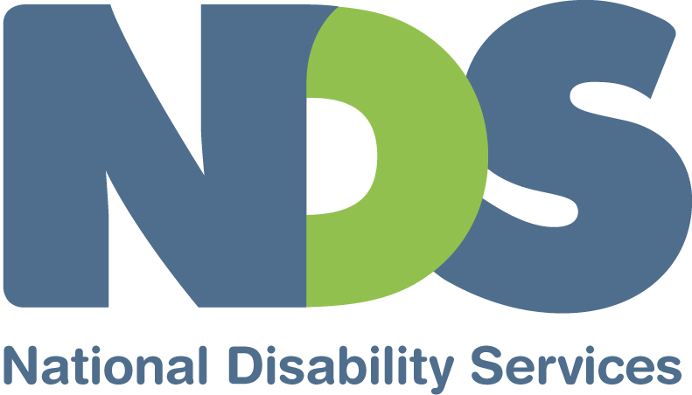

Submission to the Productivity Commission Inquiry into Childcare and Early Childhood Learning

The National Disability Strategy, endorsed by Commonwealth, State and Territory governments in 2011, is a ten-year commitment to a ‘unified, national approach to improving the lives of people with disability, their families and carers, and to providing leadership for a community-wide shift in attitudes’. The Strategy’s purpose is to:

- establish a high level policy framework to give coherence to, and guide, government activity across mainstream and disability-specific areas of public policy;
- drive improved performance of mainstream services in delivering outcomes for people with disability;
- give visibility to disability issues and ensure they are included in the development and implementation of all public policy that impact on people with disability; and
- provide national leadership toward greater inclusion of people with disability.

People with disability are significantly disadvantaged in both education and employment. For this reason, ‘learning and skills’ is one of six priority areas identified for action within the Strategy. Under this priority, two policy directions are pertinent for early childhood learning:

- strengthen the capability of all education providers to deliver inclusive high-quality educational programs for people with all abilities from early childhood through adulthood; and
- ensure that government reforms and initiatives for early childhood, education, training and skill development are responsive to the needs of people with disability.

This Productivity Commission inquiry into childcare and early childhood learning is timely as the Council of Australian Governments is due to consider a progress report on the implementation of the Strategy in mid-2014. Currently, many children with disability are significantly disadvantaged in their access to childcare and early childhood learning; or they experience inadequate assistance when there. The inquiry should identify what can be done to remove the barriers these young children encounter in their early learning to help ensure that their future potential is realised.

National Disability Insurance Scheme
The National Disability Insurance Scheme (NDIS) has been launched in four sites and will be implemented nationally by 2019–20. It is one of the most important social reforms for decades and will see the disability support system double.
The Council of Australian Governments (COAG) has agreed funding and service delivery principles for how the NDIS will interface with other service systems, including childcare and early childhood learning. Among those principles are:
- People with disability have the same right of access to services as all Australians, consistent with the goals of the National Disability Strategy which aims to maximise the potential and participation of people with disability.
- The NDIS will fund personalised supports related to people’s disability support needs, unless those supports are part of another service system’s universal service obligation (for example, meeting the health, education, housing, or safety needs of all Australians) or covered by reasonable adjustment (as required under the Commonwealth Disability Discrimination Act or similar legislation in jurisdictions).
- Clear funding and delivery responsibilities should provide for the transparency and integrity of government appropriations consistent with their agreed policy goals.
- There should be a nationally consistent approach to the supports funded by the NDIS and the basis on which NDIS engages with other systems, noting that because there will be variation in non-NDIS supports funded within jurisdictions there will need to be flexibility and innovation in the way the NDIS funds and/or delivers these activities.
- In determining the approach to the supports funded by the NDIS and other service systems governments will have regard to efficiency, the existing statutory responsibilities and policy objectives of other service systems and operational implications.
- The interactions of people with disability with the NDIS and other service systems should be as seamless as possible, with a no wrong door approach, and minimising the impact of system and organisational boundaries on people with disability, enabling coordinated and integrated plans, supports, referrals and transitions.
The NDIS trial sites provide an opportunity to test these principles. The inclusion of children with disability in mainstream early childhood environments must be enhanced through this reform (and not be undermined by ‘responsibility shifting’ between governments or departments).
Inclusion Support Subsidy
Whilst childcare and early childhood learning are necessary to support parents to participate in the workforce, their importance in the development of children should not be under-estimated.

The Inclusion Support Subsidy (ISS) for children with disability—designed to accommodate the costs of providing additional support—requires modification. Firstly, the ISS does not adequately cover the cost of additional support. For instance, the available funding is generally only for 3 to 5 hours, falling well short of the number of hours parents are working. Even though there is an expectation that the services also contribute resources to support inclusion, this is often not the case. As a result, children with disability are either excluded on the basis of financial hardship for the childcare service, or they are only be allowed to attend for the number of hours the ISS covers. Increasing the ISS so that it provides a greater number of hours of support would improve long-term outcomes for these children with disability or developmental delay.

An additional and unnecessary barrier for families is the 10 per cent cap which limits the number children with additional support needs that can be funded to attend a centre. If the centre has 59 places and 5 children with disability, it will not receive any additional ISS funding to take another child with disability. The ISS should be available at any eligible service to which the family wishes to send their child.

Families of children with disability seeking early childhood or childcare services face questions which other families do not face. If both parents fail to meet the work, training or study requirements necessary to access ISS, they are likely to be denied access to the service. No other family seeking childcare has to confront this barrier (generally, these matters are only of interest to the Government when families wish to claim the Child Care Rebate). A child with disability may not be able to gain access to a childcare place even if his or her parents are willing to pay the standard fees. This is discriminatory.

Limiting the ISS to families who meet the work, training or study test restricts many children with disability or developmental delay from receiving the benefits of participating in the early learning and development environment. It also places additional stress on families who often need a break from intensive caring responsibilities.

The review should consider how Governments can improve the access that children with disability have to early learning environments, regardless of their parents ability to pay. Improved access to these early learning environments is in the interest of children with disability or developmental delay.
Special Child Care Benefit

The Special Child Care Benefit (SCCB) is available when there is:
- a child at risk of serious abuse or neglect, or
- a family with an exceptional case of short-term financial hardship which has substantially reduced their capacity to pay child care fees.

There is evidence that families with a child with developmental delay or disability experience a greater probability of emotional and financial stress than families generally. Access to child care is important as part of a strategy to manage this risk as well as to assist a child’s social development. NDS recommends that the presence of disability or developmental delay be considered as a factor in determining SCCB eligibility.

Specialist Equipment Program
While the Specialist Equipment Program is important in supporting childcare inclusion, its value is limited by shortages of equipment and the cost of therapists to prescribe, fit, train, staff and monitor usage of the equipment.

Therapists are not funded by the Federal Government as part of the Specialist Equipment Program (even though the equipment is funded through its Inclusion and Professional Support Service). The usefulness of the program, therefore, relies heavily on the relevant state or territory early intervention service (where available), or alternatively the therapist must be paid for by parents. As state-funded early invention services are already in high demand and many parents of children with disability cannot afford to pay for private therapists, access to beneficial equipment is restricted. This shortcoming, together with improving and increasing the equipment stock, should be rectified.

Workforce
Early childhood staff can struggle to know how best to include children with disability into their programs. Increasing the focus on inclusion in the qualifications of staff and their professional development would help remedy this.

While the Inclusion and Professional Support Program (which includes the ISS) aims, in part, to improve the knowledge and skills of early childhood staff, the program has had no real increase in funding since it began in 2006. This is despite a substantial increase in childcare places over this time. Delivering high-quality, inclusive childcare is impeded by over-stretched resources.

NDS also understands that very little of the training currently delivered under the Professional Support Program focuses on improving the inclusion of children with disability (in Victoria it is thought to be as low as 1%). This needs to be rectified.

Associated with workforce issues is the assistance required by children with disability and their families in the transition from early childhood services to school. Families and schools can find this time challenging as the supports for the child with disability are negotiated, funded and/or implemented. As early childhood specialists are critical to ensuring good outcomes, their role in school transition should be funded.

February 2014

Contact: Dr Ken Baker
Chief Executive
National Disability Services
Ph: 02 6283 3200

About National Disability Services
National Disability Services is the peak industry body for non-government disability services. Its purpose is to promote and advance services for people with disability. Its Australia-wide membership includes more than 900 non-government organisations, which support people with all forms of disability. Its members collectively provide the full range of disability services—from accommodation support, respite and therapy to community access and employment. NDS provides information and networking opportunities to its members and policy advice to State, Territory and Federal governments.

Commonwealth of Australia 2011, 2010–2020 National Disability Strategy, Attorney-General’s Department, Canberra.
Ibid. p. 9.
Ibid. pp. 54-55
See http://www.coag.gov.au/node/497, viewed 1 February 2014.

