The Council for the Care of Children

Submission on the Productivity Commission
Public Inquiry on Childcare and Early Childhood Learning

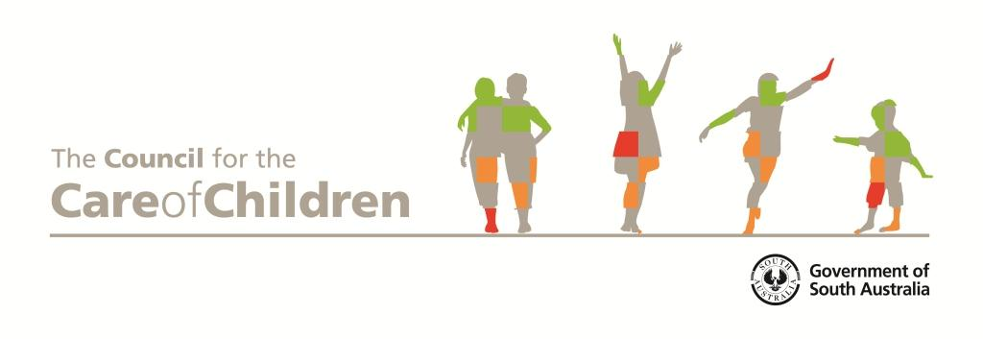

20 February 2014

Enquiries about or comments on this submission should be addressed to:

The Council for the Care of Children
GPO Box 1152
Adelaide SA 5001
AUSTRALIA

Phone: (08) 8463 6429 or
Email: ChildrenSA@sa.gov.au

The Council for the Care of Children
The South Australian Government established the Council for the Care of Children (the Council) in 2006 under the Children’s Protection Act 1993 (SA) and the Council’s functions and responsibilities extend to all children and young people from birth up to 18 years of age.

In looking out for children and young people across all communities and sectors in South Australia (SA), the Council advises government and other key stakeholders with the aim of ensuring children and young people in SA are cherished, nurtured and respected.

Broadly speaking, the Council’s role and goals in SA can be summarised as:
- advocating for and supporting the active participation of children and young people as valued citizens
- improving outcomes for children and young people by providing expert advice to government on their rights, needs and interests and the implications for policy, practice, and research
- raising awareness of issues impacting on children and young people
- monitoring the wellbeing of children and young people from before birth up to the age of 18 years and
- promoting the wellbeing, safe care and development of vulnerable children and young people (especially those living with disability and/or who are under the guardianship of the Minister and/or who are of Aboriginal or Torres Strait Islander descent.

The Council’s work is informed by the principles of the United Nations Convention on the Rights of the Child, the United Nations Convention on the Rights of Persons with Disabilities and the United Nations Declaration on the Rights of Indigenous Peoples.

Inquiry on Childcare and Early Childhood Learning (the Inquiry)
The Council has carefully reviewed a very comprehensive submission to the Inquiry from Early Childhood Australia (ECA). The Council endorses the ECA submission and makes the following additional comments and/or recommendations:

Outcomes framework
Recommendation four of the ECA submission recommends the development of an outcomes framework for early childhood education and care (ECEC) to measure the impact of higher quality programs at the individual and system level. The Council has developed such a framework in South Australia (SA) and, page 11 of the ECA submission refers to the first edition of the Council’s monitoring framework, Look out for young South Australians: A framework for improving the lives of young South Australians. The Council is pleased to bring to the Inquiry’s attention, the updated second edition of the monitoring framework, A snapshot of young South Australians, June 2013. The framework has been developed from the UK’s Every Child Matters and reports outcomes in five dimensions of the lives of children and young people in South Australia including that they:
- are healthy (enjoying good physical and emotional health and living healthy lives)
- stay safe and are nurtured (being cared for and nurtured and protected from harm and neglect)
- enjoy and achieve getting the most out of life and developing skills for life, according to their capabilities)
- make a positive contribution (being actively involved with their peers, families, culture, community and society, according to their capabilities) and
- are prepared for adult life (gaining knowledge and skills to participate as adults and not being prevented by social and economic disadvantage from achieving in life).
The Council recommends that the Inquiry considers A snapshot of young South Australians, June 2013 as it may inform the development of a nationally agreed framework. A snapshot of young South Australians, June 2013 is available at http://www.childrensa.sa.gov.au/wellbeing/outcomes-framework.html#snapshot and a copy is attached.

Social inclusion and disadvantage
The Council supports the ECA statement that schools are ideally placed to provide out of school hours care (OSHC) to their local communities and should be purpose built with, or be renovated to provide, dedicated OSHC facilities. The Council also finds these ECA statements compelling:
- community understanding of the benefits of formal ECEC is varied and
- children who are disadvantaged have the most to gain from quality early childhood education and care in terms of their subsequent achievement at school, in employment and being socially included at every stage of their lives.

Children in Australia who are disadvantaged as a result of living in a rural or remote locations, being from an Aboriginal or a culturally and linguistically diverse background with a limited ability to communicate in English, who live with disability and/or who are under the guardianship of the Minister make up some of the groups of children who have the most to gain from early ECEC.

Like ECA, the Council endorses the SNAICC recommendations for a long-term national strategy for early childhood development for Aboriginal children, mapping of current service gaps that limit access to ECEC for Aboriginal families and working with local Aboriginal communities in providing ‘integrated, child, family and community centred services’.

For new arrival families and for families on a low income the cost of access to ECEC services may be prohibitive, yet the children from these families can benefit and contribute so much to a typical ECEC service. In addition to them and others learning about diversity and equality and respect, their involvement may broaden educators’ skills and knowledge. It may also provide their parents with networking and socialising opportunities. Participating in an ECEC service in an inclusive setting has the potential to improve one’s confidence, social skills and social development and to enhance one’s physical and emotional wellbeing.

Disability
The Council supports the ECA statement that ‘15 to 20 per cent of children have additional needs which suggest that a significant number of ECEC services would be or could be working with special needs children and their families’.

Access by children with additional needs to ECEC is lower than for those who do not have special needs. Children and young people with additional needs encounter overt and covert discrimination, not only in terms of access but also in terms of having their needs met even if they do have access. The mere fact that a child or young person living with a disability is accessing a particular service does not necessarily equate to them being socially included or having their needs met.

In addition to OSHC children and young people with additional needs require other services that are tailored to their needs including specialised programs and services in an environment that is quieter. The typical OSHC setting may be noisy and a child or young person with special needs may become overwhelmed and/or agitated in such an environment. This may also impact on their capacity to learn. In particular, there is a shortage of OSHC and other suitable services for young people in their teenage years.

Conclusion
Thank you for an opportunity to provide these brief comments to the Inquiry.

The Council may be contacted by telephoning the Secretariat Office on
(08) 8463 6429 or by sending an email to ChildrenSA@sa.gov.au.

The use of the term ‘Aboriginal’ is inclusive of ‘Aboriginal and Torres Strait Islander’.

