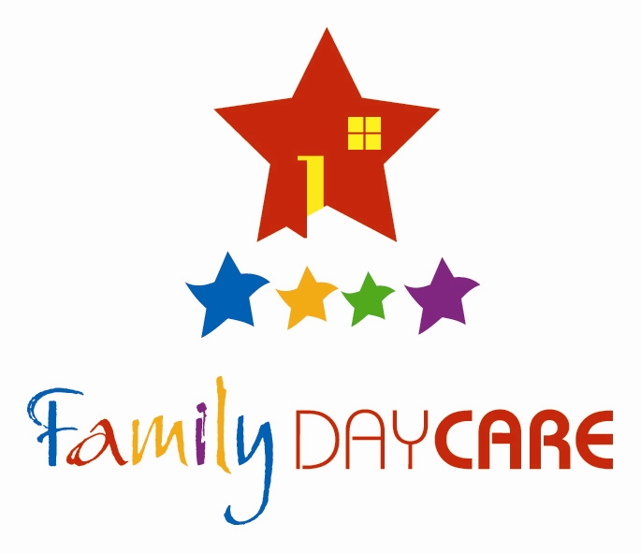
PO Box 661
Childers Qld 4660
4/75 Churchill St
Childers Qld 4660
Phone: (07) 4126 2856
Email: isis@fdcaq.com.au
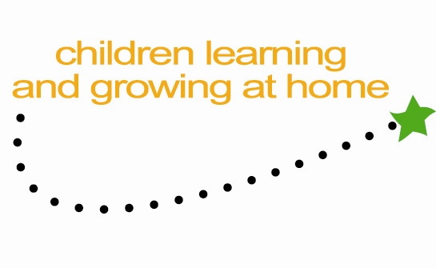

Isis

05.09.14

Regarding the Productivity Commission into Early Childhood Education and Care

My name is Leanne Fuller and I am the Manager of a small Family Day Care service in a regional town in Queensland. I am writing this submission because I feel that some of the recommendations made would be both unnecessary and also detrimental to children. I have dedicated 26 years of my life to children and to the provision of good quality education and care, in both long day care settings and Family Day Care, to achieve great outcomes for those children into the future.

Below are some points I would like to highlight.

- I am extremely disappointed in the commission’s recommendation to “split” the sector into “Care only” for younger children and “Early Learning” for 3 to 5 year olds only. We have spent years now implementing the National Quality Framework which has seen our industry become more qualified and better armed to provide learning through play to children from birth. There is no pressure in this learning, it occurs both naturally and is built upon by the educators, and also occurs through intentional teaching which targets milestones etc that children need to meet to make a smooth transition to school.
To make a recommendation like that in the face of all the scientific research on children’s brain activity and the fact that more learning happens in the first 5 years of life (Not just between 3 and 5 years) seems ridiculous.
Children who attend “care” deserve to have a qualified person from birth to maximise both the care and the learning experiences. I believe we must retain the sector wording of early childhood education and care as a whole.

- The recommendation of a “deemed fee” of $6.87 for Family Day Care in no way takes into account the loss of Community Support Funding and the impact this will have on the 1000’s of families which use Family Day Care as a more flexible education and care option for their children.

- The recommendation that nannies be included under the NQF as an education and care model I think is a good one. I think that Family Day Care already has the infrastructure, processes and model which could support the inclusion of nannies as part of our current operations. Home based monitoring and support could be for educators in their own homes or for educators in the child’s home. We can use some of the ideas from In Home Care without the cost of setting up new models.

- I definitely do not support the recommendation to remove Family Tax Benefit from families who do not send their children to “Approved Kindergarten Programs” Families should absolutely have the right to choose the best education and care option for their family and their child. And what about small rural communities who may not have access to an approved kindergarten programme. How on earth would this be managed and decided upon?

- I think the combination of the different subsidies such as CCB, CCR, JET etc is a fantastic idea as the current system is impossible for so many families to understand and manage. However I think consideration needs to be given to the fact that families don not end up worse off than they are now. Particularly the lower economic families. Once again, with the loss of Community Support funding, we are facing the issue of how those funds are to be replaced the FDC sector, so we do not want families to have to pay more on top of our possible rises.

Thank you for the opportunity to make a submission.

Leanne Fuller
Manager Isis Family Day Care

