Attachment 1 -ALGA CLIMATE CHANGE IMPLIMENTATION PLAN
2010 - 2014

This implementation plan responds to the Outcomes, Outputs, Pathways and priorities developed at the National Climate Change Leaders Forum facilitated by the Australian Local Government Association (ALGA) on April 2010.

The Forum identified 6 high level outcomes that local government should seek to promote by 2014. These are:

- All sectors of the community are informed and engaged in policies and programs to address climate change
- Climate change is embedded in everything local government does
- Strong regional, state and national collaborations to address climate change.
- That policies, regulation and incentives are aliened to achieve a coordinated approach to address climate change.
- Seeking to develop strategies to ensure long term funding capabilities to address climate change
- That business and the community begin to realise the economic benefits by addressing the opportunities arising from addressing climate change.
A Draft Strategic Plan 2010 – 2014 was developed. This Strategic Plan identified 11 outputs to achieve these outcomes and 8 pathways were specified to achieve these outputs. This Implementation Plan outlines the actions that ALGA will pursue at the national level to realise the Strategic Plan 2010 - 2014. Following consideration by the ALGA Board 2 of the 11 outputs have been collapsed into other outcomes as it was felt that they were mechanisms to achieve the desired output.

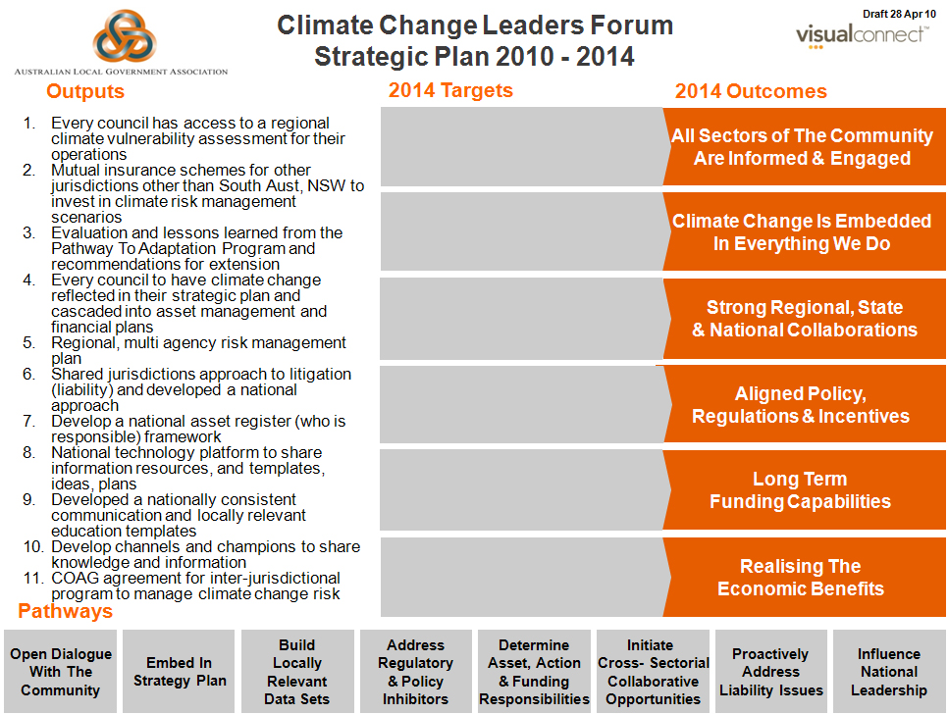

Policy Output 1 Improved Local Data and Information to Assist Councils to Address Climate Change

Understanding climate change and the potential impact of climate change is essential for informed decision-making. A basic building block for research, risk assessments and risk management is appropriate quality and locally relevant data. Comprehensive data is gradually being developed at the national level and constantly being improved. As the science and data improves it is expected that more locally and regional relevant and data and / or estimates will be available. This program is designed to ensure that local government’s needs are understood and responded to by key data providers. ALGA will also seek to ensure that adequate resources are provided to facilitate this work as a priority.

Policy Output 1 |  |  | Improved local data and information to assist councils to address climate change
Driver | Projects | Priority | Links to other policies | Policy Players | Project Outputs | Measures of success | Risks to success | Mitigation Actions
Lack of suitable locally relevant data sets to inform risk assessment and risk management | ALGA will work with key data agencies to improve data availability at the local and regional level | High | Asset management,  Output 2,3 and 4 | COAG, Australian Government, CSIRO, BOM, ABS, NCCARF and state and territory associations | National data that is locally relevant | Available to councils at a reasonable cost | Technical limitations of existing methodologies and resources | Strong political support for this project

Policy Output 2 Accelerate Risk Assessment and Risk Management Planning Across Local Government

Addressing climate change will require careful planning and targeted investment over time. It is important that local government adopt a risk based approach to planning and decision making. The Australian Government has provided some funds through the Pathways to Local Adaptation program to assist around 90 councils to undertake risk assessment projects. The South Australian Local Government Association and New South Wales Local Government and Shires Association have also been working with their Mutual Insurance Schemes to assist councils within their state to systematically undertake risk assessment projects. ALGA in partnership with state and territory associations will seek to assist all councils to undertake appropriate risk assessment projects by 2014, subject to resources.

Policy Output 2 |  |  | Accelerate risk assessment and risk management planning across local government
Driver | Projects | Priority | Links to other policies | Policy Players | Project Outputs | Measures of success | Risks to success | Mitigation Actions
Identification of risks and risk management under plausible scenarios local data | Work to provide additional resources and support for local government to undertake risk assessment and risk management scenario planning. | High | Draw out lessons from the Pathways to Adaptation Program and provide access to these learning to councils. | Australian Government, Mutual Insurance Schemes through state and territory local government associations. | Councils across having identified the risks and developed management strategies to address climate change. | A significant increase in the number of councils with risk assessment and risk management plans. | Lack of access to skilled staff and resources including at ALGA and state and territory association levels. | Collaborate with state associations and Mutual Insurance Schemes to access appropriate support to councils.

Policy Output 3 Embedding Climate Change into Local Government Strategic and Corporate Plans

The impacts of climate change are far reaching and cannot be dealt with in isolation. Climate change must be integrated across all areas of local government’s work. In particular, climate change needs strong political leadership which must be reflected through council’s corporate and strategic planning frameworks. ALGA can provide national leadership and advocacy to encourage the sector to adopt an integrated approach to climate change. Most state and territory associations provide training services to their members and ALGA will work with the associations to encourage them to incorporate appropriate material into elected member and senior management training material.

Policy Output 3 |  |  | Embedding climate change into local government strategic and corporate plans
Driver | Projects | Priority | Links to other policies | Policy Players | Project Outputs | Measures of success | Risks to success | Mitigation Actions
Adaptation to climate change requires a whole of council approach. | Work through state and territory local government associations to ensure that climate change is embedded into local government corporate and strategic training planning programs. | Medium | Training and development agencies for local government, see also policy outcomes 8 | Work with Government Skills Australia and the Australian Centre of Excellence for Local Government to ensure that climate change is included in all training programs. | Suitably skilled councillors and council staff to address climate change challenges. | A significant increase in the number of council’s strategic plans and corporate plans that embed climate change. | Lack of awareness and or competing priorities. | Collaborate with state associations to ensure advocates at a council level gain appropriate support.

Policy Output 4 Integration of Council Plans with Regional Plans

Solutions to address climate change will often exceed the boundaries of individual councils. Regional approaches will need to be developed to assist coordination of action on an appropriate scale. Councils will need to understand how their actions will compliment the actions of neighbouring councils and understand the impacts of their actions on others. These actions need to be taken at a local, regional and state level and as such ALGA has a limited direct role in facilitating this activity. However, at a national level will advocate for policy alignment and integration of local, integrated regional planning and resources to support this approach.

Policy Output 4 |  |  | Integration of council plans with regional plans
Driver | Projects | Priority | Links to other policies | Policy Players | Project Outputs | Measures of success | Risks to success | Mitigation Actions
Impacts of climate change are not limited by council boundaries. | This area of work is best developed by state and territory associations. ALGA can promote regional collaboration and cooperation through relevant intergovernmental forums. | Low | Regional development and Policy outcome 1 | State and territory associations and state, territory governments, Regional Organisations of Councils (ROCs) and relevant stakeholders. | Increased awareness of the need for regional collaboration and regional planning. | An increase in the number of regional plans and evidence of collaboration through joint initiatives. | Competing priorities | Advocacy on the urgency to address local and regional climate change issues.

Policy Output 5 A Shared Approach to Legal Liability and Litigation Arising From Climate Change.

Local government is required to implement a range of state and territory legislation and take Commonwealth legislation into account particularly in land use planning and development approvals. Imprecise scientific data and information and vague legislative drafting providing councils with considerable discretion to interpret state requirements expose local government to potential litigation. Councils need clearer guidance on key planning thresholds including for example but not limited to sea level change, in order to make legally enforceable decisions.

Policy Output 5 |  |  | A shared approach to legal liability and litigation arising from climate change
Driver | Projects | Priority | Links to other policies | Policy Players | Project Outputs | Measures of success | Risks to success | Mitigation Actions
Increasing risk of litigate brought against councils challenging council decision making in particular in respect of land management decisions. | Work through COAG to develop a national approach to manage the risk of litigation and support council decision making. | High | Planning and Development, emergency management agencies | COAG and Attorney General. | Greater clarity on councils’ authority and legal defence in regards to decision required by state or Commonwealth legislation. | Strong guidance for councils on actions required to fully discharge their responsibilities. . | Lack of a timely agreement on key benchmarks e.g. sea level changes. | Work through COAG and Local Government and Planning Ministers to express the urgency of this action.

Policy Output 6 Greater Clarity on Roles and Responsibilities in Particular on the Management of Public Assets
Protection of and maintenance of public assets to support local communities is a critical role for governments. While acknowledging the need for asset owners to manage their own assets there are 2 critical exceptions. 1) network assets and or contiguous environmental assets, and 2) where the scope of the task ahead to adapt to climate change may be beyond the capability of individual councils without assistance. Networks such as roads or contiguous environmental assets such as water ways or biodiversity corridors require a shared approach to the management of the asset. The actions of one level of government might be negated if others fail to act. At a local level the maintenance of critical infrastructure under different climate change scenarios may require considerable investments that will be beyond the capability of a single council. There needs to be an intergovernmental mechanism in place assist these councils.

Policy Output 6 |  |  | Greater Clarity on roles and responsibilities in particular on the management of public assets.
Driver | Projects | Priority | Links to other policies | Policy Players | Project Outputs | Measures of success | Risks to success | Mitigation Actions
The management of and maintenance of public assets under different climate change scenarios may require considerable investment. | Develop a framework to assist governments to identify the responsibilities of each level of government and joint responsibilities to manage public assets. | Medium | NA | State associations, emergency management agencies, Local Government and Planning Ministers, Australian Government and state/territory governments. | A Framework to guide negotiations and or funding proposals. | Greater acceptance of own responsibilities as well as an understanding of potential assistance where the council is overwhelmed by the scope of the task/issues. | Cost shifting | Greater acceptance of an adapted benefit risk assessment methodology to assign risks.
Policy Output 7 National Technology Platform to Share Information, Resources, Templates, Ideas and Plans

The proliferation of information, data, resources, tools and planning methodologies has resulted in information rich environment. However, dissemination of this information still remains problematic. To date the commissioning of research, development of materials, methodologies etc has been ad hoc and discovery of this information is extremely inefficient. A number of academic institutions have an interest in research, sharing information and making their work relevant to the local government sector.

Policy Output 7 |  |  | National technology platform to share information, resources, templates, ideas and plans.
Driver | Projects | Priority | Links to other policies | Policy Players | Project Outputs | Measures of success | Risks to success | Mitigation Actions
The need to learn from each other and share experiences between councils and other relevant experts. | Develop national technology platform for climate change which is relevant to local government. | Medium | NA | National Climate Change Research Adaptation Framework (NCCRAF).  Australian Climate Change Adaptation Research Network for settlements and Infrastructure. | A local government climate change portal | The establishment of a dynamic managed climate change portal. | Resources and on-going management | Work with key national agencies that have strong support from Government.

Policy Output 8 Nationally Consistent Communication and Locally Relevant Education Templates

Local government has a strong leadership role at the national, state and local level. At the national level ALGA represents the interests of local government and will strongly advocate its national climate change policy including this climate change adaption plan. It is important that local government across the country are aware of and support ALGA climate change policy and have resource material available to assist them communicate with their local community on the need to address climate change as well as their plans to address climate change at the local level. A key focus of any communication to business and community members is that climate change is a shared responsibility and that all stakeholders have a responsibility to act.

Policy Output 8 |  |  | Nationally consistent communication and locally relevant education templates
Driver | Projects | Priority | Links to other policies | Policy Players | Project Outputs | Measures of success | Risks to success | Mitigation Actions
The need for resources to assist local government in its advocacy and role in educating the community on climate change challenges. | Develop of tools and information to assist local government to advocate and educate the community on climate change. | High for an ALGA Policy and Medium for education material | See policy outcomes 3 | ALGA, and State and territory associations | ALGA Policy Statement and resource material for councils through state association training authorities. | Adoption of an ALGA Policy position by December 2010 and development of relevant educational material for local governments by 2012 - 13. | Lack of national agreement | Work with all state and territory associations on the development of the policy.
POLICY OUTPUT 9 POLICY ALIGNMENT BETWEEN THE THREE LEVELS OF GOVERNMENT

Solutions to address climate change will often require collaborative action and policy alignment between all levels of government. Actions taken at one level must compliment the decision made by others. The needs to be a national agreement to align priorities, policies and strategies to address climate change.

Policy Output 9 |  |  | Policy alignment between the three levels of government
Driver | Projects | Priority | Links to other policies | Policy Players | Project Outputs | Measures of success | Risks to success | Mitigation Actions
The need to ensure that policies adopted by each level of government are aliened to avoid lack of clarity, confusion and to optimise the utilisation of government resources. | Continued advocacy and collaboration in the COAG and Local Government and Planning Ministers (LGPMC) on Climate Change.* | High | See policy outcomes 4 and 5 | ALGA, Commonwealth and state jurisdictions | On-going commitment to a national climate change adaptation framework | COAG Agreement | Lack of national agreement | Continued advocacy and development of quality inputs on local government needs.
- COAG Adaptation Working Group, LGPMC National Planning Framework for Change Mitigation and Adaptation.

