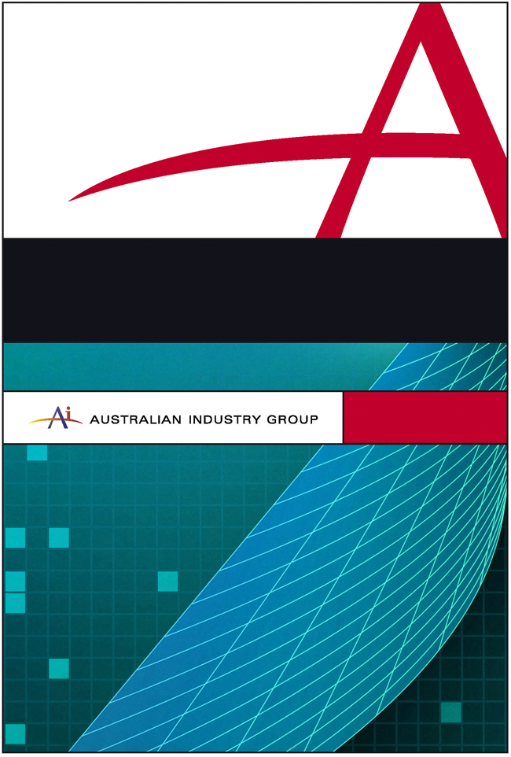

Submission to THE PRODUCTIVITY COMMISSION
Response to the Productivity Commission’s
Draft Report on Default Superannuation Funds in
Modern Awards

August 2012
Response to the Productivity Commission’s
Draft Report on Default Superannuation Funds in
Modern Awards

Introduction

Ai Group filed a detailed submission to the Productivity Commission’s public inquiry into Default Superannuation Funds in Modern Awards in April 2012. In the submission, we expressed support for the retention of default funds in modern awards and proposed criteria and a process for the selection and ongoing review of such funds.

In this submission we respond to the Commission’s June Draft Report having had the benefit of participation in a public hearing with the Commission on 30 July.

There is significant overlap between the criteria and process proposed by Ai Group and the criteria and process proposed by the Commission in the Draft Report.

Outcomes from the current system

In the Draft Report the Commission recognises that the current default superannuation arrangements have delivered stability and above-average investment returns. Ai Group agrees with this assessment.

Despite the positive outcomes which the existing system has delivered, the Commission proposes changes to the current system to better align the default superannuation arrangements with the important principle that the arrangements must meet superannuation fund members’ best interests. Ai Group supports this principle and agrees that changes are needed to the existing system.

Proposed features of a new system

The Commission proposes that the new system should:

- Place the best interests of members as the explicit overarching objective in any criteria for the selection and ongoing assessment of default superannuation funds in modern awards;
- Promote contestability;
- Promote transparency;
- Be procedurally fair;
- Impose a minimum regulatory burden;
- Promote stability in the superannuation system;
- Be consistent with other relevant policies;
- Have scope for regular assessment.

Ai Group concurs that the new system should have the above features.

Selection criteria

The Commission has identified that the criteria that will be administered by APRA for MySuper product authorisation provide a sound basis for the selection and ongoing assessment of superannuation funds for listing as default funds in modern awards, but the following factors should also be taken into account:

- Investment performance;
- Fees charged to members;
- Governance and transparency; and
- Insurance, financial advice and administrative efficiency.

Ai Group agrees with the Commission that the MySuper criteria to be administered by APRA need to be included within the criteria for the selection and ongoing assessment of default funds but that additional factors should be also taken into account.

We agree the four additional factors mentioned above should be included. This includes our agreement with the Commission’s view that the likelihood of members being switched to higher cost divisions of a fund, or facing significantly higher fees upon exiting employment should be considered as a factor to be taken into account. Ai Group listed “flipping” as an important issue in our original submission.

While we support these additional factors, we also propose that three additional factors should be taken into account in assessing default funds.

- Whether the fund is currently listed as a default fund in a modern award

Ai Group proposes that, in addition to the factors proposed by the Productivity Commission, whether a fund is currently listed as a default fund in an award should also be taken into account as a factor in assessing the default funds listed in awards.

It is quite likely that in a reassessment of default funds to be listed in awards there would be only marginal differences between some funds that might be included and some that might not be included. These differences could well relate to the vagaries of the ranking methodology employed. In these circumstances, even putting aside the costs involved in changing funds, it is likely there would be a reasonable doubt whether a move was advantageous. Once the costs of moving were taken into account, even further doubt would arise.

Changing the default funds in awards will not be costless either for employers or employees.

- Changing default funds would impose a substantial compliance burden on employers. In addition to changes in payment arrangements and the like, it would also require an employer to identify which employees had chosen to contribute to funds previously listed in an award and which employees were members of these funds as a result of their being listed as default funds.

- Similarly, asking employees to become accustomed to a new fund, to provide a new fund with information already provided to their existing fund, to reassess insurance offerings and other features of the new fund and to re-nominate their beneficiaries in the event of the employee’s death, would impose a burden upon employees.

Including the criterion of whether a fund is currently listed as a default fund in the award as a factor to be taken into account in the reassessment of default funds is a simple way to have these costs included in considerations.

The cost of moving to new funds was no doubt a key factor why the criterion of whether a fund was listed in a pre-modern award was adopted by a Full Bench of the Australian Industrial Relations Commission (AIRC) during the award modernisation process.

- The views of major representative bodies of employers and employees in the relevant industry

Representative bodies of employers and employees play a vital role in representing the interests of their members. It is important that the views of such organisations be taken into account. This criterion was determined as being important and appropriate by a Full Bench of the AIRC during the award modernisation process.

- Whether a substantial proportion of the employees in the industry or occupation covered by the modern award are members of the fund

This is an important criterion because only a limited number of funds should be specified as default funds in each modern award (five to 10, as recommended by the Commission) to avoid confusion and complexity. A fund with a substantial portion of members in an industry should be listed ahead of other funds, taking into account the other criteria.

Applying the selection criteria

The Commission has identified four options for applying the selection criteria:

Option 1: Each employer chooses a fund from all of those that offer a MySuper or other approved default product.
Option 2: Industrial parties assess all potential funds and nominate five to 10 funds to FWA for listing in awards.
Option 3: Decisions on which funds to list as default funds would be made by an FWA panel.
Option 4: Decisions on which funds to list as default funds would be made by an expert body independent of FWA.

In its Draft Report, the Commission argues convincingly against Options 1 and 2 and expresses a preference for Options 3 and 4.

Ai Group agrees with the Commission’s arguments against Options 1 and 2.

Ai Group supports Option 3. Awards are industrial instruments which are made and varied by FWA. Decisions on what provisions should be included in modern awards (including default superannuation funds) should be made by an FWA Panel with appropriate expertise.

Ai Group does not support Option 4. Option 4 would involve, in effect, an external body directing FWA on what terms it must insert in awards. This is not appropriate and it would appear to raise significant jurisdictional problems. FWA has been given the power under the Fair Work Act to determine the content of awards. It is open to Parliament to remove such power but Parliament has not done this. If FWA is to have the power to make decisions on the inclusion of particular content in awards (including default funds), the Tribunal must have the power to determine what that content will be within the framework set out in the Act. Option 4 would involve legislation which purports to give FWA a decision making power, but in effect totally removes that power and requires the Tribunal to take directions from an external party. There would appear to be significant difficulties with drafting valid legislation to achieve this outcome.

Timing of reviews

In its April 2012 submission Ai Group proposed that FWA’s 4 Yearly Reviews of modern awards would provide the ideal opportunity for the default funds to be reviewed by FWA.

In its Draft Report the Commission proposes a wholesale reassessment every eight years, with a ‘light-handed interim assessment mid-way between each wholesale reassessment.

In Ai Group’s view, a review every four years is preferable given the importance of the default fund system. The review should not require existing default funds to reapply for inclusion in the award. So long as an existing fund continues to satisfy the criteria for listing as a default fund, the fund should not be removed from the award. It would be disruptive and confusing for employers and employees if a completely new list of default funds is included in each modern award following each review. This would require a very large number of employers to change their default funds after each review, which would impose a substantial compliance burden.

In its Draft Report, the Commission proposes that an independent public review into the new default superannuation fund system be conducted in 2023. Ai Group supports this proposal but this should not prevent any problems which become apparent being addressed at an earlier time.

Draft Recommendation 8.2

The Commission has recommended that employers be permitted to choose a fund not listed in the relevant award, provided that they can justify their choice by demonstrating that they considered the factors identified by the Commission and their employees are no worse off than if a fund listed in the award had been chosen.

Ai Group is of the view that this recommendation is not desirable for the following reasons:

- Allowing such choice is inconsistent with the concept of listing default superannuation funds in awards;
- The proposal would create significant risks for employers, for example, if a fund selected did not perform well over the period following its selection by the employer, and the employees or their union challenged the selection on the basis that the employees were ‘worse off’;
- The proposal is likely to lead to disputation and litigation given the vague nature of the criteria which would need to be satisfied; and,

- There is considerable scope for actual and perceived conflicts of interest to arise under this proposal and we anticipate that this would give rise to requirements for new regulatory arrangements and new sources of compliance cost for business.

The draft recommendation that employers be permitted to choose a fund not listed in the relevant award appears to conflict with at least some of the reasoning behind the Commission’s rejection of Option 1 above (i.e. that each employer chooses a fund from all of those that offer a MySuper or other approved default product).

Among other reasons, the Commission put forward the following arguments against Option 1.

“Best interests of members
This option does not address the principal–agent problems inherent in a default superannuation system .... Rather, it shifts the burden of the decision from industrial parties to employers, who do not necessarily have the interest or expertise to make a decision that is aligned with the best interests of employees and who, like the industrial parties, can be faced with conflicts of interest.

Transparency
Under this option, there would be little improvement in transparency about the way a default fund is chosen for a member. In the current process, while FWA generally provides an explanation for its decision, its grounds for assessing each application do not lend themselves to the need to disclose much detail or relate the decision to the best interests of members….Under this option, that opaqueness would shift to the way that an employer selects a fund for their workplace.
Procedural fairness
It is somewhat difficult to assess the procedural fairness principle under this option, as the ‘decision maker’ is the employer, not a government organisation and there is no procedure that would be followed that could be deemed as being fair or unfair.
Avoiding instability
This option has the greatest potential to cause instability in the system — especially in the short term. Opening up the market for default funds in awards could induce a high degree of switching initially, and then frequent switching thereafter. This would particularly be the case if funds choose to embark upon aggressive marketing campaigns and were persistent in doing so, as occurred in Chile in the 1980s and 1990s before regulations to limit switching were introduced ....

Consistency with other policies
[Option 1] ... runs counter to the recent Future of Financial Advice (FOFA) reforms that reduce the potential for conflicts of interest where financial decisions are made by third parties. Many small employers readily concede that they do not have the expertise to choose superannuation funds available, and do not have the resources available to gain that expertise..

Regular assessments
There is no assessment mechanism built into this option. Employers would not be obliged to assess the appropriateness of the default fund at any time. This would be at the employer’s discretion. Given the principal–agent issues, many employers would probably face little incentive to assess their choice, once it is made, to check if it is still in the best interests of members (though they might switch for other reasons such as administrative convenience or improved financial outcomes for the business where superannuation is bundled with other services by a financial institution).

Ai Group acknowledges there is an important difference between Option 1 and Draft Recommendation 8.2 and that Option 1 contemplates the requirement that employers choose default funds whereas Draft Recommendation 8.2 permits employers to opt to choose the default fund. However, the arguments listed above do not seem to be any less relevant because of this distinction: the principal-agent and conflict of interest points in particular still apply.

Ai Group anticipates that, if Draft Recommendation 8.2 is adopted, similar arguments as those used by the Commission in rejecting Option 1 would be used in support of the introduction of new regulatory, reporting and monitoring arrangements designed to constrain employer choice and to attempt to improve outcomes for members.

Draft Recommendation 8.3

The Commission’s argument in support of Draft Recommendation 8.3 was as follows:

Giving employers the discretion to choose a fund not listed in the relevant award means that they could continue to make contributions to the fund they are currently using if they can demonstrate their employees are no worse off than if a listed fund had been chosen. In light of this, the Commission sees no case for retaining any type of grandfathering arrangements.

In our view Draft Recommendation 8.2 should not be adopted and, if this is the case, the Commission’s reasoning in support of Draft Recommendation 8.3 would not apply.

Ai Group opposes the abolition of grandfathering arrangements, as recommended by the Commission. Such arrangements have been common in awards since the late 1980s. For example, an employer who was using a particular complying superannuation fund prior to the making of the Metal Industry (Superannuation) Award in 1989 was entitled to continue to use that fund after the award was made. The employer is still entitled to use that fund as a default fund because the pre-modern award exemptions have been preserved through the grandfathering provision in modern awards.

In Ai Group’s view, in these long-standing arrangements, the MySuper requirements are likely to offer adequate protections to members.

For example, the Manufacturing and Associated Industries and Occupations Award 2010 includes the following in the list of default funds in subclause 35.4:

(k) any superannuation fund to which the employee was making superannuation contributions for the benefit of its employees before 12 September 2008, providing that the superannuation fund is an eligible choice fund.

Grandfathering arrangements like the above need to remain in awards. Such arrangements will operate on the basis that only funds which offer MySuper products will be eligible to accept default contributions.

Draft Report, Page 8.
Draft Report, p.12.
Draft Report, page 20.
Draft Report, page 20.
Draft Report, pages 152-154.
Draft Report, page 157.
Draft Report, page 20.

