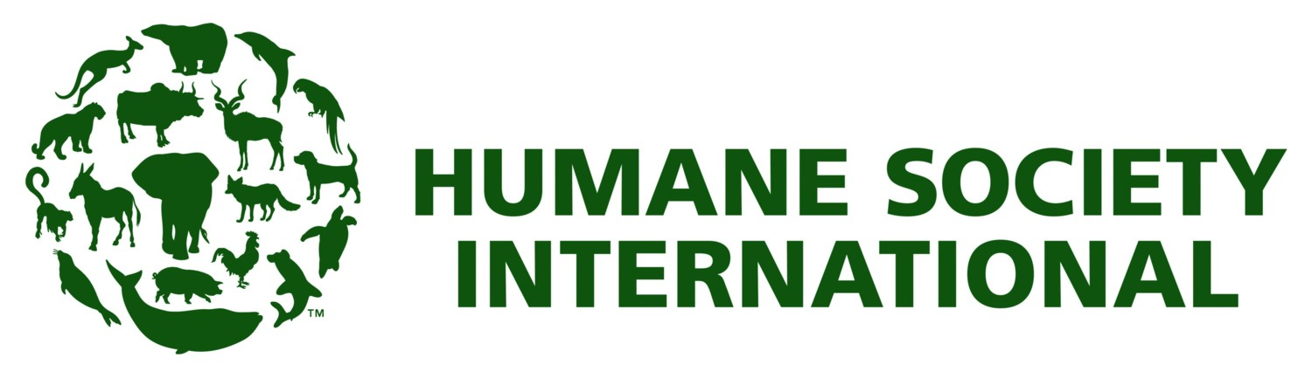

Humane Society International Inc.  ABN 63 510 927 032  PO Box 439  Avalon NSW 2107  Australia  Telephone (612) 9973 1728  Facsimile (612) 9973 1729  Email admin@hsi.org.au  www.hsi.org.au  Board of Directors:  Verna Simpson  Michael Kennedy  Peter Woolley  Elizabeth Willis-Smith  Dr John Grandy  Dr Andrew N Rowan  Jean Irwin  US Office:  Washington DC  Regional Offices:  UK/Europe  Canada  Latin America/Costa Rica | Natural Disaster Funding Arrangement  Productivity Commission  LB2 Collins Street East  Melbourne Victoria 8003  By Email: disaster.funding@pc.gov.au  17th June, 2014  Dear Sir,  Re: Submission to the enquiry into natural disaster funding  Humane Society International (HSI), one of the world’s largest animal protection organisations, writes on behalf of our 60,000 Australian supporters in regards to the funding for safety, rescue and treatment of companion animals and wildlife during natural disasters in Australia.  Last years’ disaster which caused severe flooding in Bundaberg, Queensland, clearly demonstrated the trend towards pet owners refusing to evacuate without their pets. The experience of a disaster would be traumatic enough without the added stress of the deliberating decision of whether or not to leave your pets behind. Most people describe their animals as being part of the family, and many choose not to leave disaster situations themselves in order to ensure the safety of their animals. This highlights the need for funding for agencies which would allow people to evacuate with their pets, given the importance of the human-animal bond, the wellbeing of pet owners, and the welfare of the animals.  HSI believes that funding should be improved for this sector of natural disaster management with greater focus on rescue and rehabilitation of animals within disaster plans. We urge you to consider funds for centres in which to treat wildlife and companion animals, and to manage the resources and volunteer assistance needed. Adequate resources for emergency incidents involving companion animals and wildlife is vital in ensuring not only the health and wellbeing of the animals, but humans as well. Studies have shown that owners recover better post emergency knowing that their animals have been cared for.  Wildlife recovery post disaster should be considered an important aspect for funding. Communities have been found to place great importance on the rescue and recovery of wildlife in disasters and funding to integrate wildlife and threatened species into the management and planning for natural disasters is therefore likely to improve the recovery and resilience of both animals and the community post-disaster. Due to the considerable experience and dedication of volunteer wildlife carers throughout Australia, HSI suggests that planning funds be allocated to facilitate partnerships between emergency services and local wildlife care groups where appropriate. It is anticipated that such partnerships will allow government agencies overwhelmed with disaster recovery to call on volunteer carers to ensure the capacity to provide relief for injured wildlife is maximised. Furthermore, disasters often see natural food sources destroyed and carers inundated with injured wildlife, and HSI is of the strong opinion that management funds should be allocated to support the associated and often significant care costs for those involved in wildlife rehabilitation, as well the provision of relief efforts such  as wildlife food drops in heavily impacted ecosystems.  The South Australian Veterinary Emergency Management Inc (SAVEM Inc.) and the Victorian Emergency Animal Welfare Plan are both great examples of what adequate funding for animals can achieve for disaster management. The SAVEM plan works through the establishment of regional coordination centres and enables volunteer animal workers such as veterinarians, vet nurses and wildlife carers to respond to disaster incidents involving companion animals and wildlife through triage, treatment and rescue. The above plans work by aiding other emergency agencies, and supplementing the work of emergency services. The plans help by re-uniting animals with their owners - contributing to the welfare of humans and the community. It has been found that when animal rescue teams and emergency teams operate together, people are evacuated faster as both owner and animal can leave together.  In August 2005 Hurricane Katrina struck the US and approximately 1,800 people and hundreds of thousands of animals died. Some people lost their lives because they refused to leave animals behind, and 44% of people who stayed behind cited pets as the reason. As a result, The Pets Evacuation and Transportation Standards Act (PETs ACT) was enacted into US Federal legislation. The PETs ACT means that states are required to take companion animals and service pets into consideration when formulating disaster planning.  This law, and the initiatives like it in SA and VIC, have gone a long way towards saving the lives of both people and animals affected by disasters. Therefore, HSI would like to suggest that a small pool is set aside to facilitate these partnerships nationwide, as well as some more for supporting the additional expenses of carers during these events. To ensure that entities are prepared for a response it is essential to have necessary equipment for emergency housing such as crates, carriers, bowls and collars. Examples from disaster management in the United States reiterate that partnerships between animal rescue organisations and those which do emergency housing for people are the most practical option. Partnerships assist in the ease of animal evacuation, as it allows people to care for their own animals taking the burden away from staff and volunteers. Animals can be become fearful and stressed in situations such as disasters and through separation from their owners. If partnerships are not possible it is important to have access to other facilities, ideally with trained volunteers who can expertly assist in animal handling, which will require some funding.  Animal rescue should be included in the funding for disaster plans, which can help to build improved systems of animal-friendly evacuation centres, animal rescue and effective animal treatment. Funding for this type of emergency response would enable owners to take animals with them if a natural disaster strikes, and wildlife or injured individuals have safe areas in which to be treated.  HSI would like to thank you for your attention to this important matter and we look forward to your response.  With thanks and regards,  Verna Simpson  Director  HUMANE SOCIETY INTERNATIONAL

