Submission in response to the Productivity Commission
Issues paper on Schools Workforce

Chris Bonnor

Introduction

In this submission I wish to comment on those impacts on the effectiveness of schools and the workforce in schools which are often overlooked – and are at risk of being ignored by the Commission in its current study. I note that:

In undertaking its assessments the Commission will also be mindful of wider influences on the effectiveness of the schools sector and its workforce. However, the Commission emphasises that this is not an inquiry into school education as a whole.” (Issues Paper, Page 8)

Studies of education sector and school reform initiatives pay scant attention to the contexts in which schools operate. The Commission must consider all the factors which impact on the effectiveness of the school sector and workforce. While some of these may be addressed by the Review of Funding for Schooling the current study by the Commission must consider the nature and significance of all known factors – in particular those coming to light from data and research in Australia and overseas.

In outlining the problem the Commission has made reference to some of this data and research, for example from PISA. It cannot at the same time ignore the wider messages for Australia deriving out of such valuable sources of information.

Focus of this submission

More than anything else, it is teachers who most impact on the quality of learning and on student outcomes. But their work is enhanced or handicapped by a variety of factors, including resources.

While the conversation about resources usually has a focus on the funding of schools it is the enrolled students which individually and collectively constitute a most significant resource. There is now substantial evidence that the uneven distribution of both advantaged and disadvantaged students is widening the gaps between schools. In some cases it adds to the apparent effectiveness of schools and teachers; in other cases it creates additional challenges.

Measures to improve the effectiveness of schools cannot be considered without understanding and weighing the significance of enrolled students as a resource.

Where do Australian students go to school?

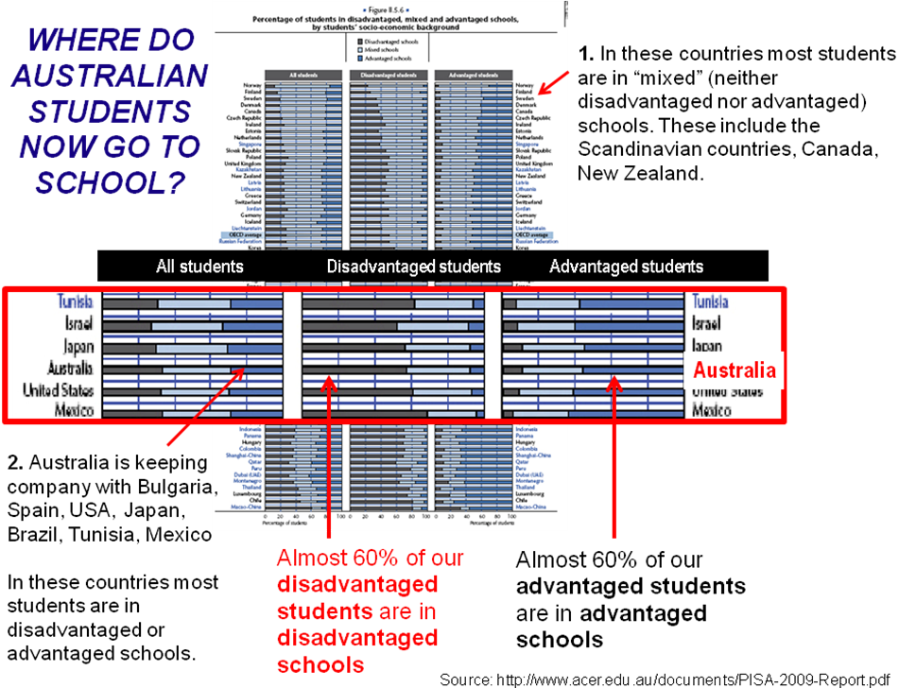
PISA 2009 tells us that Australia is concentrating disadvantage and concentrating advantage, far more so than the majority of OECD countries. Australia, shown on the enlarged section of the graphic, is about two-thirds the way down the above list of countries.

The countries towards the top tend to have most students in mixed schools – neither advantaged nor disadvantaged. We have far fewer students in mixed schools.

How is this changing?

The best known shift of students is from public to private schools. This shift has a qualitative as well as quantitative dimension: in a generation we have seen a noticeable shift in the composition of enrolments in government and non-government schools.

This graphic shows how the ratio of low income to high income students in government schools has substantially risen in that time.

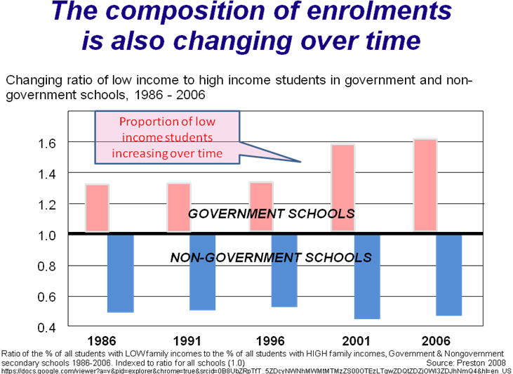

But this enrolment “drift” is more complex than commonly depicted. Both within and between government and non-government school sectors there is a shift of enrolments from schools with a low socio-educational enrolment profile to schools with a high SES enrolment profile.

The graph below shows how the size of metropolitan government secondary schools in NSW has changed over the last 20 years. The SES measure used is the ICSEA index used on the My School website.

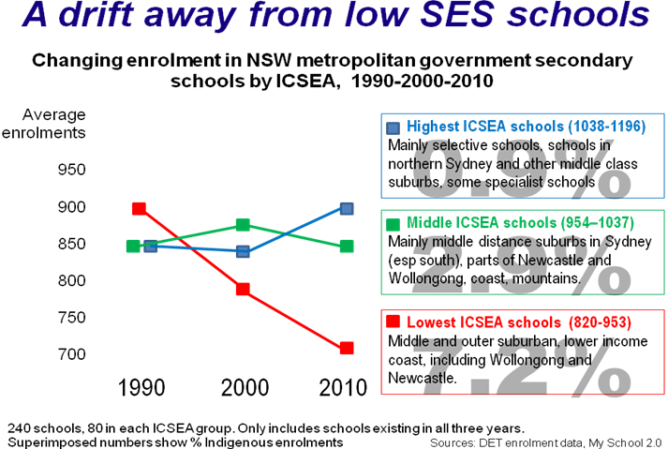

The highest and middle ICSEA schools have fared reasonably well. The enrolment rise in the highest ICSEA government schools needs to be seen alongside what we call the drift to the private schools – it has many similar elements.

The lowest ICSEA schools have declined in size from an average of around 900 to just over 700. Some of this change will include demographic change, including growth on the metropolitan fringe. The large font percentage figures show the indigenous enrolment in these groups of schools in 2010. Their density of disadvantaged students is almost certainly increasing but this graph by itself doesn’t show that.

Why is this significant?

“Regardless of their own socioeconomic background, students attending schools in which the average socioeconomic background is high tend to perform better than if they are enrolled in a school with below average socioeconomic intake.
PISA 2009

"The funding regime creates schools of different capacity ……….. If children from poorer backgrounds do not catch up, it is in no small measure because increasingly they are educated apart,"
Stephen Lamb and Richard Teese, May 2011

The impact of student SES on the achievement profile of a school is due to each student’s own socio-educational status AND the collective SES of the school’s total enrolment. The graphic below shows the significance of both effects, including for Australia.

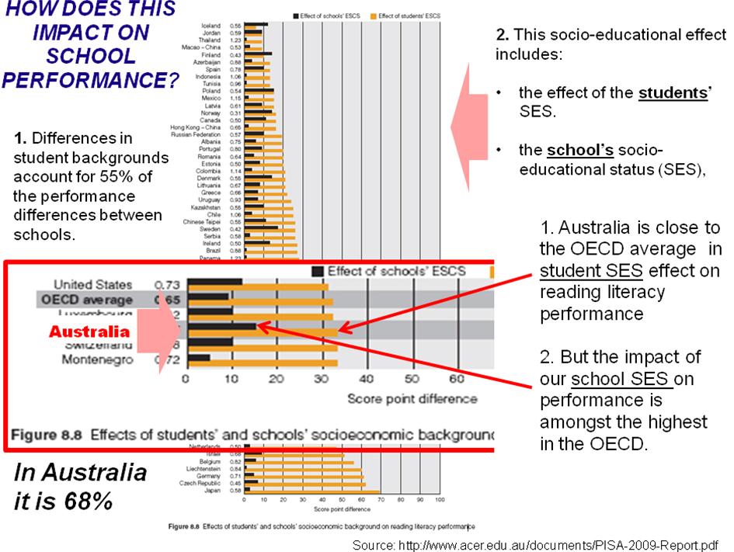

It is constantly stated that differences between classrooms are greater than differences between schools. But Australia’s between-school differences which are determined by student background are very significant. It is both the SES of individual students and the collective impact of the school SES created by this enrolment which impacts on schools’ performance.

What do students bring to their school?

Students are intellectual and cultural resources for schools – they bring prior learning, family education, networks and know-how. Shifting these resources has a compounding impact on:
  - School curriculum offerings and access
  - The experience and expertise of teachers
  - A range of other resources
Enrolment trends are increasing differences between the pooled characteristics of schools. Further details are available at http://www.deewr.gov.au/Schooling/ReviewofFunding/SubGen/Documents/Teese_Richard_and_Lamb_Stephen.pdf

What impact does this have on student outcomes?

It is becoming clearer that we are concentrating advantaged students at one end of our school system – and disadvantaged students at the other. What is also becoming clear is that we are compounding both advantage and disadvantage as a consequence.

Quite recently the DET in NSW produced a little known but disturbing study which showed the effect of collective school SES on individual student outcomes. The graph below shows the impact on individual students of enrolling in schools above or below their own SES.

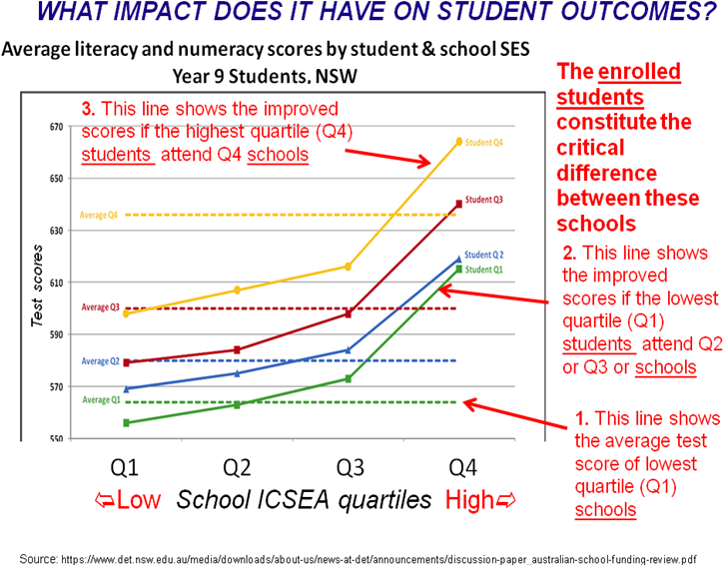

The labels on the above graph should be carefully read in order, 1, 2 and 3. Changing schools lifts many students – but at the expense of others. So how do we really improve the outcomes of those without choice – the ones who are increasingly educated alone?

It can’t be achieved by measures which only focus on lifting the efficiency of the workforce in schools.

How does this impact show up in student outcomes?

What we do know is that this situation contributes to – but is not the sole cause of – scenarios illustrated in the research completed by Richard Teese and Stephen Lamb and included in their submission to the funding review. They illustrate the multiplication of individual and pooled advantages and disadvantages between schools which can be attributed to individual and characteristics of students, as well as decisions about specialist resources, student management practices and funding

The graph below shows the distribution of VCE scores for students who all live in north-west Melbourne but attend different schools. Lowest scores are achieved by those who attend local government schools - most disadvantaged by the above three factors. Scores are higher for local students who attend schools in government schools outside the local area and higher again for those who attend private schools.

In popular language we use words like performing, good, coasting, bad, failing, achieving, underachieving etc. The reality is far more complex.

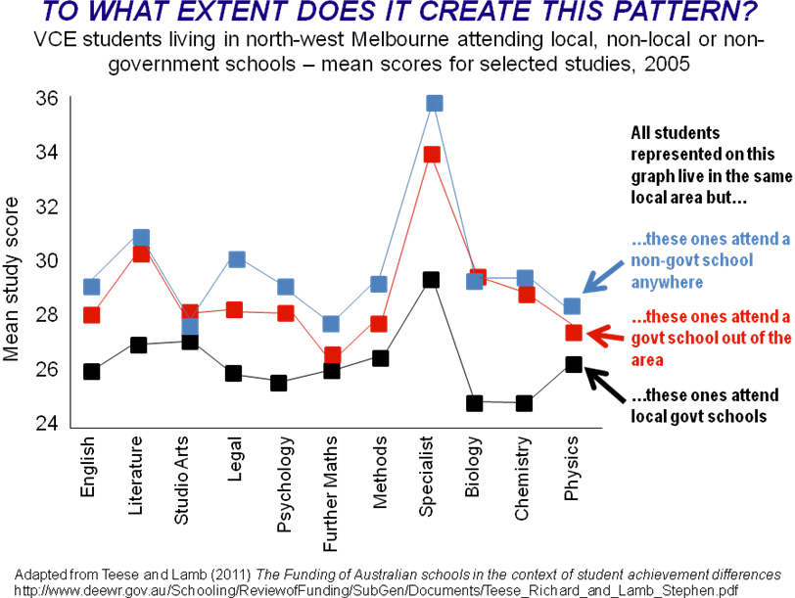

In this next graph Teese and Lamb show, for students in Victoria, variations in the take-up rate, achievement and failure rates for a more challenging mathematics course. Schools in the two groups shown are arranged by SES, from low to high. In the case of all three measures a consistent set of trends is illustrated: take-up and achievement rates rise with increasing SES, failure rates go in the reverse direction.

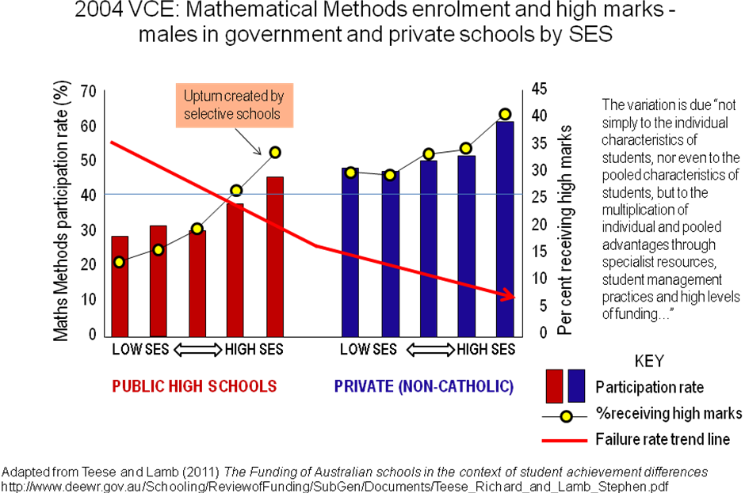

How has the academic profile of schools changed over time? One convenient, if imperfect measure, is the percentage of each school’s candidature achieving VCE scores over 40. In the graph below, showing secondary schools in Geelong, this is combined with data from My School.

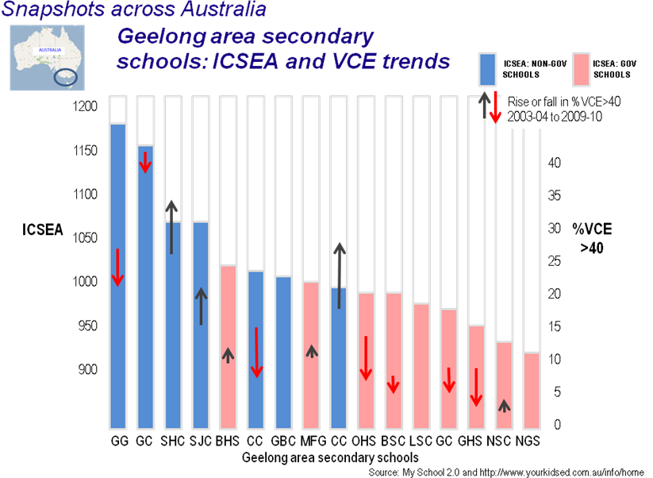

The arrows on the graph show the rise or fall in VCE scores between 2003/2004 (two years) and 2009/2010. The starting point of each arrow shows the earlier VCE score, the end point shows the most recent score. While there are notable exceptions, in general the lower ICSEA (mainly government) schools have seen their academic profile reduce in this time. The profile of most of the non-government schools has increased.

This also reflects findings from other research. Some schools have benefited from a growing and advantaged enrolment. In other schools the density of disadvantage has increased with impacts on student achievement and the academic profile of the school.

CONCLUSION

A question on page 10 of the Productivity Commission’s Issues paper asks: “What does the available evidence indicate about Australia’s education outcomes?” If the Commission is going to consider all the “available evidence” it has to be more than just “mindful of wider influences on the effectiveness of the schools sector and its workforce”. Regardless of any other study or inquiry into our wider framework of schools the Commission should fully consider the impacts on school and teacher effectiveness outlined in this submission.

Chris Bonnor
bonnorc@gmail.com

http://www.deewr.gov.au/Schooling/ReviewofFunding/SubGen/Documents/Teese_Richard_and_Lamb_Stephen.pdf

