The challenges and risks of measuring performance in a social learning system
Overview
This submission draws attention to the challenges of modelling and measuring teacher performance and the risks associated with the measurement of student and teacher performance. The first premise of this submission is that all such performances are strongly contextual, and that therefore valid modelling and measurement must take the effective dimensions of this context into account. The second premise of this submission is that this performance-context nexus operates as a system and that one of the properties of such systems is continuous feedback looping. The submission draws attention as well to an important entailment of this argument, which is that invalid modelling and measurement may lead to a distortion of the productive functioning of learning systems. This submission accordingly urges the Commission to commit to developing an econometric model which reckons with the contextual determinants of student and teacher performance, and the pursuit of system-wide productivity increases on the basis of the school learning system as the basic unit of analysis. The Commission is also urged to investigate the suggestion that performance measurement regimes which take the basic units of measurement as individual student and teacher performance rather than the school pose a risk to the productivity of schools as learning systems and innovation in the Australian economy as a whole in the longer term.
Challenges: to develop a model for econometrics to comprehend the school as a unit of analysis
Measures of student and teacher performance, and the statistical models that connect these together, provide a basis for establishing a proxy for some kinds of returns on investment in education. Measures of performance of these kinds represent an important aspect of accountability for the social contracts fulfilled by the teaching workforce. The teaching workforce does not work in isolation to fulfill these social contracts but as part of a system of learning that is attached to other systems with which they interact. Schools can be viewed as a unit of a social learning system, providing one kind of boundary for this modelling. This account needs to also recognize system level inputs, drivers and decision making into both teacher performance and student learning.
One important caveat of this account lies in recognizing that though it may appear a technical question to determine performance measures “conducive to maximising the efficiency and effectiveness of the schools workforce” (Productivity Commission, 2011, p.3), there are tensions in the different kinds of expectations made of the teaching workforce by Governments, the wider Australian community, the media and by industry. In particular “efficiency and effectiveness” implies consistently agreed upon products or processes against which measures can be developed, but where multiple products and processes are considered valuable a dissipation of energy may occur. Where there is no avenue for timely reconsideration and renegotiation of the value of particular measures and the ends that they serve, the information gathered may be of limited value as the basis for decision making. Measurement of teacher and school performance that denies the existence of this tension may end up producing a wide range of unintended consequences, from misrepresentations of school performance, the desirability of teaching as a career option, and of the direction of social and economic capital to a small subset of needs that does not suit the current or future needs of the broader community. Without a clear and consistent set of checks or balances on these tensions, an emphasis on the measurement of teaching and school performance may be counterproductive.
Despite this caveat, we see that there is a role for developing ways to measure performance for Government planning and decision making and public accountability (though noting that these represent different though potentially overlapping purposes). The deficit that we see in public accountability lies in the provision of data about the significance of different elements and subsystems to different kinds of products and processes produced through the school workforce, in particular through each school. The school as a learning system represents the most immediate and immanent boundary or parameter for the development of a performance model. This suggests that the school is the smallest unit of a learning system. The immediate reference of performance for teachers, students and leaders lies at this level and it is at this level that reform efforts and research typically focus through comparisons, such as ‘like’ or ‘unlike’ schools.
Schools may be considered as being comprised of a number of subsystems that interact and shape teaching and learning and the performances of leaders, teachers and students. In diagram 1 (below) these sub-systems in are labeled Community of Students (including ‘l’ in diagram), Community of Teachers (including ‘k’ in diagram), and Leadership / Policy / Support structures including ‘g’ and ‘b’ in diagram). Intervening in each of these subsystems are continuous links and feedback loops from performance of the other subsystems, and links and feedback loops from other systems (other schools and networks of schools). One problem for modeling lies in developing ways to account for the flows and effects of these feedback loops, which are indicated through the arrows in the diagrams. Blockages between these subsystems – through lack of data, non-cooperative behavior or time constraints – may contribute to reduced quality of information and data about performance, with compounding impact on the whole system.
Each school and subsystems within each school are composed of a number of elements that impact on both individual teacher performance and student performance. For simplicity we introduce these elements below under the headings of “individual student performance” and “individual teacher performance”, though, as Diagram 1 demonstrates, these represent two ways to understand, model and explain the same system of learning. Though some large scale effect-size studies omit questions of Socio Economic Status, the theoretical model developed includes the effects of SES on both teacher and student performance.
Student performance
In order to develop a model of student performance we consider five elements as a minimum:
- influence of teaching
Student performance is determined by different pedagogical approaches; the immediate effect of teaching performance; residual effects of teaching performance; teacher skill and knowledge; intended and unintended effects (e.g. of reproduction of inequalities).
- influence of school policies and support structures
Student performance is impacted by the refraction, adaptation and implementation of national and state policies to suit individual school contexts; school infrastructure; teaching support (administration); learning support (human and material); organizational structures such as grouping or streaming, multi-year or single year classrooms, transition programs between pre-school to school, primary to secondary and secondary to tertiary or workforce; mentoring programs; decision making by the leadership team in schools.
- influence of other students
Student performance is affected by interactions with other students within and beyond the classroom (intentional and unintentional social grouping and interactions).
- influence of other teachers
Student performance reflects other teachers’ expectations and attitude towards learning; motivation to succeed and the learnt social roles and norms of behavior that students bring from engagements with other teachers.
- out of school influences
Student performance is affected by family, socio-economic status; culture; effect of economic advantage and disadvantage on performance; mass media; developmental history of a student (biologically, socially, psychologically); social and economic conditions and contexts at local, regional, national and global levels, which provide different incentives for particular kinds of education; demographic and broad scale policies and planning.
Individual teacher performance
In order to develop a model of teacher performance we consider five elements as a minimum:
- influence of student performance

Teaching performance is constantly adjusted to student performance – both systematically (e.g. individual learning plans and strategies; reflection on teaching and planning) and spontaneously (immediate behaviour and situations).

- influence of school policies and support structures

Teaching performance is governed more or less directly by school policies and mediated by infrastructure, teaching support (administrative) and learning support (human and material).

- influence of other teachers

Teaching performance is shaped by the practice of other teachers in a school through sharing of advice, experiences and values.

- influence of other students

Teaching performance is constrained by the behaviour of individual students and groups of students within the classroom.

- out-of-school influences
Teaching performance is moulded by the teacher’s developmental and educational history, including their initial teacher training and professional development; mass media; family, socio-economic status; culture; social and economic conditions and contexts at local, regional, national and global levels, which provide different incentives for particular kinds of education; demographic and broad scale policies and planning.

Diagram 1: Performance in a learning system (school)
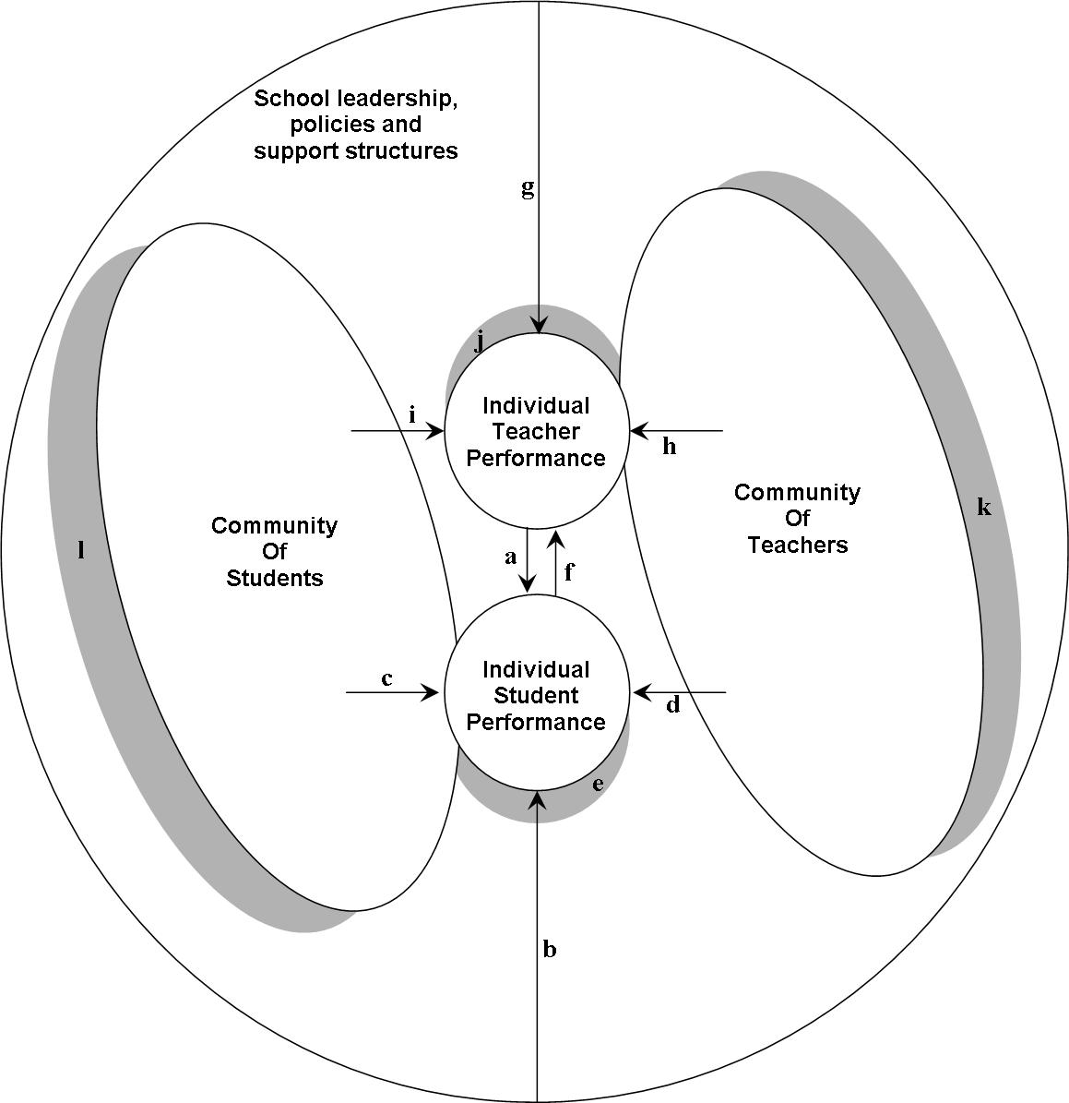

a. influence of teaching
b. influence of leadership, school policies and support structures
c. influence of other students
d. influence of other teachers
e. out-of-school influences (e.g. family, SES, history)
f. influence of student’s performance
g. influence of school policies and support structures
h. influence of other teachers
i. influence of other students
j. out-of-school influences
k. out-of-school influences on the community of teachers (e.g. history, education)
l. out-of-school influences on the community of students (e.g. family, SES, history)

Risks: distortions to the system in overemphasizing any one aspect of the system which may undermine productivity
Risks of performance measurement
The key argument outlined in this submission is that the performance of students and teachers are generated as key features of a learning system. One underemphasized aspect of this system is that the kinds of links and feedback loops that traditionally characterize the system have emerged and developed in response to changes in the system over time, and have provided an internal correcting system that acts to balance the tensions of different external and internal demands. This has proven successful in Australia’s standing in educational indicators relative to comparable nations. It has also proven successful throughout a wide range of external changes and expectations made of the system, from the rapid increase in demand made on the system through near universal provision to year 10 and comprehensive provision through to year 12 as a result of arguments about the utility of education to the production of human capital and subsequent productivity growth. That is to say that the initial arguments about investment in education and schooling were not about comparable performance in educational measures but in the economic productivity that appears to be generated from these investments. This has also proven successful throughout changes in the diversity of student cohort through calls for social inclusion of groups previously excluded, and the widening of vocational and social functions played by schools within their communities. Given that economic growth has been cited as the warrant for investment in schools, logically Australia’s economic success should be attributed to the foundational contribution of schools as systems of learning. In short the current links and feedback loops have acted as self correcting mechanisms to these external changes and internal pressures.
The risk of developing an individualized account of teacher performance which also acts as a public form of accountability to schools lies in how the measures are developed and interact with the existing internal learning feedback loops. A danger lies where external measures come to be internalized within the system and are used as a substitute and in conflict with internal feedback mechanisms. This consequently may impact on the extent to which teachers and schools meet the social contracts fulfilled by the teaching workforce. In short, limited measures may distort the way that schools work as learning systems, which may lead to system failures within schools and between schools. There are mechanisms that might explain such concern in instances where limited measures of student performance are used as direct measures of teaching performance. If limited measures of student and teacher performance are drawn on to develop performance based pay for teachers then these measures are likely to have a distorting effect on teachers’ pedagogy. Anecdotal evidence in relation to NAPLAN testing provides one case in point as to the effects that school based accountability can have on schools as system. Such measures can create pedagogical effects (‘teaching to the test’) which provide an incentive for conformity on a small number of system goals, but which can weaken pedagogical innovation (as a product of the value added by teachers), and ultimately undermine teaching productivity. Limited measures of this kind act to impose a conception of learning on teacher’s practice (behavioural) which is at odds with their training and professional practice (social constructivist), and act as a point of dislocation of those teachers recently trained in universities from their vocation.

References

Wilkinson, R., & Pickett, K. (2009). The Spirit Level: Why equality is better for everyone. London, UK: Penguin Books.

Williams, J. H. (2005). Cross-national variations in rural mathematics achievement: A descriptive overview. Journal of Research in Rural Education, 20, 1-18. Retrieved April 27, 2011 from www.umaine.edu/jrre/20-5.htm.

For example, as a system schooling provides not only parents with a service, but it provides the raw material for the development of sets of numbers with which Universities can consume the most desirable applicants for courses in the form of entrance scores, and in doing so act on behalf of Governments to distribute educational and vocational opportunities. It also provides international performance data on which the Australian Government can compare and promote the performance of its educational system to other nations, and to act as the basis for encouraging knowledge and other industries to set up in Australia. The schooling system also provides a way for governments to respond to Global pressures though the introduction of sets of knowledge, skills and values suited for the 21st century workforce, and is in fact the only institution able to achieve this on successive generations of students.
Socio-economic status is often omitted from large scale modeling of school effects, in spite of its acknowledged effects, based on the argument that schools cannot directly change a student’s SES. However as SES contributes different effect sizes in different nations, the connection between SES and educational performance can be weak or strong depending on other the characteristics of different national systems of education and local and contextual conditions (Wilkinson & Pickett 2009; Williams 2005). This suggests that there are productivity gains and policy lessons to be learned from the way different nations deal with SES. If more is done to understand the specific mechanisms and paths through which SES contributes to student performance, the influence of these mechanisms and influences can potentially be understood and diminished.
Here limited measures indicate non-systemic measures, and appear to reflect a small number dimensions of the work of the teaching workforce.

